Katie’s Steps
- Download all templates from WWS-standard-methods\Templates\water-quality-analysis to your project folder.
  - It’s suggested to store it in something similar to data\metadata.
  - (if not already downloaded) Rename wqsample-sample-tracking-template.xlsx with the project code. This will be used across sampling campaigns.
  - Rename wqsample-label-datasheet-templates.xlsx and Avery5520AddressLabels_unlinked_blank.doc with the project code and sampling date.
- Open wqsample-sample-tracking-template.xlsx, go to the FILLME tab. Fill in the highlighted information. The second group and be skipped for grab samples.
  - Site Names (Row D): List the site names with a single site name per cell.
  - Project (B3): The large project the study falls under, usually tied to a funding source.
  - Study Code (B4): The specific 3-6 letter code associated with a specific study.
  - Samples per Site (B5): How many samples are you collecting at each site (i.e., typically 24 for ISCO).
  - Sample Start Date (B6): The date that samples will be collected (or begin for ISCO samples).
  - Sample Type (B7): Either ISCO or Grab, this is a critical cell as it will determine the way the times are written.
  - Field Sample ID Type (B8): How should the labels look for the field labels that go on either the ISCO bottles or the grab sample bottles.
    - Bottle Number: Inclues the project ID, sample ID, sampling date, and bottle number.
    - Sample Date/Time: Includes the project ID, sample ID, sampling date, and date (if known, otherwise is left blank).
    - Short Bottle Number: The sample ID and the bottle number.
  - Lab Sample ID Type (B9): How should the labels look for the lab labels that go on the alliquot bottles? Options are bottle number or sample date/time as above.
  - Site 1 Sample Start Time (B11): When will sampling start for the first site in Row D [only used for ISCO samples].
  - Site 2 Sample Start Time (B12): When will sampling start for the second site in Row D [only used for ISCO samples].
  - Time Interval (Hours) (B13): How frequently will ISCO samples be collected? [only used for ISCO samples].
  - Start Bottle Number (B14): What is the starting bottle number. Used when more than one round of ISCO bottles is grabbed [only used for ISCO samples].
- Fill out the Bottle Calculator (F3:J12). It will default to an alliquot for each sample for each analysis except BPCA.
  - Put a 0 for any analyses not being performed.
- Go to the Label IDs tab. Ensure everything looks like it got autofilled correctly.
  - If you need finer control on the analyses (not every sample is being analysed for each analyte), you can use columns M:T to replace TRUE’s with FALSE’s to indicate that no label is needed for that site/analyte combination.
Printing Labels for Field Analyses

Printing Datasheets for Lab Analyses
- Once label ID’s have been filled in, print out the appropriate datasheets. Use the print option “fit all columns on one page”.
  - DS-Bottle Numbers (landscape): Used to record the bottle numbers for each analytical bottle.
  - DS-ISCO Bottle Weight (portriat): Used to record the empty and full ISCO bottle weights for SSC.
  - DS-Filter Weight (portriat): Used to record the weight of the filter before and after filters for SSC.
Printing Labels for Lab Analyses
- In file explorer, right click on your renamed copy of Avery5520AddressLabels_unlinked_blank.doc and click properties. At the bottom click “unblock” and hit OK. This will allow the macro to color the sample analyses to run.
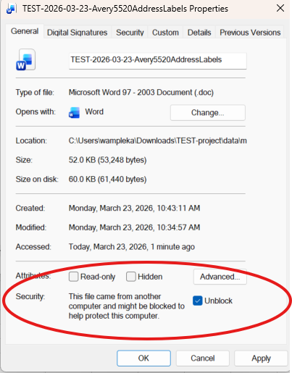
- Open your renamed copy of Avery5520AddressLabels_unlinked_blank.doc. Click “Enable Content” in the yellow bar at the top.

- In the Mailings tab on word click Start Mail Merge, select Labels.
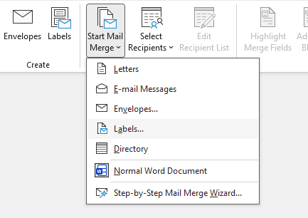
- Just hit cancel and exit the window. If you hit OK it deletes the template and opens a new window and the format gets messed up.
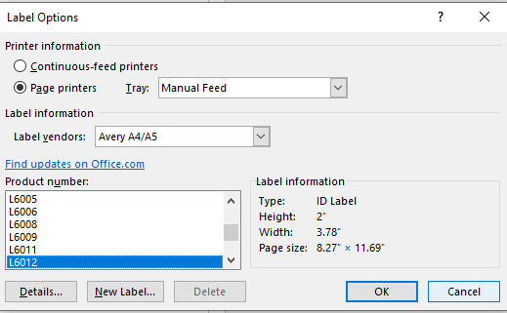
- Click Select Recipients and Use an Existing List
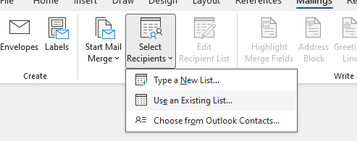
- Navigate to where your renamed and filled out copy of wqsample-label-datasheet-templates.xlsx is and hit open.
- It will ask you to select which tab on your mailing list you are using. Select the right one and hit ok
  - Note: sometimes the window will shows doubles of your tabs. Not sure why. Just click the top one. It will still work.
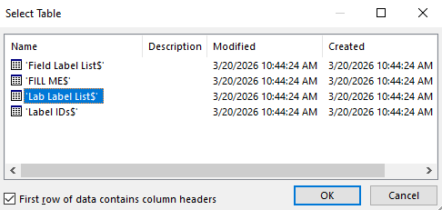
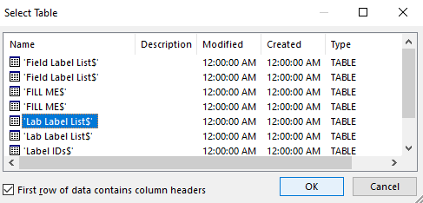
- Click Insert Merge Field
  - If your column names are greyed out, repeat step 7 choosing the other tab.
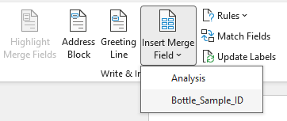
- Select which IDs you want to use
  - (e.g. select Bottle_Sample_ID, press enter to make a new line and then go back and select Analysis)
- Your first box will look something like this (below)
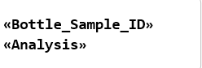
- Click preview and it should look something like this. If not you might have selected something incorrectly
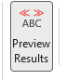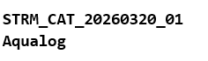
- Click update labels
  - You should get the other boxes filled with <<Next Record>>. If not to go through the steps again to reconnect the labels to your excel sheet
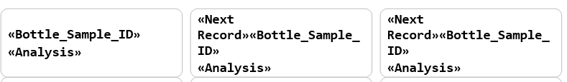
- Click on Finish & Merge, then Edit Individual Document
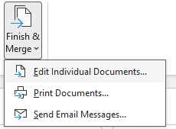
- Under Merge records All should be selected, hit OK
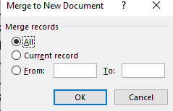

- This will open a new word document file with all your labels on it. It will be called something like “labels1”. Double check that it’s not missing anything. You can go back to the orginal document and make edits
- Update the colors for the analyses by running the macro.
  - In the View tab, click Macros and then View Macros.
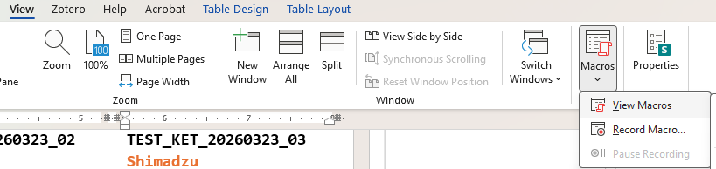
  - Select Color_Analyses and click Run. This should run the macro to apply the coloring to the analyte names.
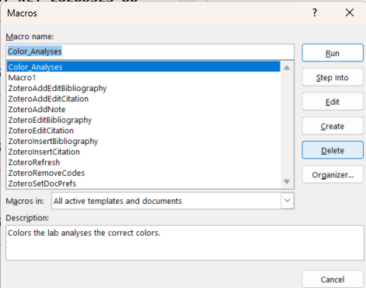
- In the home tab, find the find and replace button in the editing box
- 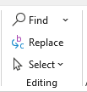
- In the find and replace window you want write the exact name (same capitals and no spacing behind) in the Find what: and Replace with: sections. You will do this for each site code.
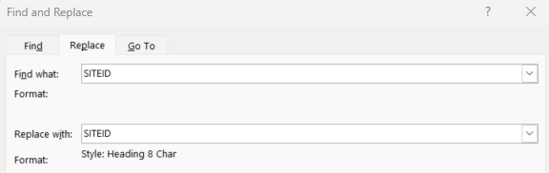
  - Essentially you are going to be going from from SITEID > SITEID
  - Make sure your cursor is in the replace box. If it is in the find box it won’t be able to find your word
- Click the more options button at the bottom left on the window. Click format and then style.
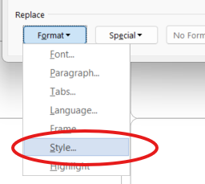
- Select SiteID.
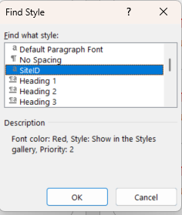
- Repeat steps 19-21 for all site names.
- Print labels using Avery 5520 Address Labels.

Notes:
This does work through box drive but it is easier to download the files to your own computer
Do not save overwrite the word documents, it makes a new document something like“label1” when you generate your labels

Files to use:
sample-ID-generator-labels
The excel sheet that will be connected to the mailing list. Only for lab. I can make one for field once we figure out the sample IDs

Avery5520AddressLabels_unlinked_blank
Just the blank document for Avery 5520 labels. You need to do every step to connect it to your list. I saved it so it should already know it’s labels. But if you take the template off the Avery website it gets confused and thinks it is a letter if you skip the start mail merge part.

Avery5520AddressLabels_template_linked_changes
It already has the merge fields inserted, the first time you use it you will need to select the recipent list but after that you shouldn’t need to. DOES NOT WORK with different users- make your own
It will give this warning when it’s already linked, hit OK
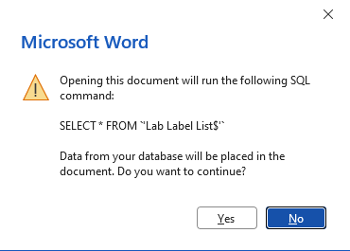
If you made changes to the excel file then simply hit edit the recipient list and press okay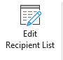

Example of field label (ISCO): OLD
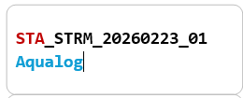

Example of lab label (ISCO): OLD
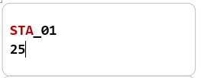

Connecting word doc to excel sheet
- In the Mailings tab on word click Start Mail Merge, select Labels

- Just hit cancel and exit the window. If you hit OK it deletes the template and opens a new window and the format gets messed up.

- Click Select Recipients and Use an Existing List

- Navigate to where your spreadsheet is saved e.g sample-ID-generator-labels
- Hit open
- It will ask you to select which tab on your mailing list you are using. Select the right one and hit ok
  - Note: sometimes the window will shows doubles of your tabs. Not sure why. Just click the top one. It will still work


- Click Insert Merge Field

- Select which IDs you want to use
  - (e.g. select Bottle_Sample_ID, press enter to make a new line and then go back and select Analysis)
- Your first box will look something like this (below)

- Click preview and it should look something like this. If not you might have selected something incorrectly

- Click update labels
  - You should get the other boxes filled with <<Next Record>>. If not to go through the steps again to reconnect the labels to your excel sheet

- Click on Finish & Merge, then Edit Individual Document

- Under Merge records All should be selected, hit OK


- This will open a new word document file with all your labels on it. It will be called something like “labels1”. Double check that it’s not missing anything. You can go back to the orginal document and make edits

Changing colors
Color table, recommended colors. Use this to copy and paste into the search boxes.
Suggested font/format/size: Consolas/bold/14
Analysis | Suggested color
Aqualog | (Turquoise, Accent 4)
Shimadzu | (Orange, Accent 2)
Levoglucosan | (Plum, Accent 5)
CCAL | (Green, Accent 3)
Excess | Excess

- In word under the home tab, find the find and replace button in the editing box
- 
- In the find and replace window you want write the exact name (same capitals and no spacing behind) in the Find what: and Replace with: sections. You will do this for each analysis and site code.
  - Essentially you are going to be going from from Aqualog > Aqualog
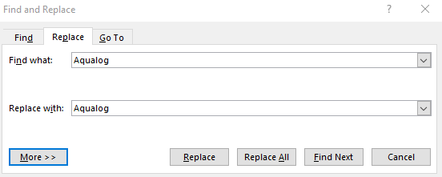
- Make sure your cursor is in the replace box. If it is in the find box it won’t be able to find your word
- 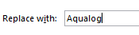
- Click the more options button at the bottom left on the window
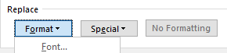
- Go to format > font
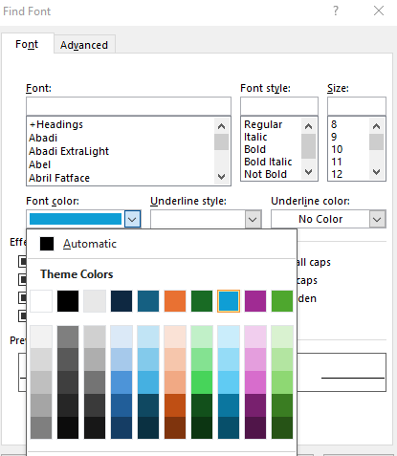
- Select your color (see table) and hit OK
- The find and replace window will look like this (below)
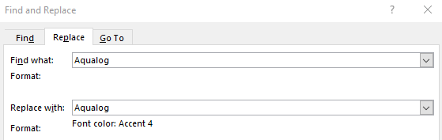
- Hit “replace all”
  - Troubleshooting: If you accidentally applied the font color to your “find what” box, then click on the box and click the “no formatting” button towards the bottom of the find and replace box. When you try to replace all it won’t find anything
- Do this for all analysis and site codes (example below)
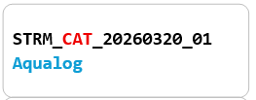
Optional step:
- If you have blank boxes at the end, we can’t use those extra labels for printing again so either save them or make cooler labels (helps organization during filtering)
- Copy/write each analysis with it’s color and increase the font size. Add the sampling date at the bottom


