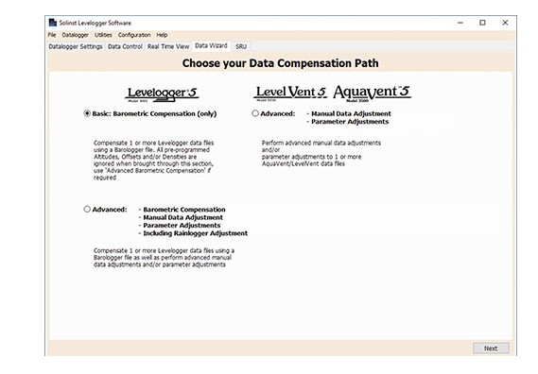
- Go to data wizard tap and chose basin compensation.
- Press “Next”

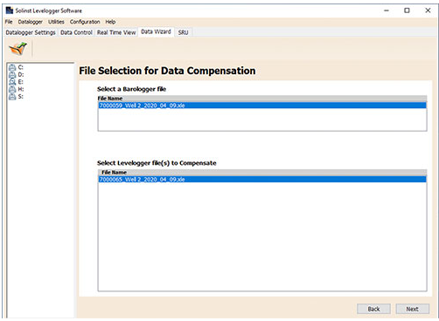
- Select the barologger file and the files of the levelogger which you want to convert. Be sure that all the files are blue when you press "Next" otherwise it will not convert those.

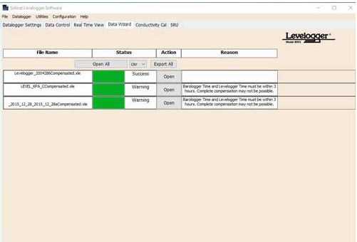
4. Press export all and save them in a good place
5. Check the files if they look good, make sure that the offset for all the files is 0

