Instrument retrieval
Supplies:
umbrella

In the field
Check out text: Send a group text in Teams to the let group know your general plan and your estimated time of return
Good practice: say out loud all the steps you are taking in the field.
- Take a general look around the site– are there any new failures on the slopes or banks? Are there any new trees or rootwads that have fallen over?
- Fill out the general information on the “field_form_stormchasing.pdf” (file location: “T:\Research\Wildfire_Water_Security\02_Nodes\01_Empirical\05_Projects\storm chasing\Lane1\forms”)

  - Record the site name (as shown on the map)

  - Record the date in the yyyy-mm-dd format

  - Record the time as 00:00 format, in Pacific Standard Time

  - Record the field crew members’ (OBS = observer) initials

  - Record the weather (WX) – Is it raining? Is it clear and sunny? Is it windy

Grab sample
      - Label the sample: XXXXXXX.

      - Check the time, if there is time between the sonde sampling, collect the grab sample, if not wait for the sonde to finish the sampling.

      - Record in the field notes the name of the sample, the bottle number and the day and hour you collected the sample.

      - Rinse the bottle of the extendo sampler 3 times with the creek water

      - Rinse the 1L sample bottle 3 times with the creek water from the extendo sampler

      - Fill the 1L sample bottle with creek water leaving no headspace.

      - Place the bottle in the cooler.

Isco retrieval
- Check the ISCO screen and record in the field notes the information displayed.

- ISCO intake line submerged? Check to see if the intake line is submerged or possibly buried by sediment. Take notes.

- Record any problem encountered, is the tube still attached? Did the samples overflow? Did the program crash?
  - If the ISCO displays “Sample missed” it is likely because either the intake line is not submerged (see step 17) or the tubing has come off at the ISCO.
  - If the ISCO displays “Pump Jam failure” you’ll need to replace the ISCO with the spare as we are not able to fix this issue in the field.

- Record the time in your field notes.

- Before opening the ISCO, make sure you have enough time before the next sampling, if not, wait for the ISCO to sample.

- Wear nitrile gloves and open the ISCO.

- If raining, use the umbrella to cover the bottles, no rain should enter the bottles.

- Empty the water that is possibly present in the plastic container of the battery and on the ISCO itself.

- Place the lid on the bottles with samples and replace them with the dirty ones, make sure you take out the lids.

- Make sure the ISCO program is still on and record the hour and date of the next sampling. Take a picture of the screen and read out loud what it is written.

- Turn the ISCO off.

- Carefully unscrew and unplug the Isco from the battery leash, on the back of the display, to disconnect it from the battery.

- Unclip the negative (black) terminal first, then the positive (red) terminal. You will be disconnected from the power source, but it is good practice to always disconnect the negative terminal first.

- Remove the ISCO hose from the stream

- Remove the Isco hose from the Isco intake coupler show below – it will either be secured with hoseclamp or with a black and white plastic piece (in the picture below). To loosen, push the two halves shown in the red square below on each piece away from each other (it will be difficult to push them apart)
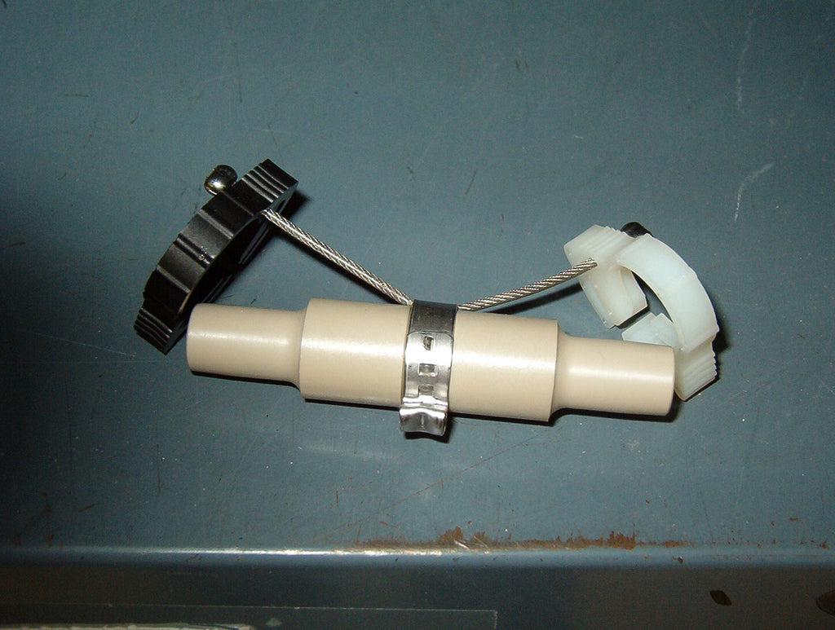
- Record the number of bottles and the bottle numbers in the field form and place the bottles in the cooler.

Pressure transducer retrieval

- Levelogger optics submerged?: Check to see that the optics are submerged by feeling underneath/into the PVC stilling well. Check to see that the optics are submerged by rotating the stilling well cap. The opening in in the red circle of the image below are the optics.
  - If the optics are buried: Record this in the field notes.
  - Flush the flume stilling well by taking a bucket of water from the stream and pouring it through the top of the stilling well. Record the time of your flushing, and get a stage reading after flushing the well.
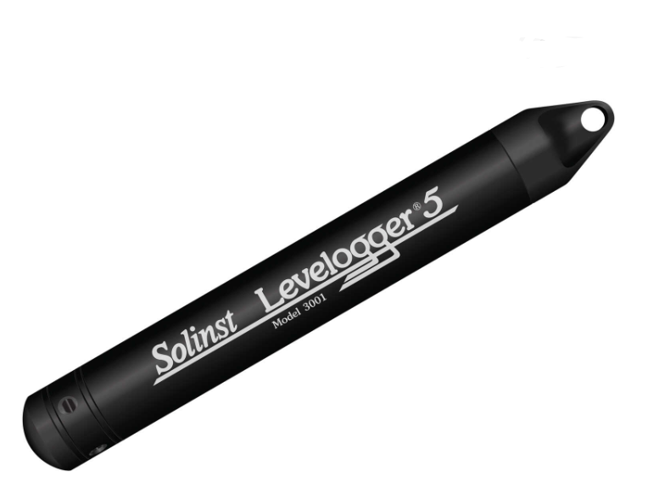

End of the field campaign
- Samples need to be filtered within 24 hours of collection. If not filtering the same day, store these samples in the walk-in cooler in Oak Creek.
  - Other lab members can assist the next day to ensure the samples are filtered if you don’t have time (post for help in TEAMS “Projects that need help” page and/or let Kate or Ryan know if you need to coordinate with another member – filtering takes ~1 – 1.5 hours).
  - The samples will be stored in the freezer only after filtering
  - Filter procedures are in:
- Bladon_FEWSLab\Equipment & Forms\SOPs or Methodology\H20_Quality\Filtration

- After unloading the field gear, return the truck to motorpool.

Calibration criteria for field checks
Parameter | Calibration criteria (pass or fail)
Temperature (°C) | ± 0.5 ºC
Sp Conductance (uS/cm) | ± 20 μS/cm or ±5 % of the measured value, whichever is greater
DO (mg/L) | ± 0.5 mg/L
pH | ± 0.5 pH unit
Turbidity (FNU) | ± 10 turbidity FNU unit or ± 5% of the measured value, whichever is greater
fDOM (QSU) | ± 10 fDOM QSU unit or ± 5% of the measured value, whichever is greater

