Lab preparation

ISCO
Bottles preparation:

- Print using the waterproof sticker paper 24 x per site labels (Waterproof film 1” x 2 5/8”) (you can find them in folder: XX_XX).

- Place one label per bottle (Label position on picture) and add the bottle number on the label (1-number of bottles per campaign, not number of bottles per ISCO).

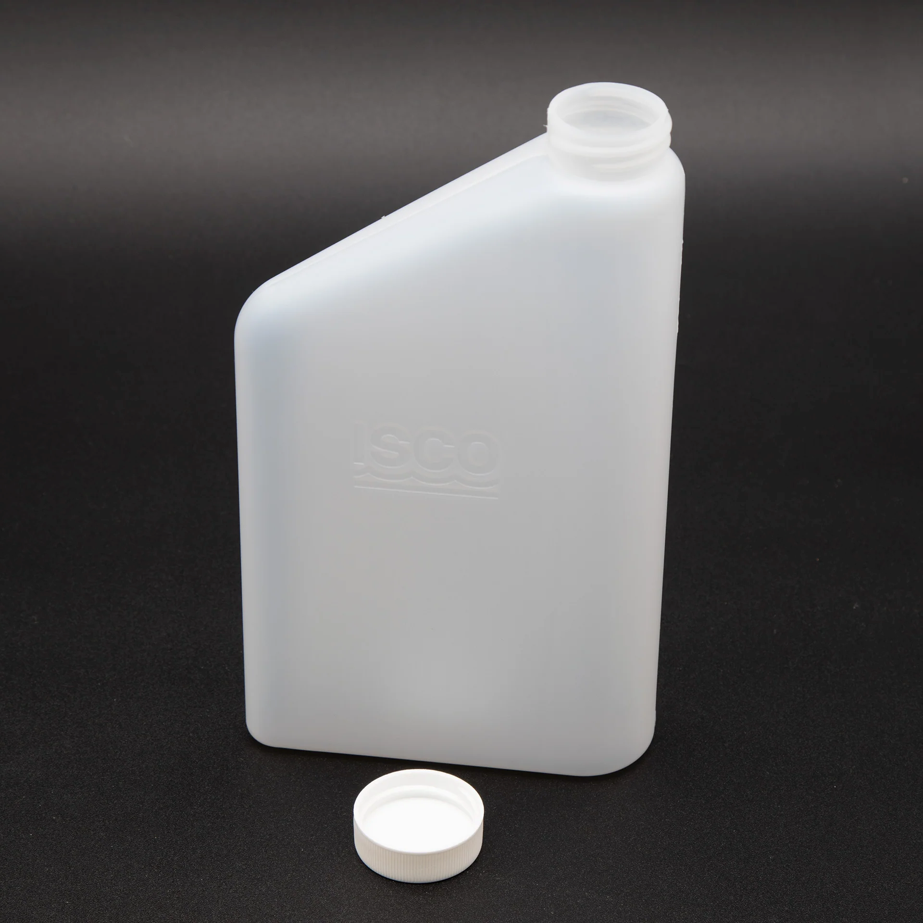

- Write the bottle number on the lid and on the bottle too.

- Weigh the bottle without the lid. Record the information on the excel stored at: T:\Groups\Cellar\Bladon_FEWSLab\Research\Wildfire_Water_Security\02_Nodes\01_Empirical\05_Projects\storm chasing\03_Forms\ISCO_bottles_weight.xlsx
  - Column A – SAMPLE_ID (name on the label)
  - ISCO bottle number (campaign bottle number)
  - Name of the site
  - Empty weight ISCO bottle (g)

Isco preparation:

- With a voltmeter, read the voltage of all Isco batteries (including spares) and record the number with labeling tape on the top of the battery.
  - For any batteries below ~12.8v, charge in batches for 12 – 24 hours
  - NOTE: Do not leave deep cycle batteries connected to the charger once they are charged! It will damage the battery! Check up on them every day while charging.

- Open up each Isco, and make sure it is outfitted with:
  - Coupler (to secure the Isco intake line)
    - Usually looks like the image below, but sometimes made of metal or plastic. Alternatively to the black and white rings, there may be a hose clamp used to secure the intake line:
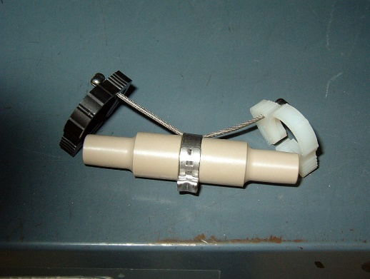
  - Isco intake line (~3 – 5 feet long)
    - These are either made of silicone (soft) or Teflon (hard – this is what we use in Hinkle)
    - For either material, check to make sure the line is free from gunk and debris

    - For Teflon hoses:
    - They are very rigid, so it’s important to make sure at least one end fits onto the coupler. If it does not fit, gently apply heat with a lighter (not in the direct flame) and, while still warm, mold the hose end by putting it onto the coupler. Another option is to use a smaller coupler to open up the Teflon hoses. Once it’s cooled or opened, it will hold its shape and should have no problem being connected/disconnected from the coupler
  - 24 capped dirty ISCO bottles for tasting.

- Reference the moisture indicator (circled in red on the image below) to see if desiccants need to be replaced. This helps to ensure that the internal wiring will stay dry!
  - Blue = OK, “I am dry”. Pink = Moist, “Please change me”
  - If desiccants need to be changed, carefully remove the panel with a screw driver, lift the panel off, and replace the packs
    - You may need to “reactivate” desiccants for this step. If so, just follow the instructions stamped on the desiccant itself, but typically it’s something like dry at 118 degrees C (245 degrees F) for ~16 hours.
  - Note: In the image below, the moisture indicator is pink because the panel has been removed from the Isco
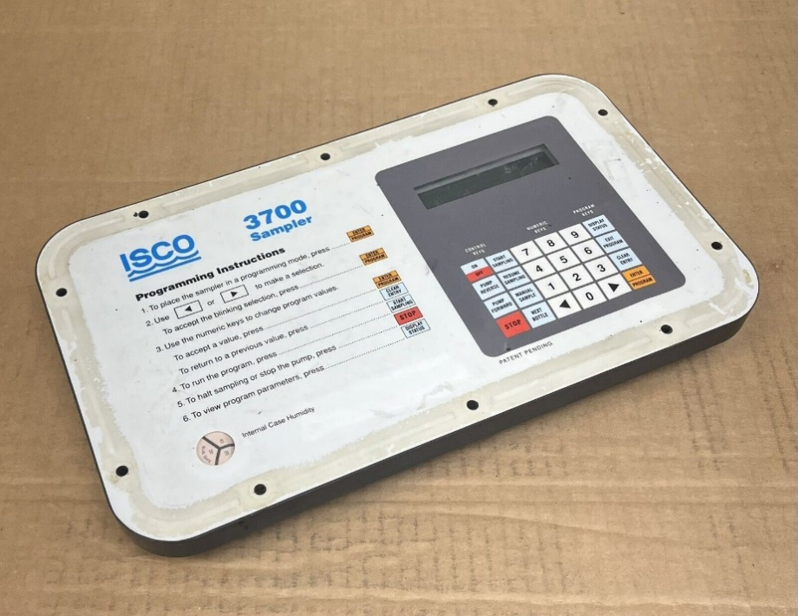

- Test the ISCO:
  - Transport the ISCO to Oak Creek and set it to collect 24 bottles in 24 hours. We want to be sure the ISCO is working correctly.
  - Remember to remove the lids before starting the test.

- ISCO working:
  - Replace the dirty ISCO bottles with capped acid washed ISCO bottles

SONDES
      - Drill three holes for each aluminum pipe you will use for sonde deployment:
        - 2 holes will be used to install the lock, be sure the holes are close enough to the edge to insert the lock
        - 1 hole will be used to insert a cable.

      - Make sure the sensors are calibrated, and the sonde is working properly.

PRESSURE TRANSDUCER
- If not stored in the lab, drill holes at the end of a PVC tube.

  - Drill two holes at the start of the pipe to be used to install the lock.

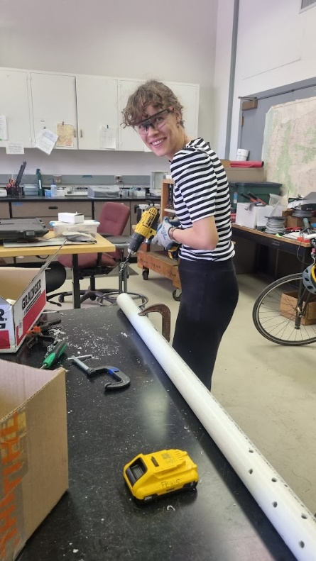

- Launch the Solinst pressure transducer via the Levellogger software on the laptop. Make sure this is done close to the level measurement location! In the software the following this should be filled in:

  - The name of the stream

  - The unit is “m”

  - An offset of “0”

  - An interval of 15 minutes

  - The future start (make sure this is a “nice” time, so a quarter past or before, or the half or whole hour)

  - Make sure that there is more than sufficient memory available for the readings

  - Don’t forget to press the start button!

  - Record the serial number of the pressure transducer together with the stream name in the project notes: (T:\Groups\Cellar\Bladon_FEWSLab\Research\Wildfire_Water_Security\02_Nodes\01_Empirical\05_Projects\storm chasing\03_Forms\Project_notes.doc)

RAIN GAUGE CALIBRATION

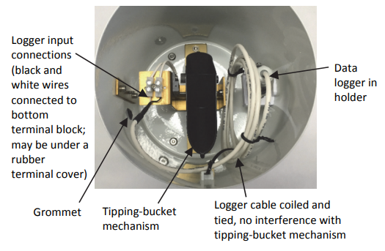
- Connect the data logger to the computer using the Optic USB Base Station and the proper coupler (Figure)
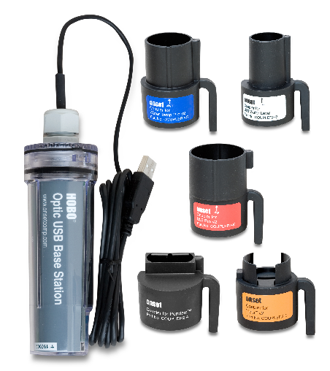

- Using the hobo software, launch the logger.
  - You will need to press the level in the coupler to connect the data logger
  - You will be sure the logger is launched when you can see an intermittent light on it.

- Depending on the rain gauge model:
  - RG3: pour exactly 473 ml of water into the bottle (Figure).
    - Fill first 450 ml, and after use a pipette to fill the remaining 23 ml.
  - RG3-M: pour exactly 373 ml of water into the bottle.
    - Fill first 350 ml, and after use a pipette to fill the remaining 23 ml.
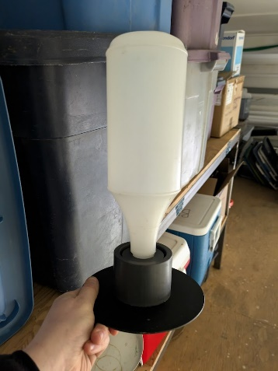

- When the water runs out, reconnect the data logger and launch the program.

- Successful field calibration should result in 100 tips +- 2.

- Adjusting screws are located on the outside bottom of the Rain Gauge housing. These two socket head set screws require a 5/64 inch Allen wrench. Turning the screws clockwise increases the number of tips per measured amount of water. Turning the screws counterclockwise decreases the number of tips per measured amount of water. A 1/4 turn on both screws either clockwise or counterclockwise increases or decreases the number of tips by approximately one tip. Adjust both screws equally; if you turn one a half turn, then turn the other a half turn.

- Repeat steps 3-5 until the rain gauge has been successfully calibrated.

