专辑英文名: The Albums Of Nirvana

专辑中文名: Nirvana

全集歌手: Nirvana

资源格式: MP3简介:

艺人乐队：Nirvana

组建时间：1987

艺人国籍：美国

风格类型：Alternative Pop/Rock（另类流行/摇滚） Grunge（垃圾摇滚）

一. Bleach 1989

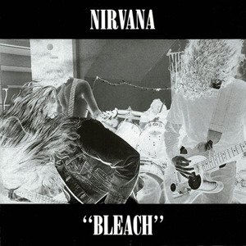

专辑曲目：

01.Blew

02.Floyd the Barber

03.About a Girl

04.School

05.Love Buzz

06.Paper Cuts

07.Negative Creep

08.Scoff

09.Swap Meet

10.Mr. Moustache

11.Sifting

12.Big Cheese

13.Downer

专辑评论：

专辑中的许多歌曲其实都只有一段歌词，它在歌中一遍、两遍、三编甚至更多遍地重复着，使得Nirvana早期作品蒙上了一种警句般的光彩。“Blew”晦暗的音调同着首歌关于心灵被俘与受控的主题呼应的天衣无缝。“About A Girl”流畅动听是 Cobain 内心一直存在的流行化倾向的挣扎，它在整张专辑里象一个不速之客，以一种莫名的优美孤寂地守侯忧伤的恋情。它也是 Cobain 往后创作倾向和人生创伤的最早艺术昭示。“School”清楚地反映了 Cobain 对西雅图音乐圈子的鄙夷心情。“Swap Meet”是 Cobain 在Aberdeen 经历的最好见证，使 Cobain 永远保持了一份对贫穷的畏惧，但也让他懂得了底层的艰辛。“Downer”是 Cobain 写得很早的一首歌，也是他作品中少有的直接表达政治意识的作品，其中包括典型的朋可政见，既有达达主义般的狂躁，也有赤子似的天真，更多的则是莫名的混乱。

二. Nevermind 1991

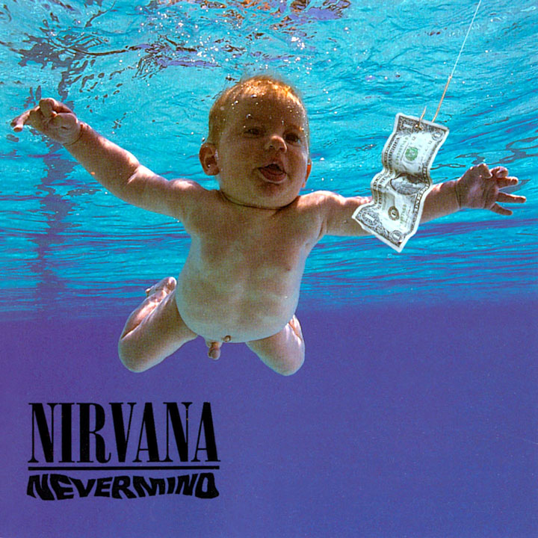

专辑曲目：

01.Smells Like Teen Spirit

02.In Bloom

03.Come As You Are

04.Breed

05.Lithium

06.Polly

07.Territorial Pissings

08.Drain You

09.Lounge Act

10.Stay Away

11.On A Plain

12.Something In The Way

专辑评论：

Nirvana凭这次转入大唱片公司之后的强力出击在Billboard排行榜上取得了爆炸性的效果。他们的冲击力是如此的强劲，又是如此的出人意料之外，甚至连《纽约时报》的商业版都以他们做封面，当华尔街的分析家和工业巨头们都在时间关注那些身穿花格衬衫的破落音乐家们的时候，你不得不承认Nirvana的确将伟大的音乐带给了更多的听众。表面上，轰鸣扭曲的吉他声与愤怒的吉他声与愤怒而具侵略性的击鼓已成为成长中的Grunge一族的必修课，实际上，《Nevermind》是一张伟大的流行乐专辑，像“Smell Like Teen Spirits”就抓住了MTV时代人们的距离感和不满情绪，但却不失精彩的噱头和出色的旋律——并且编曲上的精致巧妙绝不输于任何一张Beatles的专辑。同时Kurt Cobain的演唱与歌曲创作洋溢着天才与灵感，就长那些与他齐名的人也很少有如此泉涌才思，有不少人认为Nirvana不过是“一招鲜，吃遍天”，但只此一招便已为他们在另类摇滚史上赢得无可置疑的一席之地。

------------------------   
-------------------------   
01 Smells Like Teen Spirit   
  
  
Load up on guns and   
Bring your friends   
It's fun to lose   
And to pretend   
She's over bored   
And self assured   
Oh no, I know   
A dirty word   
  
hello, how low? (x bunch of times)   
  
With the lights out

it's less dangerous   
Here we are now   
Entertain us   
I feel stupid

and contagious   
Here we are now   
Entertain us   
A mulatto   
An albino   
A mosquito   
My Libido   
Yeah   
  
I'm worse at what I do best   
And for this gift I feel blessed   
Our little group has always been   
And always will until the end   
  
hello, how low? (x bunch of times)   
  
With the lights out it's less dangerous   
Here we are now   
Entertain us   
I feel stupid and contagious   
Here we are now   
Entertain us   
A mulatto   
An albino   
A mosquito   
My Libido   
Yeah   
  
And I forget   
Just why I taste   
Oh yeah, I guess it makes me smile   
I found it hard   
It was hard to find   
Oh well, whatever, nevermind   
  
hello, how low? (x bunch of times)   
  
With the lights out it's less dangerous   
Here we are now   
Entertain us   
I feel stupid and contagious   
Here we are now   
Entertain us   
A mulatto   
An albino   
A mosquito   
My Libido   
Yeah, a denial   
A denial   
A denial...   
--------------------------------   
02 In Bloom   
  
  
Sell the kids for food   
Weather changes moods   
Spring is here again   
Reproductive glands   
  
He's the one   
Who likes all the pretty songs   
And he likes to sing along   
And he likes to shoot his gun   
But he knows not what it mean   
Knows not what it mean   
And I say   
He's the one   
Who likes all the pretty songs   
And he likes to sing along   
But he knows not what it mean   
Knows not what it mean   
And I say yeah   
  
We can have some more   
Nature is a whore   
Bruises on the fruit   
Tender age in bloom   
  
He's the one   
Who likes all the pretty songs   
And he likes to sing along   
And he likes to shoot his gun   
But he knows not what it mean   
Knows not what it mean   
And I say   
He's the one   
Who likes all the pretty songs   
And he likes to sing along   
And he likes to shoot his gun   
But he knows not what it mean   
Knows not what it mean   
And I say   
He's the one   
Who likes all the pretty songs   
And he likes to sing along   
And he likes to shoot his gun   
But he knows not what it mean   
Knows not what it mean   
And I say yeah   
------------------   
03 Come As You Are   
  
  
Come   
As you are   
As you were   
As I want you to be   
As a friend   
As a friend   
As an old enemy   
Take your time   
Hurry up   
The Choice is yours   
Don't be late   
Take a rest   
As a friend   
As an old memoria   
memoria   
memoria   
memoria   
  
Come   
Dowsed in mud   
Soaked in bleach   
As I want you to be   
As a trend   
A s a friend   
As an old memoria   
memoria   
memoria   
memoria   
  
And I swear   
That I don't have a gun   
No I don't have a gun   
No I don't have a gun   
  
memoria   
memoria   
memoria   
memoria {don't have a gun}   
  
And I swear   
That I don't have a gun   
No I don't have a gun   
No I don't have a gun   
No I don't have a gun   
No i don't have a gun   
  
memoria   
memoria   
-----------------------------   
04 Breed   
  
  
I don't care   
I don't care   
I don't care   
I don't care   
I don't care   
Care if I'm old   
  
I don't mind   
I don't mind   
I don't mind   
I don't mind   
mind   
Don't have a mind   
  
Get way   
Get way   
Get way   
Get way   
Way from your home   
  
I'm afraid   
I'm afraid   
I'm afraid   
I'm afraid   
afraid of a ghost   
  
Even if you have   
Even if you need   
I don't mean to stare   
We don't have to breed   
We can plant a house   
We can build a tree   
I don't even care   
We could have all three   
  
She said　(X 8)   
-----------------------------------   
05 Lithium   
  
  
I'm so happy   
Cause today I found my friends   
They're in my head   
I'm so ugly   
But that's ok, 'cause so are you   
We've broke our mirrors   
Sunday morning   
Is everyday for all I care   
And I'm not scared   
Light my candles   
In a daze 'cause I've found god   
  
Yeah　(x bunch of times)   
  
I'm so lonely and   
That's ok, I shaved my head   
And I'm not sad   
And just maybe   
I'm to blame for all I've heard   
And I'm not sure   
I'm so excited   
I can't wait to meet you there   
And I don’t' care   
I'm so horny but   
That's ok, my will is good   
  
Yeah (x bunch of times)   
  
I like it   
I'm not gonna crack   
I miss you   
I'm not gonna crack   
I love you   
I'm not gonna crack   
I killed you   
I'm not gonna crack   
I like it   
I'm not gonna crack   
I miss you   
I'm not gonna crack   
I love you   
I'm not gonna crack   
I killed you   
I'm not gonna crack   
  
I'm so happy   
Cause today I found my friends   
They're in my head   
I'm so ugly   
But that's ok, 'cause so are you   
We've broke our mirrors   
Sunday morning   
Is everyday for all I care   
And I'm not scared   
Light my candles   
In a daze 'cause I've found god   
  
Yeah　(x bunch of times)   
  
I like it   
I'm not gonna crack   
I miss you   
I'm not gonna crack   
I love you   
I'm not gonna crack   
I killed you   
I'm not gonna crack   
I like it   
I'm not gonna crack   
I miss you   
I'm not gonna crack   
I love you   
I'm not gonna crack   
I killed you   
I'm not gonna crack   
-------------------------------   
06 Polly   
  
  
Polly wants a cracker   
Think I should get off of her first   
I think she wants some water   
To put out the blow torch   
  
It isn't me   
We have some seed   
Let me clip   
Your dirty wings   
Let me take a ride   
Don't hurt yourself   
I want some help   
To help myself   
I've got some rope   
You have been told   
I promise you   
I have been true   
Let me take a ride   
Don't hurt yourself   
I want some help   
To help myself   
  
Polly wants a cracker   
Maybe she would like more food   
She asks me to untie her   
A chase would be nice for a few   
  
It isn't me   
We have some seed   
Let me clip   
Your dirty wings   
Let me take a ride   
Don't hurt yourself   
I want some help   
To help myself   
I've got some rope   
You have been told   
I promise you   
I have been true   
Let me take a ride   
Don't hurt yourself   
I want some help   
To help myself   
  
{Polly said}   
Polly says her back hurts   
And she's just as bored as me   
She caught me off my guard   
It amazes me, the will of instinct   
  
It isn't me   
We have some seed   
Let me clip   
Your dirty wings   
Let me take a ride   
Don't hurt yourself   
I want some help   
To help myself   
I've got some rope   
You have been told   
I promise you   
I have been true   
Let me take a ride   
Don't hurt yourself   
I want some help   
To help myself   
-------------------------   
07 Territorial Pissings   
  
  
{intro thing}   
  
When I was an alien   
Cultures weren't opinions   
  
Gotta find a way   
To find a way   
When I'm there   
Gotta find a way   
A better way   
I had better wait   
  
Never met a wise man   
If so it's a woman   
  
Gotta find a way   
To find a way   
When I'm there   
Gotta find a way   
A better way   
I had better wait   
Gotta find a way   
To find a way   
When I'm there   
Gotta find a way   
A better way   
I had better wait   
  
Just because you're paranoid   
Don't mean they're not after you   
  
Gotta find a way   
To find a way   
When I'm there   
Gotta find a way   
A better way   
Gotta find a way   
To find a way   
When I'm there   
Gotta find a way   
A better way   
Gotta find a way   
To find a way   
When I'm there   
Gotta find a way   
A better way   
I had better wait   
Gotta find a way   
To find a way   
When I'm there   
Gotta find a way   
A better way   
I had better wait   
Gotta find a way   
To find a way   
When I'm there   
Gotta find a way   
A better way   
I had better wait   
-----------------------   
08 Drain You   
  
  
One baby to another says   
I'm lucky to have met you   
I don't care what you think unless   
It is about me   
It is now my duty to completely drain you   
A travel through a tube and end up in your infection   
  
Chew your meat for you   
Pass it back and forth   
In a passionate kiss   
From my mouth to yours   
'cause I like you   
  
With eyes so dilated   
I've became your pupil   
You've taught me everything   
Without a poison apple   
The water is so yellow   
I'm a healthy student   
Indebted and so grateful   
Vacuum out the fluids   
  
Chew your meat for you   
Pass it back and forth   
In a passionate kiss   
From my mouth to yours   
'cause I like you   
You   
You   
You   
You   
You   
  
One baby to another says   
I'm lucky to have met you   
I don't care what you think unless   
It is about me   
It is now my duty to completely drain you   
A travel through a tube and end up in your infection   
  
Chew your meat for you   
Pass it back and forth   
In a passionate kiss   
From my mouth to yours   
Sloppy it lips to lips   
You're my vitamins   
'cause I'm like you   
---------------------------------------------------   
09 Lounge Act   
  
  
Truth covered in security   
I can't let you smother me   
I'd like to but it wouldn't work   
Trading off and taking turns   
I don't regret a thing   
  
I've got this friend, you see   
Who makes me feel   
And I wanted more   
Than I could steal   
I'll arrest myself   
And wear a shield   
I'll go out of my way   
To prove I still   
Smell her on you   
  
Don't, tell me what I wanna hear   
Afraid of never knowing fear   
Experience anything you need   
I'll keep fighting jealousy   
Until it's fucking gone   
  
I've got this friend, you see   
Who makes me feel   
And I wanted more   
Than I could steal   
I'll arrest myself   
And wear a shield   
I'll go out of my way   
To prove I still   
Smell her on you   
  
Truth covered in security   
I can't let you smother me   
I'd like to but it wouldn't work   
Trading off and taking turns   
I don't regret a thing   
  
I've got this friend, you see   
Who makes me feel   
And I wanted more   
Than I could steal   
I'll arrest myself   
And wear a shield   
I'll go out of my way   
To make you a deal   
We've make a pact   
To learn from who   
Ever we want   
Without new rules   
We'll share what's lost and what we grew   
They'll go out of their way   
To prove they still   
Smell her on you   
They still, smell her on you   
Smell her on you   
--------------------------------------------   
10 Stay Away   
  
  
Monkey See, monkey do   
{I don't know why}   
I'd rather be deal than cool   
{I don't know why}   
Every line ends in rhyme   
{I don't know why}   
Less is more, love is blind   
{I don't know why}   
  
Stay   
Stay away   
Stay away   
Stay away   
  
Give an inch, take a smile   
{I don't know why}   
Fashion shits, fashion stile   
{I don't know why}   
Throw it out and keep it in   
{I don't know why}   
Have to have poison skin   
{I don't know why}   
  
Stay   
Stay away   
Stay away   
Stay away   
  
I don't know why   
I don't know why   
  
Stay   
Stay away   
Stay away   
Stay away   
  
Monkey See, monkey do   
{I don't know why}   
I'd rather be deal than cool   
{I don't know why}   
Every line ends in rhyme   
{I don't know why}   
Less is more, love is blind   
{I don't know why}   
  
Stay   
Stay away   
Stay away   
Stay away   
  
I don't know why   
I don't know why   
  
Stay   
Stay away   
Stay away   
Stay away   
  
Stay   
Stay away   
Stay away   
Stay away   
Stay away   
Stay away   
God is gay   
---------------------------   
11 On A Plain   
  
  
I'll start this off   
Without any words   
I got so high that   
I scratched 'til I bled   
  
Love myself   
Better than you   
I know it's wrong   
So what should I do?   
  
The finest day   
That I ever had   
Was when I learned   
To cry on command   
  
Love myself   
Better than you   
I know it's wrong   
So what should I do?   
  
I'm on a plain   
I can't complain   
I'm on a plain   
  
My mother died   
Every night   
It's safe to say   
Don't quote me on that   
  
Love myself   
Better than you   
I know it's wrong   
So what should I do?   
  
The black sheep got   
Blackmailed again   
Forgot to put   
Love myself   
Better than you   
I know it's wrong   
So what should I do?   
  
I'm on a plain   
I can't complain   
I'm on a plain   
  
Somewhere I have heard this before   
In a dream my memory has stored   
As defense I'm neutered and spayed   
What the hell am I trying to say?   
  
It is now time   
To make it unclear   
To write off lines   
That don't make a sense   
  
Love myself   
Better than you   
I know it's wrong   
So what should I do?   
  
One more special   
Message to go   
And then I'm done   
And I can go home   
  
Love myself   
Better than you   
I know it's wrong   
So what should I do?   
  
I'm on a plain   
I can't complain   
I'm on a plain   
I can't complain   
I'm on a plain   
I can't complain   
I'm on a plain   
I can't complain   
I'm on a plain   
I can't complain   
----------------------------   
12 Something In The Way   
  
  
Underneath the bridge   
The tarp has sprung a leak   
And the animals I've trapped   
Have all become my pets   
And I'm living off of grass   
And the drippings from the ceiling   
But it's ok to eat fish   
Cause they haven't any feelings   
  
Something in the way   
Ummmmm  
Something in the way, yea   
Ummmmm   
Something in the way   
Ummmmm   
Something in the way, yea   
Ummmmm   
Something in the way   
Ummmmm   
Something in the way, yea   
Ummmmm   
  
Underneath the bridge   
The tarp has sprung a leak   
And the animals I've trapped   
Have all become my pets   
And I'm living off of grass   
And the drippings from the ceiling   
But it's ok to eat fish   
Cause they haven't any feelings   
---------------------------------   
13 Endless Nameless   
  
  
Silence   
Here I am   
Here I am   
Silent   
  
Bright and clear   
It's what I am   
I have   
Died   
  
uhhhh   
uhhhh   
uhhhh   
uhhhh   
  
Death   
With violence   
Excitment   
Right here   
  
Died   
Go to hell   
Here I am   
Right here   
  
Ow   
  
No mas   
No mas   
No mas   
No mas   
  
Death   
Is what I am   
Go to hell   
Go to jail   
  
In back of that   
Crime   
Here I am   
Take a chance   
Dead   
  
Die   
  
Other interpretations possible

三. Incesticide 1992

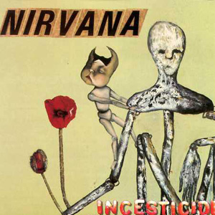

专辑曲目：

01.Dive

02.Sliver

03.Stain

04.Been A Son

05.Turnaround

06.Molly's Lips

07.Son Of A Gun

08.(New Wave) Polly

09.Beeswax

10.Downer

11.Mexican Seafood

12.Hairspray Queen

13.Aero Zeppelin

14.Big Long Now

15.Aneurysm

专辑评论：

《INCESTICIDE》并不是一张完整设计的专辑，但它充分展示了 Cobain 和乐队的种种极端甚至矛盾的方面。“Dive”是从乐队的小样上扒下来的。“Sliver”是与 Cobain 身世有关的歌。专辑中还翻唱了三首歌曲，即 Devo 乐队的“Turnaround”和 The Vaseline 乐队的“Molly's Lips”及“Son Of Gun”。“Beeswax”、“Mexican Seafood”、“Hairspray Queen”和“Aero Zeppelin”显然是1988年1月Nirvana 第一盘录音小样中的版本，这几首歌都是 Cobain 最早的一些作品。“Big Long Now”这首歌是Cobain 和 Chris 共同写的曲子。专辑的封面画是 Cobain 的作品。一个经受创伤的孩子正在爬上父母摸样的骨架人体，后者显然不愿搭理那个孩子，于是孩子充满渴望的目光投向了一束花，而那赫然便是美丽而致命的罂粟花，这幅画令人惊心动魄地看到了 Cobain 一代人的经历。

四. In Utero 1993

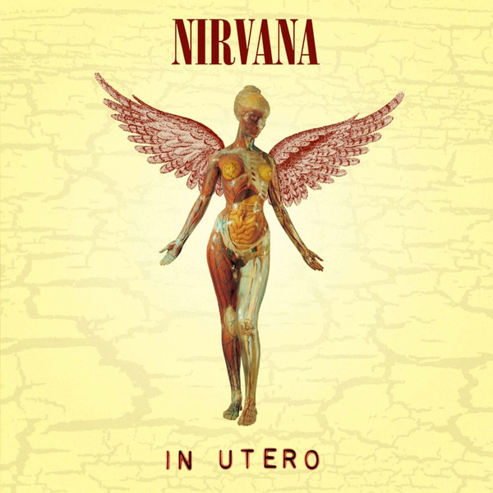

专辑曲目：

01.Serve The Servants

02.Scentless Apprentice

03.Heart-Shaped Box

04.Rape Me

05.Frances Farmer Will Have Her Revenge On Seattle

06.Dumb

07.Very Ape

08.Milk It

09.Pennyroyal Tea

10.Radio Friendly Unit Shifter

11.Tourette's

12.All Apologies

专辑评论：

这张专辑是 Nirvana作的一张Lo-Fi 专辑，专辑中的音乐的确也反映了Cobain 生活中的阴暗面，在专辑《Nevernmind》中已经初露端倪的狂躁抑郁症被发展到了极点。“Serve The Servants”涉及了 Covain生活中的各个方面。“Scentless Apprentice”是乐队三人共同作曲的歌之一，是乐队一种新创作心态的标志。“Rape Me”是《In Utero》专辑里最早写成的歌，它针对的并不仅仅是“强暴”，而是一种内心的创伤。“Frances Farmer Will Have Her Revenge On Seattle”是 Cobain 献给他心目中的圣女和殉道先烈 Frances Farmer 的颂歌。“Milk It”是 Nirvana 在《Nevernmind》之后改变方向的标志性作品之一。从一首首歌上看，《In Utero》似乎缺少“Smells Like Teen Spirit”那种一呼天下应的扛鼎之作，但是真正让 Nirvana 向前跨出一大步的正是《In Utero》，它更具真正的非主流气质，也更具对主流音乐的颠覆性。

五. MTV Unplugged in New York 1994

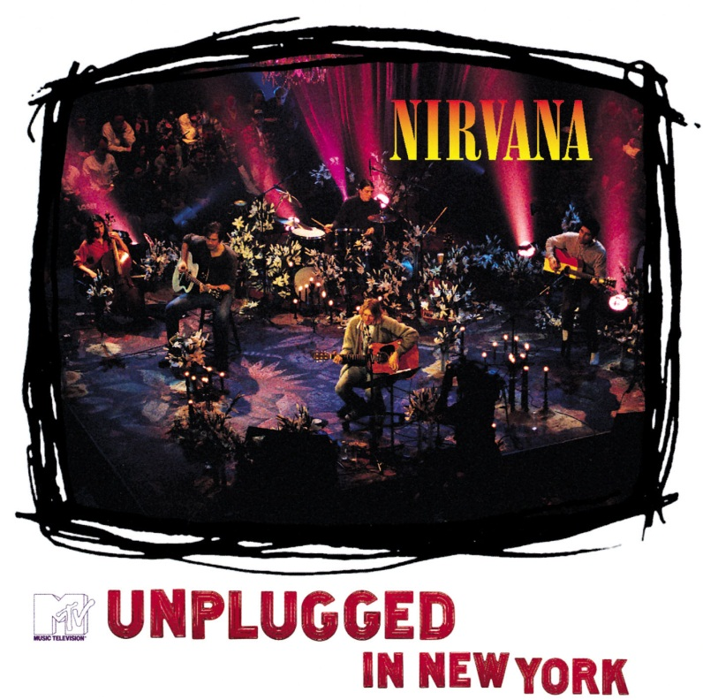

专辑曲目：

01.About A Girl

02.Come As You Are

03.Jesus Doesn't Want Me For A Sunbeam

04.The Man Who Sold The World

05.Pennyroyal Tea

06.Dumb

07.Polly

08.On A Plain

09.Something In The Way

10.Plateau

11.Oh, Me

12.Lake Of Fire

13.All Apologies

14.Where Did You Sleep Last Night (In The Pines)

专辑评论：

有人说,《In Utero》是Kurt自杀的征兆，而《Unplugged In New York》则是阴间的讯息，它集合了Kurt所有的痛苦和天才，它是那么的直接和赤裸裸，而让人无法对其接连的倾听。一个最好的例子，几乎所有非讲英语地方的人都能跟上《Where Did You Sleep Last Night?》轻轻的哼上几句，却很难明白《Smells Like Teen Spirit》究竟在喊什么，但是所有人几乎都会选择将后者重复听上几遍，而一而再再而三的承受前者散发出来的孤寂和苦痛。可是在我心中这是一张和《Nevermind》一样份量的专辑，我已经数不清倒底有多少次聆听着这张专辑而渐渐入梦，但我可以算出来我倒底有多少次为Kurt淡薄而绝望的声音感动和伤痛---几乎每次都是。换成了木琴，在Kurt的手下，依然带有浓浓的Grunge的味道，Kurt精心挑选了几首自己的合适用木琴演绎的曲子，也翻唱了几首他很喜欢的曲子。所有的这些，都在短短的几十分钟内，于纽约的一家电视台一间精心布置的演播场里通过直播向全美播放。看过的人都知道，地上摆满了点燃的蜡烛和淡紫色的鲜花，场后用红幕布置，乐队的四人呈菱形的分坐四角，场的四周坐满了观众，气氛融洽而平和。Kurt和他平时一样，穿着随意，其他人也没有刻意打扮，一切和他们平常一样的自由，还可以见到在乐曲的间隔当中Kurt的有说有笑，实在让人难以接受他在数月之后的离去。回到音乐上来，从理性上去考虑，这都不仅仅只是一场反常的Nirvana原声演出，它还展现了他们想成为R.E.M.乐队--那样的自由和独立--的真实诚挚的愿望，人们却没有意识到这一点，这或许是后来Kurt最终难敌自杀冲动的一个原因。另外这也是一张表达自己所喜欢的音乐的奇特专辑，因为从没有一张专辑象这张那样把David Bowie的歌和民谣排在一起，Nirvana办到了，而且办得非常好，尽管他们可能因此付出了极沉重的代价...

作者:毁灭天使

六. From the Muddy Banks of Wishka 1996

专辑曲目：

01.Intro

02.School

03.Drain You

04.Aneurysm

05.Smells Like Teen Spirit

06.Been A Son

07.Lithium

08.Sliver

09.Spank Thru

10.Scentless Apprentice

11.Heart-Shaped Box

12.Milk It

13.Negative Creep

14.Polly

15.Breed

16.Tourette's

17.Blew

专辑评论：

随着浑浊的Bass,几句谈话和Kurt的近似疯狂的喊叫,《From The Muddy Banks Of The Wishkah》之旅就正式开始了,这里没有精心的雕凿粉饰,没有优良的录音设备，甚至没有事先的必要准备（不过有事后的歌曲挑选和修补），这是Nirvana从1989到1994年随时随地录制的现场录音带，是真正体现一支Grunge乐队的现场，也是记录Kurt，Dave和Krist最真实一面的专辑。我一向觉得现场要比专辑要好听得多，免去了现代科技的做作，免去了在录音室里的局促不安，也免去了大家和乐队的隔阂。对于象Nirvana那样的乐队来说，现场是他们成长的地方，是他们真正的母体。在现场，他们一点也不会感到拘谨，他们可以说一些录不进音频里的话，他们可以和观众做最近距离的接触。这些对于很多乐队来说，似乎并不必要，但是对于Nirvana这样一支只是想宣扬自己的独立思想和反商业的叛逆型乐队，却是最好的释放自己的途径。专辑中的作品缺少了象《About A Girl》,《All Apologies》和《Come As You Are》那样出名的曲子，却依然有力和强韧，除了其中的《Smells Like Teen Spirit》故意加快了速度，其他没有什么太大的变化，还有就是加了一首没有在其他正式专辑中收录过的《Spank Thru》。这张专辑的动人之处就是它是在乐队的上升其间的最好见证，也从另一方面展现了Kurt和Nirvana的过人魅力。

作者：毁灭天使

七. Nirvana 2002

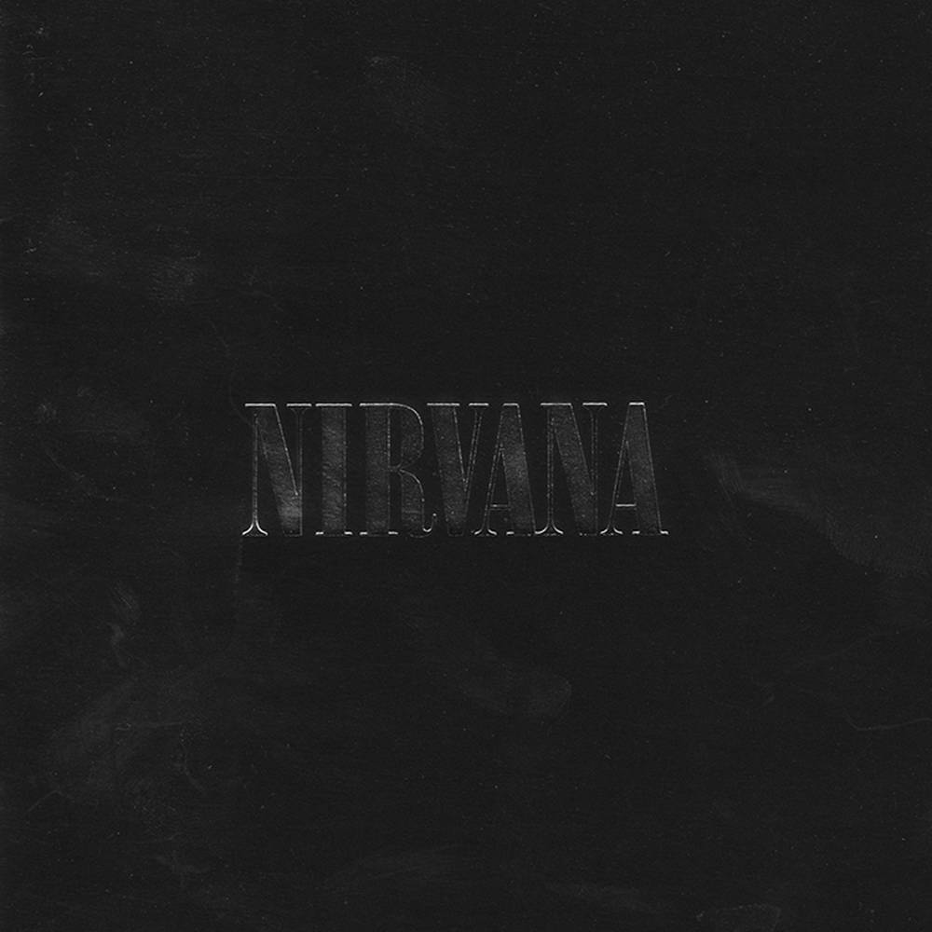

专辑曲目：

01.You Know You're Right (previously unreleased)

02.About A Girl

03.Been A Son

04.Sliver

05.Smells Like Teen Spirit

06.Come As You Are

07.Lithium

08.In Bloom

09.Heart-Shaped Box

10.Pennyroyal Tea

11.Rape Me

12.Dumb

13.All Apologies

14.The Man Who Sold The World

专辑评论：

★第9届MTV音乐录影带大奖“最佳另类音乐录影带”、“最佳新人音乐录影带” (“Smells Like Teen Spirit”)

★第12届全英音乐奖“最佳国际新人”

★第10届MTV音乐录影带大奖“最佳另类音乐录影带”(“In Bloom”)

★滚石杂志评选为“最佳乐团”；《In Utero》获选为“最佳专辑”

★第11届MTV音乐录影带大奖“最佳另类音乐录影带”、“最佳艺术指导”(“Heart-Shaped Box”)

★第38届葛莱美奖“最佳另类音乐演出”(“MTV Unplugged In New York”)

★SPIN杂志评选“90年代最伟大90张专辑”：《Nevermind》勇夺冠军

★滚石杂志与MTV音乐台合作评选“100首最伟大流行歌曲”：“Smells Like Teen Spirit”高居季军

★VH1音乐台评选“100张最伟大专辑”：《Nevermind》荣获亚军

’91年狂卖千万张的旷世钜作《Nevermind》一举震惊全世界,辑中的"Smels Like Teen Spirit"、"Come As You Are"、"Lithium"等都是歌迷及乐评一致赞赏的经典作品, 尤其堪称Grunge国歌的"Smells Like Teen Spirit",朗朗上口的旋律,加上狂傲不羁未经修饰的叛逆色彩更是满足了全球少年仔的耳朵,Nirvana带动了Grunge风潮乃至整个另类摇滚革命的爆发。随著《Nevermind》于’92年1月在Billboard流行专辑榜夺标称王,他们的人气指数在此刻可说到达巅峰,而这总总成就也让Nirvana一跃成为次流行文化的代言人,Grunge乐界的龙头老大更是非Nirvana莫属。

　　关于Nirvana的历史,应该回溯到1987年。当时,灵魂人物Kurt Cobain与贝斯手Krist Novoselic、鼓手Aaron Burckhard(’91年8月由第6任鼓手Dave Grohl接任)三人组成Nirvana。’89年独立厂牌Sub Pop为其出版仅花了606美元制作的首张大碟《Bleach》,一般公认这张专辑已经雕塑出Nirvana的雏型;’93年的《In Utero》更是张离经叛道、不具商业色彩却依然夺得冠军的震憾佳作。

　　不知27岁对摇滚人而言是否为一道难以跨越的门槛,在John Lennon、Jim Morrison、Ian Curois（Joy Division主唱）、Jimi Hendrix后,Kurt Cobain也选择加入“27岁俱乐部”,’94年4月8日,Kurt的尸体被一名电器工人发现,他藉由举枪自尽结束了重重名气背后的压抑生命,摆脱凡俗,只留给世人无限回味的4张专辑及2张现场作品。至今即使灵魂人物Kurt Cobain离开人世已逾8年多,但是Nirvana在乐坛的伟大贡献绝对是难以超越的！

曲目介绍：

1. YOU KNOW YOU’RE RIGHT (US#45、现代摇滚榜#1 <蝉联4周>)

1994年1月30日Kurt Cobain最后录音作品,Nirvana唯一新歌首度曝光

2. ABOUT A GIRL (US#22、现代摇滚榜#1)

出自《漂白》专辑 Kurt Cobain写给前女友Tracy Marander扣人心弦作品

3. BEEN A SON

出自《乱伦状态》专辑 描述一个女孩的父母渴望儿子的矛盾心境

4. SLIVER (现代摇滚榜#19)

出自《乱伦状态》专辑，半自传式的歌曲,纪录童年被父母遗弃的心酸

5. SMELLS LIKE TEEN SPIRIT (US#6、现代摇滚榜#1、UK#7)

出自《从不介意》专辑 High翻全球摇滚乐迷国歌级代表作

6. COME AS YOU ARE (US#32、现代摇滚榜#3、UK#9)

出自《从不介意》专辑 探索人类思想、行动与社会规范间的冲突矛盾

7. LITHIUM (US#32、现代摇滚榜#25、UK#11)

出自《从不介意》专辑 运用个人的崩溃类比社会的群体崩溃

8. IN BLOOM (UK#28)

出自《从不介意》专辑，标准的摇滚音乐元素包裹著Nirvana对无知歌迷的暗讽

9. HEART-SHAPED BOX (现代摇滚榜#1、UK#5)

出自《母体》专辑 传达爱与诱惑的复杂主题,让您一窥Kurt Cobain对妻子与毒品无可救药的上瘾

10. PENNYROYAL TEA

出自《母体》专辑 主题围绕极富争议性的堕胎话题,以及随之而来无可避免的罪恶感

11. RAPE ME (UK#32)

出自《母体》专辑 诉说了强暴犯被送进监牢,在狱中自我摧残的故事

12. DUMB

出自《母体》专辑，关于药物、关于麻醉自我,因为无意识状态是最快乐的

13. ALL APOLOGIES (US#45、现代摇滚榜#1)

出自《母体》专辑 Kurt Cobain献给挚爱的妻子与女儿

14. THE MAN WHO SOLD THE WORLD (US#39、现代摇滚榜#6)

出自《最后的现场》专辑，翻唱摇滚变色龙David Bowie经典作品

15. WHERE DID YOU SLEEP LAST NIGHT

出自《最后的现场》专辑，重新诠释美国早期民谣经典名曲

八. Singles Box (6 CD) 1998

专辑曲目：

01.Smells Like Teen Spirit [Edit]

02.Even in His Youth

03.Aneurysm

04.Come as You Are [LP Version]

05.Endless, Nameless

06.School [live]

07.Drain You [Live]

08.In Bloom [LP Version]

09.Sliver [Live]

10.Polly [Live]

11.Lithium [LP Version]

12.Been a Son [Live]

13.Curmudgeon

14.Heart Shaped Box [LP Version]

15.Milk It [LP Version]

16.Marigold

17.All Apologies [LP Version]

18.Rape Me [LP Version] - Kurt Cobain

19.Moist Vagina [#] - Kurt Cobain

收录了NIRVANA的单曲6张

九. Hormoaning 1992

专辑曲目：

01.Turnaround

02.Aneurysm

03.D-7

04.Son of a Gun

05.Even in His Youth

06.Molly's Lips

艺人介绍：

90年代，美国的失业危机重新抬头,朋克乐在音乐界再度爆炸，西雅图的Grunge音乐风暴引起了强烈的反响与轰动,Nirvana就是在这样的背景下诞生的，乐队由Kurt Cobain和前The Melvins的成员 Krist Novoselic组建，Dave Grohl在录制第二张唱片(Nevermind)固定了的鼓手位置，Kurt Cobain负责主音和吉它， Chris负责低音吉它。

1988年11月Nirvana推出了第一张Single：Love Buzz/Big Cheese,1989年6月发行第一张专集"Bleach"。Nirvana的第一张专辑，Dale crover负责Floyd the Barder, Paper Cuts, Downer的鼓，其余由Chad Channing负责。唱片的录制费用是$606.17，付钱的是Jason Everman，他在唱片里面连名字都未给提起。唱片的录制时间是30小时。 Downer只收录在CD版本里面。唱片由Sup Pop Records发行，92年4月Geffen公司Remaster发行。1991年四月，Nirvana正式和Geffen Records 唱片公司签约。同年九月，专集"Nevermind"发行，刚推出5周销量就已达到50万张，并且在排行榜上势如破竹，节节上升， 92年1月11日成为美国销量第一的唱片，全球的销量超过一千万大关。在商业上取得了巨大的成功。单曲“Smells Like Teen Spirit”在美国BILLBROAD公告排行榜上迅速攀升。(Nevermind)使Nirvana步向成功，同时也开始了一个神话和一场心灵的悲剧。

在(Nevermind)取得了巨大的成功之后，Nirvana把以前Singles的Side-B的和一些还没发行过的歌收集在一起，于1992年12月15日，推出专集"Incesticide"。这是一张典型的地下音乐专辑，他们表示推出这张唱片的目的是为了试试听众和电台DJ接受地下摇滚的极限。1993年九月，请来了著名的反商业的制作人Steve Albini为他们作监制，发行了"In Utero"，这是摇滚史上最佳朋克专集之一，乐队配合的天衣无缝，把Kurt Cobain 内心的狂燥、愤怒、压抑、扭曲、病态、激烈的矛盾冲突完全显示了出来，同时也也反映了KURT温柔、感性的一面。使Grunge风暴达到了极点，接近燃烧。Steve Albini试图录制一张原汁原味的朋克专辑。他运用了比以前更为丰富的音乐素材，并且在其核心蕴涵着袒露Cobain最深层的恐惧和脆弱的心，象“RAPE ME”这样个人化的歌曲的直面痛苦的展现，在现在作一回顾，也许可以看作是一种警告，它在当初被与这个烦恼的歌手最亲密的人们所忽视。但是作为艺术，这正是它的朋克所在。

1993年11月18日，Nirvana应邀为MTV 制作"Unplugged"演唱会，演出了一场经典的演唱会。1994年3月1日，Nirvana在德国慕尼黑的演出成为乐队最后的一次公开表演。1994年4月8日，一个电工在Kurt的住所发现了他的尸体，尸体身边带有一封遗书。西雅图警方证明Kurt Cobain于三天前自杀身亡。Nirvana留下的只是他们音乐里有的那种躁动不安和最深的孤寂。

----------------选自“摇滚年音乐网”