# Subs Life (EP) 2004



艺人： Subs

语种： 英语

唱片公司： 独立发行

发行时间： 2004年10月01日

专辑类别： EP、单曲

唱片封底文案：

不感謝我的父母，他們指給我的所有出路都令我發瘋； 不感謝道貌岸然的傻逼老師，教些狗屁東西； 不感謝那些跟我一起長大的朋友，他們的聚會就是在比誰的錢多； 不感謝這個城市裡的一切，塞滿了所有街道的小...

曲目：

1 8 O'clock

2 Drew the line

3 Strange country

4 What more

1.《8 O'clock》

All night out on the streets

I laugh loudly with all my friends

We never want to make party to end and

Go back home!

I'm really worried about living

I hate the day then came

Just like murder，it began of the

Eight o'clock!

Butcher is him

Butcher is her

Butcher is the idiot

Butcher is him

Butcher is her

Butcher is the wooden

Butcher is him

Butcher is her

You just have to carry on

Until, until

Until the perfect moment came

All night out on the streets

I laugh loudly with all my friends

We never want to make party to end and

Go back home!

I'm really worried about living

I hate the day then came

Just like murder，it began of the

Eight o'clock!

Butcher is him

Butcher is her

Butcher is the idiot

Butcher is him

Butcher is her

Butcher is the wooden

Butcher is him

Butcher is her

You just have to carry on

Until, until

Until the perfect moment came

I hate working for whole week

Because I can't imagine that awful feeling

I'm not feeling well, well

I'm running out for change

I'm not feeling well, well

I'm not feeling well, well

I'm not feeling well, well

I'm running out for change

out for change

out for change

out for change

Eight o'clock!

（微信公众号：subs--）（新浪微博：杀不死subs乐队）

3.《Strange country》

STRANGE COUNTRY

Traveler in a country

It is happened

Strange cool fashion

Gaudily dressed

Quality goods

But i heard all is quiet and still

No one can to talk

Guilty on all speech

Inside skull silent

As outside skull

Haven't rock

Haven't laugh

Indeed no heard heart beat sound

[By-law]

Someone talk in his sleep

Thus he was executed

"We are just little man

What can we count

We can but obey"

The most people just have thought

Well

l get safe

Well

l get safe

Do not panic

In fact we are not better than them

（微信公众号：subs—）（新浪微博：杀不死subs乐队）

4.《What more》

When you open the veins

Blood just looks the same

You should guess god's name

You just don't know what to be done

Of circulation for the duration

But you said

How did it come to this?

....

...

..

.

Shut up,shut up,shut up!

What more you wanna say?

Shut up,shut up,shut up!

What more you wanna say?

Shut up,shut up,shut up!

What more you wanna say?

Shut up,shut up,shut up!

What more you wanna say?

Now you're take it time after time

Didn't understand much what you saw

Of circulation for the duration

But you said

How did it come to this?

....

...

..

.

Shut up,shut up,shut up!

What more you wanna say?

Shut up,shut up,shut up!

What more you wanna say?

Shut up,shut up,shut up!

What more you wanna say?

Shut up,shut up,shut up!

What more you wanna say?

Shut up,shut up,shut up!

What more you wanna say?

Shut up,shut up,shut up!

What more you wanna say?

Shut up,shut up,shut up!

What more you wanna say?

Shut up,shut up,shut up!

What more you wanna say?

No god,no saint,no teachers tell

You want means,you want way

You bear bondage,you get catch

What do you mean by saying that?

You konw you don't even know you

You want means,you want way

You bear bondage,you get catch

What do you mean by saying that?

Shut up,shut up,shut up!

What more you wanna say?

Shut up,shut up,shut up!

What more you wanna say?

He said he want a wide way

He said he want a wide way

He said the way

He said the way

**Down 2006**

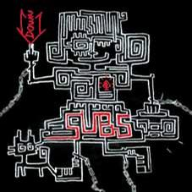

艺人： Subs

语种： 国语

唱片公司： 独立发行

发行时间： 2006年05月01日

专辑类别： 录音室专辑

**专辑介绍：**

Subs，骨子里彻头彻尾的PUNK，但融合了EMO、GARAGE、NEW WAVE、POST ROCK多种音乐元素，是一支真正开创了自我风格的独立朋克乐队，也是将真正摇滚现场精髓带给大家的中国摇滚乐队。SUBS鼓舞和催生了新一代中国摇滚乐队，也带给国际摇滚界巨大震撼! 中国最好的摇滚现场乐队之一。

曲目：

1 Down

2 So Fine Emo

3 We Won't Have To Wait Somebody

4 Brother

5 冲

6 The Man

7 Burning

1. Down

One, two, three, four

Can I tell my mind?

Focus of lighting

Come down to rocker and never leave

I fell my heart beating wildly

Why don't you see it when I say?

One one, no money, keep the naked body

Tow two, no family, like the first day

Three three, no job, throw away old cage

Four four, no future, come down to rock n' roll

No special name

No special way

Seeking still seeking the thrill

No special name

No special way

I am happy and downward

2.So Fine Emo

So fine, emotion

Today is the fuckin' day

Emo's clamour

Spirit is being killed

Emo's clamour

I want to live in childhood

Today is the fuckin' day

3.We Won't Have To Wait Someday

I give you

While you are flying

A present from my dream

Give me all the love you can give

Listen to me, won't be late today

Hold me baby, around me

(You have to be very strong)

I thought that I heard your laughing

You should stick with yourself

You try, try, try again

We won't have to wait someday

Another living day

We did as we were told, oh my dear

4.Brother

Tell me truth!

Where, where is he?

You tell me tell me tell me!

Like an old film

Really what has happened?

I'm not quite sure

Tell me truth

Tell me cause

Stop making them up

Come off it

Tell me truth! Tell the truth!

In 1989, I was ten

A friend of mine is eleven

His brother has disappeared

A film is shown every ten years

We have already grown to manhood now

He has forgotten...his brother

5. 冲

I hate when people try to help me

And I hate to have listen to anybody

Somebody had to stop me

But I will not be puppet

Show me show me show me quiet place

Don't criticize what you can't understand

Why do I give valuable time

Who don't care if I live or die

Why do I smile at people

Who I'd much rather kick in the eyes

Show me show me show me quiet place

Don't criticize what you can't understand

Accepet advice

Take order from

Get away!

6.The man

What's your name?

You say that you are 'man'

Sometimes, somewhere

You are really great enough!

The world seems to only belongs to you

You always have more opinion

You're so busy

Made everything

To lead us follow the way

Oh, so insipid, rooster or chicken or...

Bantam, butler

You wear necktie to be a deep person

But the part that you don't dare

to reveal out is handled by her

Manmade toys

You try so hard to make me happy

with anything

(Manmade society)

You try so hard to make me happy

Making everything

(Manmade society)

It's a man's, man's world

You wear necktie to be a deep person

It's a man's, man's world

Your heart is smaller than my hole

Never, never, never...

7.Burning

I get there again, we come together

The fire is blazing as warm dancing

I jump in

Easy for burning, like a piece of punk

Don't be afraid that I will burn off

Already seen it is more prosperous

I am not alone, we are omnipresent,

I am not alone, not alone, not alone

We are omnipresent

One by one

A generation

Continues

A generation

We are omnipresent

# 操万物女王Queen of Fucking Everything 2010

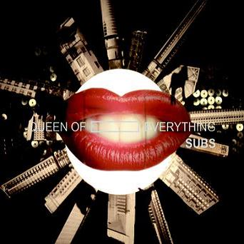

艺人： Subs

语种： 国语

唱片公司： 独立发行

发行时间： 2010年04月30日

专辑类别： 录音室专辑

**专辑介绍：**

新专辑足额收纳12首歌曲，部分曲目还从未在现场演过，也有个别完成时间超过2年以上热门老歌。这张专辑和以往的有明显不同，无论风格、编曲和录制，也收录有中文歌曲，巨大的情绪落差和间或古怪诡异的气氛尤其令人不寒而栗，展现了SUBS现场外恍若超现实的另一面。有理由猜测，SUBS从一只非典型朋克乐队，到开创了自我风格，而今酝酿了朝向黑暗气质的复杂转变。

曲目：

1 12 years

2 old dog

3 all knowing day

4 postlude

5 queen of fucking everything

6 ship's log

7 莫比乌斯圈

8 red hair

9 no.53 station

10 youth is the party

11 rock heart

12 不是每一个

# yoU aRe yoU你是你 2014

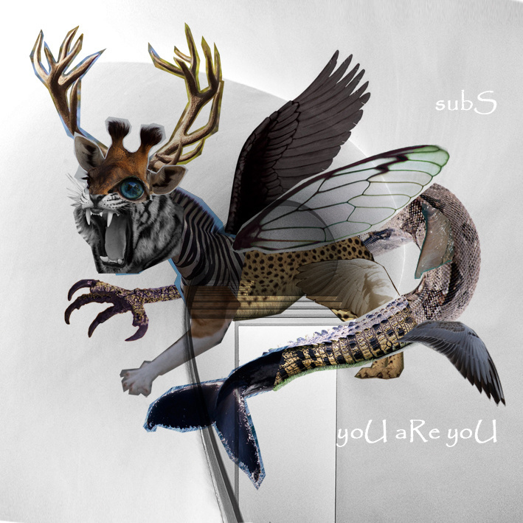

艺人： Subs

语种： 英语

唱片公司： 独立发行

发行时间： 2014年03月29日

专辑类别： 录音室专辑

专辑风格： 独立摇滚 Indie Rock, 独立电子乐 Indietronica

**专辑介绍：**IIIIIIIIIIIIIIIIIIIIIIIIIIIIIIIIIIII虾米音乐人首发IIIIIIIIIIIIIIIIIIIIIIIIIIIIIIIII   
  
SUBS第五张唱片，配器大胆改变，突破传统摇滚乐队三大件方式，取消了贝司，加入了采样器键盘，风格继以往的PUNK、HARDCORD、EMO、GARAGE、NEW WAVE特质，更突出对POSTPUNK和PSYCHEDELIC元素的融合。整张唱片将现一幕太空大航海时代的跌宕，恍若一场壮阔的星际冒险，不妨想象辗转异星的漫漫旅途，有瑰丽奇景、有骇人战场，也有船员间的惺惺相惜，死亡和新生。  
  
关于名称，在曾经的一个访谈中，乐队成员展望这张新专辑，曾这样描述：“和以往的唱片相比较，《yoU aRe yoU》更向内了，每一个人听它的时候应该会觉得不是冲别人发功，而是体会到自己的能量在身体里脑子里心里怎样冲突、平复、不可控制，然后接受它。这是一张让人们理解自己的专辑，你就是这样，你就是你。”  
  
你相信这世上会有奇迹吗？当人类世界充斥的规则、经验、证据……都不能说服你接受某种现实时，你是否也在执着于创造奇迹，信赖那种冥冥之中的力量，笃定皮囊所痛之外，更有真知永恒的美妙宇宙和灵魂。欢迎你登上SUBS飞船，一起驶往奇迹之境。你是谁，世界怎样，由你创造；船员守则：敬请珍重你的能量。  
  
每一首歌的ISRC  
01 ISRC CN-A23-14-00182  
02 ISRC CN-A23-14-00183  
03 ISRC CN-A23-14-00184  
04 ISRC CN-A23-14-00188  
05 ISRC CN-A23-14-00185  
06 ISRC CN-A23-14-00186  
07 ISRC CN-A23-14-00187  
08 ISRC CN-A23-14-00189  
09 ISRC CN-A23-14-00191

曲目：

1 10000 Arrows

2 That Happened

3 Much

4 Tomorrow Knows The Answers

5 Space Subs

6 Appleseed

7 Half Orc

8 Chocobo

9 (The+Day+After) Tomorrow Knows The Answers

10 Yours

5.《Space Subs》

Let's leave reality

Enter the metaverse

Creating an avatar

For your new life

Get connected

Come on in

Join the death match

Play the game

Don't trust an avatar

Here you are on your own

This place is called the subspace

It is where you'll fight alone

Your dreams are turning real

You feel so alive

Like you've never felt before

A life beyond reality

Get connected

Come on in

Join the death match

Play the game

Don't trust an avatar

Here you are on your own

This place is called the subspace

It is where you'll fight alone

This place is called the subspace

It is where you'll die alone