荔枝王

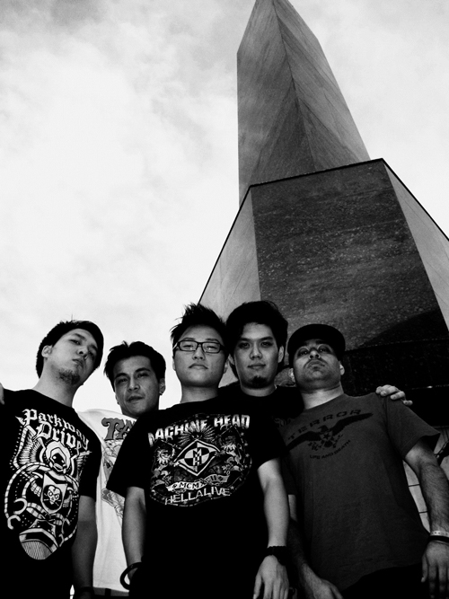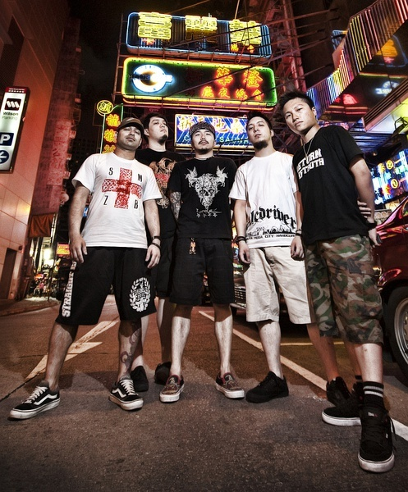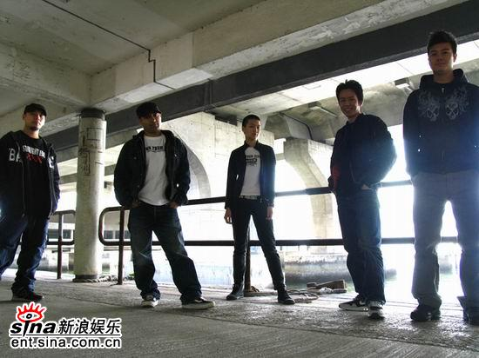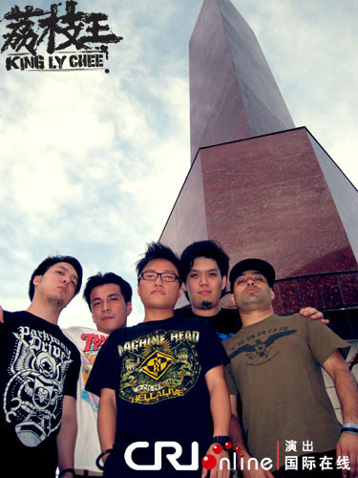

乐队介绍

乐队成员：司马刚、黄启智、黄志健、范力持  
成员： RIZ / KENT / BRIAN / JOE / EGAS

荔枝王成立于1999年5月，当时香港的地下音乐充斥着大量的非原创音乐，并把“硬心”(Hardcore)和“金属”的定义扭曲。于是，荔枝王的创立人Riz决定把的真正意思宣扬开去。首先他创办一本双语免费地下杂志《由零开始》，内容包括论文、世界各地的朋克、金属及硬心乐队访问和唱片评论等。为了增强硬心文化的渲染力。Riz深明单靠文字是不足够的，香港的观众需要听见看见才可真正的感受到这种文化，结果荔枝王正式诞生。　  
凭着一颗对硬心锲而不舍的决心，这成立了七年多的乐队孜孜不倦地发扬这个文化。期间，荔枝王把他们的声音、力量及坦诚的心带到亚洲及欧洲多个国家去，建立了荔枝王作为一队香港乐队、亚洲乐队的名字。  
2006年9月，荔枝王成立了由“由零开始唱片”，一个发掘香港土生土长声音的独立唱片公司，现在合共签了五队本地乐队(包括荔枝王)。

01 硬心 2003.12.01

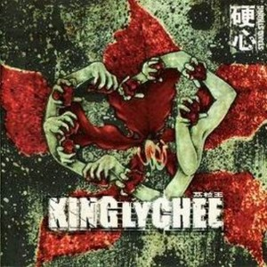

公司：Polar Bear

发行：2003-12

语言：粤语

专辑曲目：

1 企硬 Stand Strong

2 所见所闻 Sickened Eyes

3 制造距离 Masterpiece (友情客串:何超仪)

4 力竭 Frail Hands

5 拒绝 Refuse (友情客串:LMF 阿杰)

6 (对话)

7 A Useless Gift

8 (对话)

9 地乐起哄 Chaos Of Thoughts & Actions

10 土炮 I Belong

11 (音乐)

12 抛诸脑后 Charcoal (友情客串:恭硕良)

13 多谢 Thank You

14 (说话)

15 基础主义 Our Life's Blood

01 企硬 Stand Strong

我会 - 企硬 - 呢个立场 - 永远

GO AHEAD - and ridicule me

GO AHEAD - and belittle me

我踏实0既立场...your crticism won't effect me

我心里一团火...cause you're too blind to see

I've been told that nothing I've done in my life...matters

佢0地会认为我0地无作为

to us, wealth isn't measured by our bank accounts but by what's in our minds...

但我0地0既价值观不于物质但于思想

its all we have...its all we'll ever have.

我0地所拥有会与我0地直到永远...直到永远

我0地0吾会妥协

0系呢个物质社会中释放　热诚0既心

思考　寻找真我0既立场及道德思想

基于呢个立场我0地已创造　我0地0既世界

we'll forever be...connected to this...

于呢个缺乏道德丧失真我0既物质主义风气中抗衡

hardcore - 硬心

佢笑我0地太风颠　我笑佢0地太肤浅

呢个立场叫我不断反思　我0地引以为荣

02 所见所闻 Sickened Eyes

呢度所见所闻就0系0甘

Flowing through this city's arteries...

An endless stream

of polluted dreams

Instilled in me...

the belief...

that 'there's no reason to fight this'

大气候　将你0地　逐渐　洗脑

物质　主义　遍布　社会每一阶层

I run far away...

Plagued by lies,

of commercialized lives

Mould the way that you should live

Cloaked in designer labeled dreams...

Don't try and challenge

their enforced status quo...

They have millions washed

chasing their monetary hopes...

I run for away...

转载来自 ※Mojim.com　魔镜歌词网

频扑0既工作吃喝玩乐　浮于物质层次　驱壳

无建设性挥霍　死板0既思维难以开放

永不再以物质衡量一切　人性人义与我一世

冇0野可毒害我独立思想　齐对毒害无数人0既主义...唱!

FUCK YOU

NO - you can't hold me

NO - you can't silence me

MY - heart is sworn

TO - fight this war

Don't be afraid...跳出物质层次

Don't be afraid...跳出物质层次

无　人　可　以　夺　取　你　人　生

They can't silence you 独立

They can't silence me 自发

You've got us so stand strong 不再受

You've got us so stand PROUD! 大气牵引

03 制造距离 Masterpiece

演唱：荔枝王/何超仪(友情客串)

Look inside yourself and you will find 望清你自己你会发觉

that we're al the same, 我0地0系平等

no one cares about a color of skin. 无分国籍

We stand united screaming for you to listen. 团结去唱俾你听

I'm taking everything that I've learned 我将我所学到都

and erasing it from you skull.　从脑里带走

Cause you can't pollute me　因为你唔可以以你0既错...

with your false educating...　错误教育清洗我

Look closer at what you read and you will see. 望清你会发觉

They try so desperately to create and enemy. 佢0地0系制造距离

So its up to us to create 0系在乎我0地...去创造...

a better world for ourselves. 更美0既世界...

Please think before you speak. 思考...

Look at me for who I am...

not for what I am.

04 力竭 Frail Hands

COME CLOSE - 看我心滴泪

COME CLOSE - to taste the tears of me

OUR VOICE - 算得上什么

WHO STANDS - up for us today.

呢个系我　瑟缩于街角

as you pass me by...

力竭的手　苦在心头

form this bleak bleak life.

力竭　的手

无望　声音

Don't dare to provoke anything...再无要求

This battle, my weak heart, just can't take...默默　承受

My identity scratched from this city...尊敬　被带走

I'm not an asset,to society.

因为 - 我对 - 社会 - 已经 - 再冇- 价值 - 再冇价值

力竭　的手

无望　声音

Sleepy hollow streets - fading eyesight maybe,

a blessing in disguise -the ugliness I see...

will fade away - then peace may lay,

it's soft touch upon my life - and protect me...

My eyes open and the silence is gone

My eyes open and my soul is torn...

孤独的心　无望的心　有谁能理解

With your soft fingertips - you wipe my tears away

Your gentle touch on my shoulder -even for a second

reminds me that i am...

reminds me that i am...

STILL - A PERSON - VALUED - NOT FORGOTTEN

05 拒绝 Refuse

演唱：荔枝王/Lmf/阿杰(友情客串)

Page after page,

innocent minds get tricked into believing.

That without a sculptured figure or a sculptured wardrobe...

they'll amount to nothing.

我拒绝　去接受　呢个崇尚虚荣0既文化

注重形象　恶性循环影响

绰头效应0既影响　大众肯定0既肖像　伪造所谓成功0既模样

以外表　去衡量　以貌取人0既文化日渐扩张

Its so hard, to turn away,

when they say that everything is wrong with you...我不想接受

我拒绝

喂　咪做潮流奴隶

喂　咪做潮流奴隶

不知所谓　你0地仲0系屌极都唔醒

仲唔吾反省　你0地想点　呢个社会越来越肤浅

物质　虚荣　仲以为自己好型

咁0既文化　真0系好(孑然)畸形

我拒绝　去接受　呢个崇尚虚荣0既文化

06 对话

老板：进来。

助手：老板，带了一对新的乐队给你认识，他们叫荔枝王。

老板：坐吧。

助手：坐这里吧，孩子。

老板：荔枝王是吧!?有没有一些DEMO给我听？

助手：有的有的。他们带了一些DMEO上来，把它拿过来吧，孩子。

荔枝王：这里。

老板：跳！...跳跳跳跳跳！...下一首！...停停停停停！

第一，你们的歌光一个字...吵！

第二，你们唱的都是英文。这里是香港啊！这个乐队是你找回来的吗？

助手：当然不是啊！是那个张三找回来的嘛！

老板：我跟你们讲，你们玩这些东西...去吃大便啦。

07 A Useless Gift

4 short years ago,

this was just a dream we had,

to connect our thoughts,

through words and music.

With the intent,

to inspire others,

to think about their live's

but there was so much against us.

香港0既社会　Our dreams are crushed repeatedly...

香港0既社会　Our courage tested endlessly.

香港0既社会　We have to sacrofice all that we love...

but at what cost?

I will never let, I will never let this world kill my voice.

I will never let, I will never let this world kill my passion.

At night I cry,

but in the morning,

I wake up and face another day.

Everyone is born with a gift,

Something special to give to the world,

This is our gift.

Can you imagine how much it hurts when they say,

Your gift is useless...

香港0既社会　Our dreams are crushed repeatedly...

香港0既社会　Our courage tested endlessly.

香港0既社会　We have to sacrifice all that wo love...

but at what cost?

I will never let, I will never let this world kill my voice.

I will never let, I will never let this world kill my passion.

I'll stand up, I'll stand up, I'll stand up - face another day.

08 对话

老板：你们第一天在香港混吗？

你们这些歌怎么拿来唱卡拉OK呀？外国歌坛？

香港这个市场是怎么样玩你们懂吗？

传煤，策略，卡拉OK，广告。你们搅这些鬼东西出来，

要不把唱片的名字叫做'会讲不会听'吧！

09 地乐起哄 Chaos Of Thoughts & Actions

0系时候　为音乐革命　实践　改革

0系　香　港

Market demands influence the decisions that get made,

We have to affect these market demands to affect the decisions that get made.

How can you expect society change, when you can't even change yourself?

We have to raise our standards to let them know,

substanceless bullshit won't be accepted no more.

This is a call...for a revolution...of thoughts and actions

COME NO - 0系时候　为音乐

革命　实践　改革

GO!　实践改革

罐头音乐泛滥　叫雪亮眼睛慨叹

低质素　游戏规则搭够

你我受够　齐手牵手

创造音乐新风气　由我0地0既生活　来做起

支持　唱作音乐　停买　滥造次货

你我做栋梁　刺激　音乐新市场

This is a call...for a revolution...of

thoughts and actions

COME ON - 0系时候　为音乐

革命　实践　改革

GO!　实践改革

你我0既沉默　满足商家0既欲望

你我0既沉默　助长游戏0既荒谬

游戏规则抹杀　香港唱作灵魂

怒火正在中烧　地下音乐社会0既声音

Let the fire burn...burn!

Let the fire burn...

That rages inside your hearts...

Let the fire burn...

LET IT BURN...WITH CHANGE!

Will you change?　我会

10 土炮 I Belong

Do we look that different from you,

that you feel the need to desecrate my childbood?

Who are you to judge me?

0系咪因为我0地肤色不同...

你要不公平对待我

Takes a toll on me and I feel myself draining.

干竭...what it feels like...干竭...

我 - 0系 - 土 - 炮

12 抛诸脑后 Charcoal

演唱：荔枝王/恭硕良(友情客串)

Force these hands...

to play another worthless song

as i carve my insides out...

A nameless face

with unrealistic dreams...

chained to these homeless streets.

贫穷角落　生命里没有机会　更要挣扎求存

远比起我0地0既丰足生活　更要失落无望

With shattered hands he

strums his tuneless srings.

And you can try and ignore his plight

by living your life...

停一停想一想我0地0既生活　总算幸运

理应更积极　尝试将生活里负面角度　抛诸脑后

尝试将　生活里　负面角度　抛诸脑后...

When the rain falls...

despair may set in...

force yourself to step back...

clear vision is what you need.

将违背生命0既借口放开

将生活0既一时之气都放开

尝试去回想更多冇选择0既悲伤

天空仍然一样　在乎我0地去思想

13 多谢 Thank You

Our eyes are closed as we feels your love,

基于最真诚0既支持　我0地变得热血

一个唔吾只靠我0地　去实践0既目标...还有你

圈子慢慢扩大　信念日渐扩散...基于呢个每一个奋斗的心

我0地感激你...

We feel your faith.

We feel your beliefin everything...we say, we do.

We feel you cry,

as you sit in your room and read our words,

for the very first,

very first time.

我0地感激你...

我0地感激你...

听到你共鸣心声...我0地心感震奋

看到你随心舞动...我0地心感震奋

知道你得到一点启发...我0地心感震奋

我们的血　你们的泪

我们的心　你们的生命

Just received another e-mail...

You wrote about the strength we give you...

To face your lonely world alone...

But your world is our world so you're not alone.

你不是孤独...

As I write these words on this piece of paper,

I want you to know that our hearts are powered

by your love,

by your friendship

and by your thoughis.

When you take time to read our words,

you are entering our lives.

This song is dedicated to you...

for letting us become a part of your lives.

我0地 - 唔会 - 令你 - 失望

14 说话

'我们除了照顾我们的家人之外，还会关心社会的进展，对不对!

我们除了要维持生计，照顾家人之外，还会上街争取民主自由，对不对!

民主自由，就好像我们的空气及阳光，是不可缺少的，对不对!

我们一定要为下一代继续努力，好不好!'

15 基础主义 Our Life's Blood

我们的歌　带出一个主义

建立正面态度　叫你坚守本性

At times you may question your own mind, 时间飞逝

disbelieve your own self 你或会惧怕

So you fight

your heart

your soul

your thoughts 尽管时间逝

your everything that means anything to you 强权在你手

Stand by 坚守

your thoughts 本性

as they define who you are. 永不忘记

An empty mind houses an empty soul

creative minds generate hope.

Identity based on your beliefs

is an identity based on beauty.

The strengh...

you'll find...

can only come from within...

将来的你或会怀疑过去的你

因为呢个社会迫使你0地服从大气规则

别出卖你自己　别放弃

Can I ask you a question? Do you care to know who you are?

你有否面对自己

Your eyes hint that there's something you're afraid of.

你说你惧怕

Your say you're just not that strong

你不用惧怕

but when you have friends like us, strength is all yours.

因为我们在旁

其他歌曲

《这是我新的开始》

你说话污蔑   
意见狭窄   
不要再伪装   
置我于死地   
正气的心，我会战胜   
  
十年过   
十年多   
多伤痛的 都捱过   
你有多小 尽管 放马来   
无赖。。。未怕过   
  
这是我新的开始   
我们的出口   
  
这是我新的开始   
我们的出口   
  
千万不要误会我要   
建立一道围墙!!!   
让我们用沟通方式   
瓦解我们的冲突 NOW!!!   
  
这是我新的开始   
我们的出口   
  
这是我新的开始   
我们的出口   
  
你说话无mie   
意见狭窄   
不要再伪装   
置我于死地   
正气的心，我会战胜   
  
十年过   
十年多   
多伤痛的 都捱过   
你有多小 尽管 放马来   
无赖。。。未怕过   
  
你凭什么？？GET THE FUCK OUT!!!!   
  
Get the fuck out -   
给我滚出这个门口   
  
直到永远   
  
———————————————————————— 

《CNHC中国硬核》

北京的兄弟   
天津的兄弟   
大家一起站起来   
  
上海的兄弟   
武汉的兄弟   
大家团结起来   
  
（粤语）广州的兄弟   
澳门的兄弟   
大家需要一切   
  
昆明，西安，成都   
我们还没忘记你们   
  
CNHC - 中国硬核   
CNHC - 来吧，来吧，来吧   
CNHC - 中国硬核   
CNHC - 中国HARDCORE NOW!   
  
金属的兄弟   
朋克的兄弟   
大家一起站起来   
  
嘻哈的兄弟   
摇滚的兄弟   
大家团结起来   
  
Straight Edge的兄弟   
素食的兄弟   
大家振奋起来   
  
任何生活独立的朋友们   
我们还没忘记你们   
  
CNHC - 中国硬核   
CNHC - 来吧，来吧，来吧   
CNHC - 中国硬核   
CNHC - HARDCORE   
CNHC - HARDCORE   
CNHC - HARDCORE   
中国HARDCORE NOW!   
  
They may doubt us   
They may beat us down   
You have to look in your heart   
And stand your ground   
  
中国HARDCORE NOW!   
  
They may doubt us   
They may beat us down   
You have to look in your heart   
And stand your ground   
  
别忘记，别忘记。。。DIY的态度就在心里   
别忘记，别忘记。。。开放思想发自心里   
别忘记，别忘记。。。尊重他人就在心里   
诋毁留言，对我们来说没关系   
  
CNHC - HARDCORE   
CNHC - HARDCORE   
CNHC - HARDCORE   
中国HARDCORE NOW!   
  
中国HARDCORE NOW!   
  
———————————————————————— 

《This is Our New Beginning》

Your petty words   
Your petty views   
What is your excuse?   
  
You'd like to see me fail,   
with a heart so pure,   
I will prevail.   
  
10 years gone,   
10 years more,   
with shit I've all heard before.   
Keep coming at me,   
take your best shot,   
your lies are all you've got.   
  
This is our new beginning   
This is our way out   
  
This is our new beginning   
This is our way out   
  
Lets not let misunderstandings   
Build up all of these walls   
Let us use communication   
To tear these walls down - NOW!   
  
This is our new beginning   
This is our way out   
  
This is our new beginning   
This is our way out   
  
Your petty words   
Your petty views   
What is your excuse?   
  
You'd like to see me fail,   
with a heart so pure,   
I will prevail.   
  
10 years gone,   
10 years more,   
with shit I've all heard before.   
Keep coming at me,   
take your best shot,   
your lies are all you've got.   
  
Are all you've got...   
motherfucker...   
Get the fuck out!   
  
Get the fuck out - the door is not open to you.   
Any longer   
  
———————————————————————— 

《We Will Find a Way》

Where there is a will   
there will always be a way.   
A way...   
We will find a way.   
  
One day I will be set free   
To read, to see, to believe, to find the path that's right for me.   
Doesn’t mean it will lead me to a world of catastrophe.   
  
You hide, you try, you lie, you've taken it all away.   
But in this day in age, we will still find a way.   
  
Age of change,   
Age of trust,   
Information   
We will find a way   
  
Age of change,   
Age of trust,   
We will find a way   
  
No use in trying   
No use in hiding   
You’re still denying   
  
We will find a way   
  
No use in trying   
No use in hiding   
Billions spent...   
millions wither away.   
  
Away…   
  
Choking under this weight   
of questioning   
whether it’s alright for me   
to say the things I want to say...I will say.   
  
Age of change,   
Age of trust,   
Information   
We will find a way   
  
Age of change,   
Age of trust,   
We will find a way   
  
No use in trying   
No use in hiding   
You’re still denying   
  
We will find a way   
  
No use in trying   
No use in hiding   
Billions spent...   
millions wither away.   
  
You live under a cloud of paranoia   
Stubbornly denying that change will take place.   
If you just step back and use an open mind   
You could see what we both want is the same thing.   
  
The same thing...   
  
We all want the same...   
We all want the same thing   
  
To build up this country   
To build up this country   
  
Age of change,   
Age of trust,   
Information   
We will find a way   
  
Age of change,   
Age of trust,   
We will find a way   
  
No use in trying   
No use in hiding   
You’re still denying   
  
We will find a way   
  
No use in trying   
No use in hiding   
Billions spent...   
millions wither away.   
  
One day this will all change.   
  
———————————————————————— 

《奋身见证》

我们不会忘记   
这段辛酸的日子   
耗尽我光阴 粉碎我信任   
你 编织千个谎言   
你 越过了界线   
  
＊ 你猜忌 你质疑　已经没有意义   
你只懂破坏　不懂建设   
你不你不会把我击倒   
尽管你不怀好意   
你不你不会把我击倒   
尽管你散播谣言   
  
我们不会放弃   
你可以说要说的话   
但你要记着 尊重你自己   
  
我很抱歉 我们不懂放弃   
没有了你 我也可面对每一天   
  
REPEAT＊   
  
不会把我击倒   
不会把我们击倒   
  
What I feel is what I feel,   
这个　并不是我   
I can’t live any other way   
any other way is a lie   
and that’s just not me   
  
也许在您的眼里　   
我不够　我不够好   
我想听 我只想听   
我想听您说一句   
我相信您   
  
奋身见证   
  
昔日那信念　仍铭记在心头   
昔日那信念　仍铭记在心头   
So rest your head tonight,   
Need your strength to face another day   
  
曾经所拥有　从未被带走   
So rest your head tonight,   
Need your strength to face another day   
  
明天不能保证　除非今天践诺   
逃避就是偷生　今晚将与逆境对抗   
  
———————————————————————— 

《皇后码头 (Queen's Pier)》

This is   
All that's   
Left of my past...   
Every time a building gets torn down,   
My heart gets RIPPED APART.   
历史 壮烈 昔日已被破灭   
找不到确认 丧失了尊严   
When I walk down these streets,   
No longer familiar to me.   
The image in my head is now dead.   
  
我们的根已被拔去   
钢筋刺进了她脆弱心里   
活着彷佛有天会被抺去　   
填补不了万户灯火下空虚   
弥补不到明日的后悔   
  
我哋嘅血汗 已渗透在这砖墙   
我哋嘅回忆 曾影照在这老街   
我哋嘅回忆 已经灭亡   
属于我哋嘅一切 会被改变   
人民嘅过去会被遗忘   
当起重机嘅声音响起 我地嘅尊严会随着古迹 一起倒塌   
岁月留下来嘅痕迹 我地无法再追忆 身份从此 消失   
挺身 捍卫 属于 我哋嘅家   
捍卫我家   
不再坐以待毙   
不再若无其事   
不须要再忌讳强权   
  
Robbed me of my memories   
Taken - away from me   
Stolen –my history   
Tell me - what's left for me   
  
Robbed me of my memories…   
robbed me of my memories…   
身份己被夺取   
历史己被删除   
取回 我哋嘅失去   
  
———————————————————————— 

《亚洲起义》

这是我们的时代   
  
越过四海 跨过泰山   
紧握着对方臂弯   
挫败太多被否定太久   
不再随着人家尾巴走   
在沈睡中苏醒叫嚷   
吶喊出新的景象   
打破支配围墙   
团结每一颗心再燃亮   
  
这个是我们的时代   
站立! 被漠视 不再   
这个是我们的时代   
炮着怒声 不再被遮盖   
  
现在就要向世界宣告   
我们的存在   
  
让我来向你承诺 今天不再孤独   
你还在等着什么 今天不再孤独   
让我来向你承诺 今天不再孤独   
  
向世界宣告 我们的存在   
  
亚洲 起义   
  
———————————————————————— 

《My Family》

I need you,   
my family,   
when everyone has turned their back on me.   
So let them say what they want to say,   
you and I will live to fight another day.   
  
I’ve been knocked down   
One too many times   
Over the years…   
I’ve found myself broken and abused   
You’d think I’d learn by now   
But then there you were   
You picked me and held me tight…   
And you wouldn’t let me go…   
And you didn’t let me go…   
I will never forget that night and what you did for me.   
  
I need you,   
my family,   
when everyone has turned their back on me.   
So let them say what they want to say,   
you and I will live to fight another day.   
  
曾经拥有过一段日子   
没有谎言 没有诈骗   
血脉相连   
  
在这个空虚城市   
常有你在旁   
不曾感到寂寞   
  
经历几许风雨   
也抱着同一个理想   
咬紧牙根 并肩作战   
  
从那个时候开始   
在同一个场景里   
满是厌恶的脸孔审判的话儿   
  
好像不曾发生   
一切已经改变   
我们无法在牵手梦下去   
  
回到纯朴 的从前   
撇去无谓　的怀疑   
重拾承诺　再一起   
握紧久遗　的真摰   
重拾信念　再开始   
  
I need you,   
my family,   
when everyone has turned their back on me.   
So let them say what they want to say,   
you and I will live to fight another day.   
  
———————————————————————— 

《Unite Asia》

This is our time   
EVERYONE RISE   
  
This is our time   
WE WILL RISE   
  
From the streets of Hong Kong   
We hear your voices loud.   
We know all about the struggles you face,   
It’s this for which we’re bound.   
  
Our differences are our strength   
Our diversity unites us   
Our will to persevere is why stand as one   
STAND AS ONE   
  
We will rise – as long as you’re by my side   
We will rise – no longer pushed aside   
  
Look at what we’ve been through   
Look at what we’ve been through   
It’s for me and you to   
UNITE ASIA   
  
I see the desperation in your eyes, UNITE ASIA   
When it feels like no one hears you your spirit dies UNITE ASIA   
To those with no hope I sing to you UNITE ASIA   
Look around this room, you’ll see that   
  
We stand with you.   
WE STAND WITH YOU.   
  
From the streets of Hong Kong   
We hear your voices loud.   
We know all about the struggles you face,   
It’s this for which we’re bound.   
  
We will rise – as long as you’re by my side   
We will rise – no longer pushed aside   
  
We stand as one   
We stand as one   
We stand as one   
  
RISE RISE RISE RISE…   
  
We will rise   
  
———————————————————————— 

《Skinless》

Your words like daggers,   
carve out my insides…   
  
刻骨痛心 每刻 仍记得   
点解少数是我 不似 你与你的同胞   
那么 漂亮 令你自觉   
特有这权利 将我看不起   
从我起居饮食 歧视到我毛发 肤色   
刻骨痛心 每刻 仍记得   
我的 往日黑色童年   
  
If I could peel this skin,   
right off of these arms.   
I could set myself free,   
from this unwelcoming world.   
  
你 同我听清楚   
我不属于你 点解你特有这权利   
命名 我 少数民族   
下等姓名   
  
Don’t take my silence as a sign of weakness.   
I was just trying to make sense of this cold world.   
I looked to the heavens,   
pleading for answers, answers that would provide   
me with a will to survive.   
  
每个 落泪晚上   
我梦见 大同世界   
但与你一起 这梦再醒   
  
If I were invisible then would I make it through just one day free?   
抬头问天 何时从你给我的阴影 拾回属于我 的一切   
  
When even the heavens have turned on me – how do I not give in?   
  
我保证今天…我比你更强壮…号召你的同胞来支持…去建立新一代对少数民族 开放思想   
  
剩下你文明败类   
你有你腐败   
  
———————————————————————— 

《End of Suffering》

以响起警号执拾包袱 携同亲属 与最爱逃离现场   
永别家乡说再见 末日降临之前   
踏上这 不归路   
整装待发即将在你我眼前发生   
可会为人类历史上演最后一幕   
上降天灾 大自然呼喊着 蓝天不再   
下发人祸无止野心再三引发 平民战祸   
令世界完结仍望神恩典 愿我能活多一次   
珍惜你我与爱与心所有直到最后   
  
The sirens overhead,   
reminds me that,   
none of this will matter in the end…   
  
到尽头谁带走 最珍贵 直到最后   
双膝跪下问问自己今次 人类能否逃离这扼运 ?   
双膝跪下能否平安回家 留待天国里寻求解答 ?   
  
The skies plead for us to take a step back   
We’re choking on the flames of our constant needs.   
As the ashes of our faults rain down on us   
We won’t escape that one day we will live through machines.   
Will all this still be here?   
Not at this rate.   
The stars look down and count away…   
the minutes that are left.   
  
人类恶行循环 给他们上演多一次 死症再一次   
携同最爱逃离现场 剩下野心的人 埋没于遗憾   
灭于羞耻埋没于遗憾   
  
The sirens overhead,   
reminds me that,   
none of this will matter in the end…   
  
到尽头谁带走 最珍贵 直到最后   
与我逃离这扼运   
  
Blankets of devastation ,   
looming in every direction…   
and all the signs are pointing   
under the weight of the blackest skies to the inevitable…   
  
警号 启示末日   
暗涌 盖过天空   
跟我再行不陷于他们   
埋没于遗憾   
  
———————————————————————— 

《Sisters》

诚意送给你亲爱的姊妹们   
就让你信心的缺口得以修补   
This song is for you my sisters…   
to regain your trust…   
  
With all our good intentions,   
how did we let this happen?   
Now our words seem so empty.   
  
曾竭力合唱的歌 展现正气之火   
如今有你恶行 谁愿再附和这歌   
当初带着最真 高呼正面声音   
却有你无耻小人 出卖了她的信心   
  
一日有你 看不见往日的真   
一日有你 看不到宁日   
这片治疗心的乐章   
需要你我真摰的合唱 来赋予正极能量   
给你与我与这乐章 再次打开她的心窗   
  
This heart – we beat from together…   
怀着最真的心 你我本是同根生   
Together – or not at all…   
从没半点疑心 却被你害群入侵   
小人休想再逃避我的眼神   
你 有何教养 教出你如此恶行   
  
Life vanishes from her eyes…   
  
This is our moment to restore her faith in us,   
Gather around to scream:   
WE WILL PROTECT YOU   
  
这片治疗心的乐章 需要你我真摰的合唱   
来赋予正极能量 给你与我与这乐章   
再次打开她的心窗   
此刻属于你我 各就各位 赋予正极能   
给这乐章 治疗她的心   
  
This song is for you my sisters…   
to regain your trust…