2012
Guns N' Roses
The Faces/The Small Faces
Red Hot Chili Peppers
Beastie Boys

2011
Alice Cooper
Neil Diamond
Dr. John
Darlene Love
Tom Waits

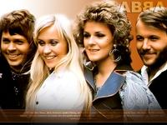
2010
Stooges
Genesis
ABBA
Hollies
Jimmy Cliff

2009
Metallica
Run-DMC
Jeff Beck
Bobby Womack
Wanda Jackson
Little Anthony and the Imperials
Bill Black
Fontana

2008
Performers:
Madonna
John Mellencamp
Leonard Cohen
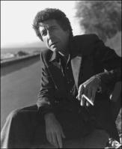
Leonard Cohen
The Dave Clark Five
The Ventures

2007
Grandmaster Fl

Patti Smith
ash and the Furious Five
Patti Smith
R.E.M.
The Ronettes
Van Halen

2006
Black Sabbath
Blondie
Lynyrd Skynyrd
Miles Davis
Sex Pistols（只是单方面邀请，被Sex Pistols拒绝）

2005
Buddy Guy
Percy Sledge
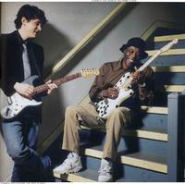
Buddy Guy(右)
The O'Jays
The Pretenders
U2

2004
Bob Seger
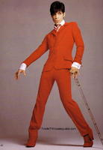
Prince
George Harrison
Jackson Browne
Prince
The Dells
Traffic
ZZ Top

2003
AC/DC
Elvis Costello & the Attractions
Righteous Brothers
The Clash
The Police

2002
Brenda Lee
Gene Pitney
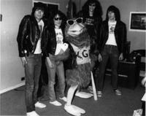
Ramones
Isaac Hayes
Ramones
Talking Heads
Tom Petty and the Heartbreakers

2001
Aerosmith
Michael Jackson
Paul Simon
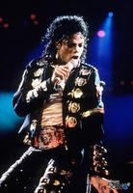
Michael Jackson
Ritchie Valens
Solomon Burke
Steely Dan
The Flamingos
Queen

2000
Bonnie Raitt
Earth, Wind & Fire
Eric Clapton
James Taylor
Lovin' Spoonful
The Moonglows

1999
Billy Joel
Bruce Springsteen
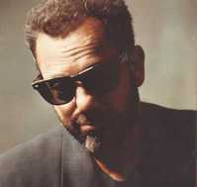
Billy Joel
Curtis Mayfield
Del Shannon
Dusty Springfield
Paul McCartney
The Staple Singers

1998
Fleetwood Mac
Gene Vincent
Lloyd Price
Santana
The Eagles
The Mamas and the Papas

1997
Buffalo Springfield
Crosby Stills and Nash
Joni Mitchell
Parliament-Funkadelic
The (Young) Rascals
The Bee Gees
The Jackson Five

1996
David Bowie
Gladys Knight and the Pips
Jefferson Airplane
Little Willie John
Pink Floyd
The Shirelles
The Velvet Underground

1995
Al Green
Frank Zappa
Janis Joplin
Led Zeppelin
Martha and the Vandellas
Neil Young
The Allman Brothers Band

1994
Bob Marley
Duane Eddy
Elton John
John Lennon
Rod Stewart
The Animals
The Band
The Grateful Dead
Willie Dixon

1993
Cream
Creedence Clearwater Revival
Etta James
Frankie Lymon and the Teenagers
Ruth Brown
Sly and the Family Stone
The Doors
Van Morrison

1992
Bobby "Blue" Bland
Booker T. and the M.G.'s
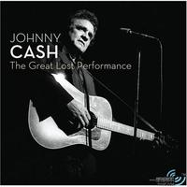
Johnny Cash
Johnny Cash
Sam and Dave
The Isley Brothers
The Jimi Hendrix Experience
The Yardbirds
The Doors

1991
Ike and Tina Turner
Jimmy Reed
John Lee Hooker
LaVern Baker
The Byrds
The Impressions
Wilson Pickett

1990
Bobby Darin
Hank Ballard
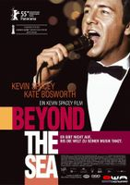
Bobby Darin
Simon and Garfunkel
The Four Seasons
The Four Tops
The Kinks
The Platters
The Who

1989
Dion
Otis Redding
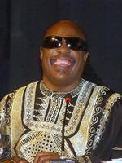
Stevie Wonder
Stevie Wonder
The Rolling Stones
The Temptations

1988
Bob Dylan
The Beach Boys
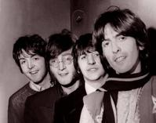
The Beatles
The Beatles
The Drifters
The Supremes

1987
Aretha Franklin
B.B. King
Big Joe Turner
Bill Haley
Bo Diddley
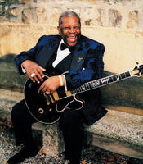
B.B. King
Carl Perkins
Clyde McPhatter
Eddie Cochran
Jackie Wilson
Marvin Gaye
Muddy Waters
Ricky Nelson
Roy Orbison
Smokey Robinson
The Coasters

1986
Buddy Holly
Chuck Berry
Elvis Presley
Fats Domino
James Brown
Jerry Lee Lewis
Little Richard
Ray Charles
Sam Cooke
The Everly Brothers

