Patrol Encounter Rate
{{ report_date }}

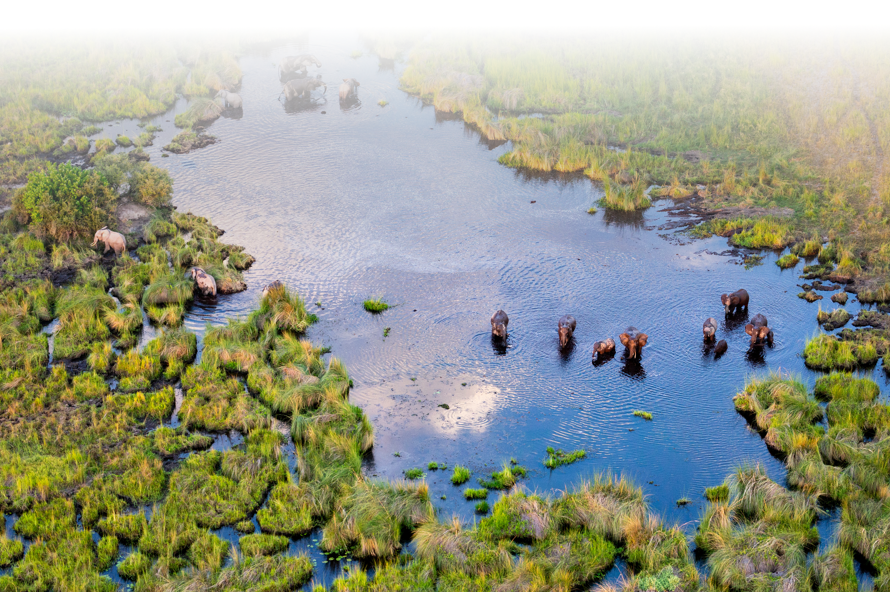

Patrol Encounter Rate Summary
{%tc for col in encounter_stats.col_labels %} | {{ col }} | {%tc endfor %}
{%tr for item in encounter_stats.tbl_contents %}
{%tc for col in item.cols %} | {{ col }} | {%tc endfor %}
{%tr endfor %}

Patrol and Event Maps

{%p for item in patrol_maps %}
{{ item.title }}
{{ item.image }}

{%p endfor %}

Patrol Encounter Rate Maps

{%p for item in rate_maps %}
{{ item.title }}
{{ item.image }}

{%p endfor %}

