
Mara Triangle Monthly Patrol Report
{{ report_date }}

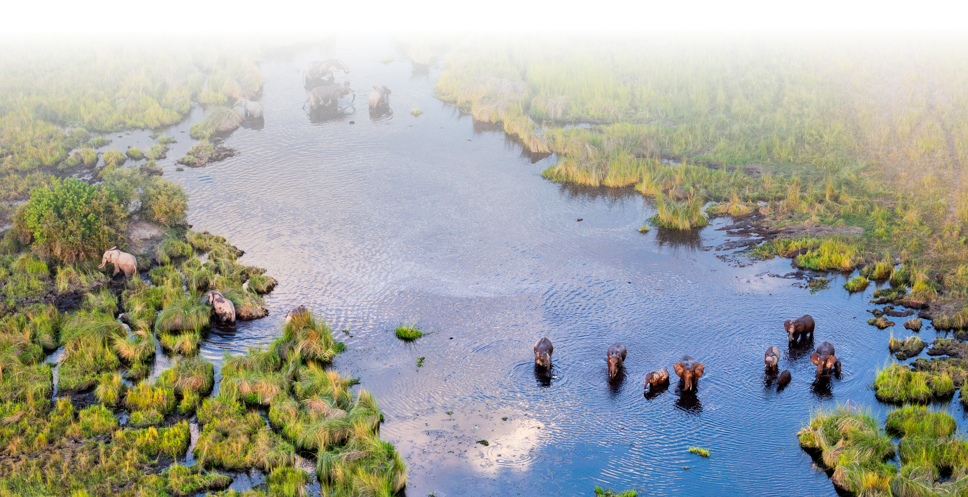

Patrol Trajectory Maps

{%p for item in patrol_maps %}
{{ item.title }}
{{ item.image }}

{%p endfor %}

Patrol Statistic Bar Chart
{{ bar_chart }}

Patrol Summary: Transport

 | {%tc for col in transport_summary.col_labels %} | {{ col }} | {%tc endfor %}

{%tr for item in transport_summary.tbl_contents %}
{{item.label }} | {%tc for col in item.cols %} | {{ col }} | {%tc endfor %}

{%tr endfor %}

Patrol Summary: Mandate

 | {%tc for col in mandate_summary.col_labels %} | {{ col }} | {%tc endfor %}

{%tr for item in mandate_summary.tbl_contents %}
{{item.label }} | {%tc for col in item.cols %} | {{ col }} | {%tc endfor %}

{%tr endfor %}

Patrol Summary: Ranger

{% for item in ranger_summary %}{% if item.title %}{{ item.title }}{% endif %}
 | {%tc for col in item.col_labels %} | {{ col }} | {%tc endfor %}

{%tr for row in item.tbl_contents %}
{{row.label }} | {%tc for col in row.cols %} | {{ col }} | {%tc endfor %}

{%tr endfor %}

{% endfor %}

