
Mara Triangle Monthly Rhino Report
{{ report_date }}

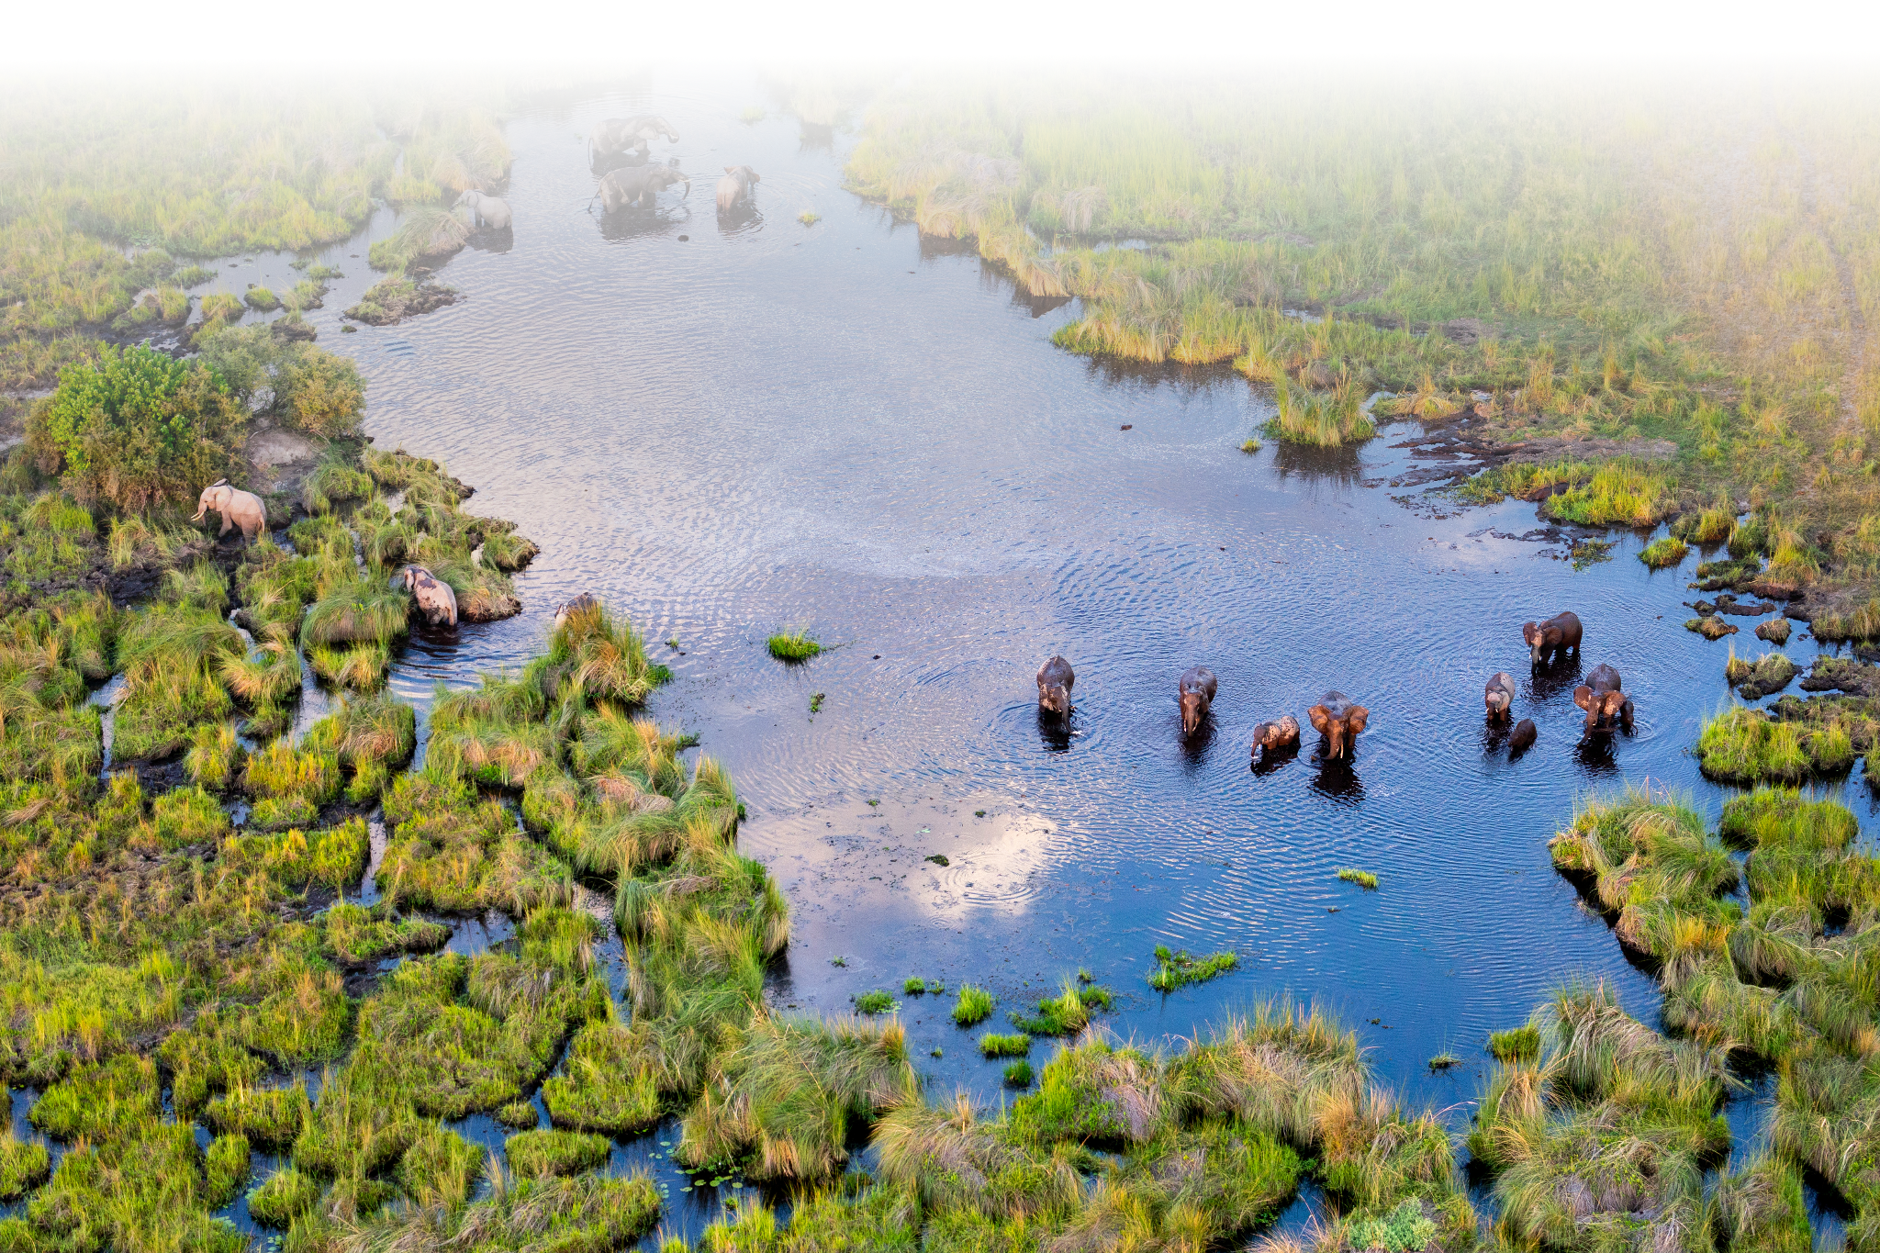

Rhino Monitoring Patrols
{{ patrol_map }}

Rhino Sightings
{{ rhino_map }}

Rhino Sightings Summary
{%tc for col in rhino_summary.col_labels %} | {{ col }} | {%tc endfor %}

{%tr for item in rhino_summary.tbl_contents %}
{%tc for col in item.cols %} | {{ col }} | {%tc endfor %}
{%tr endfor %}

Rhino Statistic Bar Chart
{{ bar_chart }}

