Resources

# Resources

## Tahoe Central Sierra Initiative

### [Tahoe-Central Sierra Initiative](https://sierranevada.ca.gov/what-we-do/tcsi/)

The [Tahoe-Central Sierra Initiative](https://storymaps.arcgis.com/stories/df5a84c6ecd34f88a99328962eb33080) (TCSI) is led by state, federal, nonprofit, and private partners who are working together to restore the resilience of 1 million acres of Sierra Nevada forests and watersheds.[1] The group’s focus is to develop and demonstrate innovative planning, investment, and management tools. In addition to developing an [Assessment of Current Landscape Conditions](https://www.fs.usda.gov/research/psw/understory/assessment-current-landscape-conditions-tahoe-central-sierra-initiative) and a [Blueprint for Resilience](https://www.fs.usda.gov/research/psw/understory/blueprint-resilience-tahoe-central-sierra-initiative), they created a Framework for Resilience - which promotes socio-ecological resilience across forested landscapes in the Sierra Nevada. Within this framework, they outline the 10 pillars of resilience. Each pillar describes a landscape benefit that is provided when a socio-ecological system is resilient. Our community food web work aims to contribute to the biodiversity conservation pillar, so that we can better understand how biodiversity contributes to resilient socio-ecological systems.

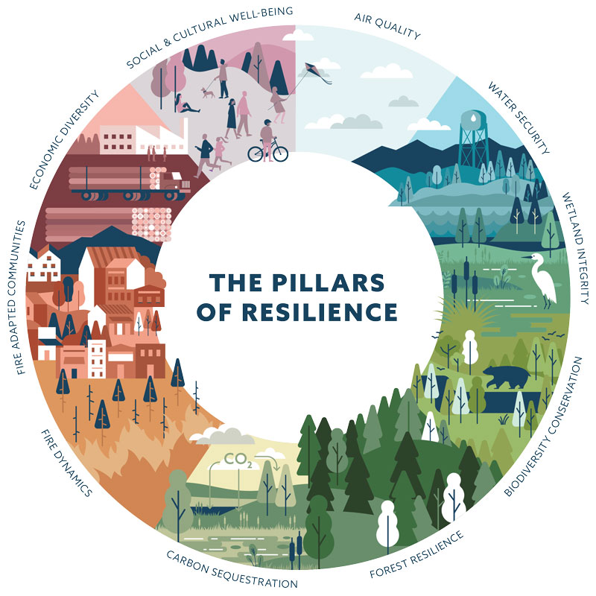

The ten pillars of resilience for the TCSI Framework for Resilience

## Planscape

### [Planscape](https://www.planscape.org/)

Planscape is an open source decision support tool to aid in management and planning to maximize ecological benefits and maximize wildfire resilience in California Forests Planscape is a collaboration of state, federal, and nonprofit partners to bring together the best available federal and state science and data to aid in regional planning and prioritizing landscape areas for treatment. Planscape presents data organized in the 10 pillars outlined in the Framework for resilience which was developed by the TCSI group.

[Planscape app (preview)](https://app.planscape.org/map)

The Planscape app provides a read-only ability to explore and build maps of data from the 10 pillars of resilience outlined in the TCSI framework for resilience.

### [Lake Tahoe](https://www.nationalforests.org/regional-programs/california-program/laketahoewest) Basin

“The Lake Tahoe West Restoration Partnership (Lake Tahoe West) is a collaborative effort to restore the resilience of forests, watersheds, and communities on 59,000 acres of Lake Tahoe’s west shore.

The forests, lakes, and alpine peaks of Lake Tahoe’s west shore make it one of America’s iconic landscapes. The region as a whole is home to 54,000 residents and attracts over 6.4 million annual visitors.

Wildfire, drought, and insects and disease epidemics—pressures that are amplified by climate change—threaten forests, watersheds, and communities across the Lake Tahoe West landscape.”

## Resilience

### [Resilience Alliance](https://www.resalliance.org/)

For those who are interested in learning more about resilience, The Stockholm Resilience Center provides a description of, [what is resilience](https://www.stockholmresilience.org/research/research-news/2015-02-19-what-is-resilience.html)? And how to [apply resilience thinking](https://www.stockholmresilience.org/download/18.10119fc11455d3c557d6928/1459560241272/SRC%20Applying%20Resilience%20final.pdf).

1. TCSI is the first pilot project under the [Watershed Improvement Program (WIP)](https://sierranevada.ca.gov/what-we-do/#SNWIP).