**ASSIGNMENT 01 FRONT SHEET**

|  |  |  |  |
| --- | --- | --- | --- |
| **Qualification** | **BTEC Level 5 HND Diploma in Computing** | | |
| **Unit number and title** | Unit 09: Software Development Life Cycle | | |
| **Submission date** | 04 – July – 2022 | **Date Received 1st submission** |  |
| **Re-submission Date** |  | **Date Received 2nd submission** |  |
| **Student Name** | Trinh Duc Anh | **Student ID** | GCH210829 |
| **Class** | GCH1002 | **Assessor name** | Do Tien Thanh |
| **Student declaration**  I certify that the assignment submission is entirely my own work and I fully understand the consequences of plagiarism. I understand that making a false declaration is a form of malpractice. | | | |
|  |  | **Student’s signature** |  |

**Grading grid**

|  |  |  |  |  |  |  |  |
| --- | --- | --- | --- | --- | --- | --- | --- |
| P1 | P2 | P3 | P4 | M1 | M2 | D1 | D2 |
|  |  |  |  |  |  |  |  |

|  |  |  |
| --- | --- | --- |
| **❒** **Summative Feedback: ❒ Resubmission Feedback:** | | |
| **Grade:** | **Assessor Signature:** | **Date:** |
| **Internal Verifier’s Comments:** | | |
| **Signature & Date:** | | |

Contents

# Introduction

The SDLC model utilized for Tune Source has been illustrated in earlier sections, and some of the hazards that the Tune Source project may encounter have been studied, handled, and explained. And the feasibility analysis demonstrated that this idea is possible. The stakeholders and their interests in the case study are then identified in this part. The requirements description is evaluated, and it is demonstrated how stakeholders deliver the needs for this project. Finally, the connection between FRs and NFRs is examined. And in this section, the TS project's Requirement Definition (with explanations of the need/purpose) is stated, as well as what requirements the relevant party(s) supply.

# Analysis

## Requirement definition

A requirement is a physical or functional necessity that is defined in product development and process optimization that a certain design, product, or process tries to meet. It is often used in formal engineering design, such as systems engineering, software engineering, or enterprise engineering. It is a wide notion that can refer to any required (or sometimes desirable) function, attribute, capacity, trait, or quality of a system in order for it to be valuable and useful to a customer, company, internal user, or other stakeholders.

A Functional Requirement (FR) describes the service that the program must provide. It refers to a software system or a component of one. A function is nothing more than the software system's inputs, behavior, and outputs. It might be a computation, data manipulation, business process, user interaction, or any other specialized activity that defines the function of a system. In software engineering, functional requirements are also known as functional specifications. (Martin, 2022)

Non-Functional Requirement (NFR) describes a software system's quality attribute. They evaluate the software system based on its responsiveness, usability, security, portability, and other non-functional characteristics that are crucial to its success. "How quickly does the website load?" is an example of a non-functional requirement. Non-functional requirements that are not met can lead to systems that do not meet the demands of the users. (Martin, 2022)

## Stakeholders and their interests

|  |  |  |
| --- | --- | --- |
| Stakeholder | Position | Interests |
| Carly Edwards | Assistant Vice president of the Marketing department, Sponsor of the project | When this project is finished, they will own stock in the firm and earn a part of the money generated by the newly established system. |
| John Margolis | Founder of Tune Source | When the project is finished, their income will grow dramatically due to additional clients and market share, and they will earn more when the project is put on the market. |
| Trinh Duc Anh | Business Analyst | A Business Analyst's goal is to develop a complete business analysis that defines a company's issues, prospects, and solutions. Forecasting and budgeting. From there, planning and monitoring will assist the firm to always rise and be rewarded by the corporation. |
| Customers | Customers, the source of revenue for the company | The customers want a quick, cheap, and convenient way to listen to music. Implementing an online music subscription would satisfy that want fully. |
| Development team | Implement an online store for Tune Source | Should the project be successful, they would earn tangible benefits in the form of bonuses along with intangible ones which are increased reputation and referral from Tune Source. |

## Stakeholders who can make functional and non-functional requirements

## Functional and non-functional requirements of the project

|  |  |  |  |
| --- | --- | --- | --- |
| ID | User stories | F/NF | Explanation |
| 1 | As a customer, I want to be able to browse the store on my phone and make purchases on the device | F | This is a requirement that involves user interaction; thus it is a functional requirement. As smartphones are the dominant internet device, a mobile-friendly online store will be able to bring and keep more customers, making the company prosper further. It is an essential aspect for an online store to have |
| 2 | As the chief accountant, I want the store to be able to connect and work with payment services like PayPal, Momo, bank apps | F | The implementation of this feature would allow the user to have more choices in how they pay for the items from the store, positively affecting the user interaction, and making this a functional process. Furthermore, shaking hands with third-party payment systems would eliminate the need for an in-house solution, keeping the development cost and time lower while giving the customer peace of mind and ease of use due to how simple it is to use these services and how famously secure they are. |
| 3 | As the warehouse manager, I want the store to integrate third-party shipping services, allowing the customers to choose what shipping service provider they want when checking out | F | This is a requirement for the user's experience along with the business process, making this a functional one. Traditionally, the company has already worked with shipment services to deliver the products to the customers' hands so it is natural that the online store would also shake hands with them. Furthermore, integrating these services into the store would automate the information handling between the store, the shipping service, and the customers, reducing time and cost along with mitigating any error in the process. |
| 4 | As the operation director, I want the website to be aesthetically pleasing | F | This is a functional requirement due to the fact that it revolves around the experience of the users. Aesthetics is important as the website needs to show the store's uniqueness in design, attracting more customers. |
| 5 | As a customer, I want to be able to create an account | F | This is a functional requirement because it is about user interaction. Allowing the customer to create an account would let them more easily track the orders that they've made, manage their cart should they switch devices, set up default information so they do not have to manually fill their billing and delivery information every time they want to make a purchase. |
| 6 | As a customer, I want to be able to change the variety of a product while in its details page | F | This is a requirement that is about user interaction, making this a functional requirement. Letting the customers customize the product right on the detail page instead of finding the specific variant on the product list would greatly improve the user experience, making the store look more professional and creating a positive impression of the store, leading to more customer satisfaction and sales. |
| 7 | As a customer, I saw this cool product and think that it would look cool on my friend, I want a short link to share it and the preview thumbnail should show concise information about the product | F | This is a user interaction requirement; therefore it is functional. The product's URL should be short so that social media platforms do not automatically flag it as spam. When a URL is shared on social media, a thumbnail of the page would also be provided. This thumbnail should be designed so that a high definition of the product should be displayed when the URL is shared so that the visitor will have a more positive impression of the website before visiting it. |
| 8 | As the operation director, I want the website to load as quickly as possible | NF | This is the requirement regarding the performance of the website. A fast-loading website improves the customer's user experience. Long loading time frustrates the customers and makes them leave the store. To make sure that the customers stay in the store as long as possible, a fast-loading time is essential to the system's performance |
| 9 | As the Managing Director, I need the system to protect the customers' information along with all the data to be protected as tightly as possible | NF | This requirement regards the security of the system, making it non-functional. Security is an essential feature of every online store; Lizzie's is not an exception. When a customer creates an account, they have entrusted us with their personal information, we need to do our best to protect it. Other data such as employee accounts should also be secured to protect our hard workers. |
| 10 | As the operating director, I want the website to be as accessible as possible | NF | This is a requirement for the usability of the website, making it non-functional.  Accessibility is important as the customers should be able to perform actions with ease on the website, this factor would keep the customer on the website for longer and increase sales for the company. |
| 11 | As the Managing Director, I need the system's maintenance to be as easy as possible | NF | This is a requirement for the effectiveness of the website, making it non-functional. Every time the system needs to be maintained; the website would be down. Downtime is bad for every online business, and developing good maintainability minimizes the downtime of the system, making the practice an important aspect of the project. |
| 12 | As the Managing Director, I need the system's expansion to be as easy as possible | NF | This is a requirement for the effectiveness of the system, making it non-functional. The website will grow over time, and when it is time to scale up, a scalable system will allow the development time and labor to be shorter, thus saving cost while giving the website more features in a shorter time. |

## Techniques used to gather requirements

Requirements elicitation, also known as requirements collecting, is one of the most complex, error-prone, and communication-intensive phases of software development. It can only be successful with strong customer-developer cooperation. It is necessary to understand what the users truly require. (Lunalovegood, 2021)

### Interviews

Interviews with stakeholders and users are essential for developing effective software. We are unlikely to satisfy users and stakeholders unless we grasp their aims and expectations. We must also identify each interviewee's point of view in order to appropriately assess and handle their contributions. Listening is the talent that allows a great analyst to extract more value from an interview than an average analyst. (tutorialspoint, 2022)

There are five basic steps to doing an interview:

1. Selecting interviewees
2. Designing interview questions
3. Preparing for the interview
4. Conducting the interview
5. Post-interview follow-up

### Join Application Development

The process of starting a new project is known as joint application development. The JAD approach is utilized for technology projects with Application Management that may be implemented for internal organizational operations or for external commercialization. (Avendano, 2021 )

This necessitates workshops or meetings with stakeholders, both IT professionals and business users, in order for them to participate and improve the system in the best way possible. Having both views that might generate inventive ideation for technology is a critical success component. (Avendano, 2021 )

* IBM created the JAD methodology in the late 1970s, and it is frequently the most effective method for gathering information from consumers.
* JAD is an organized procedure in which 10 to 20 users gather under the supervision of a JAD facilitator.
* A facilitator is someone who creates the meeting agenda and conducts the discussion but does not participate in it.
* The facilitator should be knowledgeable about both group process approaches and system analysis and design methodologies.
* A scribe or two assists the facilitator by taking notes, producing copies, and so forth.
* The JAD group meets for numerous hours, days, or weeks until all topics have been explored and all necessary information has been gathered.
* The majority of JAD meetings are held in a specially equipped conference room.
* The conference space is frequently set up in a U form so that all attendees can see each other easily.

Steps to conduct a JAD are:

1. Select participants
2. Design the JAD session
3. Prepare for the JAD session
4. Conduct the JAD session
5. Post-JAD follow-up

### Questionnaires

* A questionnaire is a collection of written questions designed to elicit information from persons.
* Questionnaires are frequently employed when a significant number of people's information and views are required.
* When compared to paper questionnaire distribution, electronic dissemination can save a large amount of money.

### Document Analysis

* Document analysis is frequently used by project teams to understand the current system.
* Unfortunately, most systems are not thoroughly documented because project teams fail to record their projects as they progress, and once the projects are completed, there is no time to go back and document them.
* There are several useful papers in the organization:
* Reports, memorandums, policy guides, user training manuals, organizational charts, and forms on paper

### Observation

* Observation, or the act of observing processes take place, is a strong technique for gaining insight into the current system.
* Observation is an excellent technique to validate information obtained from other sources such as interviews and surveys.
* The idea is to keep a low profile, not disrupt those who are working, and not affect those who are being monitored.

### Technique chosen

For Tune Source, the technique chosen to gather requirements is Joint Application Development. With this method of requirements gathering, stakeholders of the project would gather and join in a meeting. This way the needs and wants of each stakeholder can be discussed and corrected in a way that would make it to the development of the system.

## Interview questions

## Use-case

### Signs up for subscription

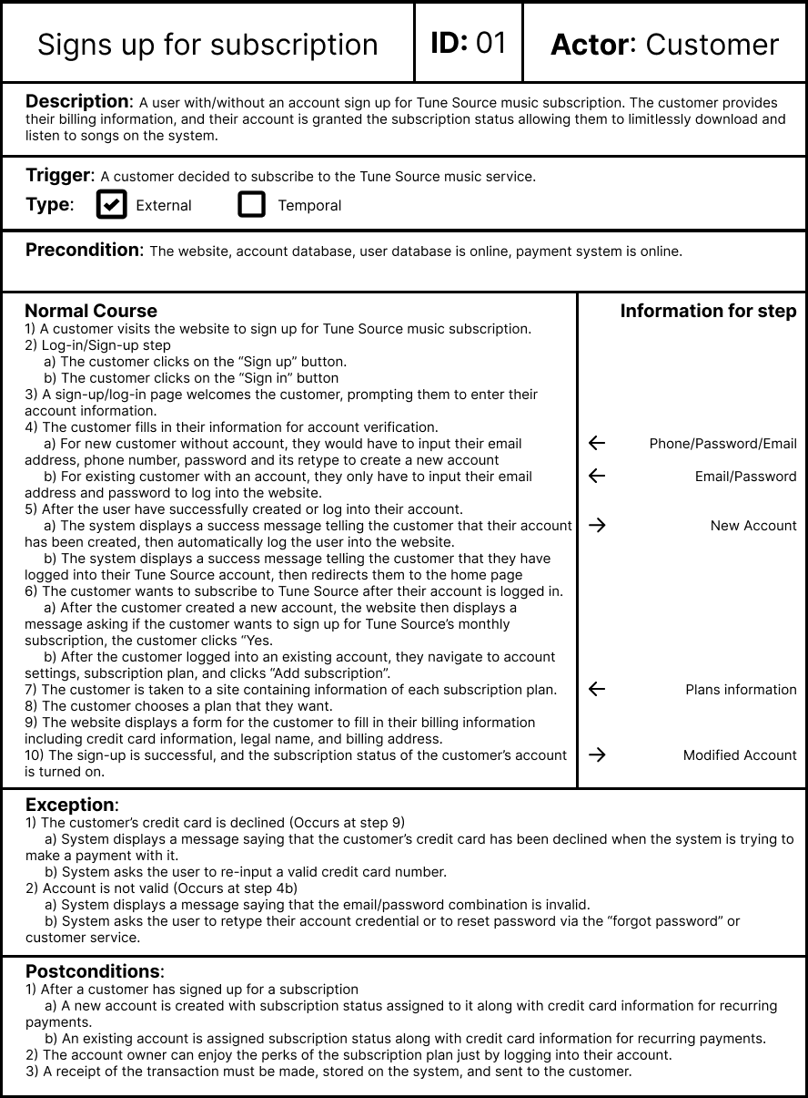

### Buys a gift card

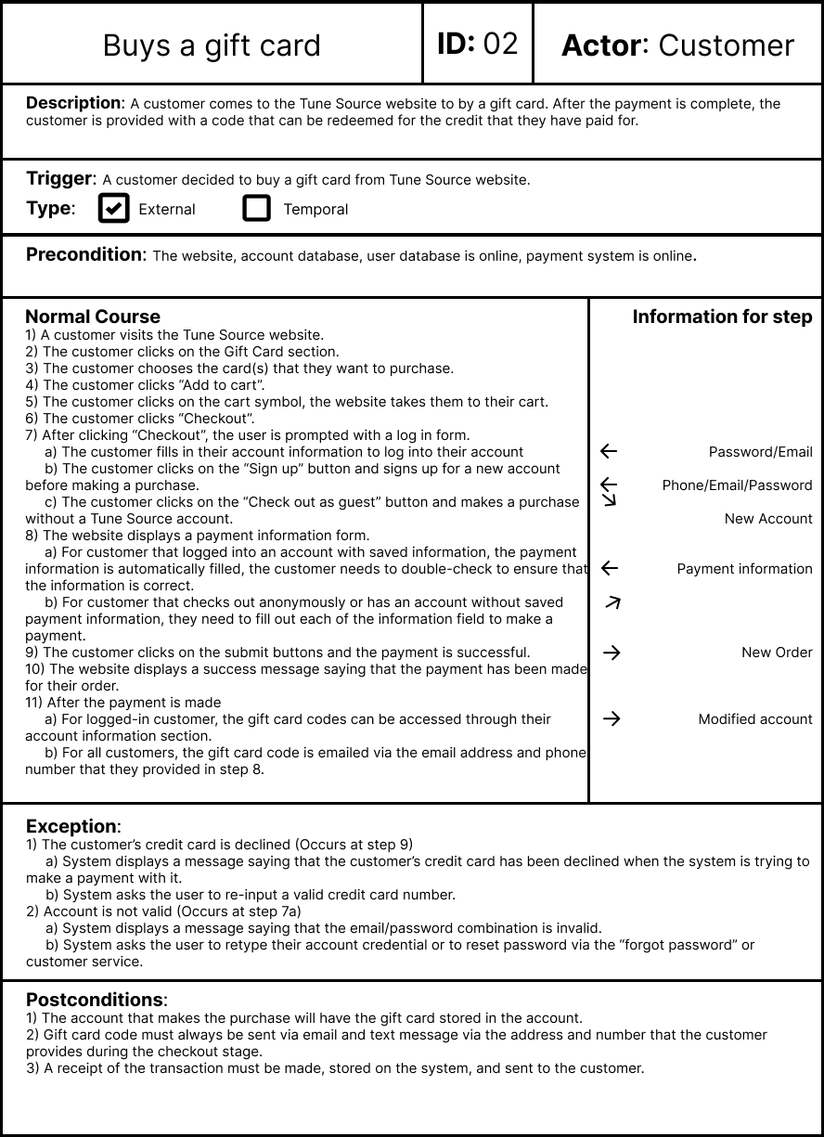

## Data flow diagram

### DFD 0

### DFD 1

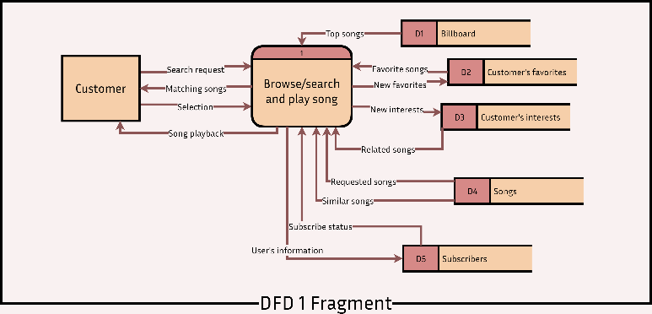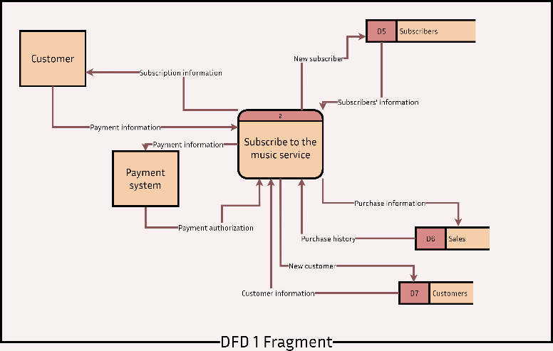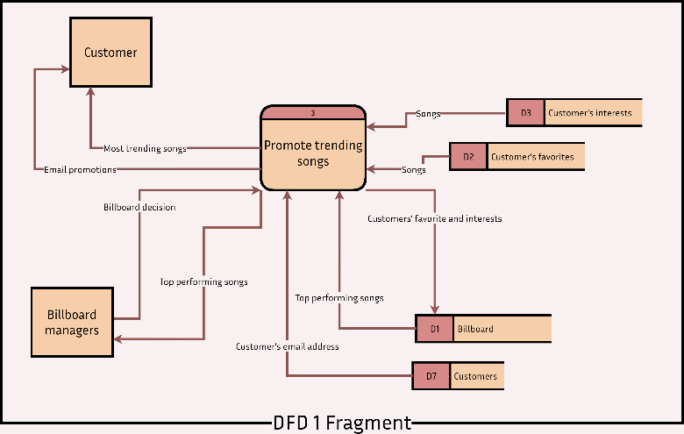

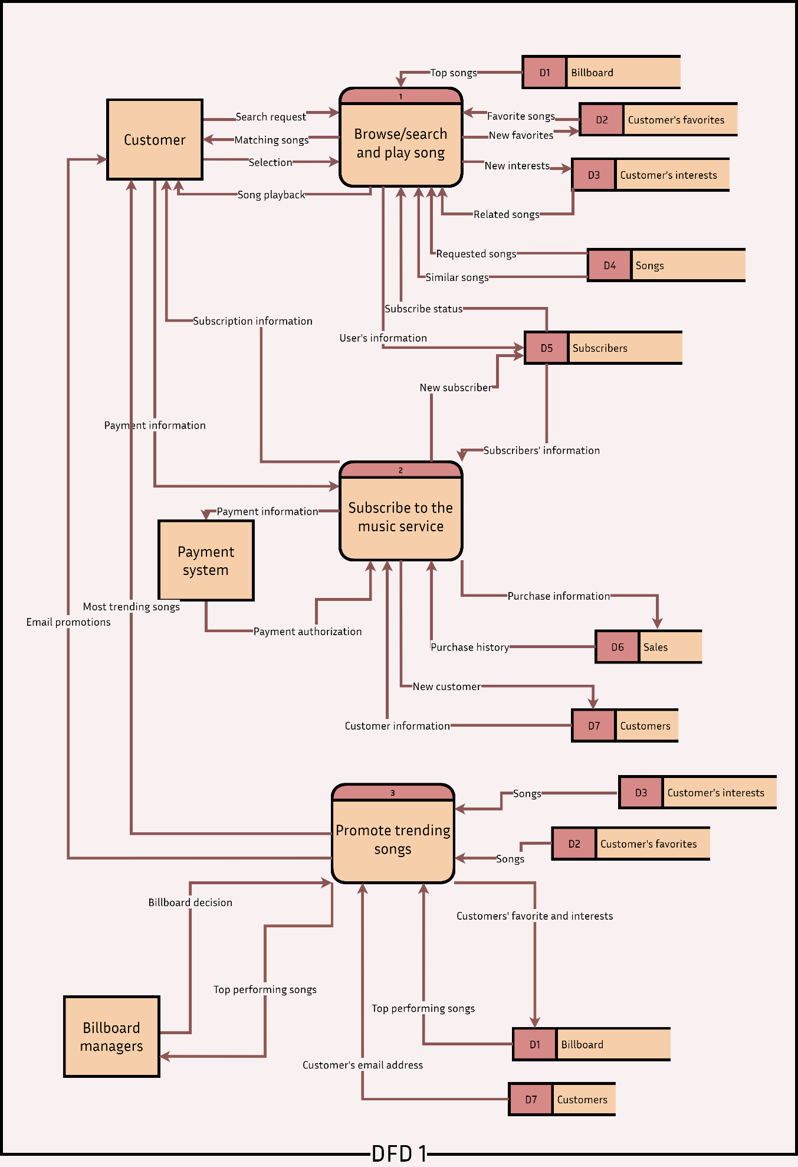

## Entity relationship diagram

## Flowchart

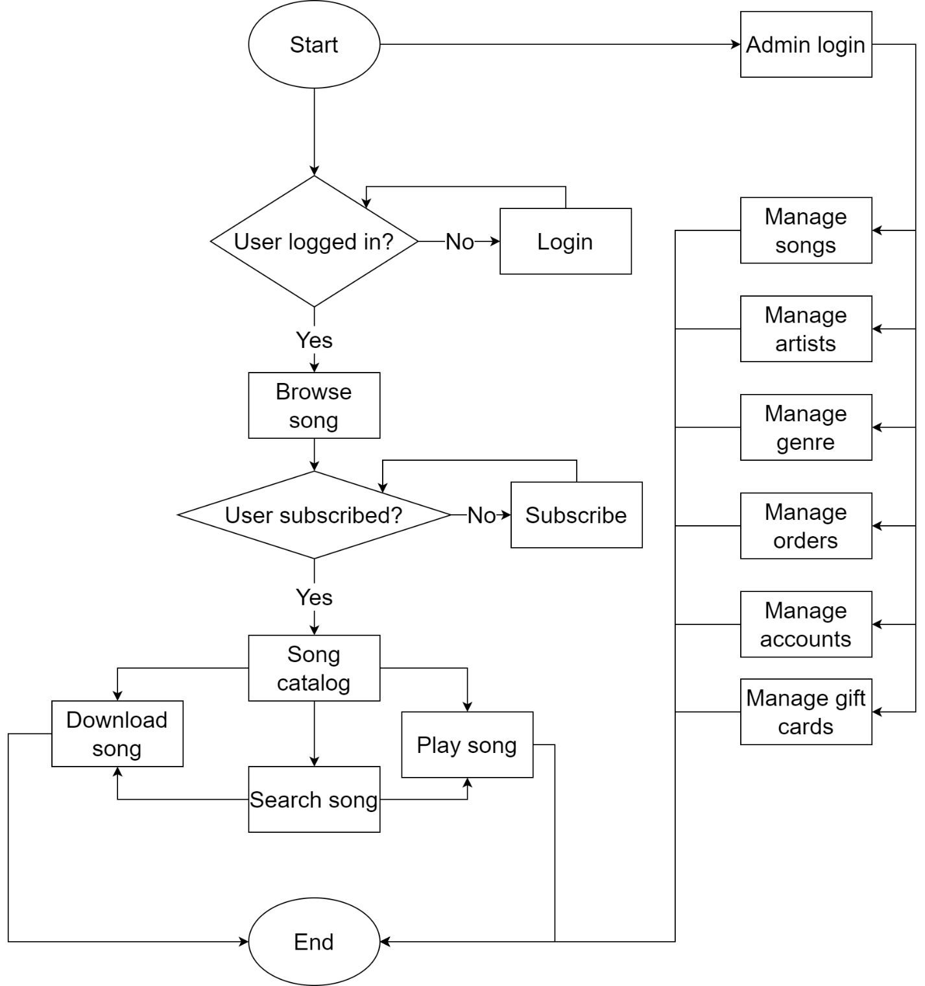

## Class diagram and activity diagram

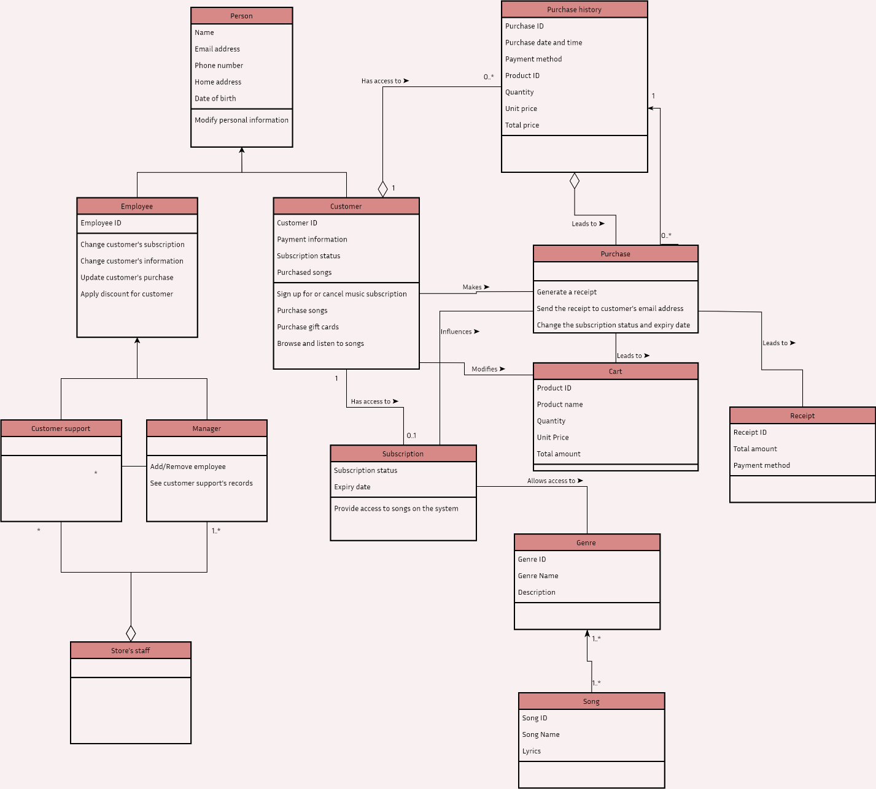

Figure Class diagram

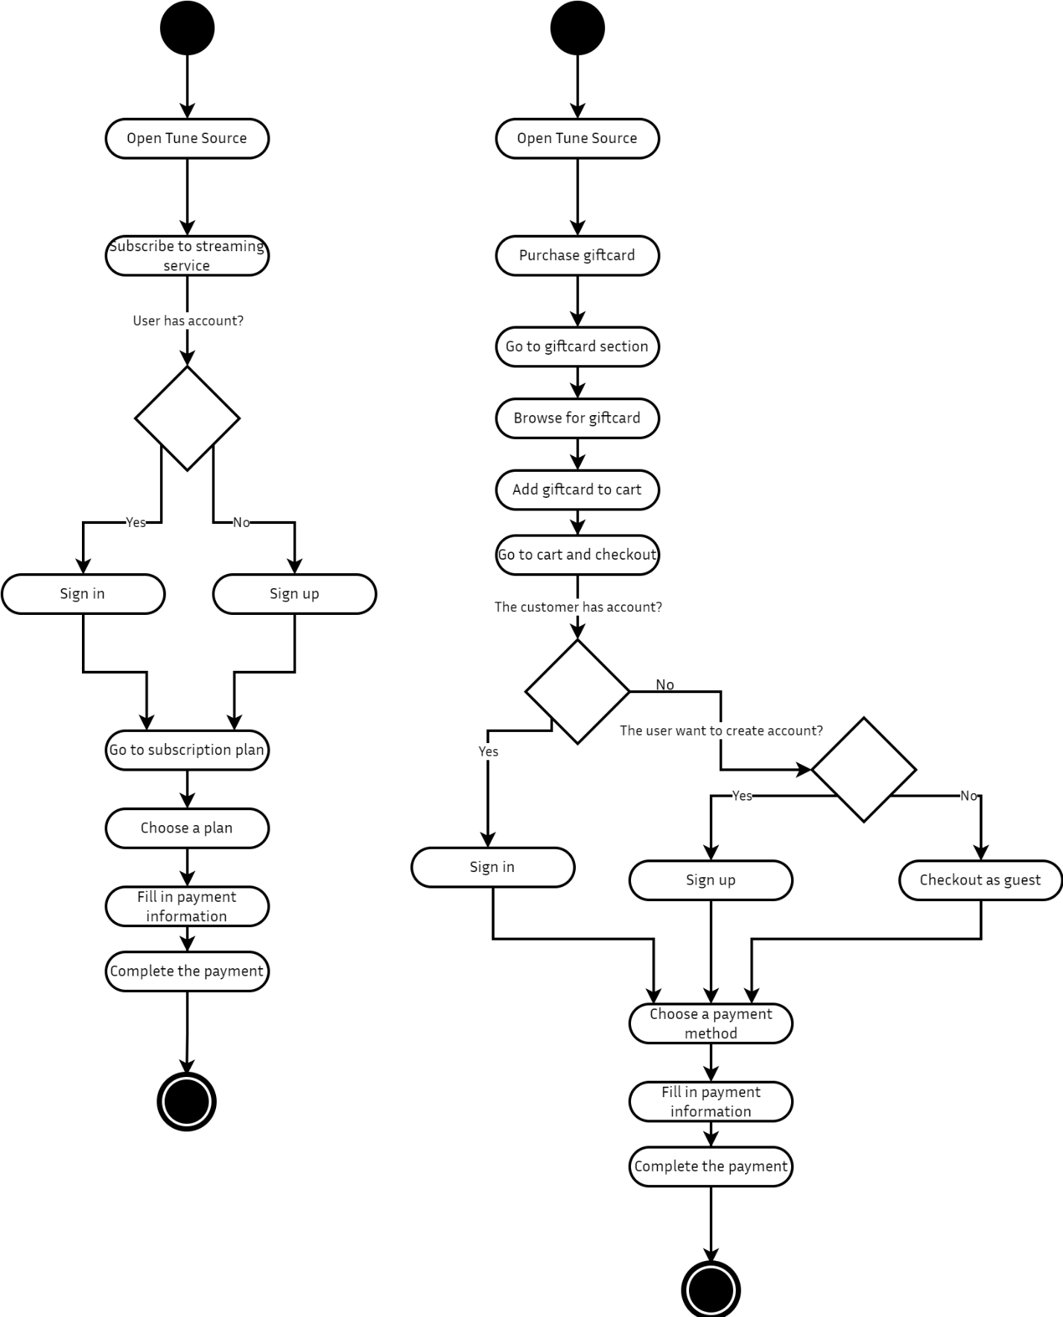

Figure Activity diagram

# Design

# References

Avendano, O., 2021 . *Joint Application Development (JAD).* [Online]   
Available at: https://www.toolshero.com/information-technology/joint-application-development/  
[Accessed 03 July 2022].

Lunalovegood, 2021. *Software Engineering | Requirements Elicitation.* [Online]   
Available at: https://www.geeksforgeeks.org/software-engineering-requirements-elicitation/  
[Accessed 03 July 2022].

Martin, M., 2022. *What is a Functional Requirement in Software Engineering? Specification, Types, Examples.* [Online]   
Available at: https://www.guru99.com/functional-requirement-specification-example.html  
[Accessed 03 July 2022].

Martin, M., 2022. *What is Non-Functional Requirement in Software Engineering? Types and Examples.* [Online]   
Available at: https://www.guru99.com/non-functional-requirement-type-example.html  
[Accessed 03 July 2022].

tutorialspoint, 2022. *Requirement Gathering Techniques.* [Online]   
Available at: https://www.tutorialspoint.com/business_analysis/business_analysis_requirement_gathering_techniques.htm  
[Accessed 03 July 2022].