**INTERNSHIP TRAINING REPORT**

**ON**

**“DIGITAL LEAVE APPLICATION”**

**(26th DECEMBER 2017-26st JANUARY 2018)**

**Submitted to**



**SOPRA STERIA INDIA PRIVATE LIMITED**

**SeaView Special Economic Zone,**

**Building 4,Plot 20 & 21, Sector 135,**

**NOIDA 201301(U.P)**

|  |  |  |
| --- | --- | --- |
| **Submitted by:**  Abhishek Garg  Dept. of Computer Science,  DIT University, Dehradun |  | **Under Guidance of:**  Deepti Khurana  Lead Engineer [Development] Sopra Steria, Noida |

# Digital Leave Application



**DLEAVE**

*APPLY LEAVES ANYTIME!*

### Acknowledgment

I feel immense pleasure in expressing my profound sense of reverence and gratitude to my supervisor **Mrs. DEEPTI KHURANA**, lead Engineer (development), Sopra Steria, Noida for her valuable and meticulous guidance, motivation constructive critics, constant inspiration and supervision throughout the course of study.

She had been my guide for the project, for her regular encouragement and guidance which has led me to complete the project with its present shape without such rendering to the project from her part, the result of my project would have been otherwise.

My thanks and appreciation also goes to the people who have willingly helped me out with their abilities.

**Abhishek Garg**

## **CERTIFICATE**

This is to certify that Abhishek Garg, Student of Bachelor of Technology from DIT University, Dehradun have successfully completed 1 month (From 26th December, 2017 to 26th January, 2018) long internship at this Organization/Company.

During the period of his internship program with us he had been exposed to different process was found punctual, hardworking andinquisitive. We wish him every success in his life and career.

Regards, Sopra Steria Group

---------------------------------

**(Signature of Authorized Person)**

## About Sopra Steria Group

Sopra Steria India is a part of Sopra Steria Company which is the group dedicated offshore delivery center and is based in Noida, India. The center is ISO 9001:2000 and ISO 27001:2005 certified.

Sopra Steria is headquartered in Paris, France with revenue size exceeding 1 billion and 13000+ employees' strength.

Founded in January 1968 by Pierre Pasquier, Leo Gantelet and François Odin, Sopra Steria is one of Europe’s longest established IT services companies. From the outset, Sopra Steria positioned itself in all of the IT services sectors and soon became a key player in the French market.

In 1990, Sopra Steria was successfully listed on the Paris Bourse. Prior to this initial public offering, a first share subscription option plan was set in place for the vast majority of employees. From that time on, Sopra Steria has maintained a balance between organic growth and growth through acquisition.

Sopra Steria, a European leader in digital transformation, provides one of the most comprehensive portfolios of end-to-end service offerings on the market: consulting, systems integration, software development, infrastructure management and business process services.

Sopra Steria’s clients belong to fortune 50 list companies, cover a wide range of domains andtechnology and are spread across continents - Europe & UK; including many world leaders and brands of international repute. Sopra Steria offers its clients an end to end approach based on a well-honed business mode. The Group's ambition is to allow its clients to focus on transformation projects that will give them a competitive edge and help them drive growth. The Group also pursues the worldwide deployment of its activities in both application integration and business process management through its subsidiary Axway, a leading provider of Business Interaction Networks, with a complete range of solutions and services.

Sopra Steria is trusted by leading private and public-sector organizations to deliver successful transformation programmes that address their most complex and critical business challenges. Combining high quality and performance services, added value and innovation, Sopra Steria enables its clients to make the best use of digital technology. With over 38,000 employees in more than 20 countries, Sopra Steria had revenue of €3.6 billion in 2015.

The primary business areas of Sopra Steria are: consulting services: strategic consulting, implementing of restructuring projects and development towards new technologies, etc.; systems integration and solutions: design and implementation of Internet technology solutions (portals, merchant sites, Intranet and Extranet networks, etc.), integration of ERP solutions, implementation of application solutions (customer relationship management, HR management, etc.). The group also offers subcontracting solutions for providing technical support to users and application maintenance; outsourcing services and operation of professional processes: supervision, administration and operation of IT infrastructures, operation of finance, administration, human resources functions, etc.

India is an Integral part of Sopra Steria’s global business strategy. We have a strong local presence in India with more than 5,000 people working across 4 delivery centers: Noida, Bangalore, Chennai and Pune.

The India operation serves more than 70 customers, including 8 of the Group’s top 10 clients Sopra Steria India’s proven offshore capabilities ensure superior value to its customers in terms of cost advantage, quality, speedy delivery and enhanced flexibility. In India, we offer a full spectrum of business solutions across a wide range of Industries to help solve customer’s complex industry challenges.

Sopra Steria in India has been successfully appraised for CMMi-L5 (Development and Service) and CMMi-L3; and is certified for ISO9001:2008, TickIT plus, ISO14001, ISO20000, ISO27001:2013 and EN9100.

**Table of Contents**

Overall Description:-……………………………………………………..

10

Product perspective: - …………………………………………………….

10

Project Category: - ………………………………………………………..

10

Tools / Platform Used: - …………………………………………………..

10

Product function: - ………………………………………………………...

11

User characteristics: -……………………………………………………..

12

General constraints: - ……………………………………………………..

12

Specific requirements: -……………………………………………………..

12

User interface: -……………………………………………………………

12

Hardware Interface: -………………………………………………………

12

Software Interface: - ……………………………………………………….

12

Introduction: -………………………………………………………………...

13

Objective of the project: -…………………………………………………….

13

Identification of need: ……………………………………………………..

15

Preliminary investigation: …………………………………………………

16

Request clarification: ……………………………………………………..

16

Request approval:…………………………………………………………

16

Technical feasibility: ....................................................................................

17

Economic feasibility:……………………………………………………..

17

Time feasibility: …………………………………………………………..

18

Purpose: ……………………………………………………………………

19

Objectives: ………………………………………………………………..

19

Preliminary investigation:…………………………………………………

20

System specification: ……………………………………………………..

20

Hardware requirements: …………………………………………………..

20

Software requirements: ……………………………………………………

20

Context DFD: ..............................................................................................

22

Modules: ......................................................................................................

22

Admin: .......................................................................................................

22

User Management: .......................................................................................

22

Employee: ................................................................................................

22

Apply for leave: ................................................................................................

22

Past Records: …………....................................................................................

22

Profile of the organization: ............................................................................

22

Manager……………………………………………………………….

22

Actions: .......................................................................................

22

Top Level DFD ……………………………………………………………..

23

DATA STRUCTURE ……………………………………………………..

24

Test Cases …………………………………………………………………

25

User Interface: ……………………………………………………………..

25

Functionality Check: ……………………………………………………..

26

Screenshot: …………………………………………………………..

28

Login- ………………………………………………………………..

28

Home page for employees………………………………………

29

Apply for leave…….…………………………………………….

30

Past Records…..………………………………………………….

32

Logout….…………………………………………………………

33

Home page for Manager……………………………………………

34

Notification…………………………………………………………

36

Conclusion………………………………………………………….

38

Bibliography …………………………………………………………

39

### ABSTRACT

Overall Description:

This app is designed such that the user can request leave or manage leave requests from a mobile device while on the go. User can request leaves by filling in an intuitive leave application form with notes and submit them to their manager. The manager can in turn check the requestor’s leave balance and approve / reject the leave. The requestor gets to see the approver’s decision.  
Now the user can view the number of leaves remaining of an employee and simultaneously approve or reject a leave request that have been made to the user. The manager can also apply leave for himself. All this from your mobile device anytime, anywhere.  
Company admins can manage their users as well as customize the application using an admin panel. You will need a corporate user account to use this app effectively.  
General App Features:  
• Request Leaves with effortless ease through your hand held mobile devices.  
• View your leave requests  
• Works perfectly in your smart phone as well as your tablets.  
• Company admin has a customized admin panel to set controls the behavior of the application and manage the users.

#### Product perspective: -

This is totally self-contained and works efficiently. It provides simple database rather than complex ones for high requirements and it provides good and easy graphical user interface for new as well as experienced users of the mobile so that they can do their work without any problem.

#### Project Category: -

• An Android Based Application using DBMS technology for database, to manage and apply for leaves digitally.

#### Tools / Platform Used: -

•**Front End:**

Android Studio,XML

•**Backend:**

Web-hosting,Php,MySql,Java.

#### Product function: -

The product functions will include the following areas:

* User login into the application by entering the user name & password.

After successful login the Default page(Home) for User appears.

* User can apply for a new leave by filling the application and simultaneously a notification goes to their respective manager.
* User can also see their past records and leaves applied in past.
* User gets a notification when manager takes any action on their leave application.
* Manager also login into the application by entering username and password and gets to Home page where he can see new leave applications of employees working under him.
* Manager can allow/deny their applications.
* Manager can himself apply for leaves and see his past records.
* Admin can add a new employee and edit their details.
* Admin can also see the report of the organization.
* Admin can see the list of all employees and all leaves applied by them.

The application is capable enough to apply leaves digitally from internet connectivity and simultaneously send notifications and also perform some editing for data that is added in database. It will be having user friendly GUI’s that will guide the user to easily achieve the same.

#### User characteristics: -

* No pre knowledge of Android,Java ,Xml, Php.
* No pre knowledge of database management.
* Should be able to do according to the graphical user interface.

#### General constraints: -

This application works well in Android devices with minimum API of 23 and android version 6.0.

Specific requirements: -

#### User interface: -

The application provides good graphical interface for the front end of the database so that new users can make use of the device application with ease and interest.

#### Hardware Interface: -

The system should have these hardware requirements:

* The processor should contain Android 6.0 Marshmallow.
* The processor should be greater than 1GHz.
* The API version of device should be minimum 23.
* Internet connectivity.

#### Software Interface: -

The software requires the support of the following software for the database and other requirements.

* Java platform.
* Access to SQL server.

### Chapter 1 INTRODUCTION

Introduction: -

The Digital Leave application **“DLeave”** is made for easy managing of the leave applications. It is useful for manager and employees as well.

It is an Android application to automate each and every activity considering leave, such as applying for a leave, keeping a track of past records, rejecting or granting leave permission, giving details about taking leave etc. and reduce the time and effort of managing them manually.

It is very sophisticated work to manage the leave application of each and every employee. To get any information about the leave information one need to go through a lot of files. For example, if manager or anyone else want to know about the information of the leave, or any details about a particular employee’s leave so he/she has to see different files concerned with that information. To accomplish all these thing one need a lot of time. Sometimes he/she did not get the needed information. So with the help of this application anyone can know almost all information regarding a user’s leave.

Objective of the project:

The objective of the project is to develop an android application, which will computerize Work related to the leave requests in an organization. It is difficult to maintain all the records manually which is related to the leaves of the employee and manager. This project is an Android application that maintains all the work which is related to the leave and make it easy to use by employees and authorized persons by just creating an account.

The application is strong enough to withstand regressive daily operations under conditions where the database is maintained.The implementation of the application in the organization will considerably reduce data entry, time and also provide notifications.

The following tasks can be performed by using this application:

* Applying for a leave
* Getting a notification for a new leave request
* Keeping a track of past leave records
* Granting or denying leave
* Getting a notification about the status of the leave request

**Chapter 2**

**SYSTEM ANALYSIS**

System analysis is the most important part of the phase of any project. During this phase, we analyze the entire thing we are going to do. We search the answers of the questions like:

* What have to do?
* How it would be done?
* Why these are needed?

During this project development, I have analyzed the entire thing very seriously. First I have identified the need. I just find the fact that why organization require such application Answer of this question helped me to study further things.

Identification of need:

Sopra Steria needs an android leave application because :-

* 1. They need an application that should help them to manage all the information about the leave requests stored in a proper way.
  2. They need to have the less human effort.
  3. In today’s scenario everything is digitalized and it makes our work easy.

As, we have already said, D Leave, manages all the information about the leave. It is very sophisticated work for management. To get any information they need to go through a lot of files. For example, if they want to know the information about the leave for employees and manager or both, so they have to see different files concerned with the information of store. To accomplish all these thing one need a lot of time. Sometimes they did not get the needed information. After this automated system, they don’t need to go through several file. They just have to click a button of mobile phone. For example, to see the leave report of a festival season, they just click a button on mobile screen. After they have click a button they will get all the information which will be very useful in making decision for the future plan.In proposed system chances of losing data is not possible because data is maintained in the form of database.

Preliminary investigation:

Preliminary investigation is another aspect of analysis.

Here I don’t have idea that what have to do and how it has been done?

In this project, I have done preliminary investigation very seriously. I have categorized this investigation in two phases as: -

* Request clarification
* Request approval

Request clarification:

I wanted to know whatever the problem they were facing with the manual system presently they have in their organization. I also wanted to know what type of system they want which will fulfill all their demands, what new feature they want to be present the proposed system etc.

Request approval:

After request clarification, it was the time of approving it. As I have met several people of concerned system of different level of organization, I got different type of request that were inconsistent and contradictory somehow. I just study it. I got all the request could not be approved. So I choose those requests that were consistent and were able to accomplish complete objective of the proposed system.

Now, after clarified the request, I have approved those were consistent and thus complete preliminary investigation gave me the information by which I became sure that I have to make such a system.

**Chapter 3**

### FEASIBLITY STUDY

Feasibility study is an important aspect of system analysis. It tell us if the proposed project is feasible for the concern organization or not. To be feasible system, we must be suited in all way to the organization. For example, if project give such as system, to the management that is not suited by the users then we cannot be considered as a feasible project. In addition, system requires such as infrastructure that is not available those resources, and then system would be treated as an unfeasible system.

In the proposed project feasibility study has been done in very well manner. It will provide a system that will be feasible in all manners. System is following all the feasibility like: -

* Technical feasibility,
* Economic feasibility,
* Time feasibility.

Now, I am describing all these feasibility study done by one by one.

Technical feasibility:

Proposed system will give an application that won’t require too much infrastructure. In addition, they have multiple persons that won’t have any trouble to use the system. Proposed project gave a system that is very simple to use by all the users for example, writing reasons for the leave, checking the past records, denying or granting leave to the employee etc. A basic overview of the application should be provided to the users for the matter of understanding how it works. Thus I can say system provided by the proposed project is technical feasible.

Economic feasibility:

Proposed project is economically feasible. As I have already discussed leave management do not need additional costly resources to use this application, they won’t have any expenses. In addition they do not require additional charges for the explanation of the application’s working mechanism. These are the advantages that make project economic feasible.

Time feasibility:

Time feasibility means proposed project must be completed under the time frame given. Provided output of the project must compatible to the present era. Proposed project is made in pre bound time frame. In addition, application (output of this project) is best compatible for the organization’s leave management in the present era. It will keep them at a better position.

**Chapter 4**

**SYSTEM REQUIRMENT**

### SPECIFICATION

A Software requirements specification (SRS), a requirements specification for a software system, is a description of the behavior of a system to be developed and may include a set of use cases that describe interactions the users will have with the software. In addition, it also contains nonfunctional requirements. Non-functional requirements impose constraints on the design or implementation. SRS is the document that completely describes what the proposed software should do without describing how the software will do it. The basic purpose of SRS is to bridge the communication gap between the parties involved in the development of the software. SRS is a medium through which the client and the user needs are accurately specified. A good SRS should satisfy all the parties – something very hard to achieve and involves trade-offs and persuasion.

Another important purpose of developing an SRS is helping the user to understand their own needs.

The main advantage of SRS is

* It establishes the basis of agreement between the client and the supplier on what the software product will do.
* It provides a reference for validation of the final product

Purpose:

The purpose of SRS is to describe the external requirement of project.

The main purpose is to translate the ideas in the mind of client into a formal document. SRS is the medium through which the client and user needs are accurately specified tothe developer. Through SRS, the client clearly describes what it expects from the proposed system and the developer clearly understands what capabilities to build inthe software. SRS helps the client determine if the software meets the requirements. The purpose of this documentation is to provide description of the new module “D LEAVE” to be made, the document will analyze how the new application should behave, and how new application should be implemented.

Objectives:

The primary objectives of testing during requirement phase are to:

* Determine that the requirements fairly represent what the user needs
* Determine that the needs have been defined and documented
* Verify that cost/benefit study has been performed and is reasonable

Preliminary investigation:

Software requirement specification produced at the top of analysis task. The function and performance allocated to the software as part of system engineering are refined by established a complete information description, a detailed functional description, a representation of system interface; validation criteria and some other information are required.

System specification:

Hardware requirements:

* A smartphone with Android mobile operating system of at least version6.0

Software requirements:

* Marshmallow
* Must have SQL Server Connectivity
* A Good Internet Connection

### Chapter 5

### SYSTEM DESIGN

Design is a meaningful engineering representation of something that is to be built. It can be traced to a customer’s requirement and at the same time accessed for quality against a set of predefined criteria for a “Good” design. In the software engineering context design focuses on four major areas of concern: - data, architecture, interface and components. In system design part true, module description and process login is given. These things are given below one by one: -

* **Data flow diagram**
* **Data structure**

**D LEAVE**

**Data Flow Diagram**

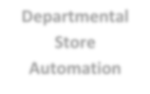

**Employee**



**Admin**



**Manager**

Context DFD

Modules:

The system will have the following modules: -

Admin:

User Management:

Admin will maintain all the employee login details, employee leave record details, assigns managers to the employees,manager leave record in the database.

Employee:

Apply for leave:

The employee can apply for a new leave request to his corresponding manager. A maximum limit will also be shown to them if the leave requests exceeds 10 in number.

Past Records:

They also can check or keep a track of their previous leave applications.

Profile of the organization:

An employee can also view information about the organization.

#### Manager:

Actions:

The manager is responsible to manage all the leave requests of the organization. They will notify when a leave is granted or denied. They can also apply leave request on their own to their corresponding managers. A maximum limit will also be shown to them if the leave requests exceeds 10 in number.

Top Level DFD

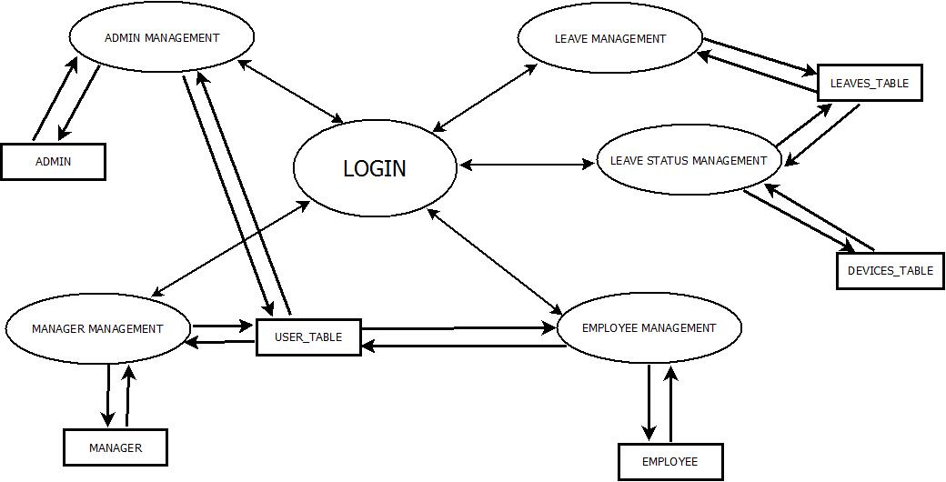

**Data Flow Diagram-TOP LEVEL**

DATA STRUCTURE

There are basically 3 tables in the project.

1. Leaves_table
2. Users_table
3. Devices_table

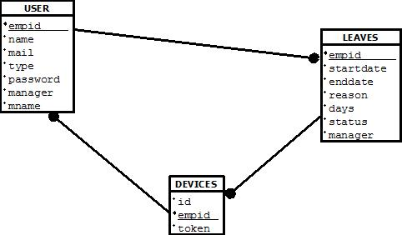

**DATA STRUCTURE**

Test Cases

User Interface:

|  |  |
| --- | --- |
| **Condition Being Tested** | **Expected Result** |
| Display member login page | Displays **Username** and **Password** text boxes. |
| Organization Details | Page displaying information the organization: |
| Past Records Page | Displays the list of all previous leave requests with the corresponding status |
| Leave apply Page | Page displaying information for applying leave:   * *Start date* * *End date* * *Number of days* * *Reason for leave* * *Proceed to submit* |
| Logout | Displays a dialog box to logout of the application |
| Manager home page | Displays actions to be performed   * *Grant leave* * *Deny leave*   Option to see new and old leave records |

**DATA STRUCTURE**

Functionality Check:

* 1. Login Page

|  |  |  |
| --- | --- | --- |
| **Condition being tested** | **Username /**  **Password** | **Expected Result** |
| Blank User ID with blank password | Empty string / Empty string | Please enter complete details |
| invalid User ID with valid password | empty string / “mypass” | Login page displays text string “Error! User not Registered.” |
| Valid user ID and invalid password | “test”/ Empty string | Login page displays text string “Error! User not Registered.” |
| valid User ID with valid password | “test” / “mypass” | Device registered Successfully |

**User Interface**

* 1. Employee Profile

|  |  |  |
| --- | --- | --- |
| **Condition being tested** | **Fields** | **Expected Result** |
| Blank Start Date | Empty string | Fill complete details |
| Blank End Date | Empty string | Fill complete details |
| Blank Number of Days | Empty string | Fill complete details |
| Blank Reason for Leave | Empty string | Fill complete details |
| Valid details | “sdate”  “edate”  “days”  “reason” | Applied successfully. Keep checking for approval. |
| Past records | No_records | No data found |

**Employee Interface**

* 1. Manager Profile

|  |  |  |
| --- | --- | --- |
| **Condition being tested** | **Fields** | **Expected Result** |
| Allow/Deny | Radio_button marked | Updated |
| Blank Start Date | Empty string | Fill complete details |
| Blank End Date | Empty string | Fill complete details |
| Blank Number of Days | Empty string | Fill complete details |
| Blank Reason for Leave | Empty string | Fill complete details |
| Valid details | “sdate”  “edate”  “days”  “reason” | Applied successfully. Keep checking for approval. |
| Past records | No_records | No data found |

**Manager Profile**

### Chapter 6

### SOFTWARE Pages

Screenshot:

#### 1. Login-

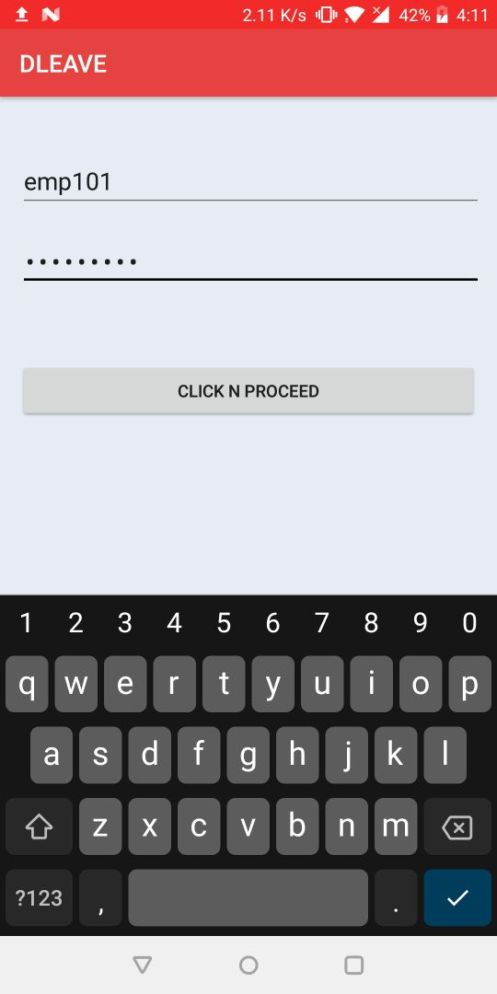

**(This is the login page where each type of user can login to their account)**

#### 2.Home Page for Employee

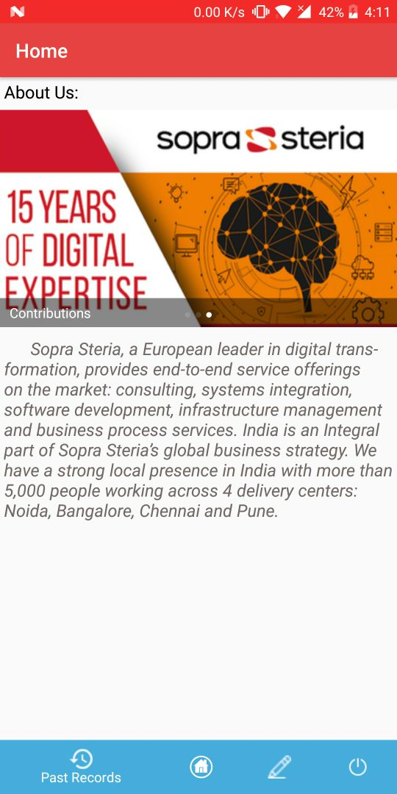

**(This is the Home page of the application which shows the various functionality)**

#### 3.Apply for Leave

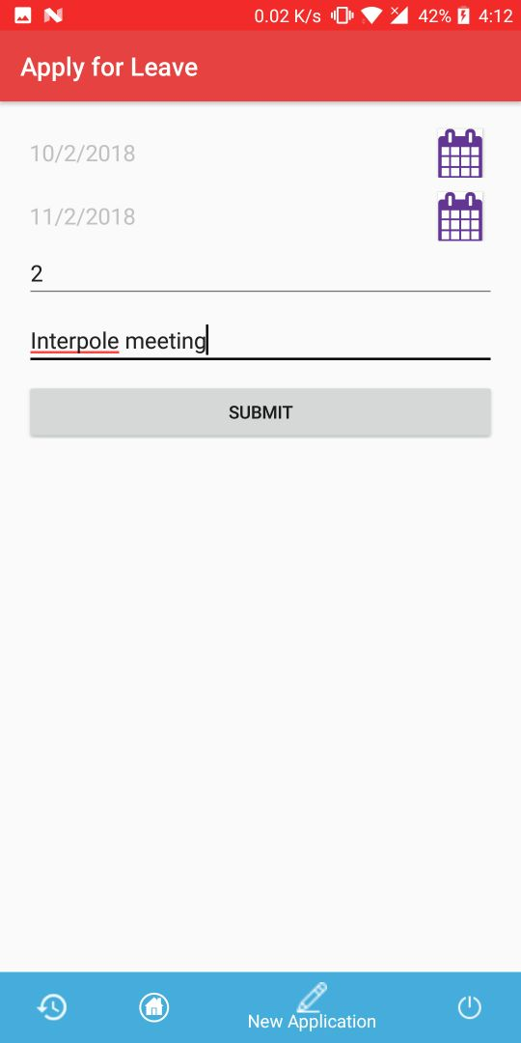

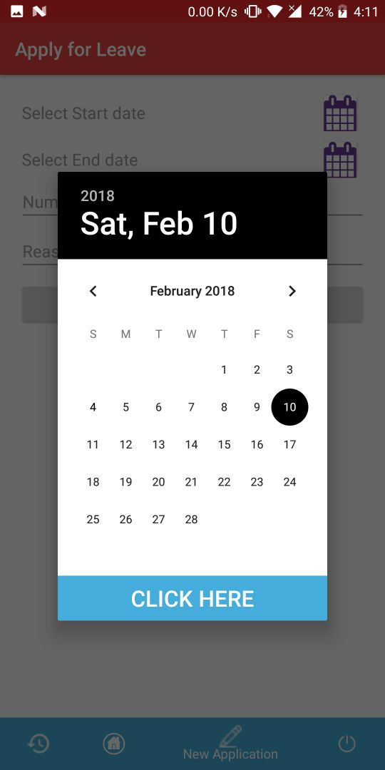

**(This is the Apply leave page where user can apply for leave.)**

#### Past Records

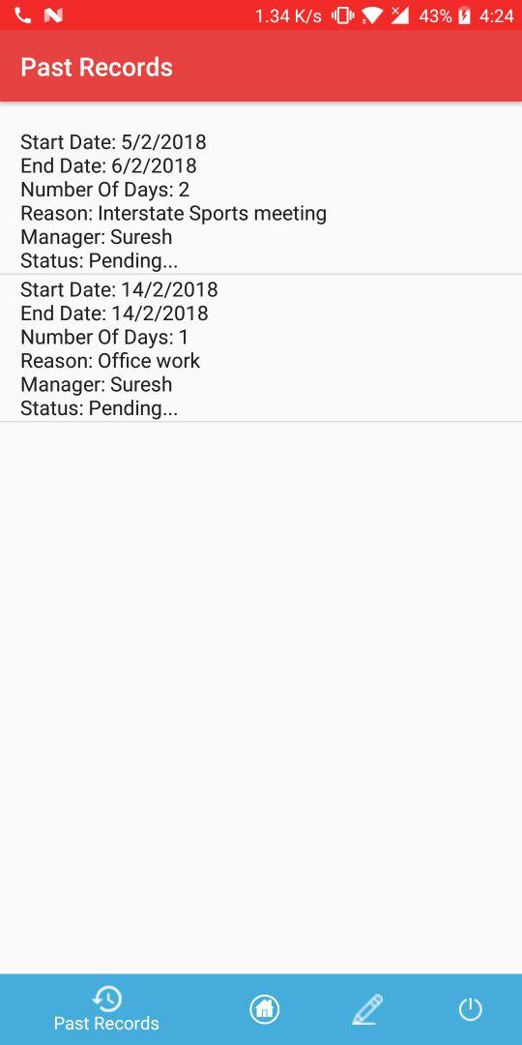

**(This page will show the leave status by displaying all information)**

#### Logout

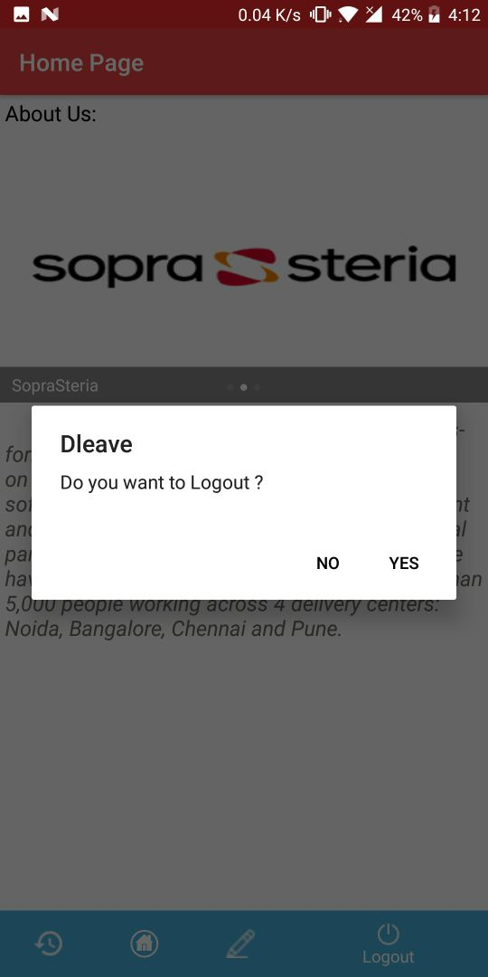

**(This displays logout confirmation dialog box)**

#### Home Page for Manager

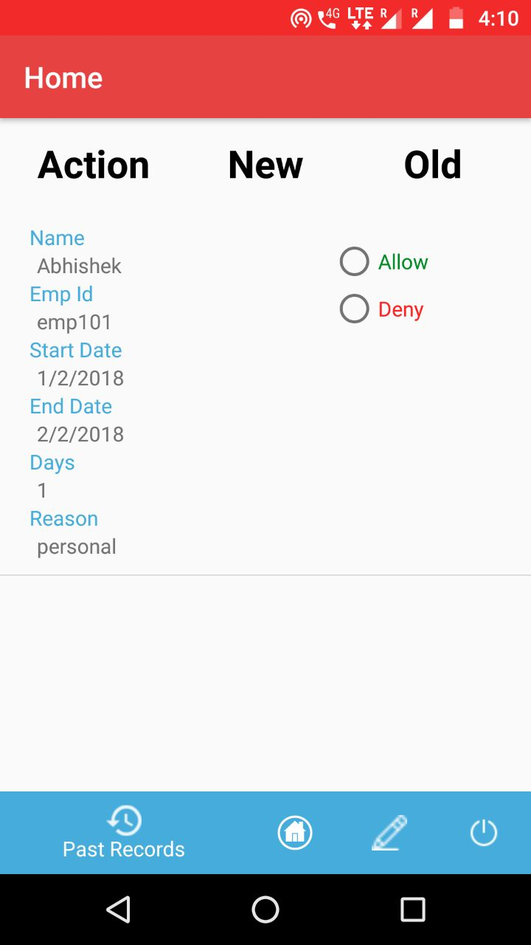

**(On this page the user can add the item and Set the quantity in stock as well as in the shelf.)**

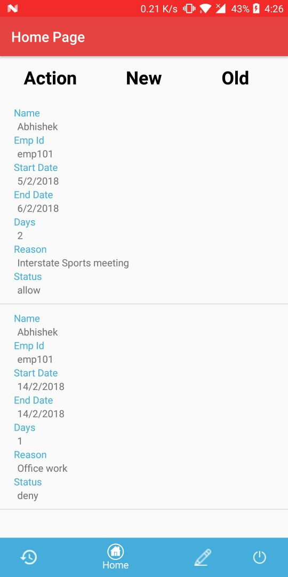

**(This page will show all the items currently in the inventory.)**

#### Notification

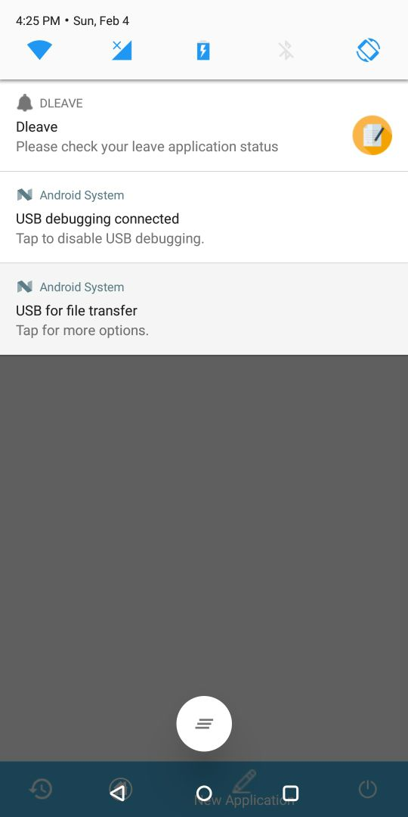

**(This notifies the employees to view the status for a leave request)**

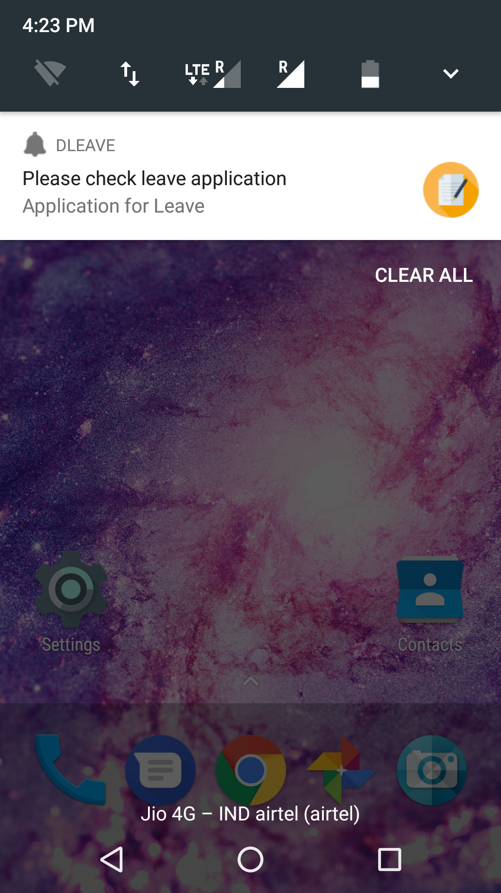

**(This notifies the manager to take action for a leave request)**

**Conclusion**

DLEAVE APPLICATION IS VERY USEFUL AS:

* User can request leaves by filling in an intuitive leave application form with notes and submit them to their manager.
* The manager can in turn check the requestor’s leave balance and approve / reject the leave.
* The requestor gets to see the approver’s decision.
* The user can view the number of leaves remaining of an employee and simultaneously approve or reject a leave request that have been made to the user. The manager can also apply leave for himself.

**Bibliography**

To Develop this “**D LEAVE**” I used:

* Android Studio as Front End
* SQL server 2008 as Back End (Database)

I take some knowledge towards automation system from some books/sites that are given below.

* Head First Android Development
* GitHub
* And of course my Project Guide.