Manual for FOCUS
Table of Contents
Client 3
Running the application 3
Logging in 3
Uploading File 4
Sending message 4
Instructor 5
Running the Web Application 5
Opening the Web Application 5
Logging In 6
Viewing the Feeds Page 6
Controlling the Student’s Computer (VNC Control) 7
Shutdown, Lock, Log Off a student’s computer and View Process List 7
Shutdown All or Lock All Computers 8
Share File 8
Chat 8
View Attendance Records 8
View Submissions 8
Download Submitted File 8
View Logs 9
Mobile (Android) 10
Opening the application 10
Shutdown All, Lock All, and Unlock all 11
Viewing a student 11
Shutdown, Lock/Unlock, Logoff a specific student 12

Client

Running the application
To run the client, execute run.sh inside out32 or out64 folder depending on the architecture of the system. The script should be run as root.

Logging in
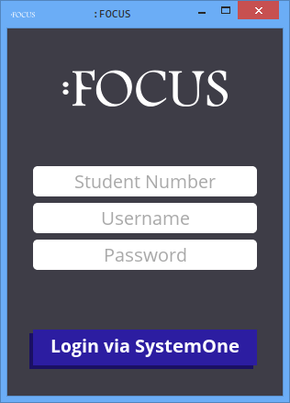

This is the main window for the client of FOCUS. Use this to communicate with the server. Input the following to login to FOCUS:
- Student Number in this format YYYY-XXXXX
- SystemOne Username
- SystemOne Password

Uploading File
To upload a file, drag and drop the message to the text area of the client. Multiple files can be uploaded by the user. You will get a notification in the field area that you successfully uploaded your file(s).

Sending message
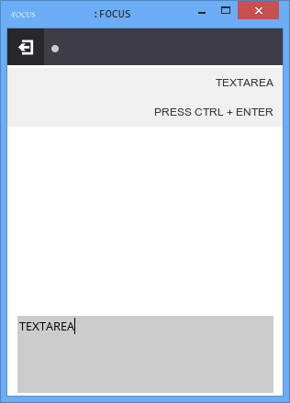
To send a message to the instructor, type your message inside the text area and then hit Ctrl + Enter. Your messages and the instructor's messages to you will appear at the field area.
Log out
Button
Log out
Button
Field Area
Field Area
Text
Area
Text
Area

Instructor

Running the Web Application
To run the web application, you will need node.js, npm and mongodb.
$ sudo apt-get install nodejs npm mongodb
After installing the packages, go to the server folder inside focus then execute:
$ npm install
This will install all the dependencies of the focus client. After finishing the installation, execute:
$ npm start
This will start the server.

Opening the Web Application
To go to the web application, just open a browser pointing to the server’s IP and port 8080. Example: http://10.0.5.49:8080. The login page should show up.

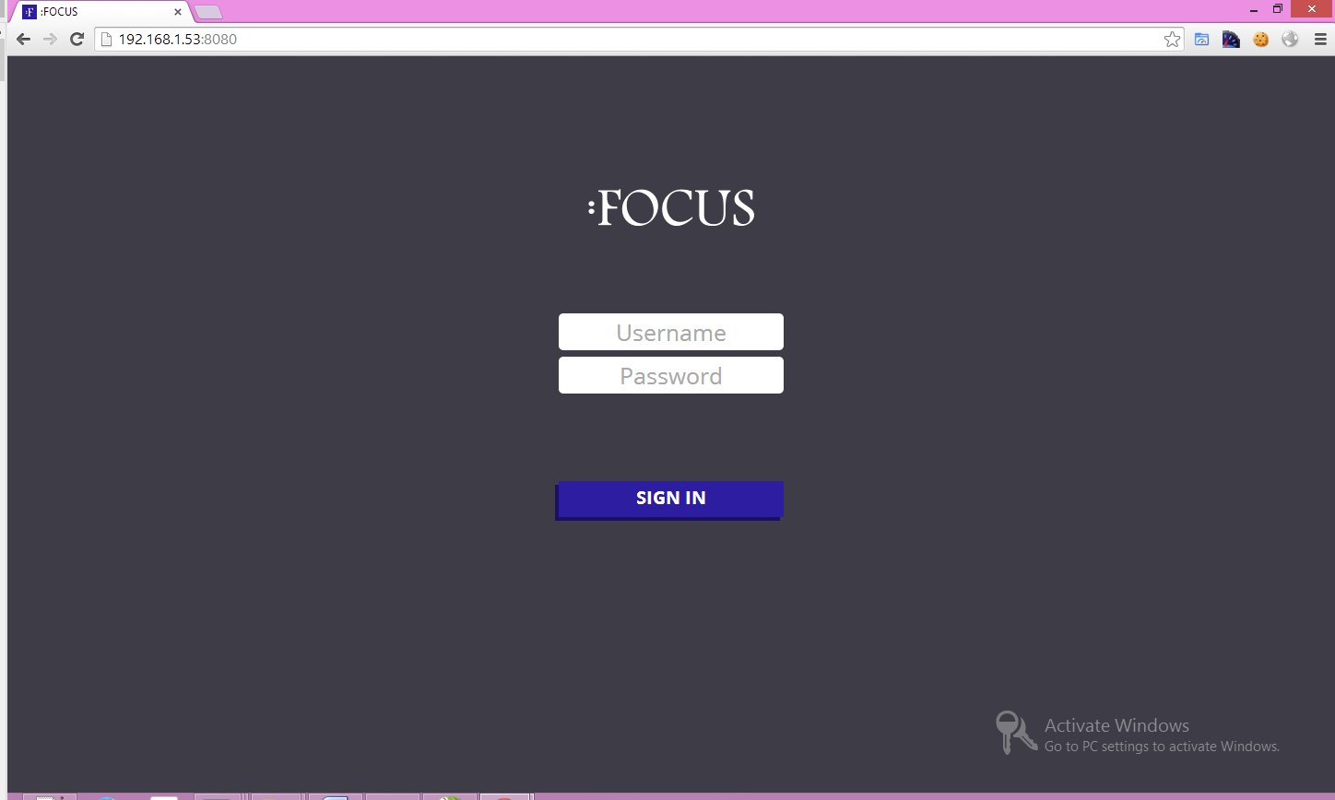

Logging In
Enter your username and password on the form then click the Login button. The button will turn to red if you entered an incorrect username or password.
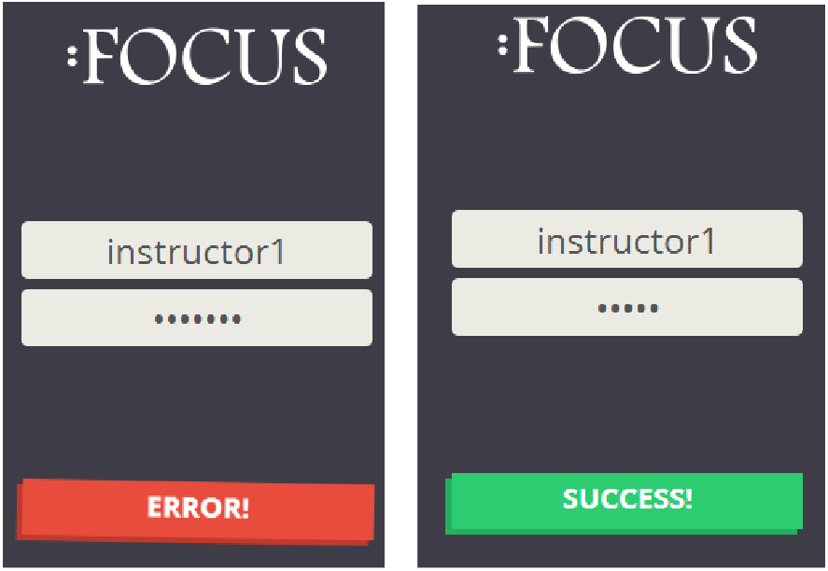

Viewing the Feeds Page
The Feeds page can only be viewed if you have a current class at the moment. By default, after a successful login, the application should take you to the Feeds page. You can also click the Feed icon on the menu on the left in case you are on a different page. The Feeds page contains the screenshot of every logged in student together with its mood and more features like chat.
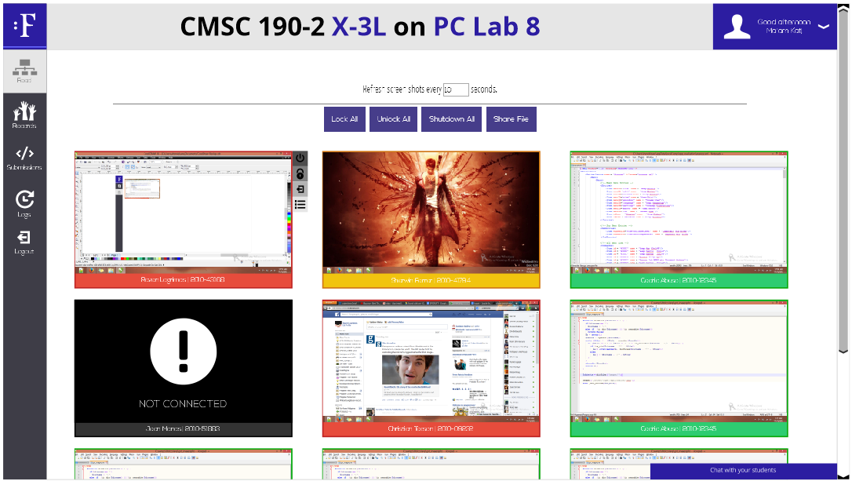
There are three different moods:
- Off Task – Color Pomegrenate (Red-ish) - the user is not hitting the keyboard.
- Idle/Confused – Color Sunflower (Yellow-ish) – the user is moderately hitting the keyboard
- Active – Color Emerald (Green-ish) – the user is actively hitting the keyboard
*Moods change every 20 seconds.
You can also change the refresh interval of the screenshots. The lowest is 3 seconds and there is no maximum.

Controlling the Student’s Computer (VNC Control)
To control the student’s computer using VNC, simply click the student’s window on the Feed page.

Shutdown, Lock, Log Off a student’s computer and View Process List
When you hover on the student’s screenshot, 4 buttons will show up on the right side of the window. The first one is the shutdown button, next is the lock button, followed by the logout button and finally the View Process List button. Shutdown button sends a signal to the student’s computer to shut down the computer. Lock button, when clicked, disables the student’s mouse and keyboard and shows a lock screen. Logout button sends a signal to log out the computer. Finally, the View Process List button shows a list of processes with a window on the half of the screen.
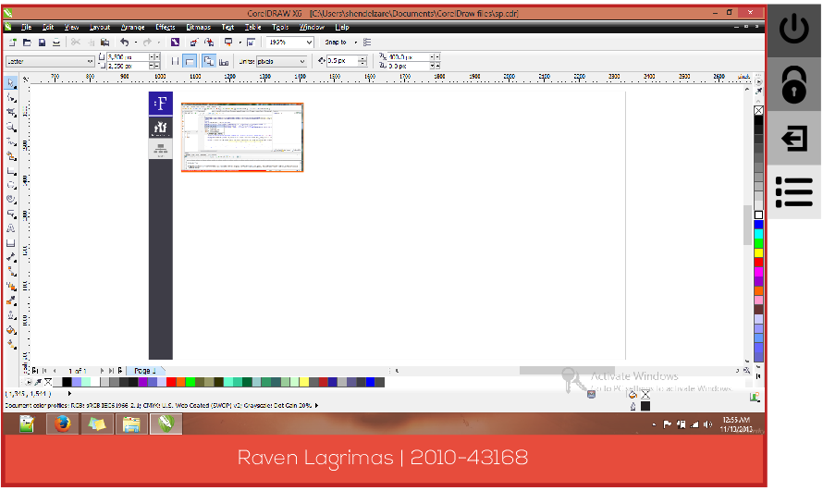

Shutdown All or Lock All Computers
To shut down all or lock all computers, simply click the corresponding button located at the top of the screenshots.

Share File
To share a file, click the Share File button then choose the file you want to share then confirm. The file will be copied to the every student’s Desktop folder.

Chat
To use the chat feature, simply click the bar at the bottom right of the screen saying “Chat with your students”. To send a chat message, type your message on the text area then hit Ctrl + Enter. You can broadcast your chat message to everyone by choosing “All” on the “send to” list. Student’s messages will be automatically pushed on the chat history.

View Attendance Records
Navigate to Records page by clicking the Records icon on the menu. You can view the student’s attendance and their total number of absences. Attendance is recorded once they logged in on the desktop application.

View Submissions
To view submissions, navigate to Submissions page by clicking the Submission icon on the menu. You can filter the submissions by section, exercise number and by student. If the student submitted a two or more files with the same name, the files will have their own corresponding version. Exercise number filter is based on the file name. Example: if the files are filtered by exercise number 1, only files with ‘exer1’ on the file name will be shown.

Download Submitted File
Simply click the file you want to start downloading.

View Logs
To view logs, navigate to Logs page by clicking the Logs icon on the menu. You can filter logs by date and by student number.

Mobile (Android)

Opening the application
Install the application by using the focus.apk file. Wait for the installation to finish, Then open
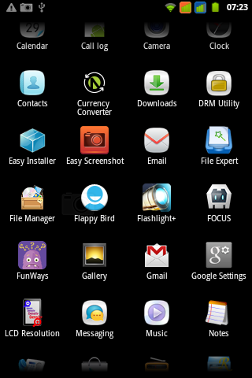

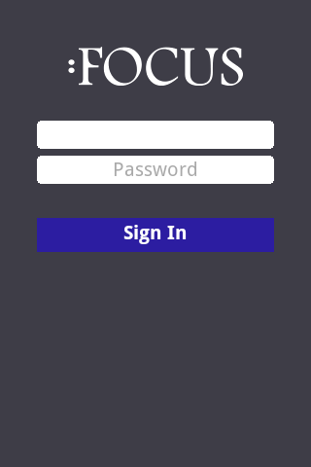

Enter username and password of the instructor.

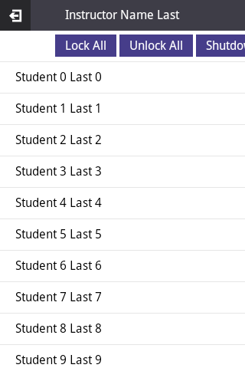

Students

Shutdown All, Lock All, and Unlock all
Use the buttons to shutdown, lock or unlock all computers of the students who are logged in.

Viewing a student
View the student information by touching the student name. In this manual, the students are named Student 1 Last 1, Student 2 Last 2 and so on.
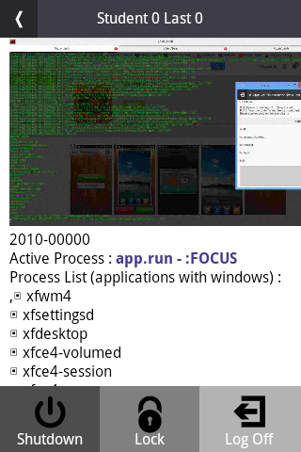
Student
Name
Back

Screenshot

Student Number
Active
Process

Process List

Shutdown, Lock/Unlock, Logoff a specific student
After selecting the student, the image above will show. This is where the instructor can issue commands to the specific computer. Use the buttons on the bottom of the display to issue shutdown, lock/unlock and logoff to the specific computer.

