Manual for FOCUS
Table of Contents
Client 3
Running the application 3
Logging in 3
Uploading File 4
Sending message 4
Instructor 5
Mobile 5

Client

Running the application

To run the client, execute run.sh inside out32 or out64 folder depending on the architecture of the system. The script should be run as root.

Logging in
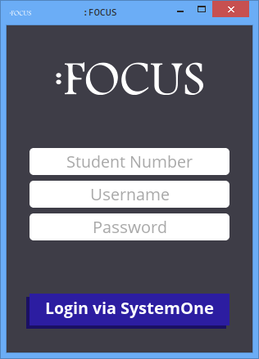

This is the main window for the client of FOCUS. Use this to communicate with the server. Input the following to login to FOCUS:

- Student Number in this format YYYY-XXXXX
- SystemOne Username
- SystemOne Password

Uploading File
To upload a file, drag and drop the message to the text area of the client. Multiple files can be uploaded by the user. You will get a notification in the field area that you successfully uploaded your file(s).

Sending message
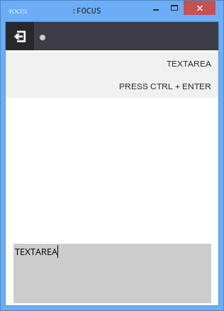
To send a message to the instructor, type your message inside the text area and then hit Ctrl + Enter. Your messages and the instructor's messages to you will appear at the field area.
Log out
Button
Field
Area
Text
Area

Instructor

Mobile

