**FOCUS: Free and Open source Computer Unit Supervision**

Submitted to the Faculty of the Institute of Computer Science

In Partial Fulfillment of the Requirements in CMSC 190-3

Presented to:

Katrina Joy H. Magno

Presented by:

Sherwin Jet B. Ferrer

BS Computer Science

Raven John M. Lagrimas

BS Computer Science

University of the Philippines Los Baños

Second Semester, 2013-2014

**Table of Contents**

ACKNOWLEDGEMENTS 1

ABSTRACT 3

INTRODUCTION 4

Background of the Study 4

Significance of the Study 4

Statement of the Problem 5

Objectives 5

Scope and Limitations 6

REVIEW OF RELATED LITERATURE 6

METHODOLOGY 10

Materials 10

Software Features and Specifications 10

Features 12

Results and Discussions 16

Implementation of the System 16

Server 16

Instructor’s Web Application 16

Client 18

User Tests – Student 19

User Tests – Instructor 22

CONCLUSION AND RECOMMENDATIONS 25

APPENDIX 26

Survey Questions 26

Survey Results 31

Bibliography 41

# ACKNOWLEDGEMENTS

I would like to thank my SP partner, **Raven John M. Lagrimas**, for the activeness in developing and making our SP and for taking the lead to start the coding process and our SP adviser, **Prof. Katrina Joy H. Magno** for always reminding us of deadlines, allowing us to use computer laboratories at late hours and giving us guidance and direction to our SP and paper.

Thank you to **Kuya Regi**, andother administrative staffwho opens up the computer laboratory when we are going to test our application. To **Sir James**, **Maam Ivy**, **Maam Lanie**, **Maam Mini**, **Maam Drio**, **Sir Reg**, **Maam Yna**, **Maam Miyah**, and **Sir Obrero**, thank you for allowing me and my partner to borrow some of your time to test our application. **IT 1 students** under Maam Drio, thank you for testing our application.

I would like to thank the **System One Development team** for giving me an opportunity to test my skills and what I’ve learned from the previous years of classes that I had. Thank you to **Sir Rommel Bulalacao**, who I see as my mentor and friend, for helping me greatly not just in SP but to my college life. I also thank him for showing me a path that I can travel on forward.

I would also like to thank my friends, **Cedric Abuso**, **Carlo Virtucio**, **Florante Gamat**, **Berna Pelaez**, **Nicole Flores**, **Julian Aseneta**, **Ivan Escamos** and **Jude Mailom**, who I can ask when I don’t know what to do and being on the same boat with me sometimes.

I would like to thank my girlfriend, **Kim Dianne Ortines**, who is always cheering for me and always believing in me and giving me courage every time that it feels like me and my partner won’t be able to finish our SP.

Lastly, I would like to thank my mother, **Fidela Ferrer**, who always asks me about our progress in SP and giving me intense pressure to finish my subjects. Without those pressures that I would just happy go lucky with my subject. To my father, **Eddie Ferrer**, who always accompanies me and fetches me whenever I’m in need. To my sister, **Sharmaine Jane Ferrer**, who gives me advice on the next step that I should do.

Sherwin Jet Ferrer

# ABSTRACT

FOCUS is a system for keeping students focused on their computer laboratory tasks by using free and open source applications. It is composed of three main applications: desktop application, web application and the mobile application. The desktop application is responsible for monitoring the students’ activity, assessing the mood and providing a means of instructor-student communication. Besides the desktop application, a web application is available for the instructor to keep in-check the moods, activities, file submissions and communication with the students. The web application also allows the instructor to distribute files, shutdown, and log off, lock or unlock a specific student’s computer or all the computers in the laboratory he or she currently handles. Lastly, a mobile application is also available for instructors for quick commands including shutting down, logging off, locking or unlocking all computers. The instructor can also see all windowed processes of the students. By surveying students and instructors after using the application, it received a mean score of 4.7 and 4.05 from the instructors and students, respectively, for ease of use category. This category pertains to how easily can use the application. For the functionality category, the students gave a mean score of 3.89 while the instructors gave 4.66. Performance of the application was tested by students and instructors. The result was 3.81 and 4.675 from the students and instructors, respectively. Performance is about how fast and efficient is the application. User interface received 3.32 and 3.3 from the students and instructors. User interface is the appearance of the application. Acceptance received 3.64 from students and 4.25 from instructor. Acceptance is how the application is perceived to be applicable to the computer laboratories or the willingness of the student and instructor to use the application on every class basis. Error category received 3.74 and 4.10 from the student and instructor. Error denotes to the experience and the encounter of error while using the application.

# INTRODUCTION

## Background of the Study

Most of the courses in the Institute of Computer Science (ICS) use computers for their laboratory component. These computers are used for studying, doing exercises and projects. Most of those computers are high end computers that catch up to the technology of today. High end computers offer a variety of things to do since they can process lot things faster. And it also helps a lot since Computer Science is a very fast updating field. Though these computers give the students the edge in doing great things, they also give them the ability to play more exciting games, and do more unrelated things.

A survey was conducted regarding this issue. The questions are found in table I while results are found in Figure 1. From the survey, 84% of the random students admitted that they do unrelated things while the instructor is discussing a lesson in the lab. There are some practical ways being done by the instructors to solve this problem like unplugging the router cable or asking the students to turn off their monitor. This method may work for some, but not for all. From Figure 1, 56% of the surveyed student said that they tend to procrastinate when the instructor is not around.

## Significance of the Study

Both the students and instructors will benefit from this system. The instructors can now assure that his/her students are really doing what they are told to. Students will also be more focused on the lesson knowing that the instructors can see what they are doing regardless if the instructor is around or at the faculty room. Besides that, both the student and instructor will benefit by using an easier way of passing exercises, attendance checking and communicating.

## Statement of the Problem

Most of the students are having a hard time finishing the exercise because they are not fully focused on what they are doing. Based from the studies and surveys, a system that helps the instructor monitor the students and helps the students focus on the lesson or exercise is needed. The system should not interfere with the students’ privacy nor stop them from doing what they want unless the instructor said it. Data collected will be kept private and will only be visible using an instructor or administrator account. The system will also include common transactions between student and instructor like chat, file submission and attendance checking.

## Objectives

The general objective is to create software that will allow instructors to monitor the activities of students in the computer laboratories.

The following are the specific objective:

* to allow the instructors to remotely shutdown, lock or log off a student’s computer.
* to assess if students are idling or having troubles base from their mood and activities to provide them with necessary assistance from the instructor.
* to facilitate common activities in the laboratory like file submission, file distribution, chat and attendance checking.

## Scope and Limitations

A network that connects the computer laboratories and the instructors’ computers is established. The system is using the Institute of Computer Sciences subnet to limit the server access to the institute only. The student can still do whatever he wants on his computer, the system will not stop him but the system will allow the instructor to see what he is doing.

Testing the software was a limit to the system. By the time the software was ready for testing, only two sections were still having laboratory classes, both IT 1 (MST). The students were surveyed after testing.

# REVIEW OF RELATED LITERATURE

The price of software is dependent on the developer’s will or to the company he is working with. Most of the time, they offer their software for a price but sometimes they offer their software not only for free but also open source. The definition of free, on software, states that the user is not bound to any rules or constraints that stop him for doing modifications, analysis and execution of the software (GNU Operating System, 2013). This gives a somewhat healthy relationship between the users and the code authors since both get mutual help from each other. Proprietary software is paid software where the source code is not publicly available while open source software; the source code can be obtained from the Internet (Crooke) and is freely available.

Free and open source software most of the time comes with a license. The license identifies the possible usages and limitations that a user can do with the source code of the software. There are two main benefits of open source licenses, namely contribution and protection. Contribution is in terms of re-factoring or editing the source code or any activity related to changes in the source code resulting to an improvement of the software. Protection of copyright ensures that there is still dedication to the software author since he owns the original code distribution (Chapman, 2010).

A lot of services have been available on a single computer network. Most of these networks have low restrictions. A good example would be the UPLB network. It only blocks few websites and peer-to-peer networking. Universities like University of Chicago Law School removed the Internet access of some of their classroom to free distractions (Douglas, 2008). Studies showed that classroom experience is getting lower and lower when you allow them to distract themselves.

A research has been conducted on students where they were asked to bring laptops. The conclusion of the study was related to the distraction not only of the owner of the laptop but also classmates near or those who can see the laptop (Sana, Wetson and Cepeda, 2013). Base from this research, this is also the case when the students are using the computer while the instructor is lecturing because the devices used are similar and the environment setting is quite the same, since students are also listening to the instructor while the computer that they are assigned is on.

The students’ distraction also results to lower performance in academics because their attention that should have been spent for listening and digesting the information taught by the instructor is spent in shifting their thoughts and instead processing irrelevant information (Sana, Wetson and Cepeda, 2013). There are ways to prevent students from being initially distracted by the computer. These include asking the students to move away from the computers when they are not necessarily needed and early distributions of study materials even before the start of classes (Abela, 2007). This seems quite a solution, but it hinders the right of the students to use the computers when they paid for it. This is different from monitoring what the students do. It will be like directing the students on how they use what they paid for.

The methods above may or may not work depending on the students. Though these methods are practical, these cannot maintain the attention of the student since the students can still use the computer. There are solutions that are found online like SMART Sync Classroom Management Software and Intelligent Teaching and Learning with Computers (iTALC). Smart Sync is a proprietary software that “helps students stay focused on learning” (SMART Sync, 2011). Some of the features that SMART Sync are computer monitoring, blocking internet access, chat, file submission, video demonstrations and more (SMART Sync, 2011). It is available for Windows NT family of operating systems but not available for Linux (SMART Sync, 2011). It requires low specification of hardware assuring that old computers can run it. Since it does not support Linux and is not free and open source, it is not very friendly software for ICS. On the other hand, iTALC is a free and open-source software that offers “a powerful didactical tool for teachers” (iTALC, 2013). The software is written in a much lower level programming language making it hard to customize. iTALC can view all the monitors, control computers, show a demo, lock the computer, power on/off, run scripts and offers home schooling. It may be free for now but maybe after some deliberate thinking of the software author he might ask for payment in the future. This software will be free forever as long as it is available.

Before the software was implemented, the researchers did a survey and asked a hundred students regarding the their use of the computer in the laboratory. The survey also included questions regarding their activity while they have exercise and their concentration in the class. Base from Figure 1 Q1 and Q4, half of the students does unrelated activities while the instructor is inside the laboratory or not. As a result, other students also tend to get distracted by the activity of another student.

Despite students doing the exercise after being given by the instructor, they still ask for extension. This might be due to the difficulty of the exercise on the or the under-utilization of the laboratory hours.

# METHODOLOGY

## Materials

* MongoDB
* Node.js
* Linux
* Phonegap

Both Node.js and MongoDB uses Javascript for scripting and implementation which made the development easier. Phonegap was used to port the application to mobile devices. The development of the client was in linux because most of the computer laboratories in the Institute of Computer Science use Ubuntu, a popular Linux distribution.

## Software Features and Specifications

The software was designed not to follow the traditional client-server model. The client computers had servers to handle requests from the instructor like receiving commands and starting VNC. The main server handled the data like schedules, sockets and it also served the web application for the instructor. Both the client and the server were implemented using Node.js. The instructors connected to the main server using only a browser. The main server was connected to Institute of Computer Sciences (ICS) subnet to ensure that only instructors of the institute can use the application. Commands from instructors were sent directly to students’ computer receiving endpoints. The endpoints are servers using Node.jss module Node Webkit(NW). Files sent by students were stored in the main server. These sent files are viewable only by the instructor of the specific class (e.g. CMSC 21 U-2L files can only be seen by the instructor holding section U-2L of CMSC 21). All methods of communications used HyperText Transfer Protocol. This includes using Virtual Network Computing (VNC).

The main identification of a client was the login mechanism. On a specified interval, the browser of the instructor requests screenshots from the one of the servers of the client. On the instance that the client got disconnected or failed to send and image to the instructor’s page within a specified timeout, the browser assumed that something went wrong on the client program and notified the instructor by replacing the image with a ”Not Connected” image. The possible scenarios that this may happen are when the client program is forcefully terminated or removed from the system or the client logged out.

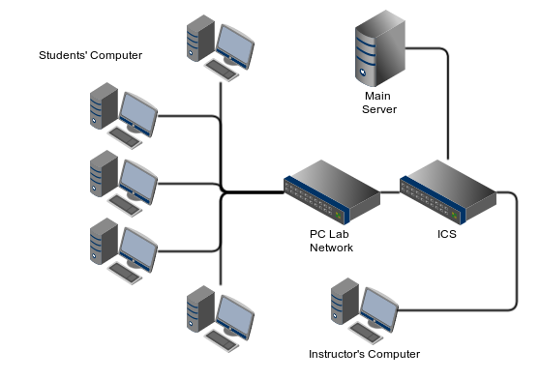

Fig. 1. Communications Model

SystemOne were used for the authentication processes. Schedules and authentication data used for logging in the client were cached to the main server so that the it can still work when the SystemOne server is down.

Computer monitoring software of Netopia and other computer shops checks the time consumed by a user on the computer. Instead of monitoring the activities of the users in the computer the main goal of the software from these shops is to ensure that the time consumed by the user will not exceed the time they requested or the time that the users incurred will be paid accordingly.

This software was different from existing software from the market by purpose and goal. This software was tailored for ICS laboratories and a contribution to our beloved university.

## Features

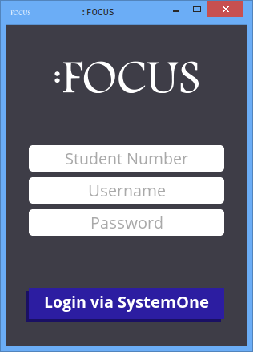

Fig. 2. The Login Screen

The software used the SystemOne API to check if a student is really included on the class he is attending in. This encouraged the students to create their SystemOne account early.

When the student logged in with a valid account, the client sent a request to the main server to record the attendance. The main server checked the subject based on the time and the room where the student logged in. The data were based from the current semesters information related sections using computer laboratories. After logging in, the student was presented with chat and file submission interface. The goal of the feature was to automate the attendance checks by putting the trust to the students.

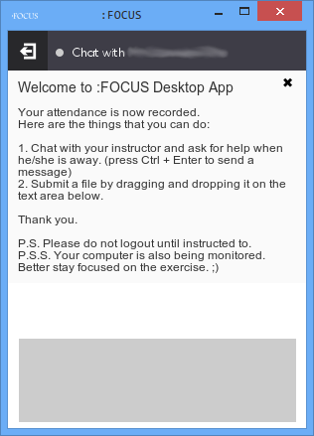

Fig. 3. Logged-in user window

File submission was triggered by dragging and dropping files to be sent on the text area. Sent files were stored to the main server. The main server gave a notification to the instructor that he received a file. File filters were used to avoid large files.

A chat message were sent by typing a message on the textarea followed by hitting Control and Enter key simultaneously. The main server identified if the instructor is logged in on the main server so that it can push the message immediately. A message appeared on the chat history right after the instructor sends a reply.

The instructor was shown with screens of monitors in the feeds page. The monitors held screenshots of the students computer. The screenshots were updated by interval specified by the instructor. On clicking the screenshot, VNC viewer opened to show a real time viewing of the target student.

A VNC server was installed on the laboratory computers to support this feature. This feature was useful when the student needs a direct tutoring from the instructor while he is away. This was also another way to inform the students that someone is watching them and they should go back to the task given to them so that they can finish it.

The instructor’s application was implemented to mobile phones using Phonegap though the functionalities will be limited to locking of PC, shutting down of PC and logging off of PC.

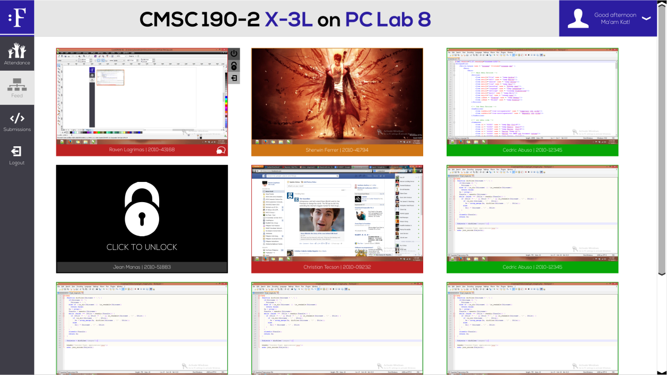

Fig. 4. Instructor’s homepage

The software locked the keyboard and/or mouse functionality of the students’ computers when the instructor wanted to. It can be a specific student or all the students in the laboratory. The lock command was from the instructor’s computer going to the targeted computers.

The software ran the native logging off and shutting down mechanism of the operating system.

The software monitored the students activeness base form his keystrokes and backspace. This monitors whether the student is off task, idling or active while doing lab room activities.

The instructor distributed files directly to the students computer without asking them to download the files from a server. The files were directly put to the students desktop.

# Results and Discussions

## Implementation of the System

The system is divided into three components, a client, a server and mobile.

### Server

The server has three main roles:

#### Static File Server

Serve static files like html, js, css and images. Static files are put together on a specific directory name public to secure other source files and distinguish what contents will be available on the web.

#### RESTful Web API

Provides an interface for the desktop application and instructors web application. It accept inputs on specific endpoints, process them and then finally, throw a JSON encoded response. The web service is made using Express.js framework.

#### Socket Server

This is only used for features requiring real-time transactions like chat and other updates. There is a specific room for every instructor-student entity. We used socket.io to ease the development since it works with Express.js well.

### Instructor’s Web Application

The web applications login page is composed of the application logo, username and password inputs, and the login button. After logging in, the server determines if the instructor has a current class based on the system time. If he/she has a current class, the Feed page will appear wherein a series of window screenshots are shown. The screenshots are hyperlinks to individual pages where the instructor can control the students PC using Virtual Network Computing (VNC). The instructor can also lock, shutdown and logoff the students PC using the icons showing when the screenshot is hovered / pointed. Every screenshot also has a chat icon. The chat icon changes color when there is a new message. When the chat icon is clicked, a chat box will appear containing the instructor-student chat history.

Whether the instructor has a current class, the menu will always have a Records Page, Submissions Page, Logs Page and of course, the logout button.

The records page contains a table of the students’ attendance summing up every students absence to easily locate excessive absences.

Submissions Page contains the list of files submitted by the students grouped by the selected section. It can also be narrowed down to files submitted by a specific student or files with substring exer1 to exer10.

The Logs Page contains the logs of students on the selected section. Same as the Submissions Page it can also be narrowed down to specific student and/or by date. It is helpful for evaluating the students’ performance like how long the student is active or off task.

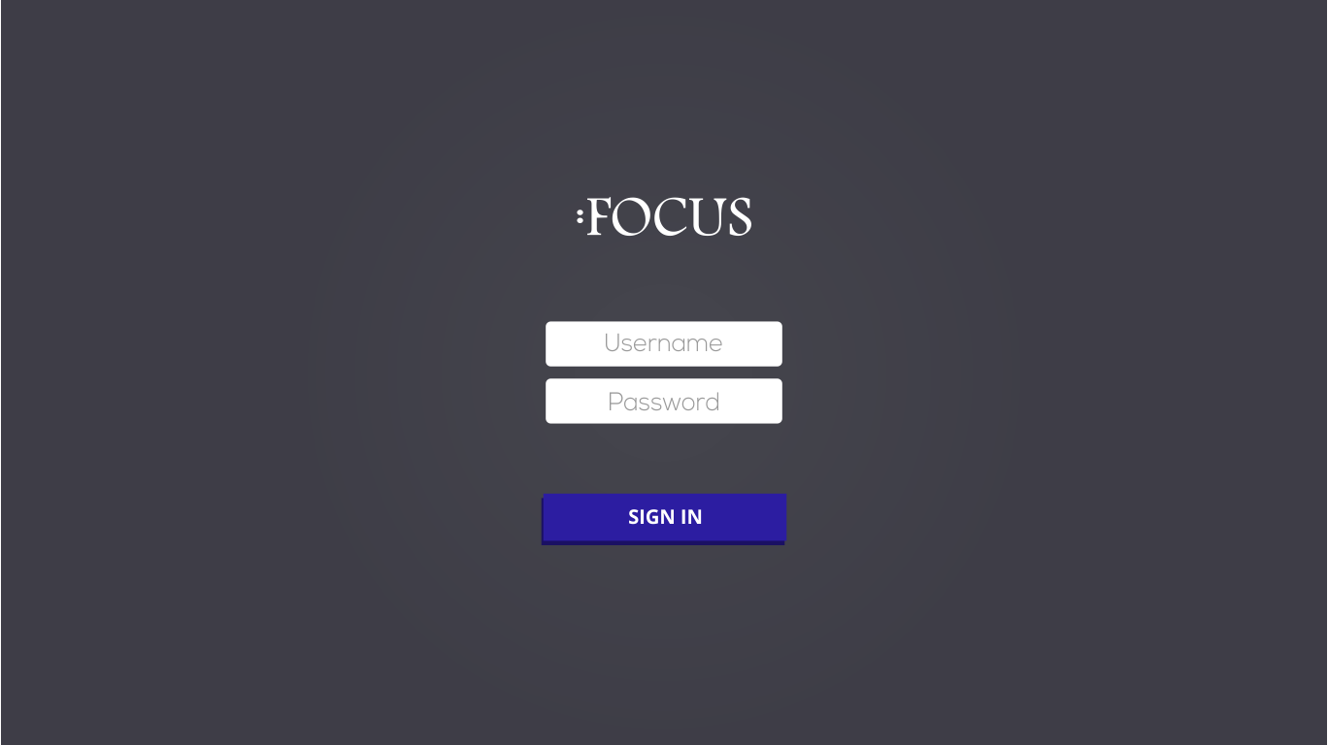

Fig. 5. Instructor’s login page

### Client

The client can be further subdivided into four different modules; the user interface and three different servers.

#### User Interface

The login screen is the main page shown by the client. Student number, username and password are needed to authenticate the user. These credentials are sent to SystemOne for verification. After logging in the user is shown with a chat window. This chat window serves as the main page for authenticated user. The name of the instructor is shown in the header and whether he or she is online. In the footer is the text area where the students input their message to the instructor. By pressing Ctrl + Enter, the message is sent to the instructor. The text area also serves as the drag and drop region for files.

#### Activity Server

This server receives the requests from the instructor that contains the commands of shutdown, logoff, unlock, lock, process list, screenshot and active window. Every request to this server needs a command, a salt and a hash. The hash is the combination of the salt and session id passed to a hash function (e.g. sha1, md5, sha256). The activity server also checks that there exists a session id in the session server. In case that there does not exist a session id in the session server, the commands are not processed.

#### Session Server

This server maintains the session id or the access token from the server. It also assures that the access token from the client is from the main server. Upon user login, this server also starts the VNC server and HTTP server that serve the VNC client. The VNC server and HTTP server are killed by this server after the student logs out.

#### Status and Upload Server

This server has two endpoints. Status endpoint does not need authentication. It serves the status or mood of the student whether they are bored, confused or others. The mood is set base from the user keystrokes and backspace counts. Upload endpoint needs authentication. It needs a salt, hash and a session on the server.

#### Mobile

Same with the instructor’s web application, its login page is simple. The instructor will not be able to login if he/she does not have a current class. After logging in, a list of students with its corresponding status will be shown. When a student’s name is tapped, the instructor will be shown a list of processes and the three buttons, shutdown, log off and lock.

## User Tests – Student

The client software was evaluated by conducting a test of the software in two laboratory classes. Both classes are IT 1. There were thirty-nine students who answered the survey after testing the software. The software was left open to the students for the duration of their class. The questions to the students were categorized as follows:

* Ease of Use : How easy was it for students to use the application?
* Functionality: Was the software perceived to be useful and advantageous to the students?
* Performance: Was the software efficient and fast enough?
* User Interface: Were the design and images acceptable and liked?
* Acceptance: Was the software accepted by students to be used in their future classes?
* Error: Did the program run properly?

Figure 2 summarized the responses for the ease of use category. In this category, which has three questions, the students gave a mean score of 4.05 as seen in from Figure 14. This means that the software is self-explanatory and is very simple to understand. The students were able to understand how to use the software because there are only two main features that are exhibited by the client, the chat and file submission features.

Base from the Figure 14, the functionality of the software received an average of 3.89. This tells us that the software achieves one of its main goal of making a bridge between the instructor and the students. It also contributed to the students’ appreciation of technology. The graph informs us that most of the students feel like the application gives them a more advantageous way to learn and that it also increase their productivity. But at the same time the first graph in Figure 3 suggests that the students are distracted by the thought that someone is watching them while they are doing their activities or exercises in the computer.

The user interface category received mean score of 3.32 from Figure 14. There are 31 students who found the interface appealing and pleasing to the eye. But most of them also were quite unsure whether the design of the software were outdated or on the trend. They are maybe not sure because they are not exposed to flat designs.

The result of the mean score for the category performance is 3.81. This value was computed from Figure 4. Most students had successful request and transactions between the instructor and their computers. They were able to login successfully and use one of the main features of the desktop application which is chatting. Most students answered between disagreeing and agreeing to the file submission may be because they were not able to test it in their lab session.

The acceptance denotes to the likelihood of the students to use the software in their laboratory classes. This category received an average score of 3.64. Most students agree that the software can be really used inside the laboratory class. But they are hesitant when it comes to the monitoring capability of the software. Most of them do not want their activities in the computer to be known to the instructor. Most students were in between regarding the use of the software as a method of file submission. But most students agreed that they would prefer to use the software to submit files instead of using the traditional use of email account.

The error category received a mean score of 3.74. As seen in Figure 6, more students did not encounter error while using the software. Most of the functionalities of the software worked for them and they did not encounter problems while they were using the application. Most students could not tell whether there were errors maybe because they were not able to extensively use the application or the simply do not treat what they encountered to be an error.

## User Tests – Instructor

The web application and mobile for the instructor was tested by ten instructors on a simulated environment. Twenty computers were used to conduct the testing and the functionalities were tested on the computers. The web application and mobile were explained one by one to the instructors. The instructor tested the application and answered a survey afterwards. The questions of the survey were classified as follows:

* Ease of Use : How easy was it for students to use the application?
* Functionality: Was the software perceived to be useful and advantageous to the students?
* Performance: Was the software efficient and fast enough?
* User Interface: Were the design and images acceptable and liked?
* Acceptance: Was the software accepted by students to be used in their future classes?
* Error: Did the program run properly?

The instructors had a very easy experience while using the software. The ease of use category received a mean score of 4.7. The values used to compute this is found in Figure 8. This denotes that the web application is easily understandable. Since the users were instructors, their level of understanding is faster than the students thus they gave a higher mean rating. Another factor is because they were supervised directly and guided on the functionalities of the software.

The functionality category received an average score of 4.66 as seen in Figure 14. The instructors find the web application to be useful in communicating to the students and relaying instructions to them. It is very important that the students can communicate to their instructors immediately so that they can ask questions and guidance even if the instructor is away. The functionality category received a mean score of 4.66 because the instructors found the software to be helpful to communicate to the students. The chat, file submission and file distribution are the biggest factor that gave this category a high score. This category’s breakdown is found in Figure 9.

The performance received a score of 4.675. The web application performed well while the instructors’ are using it. They had smooth experience with the system and it was fast enough for their satisfaction. They gave the performance category a high rating may be because the portal that they used did not slow down the computer that they were using. Also the portal is fast enough to communicate with the client computers despite managing more than fifteen (15) computers at a time.

The user interface received a mean score of 3.4 as seen in Figure 14. We can see from Figure 11 we can see that the instructors don’t find the interface as outdated. They found it good and pleasing to their eyes. The rating became 3.4 because the instructors disagreed that the user interface was outdated. The agreed that the user interface was not outdated maybe because of their exposure to current trends to interface designing since they are instructors. They have to adapt to the newest trends to teach.

In the acceptance category, an average score of 4.25 was received. It is likely that the instructors favor the use of the application, since monitoring of the students would be easier whenever they are in the faculty room. They can leave the students and still monitor them at the same time. The values used for the average score of acceptance is seen Figure 13.

A mean score of 4.10 was received by the category error. The problems experienced by the instructor while using the computer are few and most are easily fixable. They gave a high score because features like file distribution and some instances of the screenshot did not work. Having this minor problems did not yield bad result for the error category.

# CONCLUSION AND RECOMMENDATIONS

The researchers have developed a free and open source system for getting the students focus on their exercises. The instructors were able to monitor and assess their students performance easier. Students were more restrained on doing unrelated things knowing that the system is running. The students also find it simple to communicate to their instructors and submit files. The mobile application for Android devices were also proven to be helpful but lacks features.

The system needs an exhaustive testing to fully assess its scalability and performance. Use a Transport Layer Security (TLS) on the server for better security. An auto-update on the desktop application will also come in handy for updates. The node-webkit must also be updated for future use to eliminate backward-compatibility. A mobile application running on iOS devices should also be developed. FOCUS must also be publicized to attract contributors and keep it updated. The repository is located at http://github.com/wildtron/focus.

APPENDIX

Survey Questions

|  |  |
| --- | --- |
| Count | Question |
| Q1 | Do you use the computer for things unrelated to the subject while the instructor is discussing a lesson in the lab? |
| Q2 | Do you get distracted when you see someone looking on sites like 9Gag, Facebook, Youtube and other media and social networking sites in class? |
| Q3 | If you think the exercise is hard or the time left is not enough do you still do the exercise? |
| Q4 | Do you tend to procrastinate if the instructor is not around? |
| Q5 | Which do you usually do first on the lab when the instructor gives an exercise? |
| Q6 | Did you ever ask an extension for an exercise? |
| Q7 | What are your thoughts on a software that monitors your activities in the laboratory? |

Table 1Survey question given to students to determine their activities during laboratory classes

|  |  |
| --- | --- |
| Count | Question |
| Q1 | I did not have a hard time in using the application because the user interface is simple and easy to understand. |
| Q2 | I was able to use the application easily even without reading the manual or user help. |
| Q3 | The application gives the impression of user friendliness. |

Table 2 Survey questions to student for the Ease of Use category

|  |  |
| --- | --- |
| Count | Question |
| Q4 | The software is good for remote monitoring and assistance. |
| Q5 | The application provides a good means of communication between the student and the teacher. |
| Q6 | The application is useful for online instructions. |
| Q7 | The use of the application makes learning conducive for students. |
| Q8 | The use of the application increased my productivity during the laboratory class. |
| Q9 | I was not able to concentrate during the exercise knowing that someone remotely monitors my activities. |

Table 3 Survey questions to students for the Functionality category

|  |  |
| --- | --- |
| Count | Question |
| Q10 | It is easy to log in to the application. |
| Q11 | It is easy to use the chat feature of the application. |
| Q12 | I was able to communicate well with the teacher through the chat feature of the application. |
| Q13 | I was able to upload files easily. |
| Q14 | I was able to seamlessly navigate through the application. |

Table 4 Survey questions to students for the Performance category

|  |  |
| --- | --- |
| Count | Question |
| Q15 | The user interface is appealing. |
| Q16 | The user interface is pleasing to the eye. |
| Q17 | The user interface is outdated. |

Table 5 Survey questions to students for the User Interface category

|  |  |
| --- | --- |
| Count | Question |
| Q18 | I did not encounter any errors while using the application. |
| Q19 | All features of the application are properly working. |

Table 6 Survey questions to students for the Error category

|  |  |
| --- | --- |
| Count | Question |
| Q20 | The use of the application made me appreciate information technology as a tool for learning. |
| Q21 | I would prefer to use the application in submitting my exercises to the teacher. |
| Q22 | The software can be use applied and used inside the laboratory. |
| Q23 | I would like to use this application in all my computer laboratory classes. |
| Q24 | I don’t like the idea that the teacher can monitor me remotely. |
| Q25 | I like it when the teacher is able to monitor my activities during the exercise. |

Table 7 Survey questions to student for the Acceptance category

|  |  |
| --- | --- |
| Count | Question |
| Q1 | I did not have a hard time in using the application because the user interface is simple and easy to understand. |
| Q2 | The application gives the impression of user friendliness. |
| Q3 | I was able to use the application easily even without reading the manual or user help. |

Table 8 Survey questions to instructors for the User Interface category

|  |  |
| --- | --- |
| Count | Question |
| Q4 | The software is good for remote monitoring and assistance. |
| Q5 | The application provides a good means of communication between the student and the teacher. |
| Q6 | The application is useful for online instructions. |
| Q7 | The use of the application makes learning conducive for students. |
| Q8 | The use of the application made me appreciate information technology as a tool for learning. |

Table 9 Survey questions to instructors for the Functionality category

|  |  |
| --- | --- |
| Count | Question |
| Q9 | It is easy to log in to the application. |
| Q10 | It is easy to use the chat feature of the application. |
| Q11 | I was able to communicate well with the student through the chat feature of the application. |
| Q12 | I was able to seamlessly navigate through the application. |

Table 10 Survey questions to instructors for the Performance category

|  |  |
| --- | --- |
| Count | Question |
| Q13 | The user interface is appealing. |
| Q14 | The user interface is pleasing to the eye. |
| Q15 | The user interface is outdated. |

Table 11 Survey questions to instructors for the User Interface category

|  |  |
| --- | --- |
| Count | Question |
| Q16 | I did not encounter any errors while using the application. |
| Q17 | All features of the application are properly working. |

Table 12 Survey questions to instructors for the Error category

|  |  |
| --- | --- |
| Count | Question |
| Q18 | I would prefer to use the application in receiving submissions from students. |
| Q19 | The software can be use applied and used inside the laboratory. |
| Q20 | I would like to use this application in all my computer laboratory classes. |
| Q21 | I don’t like the idea that I can monitor the student remotely. |
| Q22 | The use of the application increased my guidance capability during the laboratory class. |
| Q23 | I like it when I can monitor the student’s activities during the exercise. |

Table 13 Survey questions to instructors for the Acceptance category

## Survey Results

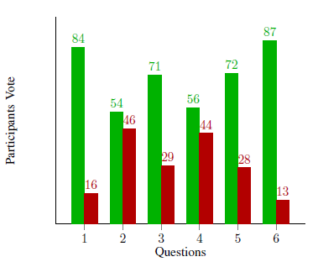

Figure 1 Survey result on students' activity in the laboratory

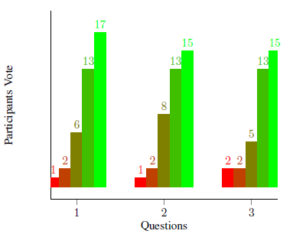

Figure 2 Survey results of students regarding the Ease of Use Category

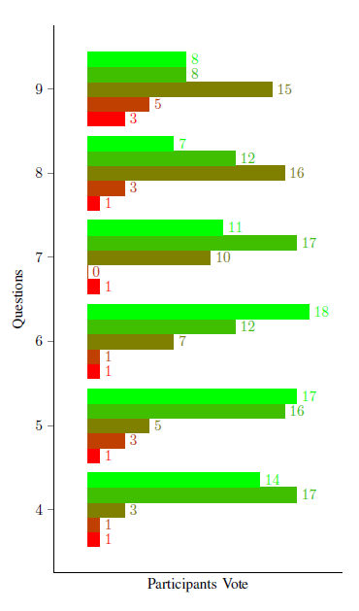

Figure 3 Survey results of students regarding the Functionality category

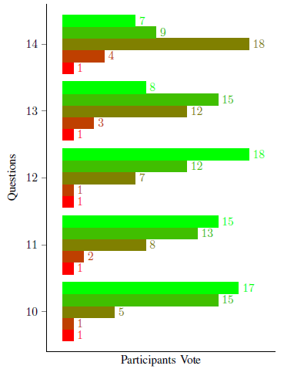

Figure 4 Survey results of students regarding the Performance category

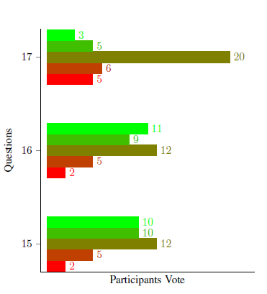

Figure 5 Survey results of students regarding the User Interface category

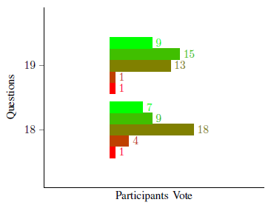

Figure 6 Survey results of students regarding the Error category

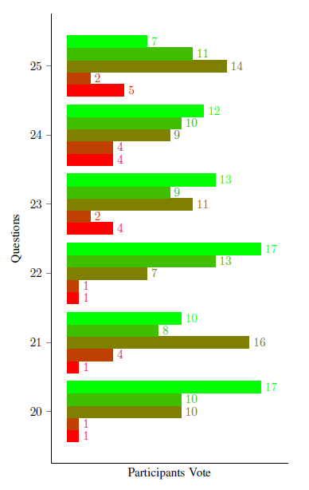

Figure 7 Survey results of students regarding the Acceptance category

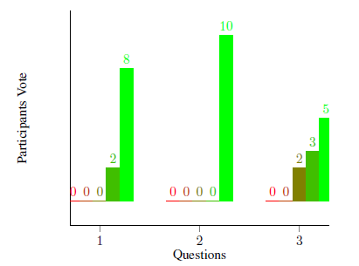

Figure 8 Survey results of instructors regarding the Ease of Use category

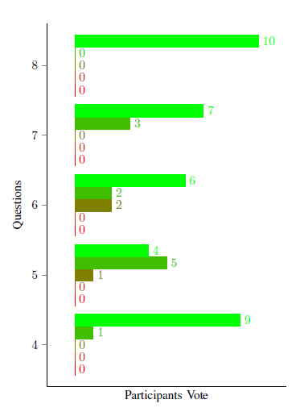

Figure 9 Survey results of instructors regarding the Functionality category

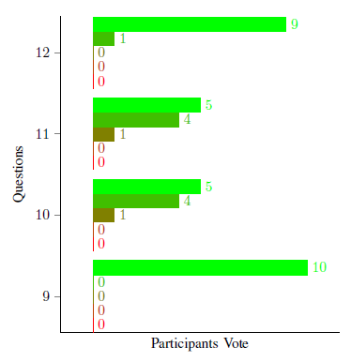

Figure 10 Survey results of instructors regarding the Performance category

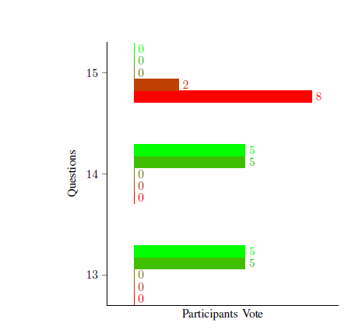

Figure 11 Survey results of instructors regarding the User Interface category

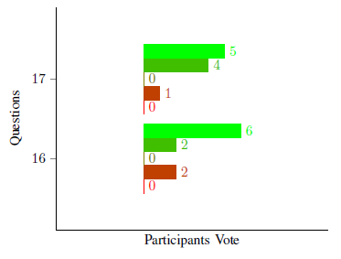

Figure 12 Survey results of instructors regarding the Error category

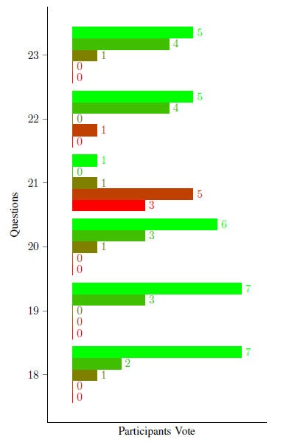

Figure 13 Survey results of instructors regarding the Acceptance category

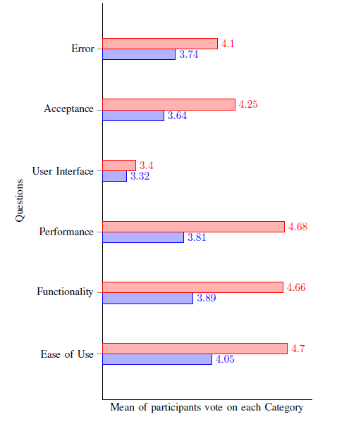

Figure 14 Mean scores of survey results for all categories and for both instructors and students

# Bibliography

Abela, J. (2007, November). *Managing Computer Lab Sessions - Keeping It Focussed.* Retrieved 2013, from http://iteslj.org/Techniques/Abela-ComputerLabSessions.html

Chapman, C. (2010, March 03). *A Short Guide To Open-Source And Similar Licenses*. Retrieved 2013, from Smashing Magazine: http://www.smashingmagazine.com/2010/03/24/a-short-guide-to-open-source-and-similar-licenses/

Crooke, D. (n.d.). *Open Source vs. Proprietary Software.* Retrieved 2013, from Green Net: http://www.gn.apc.org/support/open-source-vs-proprietary-software

Douglas, D. (2008, April 11). *University of Chicago Law School eliminates Internet access in some classrooms*. Retrieved 2013, from UChicago News: http://news.uchicago.edu/article/2008/04/11/university-chicago-law-school-eliminates-internet-access-some-classrooms

GNU Operating System. (2013). *What is a free software?* Retrieved 2013, from GNU Operating System: http://www.gnu.org/philosophy/free-sw.html

iTALC. (n.d.). *What is iTALC?* Retrieved 2013, from iTALC: http://italc.sourceforge.net/

Sana, F., Wetson, T., & Cepeda, N. J. (2013). Laptop multitasking hinders classroom learning for both users and nearby peers. *Computers & Education*, 24 - 31.

SMART Sync. (n.d.). *SMART Sync Classroom Management Software*. Retrieved 2013, from http://downloads01.smarttech.com/media/sitecore/en/pdf/brochures/sync/sync_fact_sheet.pdf

Vea, L. A., Mesina, M. D., Toriaga, R. P., & Padla, N. D. (2013). The Development and Implementation of an Intelligent Agent that Detects Student’s Negative Affect while Making a Computer Program. School of Information Technology, Mapua Institute of Technology.