Transcriptomic Analysis of Host Cell Responses to SARS-CoV-2 Infection in Human Caco-2 Cells
Authors: Robert J Wildy¹*

¹Department of Biosciences, Cardiff University; Cardiff, CF10 3AX, UK
*Email: wildyr@cardiff.ac.uk

Abstract: Declared as a pandemic by the World Health Organization (WHO) in 2020, the severe acute respiratory syndrome coronavirus 2 (SARS-CoV-2) is a highly infectious disease. This report investigates the changes in Caco-2 cells following SARS-CoV-2 infection. RNA sequencing data from different time points (4h, 12h, 48h) in both infected and mock-treated cells allow us to review gene expression over time. Key differentially expressed genes (DEGs) were analysed and visualised through heatmaps and volcano plots to outline relative expression differences between the treated and mock samples. Pathway enrichment analyses prominently featured both hormone and xenobiotic processes. These findings provide insights into the dynamics of SARS-CoV-2 and its host cells.

Introduction
The severe acute respiratory syndrome-coronavirus-2 (SARS-CoV-2) is a highly transmissible and often lethal coronavirus, responsible for the spread of coronavirus disease 2019 (COVID-19). It surfaced in late 2019 and was declared a pandemic by the World Health Organisation (WHO) in March 2020. The pandemic has had significant health, economic and social effects worldwide, and despite vaccination and treatment efforts, the virus continues to be disruptive. Continual surveillance and treatment are required.
This report will interrogate transcriptional response to SARS-CoV-2 infection. The data included gene expression levels from RNA-seq experiments with Caco-2 cells across multiple time points (4, 12 and 48 hours) for both infected and mock-treated samples. Differential gene expression was performed using DESeq2, followed by pathway enrichment analysis of the differentially expressed genes (DEGs) using Gene Ontology (GO) pathways.
One of the key discoveries was the down-regulated expression of the ACE2 gene that has been identified as the receptor for entry into host cells [1]. Pathway analysis identified significant alterations to metabolic processes. This is likely the virus mutating the host cell to avoid immunity [2].

Results
Analysis was done using DESeq2 for differential gene expression and clusterProfiler for pathway enrichment in RStudio. DESeq was performed on the entire dataset for the purposes of the distance heatmap, clustering and PCA analysis. It was then performed on each timepoint separately for the purposes of the volcano plots. Enrichment analysis was performed on up-regulated and down-regulated genes.
Differential expression analysis identified a total of 482, 1112 and 871 DEGs in our 4-, 12- and 48-hour samples, respectively. The results show stark differences in gene expression from the first 4 and 12 hours since infection and those exhibited at 48 hours.
The heatmap (Fig.1) shows tightly clustered gene expression at the 48-hour time point, whilst the 4- and 12-hour time points show much greater variability in gene expression. It also shows high similarity between mock samples regardless of hours, which is to be expected for our mock data. The infected 4-hour sample SKA03_19 shows higher similarity with our mock data than it does with other infected samples.
Fig.2 shows this grouping at a higher level. All the mock samples are consistent and highly grouped, along with the infected 48-hour samples. The infected 4- and 12-hour samples are much more spread. There is further support for this in additional plots in supplementary materials.

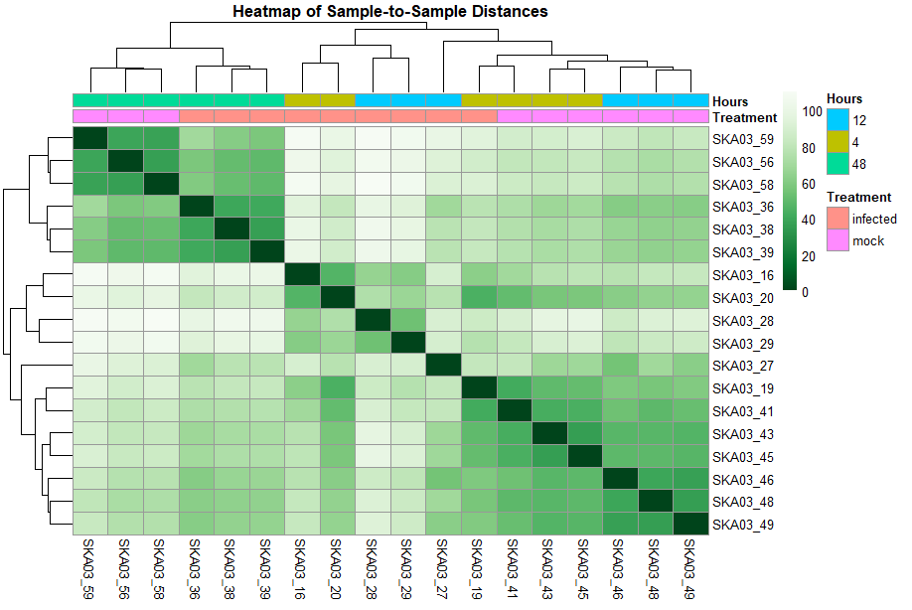
Fig. 1. Heatmap of Sample-to-Sample Distances. This heatmap illustrates the distance between samples based on their gene expression profiles. Samples are grouped by hierarchical clustering, with the dendrogram and heatmap shading highlighting similarity. There are colour bars at the top to indicate sample groups by both time point (Hours) and treatment (Infected or Mock).

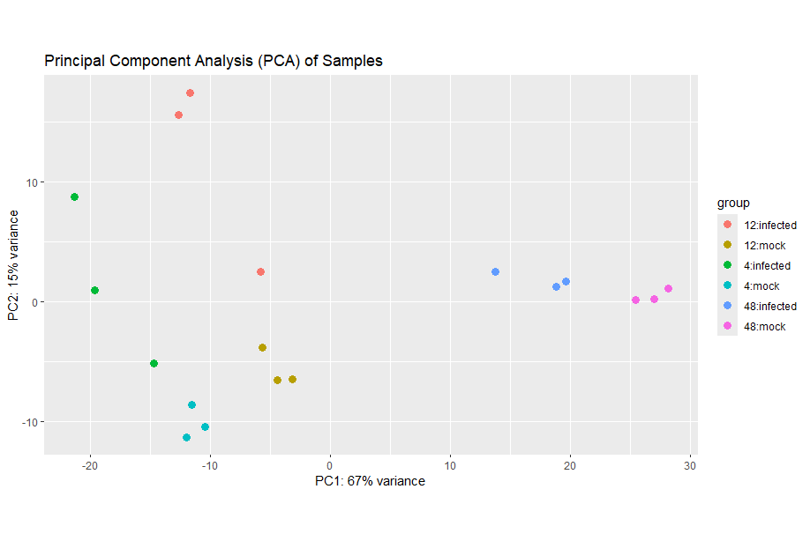
Fig. 2. Principle Component Analysis (PCA). This PCA plot was generated using a variance stabilizing transformation, defaulted to 1000 genes. It depicts our samples, colour-coded based on their time point and treatment status. Mock samples are well clustered at every time point. Infected samples are only well clustered at the 48 hour time point.

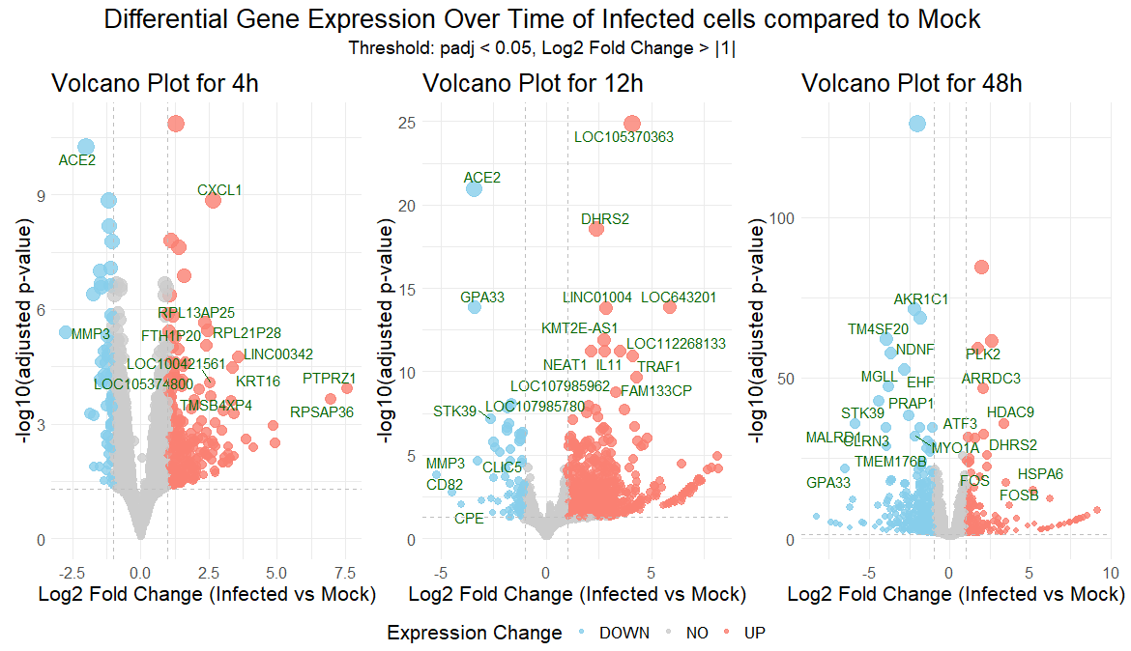
Fig. 3. Volcano plot of infected cells compared to mock at time points 4-, 12- and 48-hour intervals. Gene expression of the infected cells in comparison to the mock samples at the same time points. Coloured points are deemed statistically significant with a threshold of padj value <0.05 and log fold change of >1. Blue and red depict down and up-regulated genes respectively, with the most significant labelled explicitly. The scale varies between images.

The ACE2 gene is highly down-regulated in the 4- and 12-hour stages of infection (Fig.3), and then does not significantly appear in our 48-hour data. Whilst we saw that both infected and mock 48-hour samples were similar in Fig.1 and Fig.2 we can see that there are still substantial differences between them.
In pathway enrichment analysis no up-regulated pathways were found. The down-regulated pathways discovered related primarily to metabolic processes (Fig.4).

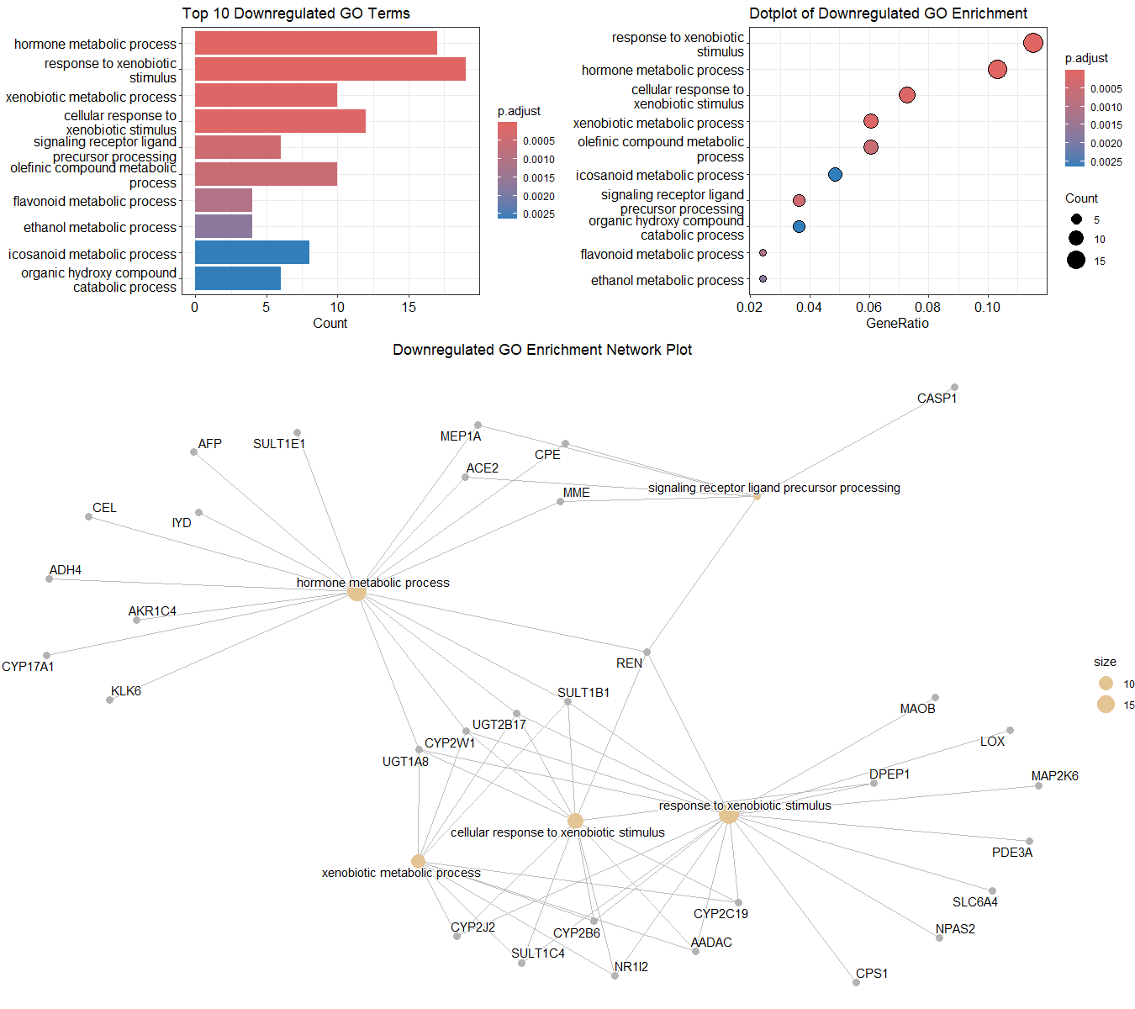
Fig. 4. Top 10 down-regulated pathways ordered by p.adjust values (top left), a dotplot of top 10 down-regulated pathways by counts (top right), and a network plot with associated expressed genes.

Discussion
The prevalence of metabolic down-regulation gives us insight into how SARS-CoV-2 affects the cells it infects, and its strategy for survival. In reducing cellular metabolism, the virus is likely redirecting energy towards viral replication [3]. It’s also likely that the reduced metabolism slows the host organism’s ability to detect the virus.
The role of the ACE2 gene appears to be important to the virus’s early survival in the host cell as it is the most down-regulated gene across the 4- and 12-hour samples. With the disappearance of the down-regulation in older samples we don’t know the point at which the infection stops having the affect on the gene. There could be a key time frame in which ACE2 has to stay suppressed for the virus to establish itself.
The heatmap and PCA analysis outline a large difference in gene expression between samples for the infected cells at 4- and 12-hours. The supplementary Fig.6 shows close clustering between a single infected 4-hour and the mocks of the same time point. A possible explanation is a greater innate resistance to the influence of the infection, however that resistance, if true, fails to persist for 48 hours.
Potential limitations of our dataset and analysis:
With only 3 data points available at each time frame, this could have an impact on our differentially expressed genes (DEGs). This could be further supported by the PCA plot in Fig.2. A greater sample size would give us a better insight into the variance we’re seeing across the infected 4- 12-hour DEGs.
No up-regulated gene pathways were identified in pathway enrichment analysis. This is potentially a flaw with the code used during analysis. It is recommended that the code be further optimised and peer evaluated for suitability.

References and Notes
- Ni, W., Yang, X., Yang, D. et al. Role of angiotensin-converting enzyme 2 (ACE2) in COVID-19. Crit Care 24, 422 (2020). https://doi.org/10.1186/s13054-020-03120-0
- Chen, P., Wu, M., He, Y. et al. Metabolic alterations upon SARS-CoV-2 infection and potential therapeutic targets against coronavirus infection. Sig Transduct Target Ther 8, 237 (2023). https://doi.org/10.1038/s41392-023-01510-8
- Mullen, P.J., Garcia, G., Purkayastha, A. et al. SARS-CoV-2 infection rewires host cell metabolism and is potentially susceptible to mTORC1 inhibition. Nat Commun 12, 1876 (2021). https://doi.org/10.1038/s41467-021-22166-4

Data and materials availability: All data used in this paper are accessible either from the original author – https://www.ncbi.nlm.nih.gov/geo/query/acc.cgi?acc=GSE217504 – or here – https://github.com/wildyr/assignment2
All code produced for and used in this paper, including versions used, are available here – https://github.com/wildyr/assignment2

Acknowledgments: All analysis was conducted in R Studio. ChatGPT was utilised in troubleshooting both R and shell coding. Phind was utilised in finding articles for further reading.

Supplementary Materials

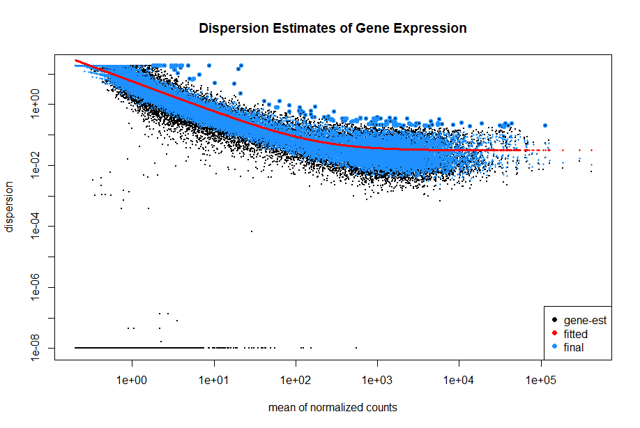

Fig. 5. Dispersion Plot.
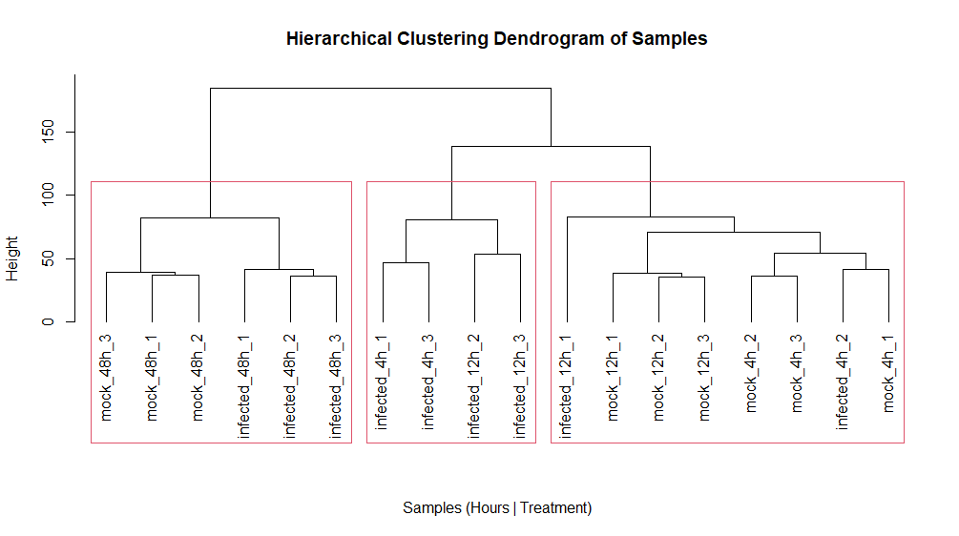
Fig. 6. Hierarchical Clustering Dendrogram. Generated with three clusters, the difference at 48h is clear.
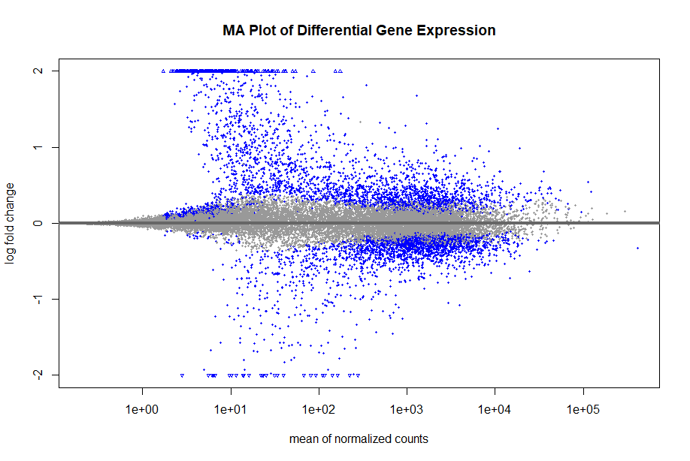
Fig. 7. MA Plot.
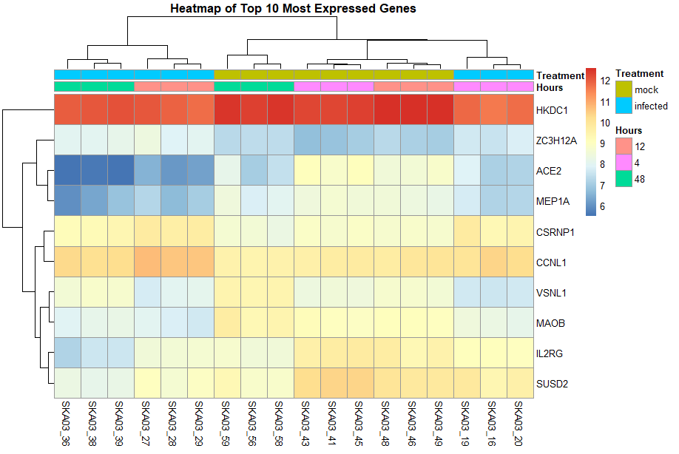
Fig. 8. Heatmap of top 10 most expressed genes
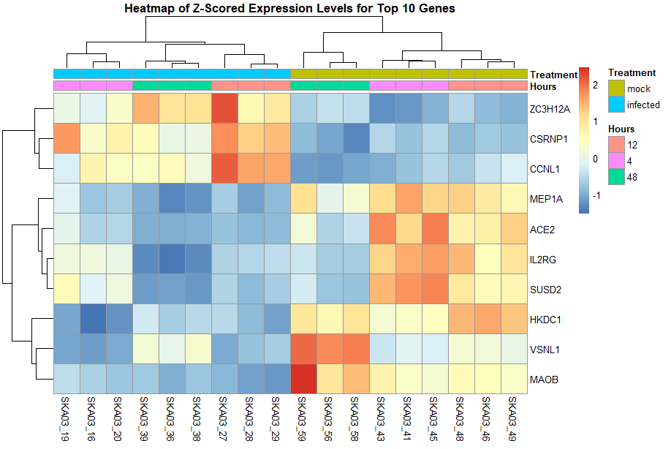
Fig. 9. Heatmap of Z-Scored Expression Levels for Top 10 genes.

