Program 4 Report

Site URL: http://program4-eng.n3thsn7s5d.us-west-2.elasticbeanstalk.com/
Object URL: https://s3-us-west-2.amazonaws.com/css490eng/input.txt

How the Site Works

When a user goes to the website, they will see two text boxes, and three buttons. The two text boxes are for the user to input a first and last name to search the database, and the functions of the buttons are to query, load data into the database, and clear the database.

When a user clicks the “Query” button, the application with search the database for a person who’s first and last name match and display their attributes. If the user only has input for one of the boxes, the application will show all results that match the appropriate name.

When the user clicks the “Load” button, the application will load data into the database based Dimpsey’s text file in an S3 bucket. It will also upload a copy of it into my S3 bucket.

When the user clicks the “Clear” button, it will wipe the database clean, and delete the copy of the data from my S3 buckt.

Dependencies Diagram and Service Level Agreements

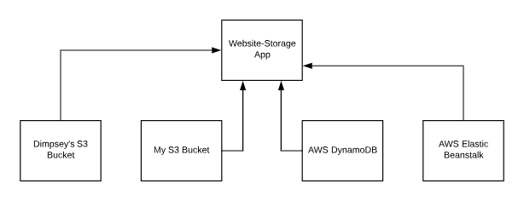

My program is dependent on four services to be able to function properly; AWS DynmoDB, AWS Elastic Beanstalk, and AWS S3 (Dimpsey’s bucket object and my bucket object). The SLA’s for each service for Monthly Uptime are as follows:

- DynamoDB (Per Region)
  - Uptime: 99.999% (5 9’s)
  - Downtime: 0.001%
- Elastic Beanstalk
  - Uptime: 99.99% (4 9’s)
  - Downtime: 0.01%
- Dimpsey’s S3 (Assumed to be General Purpose)
  - Uptime: 99.999999999% ( 11 9’s)
  - Downtime: 0.0000000001%
- My S3 (General Purpose)
  - Uptime: 99.999999999% (11 9’s)
  - Downtime: 0.0000000001%

With these dependencies and their respective SLA’s,we can can calculate the availability of this program:

0.99999 * 0.9999 * (.99999999999)^2 = 0.999890001

With these SLA’s, we can expect our program to be up effectively 99.989% of the month, meaning it should only be down for 4.3 minutes out of a month

Scalability

Because this program uses DynamoDB, which is a NoSQL database, we can expect the querying aspect of the site to be quick and scale very well with load. The things that might not query as well with load would be the loading and clearing of the database. Loading requires the data text file to be parsed, then have each person and their attributes uploaded to the database individually. The clearing also requires each entry to be individually dealt with and removed from the database.

To deal with a larger population of users at the same time, there could be a load balancer added to the application that allocates appropriate amounts of resources to match the load at difference times. At the moment this is not enabled because I am using the free tier.

Overall, the increase in load would not affect querying very much, but the loading and clearing of the database would take much longer and not scale very well.

Monitoring

Currenlty, monitoring is done on the site through the use of Elastic Beanstalk’s built in logs. These record raw information about the system, such as a errors and tracebacks. If we wanted to get even more information about the application, we could use AWS CloudWatch, a service that monitors and collects data in the form of logs, metrics, and events and helps us visualize them. This would help us set alarms in case something goes wrong, like if a dependent service goes down, or if load gets past our maximum limit.

