Data Analytics Fall2025
Assignment 6
Joelle Wilensky

- Exploratory Data Analysis
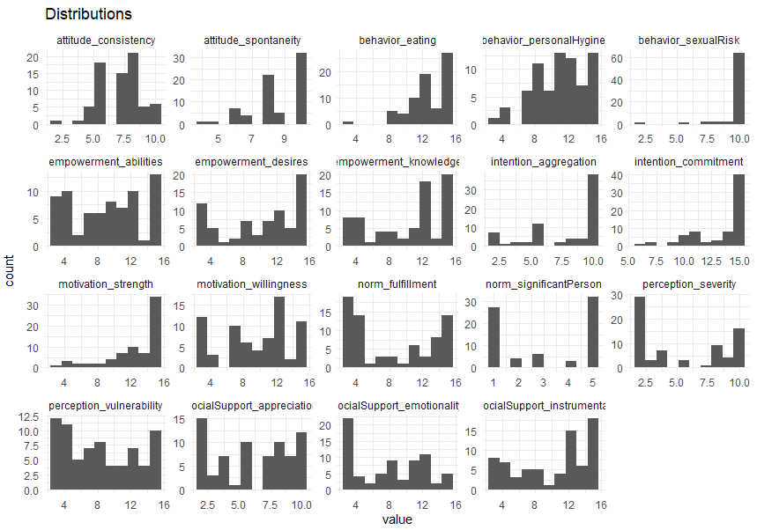
The above distributions are histograms for 19 of 20 attributes of the Cervical Cancer dataset. The missing one, ca_cervix, is not present as all values are NA and are therefore not useful for analysis. The remaining 19 are shown in the histograms above to show their general distributions for different values.
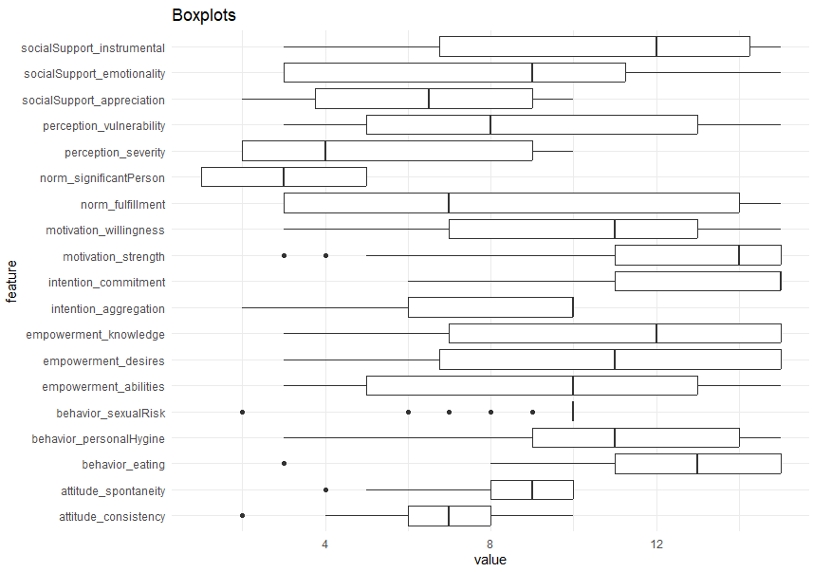
The second test I ran shows boxplots for the 19 attributes. This test is run to more clearly visualize outliers, skew, and the center of the data. With these two visualizations, it becomes easier to notice similarities between each attribute, and what change might predict a change in another.

- Model Development

- Decisions

