1. Button click：Interaction Checker

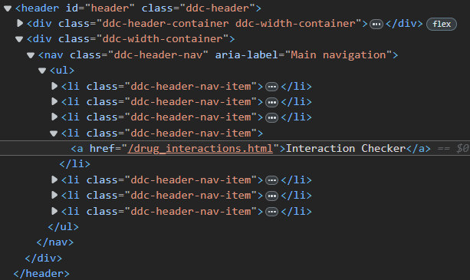

1. Input box: text(double enter)

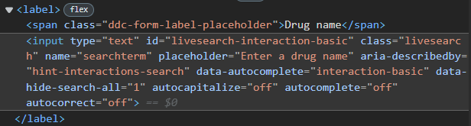

1. Check input = 2

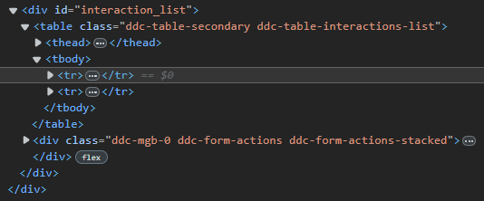

1. Button click: Check Interactions

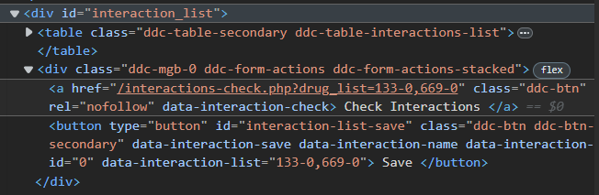

1. Button click: professional

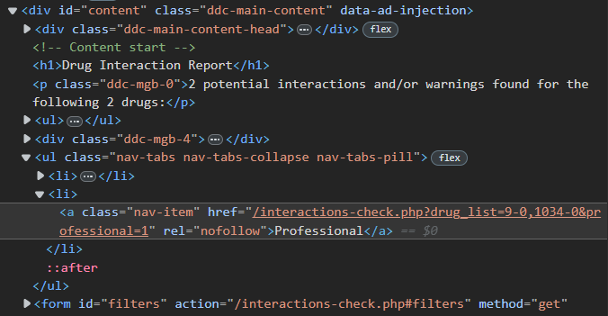

1. Get title (applies to drug_1, drug_2)

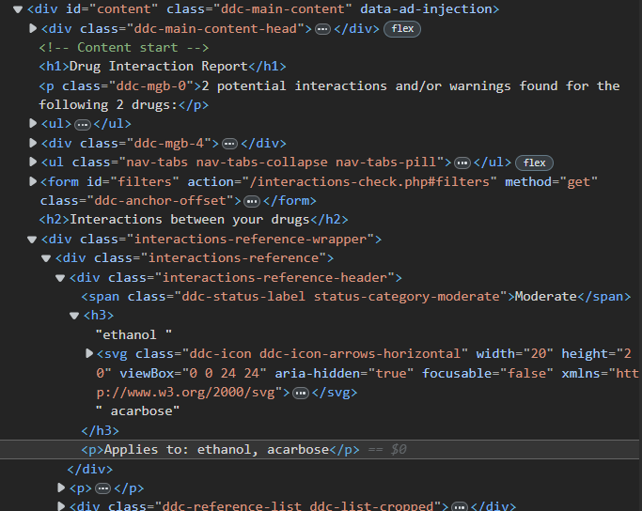

1. Get interactions

