Annotation Tool Manual
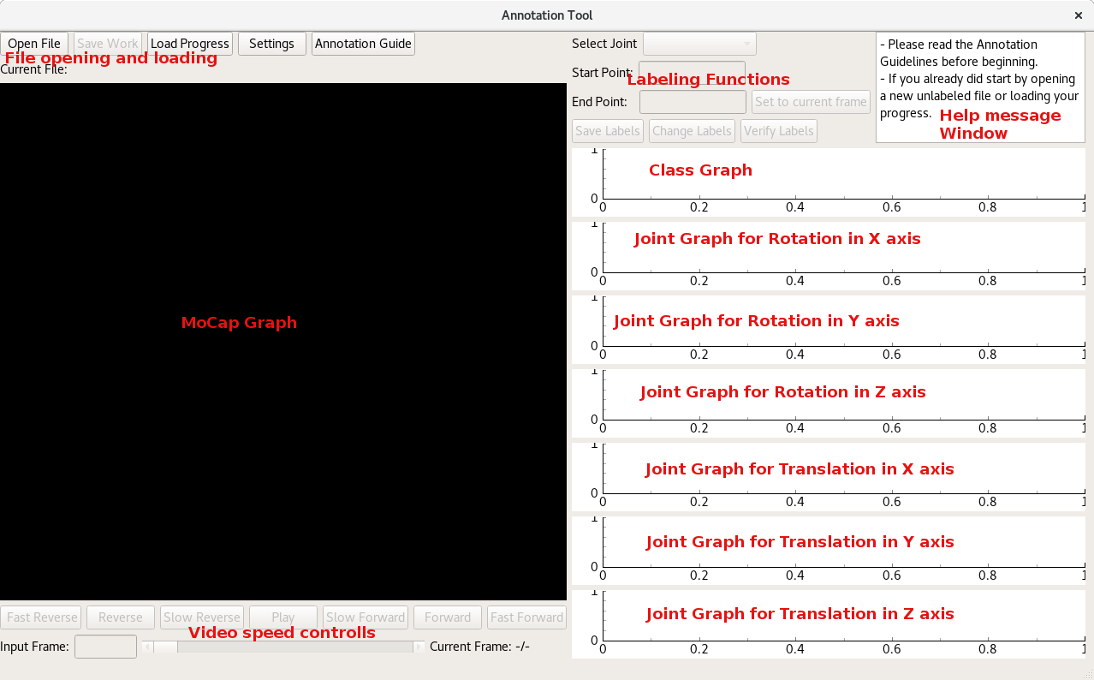
Introduction

This tool was made for annotating motion capture data in the DFG project. With this tool you can load unlabeled .cvs files, play the video data contained in them forwards and backwards with varying speeds, and set classes and attributes for intervals/windows in the video.

Starting the Annotation Tool

On windows you can simply run the start.bat file. It will open a console window and the Annotation Tool.
On Linux/Unix you can run the command “python3 main.py” to open the tool.

Opening a new file or your progress

To open a File simply click on the “Open File”-Button and select a .csv file that contains the data you want to annotate.

While you work all your progress gets saved automatically. If you need to pause working for a while, you can close the tool and start it at a later time.
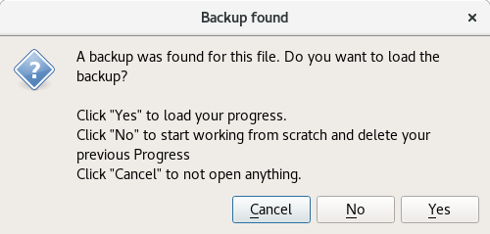
To load your progress you can do 2 things:
1. Press the “Open file”-Button and select the same file that you have been working on. You will get asked if you want to continue your previous work. See the image on the right
2. Press the “Load Progress”-Button and select the .txt with the same name as the file you want to work on. Then you need to select the folder with the original data inside.

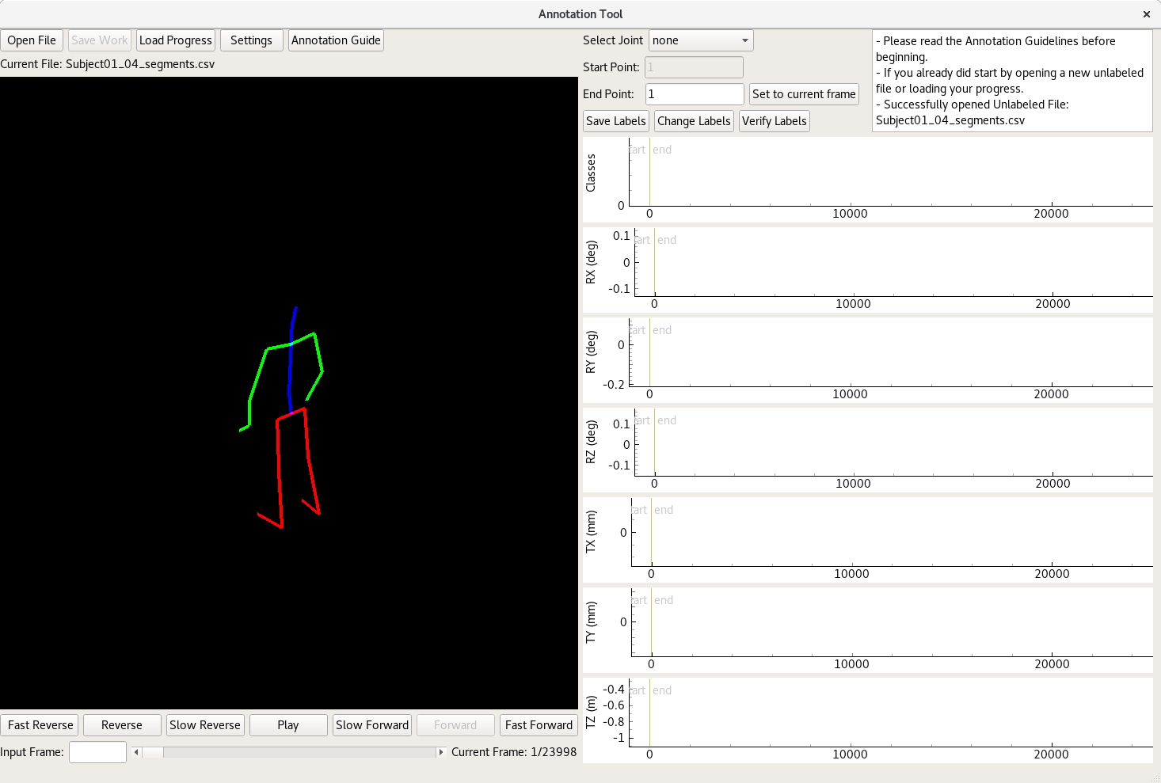
Once you open a new file it should look like this:

Video Features

Use Left clicking and dragging on the MoCap graph to rotate the view angle of the skeleton
Use the Scrollwheel to zoom in and out.

Below the Mocap graph you can find the video controls. You can Play/Pause the video and play it forwards or backwards in Fast Normal or Slow speeds. You can also use the Scrollbar to quickly go to a different part of the Video or Input the exact framenumber you want to look at in the bottom left.
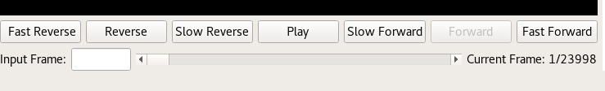
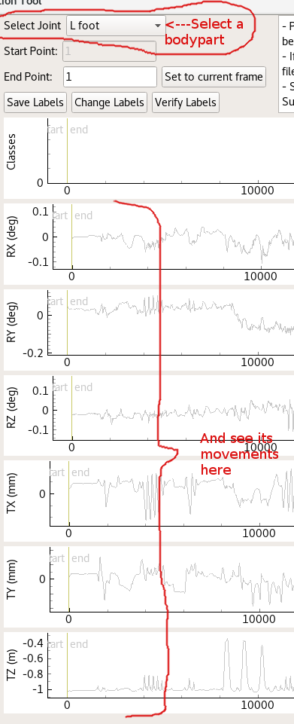
Joint Graphs

If you want to get more information on a certain body part you can click on the “Select Joint”-Combobox and choose the one you want. For example you can select “L foot” to see when the left foot moves in the TZ graph, therefore changes its height relative to the lower back. This is useful to see when the recorded person walks or ducks.

All coordinates are normalized to the lowerback, which means the lowerback is at the coordinates 0,0,0 and everything else moves around it.

Annotating/Saving Labels

Before you start annotating please make sure to read the Annotation Guidelines. The Tool provides a helpful button that opens a link to the Guidelines in your webbrowser. You can click the “Annotation Guide”-Button anytime you want to reread about some classes or attributes.
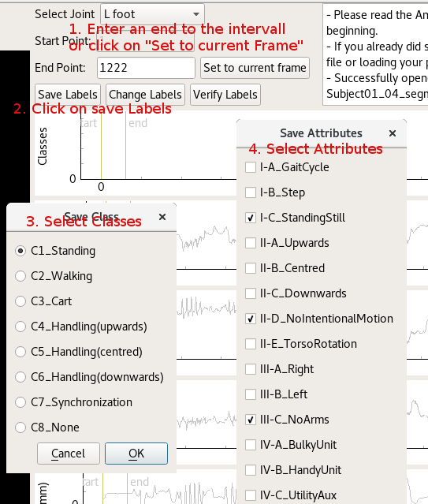
To save a label window, you need to enter an endframe, until when your labels that you want to enter are valid. Or you can use the “Set to current Frame”-Button to automatically enter the same frame thats currently shown in the video. After you have entered a valid end point, you can click on the “Save Labels“-Button. You will get 2 Dialogs. The First will prompt you to enter the class for the current window. The second dialog will ask for the Attributes in that window.

After you have successfully entered both the class and all the attributes the new window will be saved. You can see your new Class Graph has been updated with a new bar. And your start point was automatically moved to the end of the last frame.
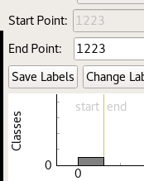

Changing Labels/Fixing Errors

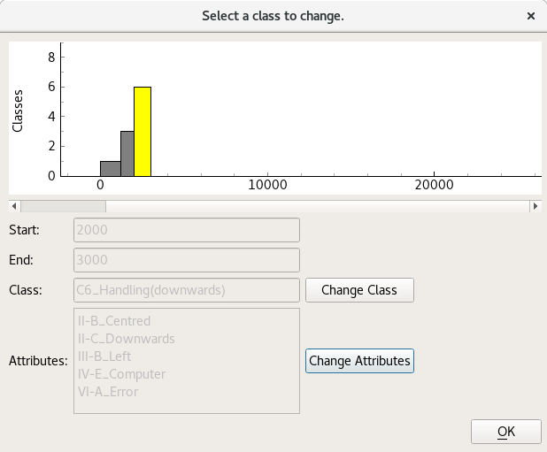
If you accidentally made an error while annotating you can use the “Change Labels”-Button.
You will get a dialog where you can select a certain window using the scrollbar and then you can click on the “Change Class”-Button and the “Change Attibutes”-Button. You will then get the same dialogs as you get when you first try to save a new Label.

Saving Completed Labeling

Once you finished labeling your entire video sequence you can then click on the “Verify Labels”-Button. If everything worked out alright you can see a confirmation message in the Help message window.

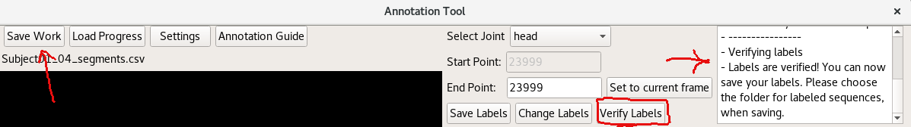
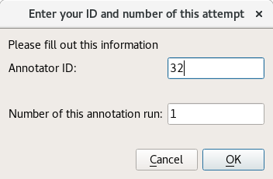
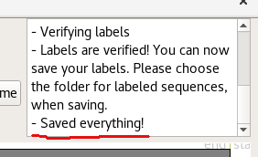
Now the “Save Work”-button has been enabled and you can click it. Once you do please select a directory where you want to save your finished work. After you select a directory you will get asked for your annotator ID and for the number of repetitions, how often you annotated this specific file. Once you fill out both you should see 3 new files in the directory you chose, together with another confirmation in the help message window.

Troubleshooting

If something goes wrong, most errors that you find should be found in the help message window. If the error is something unexpected or something severe try checking the console window that opened with the tool. If there is an error log try copying that and send it together with a description, of what you did before the error occurred, to your supervisor. They will probably send it to me (Erik) and after the error is fixed the tool will be updated so that it hopefully doesn’t happen again.

Label Correction Mode

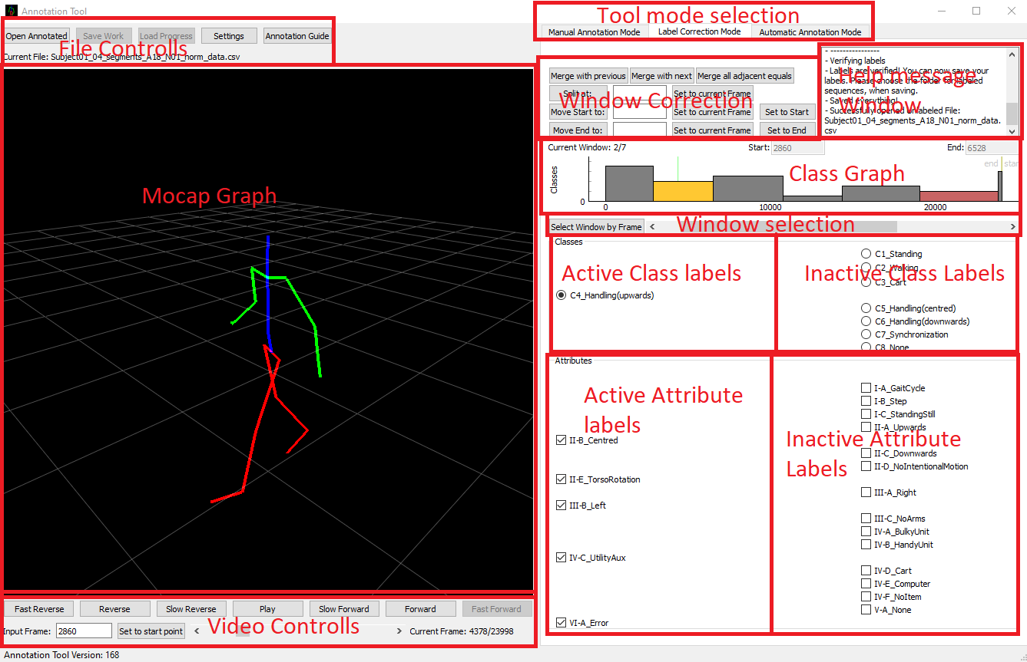

This part of the Tool was made to revise labels during or after annotation. It can change class labels, attribute labels, when a window starts/ends. It can also split windows or combine adjacent windows, which have the same labels.

Accessing Label Correction Mode
To switch between the different modes of the tool you can simply click on the tab that you need.

Opening Already Annotated Files
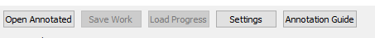
While in Label Correction Mode you can use the Open Annotated button to open a _norm_data.csv file. To work there should be the corresponding _labels.csv and _windows.txt located in the same folder.

If you already have a file opened after working in Manual Annotation Mode you don’t have to do anything before starting to work in the Label Correction Mode.

Selecting Label Windows
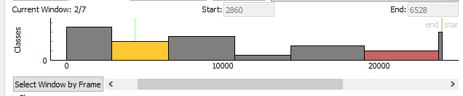
The Class Graph shows the existing windows. The selected window is shown in Yellow or Orange depending on whether the Error Attribute is present. A not selected window with the Error Attribute will be red. All other windows will be gray.

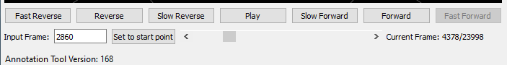

There are multiple ways to select a window to work on.
You can simply play the mocap video and the tool will automatically select the window that contains the currently shown frame. Or you can use the “Select Window by Frame”-Button to select the window based on the current frame if you don’t want to play the Video.
The third way is to use the scrollbar bellow the class graph.

Changing Labels
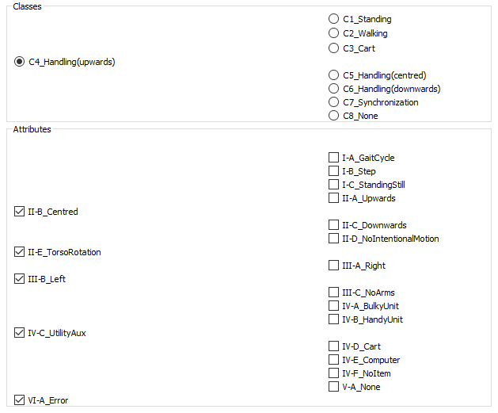
After selecting a window, to change labels simply select an unchecked radiobutton for a class, or click on the checkboxes to check and uncheck single attributes.

Manipulating The Windows
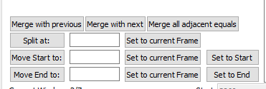
With these buttons you can change a windows start-/end-frame you can split windows and merge adjacent windows if they have the same class and attributes. To use any of the functions make sure you select the right frame. To move the startpoint, endpoint or to split a window you can either enter a frame where to move the start, end or the point at which to split at in the box next to the corresponding button. You can also use the “Set to current Frame”-Buttons to automatically fill a Box with the current video frame. Then simply use the “Split at”-,”Move Start to”- or “Move End to”-Buttons to perform the needed action.

To prevent gaps and overlaps between windows the moving of start/end frames also move the previous window’s end/next window’s start to the same frame.

The last function is the merging of windows. You can merge 2 adjacent windows if they have the same class and attributes. The “Merge with previous”-, “Merge with next”-Buttons try to merge the current window with the previous/next window. The “Merge all adjacent equals”-Button tries to go through the entire list of windows and merges all mergeable windows.

Saving corrections

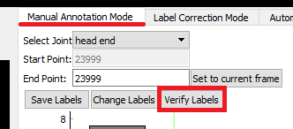

To save your work, go back to Manual Annotation Mode and click the “Verify Labels”-Button. If verified successfully you can now use the “Safe Work”-Button to save your progress.

