No. 5 A2P Hubber Domestic

Ini adalah shell script untuk loader data sms :

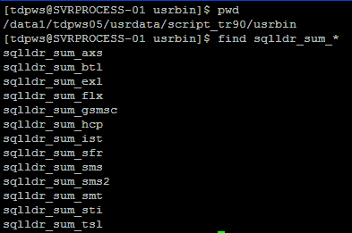

***-- list function for calculating tariff dan fee-bill A2P & P2P Hubber***

***get_sum_sms***

***get_sum_sms_bck***

***Potongan scritp :***

|  |
| --- |
| BEGIN    if r_data.DEC_SERVTP IS NOT NULL then  SELECT COUNT(1)  INTO v_chek_a2p  FROM P_CUSTOMER_A2P  WHERE CUSTOMER_NAME = v_customer  AND LINKSET = r_data.linkset  AND WAY = r_data.sms_type;    if v_chek_a2p = 0 then    v_chek_a2p := -99;    end if;    else  v_chek_a2p := -99;  end if;    EXCEPTION  WHEN no_data_found THEN    v_chek_a2p := -99;    END;    -- a2p tariff  if v_chek_a2p <> -99 then    select tariff  into v_tariff  from P_TARIFF_A2P  where linkset = r_data.linkset  and customer = v_customer  and sms_type = r_data.sms_type  and valid_from <= to_date(r_data.tgl,'dd/mm/yyyy')  and valid_until >= to_date(r_data.tgl,'dd/mm/yyyy')  ;    else  -- hubber  select tariff  into v_tariff  from p_tariff_sms  where linkset = r_data.linkset  and customer = v_customer  and sms_type = r_data.sms_type  and valid_from <= to_date(r_data.tgl,'dd/mm/yyyy')  and valid_until >= to_date(r_data.tgl,'dd/mm/yyyy')  ;  end if;    exception  when no_data_found then  v_tariff := 0;  end; |

Naming detail & Summary (berdasarkan name existing)

|  |
| --- |
| C:\DOCUME~1\triklin\LOCALS~1\Temp\x10sctmp5.png |
| C:\DOCUME~1\triklin\LOCALS~1\Temp\x10sctmp6.png |

*-- load data dashboard*

TDPWS.LOAD_DATA_DASHBOARD; *--[run by job every midnigth]*

Detail sms other (load balancing) & semua shell script detail + awk dan dan shell script summary + awk sudah di pasang di crontab tiap-tiap mesin :

|  |
| --- |
| C:\DOCUME~1\triklin\LOCALS~1\Temp\x10sctmp9.png |

List of view,procedure & script awk related patching

|  |
| --- |
| C:\DOCUME~1\triklin\LOCALS~1\Temp\x10sctmp14.png |

Capture A2P detail and summary from dashboard

|  |
| --- |
| C:\DOCUME~1\triklin\LOCALS~1\Temp\x10sctmp15.png |
| C:\DOCUME~1\triklin\LOCALS~1\Temp\x10sctmp18.png |
| Capute Detail A2P |
| C:\DOCUME~1\triklin\LOCALS~1\Temp\x10sctmp19.png |
| Capture Summary A2P |

No. 6 A2p International

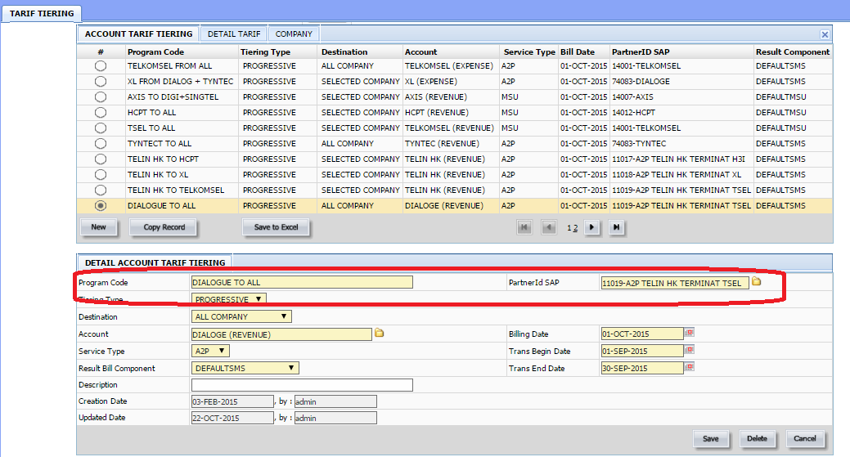

No. 7 a . Reject Event :

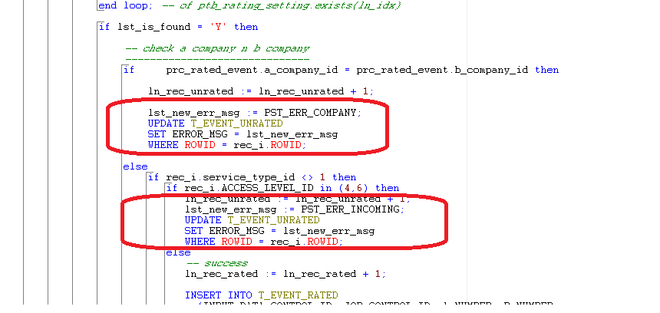

No. 7.b Menyediakan data flatfile trafik Agustus dan

September 2015

- Menyiapkan menu yang bisa di running oleh user

untuk melakukan filat file generation

