**21002 42nd Ave APT 2G,Bayside, NY 11361**

**2 beds 1 bath 900 sqft**

**FOR RENT**

**$2,150 /mo**

BAYSIDE MANOR SPAECIALIST  
LOW BROKER FEE  
FANTASTIC PLACE TO CALL HOME  
BROKER OFFERS DISCOUNTED FEE  
Recently renovated 2br garden apartment in Bayside Manor! Across the street from LIRR/Bayside ,28 min commute to Penn Station! Features large foyer with closets ,spacious living room/dining combo, new deluxe wht euro style kitchen with stainless appliances inc dishwasher and micro, slate floor ,ceramic backsplash and stone counter , updated wht and black ceramic tile bathroom with new granite floor , 2 big bedrooms with closets (great roommate setup) new wood floors ,landlord pays heat and hot water ,onsite super and laundry and garages available, CATS OK,DOGS OK!   
THIS BROKER ALWAYS OFFERS A FEE DISCOUNT!! IF YOU RENT FROM ANOTHER BROKER YOU WILL PAY MORE! Call JACK W WELLER GMUCA for all appts

**Facts and Features**

**Type**

Multi Family

**Laundry**

Shared

**Heating**

No Data

**Cooling**

No Data

**Pets**

Large dogs, small dogs

**Parking**

Attached Garage

**RENTAL FACTS**

* Date available: 1/15

Deposit: **$2,150 /mo**

**INTERIOR FEATURES**

**Bedrooms**

* Beds: 2

**Appliances**

* Appliances included: Dishwasher

**Flooring**

* Floor size: 900 sqft

**Other Interior Features**

* Storage

**CONSTRUCTION**

**Type and Style**

* Multi Family

**EXTERIOR FEATURES**

**Yard**

* Garden

**PARKING**

* Parking: Attached Garage

**OTHER**

* Fios Available, Guarantor Ok, Guarantors, Large Dogs Allowed, Live In Super, Parking Type: Garage, Small Dogs Allowed

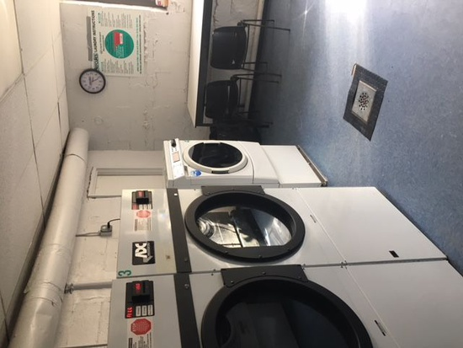

Living room

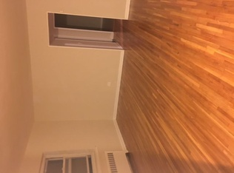

Bath room

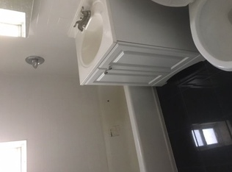

Kitchen

