CPS 232 – 2026 Fall – Assignment #2
Searching Algorithms: Membership in an Unsorted Set, and Searching Near the Front of a Sorted List
Print names: 1. Andrew Wilk
Code and experiments (GitHub): https://github.com/wilka-misericordia/CPS232-HW2
Files: search_algorithms.py (all algorithms, tests, experiments), results/ (CSV tables and PNG graphs).

Problem 1 (50 pts): Is w in the set S?

1.1 Algorithm
Input: an unsorted set S of n natural numbers (stored in an array) and a natural number w. Output: true if w is in S, otherwise false. The algorithm has two steps and uses only comparisons, indexing, arithmetic and loops (no built-in sort, search, or library).
- Merge sort S into a sorted array A.
- Binary search A for w.
MERGE-SORT(S): BINARY-SEARCH(A, w):
if |S| <= 1: return S lo = 0 ; hi = |A| - 1
mid = floor(|S| / 2) while lo <= hi:
L = MERGE-SORT(S[0 .. mid-1]) mid = floor((lo + hi) / 2)
R = MERGE-SORT(S[mid .. end]) if A[mid] == w: return mid
return MERGE(L, R) if A[mid] < w: lo = mid + 1
else: hi = mid - 1
MERGE(L, R): return -1
i = 0 ; j = 0 ; out = []
while i < |L| and j < |R|: CONTAINS(S, w):
if L[i] <= R[j]: append L[i]; i++ A = MERGE-SORT(S)
else: append R[j]; j++ return BINARY-SEARCH(A, w) != -1
append the rest of L, then the rest of R
return out

1.2 Correctness
Lemma 1 (MERGE is correct). If L and R are sorted, MERGE(L, R) returns a sorted list containing exactly the items of L and R.
Proof (loop invariant). Before each iteration of the main loop: (a) out is sorted, (b) out holds exactly L[0..i-1] and R[0..j-1], and (c) every item in out is ≤ every unused item L[i..] and R[j..]. Initially out is empty, so all three hold. Maintenance: suppose L[i] ≤ R[j]. Because L is sorted, L[i] ≤ every later item of L, and L[i] ≤ R[j] ≤ every later item of R, so L[i] is a smallest unused item. Appending it keeps (a)–(c). The other branch is symmetric. When the loop stops, one list is used up; the leftover of the other list is sorted and, by (c), ≥ everything in out, so appending it keeps the result sorted and complete. ∎
Lemma 2 (MERGE-SORT is correct). MERGE-SORT(S) returns a sorted rearrangement of S.
Proof (strong induction on n = |S|). Base case: n ≤ 1. A list with 0 or 1 items is already sorted, and the algorithm returns it unchanged. Inductive step: let n ≥ 2 and assume the claim for all sizes smaller than n. The two halves have sizes ⌊n/2⌋ and ⌈n/2⌉, both at least 1 and less than n, so by the induction hypothesis L and R are sorted rearrangements of the two halves. By Lemma 1, MERGE(L, R) is a sorted list containing exactly the items of S. ∎
Lemma 3 (BINARY-SEARCH is correct). On a sorted array A it returns an index holding w if w occurs in A, and −1 otherwise.
Proof (loop invariant). Invariant: if w occurs anywhere in A, then it occurs in A[lo..hi]. It is true at the start (the window is the whole array). If A[mid] < w, then since A is sorted every item in A[lo..mid] is ≤ A[mid] < w, so none equals w and setting lo = mid + 1 loses nothing. If A[mid] > w the symmetric argument justifies hi = mid − 1. If A[mid] = w the algorithm returns a correct index. The window shrinks every iteration, so the loop ends; if it ends with an empty window, the invariant says w does not occur in A. ∎
Theorem 1. CONTAINS(S, w) returns true exactly when w ∈ S. Proof. By Lemma 2, A is a rearrangement of S, so w ∈ S iff w occurs in A. By Lemma 3, BINARY-SEARCH decides that correctly. ∎

1.3 Time complexity
Merge sort. Merging lists of sizes a and b uses at most a + b − 1 comparisons. Let T(n) be the number of comparisons for n items. Then T(1) = 0 and T(n) ≤ T(⌈n/2⌉) + T(⌊n/2⌋) + n − 1.
Claim: T(n) ≤ n·⌈log₂ n⌉ for every n ≥ 1.
Proof (strong induction). Base: n = 1 gives T(1) = 0 = 1·0. Step: let n ≥ 2 and L = ⌈log₂ n⌉, so 2^(L−1) < n ≤ 2^L. Then n/2 ≤ 2^(L−1), so ⌈n/2⌉ ≤ 2^(L−1), which gives ⌈log₂⌈n/2⌉⌉ ≤ L − 1. Also ⌊n/2⌋ ≤ ⌈n/2⌉, so the same bound holds for it. Both halves are smaller than n, so by the induction hypothesis T(n) ≤ ⌈n/2⌉(L−1) + ⌊n/2⌋(L−1) + n − 1 = n(L−1) + n − 1 = nL − 1 ≤ n·L. ∎
The other work in one call (slicing, appending, copying the leftovers) is also at most c·n, so the running time satisfies T′(n) ≤ 2T′(n/2) + cn. Unrolling gives log₂ n levels with at most cn work per level, so merge sort is O(n log n).
Binary search. The window size starts at n and each iteration keeps at most ⌊size/2⌋ items, so after k iterations at most n/2^k items remain. The loop therefore ends after at most ⌊log₂ n⌋ + 1 iterations: O(log n).
Total: O(n log n) + O(log n) = O(n log n). After the one-time sort, every further membership question about the same set costs only O(log n).
Note on the bound. A single question on a completely unsorted set cannot be answered in o(n) time, because an algorithm that skips an element cannot rule out that this element equals w. So the O(log n) bound can only refer to the search step once the data is sorted, and the total for the whole job is O(n log n), which is what we prove. Experiment 1C shows when the sort pays off: for n = 100,000, sorting once and then using binary search is cheaper than scanning once the same set is queried about 72 times.

1.4 Experiments
All experiments are in search_algorithms.py, use a fixed random seed, and are checked against Python’s own sorted and in before timing (the built-ins are used only for testing and as a speed baseline, never inside the algorithms).
Exp 1A – time vs n. Random sets from n = 1,000 to 512,000. The time divided by n·log₂ n stays essentially flat (about 380 to 417 ns per n·log₂ n across the whole range), which is what O(n log n) predicts. Python’s built-in sorted is about 24× faster at n = 512,000 because it is written in C; this is a constant-factor difference and does not change the growth rate.
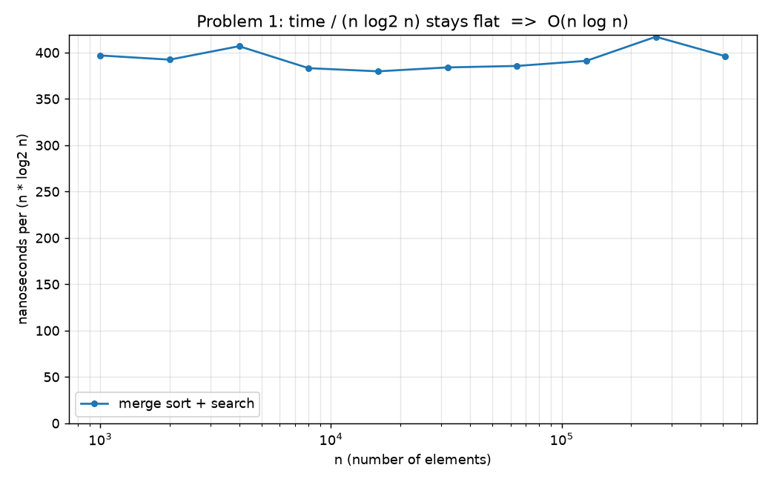
Figure 1. Time ÷ (n log₂ n) is roughly flat, so the growth is O(n log n).
Exp 1B – the proof checked by experiment. For every n tested, the measured number of comparisons was at most n·⌈log₂ n⌉ (the bound proved above); for n ≥ 128 the measured count was about 83% to 92% of the bound.
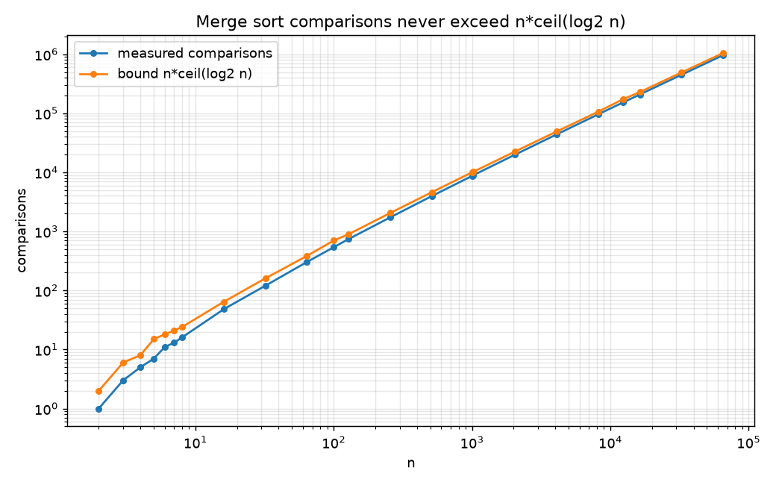
Figure 2. Measured comparisons (below) never exceed the proven bound.
Exp 1C – many queries. At n = 100,000 one sort takes 0.727 s, each binary search about 5 µs, and each linear scan 10.1 ms. Sorting once wins after about 72 queries; after 5,000 queries it is roughly 67× cheaper in total (about 0.75 s versus 50.6 s).
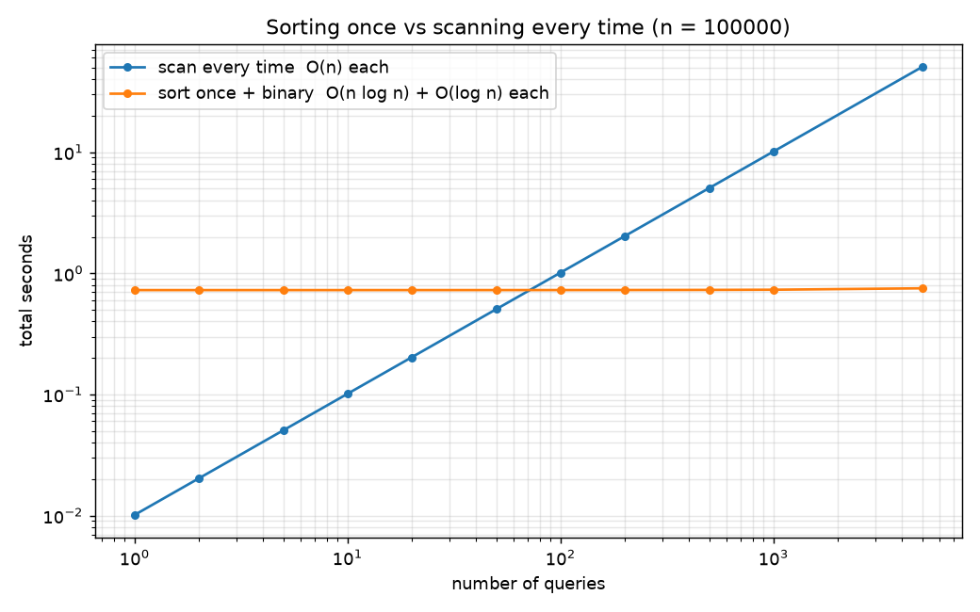
Figure 3. Sort once and search many times vs scanning every time.
Exp 1D – input order. Merge sort has no bad input: random, sorted, reversed, all-equal and few-distinct inputs of size 100,000 used between 0.8 and 1.5 million comparisons (n·log₂ n ≈ 1.7 million).

Problem 2 (50 pts): Searching near the front of a sorted list

2.1 Algorithm: exponential (galloping) search
Input: a sorted (ascending) array A of n numbers and a target x that sits at a small position i, with i ≪ n. Binary search costs O(log n) no matter where x is. The idea here is to make the cost depend on i instead of n: first find a window that must contain x by probing positions 1, 2, 4, 8, … (doubling), then binary search only inside that window. No extra data structure is used, only the array itself.
EXPONENTIAL-SEARCH(A, x):
if n == 0: return -1
if A[0] >= x: return 0 if A[0] == x else -1
bound = 1
while bound < n and A[bound] < x: # phase 1: gallop
bound = bound * 2
lo = floor(bound / 2) + 1
hi = min(bound, n - 1)
return BINARY-SEARCH(A, x, lo, hi) # phase 2: search the last window

2.2 Correctness
Invariant of phase 1. Whenever the loop test is evaluated, bound is a power of two and A[⌊bound/2⌋] < x. Initially bound = 1 and A[0] < x (the first check handled the other case). The loop doubles bound only when A[bound] < x, and the old bound becomes the new ⌊bound/2⌋, so the invariant is preserved.
When the loop stops either bound ≥ n or A[bound] ≥ x. Because A is sorted, every index ≤ ⌊bound/2⌋ holds a value ≤ A[⌊bound/2⌋] < x, so x cannot be there. If bound < n and x occurs at some index q > bound, then A[bound] ≤ A[q] = x ≤ A[bound], so A[bound] = x and bound itself is an occurrence. Hence, if x occurs in A at all, it occurs in A[⌊bound/2⌋+1 .. min(bound, n−1)]. Phase 2 runs BINARY-SEARCH (correct by Lemma 3) on exactly that range, and returns −1 if x is absent from it. Therefore the algorithm returns a correct index if x is in A and −1 otherwise. ∎

2.3 Time complexity
Let i be the index of the first element that is ≥ x (the position of x if it is present; i ≥ 1 after the first check). Phase 1 stops at the first power of two 2^k with A[2^k] ≥ x or 2^k ≥ n. At the previous step A[2^(k−1)] < x, which means 2^(k−1) < i. So k < log₂ i + 1 and phase 1 makes at most k + 1 ≤ log₂ i + 2 probes.
Phase 2 searches a window of 2^k − 2^(k−1) = 2^(k−1) < i items, and binary search on a window of s items takes at most ⌊log₂ s⌋ + 1 iterations, so phase 2 makes at most log₂ i + 1 comparisons.
Total ≤ 2·log₂ i + 3 comparisons = O(log i). This does not depend on n at all, and since i ≪ n we have log i ≪ log n, so the algorithm is asymptotically better than binary search’s O(log n). In the worst case (i close to n) the bound is still at most about 2·log₂ n, so the algorithm is never worse than O(log n). Linear search is O(i), which is exponentially worse than O(log i).

2.4 Experiments
Sorted lists of distinct random numbers (random gaps), n up to 4,096,000. Each point averages many targets at random positions between i and 2i, so one lucky or unlucky target cannot distort a result. Three algorithms are compared: linear search, binary search, and exponential search. We count comparisons (independent of the computer) and also measure wall-clock time.
Exp 2A – vary i at n = 1,000,000. Average comparisons:
i | linear | binary | exponential
1 | 1 | 19.0 | 1.0
10 | 14.2 | 18.9 | 8.9
100 | 155.7 | 18.8 | 15.5
1,000 | 1,613 | 18.7 | 21.9
10,000 | 14,801 | 18.7 | 28.5
1,000,000 | 1,000,000 | 20.0 | 40.0

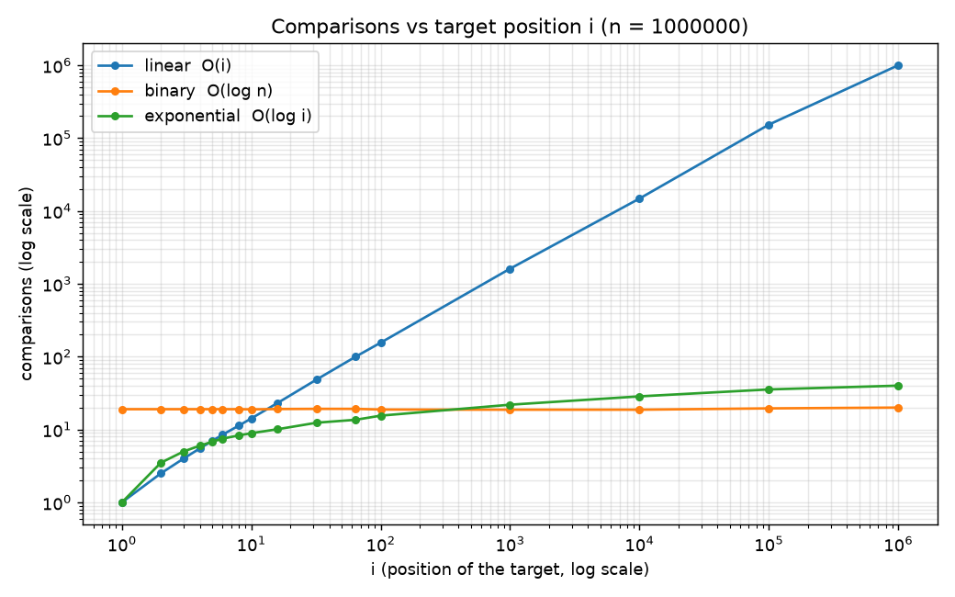
Figure 4. Exponential search beats binary search while i is small (here up to somewhere between i = 100 and 1,000).
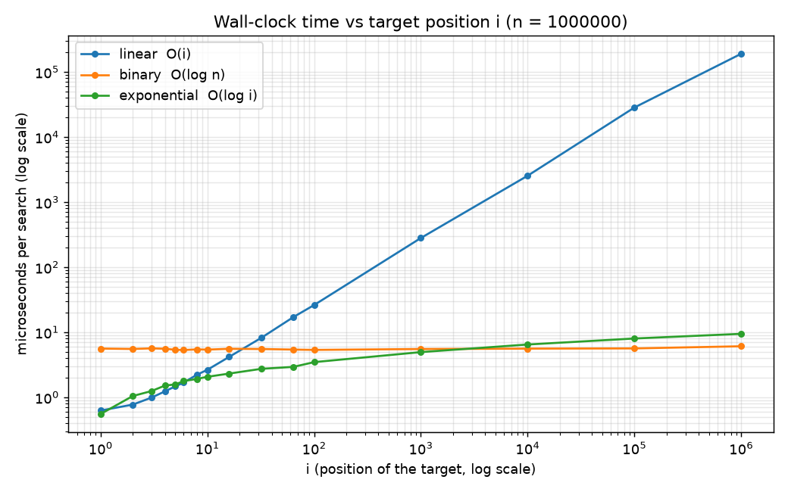
Figure 5. Wall-clock time shows the same picture.
Exp 2B – vary n with i fixed. With the target at position about 10, binary search needs more comparisons as n grows (9 at n = 1,000 up to 21 at n ≈ 4 million) while exponential search stays flat at about 9, exactly as O(log i) versus O(log n) predicts. At n = 1,000,000 and i = 10 the measured time is about 2.5 times lower; for i = 1 it is about 5–10 times lower.
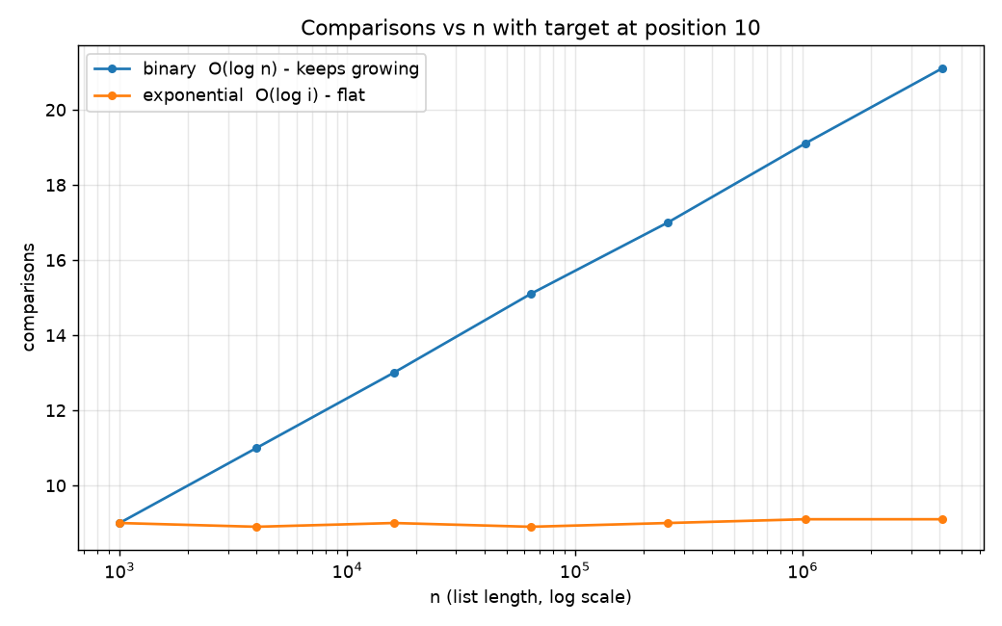
Figure 6. Binary search grows with n; exponential search does not (i = 10).
Honest limits. Exponential search does up to twice the comparisons of binary search (about 2·log₂ i versus log₂ n), so it only wins when i is smaller than roughly √n. For n = 1,000,000 the break-even measured here lies between i = 100 and i = 1,000 (theory: about √n = 1,000); for i around n it makes about twice as many comparisons (40 vs 20) but is still O(log n). In wall-clock time it stayed slightly ahead a little longer (still faster at i = 1,000: 4.95 µs versus 5.52 µs), because each gallop probe is cheaper than a binary-search step. For the tiniest targets (i ≤ about 5) plain linear search is equally cheap, but its cost grows linearly with i.

Conclusion
- Problem 1: merge sort + binary search is correct (induction and loop invariants) and runs in O(n log n) with O(log n) per search after sorting; experiments confirm the n log n growth and the proven comparison bound.
- Problem 2: exponential search is correct and runs in O(log i), better than O(log n) whenever i ≪ n; experiments show it is flat in n and about 5–10× faster for tiny i, with a break-even somewhere between i = 100 and 1,000 (theory: about √n).

