**User Guide**

cSPider 1.0 is free of charge, and can be used for various data formats (<http://pub.ist.ac.at/~schloegl/biosig/TESTED>).

**Program details:** Based on Matlab 2012b with installed Signal Processing Toolbox

**Folder Structure:**

The “biosig4octmat-2.90”-folder and the scriptfiles are supposed to lay in the same folder as the datasets which are determined for analysis. Furthermore you have to prepare a txt.file called ‘timings_csp_pulses’ which contains the respective timings of your TMS pulses.

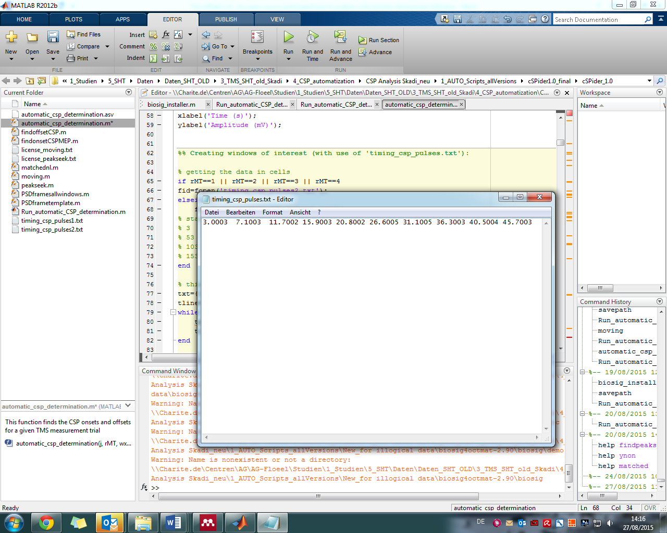

**Step 1:**

Open biosig_installer.m in Matlab and run it. Write “savepath” in the command window and press enter.

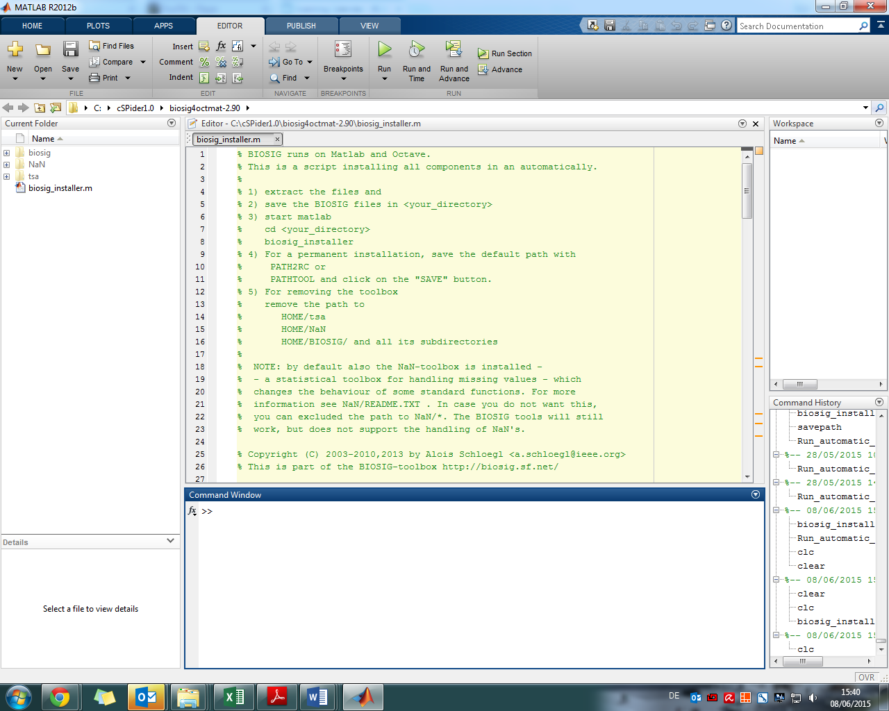

**Step 2:**

Open the scriptfile “Run_automatic_CSP_determination.m“.

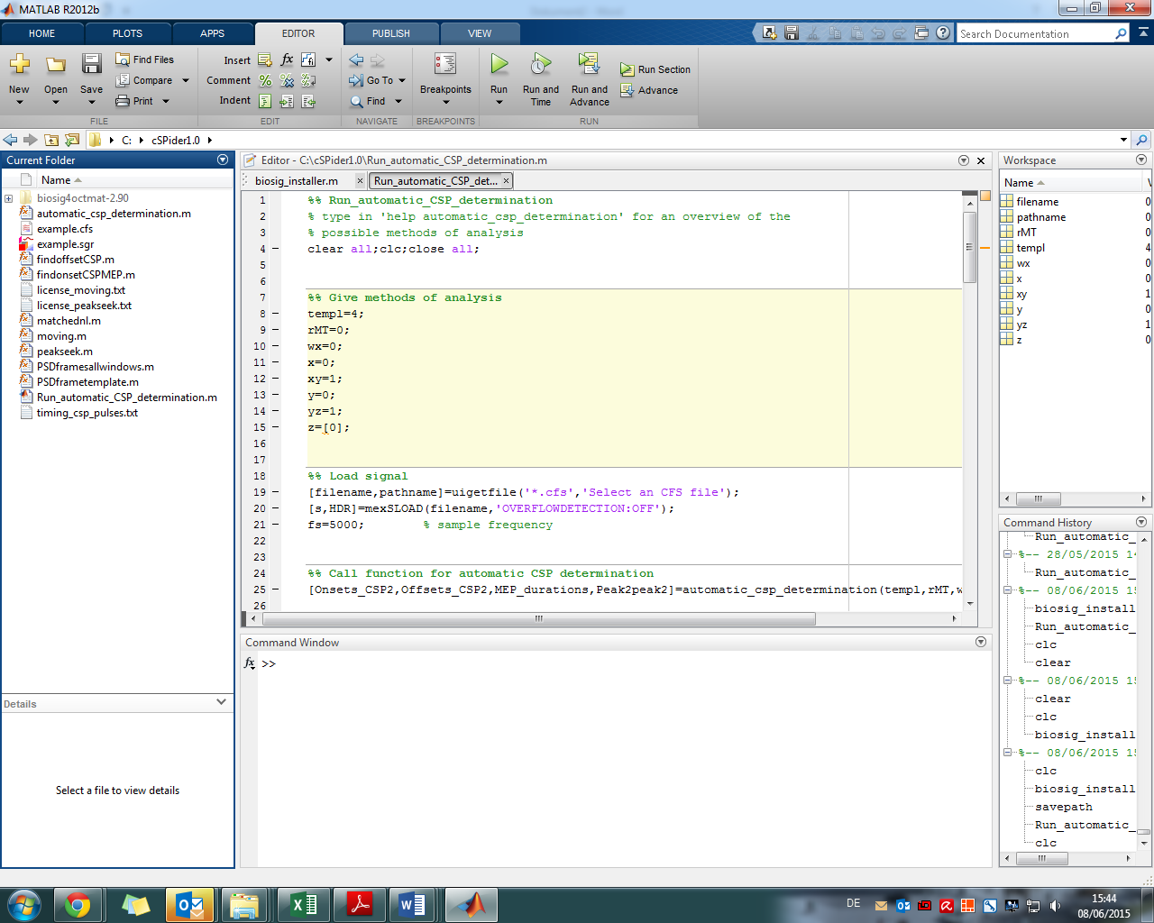

The following options are available and need to be considered:

**rMT**: choose rMT=1,2,3 or 4 when only 1 frame (10 pulses) was measured, for respectively strength TMS 110%, 120%, 130% 140% rMT, choose rMT=0 when all (4 at 10 pulses) frames are included.

**wx**: choose wx=1 to only analyze chosen template, in which the CSP offset is chosen manually and results are in the command window (**standard: wx=0**)

**x**: choose x=1 if, for any reason, a shorter window is preferred (**standard: x=0**)

**xy**: choose xy=1 if a visual check of all windows is desired, only possible for all frames (plots all windows behind each other plus on- and offsets)

**y**: choose y=0 for 1st option onset (real start) or y=1 for 2nd (minimum around 25 ms after TMS artefact)

**yz**: choose yz=0 for MEP offset finder with filtered signal + peakseek or yz=1 for MEP offset finder with spectrograms + matched filter, or yz=2 for fixed MEP duration (from found onset) of 0.025 ms (**standard: yz=1**)

**z:** give a row with failed (pulse) numbers of the data in the CSP-measurement. Give value 0 when no failures! Example: z=[3,4,8]

Run the scriptfile “Run_automatic_CSP_determination.m“. Select a datafile (.cfs) for analysis.

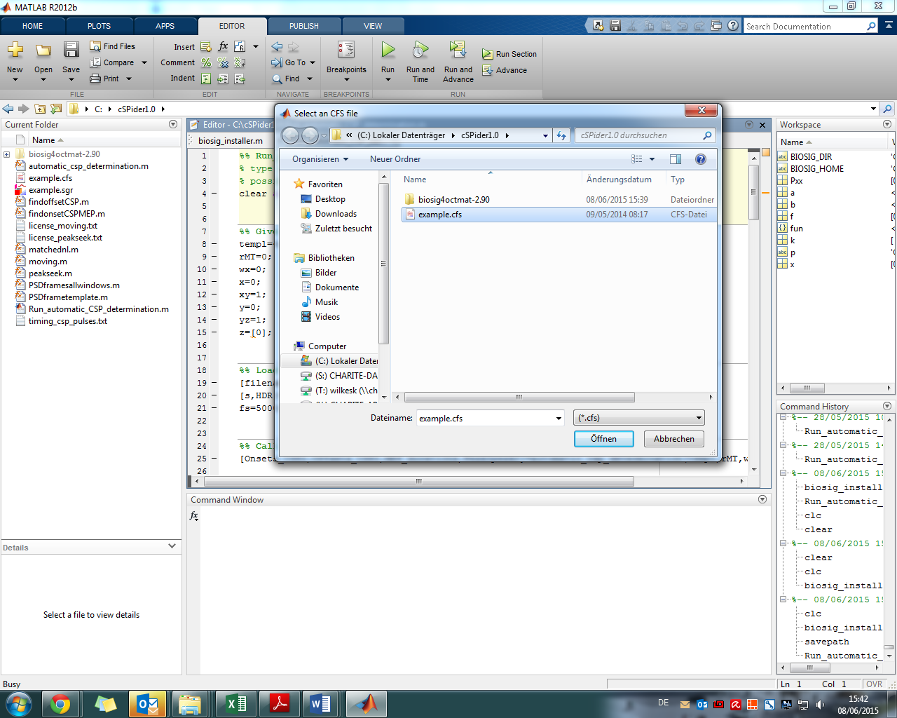

**Step 3:** A window for choosing onset and offset of an exemplary MEP opens. The dotted lines show a suggestion for MEP onset and offset. Click on dotted lines or choose other MEP onset and offset.

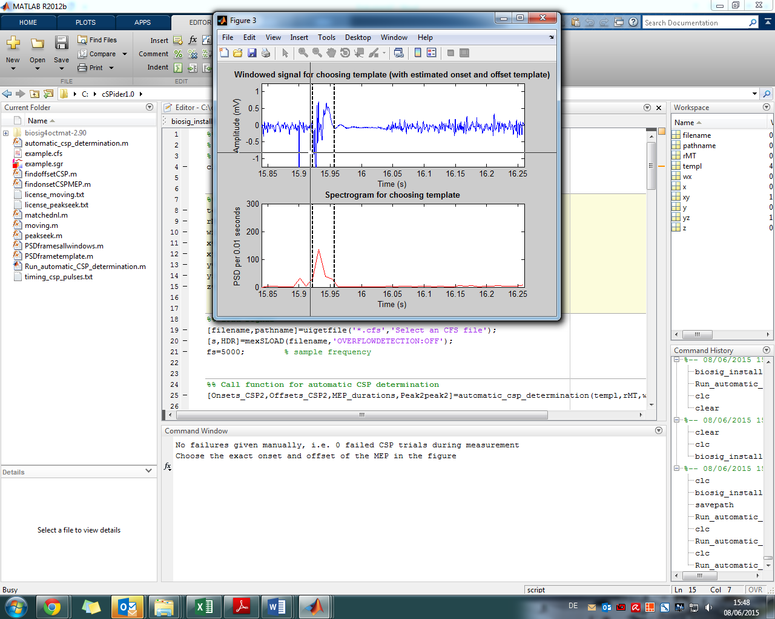

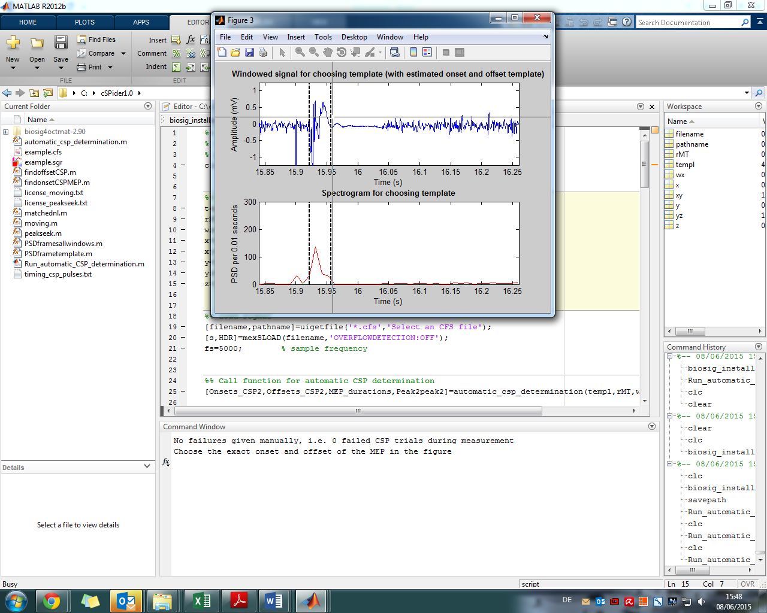

Another window might open for choosing the offset of another MEP – if no MEP is seen click on pulse artefact or somewhere in the beginning of the window.

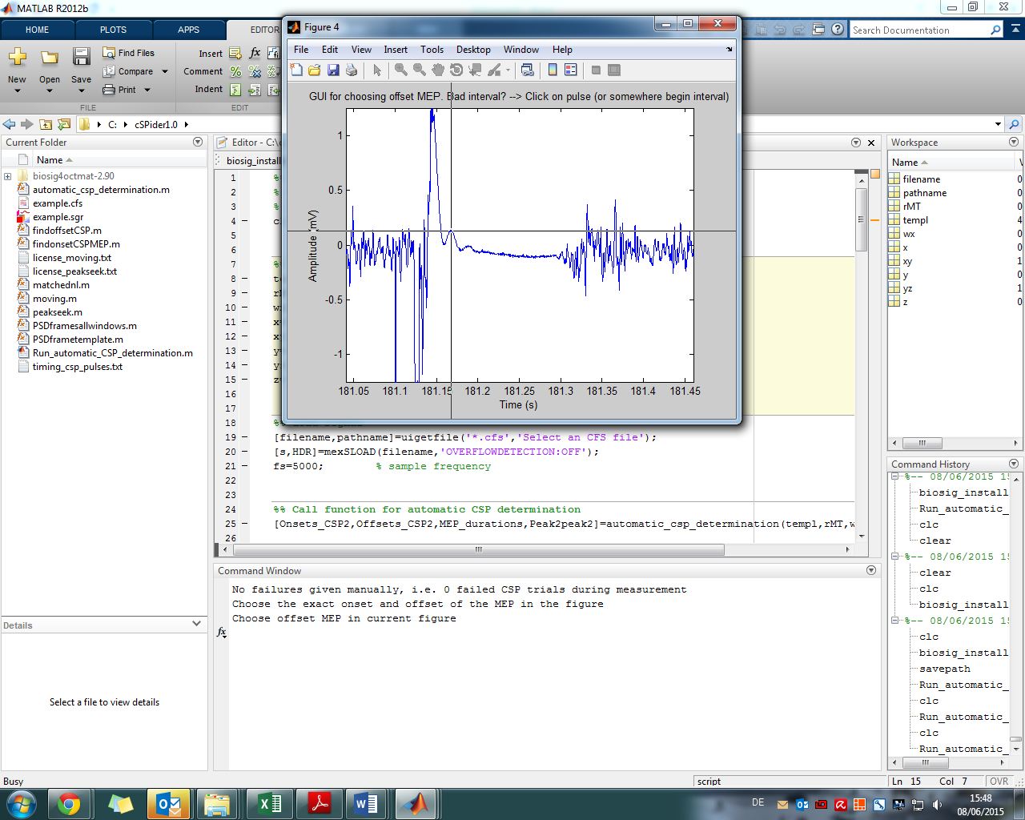

**Step 4:** Sometimes the CSP determination is not 100% clear, then you get the chance to choose the CSP offset manually. Or there actually isn’t a CSP - then click on the pulse artefact.

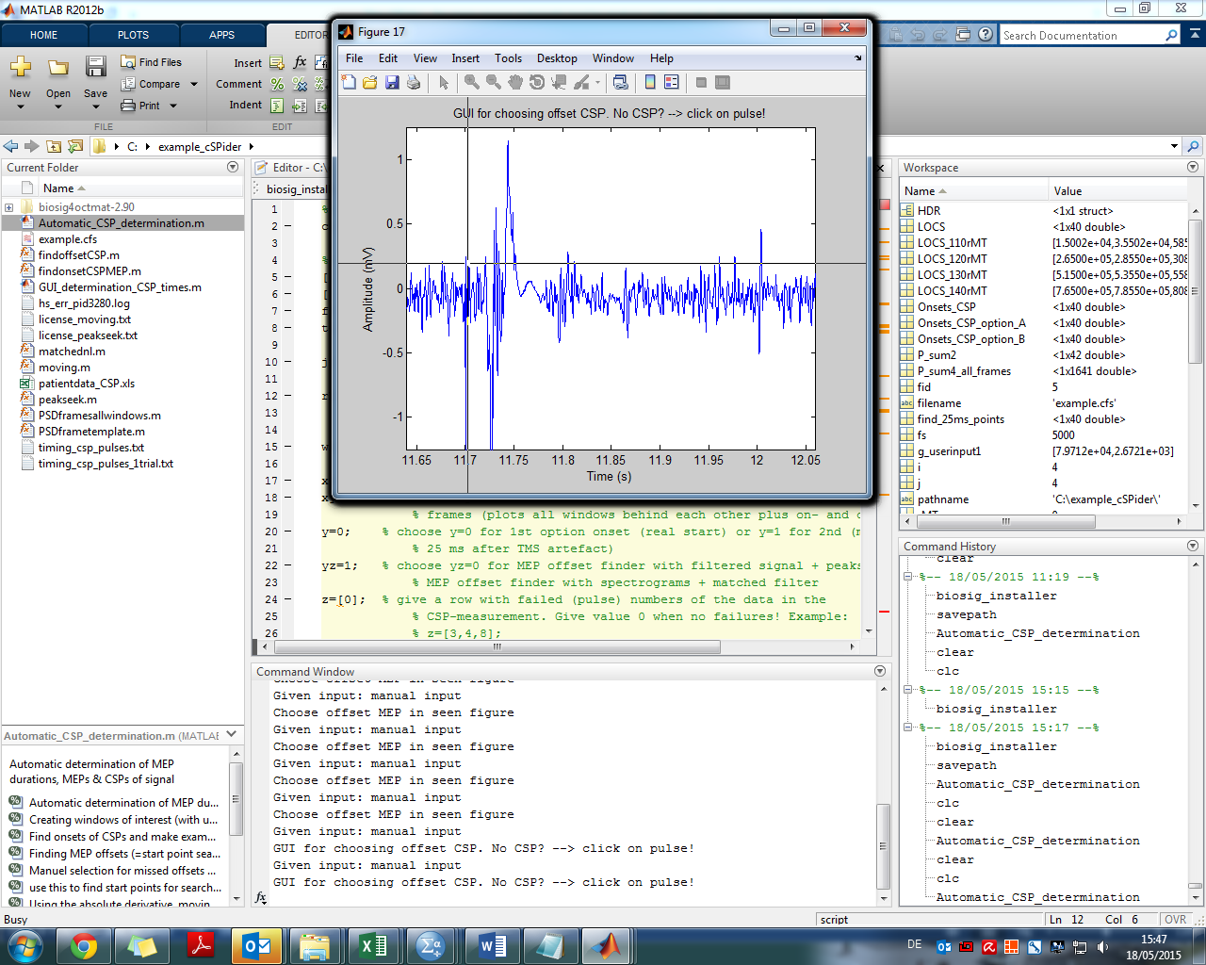

**Step 5:** An example window opens showing detected onset and offset of CSPs.

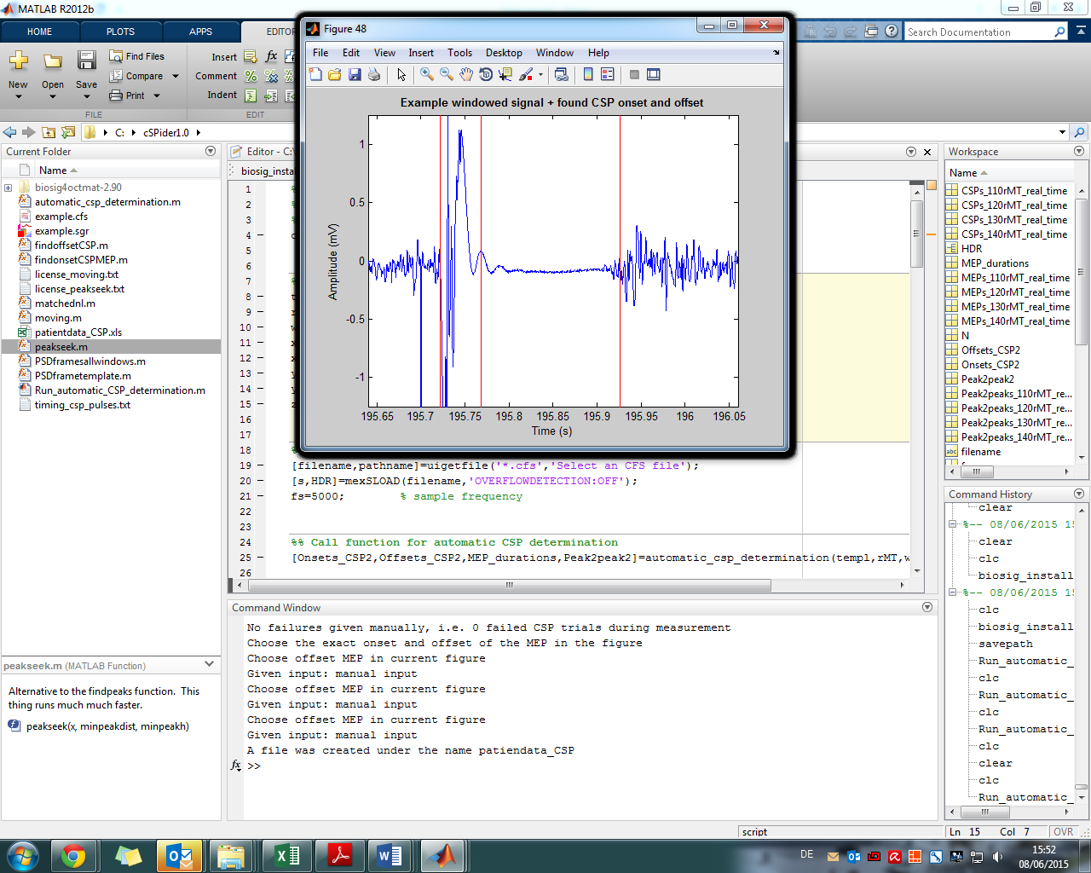

**Step 6:** Finally all detected CSPs are stored in patientdata_CSP.xls.

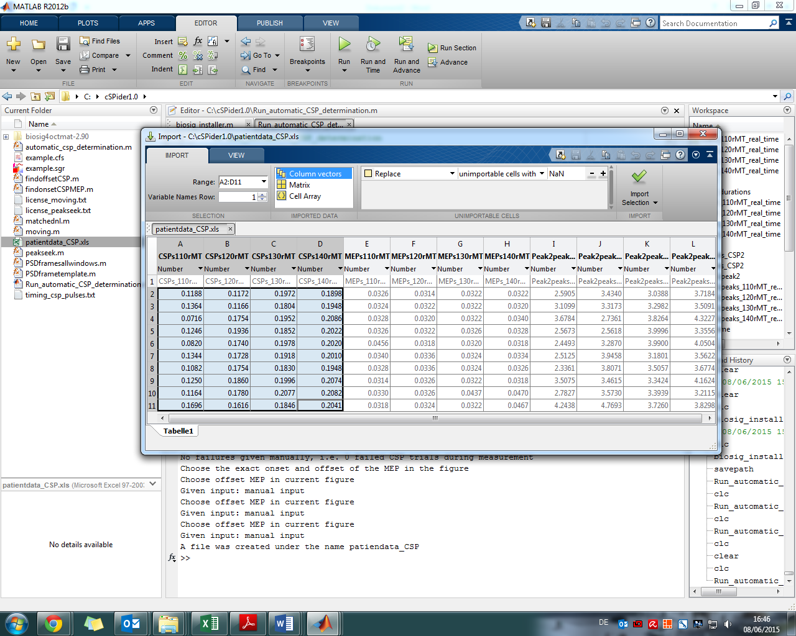

Besides, values for MEP durations (in seconds) and amplitude sizes are stored.