BIT 4107 – Mobile Application Development
ENHANCED PROFESSIONAL STUDENT LOGBOOK
Student Name: _Wilkester Ngatia_____________________________
Admission Number: __BIT/2024/55863____________________________
School/Faculty: ____COMPUTING & INFORMATICS__________________________
Programme: _Bachelor’s of Science in Information Technology_____________________________
Academic Year: __3.2____________________________
Semester: _____May-August_____________________
Lecturer: ___Michael Nyoro___________________________
Phone Number: _0113447271_____________________________

Instructions
This logbook is used to document weekly learning activities, practical exercises, skills acquired, challenges encountered, solutions applied, and reflections. Students should complete all sections every week.
Each week to follow remarks in week 1 section.

Autogenerated Table of content
Week 1: Introduction to Mobile Application Development
Practical Activities Undertaken
only screenshots needed and labeling
Screenshots/Evidence Attached (Yes/No)
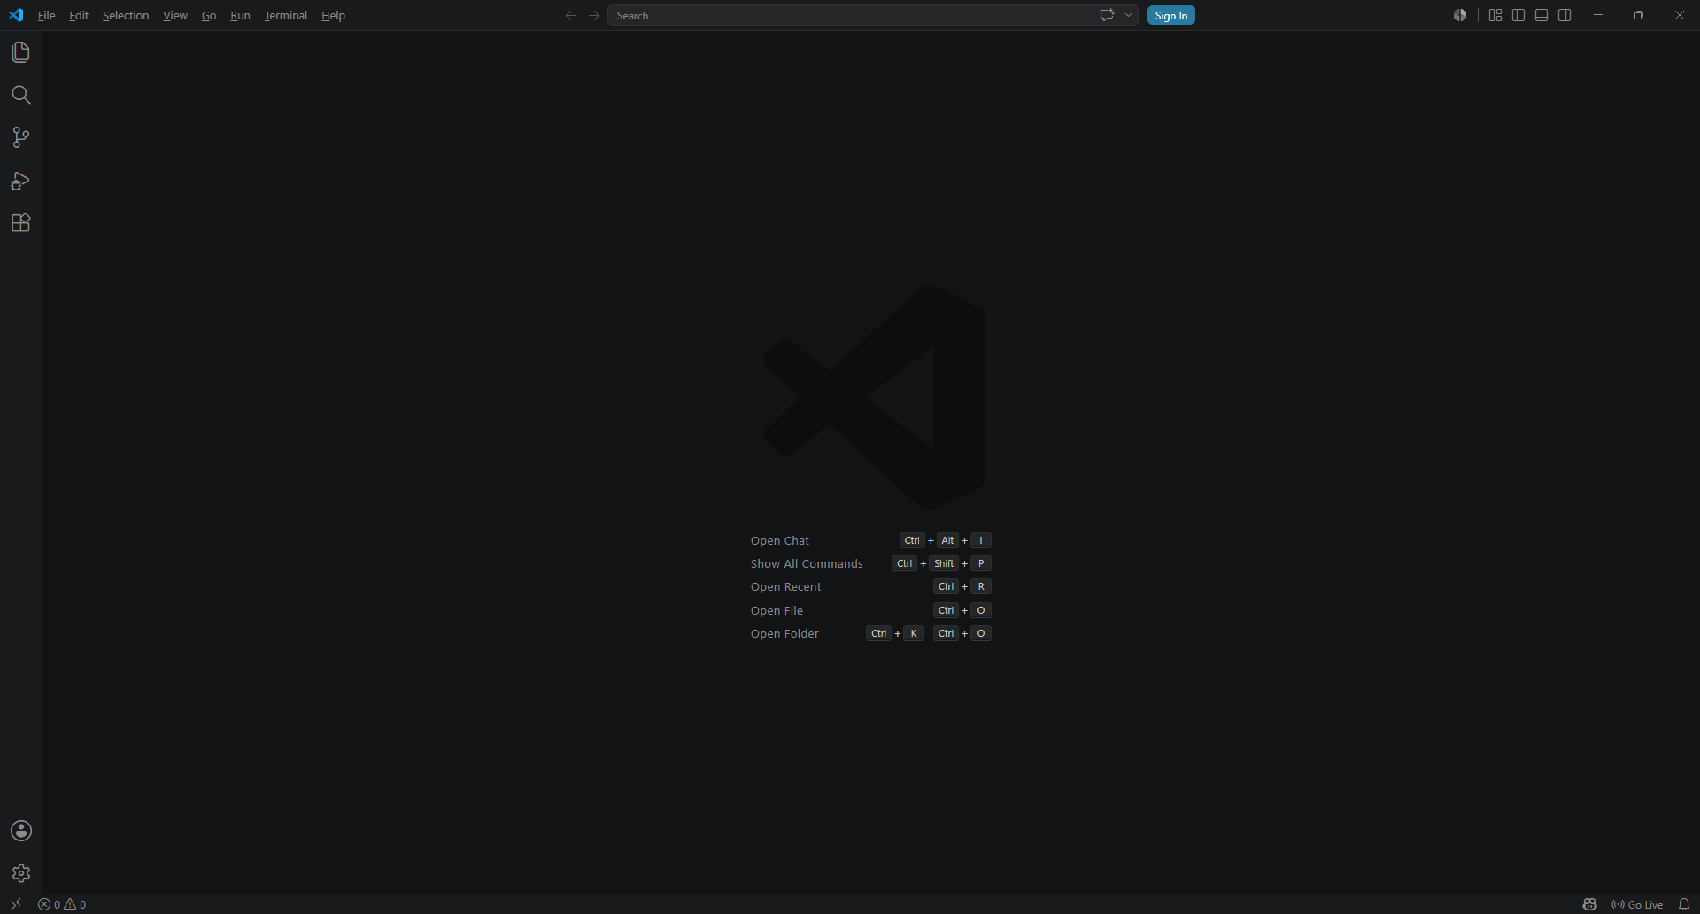
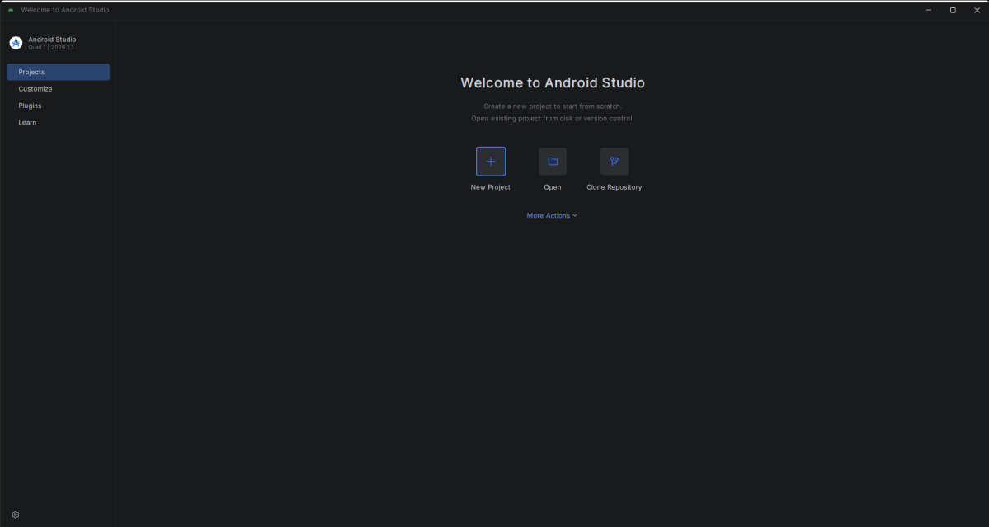
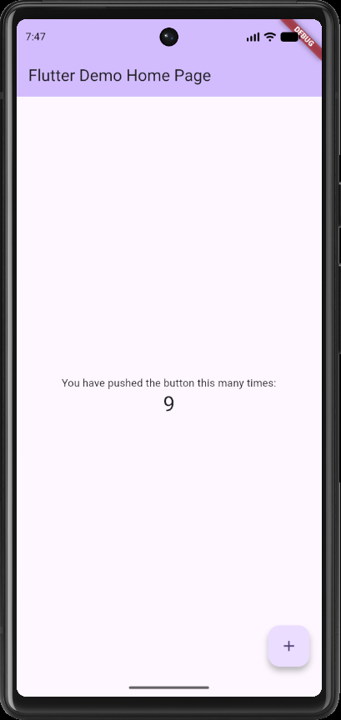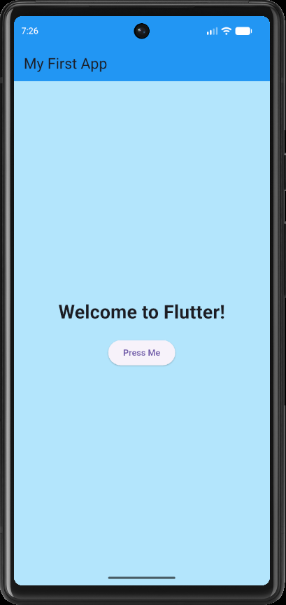

Tools/Software Used
- Visual Studio
- Flutter
- Android Studio
Personal Reflection
After Installing the Android Studio My Laptop Freezed and was not working I started losing hope I took a break then proceeded with the work.Push until something happens.
not more than 50 words

Week 2: Mobile Development Environment
Same as week 1

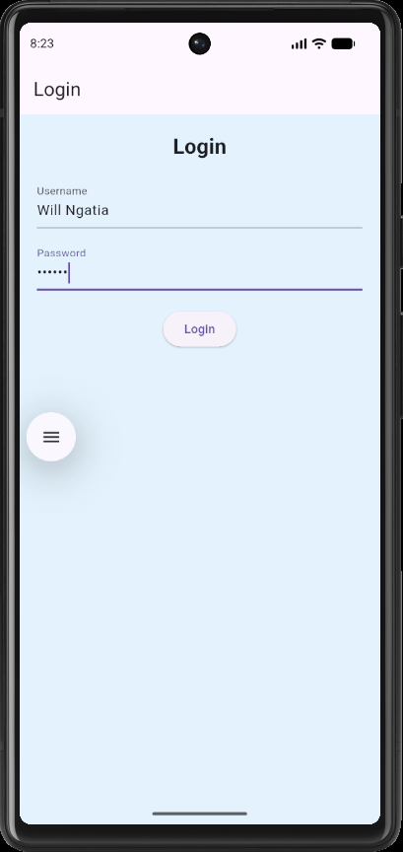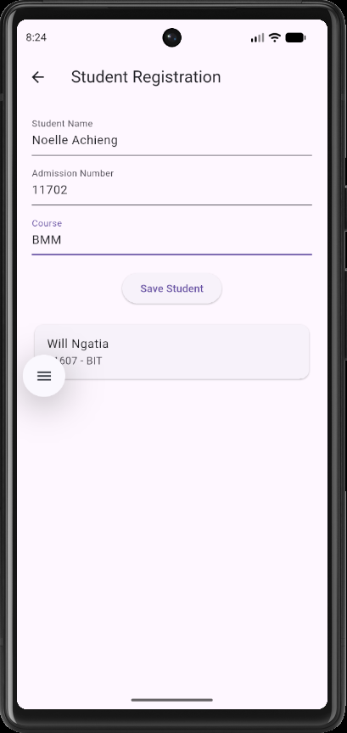

Week 3: User Interface Design

Same as week 1

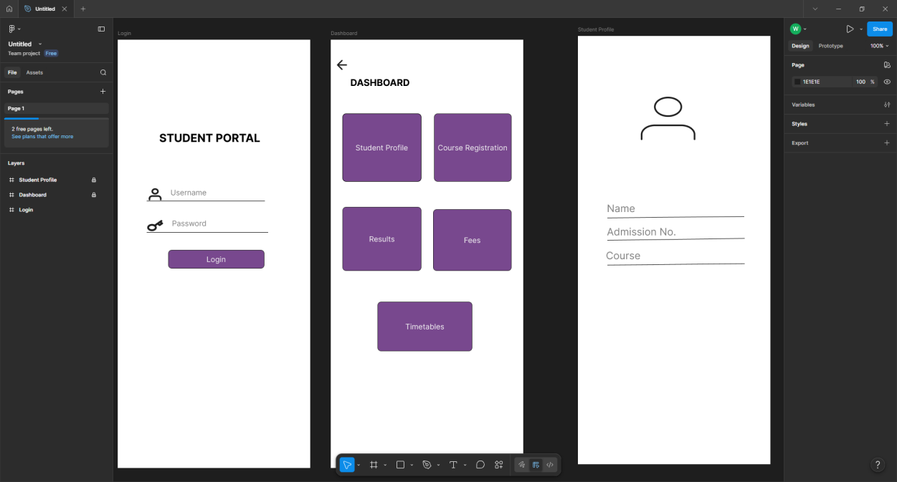

Week 4: Event Handling and User Interaction

Same as week 1
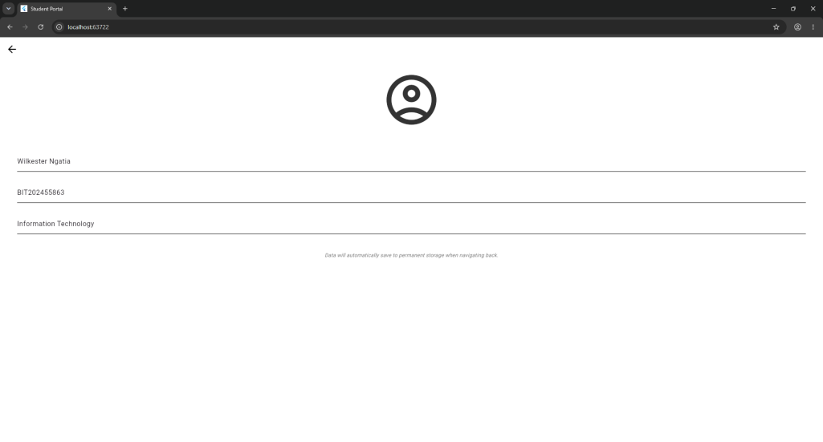
Week 5: Data Management

Same as week 1
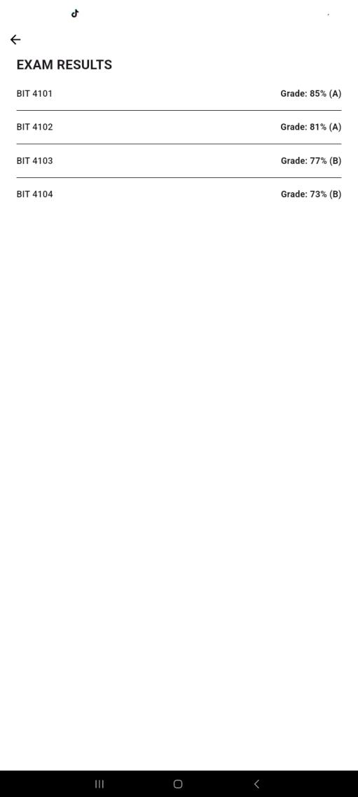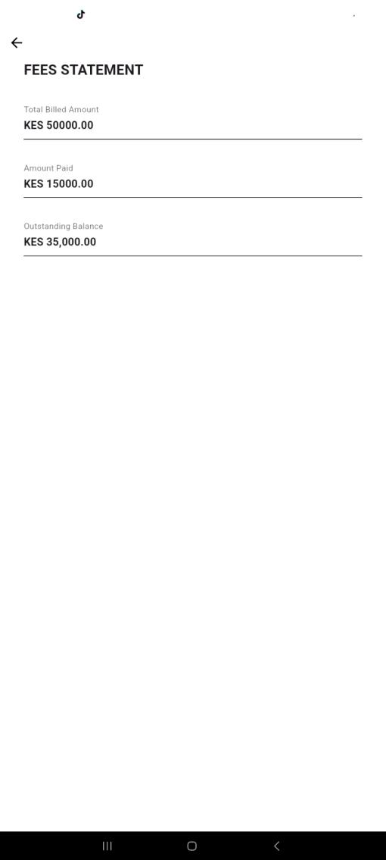

Week 6: Networking and APIs

Same as week 1

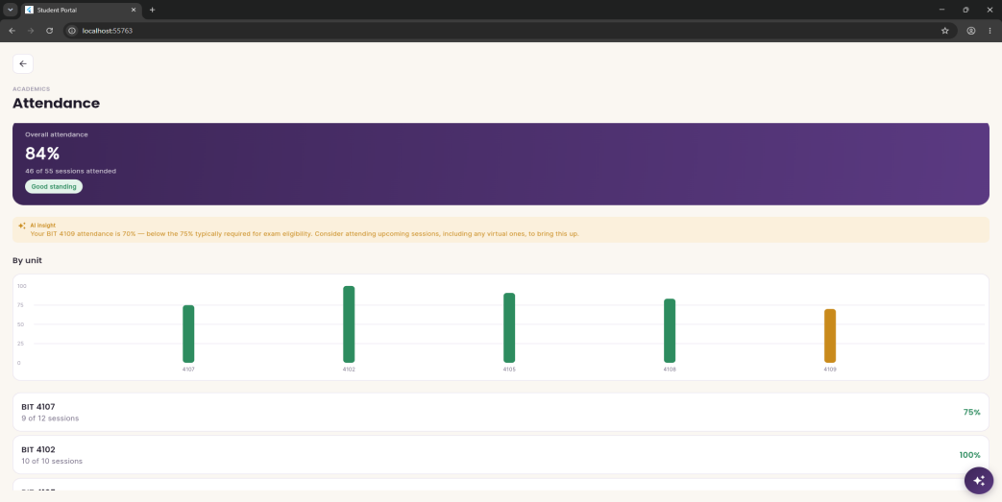
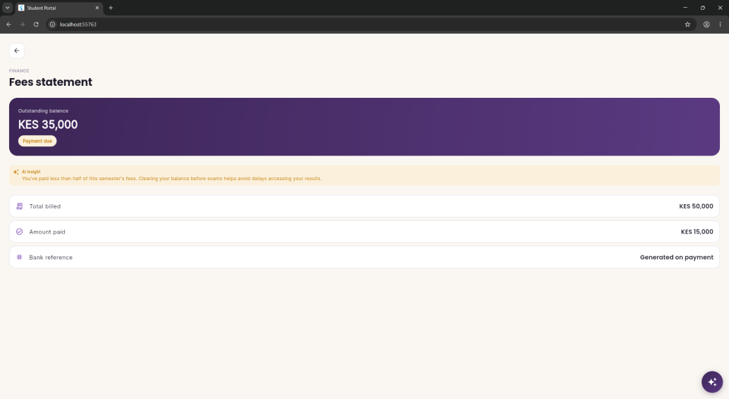

Week 7: Application Architecture

Same as week 1
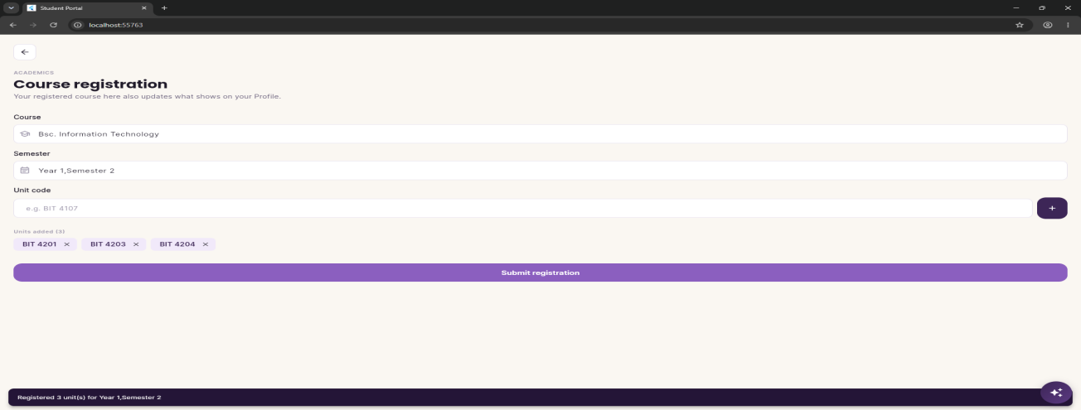
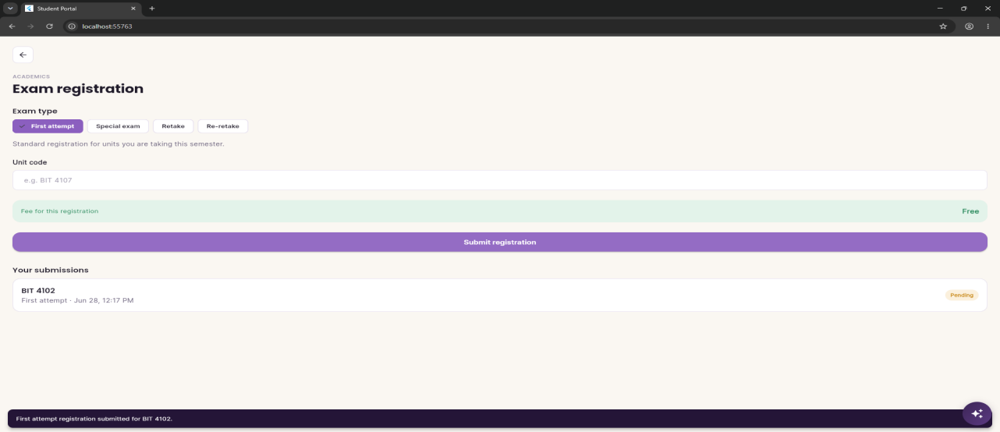

Week 8: Project Planning
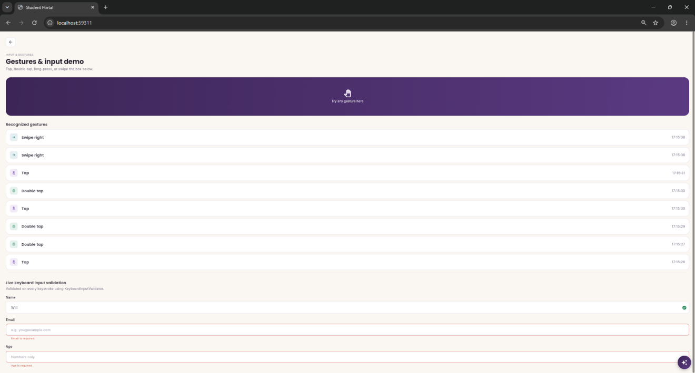

Week 9: Device Features and Sensors

Same as week 1

Week 10: Notifications and Background Services

Same as week 1

Week 11: Mobile Security

Same as week 1

Week 12: Testing and Debugging

Same as week 1

Week 13: Application Deployment

Same as week 1

Week 14: Final Project Presentation

Same as week 1

Semester Project Tracking

Project Title

Project Objectives

Project Requirements

Development Milestones

Testing Results

Lessons Learned

Future Improvements

End of Semester Reflection

Summary of Skills Acquired

Most Interesting Topic

Major Challenges Faced

How Challenges Were Overcome

Professional Growth Achieved

Overall Course Experience

Final Approval
Student Name: __________________________
Student Signature: ______________________
Date: _________________________________
Lecturer Name: _________________________
Lecturer Remarks: _____________________
Date: _________________________________

