Vildan Bozkurt- 190101042

Graduation Project : Machine Unlearning
Introduction
Subject:
"Machine unlearning" is generally a term used in the context of machine learning to describe the process of a machine learning model forgetting or erasing previously learned information or patterns. It's used to denote situations where the model needs to update or change the information it has learned.
In an other saying; machine unlearning is typically achieved by updating or resetting the weights or parameters in the model's memory.
Literature Review and Research:
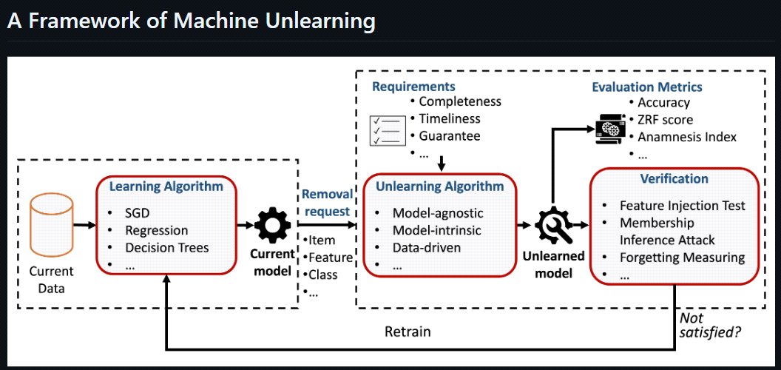
It is aimed to make progress in the project by implementing the steps shown in the figure. The resulting dataset is processed, then learning algorithms are applied (sgd, regression, decision trees, etc.). The items that need to be removed are determined and then unlearning algorithms (model-agnostic, model-intrinsic, data-driven) are applied.

Exact Unlearning Algorithms :
1. SISA
The SISA algorithm is an exact unlearning algorithm introduced in Bourtoule et al. (2021), borrowing aspects from both ensemble learning and distributed training to efficiently unlearn. This is achieved by a reorganisation of the training dataset, known as sharding and slicing, which reduces the time needed to retrain from scratch with the specified data removed. The full SISA algorithm is applicable to any machine learning model that has been trained incrementally, for example, via gradient descent. The loss function for such models need not be strongly convex, and Bourtoule et al. (2021) apply SISA successfully to deep neural networks (DNN) in a variety of architectures.
SISA without slicing is applicable to all machine learning models, including decision trees.
2. DaRE Forests
In ‘Machine Unlearning for Random Forests’, Brophy and Lowd (2021) introduce an exact unlearning algorithm that is specific to decision-tree and random-forest based machine learning models for binary classification. This is done through the development of Data Removal-Enabled (DaRE) trees, and the ensemble of these to form DaRE Forests (DaRE RF). Through the use of strategic thresholding at decision nodes for continuous attributes, high-level random nodes, and caching certain statistics at all nodes, DaRE trees enable efficient removal of training instances.
As a result, the removal mechanism is able to recall training data from the stored leaf instances, meaning that training data is not required as an explicit input to the mechanism.
Here we present SISA, whose entire method is applied to incrementally trained machine learning models and decision trees and random DaRE forests applied to forests are mentioned. Both SISA and DaRE forests are each used, often at the expense of effectiveness. It comes with two efficiency parameters to control the learning efficiency. However, without learning about Unlike subtraction methods, such parameters are also included in the initial training procedure; this means that they can be adjusted during training to maximize efficiency relative to a satisfactory effectiveness limit.
Machine Unlearning Algorithms :
Model-Agnostic Approaches: Model-agnostic machine unlearning methodologies include unlearning processes or frameworks that are applicable for different models. In some cases, they provide theoretical guarantees for only a class of models (e.g. linear models). But we still consider them model-agnostic as their core ideas are applicable to complex models (e.g. deep neural networks) with practical results.
Model-Intrinsic Approaches: The model-intrinsic approaches include unlearning methods designed for a specific type of models. Although they are model-intrinsic, their applications are not necessarily narrow, as many ML models can share the same type.
Data-Driven Approaches: The approaches fallen into this category use data partition, data augmentation and data influence to speed up the retraining process. Methods of attack by data manipulation (e.g. data poisoning) are also included for reference.
Dataset Preparation:
To test machine unlearning methods, a data set must be created or an existing data set must be used.
Confidentiality measures should be taken to protect sensitive information in the data set.

Machine Unlearning Methods:
Different methods must be learned for machine unlearning. These may include methods such as removing data points, updating model weights, and bias reduction.
It should be determined which method is most suitable for the project, depending on the dataset and project topic.
Model Training and Unlearning:
One or two machine learning models should be decided upon and trained (for example, deep neural network or linear regression).
Then, these models must be updated with unlearning methods. Unlearning can be done by removing certain data points or adjusting model weights.
Performance Evaluation:
The performance of the model after unlearning should be evaluated. Success should be measured using bias reduction, accuracy, sensitivity and other metrics.
Source:
https://deepgram.com/learn/what-is-machine-unlearning-and-why-does-it-matter
https://arxiv.org/abs/2209.02299
https://github.com/tamlhp/awesome-machine-unlearning/raw/main/framework.png
https://awesome-machine-unlearning.github.io/
https://arxiv.org/pdf/2209.00939.pdf
https://doi.org/10.48550/arXiv.2402.08787
https://github.com/cleverhans-lab/machine-unlearning

