Willy Esquivel-lopez

G01127937

**HW4 Report**

**Phase 1**

**My approach:**

When seeing the small dataset for Iris and realizing it was unlabeled and to target value was given, I could no longer use the traditional train test split among x and y. upon closer examination of the data I could still not find any correlation.

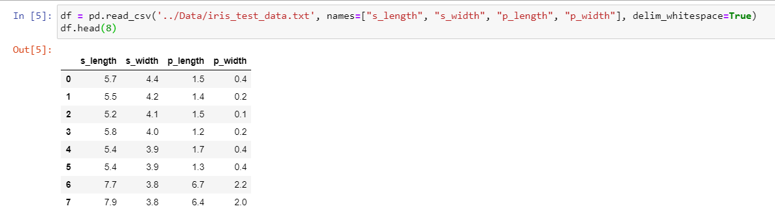

Thus, I tried plotting it to make sense and begin estimating some numbers

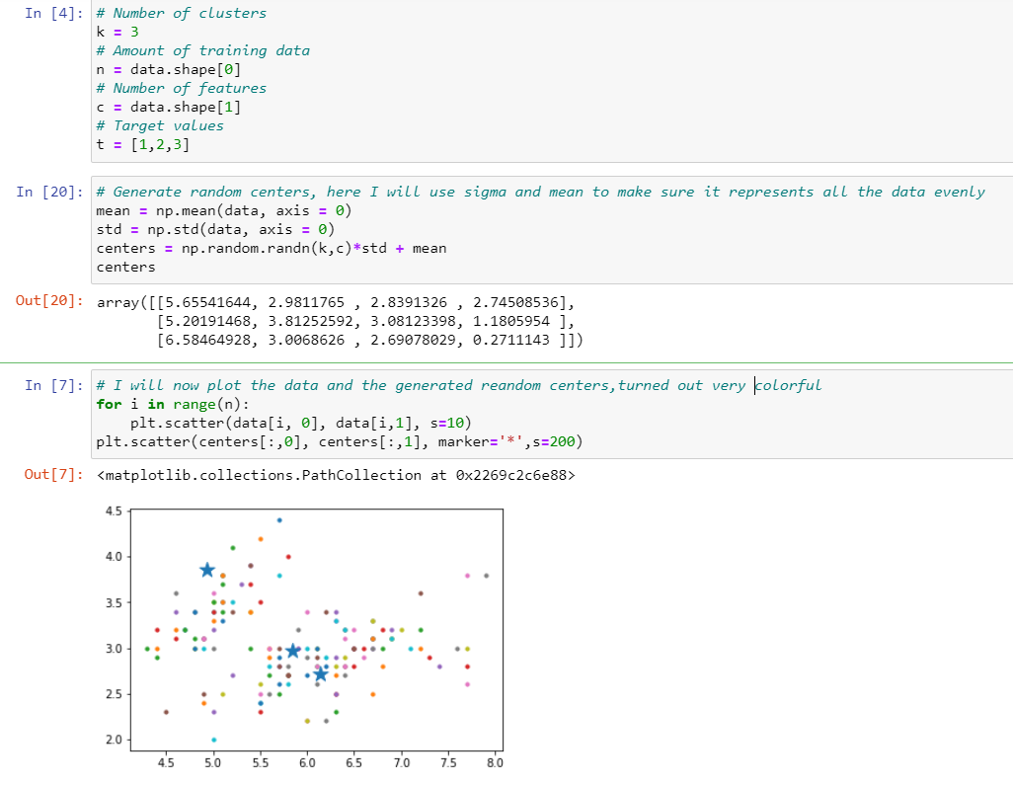

Making a scatter plot was difficult with 4 features and no target label. So I had to think of another Idea, I began to look at ways I can reduce the dimmensianality of my data but preserve the distributions and values