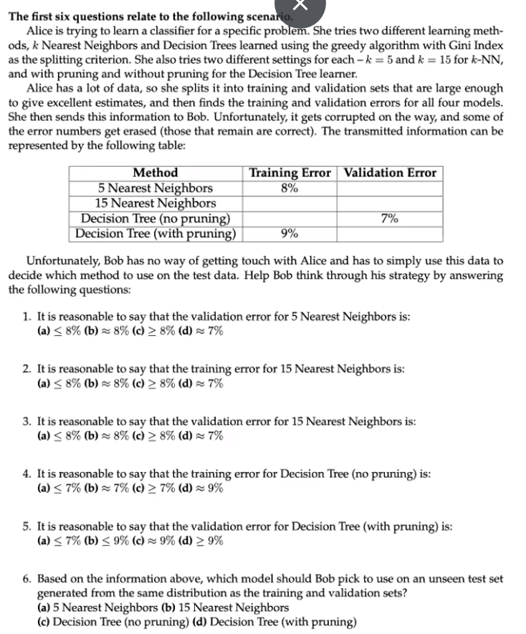

**ANSWERS:**

1. **C: >= 8%, because training error is an underestimate (optimistic) of the real error. If simple or linear they would be just about the same.**
2. **C: >= 8%, because more complex model == more overfitting. 5 is more complex 15 is less complex, thus less granular boundaries, thus training error goes up.**
3. **C: >= 8%, due to the combination of the last two answers.**
4. **A: <= 7%, because the validation error is 7% same reason as #1.**
5. **D: >= 9%, because the intuition is the same >= to its training error.**
6. **C: Decision Tree (No Pruning), because it has the lowest validation error.**

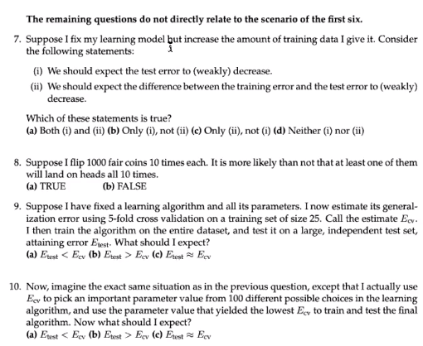

**ANSWERS:**

1. **A: Both i and ii, because our model would be more accurate and more accurace would mae the train and test error come closer while the test error decreases slightly.**
2. **A: True, because ½ ^ 10 = probability that it would become heads all the 10 times so .999 that it will not and then take .999 ^1,000 = .37 thus that is the probability it will not subtract 1-.37 = .63, thus it is TRUE.**
3. **A: Etest < Ecv: because the Ecv estimate is an estimate of how good the model would be on a training set size 20. 20 to 25 is an increase of ~25% you would get a better model training on a data set of 25. Thus, you would expect the test error to be less than the cross-validation error.**
4. **A: Etest >Ecv: because in guiding the search, leads me to overestimate how good the model is, which leads to an underestimate of the test error. And obvious switch from #9.**