Dial-a-carer

Our company aims to provide a service for elderly people in need of high quality carers, that will cater to the specific needs and requirements for the wellbeing and comfort of the targeted customers. Through the website that we are designing personalised care plans will be in place as well as having access to trained professionals so that customers will be able to access their required desires.

Context Diagram

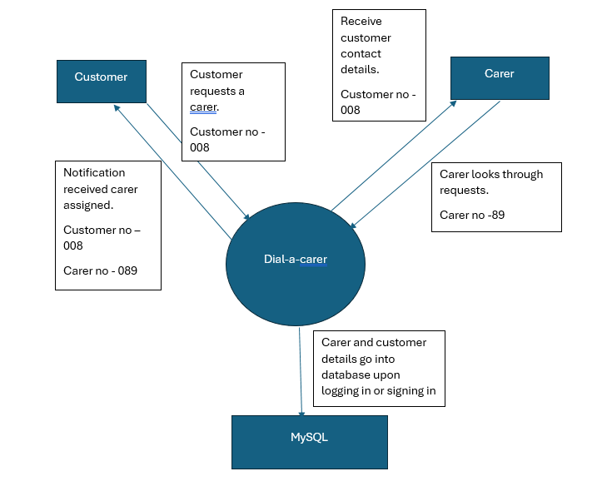

Business rules

The most important business rule that we looked at first is the qualifications of carers. All carers that are provided by the company must possess relevant qualification and certification in caregiving, nursing, or a related field. In relation to this background checks are a must to be conducted for all those that are potential carers.

Prior to providing care services, customers who are looking for a carer must thoroughly provide details of the needs and preferences that must be conducted for them. Through this assessment of their needs we are able to simply display to the carers what the customers' needs and wants are and outline any specific task or preference of the client.

A huge aspect of our business will be confidentiality and privacy. Carers must respect the confidentiality and privacy of clients and their respective families, this includes refraining from disclosing any and all personal and sensitive information without the consent of the client. All electronic information of both the client and the carer will be stored in a safe and secure location which will have a whole team monitoring the safety of our users information.

Regular communication is encouraged and expected of carers to the client and their families, it is essential to provide updates on the client condition and this will be done through means such as the client and carer having phone numbers and contact details of one another to retain good communication. This also underlines that if there is an incident a procedure to report it must be followed.

We expect a level of professional conduct from carers and will adhere to ethical standards in the interactions with clients, families and other colleagues. There is risk of potential conflicts of interest or ethical dilemmas if these were to occur they would be addressed promptly and transparently.

Lastly regular feedback from clients, families and staff will be collected and used to identify areas for improvement and implement necessary changes. This will mean that quality assurance measures should be in place to monitor the effectiveness of care services and ensure continuous improvement in service delivery.

Innovation Process

Ideataion

Define

Measure

Analyze

Implement

Control

Conclusion

Our company aims to capitalise on the growing demand for elderly care services by providing an easy to use service, reliable, and personalised care to clients. Our focus will be quality, innovation, and customer satisfaction. The business is confident in our ability to become a provider while making a positive impact on the lives of elderly individuals and their families.

Business analysis

- Business rules

- write up the project’s requirements and scope.

Website &

- Buttons for login for customer and carer

- Different pages for customer and carer to be directed to

- Update progress in google docs

Database analysis

- Customer login: Cuslog(email, password, phonenumb, user_id)

- Carer login: Carerlog (email, password, phonenumb, carer_id)

- Requests table

- Update progress in google docs

I am doing my evidence in a separate word document

Security analysis

- Look at the website after for security risks

- Update progress in google docs