# A STUDY INTO THE FUNDAMENTALS AND ENHANCEMENTS OF SOLENOID BASED ACCELERATORS

by

William Poole

A Thesis Submitted in Partial Fulfillment

of the Requirements for a Degree with Honors

(Electrical Engineering)

The Honors College

University of Maine

052023

Advisory Committee:

David Kotecki, Associate Professor

Nuri Emanetoglu, Associate Professor

Donald Hummels, Professor

2023 Poole

All Rights Reserved

*(This page is optional. You can use the U.S. Copyright Office’s* [*web portal*](https://www.copyright.gov/registration/) *to register.)*

ABSTRACT

Initial research into coilgun projects determined that they have a common issue of low efficiency and design complexity. This research aims to cover the topics of solenoid applications, magnetic fields, wires properties, and more for specific task optimization. There are many factors that come into the design and operation of solenoids which make them complicated to utilize effectively. These points will be combined for the overall system aspects dependent on application. These applications can be steady state for solenoid valves, high force for coil guns, and response time for chemistry applications. Coilguns have been studied for their unique ability to accelerate an object without adding weight or manipulating their design to allow for launches by alternative means. This advantage is purposely exploited for either a satellite launcher or another projectile accelerator. To get this data and review its interpretation my Honor’s Thesis committee shall be utilized. To prove some of this data, the ECE capstone project coilgun will use these concepts to enhance its optimization.

DEDICATION

If you would like to include a dedication, you can write it here. This section is optional. This would be the first page with a written page number. For these early pages, page numbering must use a lowercase Roman numeral, counting the title, copyright, and abstract pages. All page numbers must be 12-point Times New Roman, centered in the footer.

ACKNOWLEDGEMENTS

An acknowledgments page is optional but recommended. This is a place to thank anyone who helped you and your project get where you are. Like with the dedication page, include a lowercase Roman numeral page number, with page numbering starting on the title page.

PREFACE OR FORWARD

If you would like to include a preface or forward, you can write it here. This section is optional. Like the dedication and acknowledgements pages, include a lowercase Roman numeral page number starting with the correct number.

TABLE OF CONTENTS

A STUDY INTO THE FUNDAMENTALS AND ENHANCEMENTS OF SOLENOID BASED ACCELERATORS 1

Introduction 1

History 1

Research 1

Electromagnetics 1

Equations 1

Circuits 1

Bibliography 2

Appendices 2

Author’s Biography 2

LIST OF FIGURES

|  |  |
| --- | --- |
| Figure 1. Thesis organization | 3 |
| Figure 2. Table of contents example 1 | 6 |
| Figure 3. Table of contents example 2 | 7 |
| Figure 4. Pagination required for thesis | 9 |
| Figure 5. Heading and subheading format | 10 |
| Figure 6. Heading and subheading example with text | 11 |

List of Definitions

|  |  |
| --- | --- |
| Current |  |
| Efficiency |  |
|  |  |
|  |  |
|  |  |
|  |  |

# Introduction

A coil gun is a complex device that has many aspects which can be varied for specific applications. The following is a theoretical and experimental insight into many of these variables and how to utilize them in understanding these devices. These variables can be combined into the following groups, Electromagnetic Principle, Technologies, System design, and Losses. These groups explain the function and method of any coil gun operation. With these aspects of a coil gun theory the application can be optimized.

# History

This technology is quite old starting in the early 1900’s with a patent by a Norwegian scientist in 1904 being one of the earliest documents [3]. Past this earlier variant it has fallen into 2 main categories projectile or vehicle acceleration. Projectile acceleration is the gun designed to throw a projectile with the intent to have it destroy something, usually military. An example of this is the Darpa project to enhance mortar systems by replacing propellant weight and increasing distance [1]. Whereas the alternative is something that accelerates a container to deploy something at a distance. One of the vehicle launchers was the NASA super-cooled coil gun or quench gun project for launching liquid oxygen off of the moon for use in spaceships [2]. Allowing this technology to be used for new purposes whenever an object needs to be thrown.

# Research

## Electromagnetics

### Equations

ω=Angular frequency [Radians]

L=Inductance [Henrys]

L=μAN2/L [H/m * m^2 / m]

N=#of turns [unitless]

ZL=jωL

TL=L/R

### Circuits

#### Ideal Circuit

Figure 1: Ideal Circuit layout

The above circuit showcases how an ideal circuit for solenoid will look. The major feature of this circuit is infinitely fast switching, zero resistance, zero capacitance, perfect DC source, and the ideal inductor.

#### Realistic Circuit

Figure 2: Realistic Circuit-Resistances

The circuit above showcases the first step to realism of a solenoid circuit. These being wire resistances these begin have large affects on the voltage at the “supply” node. Below is a comparison between node “supply” and “supply1” at the time the switch is actuated [1m to 2m closed]. The effect of this is visible in current as well but it is harder to see.

Figure 3: Supply Node Comparison

Figure 4: Inductor Current Comparison

This rate change is due to the resistance limiting current through the inductor, this **becomes a charging circuit with a limit defined my time constants later explained in electromagnetic principles.**

#### Realistic Circuit Capacitance

Figure 5: Realistic Circuit with Resistance and Capacitance

The added capacitor is a model of the capacitance generated by all the wires near each other in a solenoid. This capacitance {L3_C} adds a Voltage dip at 1mS where the switch closes. This is due to the capacitor shorting the power around the inductor, but, the dip is limited by the transition time of the switch. This is due to the switch causing an AC state where the current fluctuates which capacitors short to. However, since this switch is instant the drop is limited.

Figure 6: Supply Node with Capacitance Added

The voltage dip is caused by the capacitance in parallel and the slow decay is due to the charging inductor.

Figure 7: Realistic Circuit with Capacitance Current Inductors’ Current

The above figure shows that the inductor and capacitor reach an oscillation which slowly decays through the nearby resistors.

#### Realistic Circuit Switch

Figure 8: Realistic Circuit with Power MOSFET

This switch a NMOS HEXFET which has many parasitics which causes feedback issues at the transition times of the switch. I believe this mostly capacitances as they have to charge when they reach the state of DC.

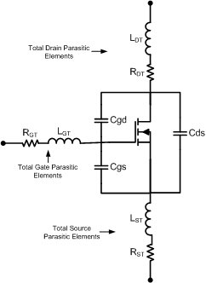

Figure 9: MOSFET parasitics A graph of a line

Description automatically generated with medium confidence

Figure 10: Realistic Circuit Switch Voltage Response

This Voltage response showcases a voltage dip at turn on [1mS] from a capacitor short circuit {L4_C}. Then after the capacitor is charged it blocks the DC having the inductor become charged which is limited by all the resistances {incoming, L4_R, and Outgoing} which creates the downward slope. At signal release, there is another capacitor short which causes a spike in the supply voltage. Also at this state the inductor begins to discharge which causes a voltage delay at the supply node. This voltage delay can be fixed with a diode.

Figure 11: Realistic Circuit Switch Current Response

The above current response showcases that the current is limited to a simple path now and no longer oscillates as it did for the ideal switch.

#### Realistic Circuit Diodes

Figure 12: Realistic Circuit with Flyback Diode

The above circuit is the realistic circuit with a flyback diode this device is commonly used to discharge the inductor by having it not charge through the capacitor and oscillate out. However, with the values currently used, the voltage drop is solved but the current through the inductor suffers.

Figure 13: Realistic Circuit with Flyback Diode Supply Node

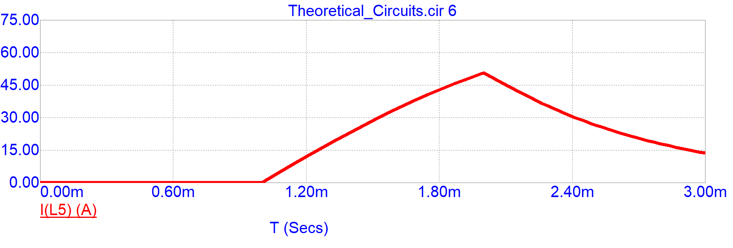

Figure 14: Realistic Circuit with Flyback Diode Current Response

The current here has a longer release time this likely due to the diode’s junction capacitance coming into effect and some principle of RLC circuitry being snubbed by the diode. **What is known is that this current is not ideal as it is likely causing a pulling force after to projectile gets through the halfway.**

# Bibliography

[1] B. N. Turman and R. J. Kaye, “EM MORTAR TECHNOLOGY DEVELOPMENT FOR INDIRECT FIRE.” Sandia National Laboratories, Albuquerque, Nov. 1, 2006

[2] N. Nottke and C. Bilby, “A Superconducting Quenchgun for Delivering Lunar Derived Oxygen to Lunar Orbit.” National Aeronautics and Space Administration, Austin, Apr. 1990

[3] S. Chaithanya and V. P. Kumar, “A Review on Technological Advancement in Electromagnetic Coil Gun System.” International Journal of Engineering Research & TEchnology, Ujire, 2018

# Appendices

# Author’s Biography