Question Set 1

1. Species class inherits from the Genus class (public class Species extends Genus)
2. Specimen inherits the variable from the Species
3. Species  
   - SpeciesName:String  
   +Species(s:String, g:String)  
   +setSpeciesName(s String):void  
   +getSpeciesName():String  
   +toString():String  
   +equals(s:Species):Boolean
4. more efficient(no duplicate code), faster development
5. 1. Because the method use only the specific class declared  
   2. Override

Question Set 2

1. The wrapping up of data under a single unit / a protective shield that prevents the data from being accessed by the code outside the field.
2. Easy to test, More secure
3. getSpeciesName()
4. String SpeciesName

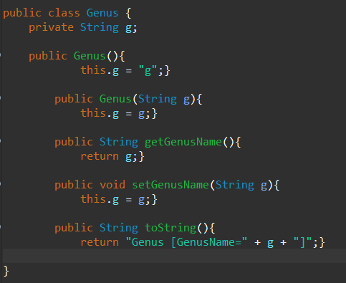

1. Advantage: the specimen object will inherit all methods and instance variables applying to the Species object  
     
   Disadvantage: Not all methods and variable will be used in all specimens so changing the species class may not apply to all specimens.

Question Set 3

1. In specimen object, create toString with specimen instance variable. For example since the instance variable is String name, we can use the toString to return “name :” + name;

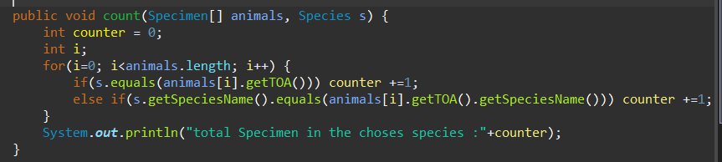

1. Function listSpecies(Specimen[] animals){   
   use linkedlist and first we check if the linkedlist is empty by using isEmpty()  
     
   if empty we put SpeciesName in the linkedlist  
     
   use the toa(type of animal) to loop again to find the animal with the sampe toa, If find the sama toa we will insert it to the next node in linked list  
     
   start to loop again to find species different from different toa and do the loop again for the speciesName  
     
   put a condition that when the size of linked list is the same with animals, we will print the linked list and stop the loop  
   }

Question Set 4

1. Code is easier to understand  
   other part of code is less dependent to other part

