[2/2] Install Ubuntu 20.04 on apollo. (Install Poseidon first). Provide screenshot of fully automated install.

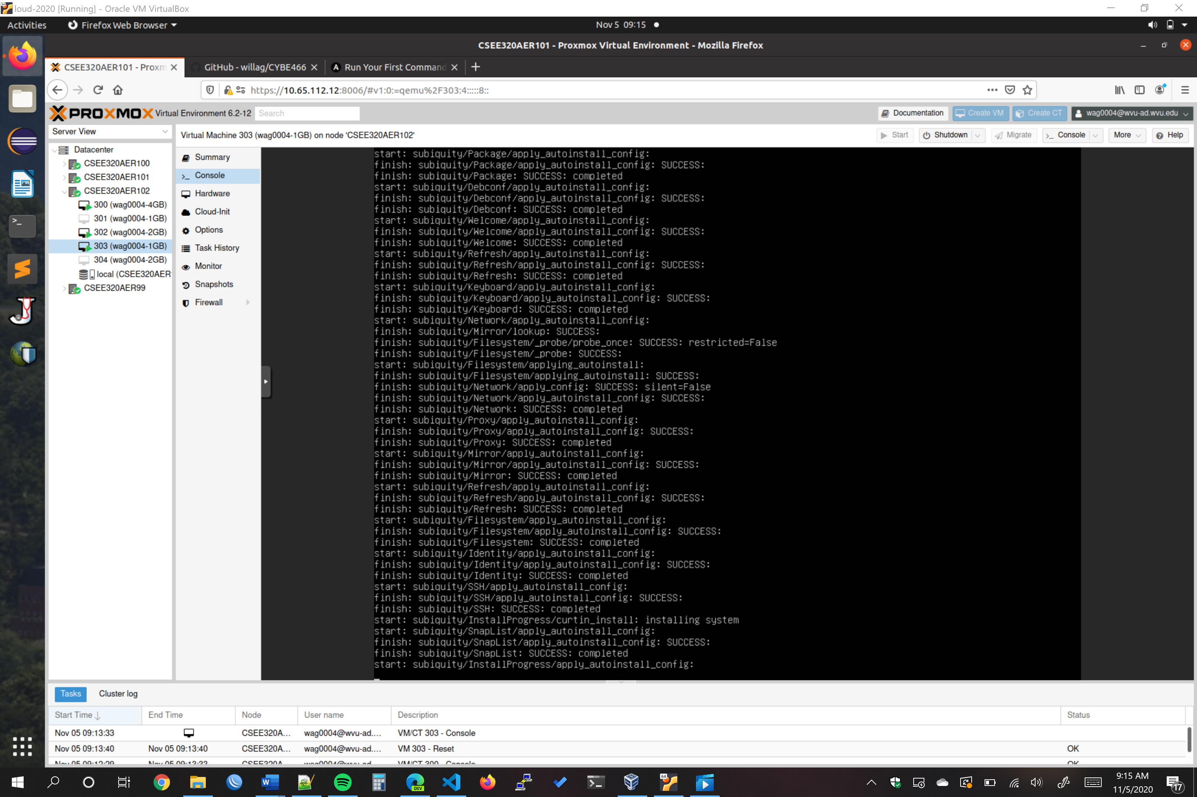

Provide at least one screenshot of something executing with description.

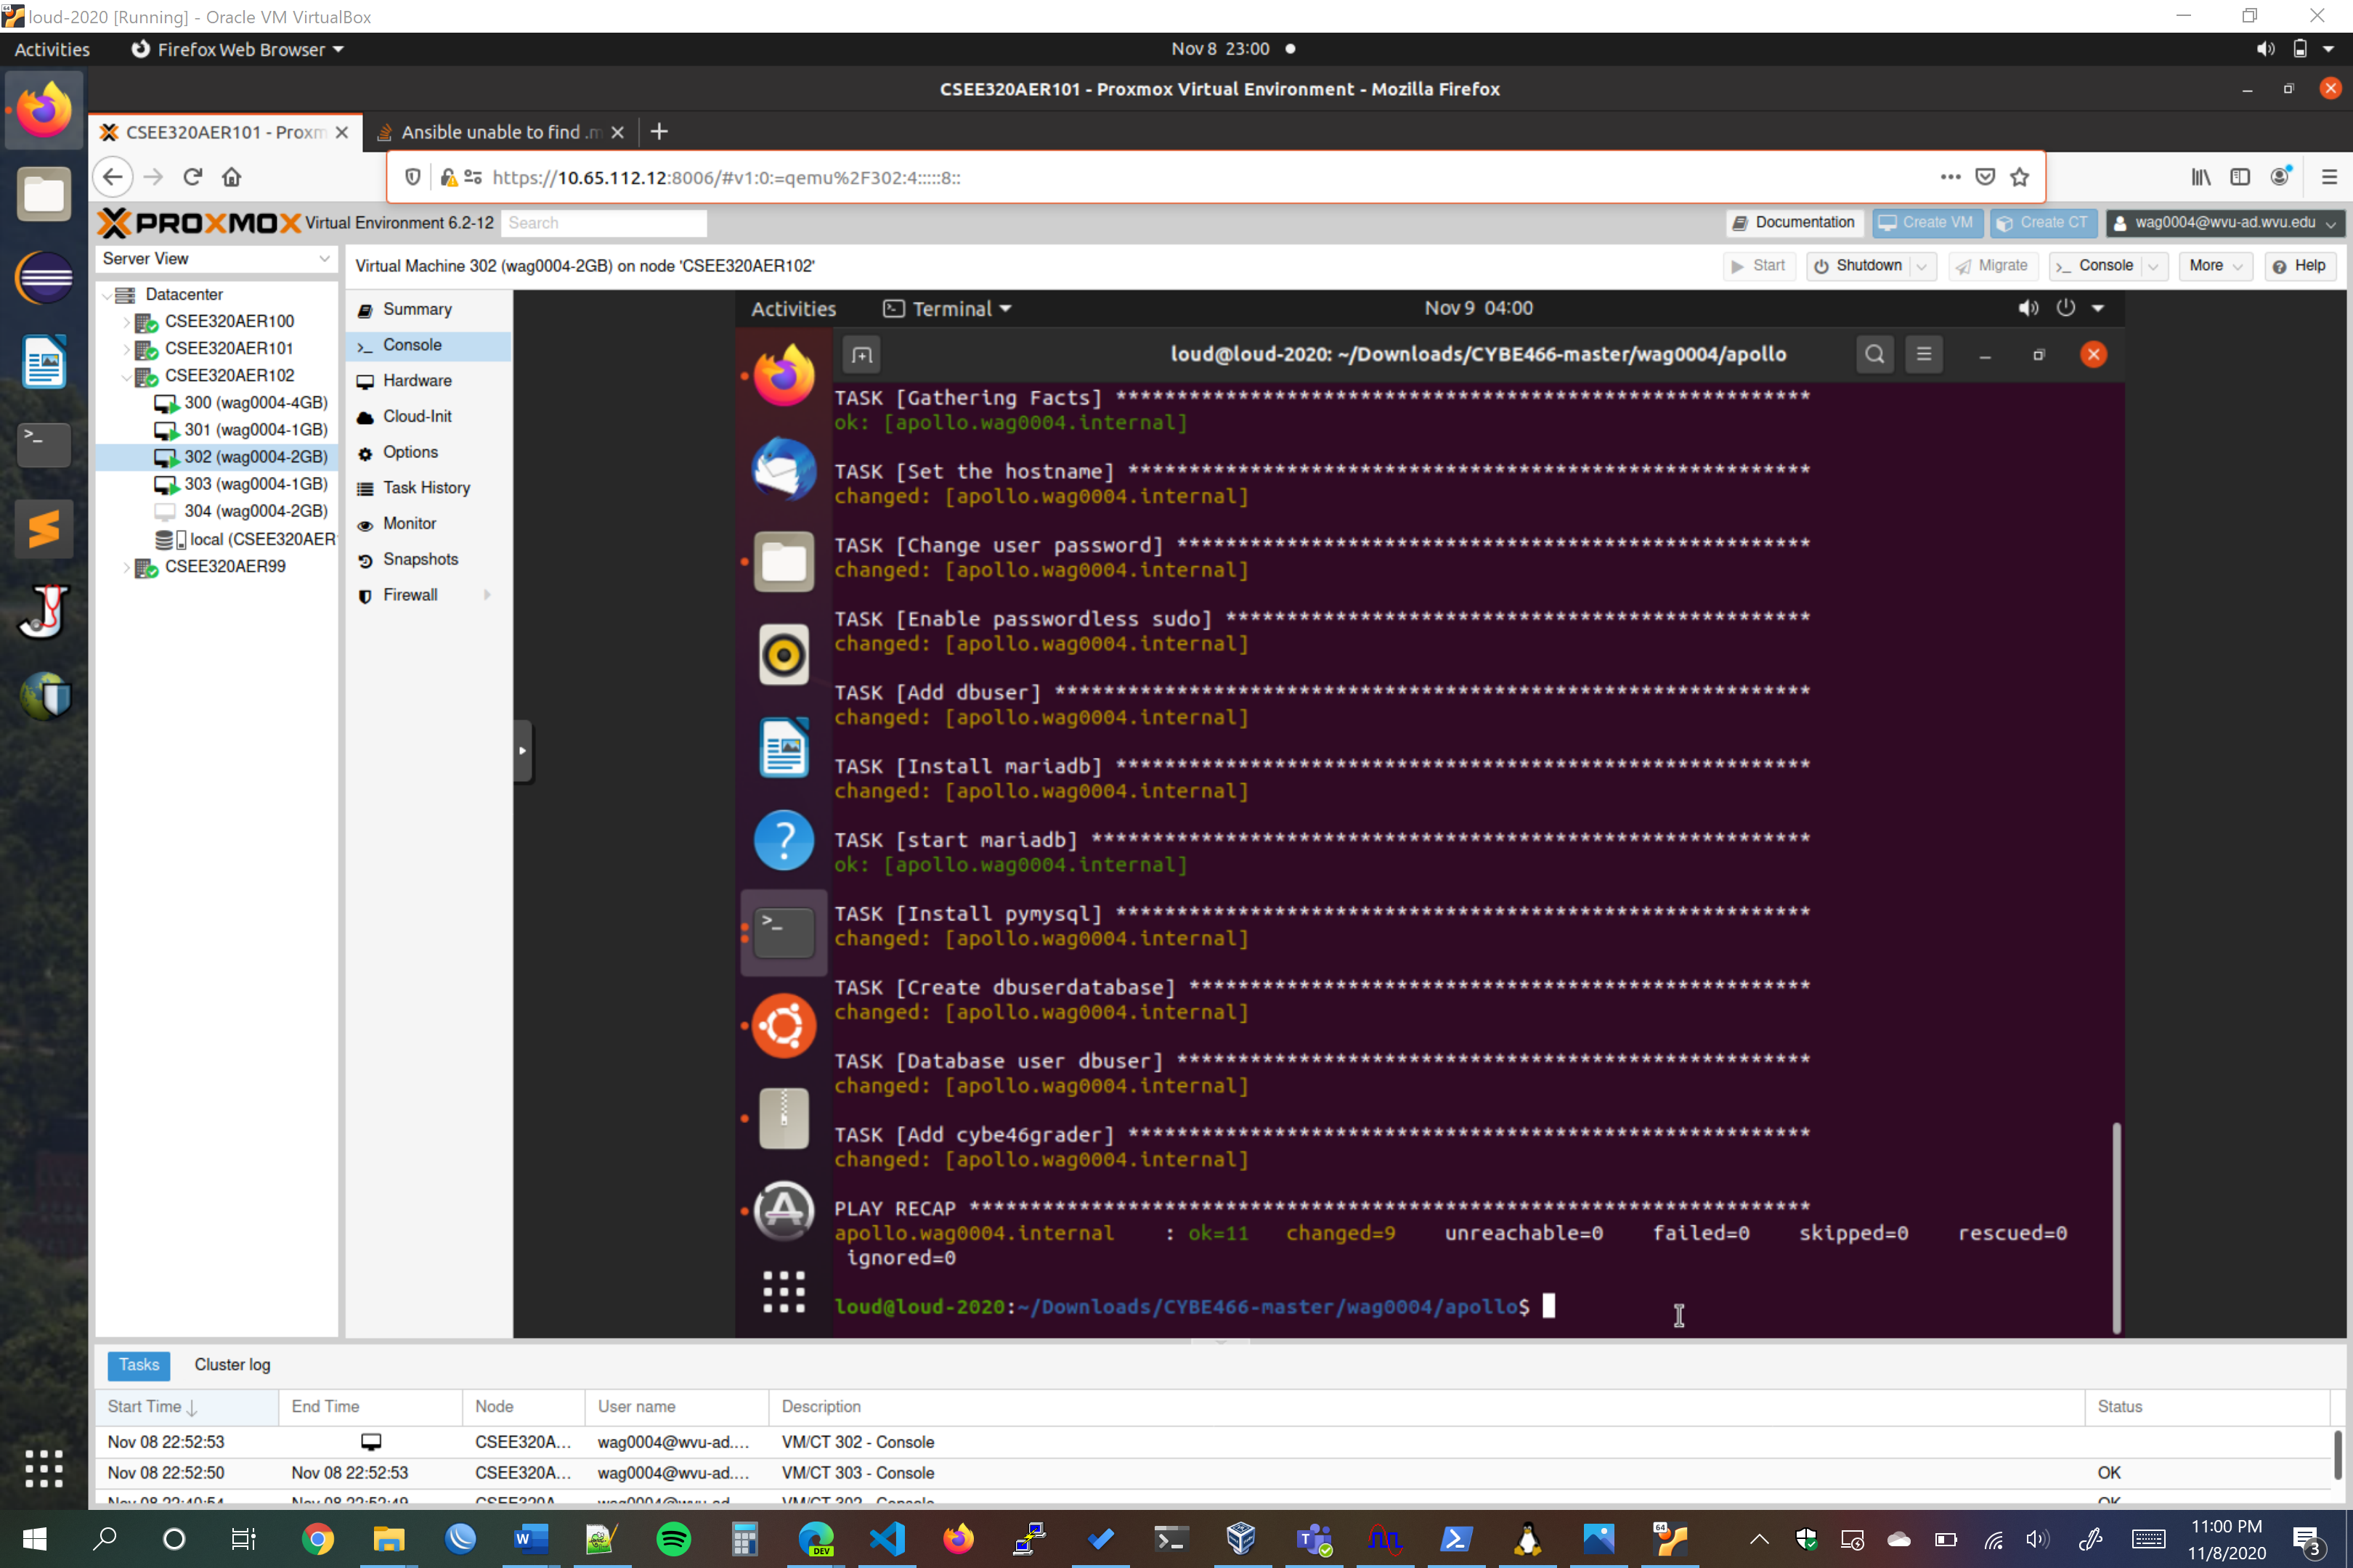

**Here is the Apollo ansible executing. In this screenshot the user data is manipulated, the hostname is changed, and mysql is installed and a database and user are added.**