[2/2] Fully automated install (Install Poseidon first). Provide a screenshot of the fully automated install in progress

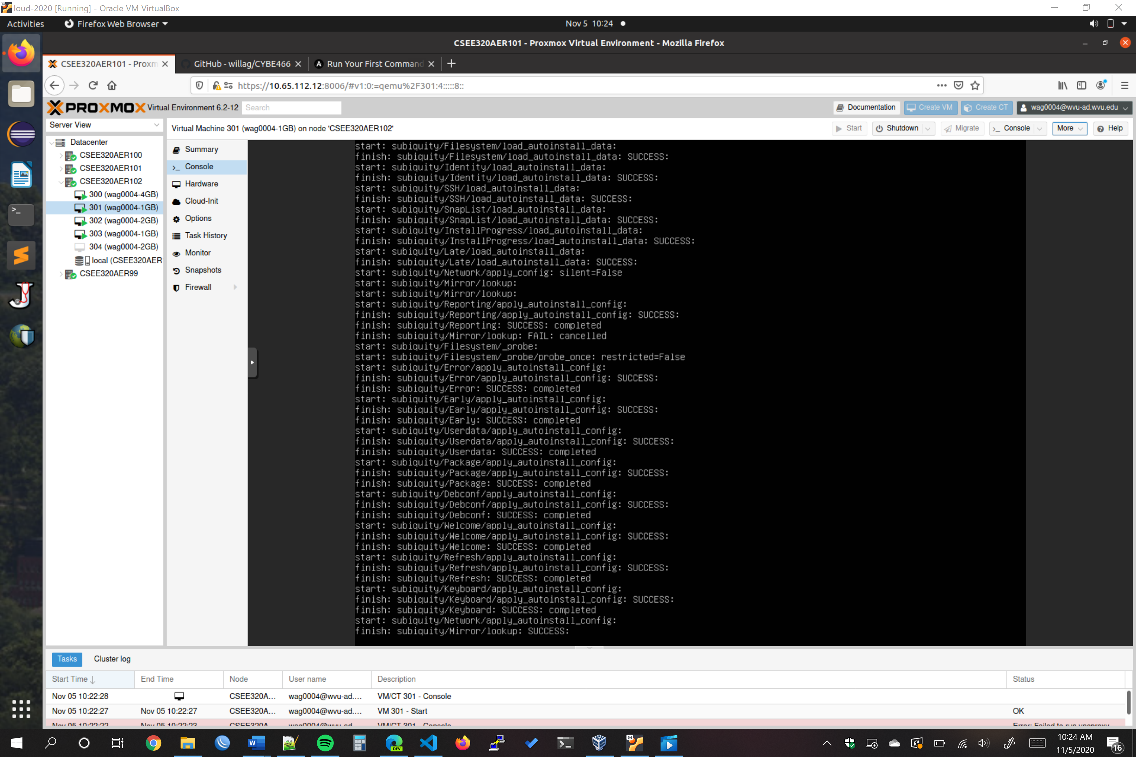

[4/4] Proper documentation on how to run ansible code. Provide at least one screenshot of something executing with description.

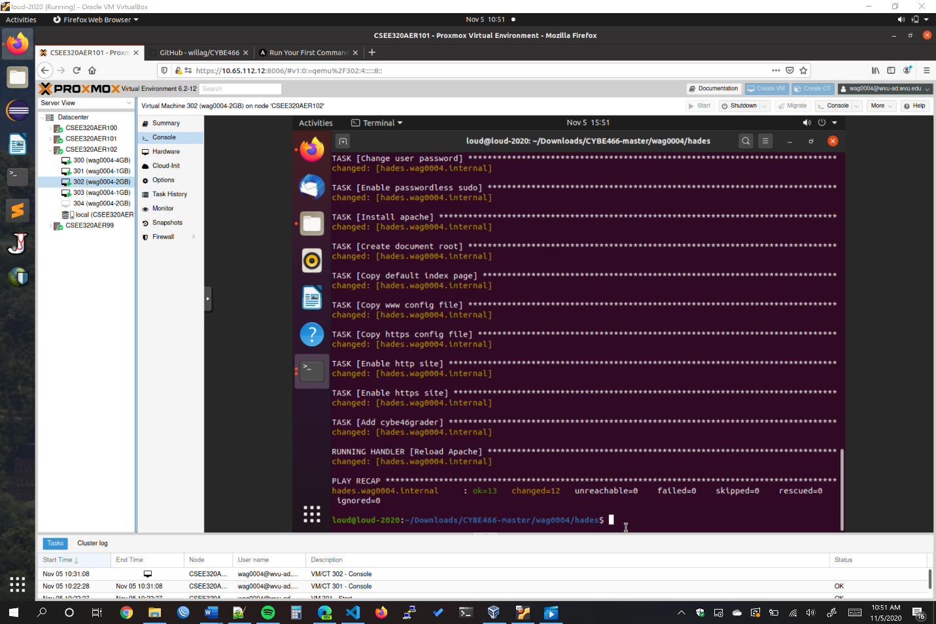

**Above is the ansible script executing for hades. Most of the configuration seen in the screenshot is setting up the webserver on hades.**