[4/4] Proper documentation on how to run powershell scripts. Provide at least one screenshot of something executing with description.

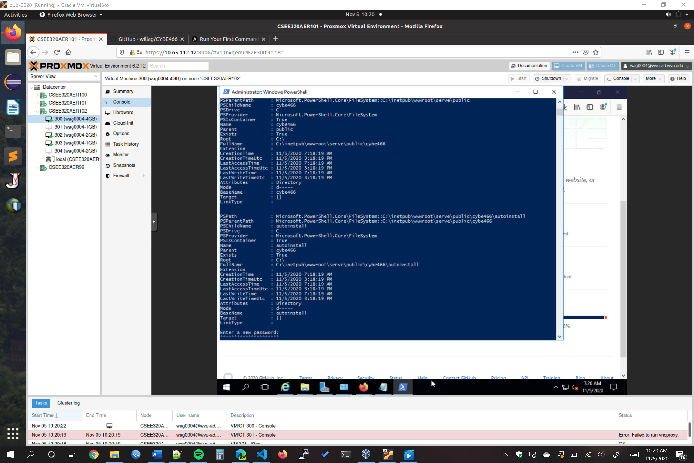

**Here is the powershell script for Poseidon executing. The output shown here is the creation of the cybe466grader account and also the creation of the autoinstall folders for the linux machines as well as capturing input for the cybe466grader account.**