# Site Flow and Sketches

## Step 1: Competitive Analysis

|  |  |
| --- | --- |
| Competitor Site 1: <site name here> https://open.spotify.com/browse/featured AnalysisWhat is good about this site?  1. Spotify shows a lot of information on the home page, yet it does so without looking cluttered. 2. Clean and easy navigation that allows and even encourages user to explore new music. 3. Spotify uses a clean color gradient in the background of the pages which is very easy to look at.  What is bad about this site?  1. There is no recommended songs feature when you’re listening to a song. 2. There is no listening history section that shows recently played songs. It only shows recently played playlists, artists and albums. 3. There is no social element to Spotify, which is a great way for people to find new music. | Competitor Site 2s: <site name here> https://soundcloud.com/stream AnalysisWhat is good about this site?  1. The social element of SoundCloud allows users to find new music through their friends. 2. The “Stream” section shows users what their friends have shared in addition to what their followed artists have posted. 3. Easy to find all of your liked songs in addition to your recently listened to songs.  What is bad about this site?  1. The plain white background, while simple, is not very appealing to look at and could be improved. 2. There is a lot of scrolling necessary if you are looking at a list of songs because they take up a lot of space on the page. 3. SoundCloud’s pages have a lot going on which, for some people, makes it feel cluttered. |

### Competitor 1 Pages

#### Page (or Screen) where you ask “What should I do tonight?”

#### 

#### Pages (or Screens) look for the answer

#### 

#### Page where you get an answer

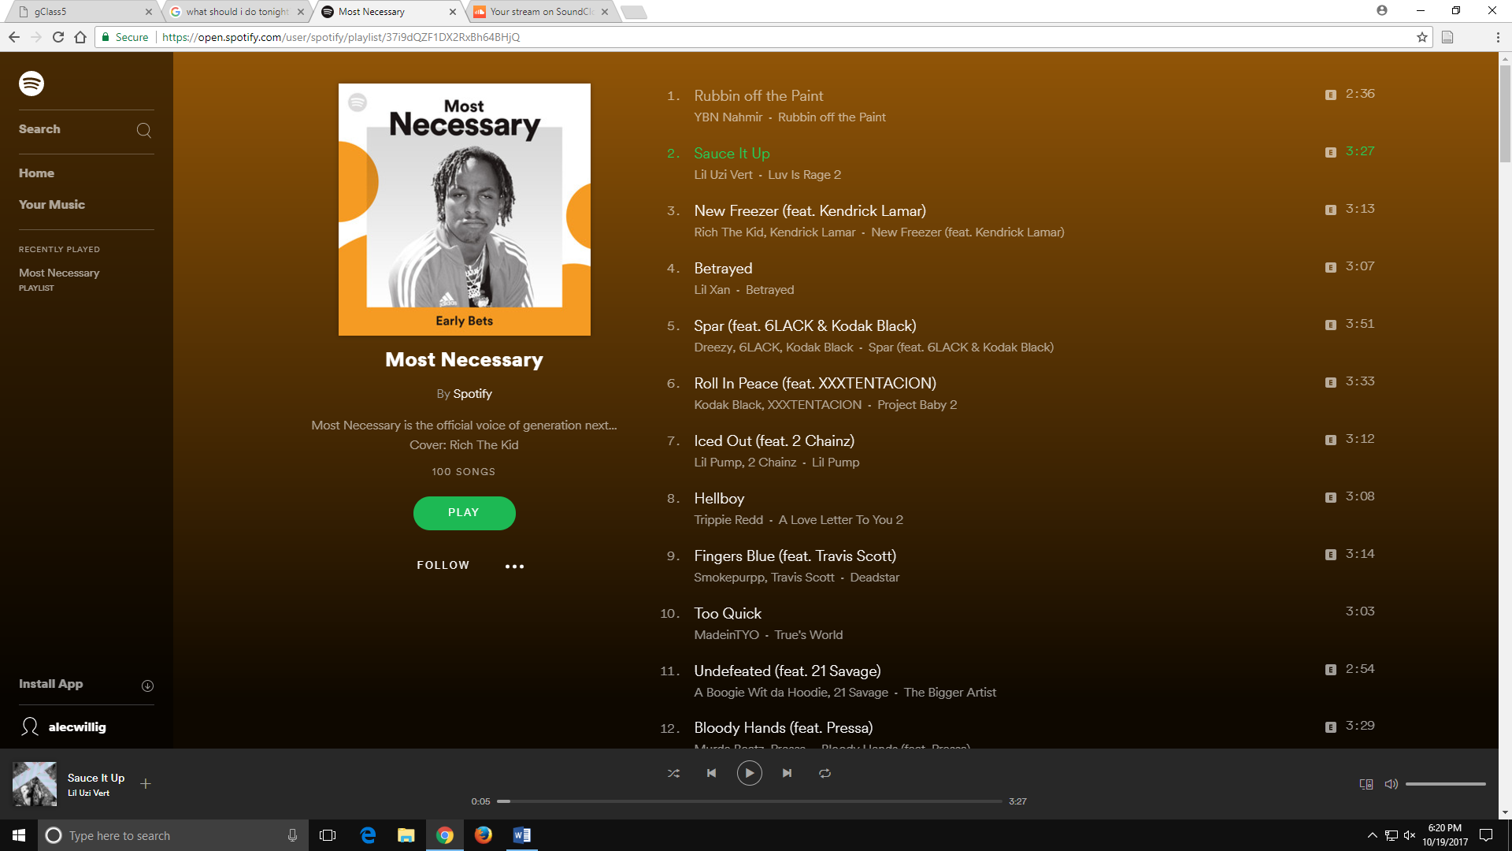

### Competitor 2 Pages

#### Page (or Screen) where you ask “What should I do tonight?”

#### 

#### Pages (or Screens) look for the answer

#### 

#### Page where you get an answer

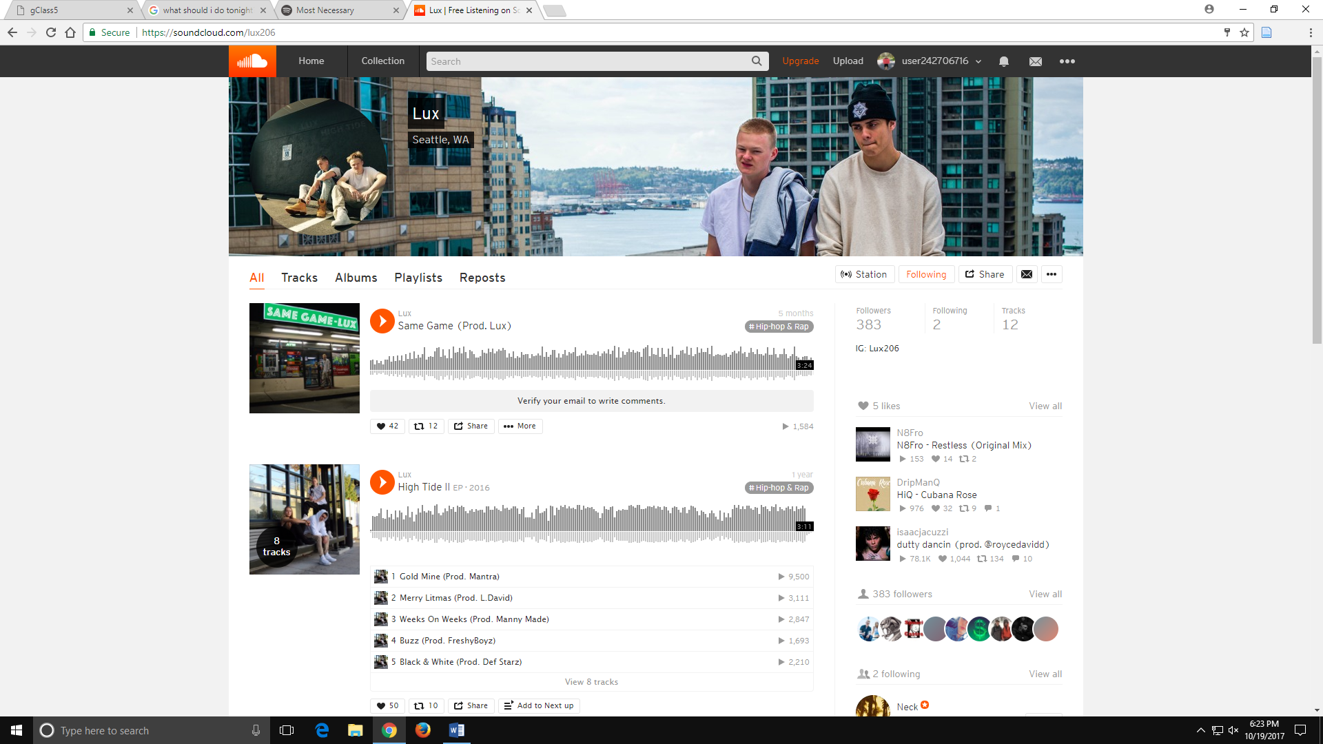

## Step 2: Sketch One Competitor Flow

### Favorite Competitor: Page Flow Sketch

Pages sketched as boxes for the flow between pages (or screens) where you ask “What should I do tonight?”, look for the answer, and get an answer. Arrows drawn between the boxes show how the pages are connected by clicks. Inside the page boxes details include:

* Where you ask the question
* Where the navigation is that allows you to find things to do
* Where the details of the “things to do” are displayed
* Where you click to move from page to page

## 

## Step 3: Sketch YOUR Flow

### My Site Name

Pear Music

#### Sketch of My Page Flow

Pages sketched as boxes for the flow between pages (or screens) where you ask “What should I do tonight?”, look for the answer, and get an answer. Arrows drawn between the boxes show how the pages are connected by clicks. Inside the page boxes details include:

* Where you ask the question
* Where the navigation is that allows you to find things to do
* Where the details of the “things to do” are displayed
* Where you click to move from page to page

