Washoe County Predictive Maintenance Program

Capstone project

William Alwin | C994 | 02/23/2020

Table of Contents

Project Proposal (Part A) 2

Summary of the Problem 2

Application Benefits 2

Data Product 3

Data Description 3

Objectives and Hypotheses 3

Project Methodology 4

Funding Requirements 5

Stakeholder Impact 5

Ethical and Legal Considerations 5

Relevant Expertise 5

Technical Proposal (Part B) 6

Problem Statement 6

Customer Summary 6

Current Product Summary 6

Data Needs 6

Design Methodology 6

Product Deliverables 7

Implementation Plan 8

Validation Plan 9

Programming Environments Related Costs 9

Timeline and Milestones 10

Postproduction Report (Part D) 10

Business Vision Document 10

Raw and Cleaned Data Sets 11

Code Used to Perform Analysis 13

Assessment of Hypotheses 19

Data Visualization 19

Accuracy Assessment 22

Data Product Testing Results 22

Source Code and Executable File(s) 22

Quick Start Guide 23

Citations 24

# Project Proposal (Part A)

### Summary of the Problem

Washoe County Community Services Department (WCCSD) operates 1.6 million linear feet of sewer collection pipes. With exception to known problem areas, the flushing schedules are not pipe specific and the priorities for maintenance are left to the determination of maintenance staff. Each pipe segment is an asset with a unique location, slope, diameter, material, number of upstream customers, and type of upstream customer. Each pipe segment has different maintenance needs and it is inefficient to apply the same preventative maintenance frequency and priority to each. The county could be over maintaining some areas and under maintaining others. The result of this inefficient process is wasted man hours as well as unneeded cost to taxpayers, whether that be through unnecessary cleaning, or costs induced by backups from too infrequent cleaning.

### Application Benefits

The goal of this project is to help build an optimal preventative maintenance schedule for each pipe. When implemented, this will allow WCCSD to balance maintenance needs, resource levels, workloads, and risk exposure. Under ideal circumstances each pipe would be maintained on a conditional basis, as opposed to a schedule basis. Unfortunately, a system wide condition inspection is not currently feasible, the best option is to calculate the condition. This change will be implemented using Manning’s Partially Full Pipe Velocity Formula, an algorithm that gives us the velocity of water flow through a pipe, and the Hjulstrom curve, which determines sediment accumulation potential and flushing frequency need. The application will also allow for maintenance worker feedback in order to further fine tune the algorithm for specific pipes, and/or pipe types.

### Data Product

This project will consist of a desktop application that will be made available to all WCCSD employees who need access, including administrators and field technicians. In addition to the desktop application there will be a database component where all tables are built.

The following features will be implemented in the final product:

* Login screen with user authentication that allows for Admin/non-Admin distinction
* User log file for usage tracking
* Associated administration and technician view
* Customizable/selectable view of sewer pipes
* Graphical representation of pipes grouped by maintenance need (next 6mo)
* Graphical representation of pipes grouped by maintenance interval
* Ability to assign work to maintenance technicians
* Ability to log completed work with maintenance assessment for algorithm fine tuning

The desktop application will be built using the Java language, with a SQL database component. For the Java component we will be implementing JavaFXML with Scene Builder for the user interface portion. This allows for a platform agnostic application in case of different hardware needs for different users. The database portion is currently built on a MySQL server, and will be hosted internally on WCCSD servers.

### Data Description

The data used for this project was collected by WCCSD on a large sampling of the sewer mains currently maintained by Washoe County. The data included categorizes each pipe by unique id, slope, diameter, material, upstream customer, last maintenance date, etc. Not all the categories were needed for this assessment.

The raw files: Sewer_Main_Variables.csv and A_table.csv, will be included with the completed application.

### Objectives and Hypotheses

The objective of the project is to more accurately predict the ideal maintenance period for sewer mains based on known criteria. The potential benefits of successful implementation are increased productiveness of maintenance staff, decreased costs, and minimized risk associated with sewer main failure.

Our hypothesis is that using the data currently available along with specific algorithms, we can predict the rate of sediment accumulation, and therefore, the optimal maintenance period for a given sewer main. This data, along with field data collected by maintenance technicians, can be used to further fine tune maintenance periods, grouped by pipe type. If properly implemented, this project will take the burden of predicting maintenance needs away from maintenance staff and leverage empirical data to optimize job planning and decrease risk of sanitary sewer overflow (SSO) events.

### Project Methodology

For this project we will using the Agile methodology. The ability to build the product incrementally, as well as allowing for frequent input from the customer, is key to providing a great end user experience. We can include all the features requested and spend as little time as possible on unnecessary components.

The following is the basic outline of the different phases we will use for the project:

* Planning Phase: Define requirements for current build of software product based on stakeholder input and define a timeline for completion
* Development Phase: Begin sprint based on requirements gathered with the goal of having a working iteration by end of sprint
* Testing Phase: Implement QA testing for defects and bugs, address any defects, and develop user documentation
* Delivery Phase: Integrate current iteration into previous version, and/or release into production
* Assessment Phase: Get stakeholder input on current iteration in order to finalize product of gather requirements for next iteration

### Funding Requirements

Initial estimates for time required and associated cost:

|  |  |  |  |
| --- | --- | --- | --- |
| Service | Cost/Hour | Total Hours | Total Cost |
|  |  |  |  |
| Planning and Design | $125 | 40 | $5000 |
| Development | $175 | 80 | $14000 |
| Documentation | $125 | 40 | $5000 |
| Total |  |  | $24000 |

### Stakeholder Impact

Through the development of this application WCCSD will gain the ability to more accurately and conveniently plan for the maintenance of its valuable sewer pipe infrastructure. It will allow field technicians to focus more fully on field work, while still valuing their input. Finally, it will help to minimize potential negative impact on the tax payors of Washoe County due to too infrequent maintenance.

### Ethical and Legal Considerations

There are no ethical or legal considerations that need to be made regarding this project. All data collected for the development of this application is publicly available. There is no risk of any potentially sensitive or damaging information being released due to this application.

### Relevant Expertise

The development team should consist of 3-4 software developers with a range of skills. In order to complete this project in a timely and efficient manner all team members will need to be skilled in one or more of the following areas. Ideally, we would want at least 2 members to be experienced in Java development, preferably with a background in UI/front end development. At least one team member should have strong SQL database design skills. The front-end lead will need to have strong communication skills as there will be training required for non-IT based users. All team members must have a strong mathematical background and be able to help in different areas as needed.

# Technical Proposal (Part B)

### Problem Statement

Develop an application that allows Washoe County Community Services Department (WCCSD) field technicians to more efficiently maintain the counties sewer mains, which is easily rolled out to existing hardware infrastructure. By leveraging collected data and industry accepted methods for accurate prediction of sediment accumulation, we can predict the maintenance needs for our community. After successful rollout of the product, feedback from field technicians will help to further refine the algorithms for increasingly better predictions of maintenance need.

### Customer Summary

Washoe County covers more than 6600 square miles (Washoe County, n.d.), much of it rural. Beyond the size of the county itself, WCCSD is responsible for maintaining much more than just sewer pipes. While manual inspections of every sewer main in the county would be ideal, the time and cost associated with such an undertaking is not currently feasible. In order to more accurately assess the maintenance needs of the counties sewer mains a different approach is needed. The development of an application that can predict maintenance intervals for WCCSD without the need for manual inspection would be a major boon for the county. The potential for increased productivity and cost savings created by implementation of the proposed application should not be ignored.

### Current Product Summary

Current maintenance schedules are not pipe specific, moreover the determination of maintenance need is left up to maintenance technicians. Each pipe has different maintenance needs based on its size, slope, construction material and number of customers serviced. Unfortunately, none of this data is being applied to the problem of when to maintain specific pipes. The result is an inefficient process that can lead to potentially costly errors due to simple oversight.

### Data Needs

Fortunately, the data needed to accurately predict maintenance routines for WCCSD sewer mains has been collected and is readily available. We will be using a sample size of more than 500 distinct pipes for analysis. For the purposes of this application they will be accessed via csv files. The data will need to be stripped of any unnecessary fields and imported into the database. After the project has been successfully implemented, new data will be collected in the field that will allow for fine tuning of maintenance intervals.

### Design Methodology

For this project we will be implementing the Agile methodology as our management model. We will do this by having daily standups throughout the entirety of the project.

The basic workflow process we will follow is listed below:

* Planning Phase: Define requirements for current build of software product based on stakeholder input and define a timeline for completion
* Development Phase: Begin sprint based on requirements gathered with the goal of having a working iteration by end of sprint
* Testing Phase:
* Unit Test: As each module is developed it will be tested to make sure that is conforms to style guides, and successfully accomplishes its required task
* Integration Test: This stage will allow us to combine all units within the application and test them as a group. The goal at this level is to find interface defects between modules and functions
* System Test: The program will be tested to ensure that it meets the technical, functional, and business requirements set by the customer. This portion of testing will need to be performed by someone outside of the development team, in an environment that closely mirrors production
* Acceptance Test: The final phase will be performed by WCCSD staff, preferable one administrative and one field tech for acceptance testing. The goal of this test is to determine if the product meets the business need defined by the client. Upon passing this test it will be ready for delivery
* Delivery Phase: Integrate current iteration into previous version, and/or integrate and deliver the working iteration into production
* Assessment Phase: Get stakeholder input on current iteration in order to finalize product of gather requirements for next iteration of lifecycle

### Product Deliverables

The deliverables for this project will be broken down into two distinct sections: Project Deliverables and Product Deliverables.

The main points of each is covered below:

Project Deliverables:

* Milestones: A detailed schedule will be need in order to verify the project is staying on schedule.
* Testing plan: For each step in the development there will need to be an appropriate test devised to ensure the product ships without defects.
* Code Overview: There will be high level write up for the application before actual coding begins
* Coding Guideline: The languages used, coding environment, and coding style will be set for all phases of development
* Product Deliverables:
* Java Desktop Application: A Java application will be created that will be used as the main hub for sewer main visualization, planning, and feedback
* User Authentication: The Java application will employ a login screen in order to authenticate users. This authentication will be used to restrict access to the application and to give appropriate access to users based on need
* Maintenance Tools: The application will provide the opportunity for end users to further refine sewer maintenance based on field observation. This feedback will be used to adjust the timing algorithm based on distinct identifiers for each pipe
* Database Tables: New database tables will be created that hold all necessary data for the project. They will use data from existing tables, which will allow for easy integration into WCCSD existing database

### Implementation Plan

The implementation plan for this application are as follows:

* Stakeholder Input: The first step will be to meet with the stakeholders and define the requirements for the project
* Design Strategy: A strategy for successful implementation of requirements will be built, and a timeline for completion and individual milestones will be finalized
* Application Development:
* Data import: In order to get the data in a usable format it must be stripped of unnecessary fields and imported into a database table
* Desktop Application Development: After the database has been implemented the next step will be development of the actual application
* Testing and Rollout: After each phase of development there will be testing phase where each iteration will be tested for bugs and/or defects. There will also be an iteration of the product given to stakeholders who will recommend improvements, and ultimately decide when the project has met their needs
* Product Deliverables: The proposed software solution will provide the client with database tables that will easily integrate with current database assets. This new data will be accessible via a desktop application that allows for manipulation and visualization of sewer main maintenance schedules.
* Product Delivery: After the product has been accepted by the stakeholders it will be installed on client machines and any end user training necessary will be completed

### Validation Plan

The validation plan for this project will have two basic stages:

* Mathematical Validation: The algorithms being used are widely accepted in the field of civil engineering. As such, the math used to calculate the velocity of flow through a pipe, and sediment collection potential are easily verifiable. If we code the algorithm correctly, this portion will be easily validated.
* Field Validation: The true test of whether our predicted outcomes prove true will come from real world assessment. While we know that the math will work, the accuracy of the variables used to build our algorithm is not so easily verifiable. This is where the field technician’s feedback will come in. By allowing for adjustments to the algorithm based on field assessments our application will learn to better predict the maintenance need.

### Programming Environments Related Costs

Programming Environment:

The application will be developed on Windows 10 machines using the NetBeans IDE for Java development. The database will be built in MySQL using MySQL Workbench.

|  |  |
| --- | --- |
| Technology Requirements | Cost |
|  |  |
| 3 desktop computers for new hires | $1800 |
| Software licensing | $1200 |
| Total | $3000 |

|  |  |  |  |
| --- | --- | --- | --- |
| Service | Cost Per Hour | Total Hours | Total |
|  |  |  |  |
| Planning and Design | $125 | 40 | $5000 |
| Development | $175 | 80 | $14000 |
| Documentation | $125 | 40 | $5000 |
| Total |  |  | $24000 |

## Timeline and Milestones

|  |  |  |  |
| --- | --- | --- | --- |
| Phase | Start Date | End Date | Duration |
|  |  |  |  |
| Requirements Gathering | 02/02/2020 | 02/05/2020 | 3 Days |
| System Design | 02/05/2020 | 02/09/2020 | 4 Days |
| Implementation | 02/09/2020 | 02/19/2020 | 10 days |
| Testing | 02/19/2020 | 02/22/2020 | 3 Days |
| Deployment/Training | 02/22/2020 | 02/23/2020 | 1-2 Days |
| Total |  |  | 21-22 Days |

# Postproduction Report (Part D)

### Business Vision Document

1. Determine maintenance intervals for WCCSD sewer mains
2. Allow user input to fine tune maintenance intervals over time
3. Provide user friendly application that allows for viewing, interacting with, and updating data

### Raw and Cleaned Data Sets

The raw data was provided in a csv file, and was formatted as shown below:

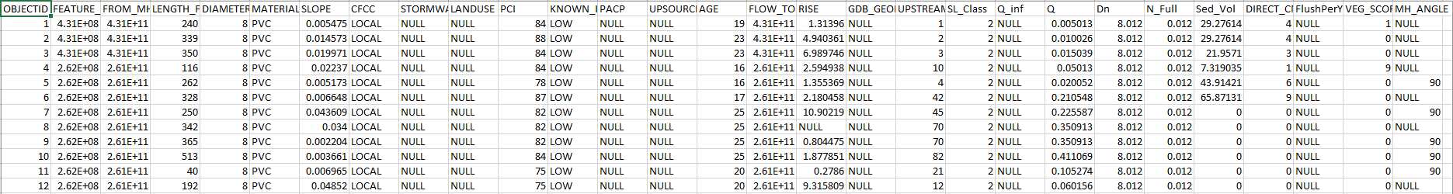

The data was stripped of all unnecessary fields and imported into a data base table shown below:

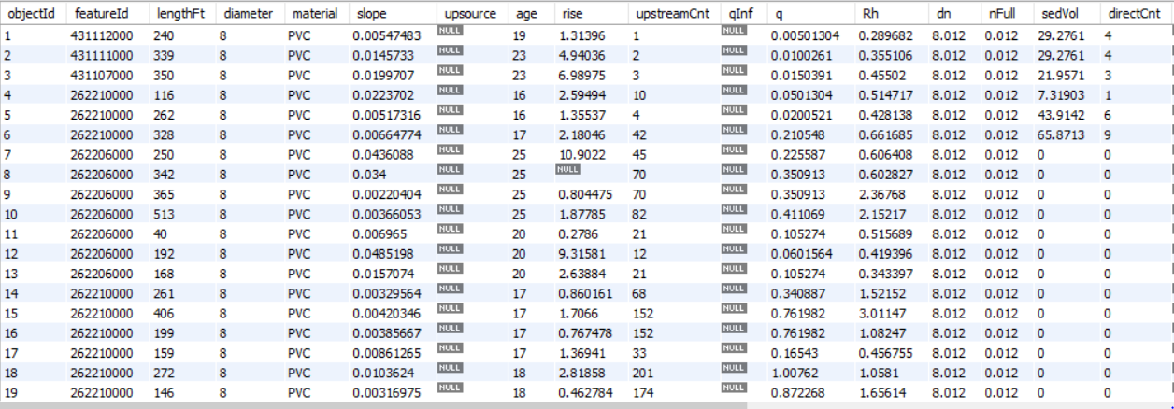

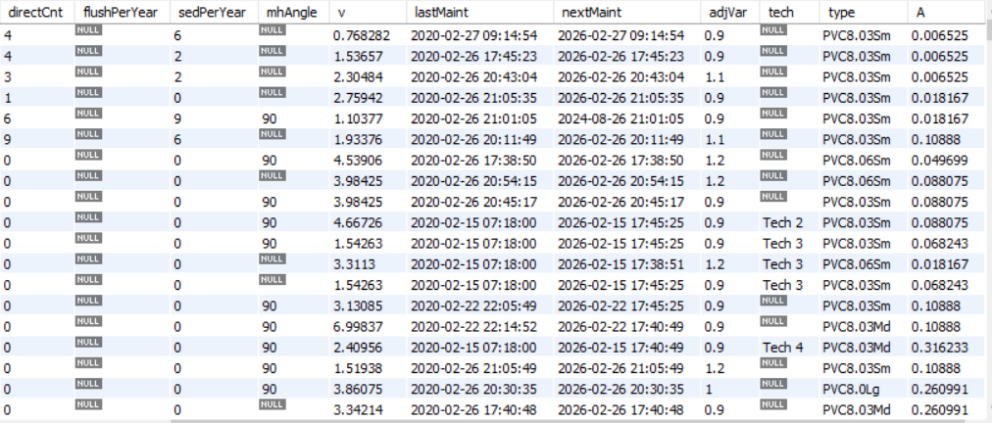

In order to get the data to be usable for our purposes the data types needed to be changed, they were all VARCHAR (255), the changes made to data are listed below:

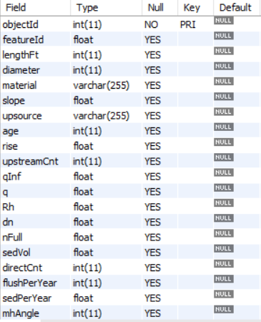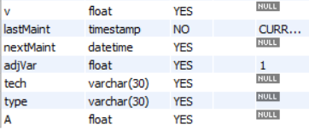

Some new fields were added to support the needs of the project, they are Rh, v, lastMaint, nextMaint, adjVar, tech, type, and A.

The value for A (flow area of pipe) was provided in a separate csv file shown below:

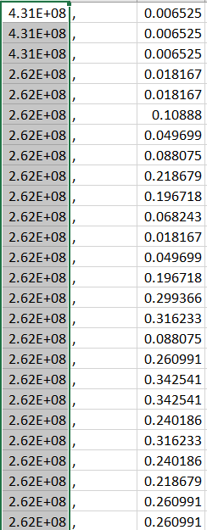

In order to integrate this data, another table was created and the merged with our WCCSD_PIPE table using the featured, that code is listed below:

UPDATE WCCSD_PIPE a

JOIN A_TABLE p ON a.featureId = p.featureID

SET a.A = p.A;

### Code Used to Perform Analysis

After the data was imported into the database a Java application was built to predict maintenance intervals based on Manning’s equation for partially full pipes. After the initial predictions a user interface was designed that allows for a descriptive implementation whereby the user can update the maintenance algorithm based on field data. Both models will be described below:

#### Prescriptive Model:

As mentioned above, for the predictive model we used Manning’s equation. The first portion needed to be calculated is solving for Rh. The equation for this is as follows:

Where: Q = Flow Rate, (cfs)

k = conversion factor of 1.49 for converting to ft from m

n = Manning’s Roughness Coefficient (unitless)

A = Flow Area, (sf)

Rh = Hydraulic Radius, (ft)

S = Slope of Energy Gradient, (ft/ft)

The code to implement this equation is shown here:



The next step was to solve for velocity based on Rh value found, the equation for this is as follows:

The code for this equation is shown below:

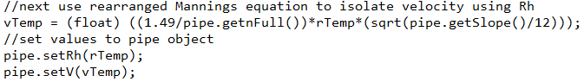

In both equations the slope needed to be divided by 12, to get slope in feet since is was listed as inches in the csv file. Once we had those variables calculated we then found the sediment accumulation potential using the following table calculations that give the sediment collection potential of three distinct types: coarse granular material, mobile, fine grained material, and fine-grained mineral and organic material. The table below shows the distributions:

Table 1.

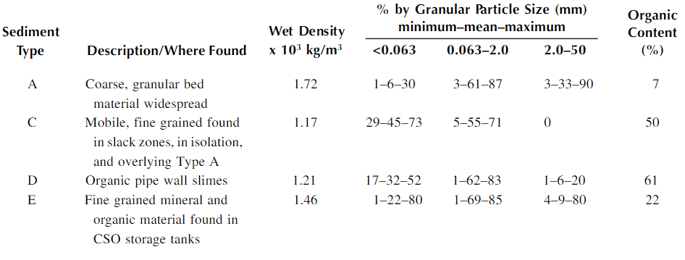

*Note*: Reprinted from *Management of Sewer Sediments*, by Ashley, Richard & Hvitved-Jacobsen, Thorkild. retrieved from <https://www.researchgate.net/publication/284510357_Management_of_Sewer_Sediments>Copyright 2003 by Lewis Publishers.

The calculations for this table are based on the Hjulström Curve which shows sediment deposit based on size of particle and velocity of flow:

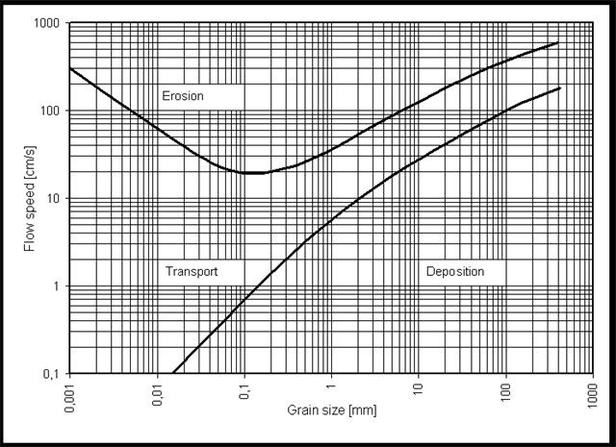

Hjulström, Filip. (1935). Hjulström Curve [Diagram]. Retrieved from <https://www.geocaching.com/geocache/GC4FMJY_can-a-creek-move-rocks?guid=2fccf6ef-9afb-4911-bff9-6c8fda9b8a27>

The implementation of this data is shown below:

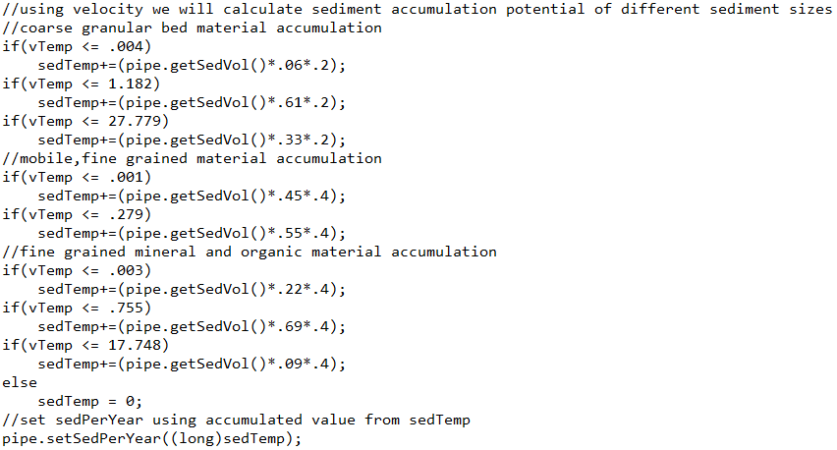

Once we have these variables in place, the next step was to calculate the maintenance interval. The max interval was set to 6 years, and the min to 6 months. Every other maintenance interval was based on calculating when the sediment accumulation would reach 50% of the total volume of each pipe. The code for this is shown below:

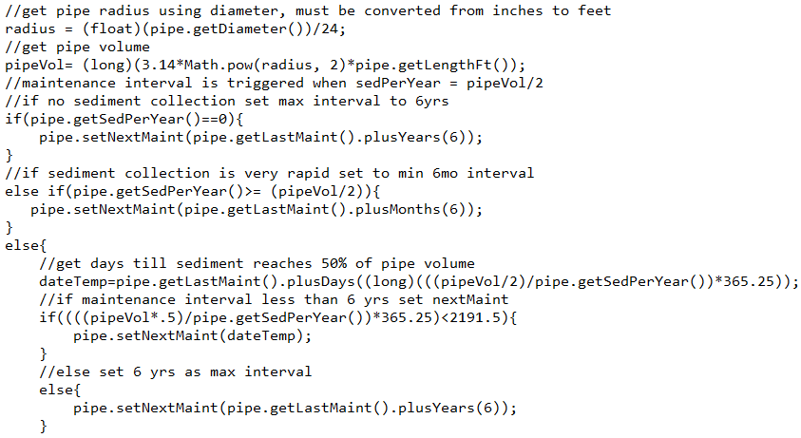

#### Descriptive Model

After the initial timeline for maintenance was established the descriptive model for adjustment was introduced via a user modifiable variable. This variable is based on field data and set by field technicians upon completion of pipe maintenance. The code implementation is virtually the same as the one listed above, but with the introduction of the variable adjVar. The code is shown below:

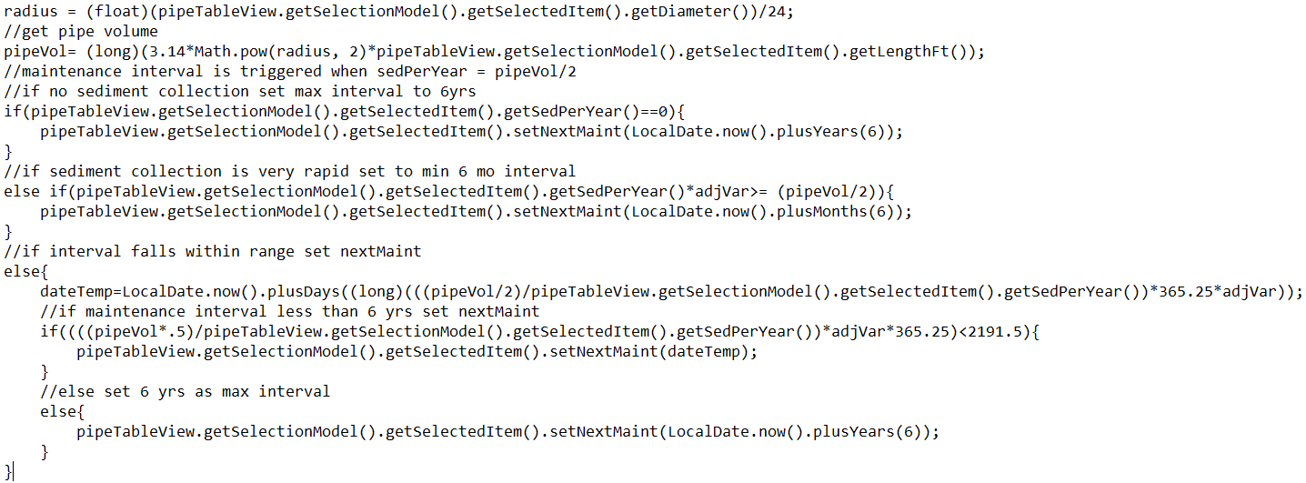

This code executes on the pipe that was maintained, after execution the application will check for pipes that fall into the same category. Pipes are categorized by material type, diameter, slope in 3% increments, and number of upstream customers in increments of 100. For these pipes we took the average of the old adjVar and the new one.

The code for pipe group is shown below:

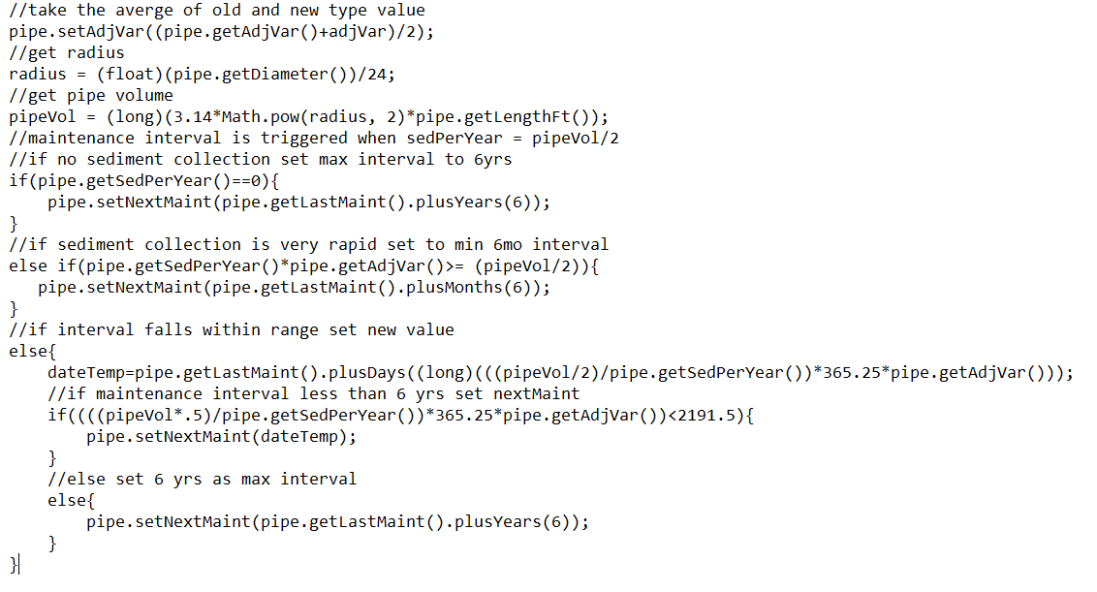

### Assessment of Hypotheses

The hypothesis for this project was as follows: “Given the data currently available and industry accepted techniques, can we develop a formula to determine sediment accumulation potential and flushing frequency need.” The validity of this hypothesis is not so easily checked since it will be driven, and improved upon, by field data which will take time to capture. Nevertheless, through careful application of the mathematical concepts discussed above we have created a model that should reliably predict maintenance need within an acceptable range, and which will only get more accurate over time.

### Data Visualization

For this application there are three forms of data visualization. First is the table view in which the user can see a list of all pipes with important criteria listed. The table view can be reordered based on any criteria in the list. This table view is also used by an administrator to assign tasks to maintenance workers. The table is shown below:

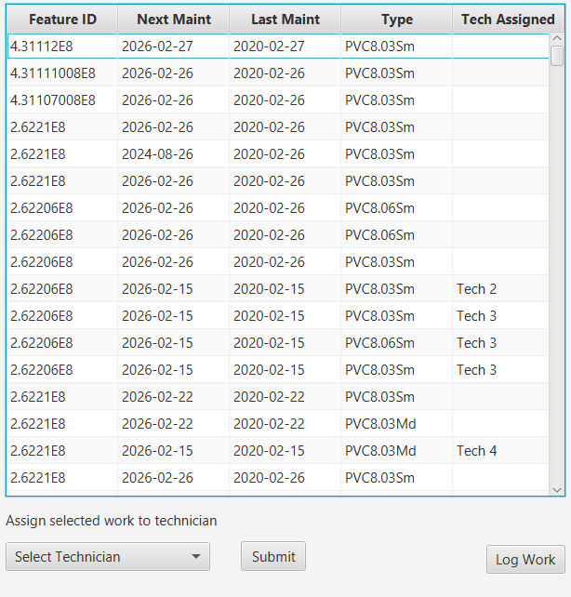

This table is also represented in the log work screen with different information that is useful to see when logging work. This version is shown below:

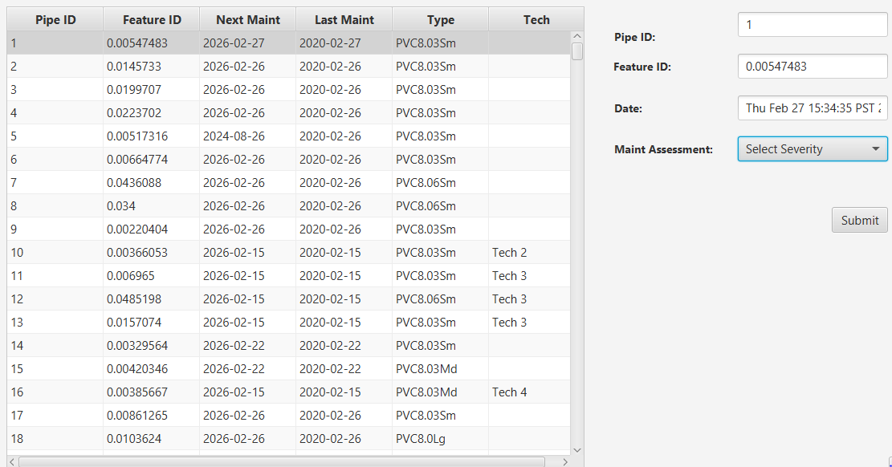

The second visualization is a bar chart that lists pipes by maintenance interval, in 6-month intervals. This is a useful way of visualizing what the average ranges are for all pipes. The chart is shown below:

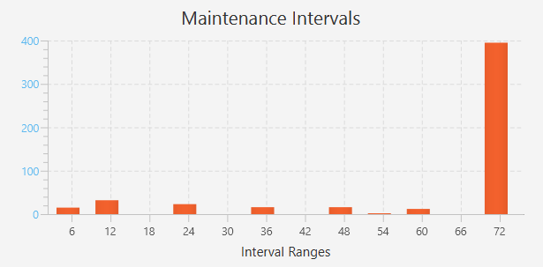

The final visualization is upcoming maintenance needed; this chart shows all pipes scheduled for the next 6-months. This chart is shown below:

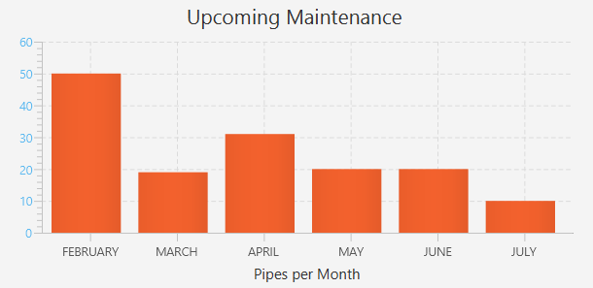

### Accuracy Assessment

The accuracy of this application is only currently verifiable as far as the algorithms used to calculate the data. The maintenance intervals calculated will need to be verified by field technicians and adjusted based on feedback. Having said that, the data used to build our predictions was collected in the field on the actual sewer mains that will be maintained so the outcomes should have a high degree of accuracy.

### Data Product Testing Results

The results of the data product testing and optimization is what would be expected. The length of maintenance interval is based on the pipes size, type, slope, and number of customers served. All pipes were weighted the same as far as amount of potential sediment so that these four variables were the deciding factor. The results are shown as the interval between last maintenance and next maintenance. The table view below gives a snapshot of this calculation:



### 

### Source Code and Executable File(s)

|  |  |
| --- | --- |
| File: | Description: |
| WillAlwinC964Capstone.zip | Folder containing Java project |
| Sewer_Main_Variables.csv | Csv file with majority of data used |
| A_table.csv | Csv file with A value linked by featureID |

### Quick Start Guide

This application was developed in NetBeans IDE version 8.2, using Java JDK 1.8. In order to run the application, you will need to first unzip the project folder, then open NetBeans, click File, click Open Project, and choose the project WillAlwinC964Capstone. Once the project is loaded click the green run button to launch application. You will see a login screen that requires a username and password.

For admin access:

Username: Admin 1

Password: test

This option will take you to the Maintenance Dashboard. From this screen you can view a list of all pipes, upcoming maintenance, and pipe grouping. By selecting a pipe from the table view and choosing a technician, you can schedule pipes for maintenance. You can also click the Log Work button which will launch the Log Work screen. In the log work screen, as an admin user you can see all pipes and submit work, which will update the next maintenance data, set last maintenance date to the current date, and remove any associated technician.

For technician access there are 4 users created:

Username: Tech 1, Tech 2, Tech 3, Tech 4

Password: test1, test2, test3, test4

As a technician you will load directly to the Log Work screen, you will be able to view only those pipes assigned to you for maintenance, and log completed work, which will function exactly as described above, with the exception that once a pipe has been logged it will be removed from the table view.

In order to exit the program, you can either click the logout button which will return you to the login screen, or simply close the application.

A log file: log.txt captures all login data, this file can be accessed in NetBeans through the ‘File’ folder in the open project, or inside the project folder by navigating to: WilliamAlwinDesktopScheduler\src\Files.

# Citations

About Washoe County. (n.d.). Retrieved February 27, 2020, from https://www.washoecounty.us/your_government/about-wc.php

Geocaching. (n.d.). Can a Creek Move Rocks. Retrieved February 27, 2020, from https://www.geocaching.com/geocache/GC4FMJY_can-a-creek-move-rocks?guid=2fccf6ef-9afb-4911-bff9-6c8fda9b8a27

Staff. (n.d.). Sewer backs up into parking lot in northwest Reno. Retrieved from <https://www.kolotv.com/content/news/Sewer-backup-into-parking-lot-in-northwest-Reno-466043583.html>

Ashley, Richard & Hvitved-Jacobsen, Thorkild. (2003). Management of Sewer Sediments. Retrieved February 27, 2020 from <https://www.researchgate.net/publication/284510357_Management_of_Sewer_Sediments>