**COMP6799001 - Database Technology**

**FINAL PROJECT DESCRIPTION ODD SEMESTER 2022/2023**

**E-TICKETING MANAGEMENT SYSTEM**



**Group Members:**

**WILLIAM JONATHAN MULYADI // 2502045683**

**BENEDICTUS FILBERT FEDERICO // 2502005263**

**HANSEL FAREN // 2501990350**

**Summary of problem description and teams:**

We decided to take this topic because of our collective enjoyment of watching music concerts/festivals. Some of the music festivals do not have a good e-ticketing management system yet therefore, we want to create this project to help them. This project is aimed to help people who like music and the event organizer that arranges the music festival. E-ticketing also helps reduce paper or plastic being used as it is compatible with countless devices. Moreover, e-ticketing is an interaction of humans to interface resulting in a faster process and promoting ease of use. In conclusion, this is why we decided to pick this topic.

Role:

1. William Jonathan Mulyadi - make the report, SQL tables, queries, code, and make GUI.
2. Benedictus Filbert Federico - no contribution
3. Hansel Faren - no contribution

Video documentation link : <https://youtu.be/l4JNqW7Jk3Q>

**Database Design:**

**Entity-Relation(ER)**

**→ the highlighted ones are the primary keys**

**{PK} → primary key**

**{FK} → foreign key**

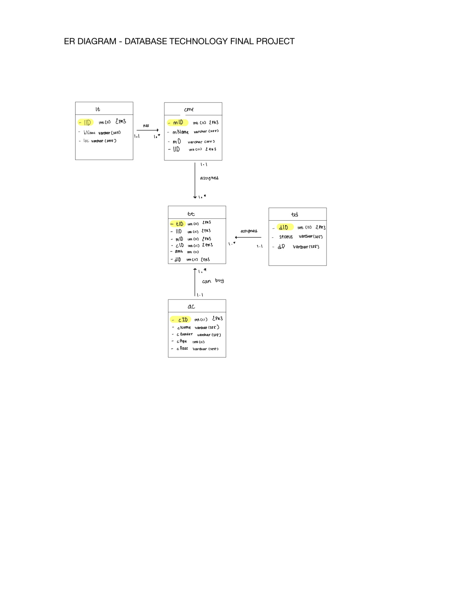

**Relations**

**Choose music festival -table**

cmf (mID, mName, mD, lID)

Foreign Key lID references lt(lID) On Delete No Action On Update Cascade

**Transaction -table**

tt (tID, lID, mID, cID, amt,dID)

Foreign Key lID references lt(lID) On Delete Cascade On Update Cascade

Foreign Key mID references cmf(mID) On Delete Cascade On Update Cascade

Foreign Key dID references td(dID) On Delete Cascade On Update Cascade

Foreign Key cID references ac(cID) On Delete RESTRICT On Update RESTRICT

**Normalisations**

**0NF**



**0NF-1NF**

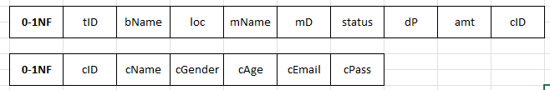

**1NF-2NF**

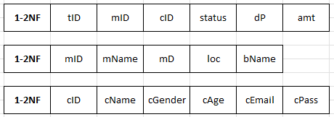

**2NF-3NF**

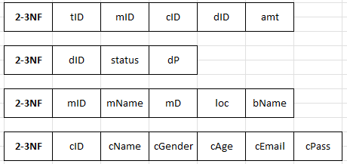

**Sample queries to generate a report:**

Database name : **festdb**

Menu Bar include Open → Table, Query

Table → **[lt], [cmf], [ac], [td], [tt]**

**[lt] - location table**

[Query 1]- TO CALCULATE MAX VALUE OF lID FROM LT TABLE

["Select MAX(lID) from lt" ]

[Query 2] - TO DISPLAY VALUE FROM LT TABLE

["Select * from lt" ]

[Query 3] - TO INSERT VALUE TO THE LT TABLE

["Insert into lt values (?,?,?)"]

[QUERY 4] - TO DELETE VALUE IN THE LT TABLE (It uses condition where lID is equal to n, n is the index when the table is clicked)

[" Delete from lt where lID = "+n;]

[QUERY 5] - TO UPDATE VALUE IN THE LT TABLE

["Update lt set bName=?, loc=? where lID=? “;]

[Query 6] - TO SELECT bName, loc FROM THE LT TABLE WITH CONDITION FROM USER INPUT EQUALS TO THE tID and from the tID it will get the lID and match the lID from the TT with lID from the LT

["Select lt.bName, lt.loc from lt, tt where lt.lID = tt.lID and tID='"TID.getText()+"'";]

**[cmf] → Choose Music Festival table**

[Query 1]- TO CALCULATE MAX VALUE OFmID FROM THE CMF TABLE

["Select MAX(mID) from cmf" ]

[Query 2] - TO DISPLAY VALUE FROM CMF TABLE

["Select * from cmf" ]

[Query 3] - TO INSERT VALUE TO THE CMF TABLE

["Insert into cmf values (?,?,?,?)"]

[QUERY 4] - TO DELETE VALUE IN THE CMF TABLE (It uses condition where lID is equal to n, n is the index when the table is clicked)

[" Delete from cmf where mID = "+n;]

[QUERY 5] - TO UPDATE VALUE IN THE CMFTABLE

["Update lt set mName=?, mD=?, lID=? where mID=? “;]

[QUERY 6] - TO DISPLAY mID and mName VALUE IN THE CMF TABLE

["Select mID,mName from cmf";]

[QUERY 7] - TO DISPLAY lID FROM THE CMF TABLE BY USING CONDITION MID EQUAL TO USER’S INPUT

["Select lID from cmf where mID ='"+ MID.getText()+"'";]

[Query 8] - TO SELECT mName, mD from CMF TABLE WITH CONDITION FROM USER INPUT EQUALS TO THE tID and from the tID it will get the mID and match the mID from the TT Table with the mID from the CMF table

["Select cmf.mName, cmf.mD from cmf, tt where cmf.mID = tt.mID and tID='"TID.getText()+"'";]

**[ac] → Add Customer table**

[Query 1]- TO CALCULATE MAX VALUE OF cIDFROM AC TABLE

["Select MAX(cID) from ac" ]

[Query 2] - TO DISPLAY VALUE FROM AC TABLE

["Select * from ac" ]

[Query 3] - TO INSERT VALUE TO THE AC TABLE

["Insert into ac values (?,?,?,?,?,?)"]

[QUERY 4] - TO DELETE VALUE IN THE CMF TABLE (It uses condition where lID is equal to n, n is the index when the table is clicked)

[" Delete from lt where cID= "+n;]

[QUERY 5] - TO UPDATE VALUE IN THE AC TABLE

["Update ac set cName=?, cGender=?,cAge=?, cEmail=?,cPass=? where cID=? ";]

[QUERY 6] - TO MATCH THE INPUT VALUE OF THE USER WITH THE VALUE IN THE AC TABLE (database security query)

[" Select * from ac where cEmail='"+ CEmail.getText()+"'and cPass= '"+CPassword.getText() +"'";]

[QUERY 7] - TO SELECT THE VALUE OF cID FROM AC TABLE WHEN THE USER’S INPUT IS EQUAL TO THE cEmail

["Select cID from ac where cEmail ='"+ CEmail.getText()+"'";]

**[td] → ticket detail table**

[QUERY 1] - TO DISPLAY VALUE IN THE td TABLE

["Select * from td";]

[Query 2] - TO SELECT status, dP from TD TABLE WITH CONDITION FROM USER INPUT EQUALS TO THE tID and from the tID it will get the dID and match the dID from the TT Table with the dID from the TD table

["Select td.status, td.dP from td, tt where td.dID = tt.dID and tID='"+TID.getText()+"'";]

**[tt] → transaction table**

[Query 1]- TO CALCULATE MAX VALUE OF tID FROM TT TABLE

["Select MAX(tID) from tt" ]

[Query 2] - TO DISPLAY VALUE FROM TT TABLE

["Select * from tt"; ]

[Query 3] - TO INSERT VALUE TO THE TT TABLE

["insert into tt values (?,?,?,?,?,?)";]

[Query 4] - TO SELECT VALUE TO THE TT TABLE WITH CONDITION OF tID EQUALS TO THE USER INPUT

[" Select * from tt where tID='"+TID.getText()+"'";]

[Query 5] - TO SELECT bName, loc FROM THE LT TABLE WITH CONDITION FROM USER INPUT EQUALS TO THE tID and from the tID it will get the lID and match the lID from the TT table with lID from the LT table

["Select lt.bName, lt.loc from lt, tt where lt.lID = tt.lID and tID='"TID.getText()+"'";]

[Query 6] - TO SELECT mName, mD from CMF TABLE WITH CONDITION FROM USER INPUT EQUALS TO THE tID and from the tID it will get the mID and match the mID from the TT Table with the mID from the CMF table

["Select cmf.mName, cmf.mD from cmf, tt where cmf.mID = tt.mID and tID='"TID.getText()+"'";]

[Query 7] - TO SELECT status, dP from TD TABLE WITH CONDITION FROM USER INPUT EQUALS TO THE tID and from the tID it will get the dID and match the dID from the TT Table with the dID from the TD table

["Select td.status, td.dP from td, tt where td.dID = tt.dID and tID='"+TID.getText()+"'";]

[Query 8] - TO SUM the amt FROM TT TABLE BY CONDITION IF ONLY THE mID equals to the clicked user input.

["Select SUM(amt) from tt where mID='"+(n)+"'";]

**User interfaces:**

**THE GUI**

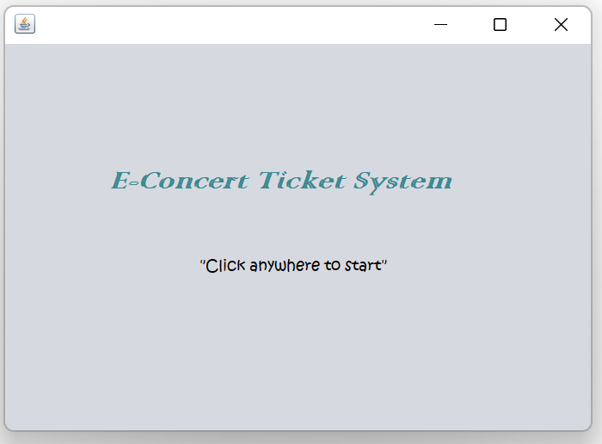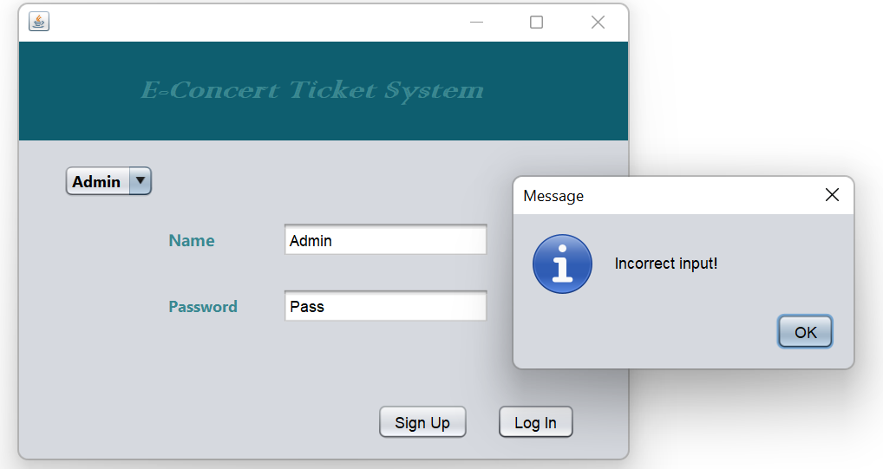

**Figure 1 Figure 2**

Figure 1 is the first page, where if you click anywhere on the screen it will redirect you to the second page which is in the Figure 2. In the Figure 2, there is a scroll bar that lets you choose between your role. You can choose between ‘admin’ and ‘visitor’. If you choose admin you will have to enter the name as Admin and password as password. On the other hand, if you choose visitor, you can straightly log in to the visitor page. There is also the sign up button which allows visitor to register his / her account.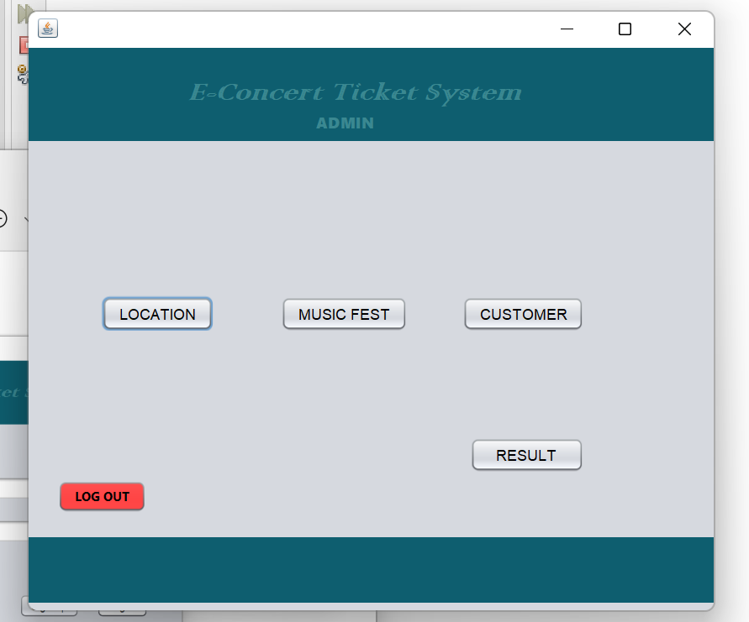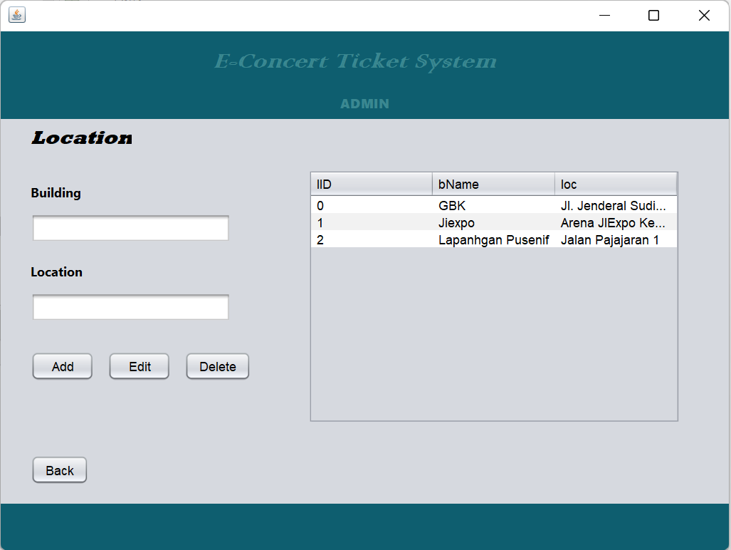

**Figure 3 Figure 4**

Figure 3 is the admin page. After you have successfully logged in as an Admin. There will be 4 buttons which redirect you to different pages. Figure 4 will be shown if you click on the location button. As you can see, admin is able to add, edit, and delete the location ( alter the location table, the queries are explained in the part before).

**Figure 5 Figure 6**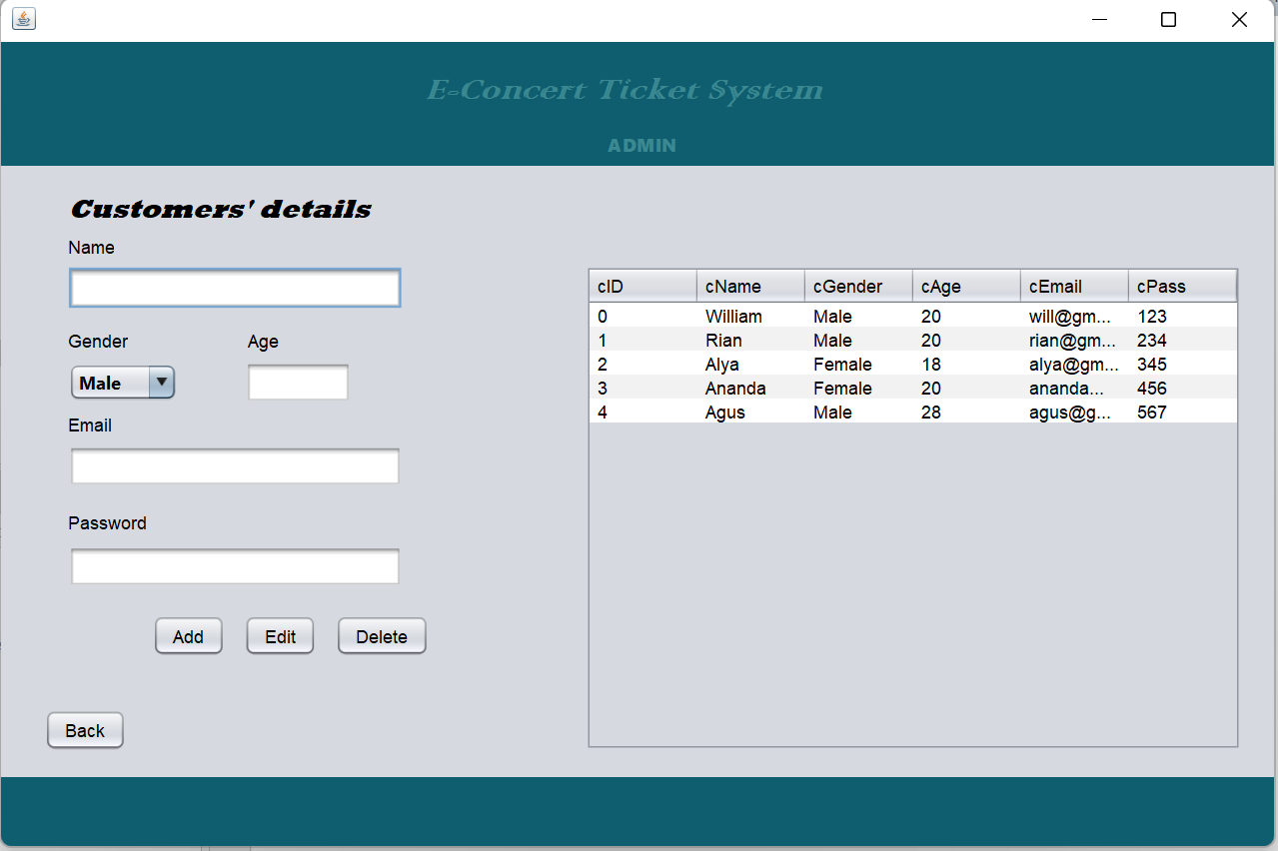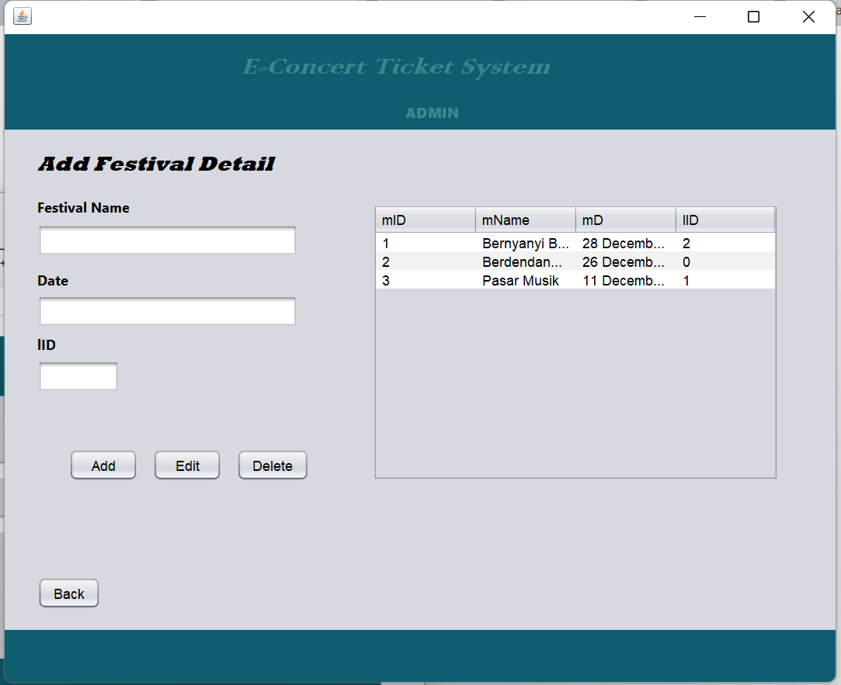

Figure 5 will be shown if the admin clicks the music fest button. The admin is able to add, edit, and delete the music festival ( alter the music festival tables, the queries are explained in the part before). Figure 6 is shown if the admin clicks on the customer button. The admin is able to look at the details of the customers that have signed up. Besides that, the admin is able to add, edit, and delete the customer ( alter the add customer table, the queries are explained in the part before).

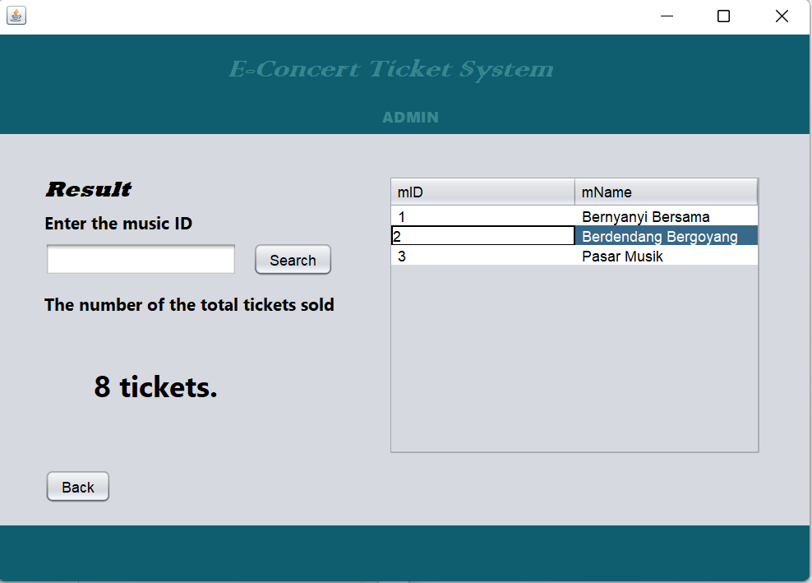

**Figure 7**

Figure 7 will be shown if the admin clicks the result button. The admin is able to see how many tickets are sold in the music festival.(Query → ["Select SUM(amt) from tt where mID='"+(n)+"'";] )

**Figure 8**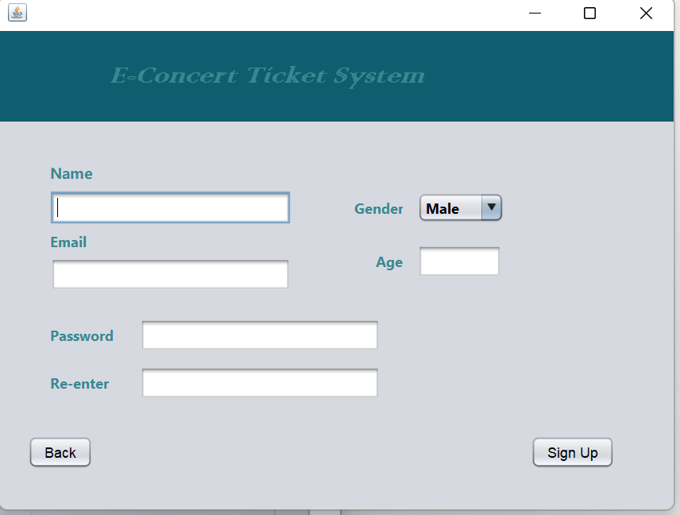

Figure 8 will be shown when the sign up button from Figure 2 is clicked. The visitor is able to register his or her account here. The password should match with the re-enter before signing up. As the account is registered, this will insert value to the ac table ( add customer table)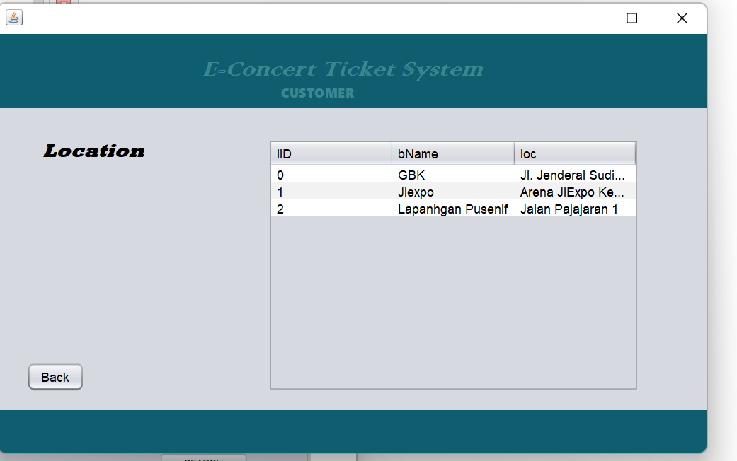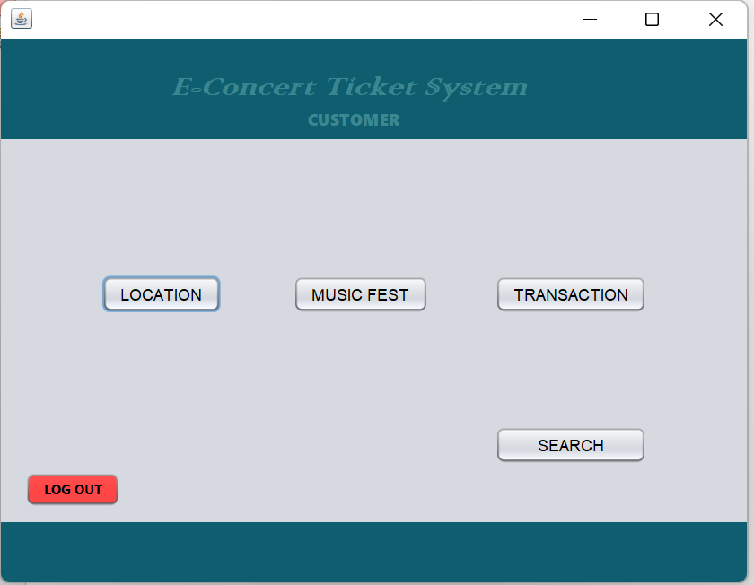

. **Figure 9 Figure 10**

Figure 9 will be shown after you click log in through the second page as visitor role. You do not have to input a name or password. You can directly log in. If you click on the location button in Figure 9, it will redirect you to Figure 10. The only thing that the visitor can do is just see the information of the location tables (Query→ ["Select * from lt" ]).

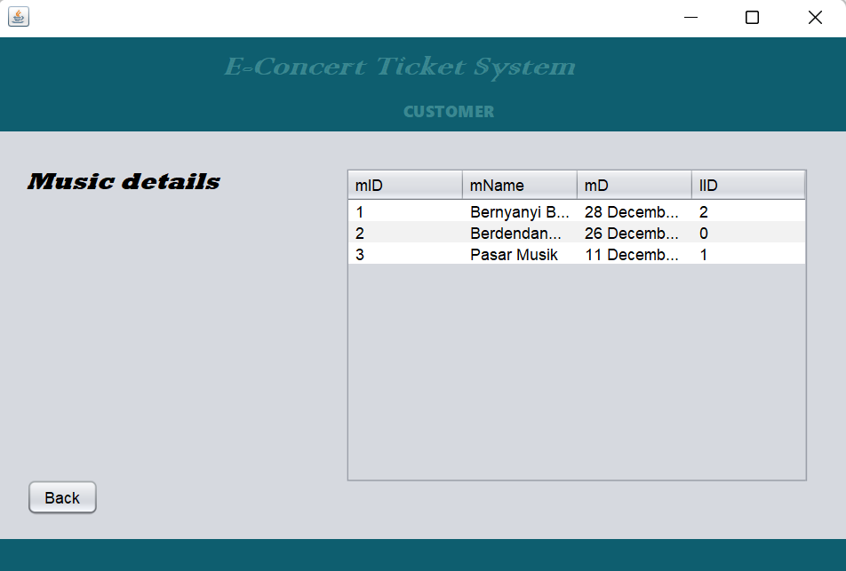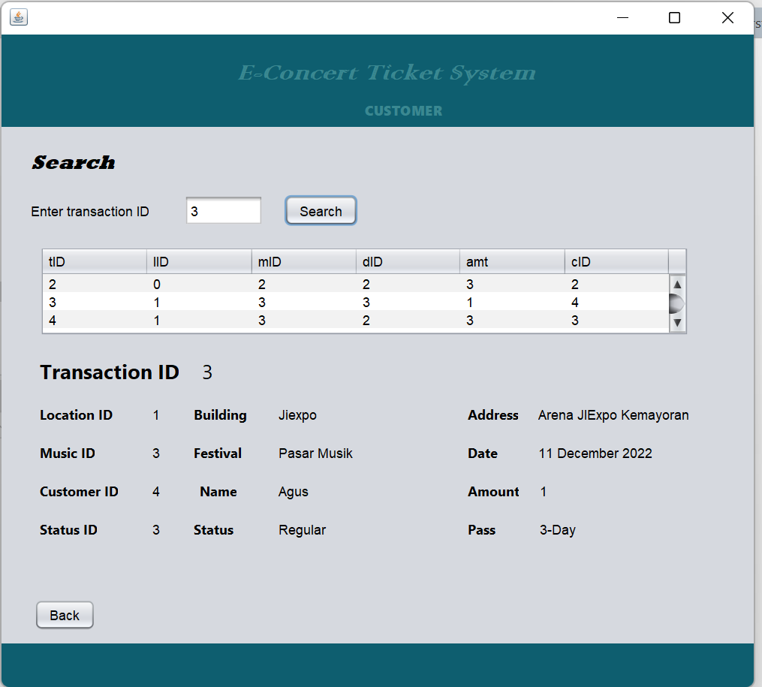

**Figure 11 Figure 12**

Figure 11 will be shown when the music fest button in Figure 9 is clicked. The visitor is only able to see the details of the music festival. The visitor is not able to alter the table. (Query →["Select * from cmf" ])

Figure 12 will be shown if you click on the search button. The visitor is able to search on any transaction and the details will be printed.(The queries are already explained in the part before).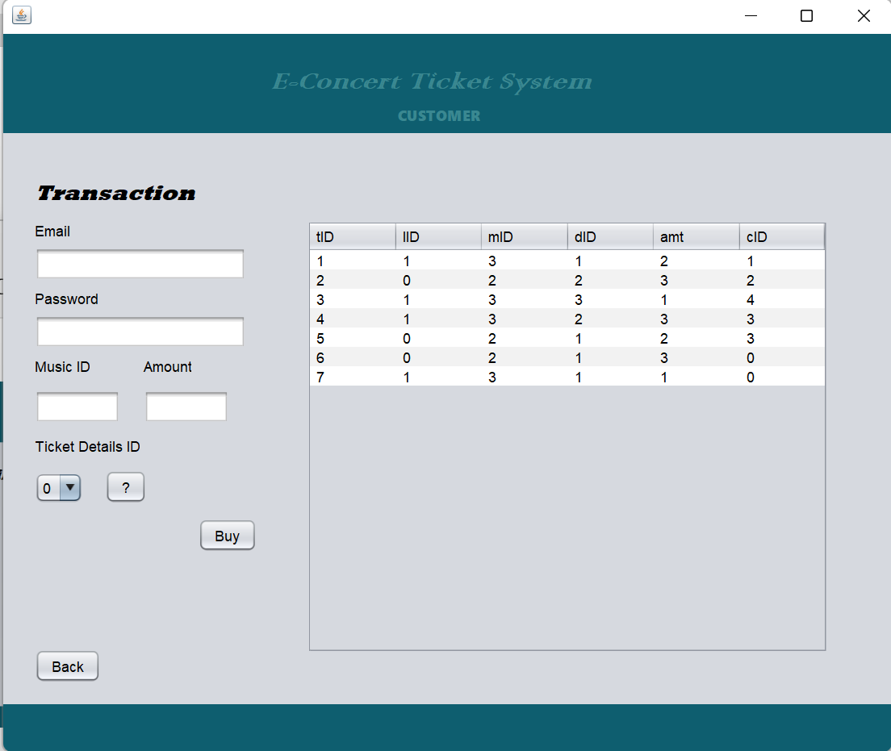

**Figure 13**

Figure 13 will be shown if the transaction button is clicked. The visitor is able to do the transaction after filling in all of the textfield ( able to insert values to the tt table). The email and password should be the same with the registered account before (Query →[" Select * from ac where cEmail='"+ CEmail.getText()+"'and cPass= '"+CPassword.getText() +"'";]). When entering the music ID, the lID will be filled automatically (Query → ["Select lID from cmf where mID ='"+ MID.getText()+"'";])

**THE SQL DATABASE:**

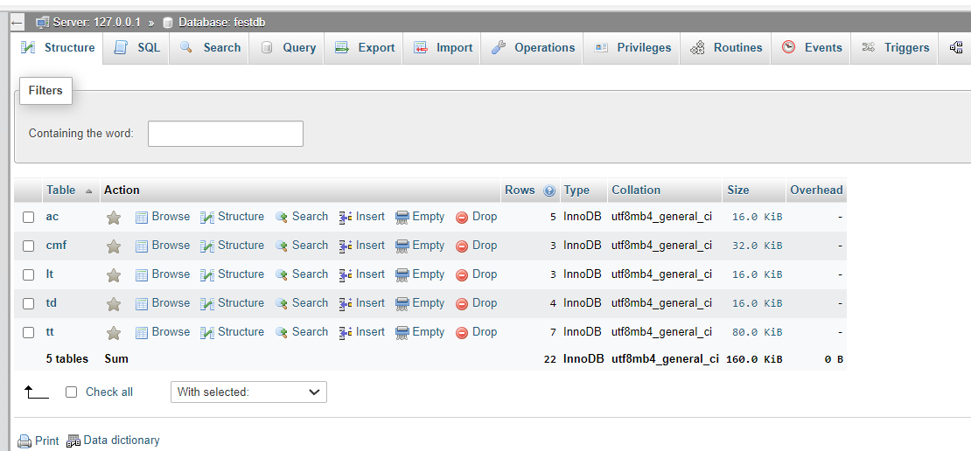

**Figure 14**

Figure 14 is the database that I created called festdb. It contains five tables as mentioned before.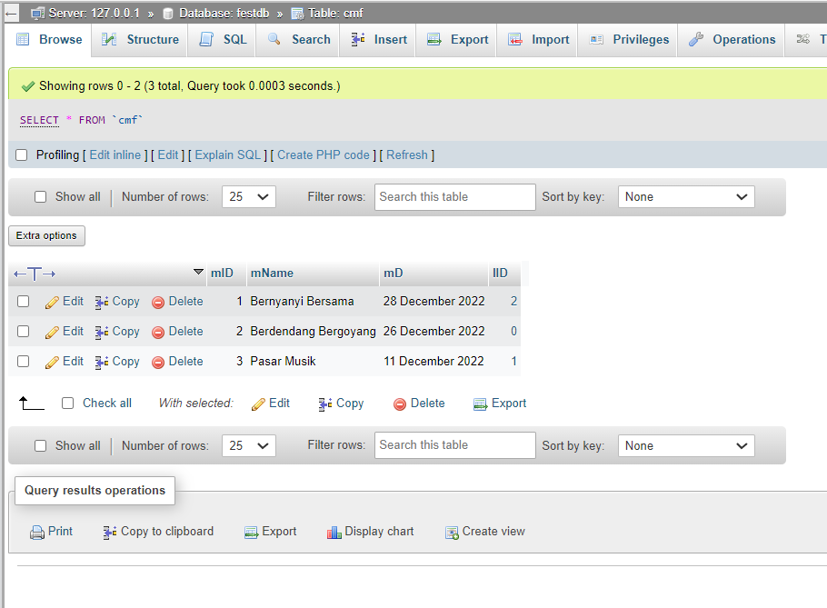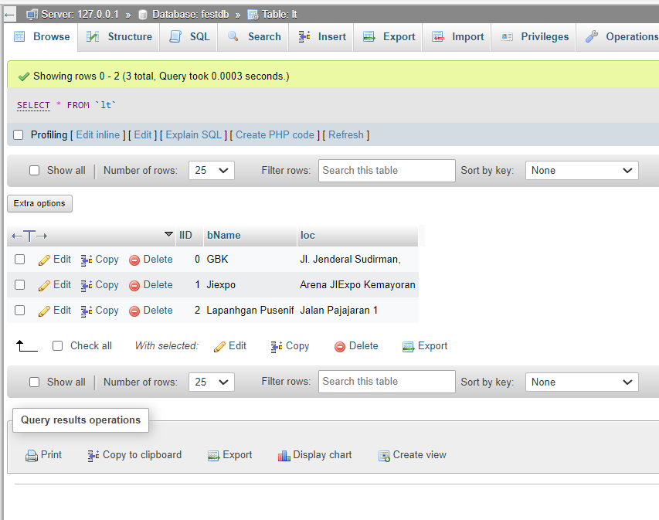

**Figure 15 Figure 16**

Figure 15 shows the lt table or location table. On the other hand, Figure 16 shows the cmf table or choose music festival table.

**Figure 17 Figure 18**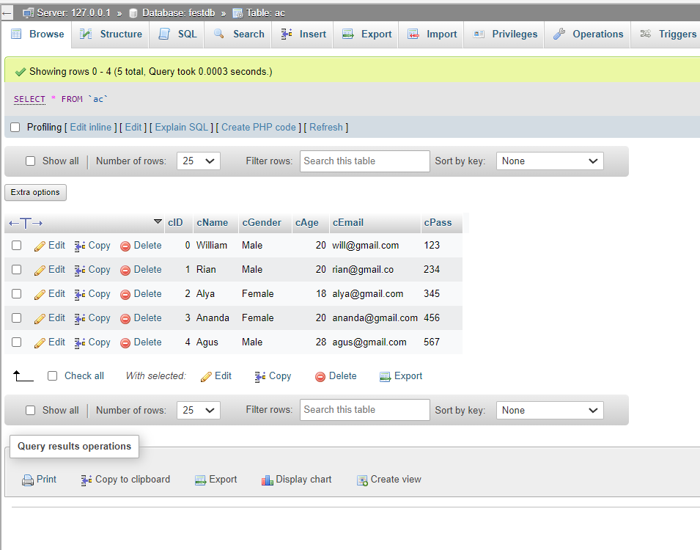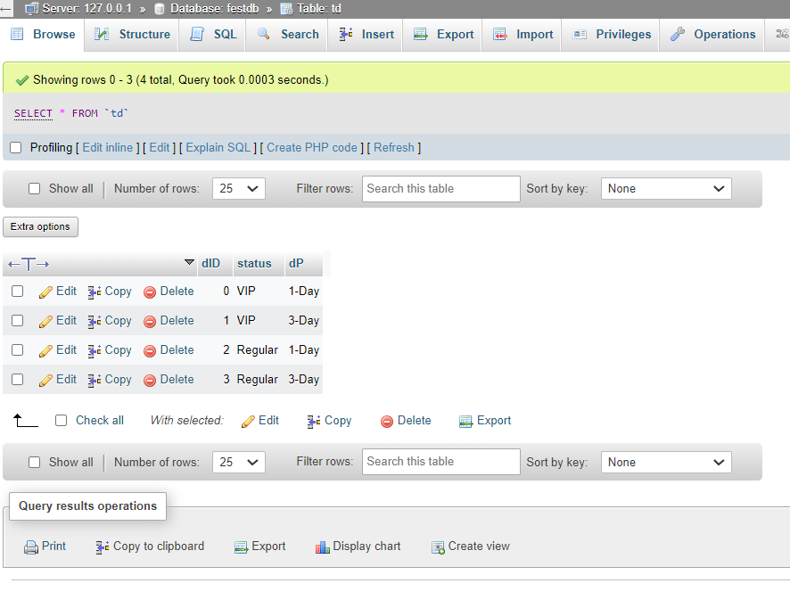

Figure 17 shows the td table or ticket detail table. Meanwhile, Figure 18 contains ac table or add customer table.

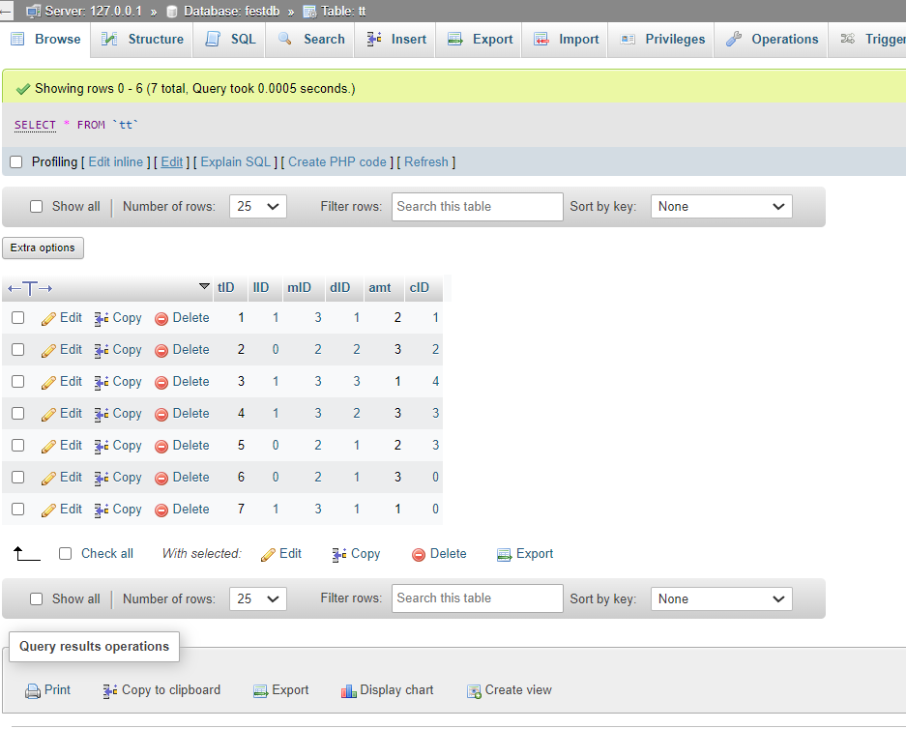

**Figure 19**

Figure 19 shows the tt table or transaction table.

**Database security:**

For the database security, we have assigned 2 roles to log in.

The first one is the admin and the second one is the visitor. If you are a visitor, you can straightly log in to the next page as it does not require you to enter your email and password. On the other hand, if you are an admin you have to enter your username and password.

For the admin (security), I set the username and password as default in the code. Hence, the username is only ‘ Admin ‘ and the password is only ‘ password ‘. If by any chance, the username or the password entered is not the same with the default, a pop up written “ Incorrect input ! “will be shown and you will not be allowed to log in.



When you logged in using the admin, you are able to add, edit, and delete the details of location, music festival, and customers (insert, update ,and delete the lt, cmf, and ac tables). Besides that, the admin can also see the result of the sales.

As for the payment (security- for visitor), when you want to buy or do a transaction, your email and password is required therefore, the visitor must input the email and password that they used to sign up before. If the email or password is not the same, it will not allow the visitor to do the transaction. It will show a pop up written “ Incorrect password or username !’

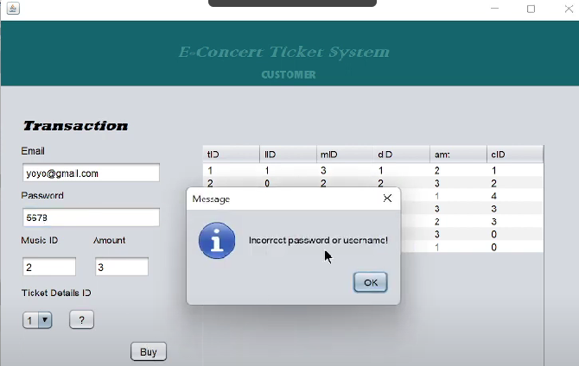

The visitor is able to add transaction ( insert value to the transaction table).

Besides that, in the sign up page, the program asked to register email and password. There is also the re-enter password part where if the password and the re-enter password are not the same, the account will not be registered.

