heartRateNormalModel

Bryan Milstead

December 1, 2016

## Background

Researchers at Pusan National University in Korea compared the cardiovascular fitness of marathon runners to a control group of non-athletes. Athletes and control group members had similar ages and weights. They found a dramatic difference in the resting heart rates (measured in beats per minute [bpm]) of the athletes compared to the control group. Marathon athletes (N=406) had a mean resting heart rate of 59.26bpm with a standard deviation of 4.01bpm. The control group (N=394) had a mean resting heart rate of 74.43bpm with a standard deviation of 9.69bpm.

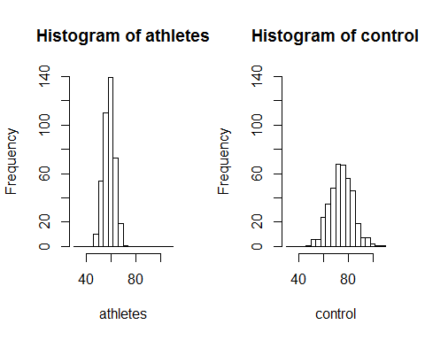

## Questions

* Is it appropriate to use the normal model to compare these two distributions? Yes / No
* Explain your answer.
* A nurse practitioner examines two subjects from the above study. The first, a marathon runner, has a resting heart rate of 50. The second is from the control group and has a resting heart rate of 64.
  + Calculate the Z scores for both subjects: Marathoner Z= Control Z=
  + Which one has a lower resting heart rate compared to other members of their group (athletes vs. control)?
  + Explain what the Z score for the marathon runner means.
* A subjects chosen at random has a resting heart rate of 64bpm.
  + Is this person more likely to be a marathon runner or a member of the control group (marathon / control)?
  + Explain your reasoning.
* A: Using the 68-95-99.7 rule what is the range of resting heart rate values you would expect for the central 68% of the marathon group. Lower range= ? Upper range= ?
* B: Using the 68-95-99.7 rule what is the range of resting heart rate values you would expect for the central 95% of the control group. Lower range= ? Upper range= ?
* A: What percent of the control group will have a heart rate between 71bpm and 80bpm
* B: What percent of the marathon group will have a heart rate between 57bpm and 61bpm