RELATIVE ABUNDANCE OF BIRDS ON THE SOUTHERN SLOPE OF THE DARWIN’S RANGE

Methods:

1. Point Counts: We conducted avian point counts every ca. 100m along transects of relatively homogeneous habitat types. The first station was chosen randomly. Surveys were conducted throughout the day when conditions when rainfall and wind speeds were low or absent. At each station all birds that were heard or seen were counted within a 50m radius. At each station we recorded the GPS locations and made a qualitative assessment of the dominant vegetation types (> 10% ground cover). Counts began when we arrived at each station and continued for 5 minutes. The same two observers conducted all censuses; 1 did the counts while the other recorded the information.
2. General Observations: at each transect we estimated the relative abundance of each species observed whether include in the point counts or not. The abundance of each species observed was ranked with the following scale: 0=absent; 1=1 to 5 individuals detected; 2 = 5 to 20 individuals detected; and, 3 = greater than 20 individuals detected.

Study Sites: Surveys were conducted in the following habitat types.

1. **Terminal Moraine of the Dirty Glacier** (TM) to the East of the main Pia glacier included (10 stations). The transect ran from the coast to the moraine including various early successional stages of shrub and forest development.
2. **Upland Lake** (UL) located on the western shore of the eastern arm of Pia Sound at ca. XXXm elevation. The transect included 12 stations starting at sea level (3 stations) and ending at the lake (9 stations). This area included vegetation of relatively undisturbed *Notofagus* forest. The understory was swampy with many rushes and mosses.
3. **Coastal Forest** (CF) on the eastern edge of the sound beginning at xxxx bay and terminating at the sandy shore near TM (18 stations). The habitat included mixed *Notofagus* and *Drimys* forest with abundant *Pernettya, Berberis, Chilotrichum,* and *Marsipospermus* shrubs and *Gunnera* ground cover. All stations were within 100m of the shore and included steep slopes and large boulders.
4. **River Forest Ecotone** (RF) of Alemania Glacier watershed (9 stations). The transect began 500m North of the mouth of the river and extended to the base of the terminal moraine. This was pioneer serial stage *Nothofagus* forest with many medium-sized boulders (ca. 50cm in diameter).
5. **Interior Forest** (IF) of Alemania Glacier watershed (9 stations). This transect began at the terminal moraine running south, ending ca. 200m from RF. This was a mature *Nothofagus* and *Drimys* forest with an open understory that included moist soils with a thick carpet of mosses.
6. **Tourist Trail** (TT) to the west of Pia Glacier (10 stations). The transect began at sea level and followed an established trail through a mixture of glacier polished bare rock outcrops with boulders and recently established *Nothofagus* forests interspersed with *Empetrum* and *Pernettya* shrubs. The transect ended at a rocky outcrop approximately xxx m of elevation

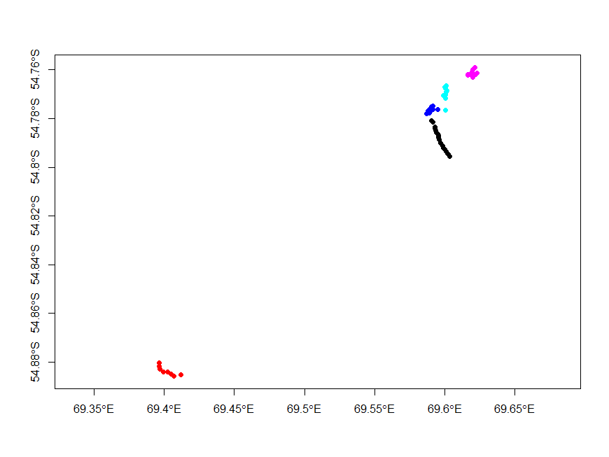

Results

|  |  |  |  |  |  |  |  |  |  |  |  |
| --- | --- | --- | --- | --- | --- | --- | --- | --- | --- | --- | --- |
| **Site** | **Estación** | **Rayadito** | **Chincól** | **ChercánDeLasVegas** | **Chercán** | **FioFio** | **Jilguero** | **Churrín** | **Churrete Común** | **Zorzal** | **Cometocino** |
| **Coastal Forest** | 18 | 0.50 | 0.00 | 0.00 | 0.06 | 0.56 | 0.06 | 0.22 | 0.06 | 0.00 | 0.06 |
| **Interior Forest** | 9 | 0.22 | 0.11 | 0.00 | 0.11 | 0.67 | 0.00 | 0.00 | 0.00 | 0.11 | 0.00 |
| **River Forest** | 9 | 0.33 | 0.11 | 0.00 | 0.11 | 0.89 | 0.00 | 0.00 | 0.00 | 0.00 | 0.22 |
| **Terminal Moraine** | 10 | 0.10 | 0.40 | 0.10 | 0.00 | 0.30 | 0.00 | 0.00 | 0.00 | 0.00 | 0.00 |
| **Tourist Trail** | 10 | 0.30 | 0.10 | 0.00 | 0.00 | 0.50 | 0.00 | 0.00 | 0.00 | 0.00 | 0.00 |
| **Upland Lake** | 12 | 0.00 | 0.00 | 0.00 | 0.08 | 0.33 | 0.08 | 0.00 | 0.00 | 0.00 | 0.08 |
| **Total** | 68 | 0.26 | 0.10 | 0.01 | 0.06 | 0.53 | 0.03 | 0.06 | 0.01 | 0.01 | 0.06 |

Table 1: Proportion of stations with observations (presence) for each species by site.

|  |  |  |  |  |  |  |  |  |  |  |  |
| --- | --- | --- | --- | --- | --- | --- | --- | --- | --- | --- | --- |
| **Site** | **Estación** | **Rayadito** | **Chincól** | **ChercánDeLasVegas** | **Chercán** | **FioFio** | **Jilguero** | **Churrín** | **Churrete Común** | **Zorzal** | **Cometocino** |
| **Coastal Forest** | 18 | 1.22 | 0 | 0 | 0.06 | 0.89 | 0.11 | 0.33 | 0.06 | 0 | 0.06 |
| **Interior Forest** | 9 | 0.44 | 0.11 | 0 | 0.11 | 1.22 | 0 | 0 | 0 | 0.11 | 0 |
| **River Forest** | 9 | 1 | 0.11 | 0 | 0.33 | 1.44 | 0 | 0 | 0 | 0 | 0.33 |
| **Terminal Moraine** | 10 | 0.3 | 1.1 | 0.1 | 0 | 0.4 | 0 | 0 | 0 | 0 | 0 |
| **Tourist Trail** | 10 | 0.7 | 0.1 | 0 | 0 | 0.8 | 0 | 0 | 0 | 0 | 0 |
| **Upland Lake** | 12 | 0 | 0 | 0 | 0.08 | 0.33 | 0.08 | 0 | 0 | 0 | 0.08 |
| **Total** | 68 | 0.66 | 0.21 | 0.01 | 0.09 | 0.82 | 0.04 | 0.09 | 0.01 | 0.01 | 0.07 |

Table 2: Mean number of individuals by species observed at each site.