
Installation Guide

3Dfx Interactive Reference Boards and Related Software 2.6

Document Revision 2.6
April 1997
Copyright © 1996, 1997 3Dfx Interactive, Inc.
All Rights Reserved

3Dfx Interactive, Inc.
4435 Fortran Drive
San Jose, CA 95134
408-935-4400
www.3dfx.com

Friendly Reminder
The software that you are using is covered by the 3Dfx Interactive LICENSE AND CONFIDENTIALITY AGREEMENT. For more specific information, please refer to the License and Confidentiality Agreement located in the back of this document. Thanks for your support!
The 3Dfx Interactive logo, Voodoo Graphics and Voodoo Rush are registered trademarks of 3Dfx Interactive, Inc.
All other trademarks are the property of their respective owners.
Information in this document is subject to change without notice. No part of this document may be reproduced or transmitted in any form or by any means, electronic or mechanical, for any purpose, without the express written permission of 3Dfx Interactive, Inc.
Copyright © 1996, 1997 3Dfx Interactive, Inc.

The 3Dfx Interactive Software Developers Kit
Introduction
Display Considerations
Compatibility Restriction
Voodoo Rush Notes
Reference Boards
The Obsidian Board:
Alliance AT3D Board and the Voodoo Rush Daughter Board:
The Trident ProVidia 9685-1 + Voodoo Rush reference design Board:
System Requirements
Obsidian Reference Board Hardware Installation
Hardware Overview
Hardware Installation Instructions
Alliance AT3D and Voodoo Rush Reference Board Hardware Installation
Hardware Overview
Hardware Installation Instructions
The Trident ProVidia 9685-1 + Voodoo Rush reference design Board Hardware Installation
Hardware Overview
Hardware Installation Instructions
Direct 3D and DirectDraw Driver Installation
General
Fresh Installation of the Direct3D Driver for Voodoo Graphics
Fresh Installation of the DirectDraw/Direct3D Driver for Voodoo Rush
Glide Installation
General
Windows 95 Fresh Installation
Fresh Installation of Drivers for Voodoo Graphics in a Windows NT 4.0 Environment
Fresh Installation of Drivers for Voodoo Rush in a Windows NT 4.0 Environment
Fresh Installation of Drivers in an MS-DOS Environment
Manual Installation of Drivers in an MS-DOS Environment
ATB Installation
ATB Driver Fresh Installation
Uninstallation
Direct3D for Voodoo Graphics
DirectDraw/Direct3D for Voodoo Rush:
Glide for Windows 95
Glide for Windows NT 4.0 (Voodoo Graphics only)
Glide for MS-DOS
ATB
Troubleshooting
All Reference Cards
Noise on screen
Voodoo Graphics
Voodoo PCI-based accelerator does not fit into Slot
Pass-through connector for Voodoo Graphics won’t attach to Compaq Desktops
Signal loss, noise or poor image quality on 2D card
Excessive signal loss when a Matrox Millennium card is present
System hang on S3-based system
Correcting S3 conflict under Windows 95
Method 1 - Memory address reassignment in Windows 95 Device Manager
Method 2 - Memory address reassignment using FXREMAP.EXE
Method 3 - Use default Windows 95 S3 968/868 driver
Correcting S3 Conflict under Windows NT 4.0
Voodoo Rush
Diagnostic Utilities
Is the configuration of the reference board OK?
Voodoo Graphics diagnostic program display graphics?
Installation problem determination
Did the D3D HAL Voodoo Graphics Setup program fail?
Is the Voodoo Graphics hardware installed properly?
The Tunnel sample program displays correctly on Voodoo Graphics?
Your D3D game under development display correctly on Voodoo Graphics?
Debugging
Third Party Errata
Stuttering sound in some games
Assistance Information
3DFX INTERACTIVE, INC. LICENSE AND CONFIDENTIALITY AGREEMENT

The 3Dfx Interactive Software Developers Kit
This document is part of the 3Dfx Interactive Software Development Kit (SDK). The 3Dfx Interactive SDK documentation consists of:

- DOCS\INSTALL.DOC - Installation Guide: 3Dfx Interactive Reference Boards and Related Software 2.6
- DOCS\GPGUIDE.DOC - Porting Guide: Glide 2.3
- DOCS\ATBRELNO.DOC - Release Notes: ATB 0.5
- DOCS\D3DRELNO.DOC - Release Notes: 3Dfx Direct 3D™ 2.08
- DOCS\GLRELNO.DOC - Release Notes: Glide 2.3

Introduction
This document is part of the 3Dfx Interactive Software Developers Kit. It is designed to assist with the installation of 3Dfx Interactive reference boards and related software.

3Dfx Interactive’s reference board, named Obsidian, incorporate the Voodoo Graphics™ 3D accelerator chipset. 3Dfx Interactive based products deliver the ultimate 3D game experience. 3Dfx Interactive’s latest chipset, Voodoo Rush, extends the Voodoo Graphics product line by adding support for compatible 2D accelerators. Voodoo Rush, combined with 2D technology from partners, provides an integrated 2D and 3D solution that allows support for 3D in a window. This document will describe the boards based on these technologies, system requirements for the boards, installation of both the hardware and the software, troubleshooting tips, and problems which may occur.
Notes:
- This release of the Glide rasterization library runtime files are shipped on the accompanying CD-ROM. Games compiled with prior releases of the Glide rasterization library will not function with Glide 2.2 or later.
- The reference boards are intended for software development and as a reference production board design.
- This release is intended to provide access to developers using a 3Dfx reference board.

Display Considerations
Although Voodoo Graphics reference boards support VGA pass through, a second monitor (in addition to the monitor connected to the normal display adapter) capable of synching a 60Hz video signal at a minimum resolution of 640x480 pixels, is recommended for development. This enables developers to debug their code while examining the graphics output.

Compatibility Restriction
There are no known compatibility restrictions with the reference boards. We encourage any feedback regarding PCI board difficulties.

Voodoo Rush Notes
At the time of publication of this document, reference designs supporting Voodoo Rush are available from Alliance Semiconductor and Trident Microsystems . Other partners, such as MRTI and Macronix, are currently developing their products. We will update you on new partnerships and document the product descriptions and installation procedures as the information becomes available.

Reference Boards

The Obsidian Board:
This release of the Obsidian contains 2 ASICs, the Pixelfx (triangle engine) and the Texelfx (texture engine). The current board revision contains the Pixelfx (triangle engine) with 2MB of frame buffer EDO DRAM and the Texelfx (texture engine) with 2MB of EDO DRAM for texture storage. This boards sits in its own PCI slot and uses a pass-through cable to utilize the 3D output.

Alliance AT3D Board and the Voodoo Rush Daughter Board:
This release of the Voodoo Rush accelerator contains 2 ASICs , the PCfx (triangle engine) and theTexelfx (texture engine). The Voodoo Rush daughter board interfaces with the Alliance AT3D board to share the video card’s memory. The Alliance AT3D chip provides high performance VGA and 2D accelerator functions - all 3D functions are performed by the 3Dfx chipset via the Voodoo Rush (VR)interface.

The Trident ProVidia 9685-1 + Voodoo Rush reference design Board:
This release of the Voodoo Rush accelerator contains 2 ASIC’s, the PCfx (triangle engine) and the Texelfx (texture engine). The Trident 9685-1 chip provides high performance VGA and 2D accelerator functions - all 3D functions are performed by the 3Dfx chipset via the VR interface. The Trident 9685-1 also provides TV out for VGA, 2D and 3D.

System Requirements
3Dfx reference boards require the following:
- 120MHz (or faster) Intel Pentium™ CPU
- Vacant PCI slot
- Minimum 16MB RAM, 32MB RAM Recommended
- At least 100MB of unused hard disk space is required to install all the demos; 22MB is required to install the Glide libraries only.
- For Glide: MS-DOS® revision 6.22 or higher, Windows® 95 or Windows® NT 4.0
For Direct3D/DirectDraw™: Windows 95 or Memphis
For ATB: Windows 95 or Windows NT 4.0

Obsidian Reference Board Hardware Installation

Hardware Overview

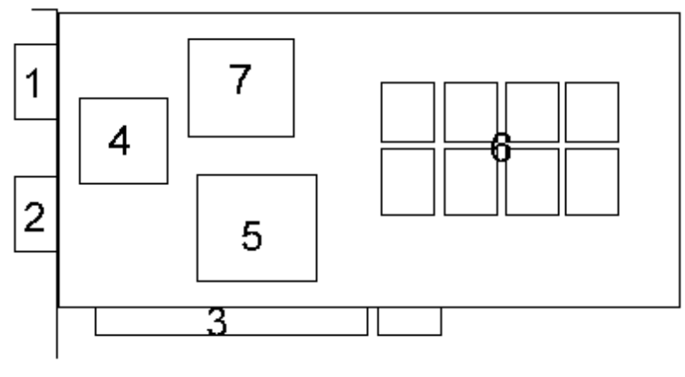

Figure 1: Layout of the Obsidian (Pro) Board
Labeled items are described as follows:
- Female Video Connector. Accepts the video cable from the monitor, where the Obsidian 3D accelerator is attached.
- Male Video Connector. Accepts input from the system’s video card.
- PCI Connector. Connects the Obsidian 3D accelerator to the system’s PCI bus.
- AT&T DAC. This chip generates the video signal for the monitor.
- Obsidian Pixelfx Frame Buffer Interface. This chip contains the interface logic for the DAC and the PCI bus, as well as the memory controller and the triangle rendering engine.
- EDO RAM. Provides the video/texture memory for the Obsidian board.
- Obsidian Texelfx Texture Mapping Unit. This chip contains the texture rendering engine.

Hardware Installation Instructions
- Shutdown system software and turn the computer off.
- Disconnect the power cable from the computer.
- Remove the case from the computer.
- Remove the cover plate for the PCI slot where the Obsidian (Pro) will be installed. PCI slots can be identified by the following:
- The color of the slot is usually (but not necessarily) white.
- The back edge of a PCI slot is roughly one centimeter further from the back of the system case than an ISA slot.
- PCI slots are roughly two-thirds the length of an ISA slot.
- Remove the board from the anti-static packaging.
- Gently place the PCI connector (Labeled 3 in Figure 1: Layout of the Obsidian (Pro) Board).
- Gently press down until the card snaps into place. If more than a slight amount of force is required, the board is improperly aligned. Check the orientation and alignment of the board before attempting to reinsert into the PCI slot.
- Reassemble the system.
- Locate the pass through cable.
- Connect the end of the pass through cable reciprocal to the Male Connector (Labeled 2 in Figure 1: Layout of the Obsidian (Pro) Board).
- Connect the other end of the pass through cable to the video card.
- Connect your monitor cable to the Female Connector (Labeled 1 in Figure 1: Layout of the Obsidian (Pro) Board).
- Power up the system.

Alliance AT3D and Voodoo Rush Reference Board Hardware Installation

Hardware Overview
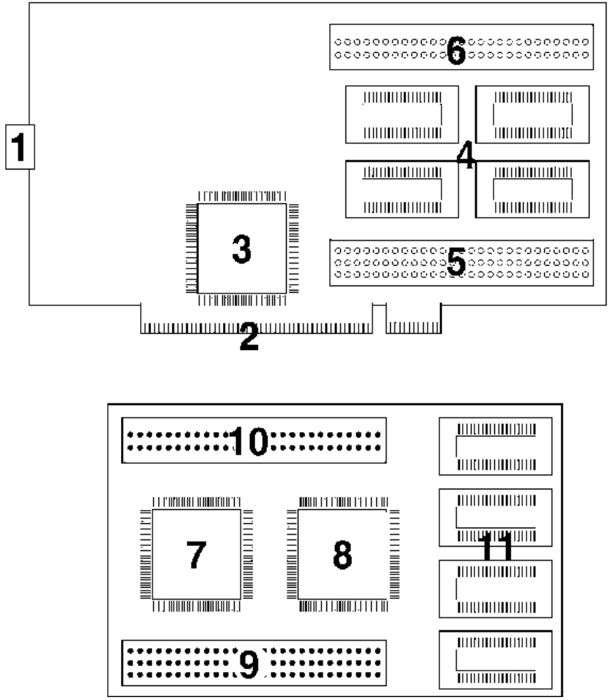
Component-side up
Figure 2: Layout of the Alliance AT3D Board and the Voodoo Rush Daughter Board
- Female Video Connector. Accepts the video cable from the monitor, where the Voodoo Rush accelerator is attached.
- PCI Connector. Connects the Voodoo Rush accelerator to your system’s PCI bus.
- AT3D. This chip acts as the central media hub.
- Frame Buffer. This provides the video/texture memory for the Voodoo Rush board. This configuration has 2MB RAM.
- 3-Rowed Female Video Receptors. These receptors connect to the 3-Rowed Male Video Memory Pins (#9). Be certain that the pins and the receptors align correctly.
- 2-Rowed Female Video Receptors. These receptors connect to the 2-Rowed Male Video Memory Pins (#10). Be certain that the pins and the receptors align correctly.
- Voodoo Rush PCfx (Triangle Engine). This chip contains the interface logic for the DAC and the PCI bus, as well as the memory controller and the triangle rendering engine.
- Voodoo Rush Texelfx (Texture Engine). This chip contains the texture rendering engine.
- 3-Rowed Male Video Memory Pins. These pins connect to the 3-Rowed Female Receptors (#5). Be certain that the pins and the receptors align correctly.
- 2-Rowed Male Video Memory Pins. These pins connect to the 2-Rowed Female Receptors (#6). Be certain that the pins and the receptors align correctly.
- Texture RAM. This RAM provides the video/texture memory for your Voodoo Rush board.

Hardware Installation Instructions
At the time this document was released, the latest Alliance AT3D chip available was revision ES5 Rev. B. Any older AT3D chip or board should be returned to Alliance for an upgrade to ES5 Rev. B or later.
A new Voodoo Rush ”Daughter board” is required to work with ES5. The latest Voodoo Rush Daughter Board is Rev. C. Any older daughter board should be returned to 3Dfx Interactive for an upgrade to REV C.
- Shutdown system software and turn the computer off.
- Disconnect the power cable from the computer.
- Remove the case from the computer.
- Remove any video card from the slot. The Alliance AT3D Board and the Voodoo Rush Daughter Board run independently and supports 2D and 3D.
- Remove the cover plate for the PCI slot where the Alliance AT3D Board and the Voodoo Rush Daughter Board will be installed. PCI slots can be identified by the following :
- The color of the slot is usually (but not necessarily) white.
- The back edge of the PCI slot is roughly one centimeter further from the back of the system case than an ISA slot.
- PCI slots are roughly two-thirds the length of an ISA slot.
- Remove the Alliance AT3D Board and the Voodoo Rush Daughter Board from the anti-static packaging.
- Attach the Voodoo Rush Daughter Board to the Alliance board’s memory pins, located at the upper-right corner (Labeled 5, 6, 9 and 10 in Figure 2: Layout of the Alliance AT3D Board and the Voodoo Rush Daughter Board)
Caution: Make certain that the pins correctly align to their corresponding connectors, i.e. the double-rowed pins should connect to the double-rowed connectors; the triple-rowed pins should connect to the triple-rowed connectors. Failure to comply may cause difficulty removing the boards. In addition, continuous strain may damage the boards’ components and hinder performance..
- Gently place the attached Voodoo Rush Daughter Board and the Alliance PCI connector (Labeled 2 in Figure 2: Layout of the Alliance AT3D Board and the Voodoo Rush Daughter Board). Gently press down until the card snaps into place. If more than a slight amount of force is required, the board is improperly aligned. Check the orientation and alignment of the board before attempting to reinsert into the PCI slot.
- Reassemble the system.
- Connect your monitor cable to the Female Connector (Labeled 1 in Figure 2: Layout of the Alliance AT3D Board and the Voodoo Rush Daughter Board).
- Power up the system if video output appears follow the DirectDraw driver install instructions for Windows 95.

The Trident ProVidia 9685-1 + Voodoo Rush reference design Board Hardware Installation

Hardware Overview
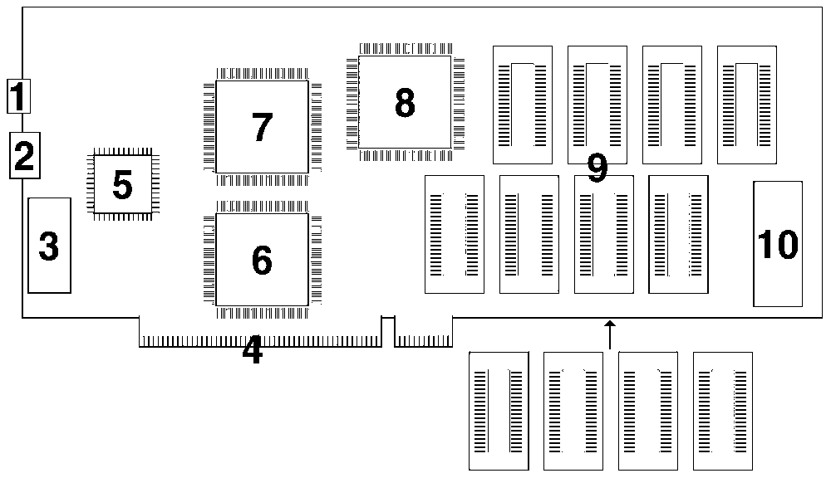
Component-side up
Figure 3: Layout of the Trident ProVidia 9685-1 + Voodoo Rush reference design Board
Here are descriptions of the labeled items:
- Composite Video Connector. Accepts the video cable from the TV.
- S-Video Connector. Accepts the video cable from any S-Video device (examples: TV with S-Video connector or VCR with S-Video connector).
- Female Video Connector. Accepts the video cable from the monitor.
- PCI Connector. Connects the Voodoo Rush accelerator to the system’s PCI bus.
- PLL This chip handles the video circuitry.
- Trident 9685-1. This is the Trident 2D accelerator chip.
- Voodoo Rush PCfx (Triangle Engine). This chip contains the interface logic to the Trident 9685-1 chip and the texture engine.
- Voodoo Rush Texelfx (Texture Engine). This chip contains the texture rendering engine.
- Memory. This provides the graphics memory for the Voodoo Rush board. This configuration has 4MB frame buffer memory (with an additional 2MB texture memory on the backside)
- BIOS. Iinitializes your video card.

Hardware Installation Instructions
- Shutdown system software and turn the computer off.
- Disconnect the power cable from the computer.
- Remove the case from the computer.
- Remove any video card from the system.
- Remove the cover plate for the PCI slot where the Trident ProVidia 9685-1 + Voodoo Rush reference design Board will be installed. PCI slots can be identified by the following:
- The color of the slot is usually (but not necessarily) white.
- The back edge of the PCI slot is roughly one centimeter further from the back of the system case than an ISA slot.
- PCI slots are roughly two-thirds the length of an ISA slot.
- Remove the Trident ProVidia 9685-1 + Voodoo Rush reference design Board from the anti-static packaging.
- Gently place the Trident ProVidia 9685-1 + Voodoo Rush reference design Board PCI connector (Labeled 4 in Figure 3: Layout of the Trident ProVidia 9685-1 + Voodoo Rush reference design Board).
- Gently press down until the card snaps into place. If more than a slight amount of force is required, the board is improperly aligned. Check the orientation and alignment of the board before attempting to reinsert into the PCI slot.
- Reassemble the system.
- Connect the monitor cable to the Female Connector (Labeled 3 in Figure 3: Layout of the Trident ProVidia 9685-1 + Voodoo Rush reference design Board).
- Connect the TV cable to the Female Connector (Labeled 1 in Figure 3: Layout of the Trident ProVidia 9685-1 + Voodoo Rush reference design Board) if TV out is desired.
- Connect the S-Video cable to the Female Connector (Labeled 2 in Figure 3: Layout of the Trident ProVidia 9685-1 + Voodoo Rush reference design Board) if TV out is desired.
- Power up the system. If video output appears follow the DirectDraw driver install instructions for Windows 95.

Direct 3D and DirectDraw Driver Installation

General
- Fresh Installation: When neither a board nor software has previously been installed.
- The latest 3Dfx Runtime drivers are always available from http://www.3dfx.com
- 3Dfx OEM’s support installing both the Direct3D drivers and Glide drivers at the same time from the same media, however in this kit Glide and Direct3D are installed separately.
- Some of the drivers in this kit may be provided by 3Dfx partners.
- Direct3D is not currently available for Windows NT.

Fresh Installation of the Direct3D Driver for Voodoo Graphics
- Install the Voodoo Graphics card into a free PCI slot.
- Start Windows 95.
- Windows 95 will detect a "PCI Multimedia Device," you need to:
- Windows 95 Standard Release users: Select "Use Driver from Mfr" and click OK
- Windows 95 OEM Service Release 2 users: Click the Next Button on the Detection Dialog Box
- Insert the 3Dfx supplied CD in your CD-ROM drive and point the driver location to E:\D3D\DRIVERS\VOODOO\RETAIL (substitute E:\ with your CD-ROM driver letter) then click OK (OEM SR2 users, just click Next).
- You may then be prompted to insert the "DirectX Drivers for Voodoo Graphics " Disk. Enter E:\D3D\DRIVERS\VOODOO\RETAIL (substitute E:\ with your CD-ROM driver letter) and press OK.
- Windows will copy the drivers from the CD. Reboot the system when prompted.
- Install DirectX 3.0.

Fresh Installation of the DirectDraw/Direct3D Driver for Voodoo Rush
- Prior to removing your existing 2D card, switch your video driver in Windows 95 to Standard VGA
- Remove your 2D card, or if the card is on your motherboard, disable it.
- Install the Voodoo Rush card into a free PCI slot.
- Start Windows 95 after hardware is installed
- Windows 95 will detect a "VGA Compatible Display", you need to:
- Windows 95 Standard Release users: Select "Use Driver from Mfr" and click OK
- Windows 95 OEM SR2 users: Click the Next Button on the Detection Dialog Box
- Insert the 3Dfx supplied CD in your CD-ROM: Drive and point the driver location to
Trident: E:\D3D\DRIVERS\VRUSH\TRIDENT
Alliance: E:\D3D\DRIVERS\VRUSH\ALLIANCE
(substitute E:\ with your CD-ROM driver letter) then click OK
OEM SR2 users: Click Next
- You MAY then be prompted to insert the (Trident or Alliance) Drivers for Voodoo Rush Disk. Enter the same path stated in step 5 and press OK.
- Windows will copy the drivers from the CD. Reboot the system when prompted
- Install DirectX 3.0.

Glide Installation

General
- Fresh Installation: When neither a board nor software has previously been installed.
- The latest 3Dfx Runtime drivers are always available from http://www.3dfx.com
- Existing Glide 2.1.1 or earlier drivers for Windows 95 and Windows NT (GLIDE.DLL and SST1INIT.DLL) are not removed during setup, as previous games may require these files. Please note that only Voodoo Graphics is supported with these earlier versions of Glide.
- If you are using OEMSR2 and a Voodoo Graphics board you should first install the Direct3D drivers.
- If you are using a Voodoo Rush based card you should first install the display drivers for that card.
- Glide does not support running Voodoo Graphics and Voodoo Rush boards in the same system through the normal installation procedure (using SETUP.EXE on the distribution kit). In order to run Voodoo Graphics and Voodoo Rush in the same system, you must manually copy GLIDE2X.DLL from the appropriate directory on the CD (Glide\Drivers\Voodoo or Glide\Drivers\Vrush). Example: If you need to use Glide with Voodoo Graphics, copy the Voodoo Graphics GLIDE2X.DLL from the CD to your Windows \SYSTEM directory. To then use Glide with Voodoo Rush, you will need to copy the Voodoo Rush GLIDE2X.DLL to your Windows \SYSTEM directory. You will need to swap the files each time you switch from Voodoo Graphcis to Voodoo Rush.

Windows 95 Fresh Installation
- Start Windows 95
- Insert the 3Dfx provided CD in your CD-ROM drive and click Start, Run, enter E:\SETUP and click OK. (Substitute E:\ for the drive letter of your CD-ROM drive)
- Follow the on screen directions to install the Glide kit and drivers.

Fresh Installation of Drivers for Voodoo Graphics in a Windows NT 4.0 Environment
Note: Running Glide on Windows NT, requires Windows NT Workstation 4.0 or higher. Windows NT Workstation 4.0 is required to run any 3Dfx Demos as DirectInput and DirectSound are used.
- Log onto the machine as administrator (required for updating the registry)
- Insert the 3Dfx provided CD in your CD-ROM drive.
- Click start, Run, enter E:\SETUP and click OK. (Substitute E:\ for the drive letter of your CD-ROM drive)
- Follow the on screen directions to install the Glide kit and drivers.

Fresh Installation of Drivers for Voodoo Rush in a Windows NT 4.0 Environment
Glide for Voodoo Rush under Windows NT will be supported in a later release.

Fresh Installation of Drivers in an MS-DOS Environment
Glide 2.3 installation procedure for Windows 95 installs the GLIDE2X.OVL DOS DLL to the Windows directory. This DLL is used by Glide 2.2 or higher applications that run under MS-DOS.

Manual Installation of Drivers in an MS-DOS Environment
- GLIDE2.OVL is copied to your Windows directory if you run the Setup program on the CD, however if you must manually copy only that file, follow these steps:
- From the 3Dfx provided CD (Glide\Drivers\Voodoo\DOS\Retail directory for Voodoo Graphics or Glide\Drivers\VRush\DOS\Retail directory for Voodoo Rush) to the Windows directory. This will ensure that GLIDE2X.OVL is accessible while running under MS-DOS Mode.
NOTE: Glide 2.1.1 (or lower) applications are statically linked with Glide and do not provide support for hardware other than Voodoo Graphics. Voodoo Rush is not supported with statically linked applications earlier than Glide 2.2.

ATB Installation

ATB Driver Fresh Installation
The 3Dfx SDK installation program gives the user the option to install the ATB drivers during installation. The demos will not run without these files.

Uninstallation

Direct3D for Voodoo Graphics
- Start registry Editor (Click Start, Run then enter REGEDIT.EXE - click OK)
- Open the HKEY_LOCALMACHINE\HARDWARE key
- Right click on the DirectDrawDrivers key and choose Delete.
- Close Registry Editor
- Delete the following files from the Windows \SYSTEM directory:
- FXMEMMAP.VXD
- DD3DFX.DRV
- DD3DFX16.DLL
- DD3DFX32.DLL
- MSVCRT.DLL (This is a shared file and may be used by other programs)
- Restart Windows 95

DirectDraw/Direct3D for Voodoo Rush:
To remove the direct draw drivers, you must switch your video card to “Standard VGA” then install a different Graphics card and its drivers.

Glide for Windows 95
- Delete GLIDE2X.DLL from your Windows \SYSTEM directory.
- If you will not be using Direct3D/Direct Draw drivers with your Voodoo Graphics or Voodoo Rush card, you may also delete FXMEMMAP.VXD from your Windows \SYSTEM directory.
(If access denied messages appear, the files may still be Open. You may have to Restart Windows 95.)

Glide for Windows NT 4.0 (Voodoo Graphics only)
- Login with an account that has local Administrator privileges
- Click Start, Control Panel, Devices
- From the Devices list, find GENPORT and click Stop to stop the Genport service
- Do the same for the MAPMEM and NTREMAP services
- Start Registry Editor (Click Start, Run, enter REGEDIT.EXE and click OK)
- Open HKEY_LOCALMACHINE\Control\CurrentControlSet\Services
- Delete the GENPORT, MAPMEM and NTREMAP keys by right clicking on each key and choosing Delete.
- GLIDE2X.DLL may then be deleted from the Winnt\System32 directory.
- GENPORT.SYS, MAPMEM.SYS and NTREMAP.SYS may also be deleted from the Winnt\System32\drivers directory. (If access denied messages appear, the files may still be Open. You may have to Restart Windows 95.)

Glide for MS-DOS
Delete GLIDE2X.OVL from the windows\command directory. However, if GLIDE2X.OVL is in a working directory, then delete that directory.

ATB
- Delete the following files from the Windows \SYSTEM directory if you are using Windows 95 (if you are using Windows NT, these files will be in the \winnt\system32 or winnt40\system32 directory)
- ATCMG. LIB
- APILIB.DLL
- FLTDATA.DLL
- LM.DLL
- MGDD.DLL
- RUNTIME.DLL
- TEXTUReeditor.DLL
- MSVCRT40.DLL (This is a shared file and may be used by other programs)
- Restart Windows 95

Troubleshooting

All Reference Cards

Noise on screen
If you see noise on the screen when running Glide tests or demos, shut the computer down and reseat the board, then try again.

Voodoo Graphics

Voodoo PCI-based accelerator does not fit into Slot
Verify that the slot is a PCI slot. Determine that no foreign object is in the slot connector. Some systems’ bays require a little force to insert the card, however excessive force should not be applied as the card may be damaged. The use of another PCI slot (if available) may avoid this problem.

Pass-through connector for Voodoo Graphics won’t attach to Compaq Desktops
The Pass-through connector used on Voodoo Graphics cards may not fit onto some older Compaq Desktops utilizing Matrox 2D cards. The Video connector may have some pins blocked on the systems. To correct this, identify the matching pins on the Pass-through connector and carefully snip those pins.

Signal loss, noise or poor image quality on 2D card
This problem is very system specific and depends upon the amount of signal degradation created by the Voodoo Graphics based card and the pass-through cable.
Cables included with monitors may not offer the best signal quality. You can attach ferrite rings on the Pass-thru cable and the monitor cable thus preventing excess noise.

Excessive signal loss when a Matrox Millennium card is present
Excessive noise may occur when a Matrox Millennium card is placed next to the Voodoo Graphics based card. The user should either increase the space between the cards or swap the card locations. Swapping the PCI slots of the Matrox card and the Voodoo based card may also alleviate boot hangs or random hangs when starting Windows 95 or running Voodoo based titles.

System hang on S3-based system
Users that have an S3 968/868 based 2D video card may experience system lock ups or erratic behavior once DirectX is installed on their system. The S3 968 and 868 have a chipset flaw which was undetected prior to the shipping of DirectX. DirectX uses a mapped memory driver for S3 based cards, whereas the Windows 95 default drivers and NT 3.51 drivers for S3 cards did not use Mapped Memory.
When a system powers on, the first device that to be allocated resources is normally the Video Card. The Voodoo Graphics based card is allocated resources next. For example, the S3 card is allocated F0000000 - F1FFFFFF and the Voodoo Graphics card F2000000-F2FFFFFF. The problem arises because the S3 968 and 868 chips report they need 32 Mbytes of memory when they actually decode 64MB of physical memory. So in the situation above, the S3 card actually requires F0000000 - F2FFFFFF, but the system and BIOS have no way to know this. Since the original S3 drivers for Windows 95 did not use mapped memory. Any data the Voodoo Graphics card used in this region was intact. However, since the DirectX S3/2D driver uses mapped memory, the Voodoo card will write to it’s own memory region, not knowing that the memory region is being used by the S3 968/868 card; this is why the system locks when any D3D or Voodoo title is run in Windows 95. Voodoo titles run under MS-DOS will work fine, since no mapped memory driver is being used by the S3 968/868 card in MS-DOS.

Correcting S3 conflict under Windows 95
Currently, there are several methods to workaround the S3 968/868 Problem under Windows 95. Method 1 involves adjusting settings in Windows 95 Device Manager, however certain BIOS’s (namely Award BIOS’s) may not work with this method. Method 2 will work with all systems, but requires utility to be run each time the system boots. Method 3 will allow the Voodoo Graphics card to work, however the S3 driver will have no DirectDraw capabilities - that is, DirectDraw titles will run but graphics performance will suffer on the S3 card.

Method 1 - Memory address reassignment in Windows 95 Device Manager
This Method uses Device Manager to adjust the Memory range provided to the Voodoo Card. This method requires a BIOS that supports Device Manager as a PCI resource control. Presently, most AMI and Phoenix BIOS systems support this. Method 2 should be used by those who have an Award BIOS.
- Install the Voodoo-Based Card
- Install the drivers provided with the card (3Dfx Drivers and DirectX Drivers)
- Restart Windows 95 if any programs have been run since boot.
- Copy the attached four files (DETECT.EXE, FXREMAP.EXE…etc…) to your \WINDOWS directory.
- Open Device Manager (Click Start on Taskbar, Choose Settings, Control Panel, Double-click on System and click on the Device Manager Tab.)
- Open the tree that the Voodoo card resides in: Normally Multimedia or Other Devices.
- Once listed on the screen, Double Click on the Voodoo based Card.
- Click on the Resources Tab.
- Remove the Automatic Setting Checkbox.
- Double Click on the Memory Range Selection, write down this address.
- Move the Memory Range to a higher area not used by other devices, you may wish to try 12000000 since it is free on most systems. Also write down this new address.
- Click OK to choose the new setting.
- Click OK to close the Voodoo Card Properties
- Click OK to close Device manager.
- Reboot the system when prompted.
- After Windows 95 Restarts, using Explorer, switch to your \WINDOWS directory.
- Double Click on DETECT (.EXE) (copied from step 3) and verify that the 3Dfx Card is at that range, e.g.: If you set the card to 12000000 it will be listed as 0x12000008.
If the memory range listed in DETECT.EXE is the old memory range, this method is not supported by your BIOS, try Method 2.
If the listed range is correct, then try to run a Direct3D application. If the system still hangs or erratic video appears, repeat the steps above, try a different memory range or use Method 2.

Method 2 - Memory address reassignment using FXREMAP.EXE
This Method sets the registers on the Voodoo card to use a specific Memory Range. The changes made to the card are reset each time the system is booted, so it is advisable to put FXREMAP.EXE into your AUTOEXEC.BAT file.
- Install the Voodoo Based Card.
- Install the drivers provided with the card (3Dfx Drivers and DirectX Drivers).
- Restart Windows 95 if any programs have been run since boot, especially DirectX Programs!
- Copy the FXREMAP files (DETECT.EXE, FXREMAP.EXE etc…) to your \WINDOWS directory.
- Using Notepad, Open your AUTOEXEC.BAT file and add the following to the beginning of the file:
C:
CD\WINDOWS
FXREMP
- Save the AUTOEXEC.BAT file and restart your system.

Method 3 - Use default Windows 95 S3 968/868 driver
This method replaces the DirectX S3 Driver with the driver Windows 95 used prior to DirectX being installed. These steps must be run each time DirectX Setup is run from a newly installed DirectX application.
- Install the Voodoo Based Card
- Install the drivers provided with the card (3Dfx Drivers and DirectX Drivers)
- Close all applications.
- Right Click on the Desktop, and choose Properties.
- Click on the Settings tab.
- Click Change Display Type
- In the “Change Display Type” dialog box, under Adapter Type, click Change.
- From the Select Device list, choose S3 968 and click OK.
- Follow any on screen instructions; when the driver is replaced, you will be returned to the Display
- Properties Screen, click OK
- Restart the System when prompted and run any Direct3D or Voodoo title.

Correcting S3 Conflict under Windows NT 4.0
The Glide 2.3 drivers for Windows NT always install an NTREMAP device service. NTREMAP looks for S3 968/868/864/964 based 2D cards and if found re-maps the Voodoo Graphics card well away from the S3 chip.
NTRemap determines the safest memory location for the Voodoo Graphics card, however if hangs still occur NTRemap may think it does not need to re-map your board or the address range it re-maps to does not work on your system. You can force a re-map to the address of your choice by opening the registry folder
\HK_LOCAL_MACHINE\SOFTWARE\3Dfx Interactive\NTRemap
From the top menubar, select EDIT>ADD VALUE. Enter ForceAddress in the VALUE NAME field. Select the REG_DWORD in the DATA TYPE popup menu at the bottom. Press Enter. In the new dialog box, type in a hexadecimal value you want to map the board at (i.e. try 12000000 as it is free on most systems) and press Enter.

Voodoo Rush
3Dfx will provide additional troubleshooting documentation for Voodoo Rush as it comes available.

Diagnostic Utilities
There is a collection MS-DOS diagnostic utilities located in the glide\diags\DOS, glide\diags\win32, glide\bin\DOS, and glide\bin\wuin32 directories:
PASS.EXE - (Voodoo Graphics only) This program will switch the display from the Pass-through to your 2D card. If only one monitor is used, you may wish to put a shortcut to PASS.EXE on the start button and assign a hot key to it, so Video output can be switched as needed. Under most cases, you may also use Ctrl-F9 to switch output.
GWHAT.EXE - When run as gwhat appname.exe determines the Version of Glide used by an executable (appname.exe for example)
DETECT.EXE - Lists the PCI cards on the system and what memory resources are used by each card.
FXREMAP.EXE - (Voodoo Graphics only) When run from AUTOEXEC.BAT will alter the registers on a Voodoo based accelerator so that mapped memory is moved well away from conflicting S3 968/868 series chipsets.
DOS4GW.EXE - Re-distributable file for DOS4GW DOS Extender. This file should be placed in the path or the same directory as FXREMAP.EXE
pcirw.exe - (Voodoo Graphics only)
resetsli.exe - (Voodoo Graphics only) Resets the SLI board.
TESTSLI.EXE - (Voodoo Graphics only) Verifies that the SLI boards are installed correctly.
mojo.exe - (see table below) Displays reference board information such as, virtual base address, Vendor ID, FBI Revision, etc…

Is the configuration of the reference board OK?
To verify this, run the program mojo.exe located in the DOS\bin directory from MS-DOS. You should see something like the following:
Info for Voodoo board # 0:
=====================================================
Virtual Base Address: 0xc59c0000
Physical Base Address: 0xfe000008
PCI Device Number: 0xe
Vendor ID: 0x121a
Device ID: 0x1
FBI Revision: 1
FBI Memory: 2 MB
FBI Video Display Type: 0x0
Scan-Line Interleaved? no
TMU Revision: 0
Number TMUs: 1
TMU 0 RAM: 2 MB
The addresses will not be exactly the same, because this information is system dependent. This utility will sync your monitor so you may see your monitor warm up. If this utility does not work correctly, then there is a problem with the installation of the Obsidian board. Please re-install the card and start again or refer to the “System Hang on S3-based system” under Troubleshooting.

Voodoo Graphics diagnostic program display graphics?
To verify this, run the program test24 from the DOS\bin directory. You should see a mirror-like background with a spinning Gouraud-shaded triangle. If you do not see this, then there is a problem with the monitor installed on the Obsidian board or the installation of the Obsidian board. Try re-installing the Obsidian board.

Installation problem determination

Did the D3D HAL Voodoo Graphics Setup program fail?
The setup program is designed to check for the required DirectX 2 release. If DirectX is not installed than an appropriate error message will be displayed. If the setup program on the CD failed with some unknown error then you can contact development support at 1.800.400.3235 or send email to devsupport@3dfx.com. Otherwise, try installing the driver manually by performing the following steps.
- Copy the following drivers from the retail directory on the 3Dfx Interactive CD to your
\windows\system directory (Note: \windows\system is the default windows directory name. Your directory may have been named something different).
- fxmemmap.vxd
- dd3dfx.drv
- dd3dfx16.dll
- dd3dfx32.dll
- Run the program called reg.exe. This will put our driver name in the registry. Make sure that the file reglist is in the same directory as reg.exe.

Is the Voodoo Graphics hardware installed properly?
Review the problem determination section in the install.doc file to verify that your Voodoo Graphics hardware is installed properly.

The Tunnel sample program displays correctly on Voodoo Graphics?
If all the problem determination steps in the install.doc run properly then there is a problem with the installation of the D3D HAL driver for Voodoo Graphics.
First of all, when you run the tunnel program does it still run in a small window and look the same as the software only code using the default DirectDraw driver? If so run the ddtest sample program from the DirectX SDK Select the options menu. Do you see the 3Dfx Interactive DirectDraw driver in the list? If the 3Dfx Interactive driver is not in the list then there was a problem with the installation. If 3Dfx Interactive driver is in the list select it and then select the connect option. If this works correctly you should see device capabilities specific to the Voodoo Graphics board which confirms that the drivers are properly installed. If the drivers are properly installed and Tunnel does not run there is some other problem. Contact the development support group at 3Dfx Interactive to investigate further.

Your D3D game under development display correctly on Voodoo Graphics?
If the tunnel sample program runs correctly but your game does not run on Voodoo Graphics and it appears in a small window then you may not have created a Direct Draw object for Voodoo Graphics. The lpGUID in the DirectDrawCreate(lpGUID, &lpDD, NULL)” must be for Voodoo Graphics. Check the sample code in DirectX sdk\samples\misc\ddcalls.c to see how to enumerate all the GUIDs in the system and then select a GUID.

Debugging
- Debug DLLs have been included into this developer’s CD to help give you more information when you are debugging your application on Voodoo Graphics. These DLLs will dump lots of good information to a remote debugging screen that may help you debug your game. These debug DLLs display messages using OutputDebugString. The OutputDebugString function displays the specified character string on the debugging terminal if a debugger is running.
- In order to install the debug DLLs, copy the content of the \debug directory from the CD to your \windows\system directory. The debug messages for Direct Draw and Direct 3D are controlled separately via statements in the win.ini file. In order to get these messages from the driver you need to add a section to the win.ini file located in the \windows directory. It should like the following
[3Dfx]
• DD_DebugLevel=4 // 0,1,2,4,5 will give different amounts of data
• D3D_DebugLevel=5 // 0,1,2,4,5 will give different amounts of data
Also, we have included a copy of a little helper program named “killhelp.exe”. This program will unload the DirectDraw and Direct3D drivers and the next time that you run your game you will start with newly loaded drivers. This is helpful when debugging programs that keep crashing and when everything does not get cleaned up during normal events. Run killhelp and enter “y” when it asks if you would like to kill a process. Note that you must run killhelp each time that you change the debug level in the win.ini. The drivers will only read the win.ini when the drivers are initially loaded.
For convenience, you can still develop your application with two monitors. If you would like to attach a second color VGA monitor (must have a minimum resolution of 640x480 pixels) to the Obsidian board then you must set the following line under the 3Dfx section in the win.ini file.
[3Dfx]

SST_VGA_PASS=0

Changing the pass-through mode while DirectDraw/Direct3D is loaded is not recommended. It is best to re-boot before changing the value. Don't forget to connect or disconnect the pass-through cable!

Third Party Errata

Stuttering sound in some games
Sound stuttering can usually be corrected by updating to the latest version audio drivers. Soundblaster 16/AWE32 users can obtain the latest Creative Labs drivers from, http://www.creaf.com

Assistance Information
When you have a question about your board, visit their website; 3Dfx’s website is located at http://www.3dfx.com/ Here, you will find useful links to various information.

3DFX INTERACTIVE, INC. LICENSE AND CONFIDENTIALITY AGREEMENT
LICENSE AND CONFIDENTIALITY: 3Dfx Interactive, Inc. (“3Dfx”) grants you the right to install the enclosed software and related documentation (collectively, the “Materials”) onto a single computer for your personal use. You may not use, copy, modify, sell, transfer or disclose any part of the Materials except as provided in this Agreement. You may only use the Materials in connection with the development of game titles, software products or demo software for 3Dfx products.
RESTRICTIONS
You may not:
Sublicense or permit simultaneous use of the Materials by more than one user;
Reverse engineer, decompile, or disassemble the enclosed software;
Use the Materials for any purpose other than developing game titles, software products, or demo software for any platform or products other than 3Dfx products. Without limiting the generality of the foregoing, you may not use or disclose all or any part of the Materials in connection with the development of products competitive with 3Dfx chips, drivers, APIs and other products;
Make copies of the Materials other than for back-up purposes, and you may not use the back-up copies other than as a replacement for the original copy. You must include on the back-up copies all copyright and other notices included on the Materials; and Export the Materials in violation of the export control laws of the United States of America and other countries.
GENERATED CODE: 3Dfx hereby grants to you the right to include the object code “runtime” version of the enclosed software in your software product for the 3Dfx platform (the “Generated Code”) and the right to replicate and distribute (and have others replicate and distribute) such object code “runtime” version of the enclosed software worldwide, but only as part of the Generated Code. You agree to indemnify 3Dfx and its affiliates against any loss, liability or expense (including reasonable legal fees) arising out of or in connection with the use, marketing, licensing or sale of the Generated Code or the maintenance, support or other services or activities related thereto. TERMINATION: Upon any violation of any of the provisions of this Agreement, your right to use the Materials shall automatically terminate and you shall be obligated to return to 3Dfx or destroy all of your copies of the Materials. OWNERSHIP AND COPYRIGHT OF MATERIALS: Except for the license expressly granted hereunder, 3Dfx retains all rights, title and interests in and to the Materials and all copies thereof. The Materials are copyrighted and are protected by United States copyright laws and international treaty provisions. You acknowledge that the Materials are valuable trade secrets of 3Dfx. You may not remove the copyright and other proprietary rights notices from the Materials. You agree that this Agreement shall be retained with all printed and electronic copies the software and documentation constituting the Materials. You agree to prevent any unauthorized copying of the Materials. Except as expressly provided herein, 3Dfx does not grant any express or implied right to you under 3Dfx patents, copyrights, trademarks, or trade secret information.
NO WARRANTY; NO LIABILITY FOR DAMAGES: THE MATERIALS ARE PROVIDED “AS IS” WITHOUT ANY EXPRESS OR IMPLIED WARRANTY OF ANY KIND INCLUDING WARRANTIES OF SATISFACTORY QUALITY, MERCHANTABILITY, NONINFRINGEMENT OF THIRD-PARTY INTELLECTUAL PROPERTY, OR FITNESS FOR ANY PARTICULAR PURPOSE. IN NO EVENT SHALL 3DFX BE LIABLE FOR ANY DAMAGES WHATSOEVER (INCLUDING, WITHOUT LIMITATION, DIRECT OR INDIRECT DAMAGES, DAMAGES FOR LOSS OF PROFITS, BUSINESS INTERRUPTION, LOSS OF INFORMATION) ARISING OUT OF THE USE OF OR INABILITY TO USE THE MATERIALS, EVEN IF 3DFX HAS BEEN ADVISED OF THE POSSIBILITY OF SUCH DAMAGES. Without limiting the generality of the foregoing, no warranty is made that the enclosed software will generate computer programs with the characteristics or specifications desired by you or that the Generated Code will be error-free.
THESE DISCLAIMERS OF WARRANTY CONSTITUTE AN ESSENTIAL PART OF THIS AGREEMENT. Because some jurisdictions prohibit the exclusion or limitation of liability for damages, the above limitation may not apply to you and you may have other legal rights that vary by jurisdiction. NO SUPPORT: 3Dfx does not provide any support for the Materials. However, 3Dfx does have a newsgroup at its web site in which the enclosed software is discussed. 3Dfx does not, however, make any representations or warranties as to the accuracy of any statements or advice provided by any participant in the newsgroup.

US GOVERNMENT RESTRICTED RIGHTS. Use, duplication or disclosure by the U.S. government is subject to restrictions set forth in subparagraphs (a) through (d) of the Commercial Computer-Restricted Rights clause at FAR 52.227-19 when applicable, or in subparagraph ©(l)(ii) of the Rights in Technical Data and Computer Software clause at DFARS 252.227-7013, or at 252.211-7015, or to 3Dfx’s standard commercial license, as applicable, and in similar clauses in the NASA FAR Supplement. Contractor/manufacturer is 3Dfx Interactive, Inc., 4435 Fortran Drive, San Jose, California 95134. OTHER AGREEMENT: If you have executed another license agreement with 3Dfx with respect to the Materials, then notwithstanding any other term in this Agreement the terms of that license agreement shall control your use of the Materials. MISCELLANEOUS. Subject to the immediately preceding paragraph, this Agreement represents the complete agreement concerning this license and may amended only by a writing executed by both parties. If any provision of this Agreement is held to be unenforceable, such provision shall be reformed only to the extent necessary to make it enforceable. This Agreement shall be governed by California, U.S.A. law (except for conflict of law provisions). The application the United Nations Convention on Contracts for the International Sale of Goods is expressly excluded. “3Dfx Interactive”, the 3Dfx Interactive logo, and other 3Dfx Interactive product names are trademarks, and in some jurisdictions may be registered trademarks, of 3Dfx Interactive or its affiliated companies. Other trademarks are the property of their respective owners. Copyright 1996, 1997 by 3Dfx Interactive, Inc. All rights reserved. 12/96 SDK

NOTICE REGARDING SOFTWARE
Any software that is made available to download from this site (“Software”) is the copyrighted work of 3Dfx Interactive, Inc. and/or its suppliers. Use of the Software is governed by the terms of the end user license agreement, if any, which accompanies or is included with the Software (“License Agreement”). You will be unable to install any Software that is accompanied by or includes a License Agreement without first agreeing to the License Agreement terms. Reproduction or redistribution of the Software, including to any other server or location, not in accordance with the License Agreement is expressly prohibited.

