# Met Éireann

***MNicGuidhir***

*2025-08-22 11:46:42*

--------------------------------------------

[Again, I don't know if this information is necessary. But, if you do want to include it, then verify against the information here: https://www.met.ie/forecasts/marine-inland-lakes/buoys/buoy-locations because the information here has some inaccuracies (M1 is retired, the mapping from stno-buoy name is incorrect, the descriptions of where the buoys are are incorrect, including the lat-lon locations - M5 is in Offaly according to this!!),](http://www.met.ie/forecasts/marine-inland-lakes/buoys/buoy-locations)

The Irish Meteorological Service

# Storm Floris

**Marine Storm Report**

Marine Unit

***MNicGuidhir***

*2025-08-22 11:42:39*

--------------------------------------------

I'm not sure about including this section at all.

In the "Description" you mention widespread disruption in the West, but this was a relatively minor storm and was worst in the North.

I think the figure of 100+ km/h is incorrect - according to Sandra's table the max speed recorded on land was 80 km/h and the max buoy wind speed was lower again at around 56 km/h. For bigger storms, Climate Services Division produce a full storm report, so we can leave this sort of analysis to them.

Report Date: 20 August 2025

Report Time: 13:42 UTC

**Storm Overview**

**Dates:** 2025-08-04, 2025-08-05

**Description:** Unseasonably strong August Bank Holiday storm bringing widespread disruption across western Ireland.

**Peak Winds:** 100+ km/h

**Areas Affected:** West Coast, Northwest, Western counties

**Marine Observations Summary**

## Data Sources

* **Buoy 62091** (M1 Buoy): 53.47°N, 5.42°W - West Coast
* **Buoy 62092** (M2 Buoy): 53.48°N, 5.42°W - West Coast
* **Buoy 62093** (M3 Buoy): 51.22°N, 6.70°W - Southwest Coast
* **Buoy 62094** (M4 Buoy): 51.69°N, 6.70°W - Southwest Coast
* **Buoy 62095** (M5 Buoy): 53.06°N, 7.90°W - West Coast

## Peak Conditions Observed

* **Maximum Wind Speed:** 30.2 m/s (108.7 km/h) at Buoy 62093

***MNicGuidhir***

*2025-08-22 11:59:43*

--------------------------------------------

The database windsp is in knots, so this is ~55.6km/h.

***MNicGuidhir***

*2025-08-22 12:05:44*

--------------------------------------------

18.27 I think.

***MNicGuidhir***

*2025-08-22 12:08:25*

--------------------------------------------

East

* **Maximum Significant Wave Height (Hm0):** 5.4 m at Buoy 62095
* **Maximum Wave Height (Hmax):** 9.1 m at Buoy 62095

***MNicGuidhir***

*2025-08-22 12:03:46*

--------------------------------------------

This is OK, but just FYI the data in the csv file still includes the 10.47m value for M5.

* **Minimum Pressure:** 1001.1 hPa at Buoy 62095
* **Temperature Range:** 13.5°C (Buoy 62095) to 18.7°C (Buoy 62094)
* **Total Observations:** 669 records from 5 stations (QC good data only)

***MNicGuidhir***

*2025-08-22 12:07:38*

--------------------------------------------

There are around 500 in the csv. When backup logger is removed, this should fall further.

## Station-by-Station Analysis Buoy 62091 - M1 Buoy

***MNicGuidhir***

*2025-08-22 12:10:55*

--------------------------------------------

As mentioned prev, the stno-buoy mappings, buoy lat-lon locations and region descriptions are wrong in this section.

* **Location:** 53.47°N, 5.42°W
* **Region:** West Coast
* **Peak Wind Speed:** 27.8 m/s (100.0 km/h)

***MNicGuidhir***

*2025-08-22 12:12:29*

--------------------------------------------

Units are knots for windsp from database

### Peak Significant Wave Height (Hm0): 2.5 m

* **Peak Maximum Wave Height (Hmax):** 4.2 m
* **Minimum Pressure:** 1003.7 hPa
* **Data Quality:** Excellent (100.0% good data)
* **Observations:** 144 records (QC good data only)

## Buoy 62092 - M2 Buoy

* **Location:** 53.48°N, 5.42°W
* **Region:** West Coast
* **Peak Wind Speed:** 23.3 m/s (84.1 km/h)

***MNicGuidhir***

*2025-08-22 12:12:01*

--------------------------------------------

should be 48 or 72 depending on how many days you include in the storm. I assume the factor of 2 is due to the dual logger. Might be better to leave out, as its a bit confusing; ex why so few records for M4 compared to the other buoys.

### Peak Significant Wave Height (Hm0): 4.1 m

* **Peak Maximum Wave Height (Hmax):** 8.0 m
* **Minimum Pressure:** 1010.7 hPa
* **Data Quality:** Excellent (100.0% good data)
* **Observations:** 153 records (QC good data only)

## Buoy 62093 - M3 Buoy

* **Location:** 51.22°N, 6.70°W
* **Region:** Southwest Coast
* **Peak Wind Speed:** 30.2 m/s (108.7 km/h)

### Peak Significant Wave Height (Hm0): 4.6 m

* **Peak Maximum Wave Height (Hmax):** 7.8 m
* **Minimum Pressure:** 1004.0 hPa
* **Data Quality:** Excellent (100.0% good data)
* **Observations:** 81 records (QC good data only)

## Buoy 62094 - M4 Buoy

* **Location:** 51.69°N, 6.70°W
* **Region:** Southwest Coast
* **Peak Wind Speed:** 29.0 m/s (104.6 km/h)

### Peak Significant Wave Height (Hm0): 3.4 m

* **Peak Maximum Wave Height (Hmax):** 4.4 m
* **Minimum Pressure:** 1010.4 hPa

***MNicGuidhir***

*2025-08-22 12:12:38*

--------------------------------------------

knots

***MNicGuidhir***

*2025-08-22 12:15:16*

--------------------------------------------

Given 30.2knots ~ 56 km/h, this probably doesn't apply. There was a small craft warning and gale warning in effect though.

***MNicGuidhir***

*2025-08-22 12:18:31*

--------------------------------------------

the "Sea State Classification" is a category assigned based on teh significant wave height only, to describe the sustained sea conditions at a location. hmax values are usually indicative of unusual waves in their context so wouldn't be relevant to the Sea State classification. Ie: it is good to include the max hmax, but don't allocate it a sea state classification because sea state and hmax are measures of different things.

* **Data Quality:** Excellent (100.0% good data)
* **Observations:** 120 records (QC good data only)

## Buoy 62095 - M5 Buoy

* **Location:** 53.06°N, 7.90°W
* **Region:** West Coast
* **Peak Wind Speed:** 29.2 m/s (105.0 km/h)

### Peak Significant Wave Height (Hm0): 5.4 m

* **Peak Maximum Wave Height (Hmax):** 9.1 m
* **Minimum Pressure:** 1001.1 hPa
* **Data Quality:** Excellent (100.0% good data)
* **Observations:** 171 records (QC good data only)

**Meteorological Analysis**

## Wind Analysis

The storm produced maximum sustained winds of **30.2 m/s** (108.7 km/h), representing significant marine weather conditions. Wind speeds of this magnitude pose considerable risks to marine operations and coastal areas.

### Wind Categories:

* Force 7 (Strong Gale): 13.9-17.1 m/s (50-61 km/h)
* Force 8 (Gale): 17.2-20.7 m/s (62-74 km/h)
* Force 9 (Strong Gale): 20.8-24.4 m/s (75-88 km/h)
* Force 10+ (Storm): >24.5 m/s (>88 km/h)

## Wave Analysis

**Significant Wave Heights (Hm0):** Peak values reached **5.4 m**, representing **very rough** sea states according to the World Meteorological Organization classification.

**Maximum Wave Heights (Hmax):** Individual wave heights peaked at **9.1 m**, representing **very high** conditions for maximum wave heights.

**Wave Height Relationship:** The Hmax/Hm0 ratio was **1.68**, within normal range (1.3-1.8).

### Sea State Classification (Hm0):

* Rough: 2.5-4.0 m
* Very Rough: 4.0-6.0 m
* High: 6.0-9.0 m
* Very High: 9.0-14.0 m
* Phenomenal: >14.0 m

### Wave Height Definitions:

* **Hm0 (Significant Wave Height):** Average height of the highest one-third of waves
* **Hmax (Maximum Wave Height):** Highest individual wave recorded during the period

***MNicGuidhir***

*2025-08-22 12:19:26*

--------------------------------------------

I wouldn't include this. Particularly in this case, it's not a very notable depression. Even in more extreme cases, I would leave this kind of analysis to CSD.

***MNicGuidhir***

*2025-08-22 12:20:26*

--------------------------------------------

I would remove this section, it doesn't add anything.

## Pressure Analysis

Atmospheric pressure dropped to a minimum of **1001.1 hPa**, representing a pressure anomaly of 12.2 hPa below standard atmospheric pressure (1013.25 hPa).

### Pressure Categories:

* Normal: 1013-1023 hPa
* Low: 1000-1013 hPa
* Very Low: 980-1000 hPa
* Extremely Low: <980 hPa

**Storm Timeline**

**Storm Period:** 2025-08-03 00:00 to 2025-08-07 00:00 UTC

**Duration:** 4 days, 0 hours

### Key Timeline Points:

* Storm approach: Pressure began dropping and winds increased
* Peak intensity: Maximum winds and waves recorded
* Storm passage: Gradual improvement in conditions

**Quality Control Summary**

### Total Records: 669

**QC Status Distribution:**

* Good Data (QC=1): 669 records (100.0%)
* Adjusted Data (QC=5): 0 records (0.0%)
* Failed QC (QC=4): 0 records (0.0%)
* Missing Data (QC=9): 0 records (0.0%)
* No QC (QC=0): 0 records (0.0%)

**Data Visualization**

!Storm Overview

*Figure 1: Comprehensive marine meteorological analysis showing wind speed, wave height, atmospheric pressure, air temperature, wind direction, and wave period during Storm Floris.*

**Technical Notes**

## QC Methods Applied

***MNicGuidhir***

*2025-08-22 12:21:27*

--------------------------------------------

Am I right in thinking this QC'check isn't being applied yet? If not, then remove it from this list.

***MNicGuidhir***

*2025-08-22 12:22:48*

--------------------------------------------

Can I ask where you got these figures? If they are just generic estimates then I would remove them.

* **Manual QC:** Visual inspection and expert validation
* **Automatic QC:** Range checks, spike detection, and flat-line identification
* **AI-powered QC:** Machine learning algorithms for anomaly detection

## Data Quality Indicators

* 0: No QC performed
* 1: QC performed, data OK
* 4: QC performed, raw data not OK and not adjusted
* 5: QC performed, raw data not OK but value adjusted/interpolated
* 6: QC performed, data OK (Datawell Hmax sensor specific)
* 9: Data missing

## Measurement Uncertainties

* Wind Speed: ±0.3 m/s
* Wave Height: ±5% or 0.5m (whichever greater)
* Atmospheric Pressure: ±0.5 hPa
* Air Temperature: ±0.2°C

---

*Report generated by Marine Storm Analysis System Data source: Irish Marine Data Buoy Network Quality controlled data from Met Éireann marine observations*

**Marine Meteorological Analysis**

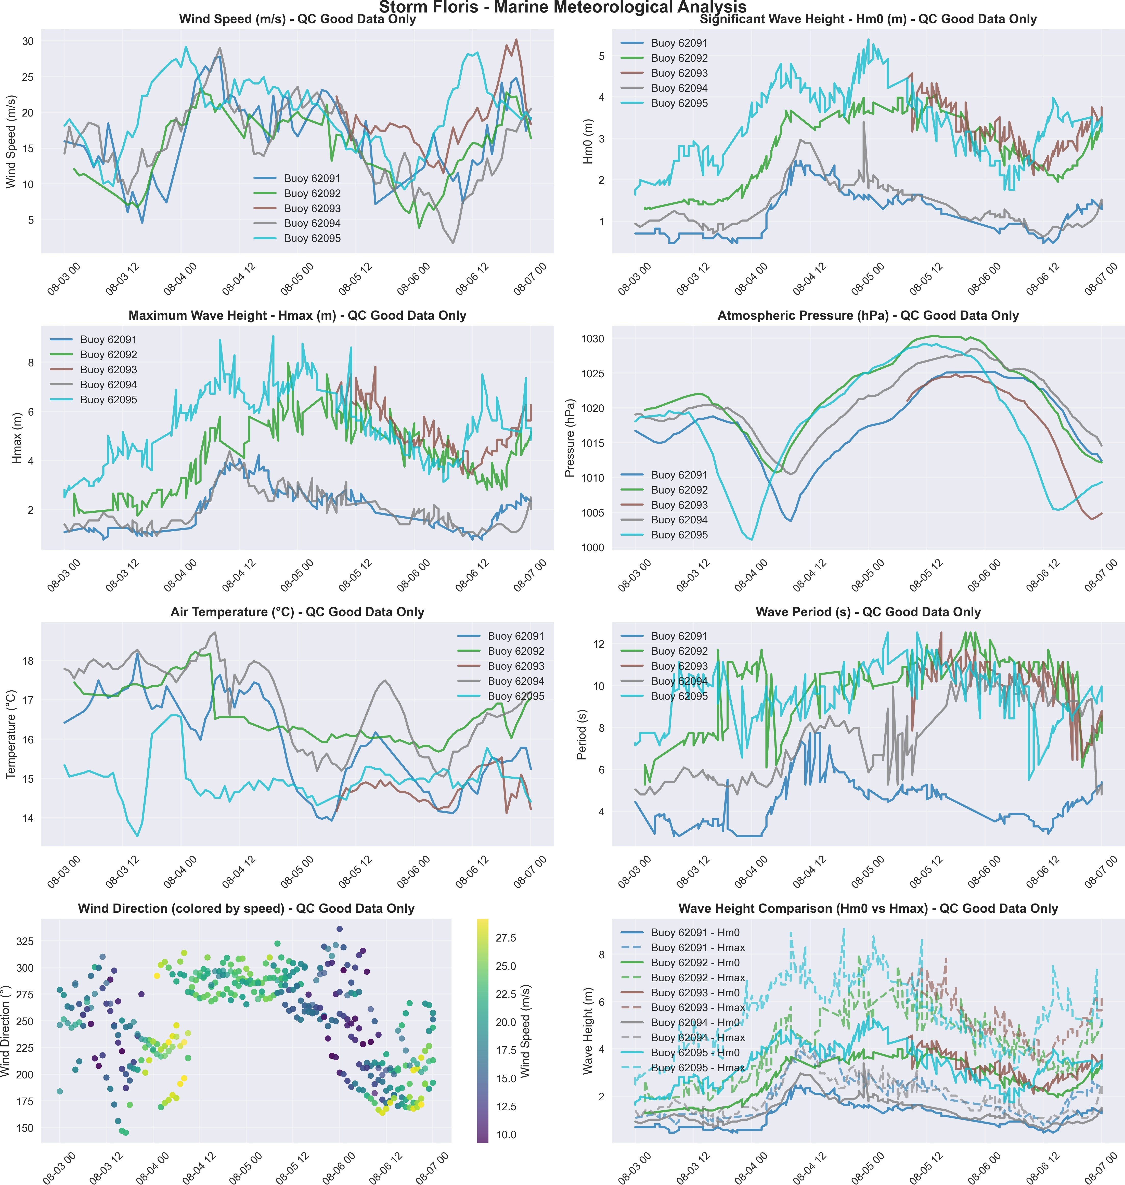

***MNicGuidhir***

*2025-08-22 12:23:51*

--------------------------------------------

I think the secondary logger data is still included - just based on the slightly jagged look of the hmax and hm0 plots.

**Figure 1:** Marine meteorological observations during Storm Floris. Eight-panel analysis showing wind speed, significant wave height (Hm0), maximum wave height (Hmax), atmospheric pressure, air temperature, wave period, wind direction patterns, and comparative wave heights across the Irish Marine Data Buoy Network. Quality-controlled data only.

**Met Éireann Marine Unit**

Irish Marine Data Buoy Network

Valentia Observatory, Co. Kerry [www.met.ie/climate/storm-centre](http://www.met.ie/climate/storm-centre)