Deliverable 6

CLIENT

CREATE TABLE
CREATE TABLE CLIENT (
Client_ID INT PRIMARY KEY,
L_Name NVARCHAR(35),
F_Name NVARCHAR(35),
Gender CHAR(1) CHECK(Gender IN ('M','F','O')),
DOB DATE,
Date_joined DATE,
Mentor_ID_FK INT NULL,
CONSTRAINT FK_CLIENT_MENTOR
FOREIGN KEY (Mentor_ID_FK) REFERENCES CLIENT(Client_ID)
);

INSERT
INSERT INTO CLIENT (Client_ID, L_Name, F_Name, Gender, DOB, Date_joined, Mentor_ID_FK)
VALUES
(1, 'Jackson', 'Mia', 'F', '1990-04-12', '2025-01-10', NULL),
(2, 'Reed', 'Noah', 'M', '1988-09-03', '2025-02-01', 3),
(3, 'Patel', 'Ava', 'F', '1993-11-22', '2024-12-15', NULL),
(4, 'Nguyen', 'Eli', 'M', '1995-06-30', '2025-03-05', 3);

SELECT *
SELECT * FROM CLIENT;
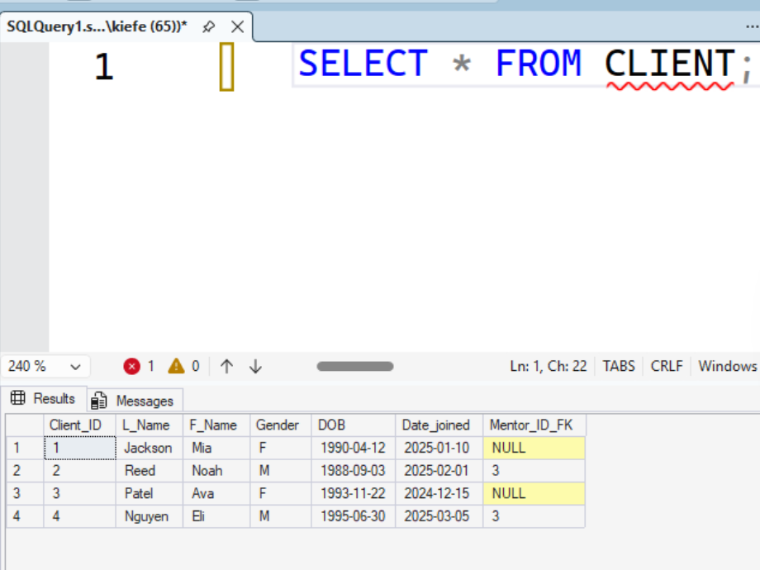

CRIMINAL_RECORD

CREATE TABLE
CREATE TABLE CRIMINAL_RECORD (
Crime_ID INT PRIMARY KEY,
Type_of_crime NVARCHAR(35),
Date_commited DATE,
Date_sentenced DATE,
Length_of_sentence DECIMAL(5,0) CHECK(Length_of_sentence > 0),
Client_ID_FK INT,
CONSTRAINT FK_CRIMINAL_RECORD_CLIENT
FOREIGN KEY (Client_ID_FK) REFERENCES CLIENT(Client_ID)
);

INSERT
INSERT INTO CRIMINAL_RECORD (Crime_ID, Type_of_crime, Date_commited, Date_sentenced, Length_of_sentence, Client_ID_FK)
VALUES
(101, 'Theft', '2020-05-14', '2020-07-01', 24, 1),
(102, 'Burglary', '2019-02-10', '2019-04-18', 36, 2),
(103, 'Drug Possession', '2021-09-08', '2021-10-20', 18, 3),
(104, 'Assault', '2018-11-30', '2019-01-15', 48, 3),
(105, 'Fraud', '2022-03-12', '2022-06-02', 30, 4);

SELECT *
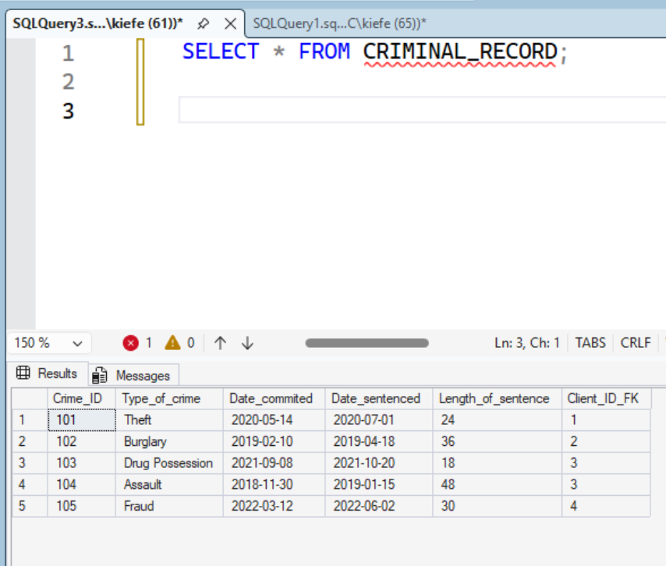
SELECT * FROM CRIMINAL_RECORD;

COURSE

CREATE TABLE
CREATE TABLE COURSE (
Course_ID INT PRIMARY KEY,
Title NVARCHAR(35),
Duration DECIMAL(4,0) CHECK(Duration > 0)
);

INSERT
INSERT INTO COURSE (Course_ID, Title, Duration)
VALUES
(10, 'Resume Writing', 8),
(11, 'Interview Skills', 6),
(12, 'Financial Literacy', 10);

SELECT *
SELECT * FROM COURSE;

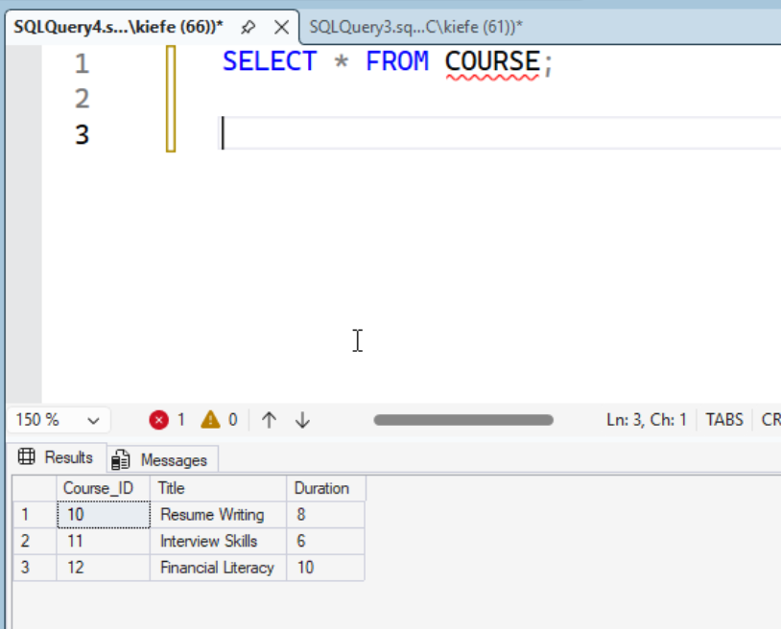

COUNSELING_SERVICE

CREATE TABLE
CREATE TABLE COUNSELING_SERVICE (
Service_ID INT PRIMARY KEY,
Focus_area NVARCHAR(35)
);

INSERT
INSERT INTO COUNSELING_SERVICE (Service_ID, Focus_area)
VALUES
(20, 'Substance Abuse'),
(21, 'Conflict Resolution'),
(22, 'Anger Management');

SELECT *
SELECT * FROM COUNSELING_SERVICE;
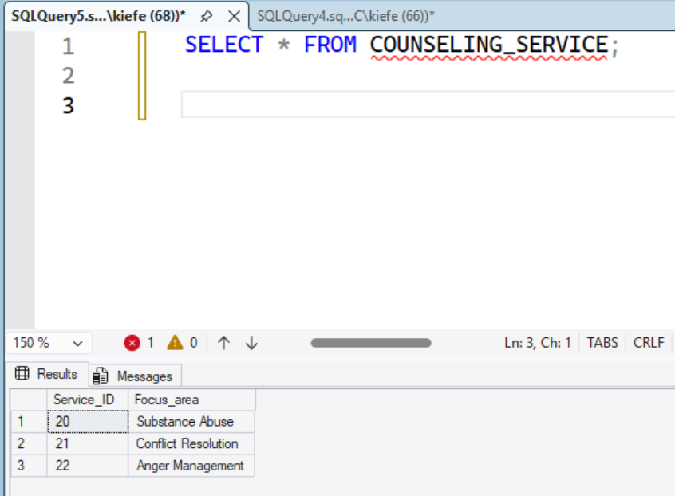

JOB_OPENING

CREATE TABLE
CREATE TABLE JOB_OPENING (
Opening_ID INT PRIMARY KEY,
Title NVARCHAR(35),
Company_name NVARCHAR(35),
Hourly_wage DECIMAL(7,2) CHECK(Hourly_wage >= 0)
);

INSERT
INSERT INTO JOB_OPENING (Opening_ID, Title, Company_name, Hourly_wage)
VALUES
(30, 'Warehouse Associate', 'Bay Logistics', 18.50),
(31, 'Line Cook', 'Sunset Diner', 16),
(32, 'Customer Service Rep', 'Gulf Telecom', 17.25),
(33, 'Landscaping Helper', 'GreenScape', 15.50);

SELECT *
SELECT * FROM JOB_OPENING;
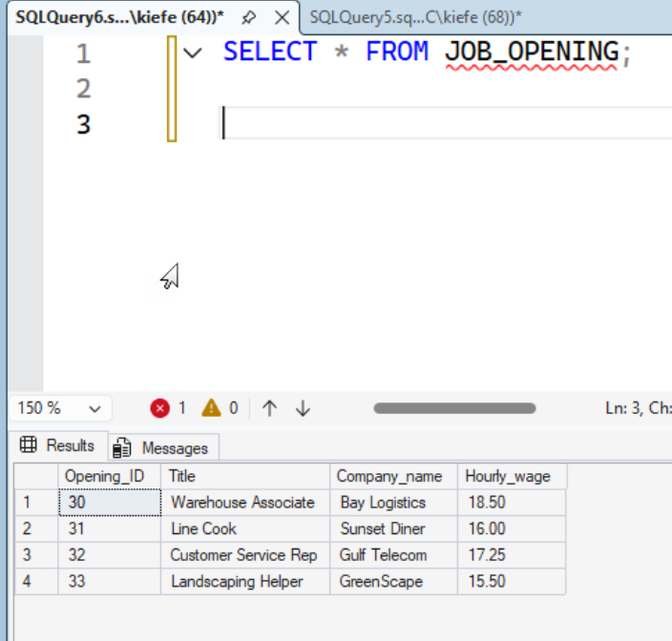

CLIENT_SERVICE

CREATE TABLE
CREATE TABLE CLIENT_SERVICE (
Client_ID_FK INT,
Service_ID_FK INT,
Hours_used DECIMAL(6,2) CHECK(Hours_used >= 0),
CONSTRAINT PK_CLIENT_SERVICE PRIMARY KEY (Client_ID_FK, Service_ID_FK),
CONSTRAINT FK_CLIENT_SERVICE_CLIENT
FOREIGN KEY (Client_ID_FK) REFERENCES CLIENT(Client_ID),
CONSTRAINT FK_CLIENT_SERVICE_SERVICE
FOREIGN KEY (Service_ID_FK) REFERENCES COUNSELING_SERVICE(Service_ID)
);

INSERT
INSERT INTO CLIENT_SERVICE (Client_ID_FK, Service_ID_FK, Hours_used)
VALUES
(1, 20, 12.50),
(1, 21, 6),
(2, 21, 4.50),
(3, 22, 9),
(4, 20, 3);

SELECT *
SELECT * FROM CLIENT_SERVICE;
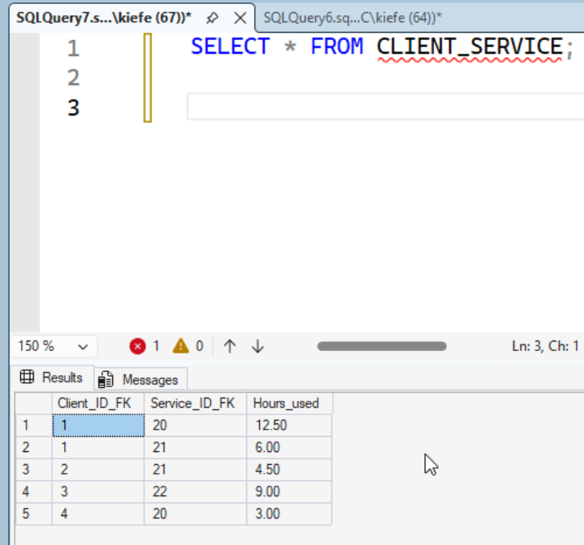

APPLICATION

CREATE TABLE
CREATE TABLE APPLICATION (
Client_ID_FK INT,
Opening_ID_FK INT,
Date_applied DATE,
Successful BIT,
CONSTRAINT PK_APPLICATION PRIMARY KEY (Client_ID_FK, Opening_ID_FK),
CONSTRAINT FK_APPLICATION_CLIENT
FOREIGN KEY (Client_ID_FK) REFERENCES CLIENT(Client_ID),
CONSTRAINT FK_APPLICATION_JOB
FOREIGN KEY (Opening_ID_FK) REFERENCES JOB_OPENING(Opening_ID)
);

INSERT
INSERT INTO APPLICATION (Client_ID_FK, Opening_ID_FK, Date_applied, Successful)
VALUES
(1, 32, '2025-02-20', 1),
(2, 30, '2025-03-01', 0),
(3, 31, '2025-01-22', 1),
(4, 33, '2025-03-08', 0);

SELECT *
SELECT * FROM APPLICATION;
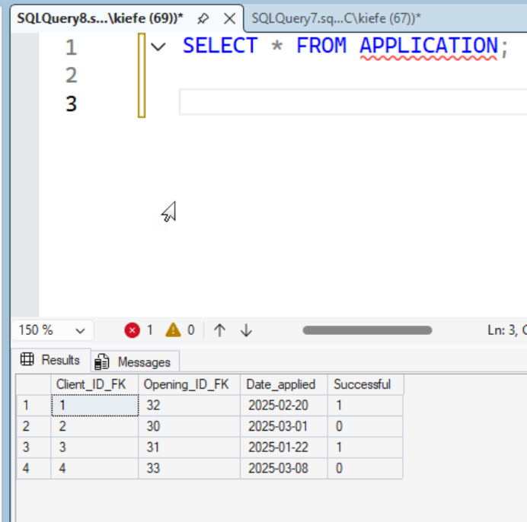

CLIENT_COURSE

CREATE TABLE
CREATE TABLE CLIENT_COURSE (
Client_ID_FK INT,
Course_ID_FK INT,
Date_completed DATE,
Grade NVARCHAR(5),
Behavior_score DECIMAL(3,0) CHECK(Behavior_score BETWEEN 0 AND 100),
CONSTRAINT PK_CLIENT_COURSE PRIMARY KEY (Client_ID_FK, Course_ID_FK),
CONSTRAINT FK_CLIENT_COURSE_CLIENT
FOREIGN KEY (Client_ID_FK) REFERENCES CLIENT(Client_ID),
CONSTRAINT FK_CLIENT_COURSE_COURSE
FOREIGN KEY (Course_ID_FK) REFERENCES COURSE(Course_ID)
);

INSERT
INSERT INTO CLIENT_COURSE (Client_ID_FK, Course_ID_FK, Date_completed, Grade, Behavior_score)
VALUES
(1, 10, '2025-02-05', 'A', 92),
(1, 12, '2025-03-02', 'B+', 88),
(2, 11, '2025-03-10', 'A-', 90),
(3, 10, '2025-01-10', 'B', 85),
(4, 12, '2025-03-15', 'C+', 73);

SELECT *
SELECT * FROM CLIENT_COURSE;
