Aerohive Networks Inc.
QA TestCase Hole 196

Revision History
Version | Date | Author | Description
0.1 | 08/18/2010 | czhong | Initial version
0.2 | 02/02/2012 | czhong | Add some debug info to cases

Table of Contents
Glossary and Abbreviations

Introduction
<Descript this feature in high level>

Test point or strategy
<Descript how to test this feature in high level, this section can reflect the organization of the case>

Topology
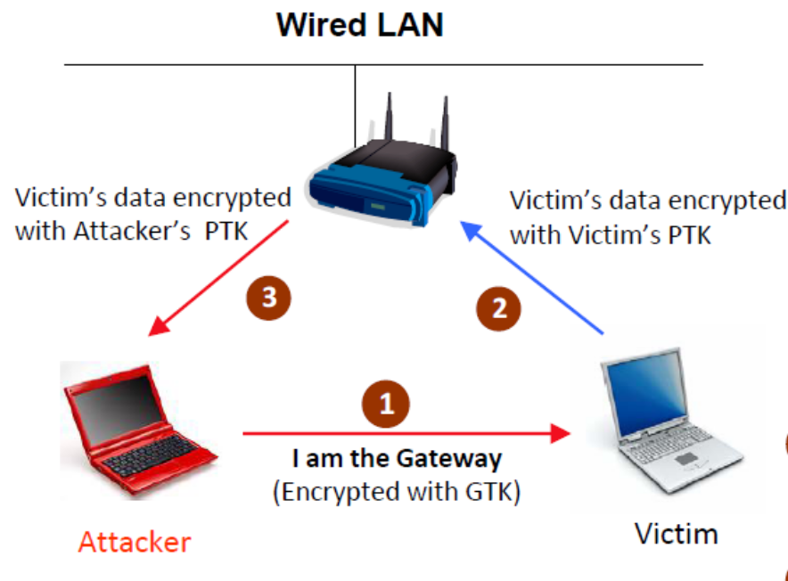

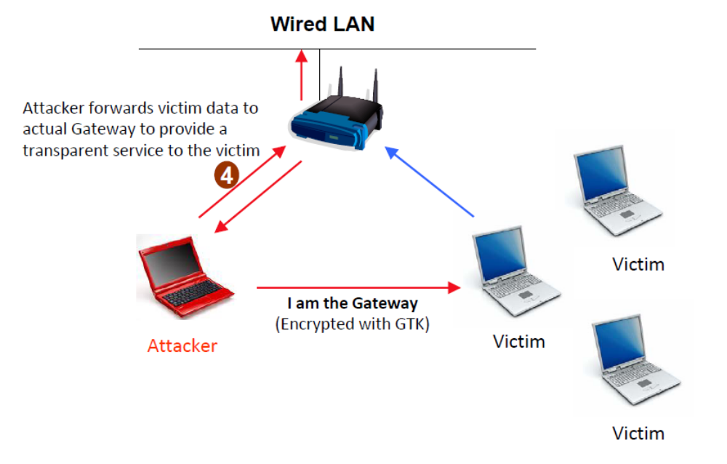

TestCase
<Good organization, the organization should be able to reflect your test strategy>
Case table:
<comments about case table:
1: CaseID format: (FT/ST)_(FeatureName)_(Customized String)_(Number)
FT means Feature Test;ST means System Test.
“Customized String” should be reflected your organization.
2: Priority has three levels: High,Middle,Low
3: Automation flag, yes means it had been automated; No means it had not been automated; NA means it is not able to automated
4: Description indicates the purpose of this case>

Example:

Function Test Case

Hole 196 releated attack detection

AP detect a AP-Tx-Spoofing attack
Case ID | FT_HOLE_196_ATTACK_DETECTION_1
Priority | High | Automation Flag | No
Topology to use | -----------AP-------sw------GW  | |  STA1 STA2(victim)  (Malicious Insider)
Description | AP detect a AP-Tx-Spoofing attack
Pre-condition | -STA1 and STA2 are connecting to the same ssid  -put AP to promiscuous mode to detect the attack  CLI：radio profile xxx detect-ssid-spoofing
Test procedure | -sta1 broadcast a frame with FromDS(1), TA==BSSID owned by this AP
Expect result | - AP will capture this attack packet,report it as a AP-Tx-Spoofing attack  - AP will not forward these packet
Test result | AH-001080#_kdebug wifi-driver wifi0.1 crypto  AH-001080#2011-10-28 06:50:48 debug kernel: ah_bssid_spoof_detect wifi0.1 raw pkt in: 8842 0000 000c435382e3 001977001088 001977001080 9004 000090004f00000000000000e3fa51221991f5fa9061209d
Comment

AP-Tx-Spoofing attack effect all auth types
Case ID | FT_HOLE_196_ATTACK_DETECTION_2
Priority | Middle | Automation Flag | No
Topology to use | -----------AP-------sw------GW  | |  STA1 STA2(victim)  (Malicious Insider)
Description | AP-Tx-Spoofing attack effect all auth types
Pre-condition | -STA1 and STA2 are connecting to the same ssid  -put AP to promiscuous mode to detect the attack
Test procedure | -sta1 broadcast a frame with FromDS(1), TA==BSSID owned by this AP
Expect result | - This attack will effect all auth type, like open wep(open/share),wpa,wpa2
Test result
Comment | TestTool: CommView

AP detect a GTK-Tx-spoofing attack
Case ID | FT_HOLE_196_ATTACK_DETECTION_3
Priority | High | Automation Flag | No
Topology to use | -----------AP-------sw------GW  | |  STA1 STA2(victim)  (Malicious Insider)
Description | AP detect a GTK-Tx-spoofing attack
Pre-condition | -STA1 and STA2 are connecting to the same ssid  -put AP to promiscuous mode to detect the attack
Test procedure | -sta1 broadcast a frame with FromDS(1), TA==BSSID owned by this AP,and this packet is encrypted by the gtk owned by this AP too
Expect result | - AP will capture this attack packet,report it as a GTK-Tx-spoofing attack  - AP will ignore this packet,not forward
Test result | AH-001080#  AH-001080#2011-10-28 07:02:50 debug kernel: ah_bssid_spoof_detect wifi0.1 raw pkt in: 0842 0000 ffffffffffff 001977001088 001977001080 901f e903006000000000aaaa0300000008060001080006040001  2011-10-28 07:02:50 debug kernel: ah_bssid_spoof_detect wifi0.1 pkt info: attacker 00:19:77:00:10:80 bssid 00:19:77:00:10:88 victim ff:ff:ff:ff:ff:ff proto 0806 arp_opcode 0001 src_ip 0xac105b0c tgt_ip 0xac105bfd  2011-10-28 07:02:50 debug kernel: ah_bssid_spoof_detect wifi0.1 pkt decryted decaped: ffffffffffff 001977001080 0806 0001080006040001  2011-10-28 07:02:51 debug kernel: ah_bssid_spoof_detect wifi0.1 raw pkt in: 0842 0000 ffffffffffff 001977001088 001977001080 901f e903006000000000aaaa0300000008060001080006040001  2011-10-28 07:02:51 debug kernel: ah_bssid_spoof_detect wifi0.1 pkt info: attacker 00:19:77:00:10:80 bssid 00:19:77:00:10:88 victim ff:ff:ff:ff:ff:ff proto 0806 arp_opcode 0001 src_ip 0xac105b0c tgt_ip 0xac105bfd  2011-10-28 07:02:51 debug kernel: ah_bssid_spoof_detect wifi0.1 pkt decryted decaped: ffffffffffff 001977001080 0806 0001080006040001
Comment

AP detect a hole196 attack
Case ID | FT_HOLE_196_ATTACK_DETECTION_4
Priority | Middle | Automation Flag | No
Topology to use | -----------AP-------sw------GW  | |  STA1 STA2(victim)  (Malicious Insider)
Description | AP detect a hole196 attack
Pre-condition | 1. STA1 and STA2 are connecting to the same ssid  -put AP to promiscuous mode to detect the attack
Test procedure | -sta1 send a packet encrypted with the GTK owned by this AP
Expect result | -AP will capture this attack packet,report it as a hole 196 attack  -AP will ignore this packet,not forward
Test result
Comment | - AP will check very packet it captured,and try to decrypt with its GTK??

AP detect an ARP spoofing attack
Case ID | FT_HOLE_196_ATTACK_DETECTION_5
Priority | Accept | Automation Flag | No
Topology to use | -----------AP-------sw------GW  | |  STA1 STA2(victim)  (Malicious Insider)
Description | AP detect an ARP spoofing attack
Pre-condition | -STA1 and STA2 are connecting to the same ssid  -put AP to promiscuous mode to detect the attack
Test procedure | -sta1 send a packet encrypted with the GTK owned by this AP,and the payload of this packet is ARP
Expect result | - AP will capture this attack packet,report it as an ARP spoofing attack  - Make sure AP will ignore these packets,not forward them
Test result | AH-001080#2011-10-31 03:18:10 debug kernel: [fe_arp]: fe receive request to remediate arp  spoofing 172.16.91.6 ifindex 12  2011-10-31 03:18:10 debug kernel: [fe_arp]: Searching ARP entry for IP = 172.16.91.6  2011-10-31 03:18:10 debug kernel: [fe_arp]: ARP entry found: IP=172.16.91.6(0,wifi0.1)  mac=0024:d7f4:3114  2011-10-31 03:18:10 debug kernel: [fe_arp]: found arp entry for spoofed ip 172.16.91.6  0024:d7f4:3114  2011-10-31 03:18:10 debug kernel: [fe_arp]: wifi0.1 send ARP request  172.16.91.6/0024:d7f4:3114 -> 172.16.91.6 vlan 0
Comment | STA linux CLI:  root@ubuntu:~# iwconfig wlan0 retry 8  root@ubuntu:~# iwconfig wlan0  wlan0 IEEE 802.11abgn ESSID:off/any  Mode:Ad-Hoc Frequency:2.412 GHz Cell: Not-Associated  Tx-Power=15 dBm  Retry limit:8 RTS thr:off Fragment thr:off  Encryption key:off  Power Management:off  root@ubuntu:~#  arping -A -c 1 -I wlan0 -s 172.16.85.76 192.168.85.73

AP receive a PTK packet with fromDS set and TA==BSSID owned by this AP
Case ID | FT_HOLE_196_ATTACK_DETECTION_6
Priority | Low | Automation Flag | No
Topology to use | -----------AP-------sw------GW  | |  STA1 STA2(victim)  (Malicious Insider)
Description | AP receive a PTK packet with fromDS set and TA==BSSID owned by this AP
Pre-condition | -STA1 and STA2 are connecting to the same ssid  -put AP to promiscuous mode to detect the attack
Test procedure | -sta1 send a PTK packet with fromDS set and TA==BSSID owned by this AP
Expect result | - AP will capture this attack packet,report it as an spoofing packet  - Make sure AP will ignore these packets,not forward them
Test result
Comment | -tool for testing ??

Hole 196 4.2. Attack reporting

AP reports hole 196 related attack info to HM
Case ID | FT_HOLE_196_REPORTING_1
Priority | High | Automation Flag | No
Topology to use | -----------AP-------sw------GW  | |  STA1 STA2(victim)  (Malicious Insider)
Description | AP reports hole 196 related attack info to HM
Pre-condition | -STA1 and STA2 are connecting to the same ssid  -put AP to promiscuous mode to detect the attack
Test procedure | -sta1 launch a hole 196 related attack
Expect result | - AP captured this attack,reported to HM  - This info contains Alarm name,If_index,Attacker MAC,Attacker MAC,Attack count,Protocol,Targeted IP and Source IP,check all of the info is correct
Test result
Comment | -10 minutes one trap per attack type

Hole 196 4.3. Attack mitigation and damage control

Restore victim ARP cache when detecting an arp spoofing attack
Case ID | FT_HOLE_196_MITIGATION_1
Priority | Accept | Automation Flag | No
Topology to use | -----------AP-------sw------GW  | |  STA1 STA2(victim)  (Malicious Insider)
Description | Restore victim ARP cache when detecting an arp spoofing attack
Pre-condition | -STA1 and STA2 are connecting to the same ssid  -put AP to promiscuous mode to detect the attack
Test procedure | -sta1 launch a arp spoofing attack using hole 196
Expect result | - AP will restore victim ARP cache when detecting this type of attack  - The victim client will get the correct arp entity
Test result | 2011-10-16 15:17:25 debug [fe_arp]: fe receive request to remediate arp spoofing 172.16.91.6 ifindex 13  2011-10-16 15:17:25 debug [fe_arp]: Searching ARP entry for IP = 172.16.91.6  2011-10-16 15:17:25 debug [fe_arp]: ARP entry found: IP=172.16.91.6(0,wifi0.1) mac=0024:d7f4:3114  2011-10-16 15:17:25 debug [fe_arp]: found arp entry for spoofed ip 172.16.91.6 0024:d7f4:3114  2011-10-16 15:17:25 debug [fe_arp]: wifi0.1 send ARP request 172.16.91.6/0024:d7f4:3114 -> 172.16.91.6 vlan 0
Comment

Turn on client traffic isolation when detecting arp spoofing attack
Case ID | FT_HOLE_196_MITIGATION_2
Priority | Accept | Automation Flag | No
Topology to use | -----------AP-------sw------GW  | |  STA1 STA2(victim)  (Malicious Insider)
Description | Turn on client traffic isolation when detecting arp spoofing attack
Pre-condition | -STA1 and STA2 are connecting to the same ssid  -put AP to promiscuous mode to detect the attack
Test procedure | -sta1 launch a arp spoofing attack using hole 196
Expect result | - AP will turn on client traffic isolation when detecting arp spoofing attack  - All traffic go to the attacker will be blocked for 15 mins
Test result | AH-001080#2011-11-01 03:09:36 debug kernel: [fe_arp]: fe receive request to remediate arp spoofing 172.16.91.6 ifindex 12  2011-11-01 03:09:36 debug kernel: [fe_arp]: Searching ARP entry for IP = 172.16.91.6  2011-11-01 03:09:36 debug kernel: [fe_arp]: no arp entry for spoofed ip 172.16.91.6  2011-11-01 03:09:36 debug kernel: [fe_arp]: Enabling client isolation for wifi0.1(idx 12)
Comment | What the detail meaning of isolation,mac filter ban??

All types of the hole 196 attack should be logged
Case ID | FT_HOLE_196_MITIGATION_3
Priority | High | Automation Flag | No
Topology to use | -----------AP-------sw------GW  | |  STA1 STA2(victim)  (Malicious Insider)
Description | All types of the hole 196 attack should be logged
Pre-condition | -STA1 and STA2 are connecting to the same ssid  -put AP to promiscuous mode to detect the attack
Test procedure | -sta1 launch a hole 196 related attack
Expect result | - AP will detect and log evry attack
Test result
Comment

Stress Test Case

Duration Test Case

Performance and Stress

Scalability

6.6. Compatibility Test Case

CLI Management (Automation Status: Yes/No)
<Just list all cli that this feature has one by one>

Customer Issue or Typical Bug

