Aerohive Networks Inc.
MiNi-HiveUI Test Case

Revision History
Version | Date | Author | Description
0.1 | 2011-01-10 | Zhao haihui | Initial version
0.2 | 2011-01-11 | Zhao haihui | Add case according to case review
0.3 | 2011-01-18 | Zhao haihui | Modify some case
0.4 | 2011-6-14 | Zhao haihui | Add a case MiNi-HiveUI_Function_10

Table of Contents
Glossary and Abbreviations

Introduction
HiveUI is a web interface used for element management within the Aerohive system. It provides a web-based configuration tool to configure a single access point. As the HiveManager product family has matured, it has become less important to maintain HiveUI, and the cost of maintaining HiveUI has grown to the point where it makes sense to discontinue HiveUI support for most features. In 3.5r3, HiveUI is planned for removal.
A limited set of basic element management tasks is important to retain, especially for devices that do not have serial ports. This document describes the requirements for a “mini-HiveUI” that provides only extremely basic functionality and supplies network administrators with the tools to upgrade devices to the latest software version, attach them to the network, and configure them with a HiveManager.
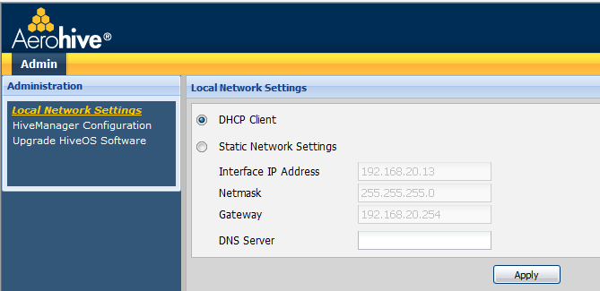
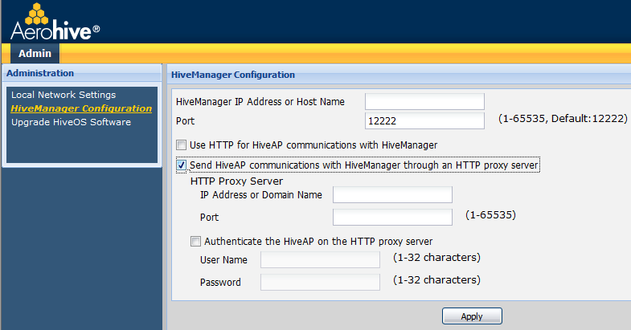

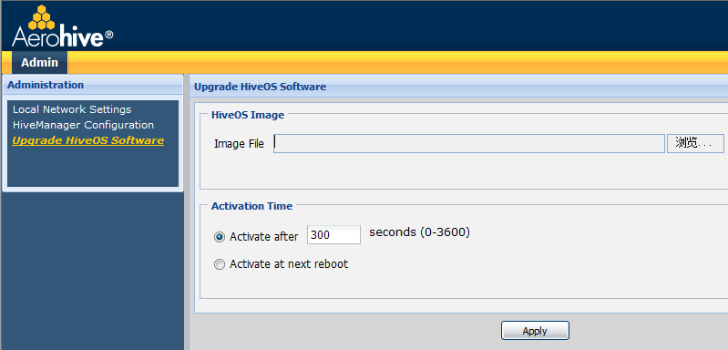

Test Objectives
Can use MiNi-HiveUI to config ip address/netmask/gateway and DNS server
Can use MiNi-HiveUI to config HM and port (through HTTP proxy server or not)
Can use MiNi-HiveUI to update HiveOS image

Test Acceptance Criterion from Development
- Approved – Functional Specifications
- Approved – Unit Test Plans

Product Pass Criterion
Meet all objects in marketing requirement or function spec which may include key function objectives, scalability objectives, performance objectives and so on.

Test Bed/Topo Design

Test Case

Function Test Case

MiNi-HiveUI_Function_1
Case ID | MiNi-HiveUI_Function_1
Priority | Accept | Automation Flag | NA
Topology to use | AP------SW------DHCP server  |  PC
Description | Default MiNi-HiveUI use DHCP to config IP networking, but can config DNS server
Pre-condition | AP can obtain ip address from DHCP server  From PC can access AP
Test procedure | - Login MiNi-HiveUI via web page from PC, check default setting  - Config a DNS server and apply, show dns to check DNS server on AP
Expect result | - Default DHCP is be used, can see ip address/netmask/gateway that obtained from DHCP server  - DNS server be configured and be used on AP

MiNi-HiveUI_Function_2
Case ID | MiNi-HiveUI_Function_2
Priority | Accept | Automation Flag | NA
Topology to use | AP------SW------DHCP server  |  PC
Description | Use MiNi-HiveUI to config static network setting for AP
Pre-condition | AP can obtain ip address from DHCP server  From PC can access AP
Test procedure | - Login MiNi-HiveUI via web page from PC, select static network setting, config ip address/netmask/gateway/DNS server and apply  - Show running-config and show interface mgt0 to check these network setting on AP
Expect result | - Can config ip address/netmask/gateway/DNS server and apply successful(ipaddress/netmask/gateway should be required field)  - AP use static ip address, DHCP be disabled

MiNi-HiveUI_Function_3
Case ID | MiNi-HiveUI_Function_3
Priority | Accept | Automation Flag | NA
Topology to use | AP------SW------DHCP server  |  PC
Description | Use MiNi-HiveUI to config HM for AP
Pre-condition | AP can obtain ip address from DHCP server  From PC can access AP
Test procedure | - Login MiNi-HiveUI via web page from PC, select “HiveManager Configuration”, config HM for AP and apply  - Show running-config and show capwap client to check if HM be configured and used by AP on AP
Expect result | - HM be configured for AP through MiNi-HiveUI  - AP use configured HM

MiNi-HiveUI_Function_4
Case ID | MiNi-HiveUI_Function_4
Priority | Accept | Automation Flag | NA
Topology to use | AP------SW------DHCP server  |  PC
Description | Use MiNi-HiveUI to set use HTTP and port 80 for AP communications with HM
Pre-condition | AP can obtain ip address from DHCP server  From PC can access AP
Test procedure | - Login MiNi-HiveUI, config HM , enable HTTP and apply, show capwap client to check if HTTP be used  - Reset port and transport to default, check result by show running-config
Expect result | - AP use HTTP to communicate with HM  - Transport and port be reset to default

MiNi-HiveUI_Function_5
Case ID | MiNi-HiveUI_Function_5
Priority | Accept | Automation Flag | NA
Topology to use | AP------SW------DHCP server  |  PC
Description | Use MiNi-HiveUI to config HTTP proxy server
Pre-condition | AP can obtain ip address from DHCP server  From PC can access AP
Test procedure | - Login MiNi-HiveUI via web page from PC, config HM, select “HiveManager Configuration”, select “Send HiveAP communications with HiveManager through an HTTP proxy server”, config HTTP proxy server and port, apply, show running-config on AP to check  - Select “Authenticate the HiveAP on the HTTP proxy server”, config user name/password and apply, show running-config to check(check the max length of user name/password)  - Disable “Authenticate the HiveAP on the HTTP proxy server” and apply, check result  - Unselect “Send HiveAP communications with HiveManager through an HTTP proxy server” and apply, check result
Expect result | - HTTP proxy server be configured  - HTTP proxy user name/password be configured  - The config of proxy user be removed  - The config of proxy server be removed

MiNi-HiveUI_Function_6
Case ID | MiNi-HiveUI_Function_6
Priority | Accept | Automation Flag | NA
Topology to use | AP------SW------DHCP server  |  PC
Description | Use MiNi-HiveUI to upgrade image with time offset
Pre-condition | AP can obtain ip address from DHCP server  From PC can access AP
Test procedure | - Login MiNi-HiveUI via web page from PC, select “Upgrade HiveOS Software”, load a image, set offset time, and apply  - Check reboot time on AP, verify if AP will reboot on time
Expect result | - Upgrade image successful  - AP will reboot on time

MiNi-HiveUI_Function_7
Case ID | MiNi-HiveUI_Function_7
Priority | Accept | Automation Flag | NA
Topology to use | AP------SW------DHCP server  |  PC
Description | Use MiNi-HiveUI to upgrade image without reboot
Pre-condition | AP can obtain ip address from DHCP server  From PC can access AP
Test procedure | - Login MiNi-HiveUI via web page from PC, select “Upgrade HiveOS Software”, load a image, Select “Active at next reboot”, and apply  - After load image, verify if AP will reboot  - Reboot AP, verify version
Expect result | - Load image successful  - AP doesn’t reboot  - AP be updated

MiNi-HiveUI_Function_8
Case ID | MiNi-HiveUI_Function_8
Priority | High | Automation Flag | NA
Topology to use | AP------SW------DHCP server  |  PC
Description | After root use be changed, use new user can login MiNi-HiveUI and execute operation
Pre-condition | AP can obtain ip address from DHCP server  From PC can access AP  Change root user of AP
Test procedure | Use new user to login MiNi-HiveUI, set DNS server for AP and apply
Expect result | Can login, set DNS server and apply successfully

MiNi-HiveUI_Function_9
Case ID | MiNi-HiveUI_Function_9
Priority | Middle | Automation Flag | NA
Topology to use | AP------SW------DHCP server  |  PC
Description | Check help of MiNi-HiveUI
Pre-condition | AP can obtain ip address from DHCP server  From PC can access AP
Test procedure | Login MiNi-HiveUI via web page from PC, check help
Expect result | Introduce all topic of MiNi-HiveUI

MiNi-HiveUI_Function_10
Case ID | MiNi-HiveUI_Function_10
Priority | High | Automation Flag | NA
Topology to use | AP------SW------DHCP server  |  PC
Description | After disable web server, will could not login MiNi-HiveUI
Pre-condition | AP can obtain ip address from DHCP server  From PC can access AP
Test procedure | Login MiNi-HiveUI via web page from PC
Expect result | Could not login MiNi-HiveUI

Negative Test Case

MiNi-HiveUI_Negative_1
Case ID | MiNi-HiveUI_Negative_1
Priority | Middle | Automation Flag | NA
Topology to use | AP------SW------DHCP server  |  PC
Description | Only root user can login MiNi-HiveUI
Pre-condition | AP can obtain ip address from DHCP server  From PC can access AP  Create a read-write user and a read-only user on AP
Test procedure | - Use read-write user to login MiNi-HiveUI, verify if can login successful  - Use read-only user to login MiNi-HiveUI, verify if can login successful
Expect result | - Could not login  - Could not login

MiNi-HiveUI_Negative_2
Case ID | MiNi-HiveUI_Negative_2
Priority | Middle | Automation Flag | NA
Topology to use | AP------SW------DHCP server  |  PC
Description | Config domain name of HM and apply， must suggest config DNS server
Pre-condition | AP can obtain ip address from DHCP server  From PC can access AP
Test procedure | Login MiNi-HiveUI, config hostname of HM and apply
Expect result | Should suggest config DNS server

MiNi-HiveUI_Negative_3
Case ID | MiNi-HiveUI_Negative_3
Priority | Middle | Automation Flag | NA
Topology to use | AP------SW------DHCP server  |  PC
Description | When use incorrect image to update, should suggest
Pre-condition | AP can obtain ip address from DHCP server  From PC can access AP
Test procedure | Login MiNi-HiveUI, select a incorrect imageand apply
Expect result | Should suggest error

MiNi-HiveUI_Negative_4
Case ID | MiNi-HiveUI_Negative_4
Priority | Middle | Automation Flag | NA
Topology to use | AP------PC  Config ip address 192.168.1.2 to PC
Description | When AP with default ip address 192.168.1.1, can login MiNi-HiveUI through this ip address
Pre-condition | AP with default setting
Test procedure | Login MiNi-HiveUI 192.168.1.1 from PC
Expect result | Can login successful

MiNi-HiveUI_Negative_5
Case ID | MiNi-HiveUI_Negative_5
Priority | Middle | Automation Flag | NA
Topology to use | AP------SW------DHCP server  |  PC
Description | Kill Hiawatha process, verify if process can restart, verify if can login MiNi-HiveUI
Pre-condition | AP can obtain ip address from DHCP server  From PC can access AP
Test procedure | - Kill Hiawatha process in shell, verify if process can restart  - Login MiNi-HiveUI, verify if can login
Expect result | - The process can restart  - Can login

Stress Test Case

Duration Test Case

Performance Test Case

Scalability Test Case

Compatibility Test Case

CLI Management (Automation Status: Yes/No)

GUI Management-HiveManager

GUI Management-HiveUI

Customer Issue or Typical Bugs

