Aerohive Networks Inc.
HiveOS_Performance_TestCase

Revision History
Version | Date | Author | Description
0.1 | 10/25/2012 | Guoqing Zhu | Initial version

Table of Contents
Glossary and Abbreviations

Introduction
<Descript this feature in high level, why need this feature, what is the background and requirement>
<Tell reader where to find function spec and market requirement>

Test Strategy
<solution, simulate the customers’ deployment>
<in function level, list the key marketing and engineering requirements>
<list the objectives when this feature works under stress, e.g. CWP login/logout again and again, mesh failover again and again>
<list the objectives when this feature works for long time, even under the maximum stress, e.g. GTK rekey for maximum clients and run about 72 hours>
<list the objectives for performance of this feature, e.g. roaming delay, VPN tunnel performance>
<list the objectives for capacity of this feature, e.g. maximum users number, maximum VOIP pairs>
<list the objectives for compatibility of this feature, e.g. different vendors’ browser for cwp>

Note: All of this info should come from requirement/spec, if has not this info in requirement/spec, pls ask dev and get the expected info/number. If no expected number, we try to give out the QA’s expected number.

Test Acceptance Criterion from Development
- MRD -NA

- Functional Specifications -NA

- Unit Test Plans -NA

- CLI Review -NA

Product Pass Criterion
Meet all objects in marketing requirement or function spec which may include key function objectives, capacity objectives, performance objectives and so on.

Test Bed/Topo Design
<Topo1>
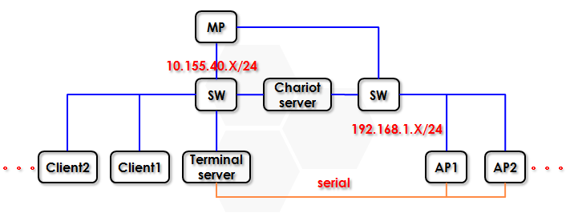
PS: a> For IP net 10.155.40.X/24, it is used for equipment management.
b> For IP net 192.168.1.X/24, it is used for data transmission.

Test Case
<Good organization should be able to reflect your test strategy>

Solution

Function Test Case

Performance_Function_01

CaseID | Performance_Function_01
Priority | Accept | Automation Flag | Yes
Topology | Topo1
Description | Performance test cover all scenarios
PlatformDependence | AP110/AP120/AP121/AP141/AP170/AP320/AP340/AP330/AP350/APBR100/APCVG  BR100/BR200-WP/BRAP330/BRAP350/BRAP121/BRAP141
Pre-condition | - Reboot chariot server, start endpoint automatically after reboot  - Reboot client  - Reboot DUT by CLI “reset config”
TestProcedure | ///Due to so many loop in this case, so just list the loop rule here.  For <First loop-Range: 5m,10m,20m,30m,50m> {  For <Second loop-Angle: 0º, 90º, 180º, 270º >{  For <Third loop-Encryption: open,wep-open,wpa-aes-psk>{  For <Fourth loop-Channel: 1,11,36,157>{  Run downlink;  Run uplink;  Run duallink;  };  };  };  };  /// Take 5m/0º/open/channel 1 as an example  - Config the client which is 5m away from the DUT  Reboot  Start endpoint  - Config DUT for channel 1 traffic test  CLI: radio profile 11ng  radio profile 11ng phymode 11ng  radio profile ng short-guard-interval  no radio profile 11ng scan access  ssid gqzhu  interface wifi0 radio profile 11ng  interface wifi0 radio channel 11  interface wifi0 radio power 20  interface mgt0 hive gq  interface wifi0 ssid gqzhu  save config  - Set DUT’s angle to 0º  - Client associate to DUT  - Verify the connection between client and DUT by ping  - Verify the connection between client and chariot server  - Run downlink/uplink/duallink by IxChariot between client and chariot server, check, Result 1  - Reset DUT’s angle to 0º  - Reset config DUT  CLI: reset config  /// Take 50m/270º/wpa-aes-psk/channel 157 as an example  - Config the client which is 5m away from the DUT  Reboot  Start endpoint  - Config DUT for channel 157 traffic test  CLI: radio profile 11na  radio profile 11na phymode 11na  radio profile 11na short-guard-interval  radio profile 11na channel-width 40-below  no radio profile 11ng scan access  ssid gqzhu  interface wifi1 radio profile 11na  interface wifi1 radio channel 157  interface wifi0 radio power 20  interface wifi0 ssid gqzhu  security-object psk  security-object psk security protocol-suite wpa-aes-psk ascii-key 12345678  ssid gqzhu security-object psk  save config  - Set DUT’s angle to 270º  - Client associate to DUT  - Verify the connection between client and DUT by ping  - Verify the connection between client and chariot server  - Run downlink/uplink/duallink by IxChariot between client and chariot server, check, Result 1  - Reset DUT’s angle to 0º  - Reset config DUT  CLI: reset config
ExpectResult
TestResult
Comment | For daily build performance, settings is suggested as below:  Range: 5m  Angle: 0º  Encryption: wpa-aes-psk  Channel: 1,11,36,157  Run downlink/uplink/duallink

Stress Test Case

Longevity Test Case

Performance Test Case

Capacity Test Case

Compatibility Test Case

Negative Test Case

Other Test Case

CLI Management (Automation Status: Yes/NA)
<firstly, list all cli that this feature has one by one>
<CLI test case>

GUI Management-HiveManager
<List HM test case or test log>

GUI Management-HiveUI
<List HiveUI test case or test log>

Typical issue Test Case

