Aerohive Networks Inc.
QA TestCase of IP Policy URL redirect

Revision History
Version | Date | Author | Description
0.1 | 09/23/2014 | Jian Zhang | Initial version

Table of Contents
Contents
Glossary and Abbreviations

Introduction
<Descript this feature in High level, why need this feature, what is the background and requirement>
<Tell reader where to find function spec and market requirement>

Test Objectives
<in function level, list the key marketing and engineering requirements>
<list the objectives when this feature works under stress, e.g. CWP login/logout again and again, mesh failover again and again>
<list the objectives when this feature works for long time, even under the maximum stress, e.g. GTK rekey for maximum clients and run about 72 hours>
<list the objectives for performance of this feature, e.g. roaming delay, VPN tunnel performance>
<list the objectives for scalability of this feature, e.g. maximum users number, maximum VOIP pairs>
<list the objectives for compatibility of this feature, e.g. different vendors’ browser for cwp>

Note: All of this info should come from requirement/spec, if has not this info in requirement/spec, pls ask dev and get the expected info/number. If no expected number, we try to give out the QA’s expected number.

Test Acceptance Criterion from Development
- Approved – MRD
The link to MRD

- Approved – Functional Specifications
The link to function spec

- Approved – Unit Test Plans
The link to unit test report of dev

Product Pass Criterion
Meet all objects in marketing requirement or function spec which may include key function objectives, capacity objectives, performance objectives and so on.

Test Bed/Topo Design

Topology 1
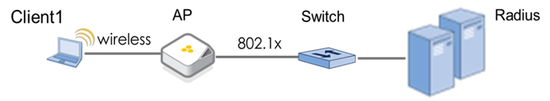

Topology 2
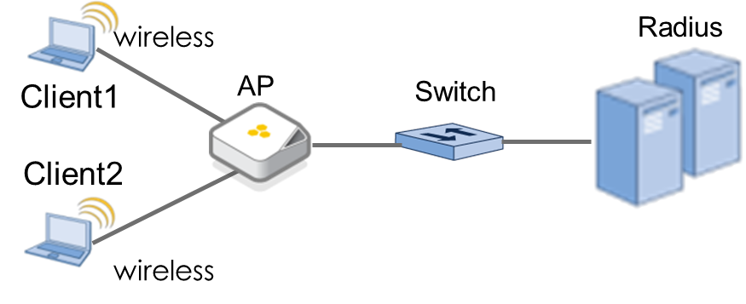

Topology 3
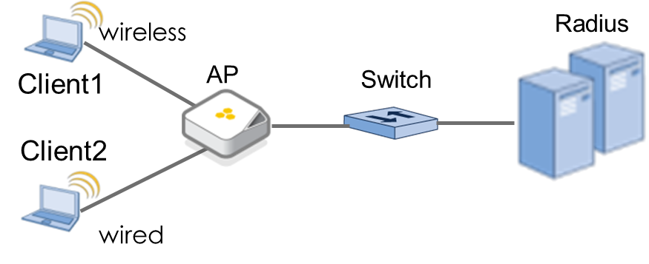

Topology 4
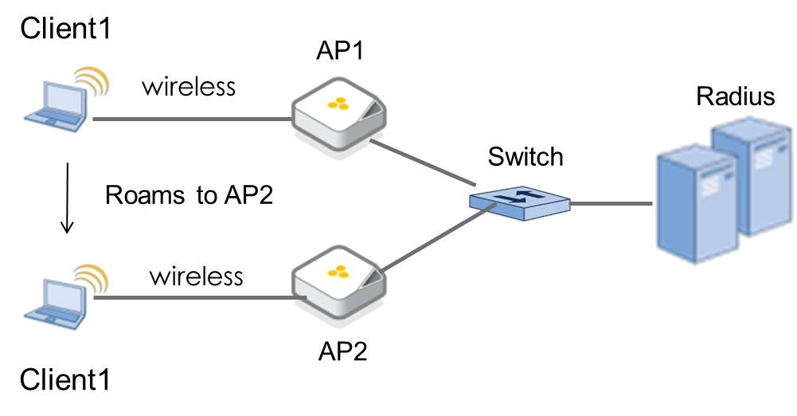

Test Case
<Good organization, the organization should be able to reflect your test strategy>
Case table format:

<comments about case table:
1: Priority has four levels: Accept,High,Middle,Low. “Accept” cases will be executed in acceptance testing, any one of these fails, will cause denial of feature testing.
2: Automation flag, yes means it had been automated; No means it had not been automated; NA means it is not able to be automated.
3: spaces or special characters should not be used as part of case ID
4: FeatureName should be full name of a specific feature, such as “HighDensity”, rather than “HD”, or “SpectrumAnalysis” rather than “SA”
5: TestType should be one of “KeyScenario”,”Function”,”Stress”,”Duration”,”Performance”,”Capacity”,”Campatibility”,”Cli”,”GUI”.>

Key Scenarios
Case ID | ip-policy-redirect-url _ key_scenarios_1
Priority |  | Automation Flag | No
Topology to use | Topology 6
Description | Key usage of ip policy redirect URL
Pre-condition
Test procedure | 1. Configure wpa2-aes-802.1x auth for wireless client on AP .  2. create some user-profiles with different UPID, additionally, create different ip policy binding to user-profile, ensure different user-profile access different subnets. For example:  ip-policy sc_initial_acl  ip-policy sc_initial_acl id 1 from 0.0.0.0 0.0.0.0 to 0.0.0.0 0.0.0.0 service any action permit  ip-policy sc_guest_acl  ip-policy sc_guest_acl id 1 from 0.0.0.0 0.0.0.0 to 0.0.0.0 0.0.0.0 service DNS action permit  ip-policy sc_guest_acl id 2 from 0.0.0.0 0.0.0.0 to 0.0.0.0 0.0.0.0 service DHCP-Server action permit  ip-policy sc_guest_acl id 3 from 0.0.0.0 0.0.0.0 to 0.0.0.0 0.0.0.0 service DHCP-Client action permit  ip-policy sc_guest_acl id 4 from 0.0.0.0 0.0.0.0 to 10.155.39.64 255.255.255.255 service any action permit  ip-policy sc_guest_acl id 5 from 0.0.0.0 0.0.0.0 to 198.31.193.211 255.255.255.255 service any action permit  ip-policy sc_guest_acl id 6 from 0.0.0.0 0.0.0.0 to 67.43.15.251 255.255.255.255 service any action permit  ip-policy sc_guest_acl id 7 from 0.0.0.0 0.0.0.0 to 10.0.0.0 255.0.0.0 service any action deny  ip-policy sc_guest_acl id 8 from 0.0.0.0 0.0.0.0 to 172.16.0.0 255.240.0.0 service any action deny  ip-policy sc_guest_acl id 9 from 0.0.0.0 0.0.0.0 to 192.168.0.0 255.255.0.0 service any action deny  ip-policy sc_guest_acl id 10 from 0.0.0.0 0.0.0.0 to 0.0.0.0 0.0.0.0 service any action permit  ip-policy sc_quarantine_acl  ip-policy sc_quarantine_acl id 1 from 0.0.0.0 0.0.0.0 to 0.0.0.0 0.0.0.0 service DNS action permit  ip-policy sc_quarantine_acl id 2 from 0.0.0.0 0.0.0.0 to 0.0.0.0 0.0.0.0 service DHCP-Server action permit  ip-policy sc_quarantine_acl id 3 from 0.0.0.0 0.0.0.0 to 0.0.0.0 0.0.0.0 service DHCP-Client action permit  ip-policy sc_quarantine_acl id 4 from 0.0.0.0 0.0.0.0 to 10.155.39.64 255.255.255.255 service any action permit  ip-policy sc_quarantine_acl id 5 from 0.0.0.0 0.0.0.0 to 198.31.193.211 255.255.255.255 service any action permit  ip-policy sc_quarantine_acl id 6 from 0.0.0.0 0.0.0.0 to 67.43.15.251 255.255.255.255 service any action permit  ip-policy sc_quarantine_acl id 7 from 0.0.0.0 0.0.0.0 to 0.0.0.0 0.0.0.0 service any action deny  ip-policy sc_compliant_acl  ip-policy sc_compliant_acl id 1 from 0.0.0.0 0.0.0.0 to 0.0.0.0 0.0.0.0 service any action permit  user-profile SC_Compliant_Profile security ip-policy from-access sc_compliant_acl to-access sc_compliant_acl  user-profile SC_Quarantine_Profile security ip-policy from-access Redirect-Only to-access Redirect-Only  user-profile SC_Guest_Profile security ip-policy from-access sc_guest_acl to-access sc_guest_acl  user-profile SC_Initial_Profile security ip-policy from-access sc_initial_acl to-access sc_initial_acl  SC_Initial_Profile is the initial user-profile for client, it can permit all packets of all subnets  If client is compliant with network regulations C_Compliant_ is used for such client.  SC_Guest_Profile is for client who can only access partial subnets. Such cutomers of one company, then can access internal, but can’t acess internal resource like a employee.  SC_Quarantine_Profile is for client which is not compliant network rules, they can only access few servers, most subnets are forbidden for these clients. If clients belongs to SC_Quarantine_Profile, they will be redirected to special website once they access internet by using browser.  3.client connect s to AP, and assign SC_Initial_Profile for client  4. change client’s user-profile to SC_Quarantine_Profile by sending correct CoA packet.result1  5.client attempts to access internet by using browser.
Expect result | 1. client’s UPID is updated correctly.  2. client is redirected to the setting website successfully.
comment

Function Test Case

Redirect for one user-profile
Case ID | ip-policy-redirect-url_1
Priority | accept | Automation Flag | no
Topology to use | Topology 1
Description | Redirect for one user-profile
Pre-condition | -
Test procedure | 1. Configure wpa2-aes-802.1x auth for wireless client on AP  2. create a user-profile including http redirect action and URL, ensure the URL is permitted to forward outside.  user-profile SC_Quarantine_Profile security ip-policy from-access Redirect-Only to-access Redirect-Only  ip-policy Redirect-Only id 7 service http action redirect  user-profile SC_Quarantine_Profile ip-policy-redirect-url https://bugzilla.aerohive.com  3. client connects to AP and pass auth, result 1.  4. client attempts to access internet by using browser, result 2  5. delete the redirect action in user-profile, result 3
Expect result | 1. client can get correct IP address and DNS works.  2. client’s browser will be redirected the configured URL  3. client ‘s browser won’t be redirected to the configured URL
comment | DNS, dhcp, and the URL should be permitted by ACL rule:  ip-policy Redirect-Only id 1 from 0.0.0.0 0.0.0.0 to 0.0.0.0 0.0.0.0 service DHCP-Server action permit  ip-policy Redirect-Only id 2 from 0.0.0.0 0.0.0.0 to 0.0.0.0 0.0.0.0 service DHCP-Client action permit  ip-policy Redirect-Only id 3 from 0.0.0.0 0.0.0.0 to 0.0.0.0 0.0.0.0 service DNS action permit

Redirect for multiple user-profile
Case ID | ip-policy-redirect-url_2
Priority | Middle | Automation Flag | yes
Topology to use | Topology 1
Description | Redirect for multiple user-profile
Pre-condition | -
Test procedure | 1. Configure wpa2-aes-802.1x auth for wireless client on AP  2. create user-profile1 and user-profile2 ,both include http redirect action and URL, ensure the URL is permitted to forward outside.  3. client1 connects to AP and pass auth, ensure client belongs to user-profile1, client2 connects to AP and pass auth, ensure client belongs to user-profile2,result 1.  4. client1 and client2 attempts to access internet by using their browsers, result 2  5. delete the redirect action in user-profile1 or user-profile2, result 3
Expect result | 1. both client1 and client2 can get correct IP address and DNS works.  2. both client1 and client2 will be redirected the configured URL  3. client ‘s browser won’t be redirected to the configure URL ,if the redirect action is canceled.
comment | DNS, dhcp, and the URL should be permitted by ACL rule:

Mixed Redirect user-profile and non-redirect user-profile
Case ID | ip-policy-redirect-url_3
Priority | high | Automation Flag | No
Topology to use | Topology 1
Description | Mixed Redirect user-profile and non-redirect user-profile
Pre-condition | -
Test procedure | 1. Configure wpa2-aes-802.1x auth for wireless client on AP  2. create user-profile1 and user-profile2 , user-profile1 includes http redirect action and URL, ensure the URL is permitted to forward outside; and user-profile2 with no redirect action.  3. client1 connects to AP and pass auth, ensure client belongs to user-profile1, client2 connects to AP and pass auth, ensure client belongs to user-profile2,result 1.  4. client1 and client2 attempts to access internet by using their browsers, result 2
Expect result | 1.both client1 and client2 can get correct IP address and DNS works.  2. client1 will be redirected the configured URL,client2 won’t be redirected to a URL as expectd.
comment | DNS, dhcp, and the URL should be permitted by ACL rule:

http/https redirect
Case ID | ip-policy-redirect-url_4
Priority | high | Automation Flag | yes
Topology to use | Topology 1
Description | http/https redirect
Pre-condition | -
Test procedure | 1. Configure wpa2-aes-802.1x auth for wireless client on AP  2. create a user-profile including http/https redirect action and URL, ensure the URL is permitted to forward outside.  3. client connects to AP and pass auth, result 1.  4. client attempts to access internet by using browser,including http /https format. result 2 (http->http https->https ,http->https,https->http)  5. delete the redirect action in user-profile, result 3
Expect result | 1. client can get correct IP address and DNS works.  2. client’s browser will be redirected the configured URL  3. client ‘s browser won’t be redirected to the configured URL
comment

URL test
Case ID | ip-policy-redirect-url_5
Priority | high | Automation Flag | No
Topology to use | Topology 1
Description | URL test
Pre-condition | -
Test procedure | 1. Configure wpa2-aes-802.1x auth for wireless client on AP  2. create a user-profile including http/https redirect action and URL, ensure the URL is permitted to forward outside.  3. client connects to AP and pass auth, result 1.  4. try different types of URL, including different length, mixed cases, digital or special characters  5. client attempts to access internet by using browser, result 2  6. delete the redirect action in user-profile, result 3
Expect result | 1. client can get correct IP address and DNS works.  2. client’s browser will be redirected the configured URL  3. client ‘s browser won’t be redirected to the configured URL
comment

Different types of client OS
Case ID | ip-policy-redirect-url_6
Priority | high | Automation Flag | No
Topology to use | Topology 1
Description | Different types of client OS test
Pre-condition | -
Test procedure | 1. Configure wpa2-aes-802.1x auth for wireless client on AP  2. create a user-profile including http/https redirect action and URL, ensure the URL is permitted to forward outside.  3. client connects to AP and pass auth, result 1.  4. try different types of client OS, including windows, MAC book, IOS, Android  5. client attempts to access internet by using browser, result 2  6. delete the redirect action in user-profile, result 3
Expect result | 1. client can get correct IP address and DNS works.  2. client’s browser will be redirected the configured URL  3. client ‘s browser won’t be redirected to the configured URL
comment

Different types of client browsers
Case ID | ip-policy-redirect-url_7
Priority | high | Automation Flag | No
Topology to use | Topology 1
Description | Different types of client browsers
Pre-condition | -
Test procedure | 1. Configure wpa2-aes-802.1x auth for wireless client on AP  2. create a user-profile including http/https redirect action and URL, ensure the URL is permitted to forward outside.  3. client connects to AP and pass auth, result 1.  4. try different types of client browser, including IE, Safari, Chrome , Firefox.(ask Litian Wu for help)  5. client attempts to access internet by using browser, result 2  6. delete the redirect action in user-profile, result 3
Expect result | 1. client can get correct IP address and DNS works.  2. client’s browser will be redirected the configured URL  3. client ‘s browser won’t be redirected to the configured URL
comment

IP policy rule test
Case ID | ip-policy-redirect-url_8
Priority | low | Automation Flag | No
Topology to use | Topology 1
Description | IP policy rule test
Pre-condition | -
Test procedure | 1. Configure wpa2-aes-802.1x auth for wireless client on AP  2. create a user-profile including http/https redirect action and URL, ensure the URL is permitted to forward outside.  3. client connects to AP and pass auth, result 1.  4. try different types of http/https packet, including 80, 8080, 3128,443 and so on. ()  5. client attempts to access internet by using browser, result 2  6. delete the redirect action in user-profile, result 3
Expect result | 1. client can get correct IP address and DNS works.  2. client’s browser will be redirected the configured URL  3. client ‘s browser won’t be redirected to the configured URL
comment | Ensure non-http and non-https packet won’t trigger the redirection.

Roaming test
Case ID | ip-policy-redirect-url_7
Priority |  | Automation Flag | No
Topology to use | Topology 2
Description | Roaming test
Pre-condition | -
Test procedure | 1. Configure wpa2-aes-802.1x auth for wireless client on AP1 and AP2  2. create a user-profile including http/https redirect action and URL on AP1 and AP2, ensure the URL is permitted to forward outside.  3. client connects to AP1 and pass auth, result 1.  4. client roams to AP2 and attempts to access internet website by using browser, result2  5. delete the redirect action in user-profile, result 3  6. client roams back to AP1 and attempts to access internet website by using browser,result2
Expect result | 1. client can get correct IP address and DNS works.  2. client’s browser will be redirected the configured URL  3. client ‘s browser won’t be redirected to the configured URL
comment

Impulse integration test
Case ID | ip-policy-redirect-url_7
Priority |  | Automation Flag | No
Topology to use | Topology 2
Description | Roaming test
Pre-condition | -
Test procedure | 1. Configure wpa2-aes-802.1x auth for wireless client on AP,the radius server should be Impulse.  security-object Imp_Aerohive_Secure security aaa radius-server primary 10.155.39.64 shared-secret impuls3  security-object Imp_Aerohive_Secure security aaa radius-server accounting primary 10.155.39.64 shared-secret impuls3  2. create a user-profile including http/https redirect action and URL on AP, ensure the URL is permitted to forward outside, besides, the URL is https://auth.impulse.com:8443/deniedAccess.!^  3. client connects to AP1 and pass auth, result 1.  4. change the UPID of client by sending CoA packet from Impulse,result2  5. client attempts to access internet by using browser,result3
Expect result | 1. client can get correct IP address and DNS works.  2. client’UPID is updated to new one  3. client will be redirect to Impulse home server
comment

Stress test

GUI Management-HiveManager
<List HM test case or test log>

GUI Management-HiveUI
<List HiveUI test case or test log>

