HiveOS BR StaticRouting TestCase

Revision History
Version | Date | Author | Description
0.1 | ShenJie
0.2
0.3
0.4

Table of Contents
Glossary and Abbreviations

Introduction
Small, home-office deployments of an Aerohive BR will usually have PCs, laptops and phones connected to the BR’s LAN ports and Wifi SSIDs. However, for larger branch office deployments, a BR may need to route traffic to/from separate subnets behind another router. At a high level, customer may also desire that certain networks be routable to/from a given BR without those networks being shared across the VPN.
In this way, the admin must be able to configure static routes for each BR and optionally enable the sharing of the routes’ subnets with the VPN Gateway. So the feature add some CLIs to help deal with the function.
When a BR’s subnet (from a static route) is shared with the VPN, and the CVG is configured to speak OSPF or RIP, the subnet is automatically advertised via OSPF/RIP by the CVG to other routers on the enterprise network

Test Objectives
Test object is based on static route check and static routing distributing to vpn check. For static route check, it focus on checking the traffic connection between br’s mgt0.1 network and subnet-network under br’s l3sw. For static routing distributing, it focus on checking whether the static route can be distributed to vpn when static route “ip route net” and route distribution “routing internal-sub-network” both set.

CLIs:
ip route net <destination.ip> <netmask> gateway <gateway.ip>
routing route-request enable
routing internal-sub-network <ip.address/mask>

Test Acceptance Criterion from Development
- Approved – MRD
Dakar-BR-StaticRouting-v1[1].1 \\10.155.3.250\qa$\MRD\Dark

- Approved – Functional Specifications
Aerohive_FS_Dakar_BR_StaticRouting_v0.3.doc http://saturn.aerohive.com/view.php?fDocumentId=3690

Test Bed/Topo Design
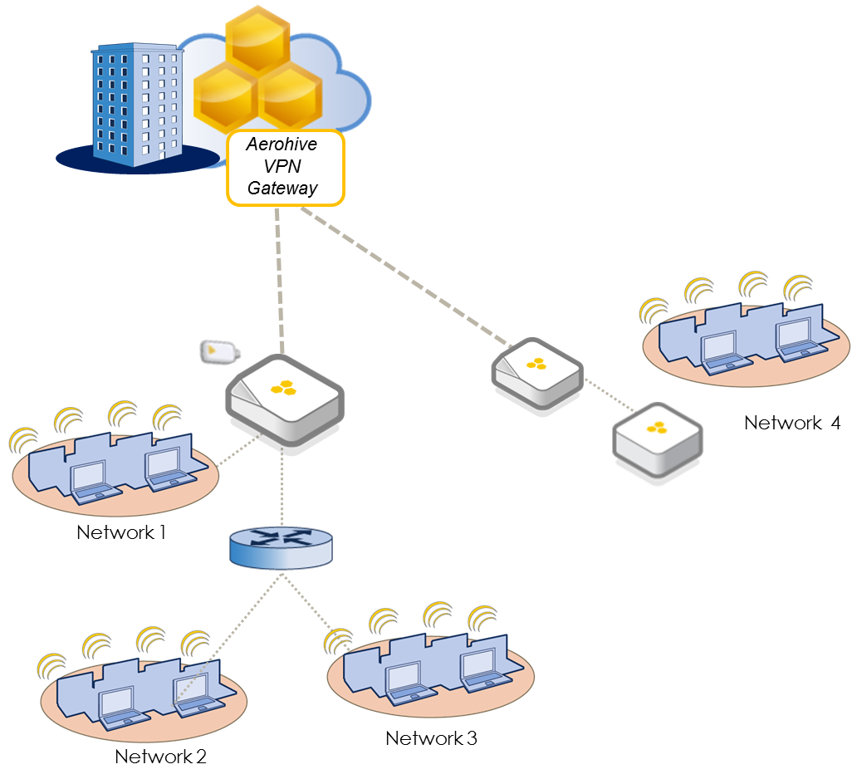
Topo-1

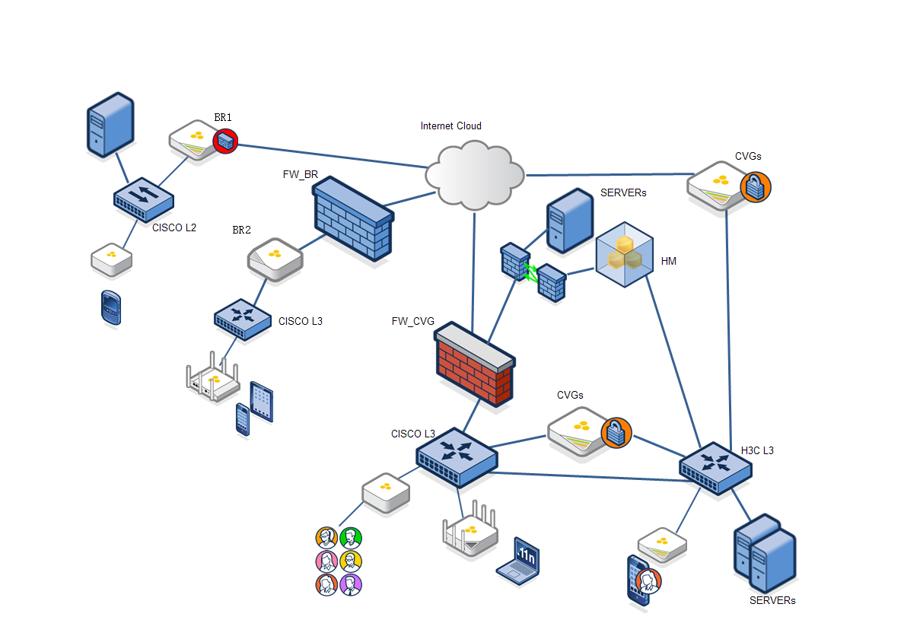
Topo-2

Test Case

Function Test Case

BR StaticRouting

Check static route set on host which is reachable
Case ID | FT_BR_StaticRouting_1
Priority | High | Automation Flag | No
Topology to use | Topo-1
Description | Check static route set on host which is reachable
Pre-condition | BR:  Mgt0.x : 10.2.3.1/24  Network1: 192.168.40.0/24  L3sw(connecting to br of vpn client):  Ip: 10.2.3.11/24, gateway: 10.2.3.1/24  Network2: 192.168.20.0/24 Network3: 192.168.30.0/24  Network2 with 2 pcs, pc1 with 192.168.20.10, pc2 with 192.168.20.20
Test procedure | - BR ping network2’s pc1 and pc2 to verify, and check log of pkt out interface  Open debug on br: _ff id 1 dst-ip network2’s_pc_ip protocol 1 bidirectional  _kdebug fe basic  _kdebug fe detail  - Set static route to host of network2’s pc1  CLI: ip route host 192.168.20.10 gateway 10.2.3.11  - Network1 ping network2’s pc1 and pc2 to verify, and check log of pkt out interface  - Delete static route on br and then network1 ping network2’s pc1 to verify  CLI: no ip route host 192.168.20.10 gateway 10.2.3.11
Expect result | - Ping failed, ping pkt will be out from wan interface  - Set successful  - Ping pc1 successful, ping pkt will be sent to mgt0.x and then out from ethx interface connected to l3sw  Ping pc2 failed, ping pkt will still be out from wan interface  - Delete static route successful  Ping pc1 failed
Comments | Pass

Check static route set on net
Case ID | FT_BR_StaticRouting_2
Priority | Accept | Automation Flag | No
Topology to use | Topo-1
Description | Check static route set on net
Pre-condition | BR:  Mgt0.x : 10.2.3.1/24  Network1: 192.168.40.0/24  L3sw(connecting to br of vpn client):  Ip: 10.2.3.11/24, gateway: 10.2.3.1/24  Network2: 192.168.20.0/24 Network3: 192.168.30.0/24
Test procedure | - Network1 ping network2 to verify, and check log of pkt out interface  Open debug on br:  _ff id 1 dst-ip network2.ip protocol 1 bidirectional  _kdebug fe basic  _kdebug fe detail  - Set static routing to net on network2  CLI: ip route net 192.168.20.0 255.255.255.0 gateway 10.2.3.11  - Network1 ping network2 to verify , and check log of pkt out interface  - Delete static route on br and then network1 ping network2 to verify
Expect result | - Ping failed, ping pkt will be out from wan interface  - Set successful, check will add the route to ip route table  - Ping successful, ping pkt will be sent to mgt0.x and then out from ethx interface connected to l3sw  - Delete static route successful  Ping network2 failed
Comments | Pass  2. CLI: ip route net 192.168.20.0 255.255.255.0 gateway 172.18.0.131  AH-8c7a80#show ip route | include 192  192.168.20.0 172.18.0.131 255.255.255.0 UG 0 0 0 mgt0  3. L3switch connect to BR’s eth1, with default-gateway to mgt0-ip.  check log, packet to network “192.168.20.0/24” will be sent to mgt0,and out from connecting port eth1.  2012-11-02 14:03:47 debug kernel: L*: (i) mgt0 172.18.0.129->192.168.20.1(0) ttl(64) icmp-echo-req(26325/1) 84 bytes  2012-11-02 14:03:47 debug kernel: [fe]: MAC session (id [3]) found  2012-11-02 14:03:47 debug kernel: [fe]: fflow 0019:778c:7a80->0019:778c:5240 flag 0x89210, rflow 0019:778c:5240->0019:778c:7a80 flag 0x9002  2012-11-02 14:03:47 debug kernel: [fe]: fflow acl 0x0/0x0, rflow acl 0x0/0x0  2012-11-02 14:03:47 debug kernel: [fe]: QoS: host pkt fwd(mgt0) qos=2 profile=0  2012-11-02 14:03:47 debug kernel: [fe]: eth1 Tx 0019:778c:7a80 -> 0019:778c:5240 type 0x0800 98 bytes  2012-11-02 14:03:47 debug kernel: L*: (o) eth1 172.18.0.129->192.168.20.1(0) ttl(64) icmp-echo-req(26325/1) 98 bytes  2012-11-02 14:03:47 debug kernel: [fe]: update to-access counters 98 bytes  2012-11-02 14:03:47 debug kernel: [fe]: QoS: pkt forwarded (eth1) qos=2 profile=0  2012-11-02 14:03:47 debug kernel: L*: (i) eth1 192.168.20.1->172.18.0.129(62281) ttl(64) icmp-echo-reply(26325/1) 84 bytes  2012-11-02 14:03:47 debug kernel: [fe]: MAC session (id [3]) found  2012-11-02 14:03:47 debug kernel: [fe]: fflow 0019:778c:5240->0019:778c:7a80 flag 0x9002, rflow 0019:778c:7a80->0019:778c:5240 flag 0x89210  2012-11-02 14:03:47 debug kernel: [fe]: fflow acl 0x0/0x0, rflow acl 0x0/0x0  2012-11-02 14:03:47 debug kernel: [fe]: update from-access counters 98 bytes  2012-11-02 14:03:47 debug kernel: [fe]: QoS: ingress pkt fwd(eth1) profile=4096 qos=2  2012-11-02 14:03:47 debug kernel: [fe]: set pkt to self  2012-11-02 14:03:47 debug kernel: [fe]: swap incoming dev eth1 -> mgt0  2012-11-02 14:03:47 debug kernel: [fe]: allow to self-pak, dst-ip 172.18.0.129,allow-arp 0 allow-dhcp 0 allow-forwarding 1  2012-11-02 14:03:47 debug kernel: [fe]: deliver pak to self on mgt0 with fw mark 0  2012-11-02 14:03:47 debug kernel: L*: (u) mgt0 192.168.20.1->172.18.0.129(62281) ttl(64) icmp-echo-reply(26325/1) 84 bytes  2012-11-02 14:03:47 debug kernel: [kernel]: iptables PRE_ROUTING pkt 192.168.20.1(mgt0)->172.18.0.129(<NULL>) proto(1) 84 bytes: ACCEPT  2012-11-02 14:03:47 debug kernel: [kernel]: iptables LOCAL_IN pkt 192.168.20.1(mgt0)->172.18.0.129(<NULL>) proto(1) 84 bytes: ACCEPT  2012-11-02 14:03:48 debug kernel: [fe]: mark pkt as from self  2012-11-02 14:03:48 debug kernel: [fe]: inject pkt back into flow from mgt0 xmit

Check static route set on super-net
Case ID | FT_BR_StaticRouting_3
Priority | High | Automation Flag | No
Topology to use | Topo-1
Description | Check static route set on super-net (HOS only)
Pre-condition | BR:  Mgt0.x : 10.2.3.1/24  Network1: 192.168.40.0/24  L3sw(connecting to br of vpn client):  Ip: 10.2.3.11/24, gateway: 10.2.3.1/24  Network2: 192.168.20.0/25 Network3: 192.168.20.129/25
Test procedure | - Network1 ping network2 to verify  - Network1 ping network3 to verify  - Set static routing to super-net of network2 and network3  CLI: ip route net 192.168.20.0 255.255.255.0 gateway 10.2.3.11  - Network1 ping network2 to verify  - Network1 ping network3 to verify  - Delete static route on br and then network1 ping network2 to verify
Expect result | - Ping failed  - Ping failed  - Set successful  - Ping successful  - Ping successful  - Delete static route successful  Ping network2 failed
Comments

Check static route should not in tunnel-all route table
Case ID | FT_BR_StaticRouting_4
Priority | High | Automation Flag | No
Topology to use | Topo-1
Description | Check static route should not in tunnel-all route, and static route won’t take effect
Pre-condition | BR:  Mgt0.x : 10.2.3.1/24  Enable dhcp server on mgt0.x  Ssid xx, bind security-object xx, bind user-profile xx  User-profile xx tunnel-policy xx  User-profile xx l3-tunnel-action all  L3sw(connecting to br of vpn client):  Ip: 10.2.3.11/24, gateway: 10.2.3.1/24  Network2: 192.168.20.0/25 Network3: 192.168.20.129/25
Test procedure | - Connect a laptop to ssid xx on br, ensure it is authenticated and obtained ip  - Laptop ping cvg to verify, and check log of pkt out interface  Set debug: _ff id 1 src-ip laptop.ip protocol 1 bidirectional  _ff id 2 protocol 47 bidirectional  _ff id 3 protocol 50 bidirectional  - Set static route to network2 on br  CLI: ip route net 192.168.20.0 255.255.255.0 gateway 10.2.3.11  - Check 4 tunnel route table  - Laptop ping network2 to verify, and check log of pkt out interface
Expect result | - Laptop connects on ssid xx, and obtain ip from mgt0.x dhcp pool  - Ping successful, ping pkt will be out from tunnel interface  - Set successful  - Static route not in tunnel-all routing table  - Ping failed, ping pkt will be out from tunnel interface, won’t be sent to mgt0.x
Comments | 4. CLI: AH-8c7a80#show ip policy-route l3-tunnel-all  Static route not in tunnel-all routing table

Check static route will be in tunnel-all with exception routing table
Case ID | FT_BR_StaticRouting_5
Priority | High | Automation Flag | No
Topology to use | Topo-1
Description | Check static route will be in tunnel-all with exception routing table
Pre-condition | BR:  Mgt0.x : 10.2.3.1/24  Enable dhcp server on mgt0.x  Ssid xx, bind security-object xx, bind user-profile xx  User-profile xx tunnel-policy xx  User-profile xx l3-tunnel-action with-exception  L3sw(connecting to br of vpn client):  Ip: 10.2.3.11/24, gateway: 10.2.3.1/24  Network2: 192.168.20.0/25 Network3: 192.168.20.129/25
Test procedure | - Connect a laptop to ssid xx on br, ensure it is authenticated and obtained ip  - Laptop ping cvg to verify, and check log of pkt out interface  Set debug: _ff id 1 src-ip laptop.ip protocol 1 bidirectional  _ff id 2 protocol 47 bidirectional  _ff id 3 protocol 50 bidirectional  - Set static route to network2 on br  CLI: ip route net 192.168.20.0 255.255.255.0 gateway 10.2.3.11  - Set vpn l3-tunnel-exception list on br  CLI: vpn l3-tunnel-exception 192.168.20.0/24  - Check tunnel-all with exception routing table on br  - Laptop ping network2 to verify, and check log of pkt out interface
Expect result | - Laptop connects on ssid xx, and obtain ip from mgt0.x dhcp pool  - Ping successful, ping pkt will be out from tunnel interface  - Set successful  - Set successful  - Static route should in tunnel-all with exception routing table, with interface mgt0.x  - Ping successful, ping pkt will be send to mgt0.x and out from ethx which connecting to l3sw
Comments | 5. AH-8c7a80#show ip policy-route l3-tunnel-exception | include 192  172.18.255.192 0.0.0.0 255.255.255.192 41 0 unicast tunnel0  192.168.20.0 10.2.2.1 255.255.255.0 0 0 unicast eth0

Check static route should not in tunnel-drop route table
Case ID | FT_BR_StaticRouting_6
Priority | High | Automation Flag | No
Topology to use | Topo-1
Description | Check static route should not in tunnel-drop routing table, and static route can take effect
Pre-condition | BR:  Mgt0.x : 10.2.3.1/24  Enable dhcp server on mgt0.x  Ssid xx, bind security-object xx, bind user-profile xx  User-profile xx tunnel-policy xx  User-profile xx l3-tunnel-action drop-tunnel-traffic  L3sw(connecting to br of vpn client):  Ip: 10.2.3.11/24, gateway: 10.2.3.1/24  Network2: 192.168.20.0/25 Network3: 192.168.20.129/25
Test procedure | - Connect a laptop to ssid xx on br, ensure it is authenticated and obtained ip  - Laptop ping cvg to verify, and check log of pkt out interface  Set debug: _ff id 1 src-ip laptop.ip protocol 1 bidirectional  _ff id 2 protocol 47 bidirectional  _ff id 3 protocol 50 bidirectional  - Set static route to network2 on br  CLI: ip route net 192.168.20.0 255.255.255.0 gateway 10.2.3.11  - Check tunnel drop routing table on br  - Laptop ping network2 to verify, and check log of pkt out interface
Expect result | - Laptop connects on ssid xx, and obtain ip from mgt0.x dhcp pool  - Ping failed, ping pkt will be dropped when out from tunnel interface  - Set successful  - Static route should not in tunnel drop routing table, and the not tunnel traffic will be permitted  - Ping successful, ping pkt will be send to mgt0.x and out from ethx which connecting to l3sw
Comments

BR StaticRouting distributing to cvg

Check static route set on br be distributed to cvg
Case ID | FT_BR_StaticRouting_distribute_1
Priority | Accept | Automation Flag | No
Topology to use | Topo-1
Description | Static route set on net be distributed to cvg
Pre-condition | BR:  Mgt0.x : 10.2.3.1/24  Network1: 192.168.40.0/24  L3sw(connecting to br of vpn client):  Ip: 10.2.3.11/24, gateway: 10.2.3.1/24  Network2: 192.168.20.0/24 Network3: 192.168.30.0/24  CVG:  Network4: 192.168.40.0/24
Test procedure | - Set static route to network2 on br  CLI: ip route net 192.168.20.0 255.255.255.0 gateway 10.2.3.11  - Network2 ping CVG to verify, and check log of pkt out and ingress interface  - On br, enable routing internal-sub-network distributing to cvg  CLI: routing route-request enable  routing internal-sub-network 192.168.20.0/24  - Check static routing be learned on cvg by “show ip route”  - Network2 ping CVG to verify, and check log of pkt out and ingress interface  - Network3 ping CVG to verify  - On br, disable routing distribution to vpn and wait for more than 1 miniute to check ip route on vpn  CLI: no routing route-request enable  - Network2 ping CVG to verify
Expect result | - Set successful  - Ping failed, ping pkt will be out from tunnel interface of br, and no icmp-reply pkt from tunnel interface of br  - Set successful  - On cvg, “show ip route” can see static routing be installed on tunnel interface  - Ping successful, ping pkt will be out from tunnel interface of br, and receiving icmp-reply pkt from tunnel interface of br  - Ping failed, as no static route set on network3 and be distributed to cvg  - Set successful, static route will be deleted from ip route table  - Ping failed
Comments | 4. check route on cvg:  AH-bc922a#show ip route | include 192  192.168.20.0 172.18.0.129 255.255.255.0 UG 0 0 0 tunnel0  5. set debug:  _ff id 1 protocol 47 bidirectional  _ff id 2 protocol 50 bidirectional  id 3 src-ip 192.168.20.x(network2’s ip) protocol 1 bidirectional  _kdebug fe detail  _kdebug fe basic  2012-11-02 15:03:25 debug kernel: L*: (i) eth1 192.168.20.10->10.3.3.1(30594) ttl(127) icmp-echo-req(1/1921) 60 bytes  2012-11-02 15:03:25 debug kernel: [fe]: MAC session (id [7]) found  2012-11-02 15:03:25 debug kernel: [fe]: fflow 0019:778c:5240->0019:778c:7a80 flag 0x9202, rflow 0019:778c:7a80->0019:778c:5240 flag 0x89010  2012-11-02 15:03:25 debug kernel: [fe]: fflow acl 0x0/0x0, rflow acl 0x0/0x0  2012-11-02 15:03:25 debug kernel: [fe]: update from-access counters 74 bytes  2012-11-02 15:03:25 debug kernel: [fe]: QoS: ingress pkt fwd(eth1) profile=4096 qos=2  2012-11-02 15:03:25 debug kernel: [fe]: set pkt to self  2012-11-02 15:03:25 debug kernel: [fe]: swap incoming dev eth1 -> mgt0  2012-11-02 15:03:25 debug kernel: [fe]: allow to self-pak, dst-ip 10.3.3.1,allow-arp 0 allow-dhcp 0 allow-forwarding 1  2012-11-02 15:03:25 debug kernel: [fe]: ip forward: ip pkt with dst-ip 10.3.3.1 received on eth1  2012-11-02 15:03:25 debug kernel: [fe]: deliver pak to self on mgt0 with fw mark 0  2012-11-02 15:03:25 debug kernel: L*: (u) mgt0 192.168.20.10->10.3.3.1(30594) ttl(127) icmp-echo-req(1/1921) 60 bytes  2012-11-02 15:03:25 debug kernel: [kernel]: iptables PRE_ROUTING pkt 192.168.20.10(mgt0)->10.3.3.1(<NULL>) proto(1) 60 bytes: ACCEPT  2012-11-02 15:03:25 debug kernel: [kernel]: iptables FORWARD pkt 192.168.20.10(mgt0)->10.3.3.1(tunnel0) proto(1) 60 bytes: ACCEPT  2012-11-02 15:03:25 debug kernel: [kernel]: iptables POST_ROUTING pkt 192.168.20.10(<NULL>)->10.3.3.1(tunnel0) proto(1) 60 bytes: ACCEPT  2012-11-02 15:03:25 debug kernel: L*: (o) tunnel0 192.168.20.10->10.3.3.1(30594) ttl(126) mtu(1398) icmp-echo-req(1/1921) 60 bytes  2012-11-02 15:03:25 debug kernel: [fe]: QoS: pkt forwarded (tunnel0) qos=2 profile=4096  2012-11-02 15:03:25 debug kernel: [kernel]: GRE-encap packet: 192.168.20.10->10.3.3.1 ttl(126) proto(1) mark(0) 60 bytes mtu 1398  2012-11-02 15:03:25 debug kernel: [kernel]: update mtu to 1398 clamp tcp mss flag: 1  2012-11-02 15:03:25 debug kernel: [kernel]: GRE-encap packet done =>172.18.0.129->10.3.3.202 ttl(126) proto(47) mark(0) 84 bytes  2012-11-02 15:03:25 debug kernel: [kernel]: iptables LOCAL_OUT pkt 172.18.0.129(<NULL>)->10.3.3.202(eth0) proto(47) 84 bytes: ACCEPT  2012-11-02 15:03:25 debug kernel: [kernel]: iptables POST_ROUTING pkt 172.18.0.129(<NULL>)->10.3.3.202(eth0) proto(47) 84 bytes: ACCEPT  2012-11-02 15:03:25 debug kernel: [kernel]: encap outgoing packet 172.18.0.129->10.3.3.202 ttl(126) proto(47) 84 bytes  2012-11-02 15:03:25 debug kernel: [kernel]: encap(ESP, SPI:a019599) packet successfully(rc=-115) =>10.2.2.66->10.155.32.174 ttl(64) proto(17) mark(0) 160 bytes  2012-11-02 15:03:25 debug kernel: [kernel]: iptables LOCAL_OUT pkt 10.2.2.66(<NULL>)->10.155.32.174(eth0) proto(17) 160 bytes: ACCEPT  2012-11-02 15:03:25 debug kernel: [kernel]: iptables POST_ROUTING pkt 10.2.2.66(<NULL>)->10.155.32.174(eth0) proto(17) 160 bytes: ACCEPT  2012-11-02 15:03:25 debug kernel: L*: (o) eth0 10.2.2.66->10.155.32.174(60224) ttl(64) mtu(1500) UDP 4500->4500 174 bytes  2012-11-02 15:03:25 debug kernel: [fe]: bypass fe egress procesing and deliver packet to stack on eth0  2012-11-02 15:03:25 debug kernel: L*: (i) eth0 10.3.3.202->172.18.0.129(0) ttl(63) proto(47) 84 bytes  2012-11-02 15:03:25 debug kernel: [fe]: bypass fe ingress procesing and deliver packet to stack on eth0  2012-11-02 15:03:25 debug kernel: [kernel]: iptables PRE_ROUTING pkt 10.3.3.202(eth0)->172.18.0.129(<NULL>) proto(47) 84 bytes: ACCEPT  2012-11-02 15:03:25 debug kernel: [kernel]: iptables LOCAL_IN pkt 10.3.3.202(eth0)->172.18.0.129(<NULL>) proto(47) 84 bytes: ACCEPT  2012-11-02 15:03:25 debug kernel: [kernel]: recv GRE packet 10.3.3.202->172.18.0.129 ttl(63) proto(47) mark(0) 64 bytes  2012-11-02 15:03:25 debug kernel: [kernel]: GRE tunnel found 172.18.0.129<->10.3.3.202 GRE iface (tunnel0) proto(47)  2012-11-02 15:03:25 debug kernel: [kernel]: GRE-decap packet done => 10.3.3.1->192.168.20.10 ttl(63) proto(1) mark(0) 60 bytes  2012-11-02 15:03:25 debug kernel: L*: (i) tunnel0 10.3.3.1->192.168.20.10(51913) ttl(63) icmp-echo-reply(1/1921) 60 bytes  2012-11-02 15:03:25 debug kernel: [fe]: deliver pak to self on tunnel0 with fw mark 0  2012-11-02 15:03:25 debug kernel: L*: (u) tunnel0 10.3.3.1->192.168.20.10(51913) ttl(63) icmp-echo-reply(1/1921) 60 bytes  2012-11-02 15:03:25 debug kernel: [kernel]: iptables PRE_ROUTING pkt 10.3.3.1(tunnel0)->192.168.20.10(<NULL>) proto(1) 60 bytes: ACCEPT  2012-11-02 15:03:25 debug kernel: [kernel]: iptables FORWARD pkt 10.3.3.1(tunnel0)->192.168.20.10(mgt0) proto(1) 60 bytes: ACCEPT  2012-11-02 15:03:25 debug kernel: [kernel]: iptables POST_ROUTING pkt 10.3.3.1(<NULL>)->192.168.20.10(mgt0) proto(1) 60 bytes: ACCEPT  2012-11-02 15:03:25 debug kernel: [fe]: bypass fe egress procesing and deliver packet to stack on mgt0  2012-11-02 15:03:25 debug kernel: [fe]: mark pkt as from self  2012-11-02 15:03:25 debug kernel: [fe]: inject pkt back into flow from mgt0 xmit  2012-11-02 15:03:25 debug kernel: L*: (i) mgt0 10.3.3.1->192.168.20.10(51913) ttl(62) icmp-echo-reply(1/1921) 60 bytes  2012-11-02 15:03:25 debug kernel: [fe]: MAC session (id [7]) found  2012-11-02 15:03:25 debug kernel: [fe]: fflow 0019:778c:7a80->0019:778c:5240 flag 0x89010, rflow 0019:778c:5240->0019:778c:7a80 flag 0x9202  2012-11-02 15:03:25 debug kernel: [fe]: fflow acl 0x0/0x0, rflow acl 0x0/0x0  2012-11-02 15:03:25 debug kernel: [fe]: QoS: host pkt fwd(mgt0) qos=2 profile=0  2012-11-02 15:03:25 debug kernel: [fe]: eth1 Tx 0019:778c:7a80 -> 0019:778c:5240 type 0x0800 74 bytes  2012-11-02 15:03:25 debug kernel: L*: (o) eth1 10.3.3.1->192.168.20.10(51913) ttl(62) icmp-echo-reply(1/1921) 74 bytes  2012-11-02 15:03:25 debug kernel: [fe]: update to-access counters 74 bytes  2012-11-02 15:03:25 debug kernel: [fe]: QoS: pkt forwarded (eth1) qos=2 profile=0

Check static route set on br be distributed to 2 cvg
Case ID | FT_BR_StaticRouting_distribute_2
Priority | High | Automation Flag | No
Topology to use | Topo-1
Description | Static route set on net be distributed to 2 cvg
Pre-condition | BR:  Mgt0.x : 10.2.3.1/24  Network1: 192.168.40.0/24  L3sw(connecting to br of vpn client):  Ip: 10.2.3.11/24, gateway: 10.2.3.1/24  Network2: 192.168.20.0/24 Network3: 192.168.30.0/24  CVG1:  Network4: 192.168.40.0/24  CVG2:  Network5: 192.168.50.0/24
Test procedure | - Set static route to network2 on br  CLI: ip route net 192.168.20.0 255.255.255.0 gateway 10.2.3.11  - Network2 ping CVG1 to verify, and check log of pkt out and ingress interface  - Network2 ping CVG2 to verify, and check log of pkt out and ingress interface  - On br, enable routing internal-sub-network distributing to cvg  CLI: routing route-request enable  routing internal-sub-network 192.168.20.0/24  - Check static routing be learned on cvg1 and cvg2 by “show ip route”  - Network2 ping CVG1 and CVG2 to verify, and check log of pkt out and ingress interface  - On br, disable routing distribution to vpn and wait for more than 1 miniute to check ip route on vpn  CLI: no routing route-request enable  - Network2 ping CVG to verify
Expect result | - Set successful  - Ping cvg1 failed, ping pkt will be out from tunnel interface of br, and no icmp-reply pkt from tunnel interface of br  - Ping cvg2 failed, ping pkt will be out from tunnel interface of br, and no icmp-reply pkt from tunnel interface of br  - Set successful  - “show ip route” can see static routing be installed on tunnel interface on both cvg1 and cvg2  - Ping successful, ping pkt will be out from tunnel interface of br, and receiving icmp-reply pkt from tunnel interface of br  - Ping failed, as no static route set on network3 and be distributed to cvg  - Set successful, static route will be deleted from ip route table  - Ping failed
Comments | AH-8c7a80#show ip route  Ref=references; Iface=interface;  U=route is up;H=target is a host; G=use gateway;  Destination Gateway Netmask Flags Metric Ref Use Iface  --------------- --------------- --------------- ----- ------ ------ --- -----  192.169.20.0 172.32.10.193 255.255.255.0 UG 0 0 0 tunnel0

Check static routing set on br manually be aggregated to one route then distribute to cvg
Case ID | FT_BR_StaticRouting_distribute_3
Priority | High | Automation Flag | No
Topology to use | Topo-1
Description | Check static routing set on br manually be aggregated to one route then distribute to cvg
Pre-condition | BR:  Mgt0.x : 10.2.3.1/24  Network1: 192.168.40.0/24  L3sw (connecting to br of vpn client):  Ip: 10.2.3.11/24, gateway: 10.2.3.1/32  Network2: 192.168.20.0/25 Network3: 192.168.20.128/25  CVG:  Mgt0.x: 10.2.4.1/24  L3sw (connecting to br of vpn server)  Ip: 10.2.4.11/24, gateway: 10.2.4.1/32
Test procedure | - CVG4 ping br to verify  - Set static routing to network2 and networkt3 on br, and push the static route to cvg  CLI: ip route net 192.168.20.0 255.255.255.128 gateway 10.2.3.11  routing route-request enable  ip route net 192.168.20.128 255.255.255.128 gateway 10.2.3.11  routing route-request enable  routing internal-sub-network 192.168.20.0/24  - Check static route be learned on cvg by “show ip route”  - CVG ping network2 to verify  - CVG ping network3 to verify
Expect result | - Ping failed  - Set successful  - On cvg, “show ip route” can see route  - Ping successful  - Ping successful
Comments

Check cvg will distribute learned static routing by ospf
Case ID | FT_BR_StaticRouting_distribute_4
Priority | High | Automation Flag | No
Topology to use | Topo-1
Description | Check cvg will distribute learned static routing by ospf
Pre-condition | BR1:  Mgt0.x : 10.2.3.1/24  Network1: 192.168.40.0/24  L3sw (connecting to br of vpn client):  Ip: 10.2.3.11/24, gateway: 10.2.3.1/24  Network2: 192.168.20.0/24 Network3: 192.168.30.0/24  CVG:  routing protocol enable  L3sw (connecting to cvg of vpn server):  Enable routing protocol ospf only  Network4: 192.168.50.0/24
Test procedure | - Network4 ping network2 to verify  - Set static routing to network2 on br, and push the static route to cvg  CLI: ip route net 192.168.20.0 255.255.255.0 gateway 10.2.3.11  routing route-request enable  routing internal-sub-network 192.168.20.0/24  - Check static route be installed on cvg by “show ip route”  - Check static route be advertised to l3sw by “show ip route” on l3sw  - Network4 ping network2 to verify
Expect result | - Ping failed  - Set successful  - On CVG, “show ip route” can see static routing be installed on tunnel interface  - On l3sw, “show ip route” can see static routing be installed on related interface  - Ping successful
Comments

Check cvg will distribute learned static routing by rip
Case ID | FT_BR_StaticRouting_distribute_5
Priority | High | Automation Flag | No
Topology to use | Topo-1
Description | Check cvg will distribute learned static routing by rip
Pre-condition | BR1:  Mgt0.x : 10.2.3.1/24  Network1: 192.168.40.0/24  L3sw (connecting to br of vpn client):  Ip: 10.2.3.11/24, gateway: 10.2.3.1/24  Network2: 192.168.20.0/24 Network3: 192.168.30.0/24  CVG:  routing protocol enable  L3sw (connecting to cvg of vpn server):  Enable routing protocol rip only  Network4: 192.168.50.0/24
Test procedure | - Network4 ping network2 to verify  - Set static routing to network2 on br, and push the static route to cvg  CLI: ip route net 192.168.20.0 255.255.255.0 gateway 10.2.3.11  routing route-request enable  routing internal-sub-network 192.168.20.0/24  - Check static route be installed on cvg by “show ip route”  - Check static route be advertised to l3sw by “show ip route” on l3sw  - Network4 ping network2 to verify
Expect result | - Ping failed  - Set successful  - On CVG, “show ip route” can see static routing be installed on tunnel interface  - On l3sw, “show ip route” can see static routing be installed on related interface  - Ping successful
Comments

Check static routing set on cvg be distributed to br client
Case ID | FT_BR_StaticRouting_distribute_6
Priority | High | Automation Flag | No
Topology to use | Topo-2
Description | Check cvg will distribute static route to br client
Pre-condition | BR1:  Mgt0.x: 10.2.2.1/24  Network1: 192.168.10.0/24  BR2:  Mgt0.x : 10.2.3.1/24  L3sw (connecting to br of vpn client br1):  Ip: 10.2.3.11/24, gateway: 10.2.3.1/32  Network2: 192.168.20.0/24 Network3: 192.168.30.0/24  CVG:
Test procedure | - Network2 ping network1 to verify  - Set static routing to network2 on br, and push the static route to cvg  CLI: ip route net 192.168.20.0 255.255.255.0 gateway 10.2.3.11  routing internal-sub-network 192.168.20.0/24  - Check static route be learned on cvg by “show ip route”  - Check static route be learned on br1 by “show ip route”  - Network4 ping network2 to verify
Expect result | - Ping failed  - Set successful  - On cvg, “show ip route” can see static routing be learned on tunnel interface  - On br1, “show ip route” can see static routing be learned on tunnel interface  - Ping successful
Comments

disconnect and reconnect vpn connection to check static route dristribution
Case ID | FT_BR_StaticRouting_distribute_7
Priority | High | Automation Flag | Yes/No/NA
Topology to use | Topo-1
Description | disconnect and reconnect vpn connection to check static route dristribution
Pre-condition | BR:  Mgt0.x : 10.2.3.1/24  Network1: 192.168.40.0/24  L3sw(connecting to br of vpn client):  Ip: 10.2.3.11/24, gateway: 10.2.3.1/24  Network2: 192.168.20.0/24 Network3: 192.168.30.0/24  CVG:  Routing protocol enable  Network4: 192.168.40.0/24
Test procedure | - Set static route on network2 and distribute it to vpn  CLI: ip route net 192.168.20.0 255.255.255.0 gateway 10.2.3.11  routing route-request enable  routing internal-sub-network 192.168.20.0/24  - check ip route on cvg  - Network4 ping network2 to verify  - disconnect vpn connection( by delete vpn client/vpn server configuration, or disconnect wan connection), check static route deleted from ip route table of vpn  - reconnect vpn connection to check static route can be advertised to vpn again  - network4 ping network2 to verify
Expect result | - Set successful  - with static route in ip route table  - ping successful  - static route deleted from ip route table of vpn  - static route added into ip route table of vpn again  - ping successful
Comments

static route be deleted from br
Case ID | FT_BR_StaticRouting_distribute_8
Priority | High | Automation Flag | No
Topology to use | Topo-1
Description | static route be deleted from br
Pre-condition | BR:  Mgt0.x : 10.2.3.1/24  Network1: 192.168.40.0/24  L3sw(connecting to br of vpn client):  Ip: 10.2.3.11/24, gateway: 10.2.3.1/24  Network2: 192.168.20.0/24 Network3: 192.168.30.0/24  CVG:  Routing protocol enable  Network4: 192.168.40.0/24
Test procedure | - Set static route on network2 and distribute it to vpn  CLI: ip route net 192.168.20.0 255.255.255.0 gateway 10.2.3.11  routing route-request enable  routing internal-sub-network 192.168.20.0/24  - Check ip route on cvg  - Network4 ping network2 to verify  - Delete static route on br to check static route table distribution to vpn  - re-add static route on br to check static route table distribution to vpn  - network4 ping network2 to verify
Expect result | - Set successful  - with static route in ip route table  - ping successful  - Static route will be deleted from ip route on cvg  - Static route added into cvg’s ip route table again  - Ping successful
Comments

mgt0.x be deleted when static route’s gateway set on it
Case ID | FT_BR_StaticRouting_distribute_9
Priority | High | Automation Flag | No
Topology to use | Topo-1
Description | mgt0.x be deleted when static route’s gateway set on it
Pre-condition | BR:  Mgt0.x : 10.2.3.1/24  Network1: 192.168.40.0/24  L3sw(connecting to br of vpn client):  Ip: 10.2.3.11/24, gateway: 10.2.3.1/24  Network2: 192.168.20.0/24 Network3: 192.168.30.0/24  CVG:  Routing protocol enable  Network4: 192.168.40.0/24
Test procedure | - Set static route on network2 and distribute it to vpn  CLI: ip route net 192.168.20.0 255.255.255.0 gateway 10.2.3.11  routing route-request enable  routing internal-sub-network 192.168.20.0/24  - Check ip route on cvg  - Network4 ping network2 to verify  - Delete mgt0.x from br when static route’s gateway set on it, check static route table distribution to vpn  - Re-add mgt0.x on br with static route’s gateway set on it to check static route table distribution to vpn  - Network4 ping network2 to verify
Expect result | - Set successful  - with static route in ip route table  - ping successful  - Static route will be deleted from ip route table on cvg  - Static route will be added into ip route table again on cvg  - Ping successful
Comments

Static route set gateway address with mgt0.x ip, check route distribution
Case ID | FT_BR_StaticRouting_distribute_10
Priority | High | Automation Flag | No
Topology to use | Topo-1
Description | Static route set gateway address with mgt0.x ip, check route distribution
Pre-condition | BR:  Mgt0.x : 10.2.3.1/24  Network1: 192.168.40.0/24  L3sw(connecting to br of vpn client):  Ip: 10.2.3.11/24, gateway: 10.2.3.1/24  Network2: 192.168.20.0/24 Network3: 192.168.30.0/24  CVG:  Routing protocol enable  Network4: 192.168.40.0/24
Test procedure | - Set static route on network2 with gateway on mgt0.x and distribute it to vpn  CLI: ip route net 192.168.20.0 255.255.255.0 gateway 10.2.3.1  routing route-request enable  routing internal-sub-network 192.168.20.0/24  - Check ip route on cvg  - Network4 ping network2 to verify  - Delete mgt0.x from br when static route’s gateway set on it, check static route table distribution to vpn  - Re-add mgt0.x on br with static route’s gateway set on it to check static route table distribution to vpn  - Network4 ping network2 to verify
Expect result | - Set successful  - with static route in ip route table  - ping successful  - Static route will be deleted from ip route table on cvg  - Static route will be added into ip route table again on cvg  - Ping successful
Comments

Negative Test Case

Kill brd process
Case ID | Neg_BR_StaticRouting_1
Priority | High | Automation Flag | No
Topology to use | Topo-1
Description | Kill brd process to check static route distribution
Pre-condition | BR:  Mgt0.x : 10.2.3.1/24  Network1: 192.168.40.0/24  L3sw(connecting to br of vpn client):  Ip: 10.2.3.11/24, gateway: 10.2.3.1/24  Network2: 192.168.20.0/24 Network3: 192.168.30.0/24  CVG:  Routing protocol enable  Network4: 192.168.40.0/24
Test procedure | - Set static route on network2 and distribute it to vpn  CLI: ip route net 192.168.20.0 255.255.255.0 gateway 10.2.3.11  routing route-request enable  routing internal-sub-network 192.168.20.0/24  - Check ip route on cvg  - Network2 ping CVG to verify  - Kill brd process on br, wait for route timeout timer, then check ip route on vpn  - network4 ping network2 to verify
Expect result | - Set successful  - On cvg, will add static route into ip route table  - Ping successful  - brd process is inactive  Static route will be deleted from ip route table of vpn, when route timeout exceed (?)  - ping failed
Comments

Stress Test Case

Durative to add and remove static route from br
Case ID | Dura_BR_StaticRouting_1
Priority | High | Automation Flag | No
Topology to use | Topo-1
Description | Durative to add and remove static route from br
Pre-condition | BR:  Mgt0.x : 10.2.3.1/24  Network1: 192.168.40.0/24  L3sw(connecting to br of vpn client):  Ip: 10.2.3.11/24, gateway: 10.2.3.1/24  Network2: 192.168.20.0/24 Network3: 192.168.30.0/24  CVG:  Routing protocol enable  Network4: 192.168.40.0/24
Test procedure | - Set static route on network2 and distribute it to vpn  CLI: ip route net 192.168.20.0 255.255.255.0 gateway 10.2.3.11  routing route-request enable  routing internal-sub-network 192.168.20.0/24  - Check ip route on cvg  - Network4 ping network2 to verify  - Delete static route on br to check static route table distribution to vpn  - re-add static route on br to check static route table distribution to vpn  - network4 ping network2 to verify  - Durative to repeat step4 to step6 to check behaviors on br
Expect result | - Set successful  - with static route in ip route table  - ping successful  - Static route will be deleted from ip route on cvg  - Static route added into cvg’s ip route table again  - Ping successful  - No memory leak and crash event, function works well
Comments

Duration Test Case

Performance Test Case

Capacity Test Case

max static routes and routing distribution items
Case ID | Cap_BR_StaticRouting_1
Priority | Middle | Automation Flag | Yes/No/NA
Topology to use | Topo-1
Description | Max static routes and routing distribution items  (route distribution max support 127 items)
Pre-condition
Test procedure | - Set max minus 1(max-1) static routes and distribute them to vpn  CLI: ip route net 192.168.20.0 255.255.255.0 gateway 10.2.3.11  ip route net 192.168.30.0 255.255.255.0 gateway 10.2.3.11  ···  routing route-request enable  routing internal-sub-network 192.168.20.0/24  routing internal-sub-network 192.168.30.0/24  ···  - Check all the static routes are learned on cvg  - Set one more static route and distribute it to vpn  - Check static route can be learned on cvg  - Set one more static route and distribute it to vpn again  - Check behaviors on br and cvg
Expect result | - Set successful  - All the staic routes are learned on cvg  - Set successful  - the static route is learned on cvg  - Set failed, will prompt error  - No any more static routes can be created when meet the maximum capacity
Comments

Compatibility Test Case

CLI Management

staic routing cli
Case ID | CLI_BR_StaticRouting_1
Priority | Low | Automation Flag | No
Topology to use
Description | ip route host [ip.address] gateway [gateway.ip]  ip route net [ip.address] [ip.netmask] gateway [gateway.ip]  routing route-request enable  routing internal-sub-network [ip/mask]  show routing internal-sub-network  show ip route
Pre-condition
Test procedure | - Set static routing on host with valid value  CLI: ip route host 192.168.20.x gateway 10.2.3.11  - Set static routing on net with valid value  CLI: ip route net 192.168.30.0 255.255.255.0 gateway 10.2.3.11  - Show running , show ip route to check  - Set static routing on host with invalid value, including invalid ip, and no same subnet ip on gateway and etc  CLI: ip route host 192.168.20.x gateway 1.1.1.1  ip route host 192.168.20.256 gateway 10.2.3.11  - Set static routing on net with invalid value, including invalid ip, invalid mask, and no same subnet ip on gateway and etc  CLI: ip route net 192.168.20.0 255.255.255.0 gateway 1.1.1.1  - Show running, show ip route to check  - Set routing distributing to vpn  CLI: routing route-request enable  routing internal-sub-network 192.168.30.0/24  - Show running, show routing internal-sub-network to check
Expect result | - set successful  - Set successful  - static routing showing in the running config file and ip route file  - set failed  - set failed  - static routing showing in the running config file and ip route file return same value asd step 3  - set successful  - routing distribution info showing in the running config file and route internal-sub-network file
Comments

save configurations of static routing
Case ID | CLI_BR_StaticRouting_2
Priority | Middle | Automation Flag | No
Topology to use
Description | Save config
Pre-condition
Test procedure | - Set static routing on host and net, and enable the static routing on net be distributing to vpn  CLI: ip route host 192.168.20.x gateway 10.2.3.11  ip route net 192.168.30.0 255.255.255.0 gateway 10.2.3.11  routing route-request enable  routing internal-sub-network 192.168.30.0/24  - show running to check  - save config and reboot to check
Expect result | - set successful  - show running config with right value  - save successful, after reboot it return right value as steps2
Comments

