R Notebook

library(readxl)  
library(mosaic)  
library(tidyverse)  
library(tibble)  
library(matrixStats)  
Shipments <- read_excel("Shipments.xls", col_names = FALSE)  
NewOrders <- read_excel("NewOrders.xls", col_names = FALSE)  
UnfilledOrders <- read_excel("UnfilledOrders.xls", col_names = FALSE)  
TotalInventories <- read_excel("TotalInventories.xls", col_names = FALSE)  
InventoriesToShipments <- read_excel("InventoriesToShipments.xls", col_names = FALSE)  
UnfilledOrdersToShipments <- read_excel("UnfilledOrdersToShipments.xls", col_names = FALSE)

shipments_industry_code_list <- as.array(unique(Shipments$...1))  
shipments_dataframe <- tibble(.rows = 360)

for (i in 1:length(shipments_industry_code_list))  
{  
 current_code <- shipments_industry_code_list[i]  
 current_industry <- Shipments %>% filter(Shipments$...1 == current_code, Shipments$...2 != "2022") %>% select(3:14)  
 current_industry_transpose <- as.list(t(current_industry))  
 for (j in 1:length(current_industry_transpose))  
 {  
 shipments_dataframe[j,i] = current_industry_transpose[j]  
 }  
 shipments_dataframe[i] <- sapply(shipments_dataframe[i],as.numeric)  
}  
colnames(shipments_dataframe) = shipments_industry_code_list  
dates <- seq(from = as.Date("1992/01/01"), to = as.Date("2021/12/01"), by = "months")  
dates2 <- format(dates, "%m/%y")  
shipments_dataframe_time <- shipments_dataframe %>% add_column(Date = dates2)  
head(shipments_dataframe_time,12)

## # A tibble: 12 x 175  
## AMTMVS AMXTVS AMXDVS AMTUVS AMDMVS A21SVS A27SVS A31SVS A31AVS AANMVS A31CVS  
## <dbl> <dbl> <dbl> <dbl> <dbl> <dbl> <dbl> <dbl> <dbl> <dbl> <dbl>  
## 1 227721 195546 218731 85081 117958 4616 4619 9924 4701 4357 866  
## 2 228860 194551 219614 85693 119895 4848 4615 9926 4621 4413 892  
## 3 238604 202999 229686 88670 124897 5196 5122 10245 4755 4556 934  
## 4 239877 203862 230568 89900 126174 5166 4993 10409 4796 4659 954  
## 5 243732 206982 235135 90226 127638 5121 5156 10714 4855 4826 1033  
## 6 245693 208867 236595 91023 127867 5237 5190 10507 4799 4693 1015  
## 7 245608 207363 236750 91638 129589 5082 5269 10561 4698 4856 1007  
## 8 242874 206171 234059 90713 127652 5080 5379 10466 4645 4822 999  
## 9 244894 209848 236252 89831 126553 5150 5396 10282 4567 4714 1001  
## 10 243190 206553 234713 90649 127779 5043 5446 10275 4524 4739 1012  
## 11 246901 209575 238163 91520 128989 5043 5306 10257 4562 4651 1044  
## 12 248199 210892 238940 92548 130106 5167 5133 9883 4225 4619 1039  
## # ... with 164 more variables: A32SVS <dbl>, A33SVS <dbl>, A33AVS <dbl>,  
## # A33CVS <dbl>, A33DVS <dbl>, A33EVS <dbl>, A33GVS <dbl>, A33HVS <dbl>,  
## # A33IVS <dbl>, ATGPVS <dbl>, A33MVS <dbl>, A34SVS <dbl>, A34AVS <dbl>,  
## # A34BVS <dbl>, A34CVS <dbl>, A34DVS <dbl>, A34EVS <dbl>, A34FVS <dbl>,  
## # A34GVS <dbl>, A34HVS <dbl>, A34IVS <dbl>, A34JVS <dbl>, A34KVS <dbl>,  
## # A35SVS <dbl>, A35AVS <dbl>, A35BVS <dbl>, A35CVS <dbl>, A35DVS <dbl>,  
## # A36SVS <dbl>, A36AVS <dbl>, A36BVS <dbl>, A36CVS <dbl>, ABTPVS <dbl>, ...

neworders_industry_code_list <- as.array(unique(NewOrders$...1))  
neworders_dataframe <- tibble(.rows = 360)

for (i in 1:length(neworders_industry_code_list))  
{  
 current_code <- neworders_industry_code_list[i]  
 current_industry <- NewOrders %>% filter(NewOrders$...1 == current_code, NewOrders$...2 != "2022") %>% select(3:14)  
 current_industry_transpose <- as.list(t(current_industry))  
 for (j in 1:length(current_industry_transpose))  
 {  
 neworders_dataframe[j,i] = current_industry_transpose[j]  
 }  
 neworders_dataframe[i] <- sapply(neworders_dataframe[i],as.numeric)  
}  
colnames(neworders_dataframe) = neworders_industry_code_list  
dates <- seq(from = as.Date("1992/01/01"), to = as.Date("2021/12/01"), by = "months")  
dates2 <- format(dates, "%m/%y")  
neworders_dataframe_time <- neworders_dataframe %>% add_column(Date = dates2)  
head(neworders_dataframe_time,12)

## # A tibble: 12 x 105  
## AMTMNO AMXTNO AMXDNO AMTUNO AMDMNO A31SNO A31ANO AANMNO A31CNO A32SNO A33SNO  
## <dbl> <dbl> <dbl> <dbl> <dbl> <dbl> <dbl> <dbl> <dbl> <dbl> <dbl>  
## 1 NA NA NA NA NA NA NA NA NA NA NA  
## 2 223500 191896 215154 82864 114535 9777 4449 4515 813 13385 14202  
## 3 233732 199432 227061 86424 120025 10283 4880 4433 970 13542 15050  
## 4 238173 200307 229698 90805 124470 10452 4815 4641 996 13441 15704  
## 5 241916 204434 233699 91120 125822 10779 4960 4767 1052 14086 15439  
## 6 240660 206045 233704 88649 122834 10822 4976 4816 1030 14416 16029  
## 7 238609 203746 232728 87342 122590 10801 4928 4965 908 13991 15458  
## 8 235633 202719 229766 85995 120411 10778 4748 4903 1127 14156 15379  
## 9 239052 207022 232363 86668 120711 9907 4503 4501 903 14560 16511  
## 10 242803 202475 231138 93051 127392 9896 4327 4601 968 14541 15630  
## 11 240286 207409 232028 87613 122374 10100 4411 4646 1043 14301 16071  
## 12 244173 209452 235795 91480 126080 10602 5138 4475 989 14938 16704  
## # ... with 94 more variables: A33CNO <dbl>, A33DNO <dbl>, A33ENO <dbl>,  
## # A33GNO <dbl>, A33HNO <dbl>, A33INO <dbl>, ATGPNO <dbl>, A33MNO <dbl>,  
## # A34SNO <dbl>, A34ANO <dbl>, A34DNO <dbl>, A34ENO <dbl>, A34HNO <dbl>,  
## # A34INO <dbl>, A34JNO <dbl>, A34KNO <dbl>, A35SNO <dbl>, A35ANO <dbl>,  
## # A35BNO <dbl>, A35CNO <dbl>, A36SNO <dbl>, ABTPNO <dbl>, ANAPNO <dbl>,  
## # ADAPNO <dbl>, A36ZNO <dbl>, A37SNO <dbl>, AMNMNO <dbl>, ACMSNO <dbl>,  
## # AITINO <dbl>, ACRPNO <dbl>, AMVPNO <dbl>, ATCGNO <dbl>, ANDENO <dbl>, ...

unfilledorders_industry_code_list <- as.array(unique(UnfilledOrders$...1))  
unfilledorders_dataframe <- tibble(.rows = 360)

for (i in 1:length(unfilledorders_industry_code_list))  
{  
 current_code <- unfilledorders_industry_code_list[i]  
 current_industry <- UnfilledOrders %>% filter(UnfilledOrders$...1 == current_code, UnfilledOrders$...2 != "2022") %>% select(3:14)  
 current_industry_transpose <- as.list(t(current_industry))  
 for (j in 1:length(current_industry_transpose))  
 {  
 unfilledorders_dataframe[j,i] = current_industry_transpose[j]  
 }  
 unfilledorders_dataframe[i] <- sapply(unfilledorders_dataframe[i],as.numeric)  
}  
colnames(unfilledorders_dataframe) = unfilledorders_industry_code_list  
dates <- seq(from = as.Date("1992/01/01"), to = as.Date("2021/12/01"), by = "months")  
dates2 <- format(dates, "%m/%y")  
unfilledorders_dataframe_time <- unfilledorders_dataframe %>% add_column(Date = dates2)  
head(unfilledorders_dataframe_time,12)

## # A tibble: 12 x 101  
## AMTMUO AMXTUO AMXDUO AMDMUO A31SUO A31AUO AANMUO A31CUO A32SUO A33SUO A33CUO  
## <dbl> <dbl> <dbl> <dbl> <dbl> <dbl> <dbl> <dbl> <dbl> <dbl> <dbl>  
## 1 471297 194865 305561 471297 17998 8078 7542 2378 31219 40073 2150  
## 2 468468 194741 303632 468468 17849 7906 7644 2299 30951 40039 2250  
## 3 466222 193800 303633 466222 17887 8031 7521 2335 30543 39643 2353  
## 4 467127 192854 305372 467127 17930 8050 7503 2377 29991 39933 2256  
## 5 468021 193016 306646 468021 17995 8155 7444 2396 29708 40136 2403  
## 6 465647 192853 306414 465647 18310 8332 7567 2411 29778 40253 2374  
## 7 461351 191939 305095 461351 18550 8562 7676 2312 29298 40423 2337  
## 8 456633 191010 303325 456633 18862 8665 7757 2440 28909 40396 2141  
## 9 453470 190863 302115 453470 18487 8601 7544 2342 29310 40946 2333  
## 10 455872 189574 301329 455872 18108 8404 7406 2298 29462 41132 2651  
## 11 451965 190116 297902 451965 17951 8253 7401 2297 29282 41445 2552  
## 12 450897 191634 297715 450897 18670 9166 7257 2247 29717 41031 2479  
## # ... with 90 more variables: A33DUO <dbl>, A33EUO <dbl>, A33GUO <dbl>,  
## # A33HUO <dbl>, A33IUO <dbl>, ATGPUO <dbl>, A33MUO <dbl>, A34SUO <dbl>,  
## # A34AUO <dbl>, A34DUO <dbl>, A34EUO <dbl>, A34HUO <dbl>, A34IUO <dbl>,  
## # A34JUO <dbl>, A34KUO <dbl>, A35SUO <dbl>, A35AUO <dbl>, A35BUO <dbl>,  
## # A35CUO <dbl>, A36SUO <dbl>, ABTPUO <dbl>, ANAPUO <dbl>, ADAPUO <dbl>,  
## # A36ZUO <dbl>, A37SUO <dbl>, ACMSUO <dbl>, AITIUO <dbl>, ACRPUO <dbl>,  
## # AMVPUO <dbl>, ATCGUO <dbl>, ANDEUO <dbl>, ANXAUO <dbl>, ADEFUO <dbl>, ...

totalinventories_industry_code_list <- as.array(unique(TotalInventories$...1))  
totalinventories_dataframe <- tibble(.rows = 360)

for (i in 1:length(totalinventories_industry_code_list))  
{  
 current_code <- totalinventories_industry_code_list[i]  
 current_industry <- TotalInventories %>% filter(TotalInventories$...1 == current_code, TotalInventories$...2 != "2022") %>% select(3:14)  
 current_industry_transpose <- as.list(t(current_industry))  
 for (j in 1:length(current_industry_transpose))  
 {  
 totalinventories_dataframe[j,i] = current_industry_transpose[j]  
 }  
 totalinventories_dataframe[i] <- sapply(totalinventories_dataframe[i],as.numeric)  
}  
colnames(totalinventories_dataframe) = totalinventories_industry_code_list  
dates <- seq(from = as.Date("1992/01/01"), to = as.Date("2021/12/01"), by = "months")  
dates2 <- format(dates, "%m/%y")  
totalinventories_dataframe_time <- totalinventories_dataframe %>% add_column(Date = dates2)  
head(totalinventories_dataframe_time,12)

## # A tibble: 12 x 317  
## AMTMTI AMXTTI AMXDTI AMTUTI AMDMTI A21STI A27STI A31STI A31ATI AANMTI A31CTI  
## <dbl> <dbl> <dbl> <dbl> <dbl> <dbl> <dbl> <dbl> <dbl> <dbl> <dbl>  
## 1 377883 307364 346810 198103 242159 6508 7991 16961 8258 7331 1372  
## 2 376757 306561 346118 196859 241142 6595 7982 16813 8236 7173 1404  
## 3 377688 307950 346909 197677 242116 6689 7942 18335 9803 7106 1426  
## 4 377491 308111 347009 197111 241520 6812 7950 18412 9799 7167 1446  
## 5 377450 309049 347091 196382 240786 6853 7913 18309 9741 7136 1432  
## 6 377055 308996 347438 196027 240148 6837 7950 18348 9767 7143 1438  
## 7 377301 309934 347877 195358 239228 6850 7933 18247 9704 7146 1397  
## 8 379317 311390 349940 196093 240139 6780 7983 18333 9738 7165 1430  
## 9 379343 312520 351039 195811 239765 6680 7977 18471 9734 7296 1441  
## 10 379138 312277 350812 194943 238799 6726 7954 18217 9654 7140 1423  
## 11 377990 311828 350291 193831 237825 6642 8033 18098 9587 7091 1420  
## 12 378609 312296 351089 194177 237854 6689 7990 18046 9648 6968 1430  
## # ... with 306 more variables: A32STI <dbl>, A33STI <dbl>, A33ATI <dbl>,  
## # A33CTI <dbl>, A33DTI <dbl>, A33ETI <dbl>, A33GTI <dbl>, A33HTI <dbl>,  
## # A33ITI <dbl>, ATGPTI <dbl>, A33MTI <dbl>, A34STI <dbl>, A34ATI <dbl>,  
## # A34BTI <dbl>, A34CTI <dbl>, A34DTI <dbl>, A34ETI <dbl>, A34FTI <dbl>,  
## # A34HTI <dbl>, A34ITI <dbl>, A34JTI <dbl>, A34KTI <dbl>, A35STI <dbl>,  
## # A35ATI <dbl>, A35BTI <dbl>, A35CTI <dbl>, A35DTI <dbl>, A36STI <dbl>,  
## # A36ATI <dbl>, A36BTI <dbl>, A36CTI <dbl>, ABTPTI <dbl>, ANAPTI <dbl>, ...

inventoriestoshipments_industry_code_list <- as.array(unique(InventoriesToShipments$...1))  
inventoriestoshipments_dataframe <- tibble(.rows = 360)

for (i in 1:length(inventoriestoshipments_industry_code_list))  
{  
 current_code <- inventoriestoshipments_industry_code_list[i]  
 current_industry <- InventoriesToShipments %>% filter(InventoriesToShipments$...1 == current_code, InventoriesToShipments$...2 != "2022") %>% select(3:14)  
 current_industry_transpose <- as.list(t(current_industry))  
 for (j in 1:length(current_industry_transpose))  
 {  
 inventoriestoshipments_dataframe[j,i] = current_industry_transpose[j]  
 }  
 inventoriestoshipments_dataframe[i] <- sapply(inventoriestoshipments_dataframe[i],as.numeric)  
}  
colnames(inventoriestoshipments_dataframe) = inventoriestoshipments_industry_code_list  
dates <- seq(from = as.Date("1992/01/01"), to = as.Date("2021/12/01"), by = "months")  
dates2 <- format(dates, "%m/%y")  
inventoriestoshipments_dataframe_time <- inventoriestoshipments_dataframe %>% add_column(Date = dates2)  
head(inventoriestoshipments_dataframe_time,12)

## # A tibble: 12 x 49  
## AMTMIS AMDMIS A21SIS A27SIS A31SIS A32SIS A33SIS A34SIS A35SIS A36SIS A37SIS  
## <dbl> <dbl> <dbl> <dbl> <dbl> <dbl> <dbl> <dbl> <dbl> <dbl> <dbl>  
## 1 1.66 2.05 1.41 1.73 1.71 1.96 2.48 2.04 1.99 2.19 1.68  
## 2 1.65 2.01 1.36 1.73 1.69 1.89 2.52 2.07 2.03 2.05 1.65  
## 3 1.58 1.94 1.29 1.55 1.79 1.84 2.31 2.03 1.92 1.96 1.6   
## 4 1.57 1.91 1.32 1.59 1.77 1.83 2.32 1.95 1.89 1.93 1.57  
## 5 1.55 1.89 1.34 1.53 1.71 1.82 2.35 1.94 1.86 1.86 1.57  
## 6 1.53 1.88 1.31 1.53 1.75 1.82 2.25 1.96 1.93 1.85 1.61  
## 7 1.54 1.85 1.35 1.51 1.73 1.8 2.35 1.91 1.84 1.76 1.58  
## 8 1.56 1.88 1.33 1.48 1.75 1.8 2.32 1.98 1.84 1.85 1.56  
## 9 1.55 1.89 1.3 1.48 1.8 1.85 2.25 1.98 1.82 1.91 1.6   
## 10 1.56 1.87 1.33 1.46 1.77 1.83 2.32 1.95 1.78 1.82 1.6   
## 11 1.53 1.84 1.32 1.51 1.76 1.81 2.28 1.93 1.74 1.77 1.61  
## 12 1.53 1.83 1.29 1.56 1.83 1.79 2.11 1.9 1.74 1.78 1.65  
## # ... with 38 more variables: A39SIS <dbl>, AMNMIS <dbl>, A11SIS <dbl>,  
## # A12SIS <dbl>, A13SIS <dbl>, A14SIS <dbl>, A15SIS <dbl>, A16SIS <dbl>,  
## # A22SIS <dbl>, A23SIS <dbl>, A24SIS <dbl>, A25SIS <dbl>, A26SIS <dbl>,  
## # UMTMIS <dbl>, UMDMIS <dbl>, U21SIS <dbl>, U27SIS <dbl>, U31SIS <dbl>,  
## # U32SIS <dbl>, U33SIS <dbl>, U34SIS <dbl>, U35SIS <dbl>, U36SIS <dbl>,  
## # U37SIS <dbl>, U39SIS <dbl>, UMNMIS <dbl>, U11SIS <dbl>, U12SIS <dbl>,  
## # U13SIS <dbl>, U14SIS <dbl>, U15SIS <dbl>, U16SIS <dbl>, U22SIS <dbl>, ...

unfilledorderstoshipments_industry_code_list <- as.array(unique(UnfilledOrdersToShipments$...1))  
unfilledorderstoshipments_dataframe <- tibble(.rows = 360)

for (i in 1:length(unfilledorderstoshipments_industry_code_list))  
{  
 current_code <- unfilledorderstoshipments_industry_code_list[i]  
 current_industry <- UnfilledOrdersToShipments %>% filter(UnfilledOrdersToShipments$...1 == current_code, UnfilledOrdersToShipments$...2 != "2022") %>% select(3:14)  
 current_industry_transpose <- as.list(t(current_industry))  
 for (j in 1:length(current_industry_transpose))  
 {  
 unfilledorderstoshipments_dataframe[j,i] = current_industry_transpose[j]  
 }  
 unfilledorderstoshipments_dataframe[i] <- sapply(unfilledorderstoshipments_dataframe[i],as.numeric)  
}  
colnames(unfilledorderstoshipments_dataframe) = unfilledorderstoshipments_industry_code_list  
dates <- seq(from = as.Date("1992/01/01"), to = as.Date("2021/12/01"), by = "months")  
dates2 <- format(dates, "%m/%y")  
unfilledorderstoshipments_dataframe_time <- unfilledorderstoshipments_dataframe %>% add_column(Date = dates2)  
head(unfilledorderstoshipments_dataframe_time,12)

## # A tibble: 12 x 19  
## AMTMUS AMDMUS A31SUS A32SUS A33SUS A34SUS A35SUS A36SUS A37SUS UMTMUS UMDMUS  
## <dbl> <dbl> <dbl> <dbl> <dbl> <dbl> <dbl> <dbl> <dbl> <dbl> <dbl>  
## 1 5.54 5.54 1.81 2.51 2.99 5.25 2.12 12.4 1.16 6.23 6.23  
## 2 5.47 5.47 1.8 2.39 3.05 5.45 2.13 11.8 1.19 5.44 5.44  
## 3 5.26 5.26 1.75 2.31 2.76 5.27 2.02 11.6 1.17 4.94 4.94  
## 4 5.2 5.2 1.72 2.26 2.78 5.04 1.99 11.5 1.18 5.3 5.3   
## 5 5.19 5.19 1.68 2.17 2.83 5.09 1.97 11.6 1.17 5.28 5.28  
## 6 5.12 5.12 1.74 2.18 2.68 5.11 2.06 11.2 1.17 4.7 4.7   
## 7 5.03 5.03 1.76 2.14 2.8 4.88 1.94 11.0 1.15 5.75 5.75  
## 8 5.03 5.03 1.8 2.09 2.77 4.99 1.97 11.1 1.1 5.15 5.15  
## 9 5.05 5.05 1.8 2.18 2.71 4.94 1.9 11.5 1.13 4.67 4.67  
## 10 5.03 5.03 1.76 2.16 2.83 4.89 1.88 11.1 1.13 4.83 4.83  
## 11 4.94 4.94 1.75 2.13 2.84 4.9 1.84 10.7 1.17 4.9 4.9   
## 12 4.87 4.87 1.89 2.17 2.58 4.96 1.83 10.4 1.23 4.69 4.69  
## # ... with 8 more variables: U31SUS <dbl>, U32SUS <dbl>, U33SUS <dbl>,  
## # U34SUS <dbl>, U35SUS <dbl>, U36SUS <dbl>, U37SUS <dbl>, Date <chr>

mean_row_ship <- colMeans(shipments_dataframe_time[sapply(shipments_dataframe_time, is.numeric)],na.rm = TRUE)  
median_row_ship <- colMedians(as.matrix(shipments_dataframe_time[sapply(shipments_dataframe_time, is.numeric)]),na.rm = TRUE)  
sd_row_ship <- colSds(as.matrix(shipments_dataframe_time[sapply(shipments_dataframe_time, is.numeric)]),na.rm = TRUE)  
shipments_mmv1 <- shipments_dataframe_time %>% rbind(shipments_dataframe_time, mean_row_ship)  
shipments_mmv2 <- shipments_mmv1 %>% rbind(shipments_mmv1, median_row_ship)  
shipments_mmv <- shipments_mmv2 %>% rbind(shipments_mmv2, sd_row_ship)  
shipments_mmv[nrow(shipments_mmv)-2,ncol(shipments_mmv)] <- "Mean"  
shipments_mmv[nrow(shipments_mmv)-1,ncol(shipments_mmv)] <- "Median"  
shipments_mmv[nrow(shipments_mmv),ncol(shipments_mmv)] <- "Standard Deviation"  
tail(shipments_mmv,10)

## # A tibble: 10 x 175  
## AMTMVS AMXTVS AMXDVS AMTUVS AMDMVS A21SVS A27SVS A31SVS A31AVS AANMVS A31CVS  
## <dbl> <dbl> <dbl> <dbl> <dbl> <dbl> <dbl> <dbl> <dbl> <dbl> <dbl>  
## 1 500673 4.28e5 4.87e5 1.77e5 2.52e5 11732 11637 23234 11666 10285 1283   
## 2 507959 4.32e5 4.93e5 1.80e5 2.57e5 11437 11646 23911 11895 10616 1400   
## 3 508234 4.35e5 4.94e5 1.81e5 2.56e5 11335 11698 23896 12081 10454 1361   
## 4 513205 4.40e5 4.99e5 1.83e5 2.57e5 11349 11777 24060 12310 10399 1351   
## 5 523458 4.48e5 5.09e5 1.85e5 2.62e5 11465 11896 24692 12483 10809 1400   
## 6 526864 4.50e5 5.12e5 1.86e5 2.64e5 11669 12172 24606 12447 10764 1395   
## 7 530726 4.53e5 5.16e5 1.87e5 2.67e5 11808 12402 24849 12313 11104 1432   
## 8 390609. 3.32e5 3.81e5 1.39e5 1.99e5 7683. 8581. 16808. 8158. 7248. 1402.  
## 9 397044. 3.46e5 3.86e5 1.37e5 1.97e5 7580. 8217 16992. 8267 7252 1426   
## 10 79593. 6.77e4 7.75e4 2.39e4 3.30e4 1427. 1756. 4363. 2486. 1803. 189.  
## # ... with 164 more variables: A32SVS <dbl>, A33SVS <dbl>, A33AVS <dbl>,  
## # A33CVS <dbl>, A33DVS <dbl>, A33EVS <dbl>, A33GVS <dbl>, A33HVS <dbl>,  
## # A33IVS <dbl>, ATGPVS <dbl>, A33MVS <dbl>, A34SVS <dbl>, A34AVS <dbl>,  
## # A34BVS <dbl>, A34CVS <dbl>, A34DVS <dbl>, A34EVS <dbl>, A34FVS <dbl>,  
## # A34GVS <dbl>, A34HVS <dbl>, A34IVS <dbl>, A34JVS <dbl>, A34KVS <dbl>,  
## # A35SVS <dbl>, A35AVS <dbl>, A35BVS <dbl>, A35CVS <dbl>, A35DVS <dbl>,  
## # A36SVS <dbl>, A36AVS <dbl>, A36BVS <dbl>, A36CVS <dbl>, ABTPVS <dbl>, ...

mean_row_neword <- colMeans(neworders_dataframe_time[sapply(neworders_dataframe_time, is.numeric)],na.rm = TRUE)  
median_row_neword <- colMedians(as.matrix(neworders_dataframe_time[sapply(neworders_dataframe_time, is.numeric)]),na.rm = TRUE)  
sd_row_neword <- colSds(as.matrix(neworders_dataframe_time[sapply(neworders_dataframe_time, is.numeric)]),na.rm = TRUE)  
neworders_mmv1 <- neworders_dataframe_time %>% rbind(neworders_dataframe_time, mean_row_neword)  
neworders_mmv2 <- neworders_mmv1 %>% rbind(neworders_mmv1, median_row_neword)  
neworders_mmv <- neworders_mmv2 %>% rbind(neworders_mmv2, sd_row_neword)  
neworders_mmv[nrow(neworders_mmv)-2,ncol(neworders_mmv)] <- "Mean"  
neworders_mmv[nrow(neworders_mmv)-1,ncol(neworders_mmv)] <- "Median"  
neworders_mmv[nrow(neworders_mmv),ncol(neworders_mmv)] <- "Standard Deviation"  
tail(neworders_mmv,10)

## # A tibble: 10 x 105  
## AMTMNO AMXTNO AMXDNO AMTUNO AMDMNO A31SNO A31ANO AANMNO A31CNO A32SNO A33SNO  
## <dbl> <dbl> <dbl> <dbl> <dbl> <dbl> <dbl> <dbl> <dbl> <dbl> <dbl>  
## 1 506128 4.29e5 4.94e5 1.87e5 2.58e5 24033 12173 10429 1431 35446 37393   
## 2 509490 4.33e5 4.95e5 1.86e5 2.59e5 24442 12093 10856 1493 35720 38524   
## 3 514637 4.35e5 5.01e5 1.92e5 2.62e5 23975 12059 10476 1440 36593 38188   
## 4 517066 4.40e5 5.00e5 1.91e5 2.61e5 24207 12217 10432 1558 36735 38757   
## 5 523433 4.46e5 5.09e5 1.89e5 2.62e5 24438 12372 10665 1401 36511 38569   
## 6 533104 4.50e5 5.17e5 1.96e5 2.70e5 24424 12206 10717 1501 36998 38231   
## 7 536660 4.52e5 5.25e5 1.97e5 2.73e5 25225 12167 11349 1709 37482 38717   
## 8 388304. 3.28e5 3.78e5 1.42e5 1.96e5 16892. 8196. 7277. 1418. 24704. 26547.  
## 9 400506 3.44e5 3.87e5 1.40e5 1.95e5 16645 8041 7329 1454 25141 26630   
## 10 82148. 6.80e4 7.98e4 2.73e4 3.60e4 4434. 2527. 1839. 206. 5463. 5656.  
## # ... with 94 more variables: A33CNO <dbl>, A33DNO <dbl>, A33ENO <dbl>,  
## # A33GNO <dbl>, A33HNO <dbl>, A33INO <dbl>, ATGPNO <dbl>, A33MNO <dbl>,  
## # A34SNO <dbl>, A34ANO <dbl>, A34DNO <dbl>, A34ENO <dbl>, A34HNO <dbl>,  
## # A34INO <dbl>, A34JNO <dbl>, A34KNO <dbl>, A35SNO <dbl>, A35ANO <dbl>,  
## # A35BNO <dbl>, A35CNO <dbl>, A36SNO <dbl>, ABTPNO <dbl>, ANAPNO <dbl>,  
## # ADAPNO <dbl>, A36ZNO <dbl>, A37SNO <dbl>, AMNMNO <dbl>, ACMSNO <dbl>,  
## # AITINO <dbl>, ACRPNO <dbl>, AMVPNO <dbl>, ATCGNO <dbl>, ANDENO <dbl>, ...

mean_row_unfillord <- colMeans(unfilledorders_dataframe_time[sapply(unfilledorders_dataframe_time, is.numeric)],na.rm = TRUE)  
median_row_unfillord <- colMedians(as.matrix(unfilledorders_dataframe_time[sapply(unfilledorders_dataframe_time, is.numeric)]),na.rm = TRUE)  
sd_row_unfillord <- colSds(as.matrix(unfilledorders_dataframe_time[sapply(unfilledorders_dataframe_time, is.numeric)]),na.rm = TRUE)  
unfillord_mmv1 <- unfilledorders_dataframe_time %>% rbind(unfilledorders_dataframe_time, mean_row_unfillord)  
unfillord_mmv2 <- unfillord_mmv1 %>% rbind(unfillord_mmv1, median_row_unfillord)  
unfillord_mmv <- unfillord_mmv2 %>% rbind(unfillord_mmv2, sd_row_unfillord)  
unfillord_mmv[nrow(unfillord_mmv)-2,ncol(unfillord_mmv)] <- "Mean"  
unfillord_mmv[nrow(unfillord_mmv)-1,ncol(unfillord_mmv)] <- "Median"  
unfillord_mmv[nrow(unfillord_mmv),ncol(unfillord_mmv)] <- "Standard Deviation"  
tail(unfillord_mmv,10)

## # A tibble: 10 x 101  
## AMTMUO AMXTUO AMXDUO AMDMUO A31SUO A31AUO AANMUO A31CUO A32SUO A33SUO A33CUO  
## <dbl> <dbl> <dbl> <dbl> <dbl> <dbl> <dbl> <dbl> <dbl> <dbl> <dbl>  
## 1 1.22e6 4.09e5 1.01e6 1.22e6 40312 18849 14643 6820 1.00e5 1.07e5 9857   
## 2 1.23e6 4.14e5 1.01e6 1.23e6 40843 19047 14883 6913 1.01e5 1.09e5 10094   
## 3 1.24e6 4.19e5 1.03e6 1.24e6 40922 19025 14905 6992 1.03e5 1.11e5 10385   
## 4 1.25e6 4.23e5 1.03e6 1.25e6 41069 18932 14938 7199 1.04e5 1.12e5 10804   
## 5 1.25e6 4.25e5 1.04e6 1.25e6 40815 18821 14794 7200 1.04e5 1.14e5 11025   
## 6 1.26e6 4.29e5 1.05e6 1.26e6 40633 18580 14747 7306 1.05e5 1.15e5 11093   
## 7 1.27e6 4.33e5 1.06e6 1.27e6 41009 18434 14992 7583 1.05e5 1.16e5 11024   
## 8 7.96e5 3.00e5 6.27e5 7.96e5 28205. 14995. 9684. 3526. 5.83e4 7.76e4 7203.  
## 9 8.02e5 3.14e5 6.23e5 8.02e5 26902 14064. 9480. 3390. 6.34e4 8.16e4 6180.  
## 10 3.10e5 6.57e4 2.84e5 3.10e5 7014. 4428. 2487. 1287. 1.94e4 2.52e4 4290.  
## # ... with 90 more variables: A33DUO <dbl>, A33EUO <dbl>, A33GUO <dbl>,  
## # A33HUO <dbl>, A33IUO <dbl>, ATGPUO <dbl>, A33MUO <dbl>, A34SUO <dbl>,  
## # A34AUO <dbl>, A34DUO <dbl>, A34EUO <dbl>, A34HUO <dbl>, A34IUO <dbl>,  
## # A34JUO <dbl>, A34KUO <dbl>, A35SUO <dbl>, A35AUO <dbl>, A35BUO <dbl>,  
## # A35CUO <dbl>, A36SUO <dbl>, ABTPUO <dbl>, ANAPUO <dbl>, ADAPUO <dbl>,  
## # A36ZUO <dbl>, A37SUO <dbl>, ACMSUO <dbl>, AITIUO <dbl>, ACRPUO <dbl>,  
## # AMVPUO <dbl>, ATCGUO <dbl>, ANDEUO <dbl>, ANXAUO <dbl>, ADEFUO <dbl>, ...

mean_row_totalinv <- colMeans(totalinventories_dataframe_time[sapply(totalinventories_dataframe_time, is.numeric)],na.rm = TRUE)  
median_row_totalinv <- colMedians(as.matrix(totalinventories_dataframe_time[sapply(totalinventories_dataframe_time, is.numeric)]),na.rm = TRUE)  
sd_row_totalinv <- colSds(as.matrix(totalinventories_dataframe_time[sapply(totalinventories_dataframe_time, is.numeric)]),na.rm = TRUE)  
totalinv_mmv1 <- totalinventories_dataframe_time %>% rbind(totalinventories_dataframe_time, mean_row_totalinv)  
totalinv_mmv2 <- totalinv_mmv1 %>% rbind(totalinv_mmv1, median_row_totalinv)  
totalinv_mmv <- totalinv_mmv2 %>% rbind(totalinv_mmv2, sd_row_totalinv)  
totalinv_mmv[nrow(totalinv_mmv)-2,ncol(totalinv_mmv)] <- "Mean"  
totalinv_mmv[nrow(totalinv_mmv)-1,ncol(totalinv_mmv)] <- "Median"  
totalinv_mmv[nrow(totalinv_mmv),ncol(totalinv_mmv)] <- "Standard Deviation"  
tail(totalinv_mmv,10)

## # A tibble: 10 x 317  
## AMTMTI AMXTTI AMXDTI AMTUTI AMDMTI A21STI A27STI A31STI A31ATI AANMTI A31CTI  
## <dbl> <dbl> <dbl> <dbl> <dbl> <dbl> <dbl> <dbl> <dbl> <dbl> <dbl>  
## 1 740661 5.89e5 7.16e5 3.64e5 4.51e5 13748 14450 39292 22070 14871 2351   
## 2 745171 5.93e5 7.21e5 3.67e5 4.54e5 13824 14563 40014 22607 15050 2357   
## 3 750633 5.97e5 7.26e5 3.70e5 4.59e5 13773 14734 40568 23032 15176 2360   
## 4 757820 6.03e5 7.33e5 3.73e5 4.63e5 13767 14900 41123 23421 15297 2405   
## 5 764728 6.11e5 7.40e5 3.76e5 4.67e5 13904 15064 41912 23974 15495 2443   
## 6 770850 6.17e5 7.46e5 3.79e5 4.70e5 14006 15204 42264 24195 15598 2471   
## 7 774004 6.20e5 7.49e5 3.82e5 4.74e5 14083 15335 42706 24437 15752 2517   
## 8 528139. 4.37e5 5.05e5 2.59e5 3.22e5 10102. 10977. 28046. 15888. 10250. 1909.  
## 9 505360 4.26e5 4.81e5 2.42e5 3.03e5 9918. 10726 27710 15798. 9918. 1907   
## 10 109427. 8.30e4 1.08e5 5.18e4 6.17e4 1643. 2154. 7320. 4640. 2469. 320.  
## # ... with 306 more variables: A32STI <dbl>, A33STI <dbl>, A33ATI <dbl>,  
## # A33CTI <dbl>, A33DTI <dbl>, A33ETI <dbl>, A33GTI <dbl>, A33HTI <dbl>,  
## # A33ITI <dbl>, ATGPTI <dbl>, A33MTI <dbl>, A34STI <dbl>, A34ATI <dbl>,  
## # A34BTI <dbl>, A34CTI <dbl>, A34DTI <dbl>, A34ETI <dbl>, A34FTI <dbl>,  
## # A34HTI <dbl>, A34ITI <dbl>, A34JTI <dbl>, A34KTI <dbl>, A35STI <dbl>,  
## # A35ATI <dbl>, A35BTI <dbl>, A35CTI <dbl>, A35DTI <dbl>, A36STI <dbl>,  
## # A36ATI <dbl>, A36BTI <dbl>, A36CTI <dbl>, ABTPTI <dbl>, ANAPTI <dbl>, ...

mean_row_invtoship <- colMeans(inventoriestoshipments_dataframe_time[sapply(inventoriestoshipments_dataframe_time, is.numeric)],na.rm = TRUE)  
median_row_invtoship <- colMedians(as.matrix(inventoriestoshipments_dataframe_time[sapply(inventoriestoshipments_dataframe_time, is.numeric)]),na.rm = TRUE)  
sd_row_invtoship <- colSds(as.matrix(inventoriestoshipments_dataframe_time[sapply(inventoriestoshipments_dataframe_time, is.numeric)]),na.rm = TRUE)  
invtoship_mmv1 <- inventoriestoshipments_dataframe_time %>% rbind(inventoriestoshipments_dataframe_time, mean_row_invtoship)  
invtoship_mmv2 <- invtoship_mmv1 %>% rbind(invtoship_mmv1, median_row_invtoship)  
invtoship_mmv <- invtoship_mmv2 %>% rbind(invtoship_mmv2, sd_row_invtoship)  
invtoship_mmv[nrow(invtoship_mmv)-2,ncol(invtoship_mmv)] <- "Mean"  
invtoship_mmv[nrow(invtoship_mmv)-1,ncol(invtoship_mmv)] <- "Median"  
invtoship_mmv[nrow(invtoship_mmv),ncol(invtoship_mmv)] <- "Standard Deviation"  
tail(invtoship_mmv,10)

## # A tibble: 10 x 49  
## AMTMIS AMDMIS A21SIS A27SIS A31SIS A32SIS A33SIS A34SIS A35SIS A36SIS A37SIS  
## <dbl> <dbl> <dbl> <dbl> <dbl> <dbl> <dbl> <dbl> <dbl> <dbl> <dbl>  
## 1 1.48 1.79 1.17 1.24 1.69 1.71 2.03 1.62 1.65 2.09 1.28   
## 2 1.47 1.77 1.21 1.25 1.67 1.68 2.02 1.62 1.64 2.01 1.34   
## 3 1.48 1.79 1.22 1.26 1.7 1.69 2.02 1.62 1.67 2.1 1.35   
## 4 1.48 1.8 1.21 1.27 1.71 1.69 2.02 1.62 1.68 2.12 1.35   
## 5 1.46 1.78 1.21 1.27 1.7 1.69 2.06 1.64 1.66 2.04 1.35   
## 6 1.46 1.78 1.2 1.25 1.72 1.7 2.09 1.64 1.67 2.01 1.41   
## 7 1.46 1.77 1.19 1.24 1.72 1.7 2.08 1.64 1.7 1.98 1.44   
## 8 1.36 1.62 1.32 1.29 1.67 1.62 2.03 1.59 1.57 1.55 1.27   
## 9 1.37 1.64 1.32 1.28 1.66 1.6 2.05 1.62 1.58 1.55 1.2   
## 10 0.109 0.150 0.0982 0.129 0.155 0.102 0.158 0.165 0.142 0.284 0.159  
## # ... with 38 more variables: A39SIS <dbl>, AMNMIS <dbl>, A11SIS <dbl>,  
## # A12SIS <dbl>, A13SIS <dbl>, A14SIS <dbl>, A15SIS <dbl>, A16SIS <dbl>,  
## # A22SIS <dbl>, A23SIS <dbl>, A24SIS <dbl>, A25SIS <dbl>, A26SIS <dbl>,  
## # UMTMIS <dbl>, UMDMIS <dbl>, U21SIS <dbl>, U27SIS <dbl>, U31SIS <dbl>,  
## # U32SIS <dbl>, U33SIS <dbl>, U34SIS <dbl>, U35SIS <dbl>, U36SIS <dbl>,  
## # U37SIS <dbl>, U39SIS <dbl>, UMNMIS <dbl>, U11SIS <dbl>, U12SIS <dbl>,  
## # U13SIS <dbl>, U14SIS <dbl>, U15SIS <dbl>, U16SIS <dbl>, U22SIS <dbl>, ...

mean_row_unfilltoship <- colMeans(unfilledorderstoshipments_dataframe_time[sapply(unfilledorderstoshipments_dataframe_time, is.numeric)],na.rm = TRUE)  
median_row_unfilltoship <- colMedians(as.matrix(unfilledorderstoshipments_dataframe_time[sapply(unfilledorderstoshipments_dataframe_time, is.numeric)]),na.rm = TRUE)  
sd_row_unfilltoship <- colSds(as.matrix(unfilledorderstoshipments_dataframe_time[sapply(unfilledorderstoshipments_dataframe_time, is.numeric)]),na.rm = TRUE)  
unfilltoship_mmv1 <- unfilledorderstoshipments_dataframe_time %>% rbind(unfilledorderstoshipments_dataframe_time, mean_row_unfilltoship)  
unfilltoship_mmv2 <- unfilltoship_mmv1 %>% rbind(unfilltoship_mmv1, median_row_unfilltoship)  
unfilltoship_mmv <- unfilltoship_mmv2 %>% rbind(unfilltoship_mmv2, sd_row_unfilltoship)  
unfilltoship_mmv[nrow(unfilltoship_mmv)-2,ncol(unfilltoship_mmv)] <- "Mean"  
unfilltoship_mmv[nrow(unfilltoship_mmv)-1,ncol(unfilltoship_mmv)] <- "Median"  
unfilltoship_mmv[nrow(unfilltoship_mmv),ncol(unfilltoship_mmv)] <- "Standard Deviation"  
tail(unfilltoship_mmv,10)

## # A tibble: 10 x 19  
## AMTMUS AMDMUS A31SUS A32SUS A33SUS A34SUS A35SUS A36SUS A37SUS UMTMUS UMDMUS  
## <dbl> <dbl> <dbl> <dbl> <dbl> <dbl> <dbl> <dbl> <dbl> <dbl> <dbl>  
## 1 6.9 6.9 1.74 3.04 3.33 5.26 2.6 16.9 2.12 6.41 6.41  
## 2 6.81 6.81 1.71 3 3.35 5.27 2.58 16.6 2.19 7.24 7.24  
## 3 6.85 6.85 1.71 3.01 3.35 5.26 2.65 16.8 2.21 6.69 6.69  
## 4 6.82 6.82 1.71 2.99 3.38 5.27 2.67 16.7 2.2 6.41 6.41  
## 5 6.77 6.77 1.65 2.95 3.4 5.3 2.67 16.6 2.16 6.7 6.7   
## 6 6.79 6.79 1.65 2.95 3.41 5.34 2.7 16.6 2.23 6.93 6.93  
## 7 6.8 6.8 1.65 2.93 3.39 5.32 2.71 16.8 2.3 6.63 6.63  
## 8 5.55 5.55 1.69 2.41 3.18 5.05 2.03 12.4 1.39 5.57 5.57  
## 9 5.33 5.33 1.69 2.42 3.21 5.14 1.96 11.9 1.34 5.45 5.45  
## 10 1.41 1.41 0.138 0.332 0.538 0.777 0.263 3.98 0.225 1.47 1.47  
## # ... with 8 more variables: U31SUS <dbl>, U32SUS <dbl>, U33SUS <dbl>,  
## # U34SUS <dbl>, U35SUS <dbl>, U36SUS <dbl>, U37SUS <dbl>, Date <chr>

shipment_means <- shipments_mmv %>% filter(shipments_mmv$Date == "Mean") %>% select_if(. >= 300000)  
shipment_means

## # A tibble: 1 x 7  
## AMTMVS AMXTVS AMXDVS UMTMVS UMXTVS UMXDVS Date   
## <dbl> <dbl> <dbl> <dbl> <dbl> <dbl> <chr>  
## 1 390609. 331821. 380626. 390730. 331890. 380745. Mean

AMTMVS <- ts(data = shipments_mmv$AMTMVS, start=c(1992), end=c(2021), frequency = 12)  
AMXTVS <- ts(data = shipments_mmv$AMXTVS, start=c(1992), end=c(2021), frequency = 12)  
AMXDVS <- ts(data = shipments_mmv$AMXDVS, start=c(1992), end=c(2021), frequency = 12)  
ts.plot(AMTMVS, AMXTVS, AMXDVS, gpars=list(xlab="Year", ylab="Value",lty=c(1:3)), col=rep(c("red","blue","green")))  
legend("topleft", legend = c("AMTMVS","AMXTVS","AMXDVS"), col = c("red","blue","green"), lty=c(1:3))

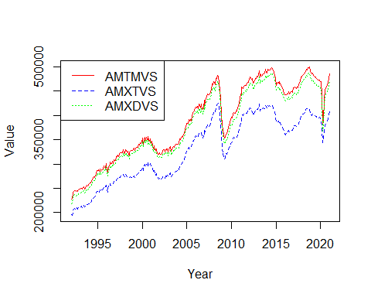

shipments_order <- order(colMeans(shipments_dataframe_time[sapply(shipments_dataframe_time, is.numeric)],na.rm = TRUE))  
shipments_mmv_ordered_mean <- shipments_mmv %>% select(all_of(shipments_order), ncol(shipments_mmv))  
shipments_mmv_ordered_mean_adj <- shipments_mmv_ordered_mean %>% select(starts_with('A')) #87 Columns  
shipments_mmv_ordered_mean_unadj <- shipments_mmv_ordered_mean %>% select(starts_with('U')) #87 Columns  
for (i in c(1,6,11,16,21,26,31,36,41,46,51,56,61,66,71,76,81))  
{  
 Series1 <- ts(data = shipments_mmv_ordered_mean_adj[,i], start=c(1992), end=c(2021), frequency = 12)  
 Series2 <- ts(data = shipments_mmv_ordered_mean_adj[,i+1], start=c(1992), end=c(2021), frequency = 12)  
 Series3 <- ts(data = shipments_mmv_ordered_mean_adj[,i+2], start=c(1992), end=c(2021), frequency = 12)  
 Series4 <- ts(data = shipments_mmv_ordered_mean_adj[,i+3], start=c(1992), end=c(2021), frequency = 12)  
 Series5 <- ts(data = shipments_mmv_ordered_mean_adj[,i+4], start=c(1992), end=c(2021), frequency = 12)  
 ts.plot(Series1, Series2, Series3, Series4, Series5, gpars=list(xlab="Year", ylab="Value",lty=c(1:5)), col=rep(c("red","purple","black","green","blue")))  
 legend("topleft", legend = c(colnames(shipments_mmv_ordered_mean_adj)[i],colnames(shipments_mmv_ordered_mean_adj)[i+1],colnames(shipments_mmv_ordered_mean_adj)[i+2],colnames(shipments_mmv_ordered_mean_adj)[i+3],colnames(shipments_mmv_ordered_mean_adj)[i+4]), col = c("red","purple","black","green","blue"), lty=c(1:4))  
}

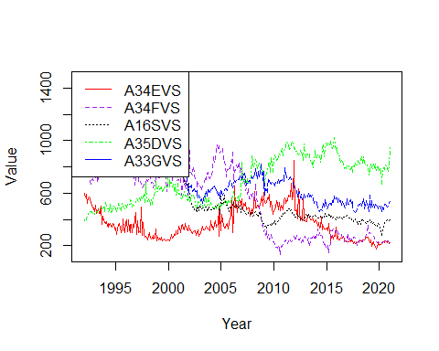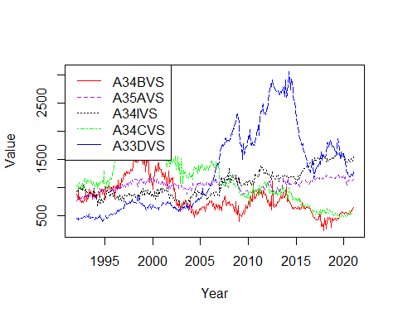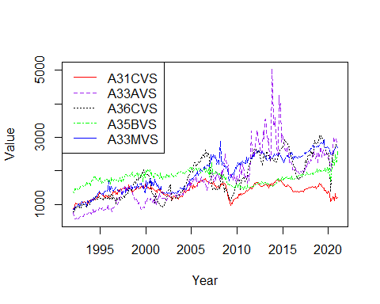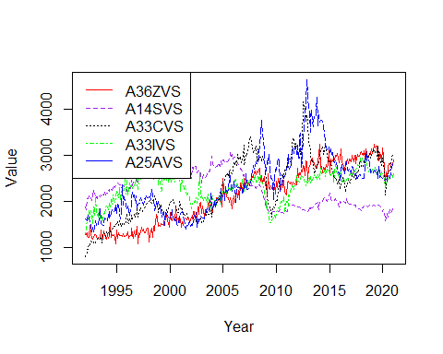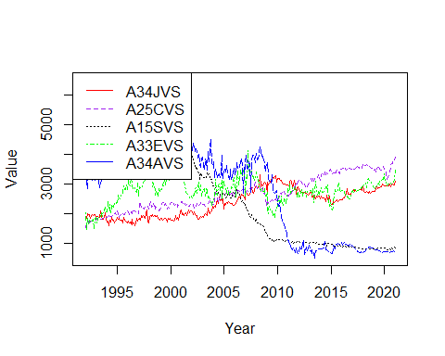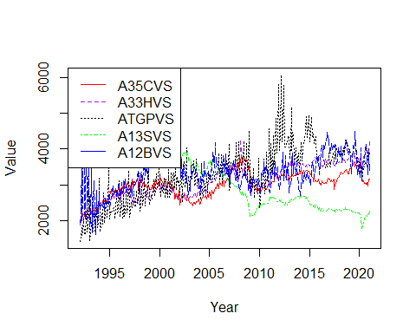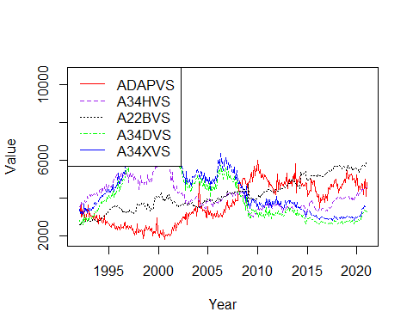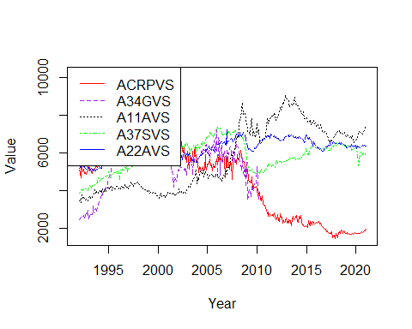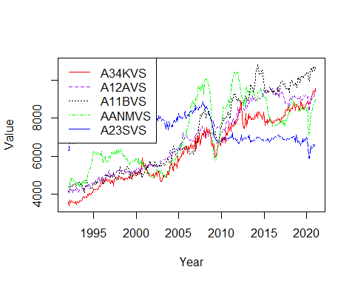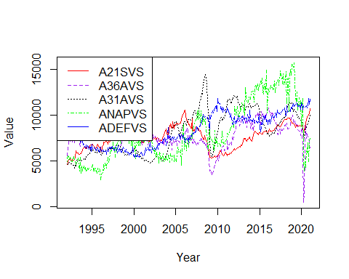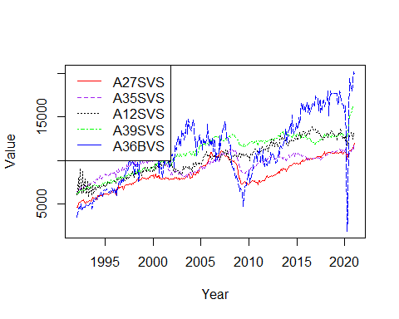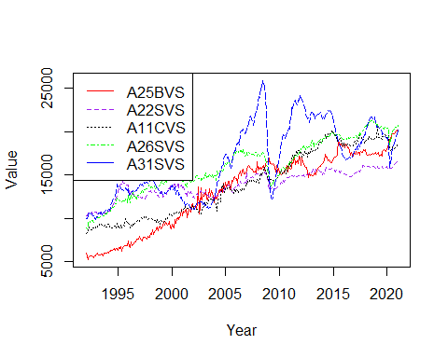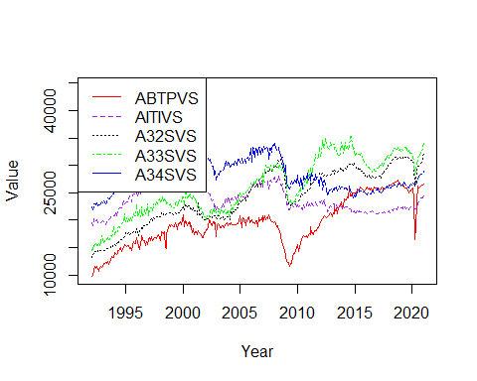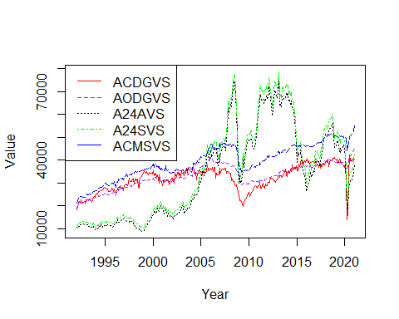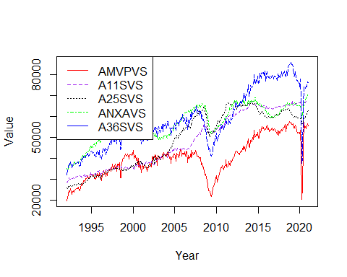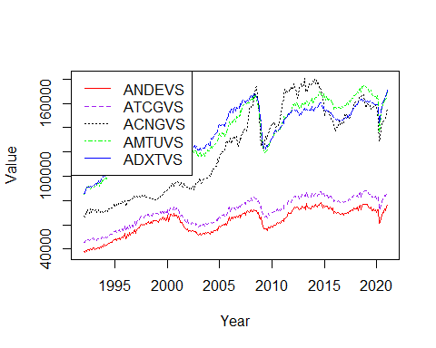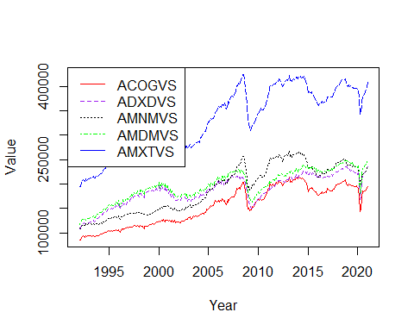

for (i in c(1,6,11,16,21,26,31,36,41,46,51,56,61,66,71,76,81))  
{  
 Series1 <- ts(data = shipments_mmv_ordered_mean_unadj[,i], start=c(1992), end=c(2021), frequency = 12)  
 Series2 <- ts(data = shipments_mmv_ordered_mean_unadj[,i+1], start=c(1992), end=c(2021), frequency = 12)  
 Series3 <- ts(data = shipments_mmv_ordered_mean_unadj[,i+2], start=c(1992), end=c(2021), frequency = 12)  
 Series4 <- ts(data = shipments_mmv_ordered_mean_unadj[,i+3], start=c(1992), end=c(2021), frequency = 12)  
 Series5 <- ts(data = shipments_mmv_ordered_mean_unadj[,i+4], start=c(1992), end=c(2021), frequency = 12)  
 ts.plot(Series1, Series2, Series3, Series4, Series5, gpars=list(xlab="Year", ylab="Value",lty=c(1:5)), col=rep(c("red","purple","black","green","blue")))  
 legend("topleft", legend = c(colnames(shipments_mmv_ordered_mean_unadj)[i],colnames(shipments_mmv_ordered_mean_unadj)[i+1],colnames(shipments_mmv_ordered_mean_unadj)[i+2],colnames(shipments_mmv_ordered_mean_unadj)[i+3],colnames(shipments_mmv_ordered_mean_unadj)[i+4]), col = c("red","purple","black","green","blue"), lty=c(1:4))  
}

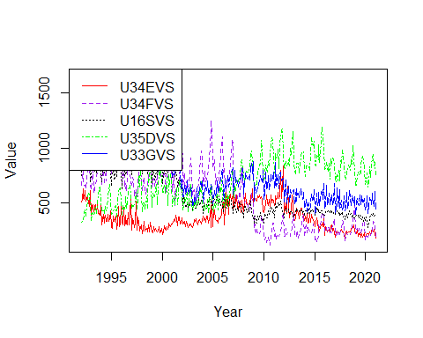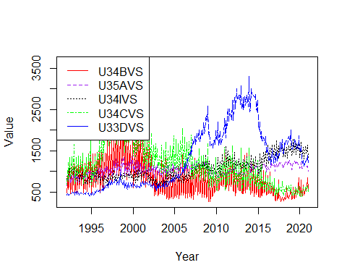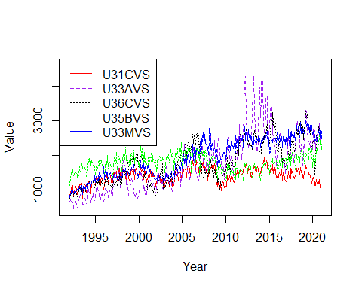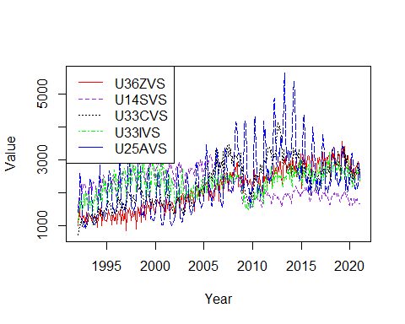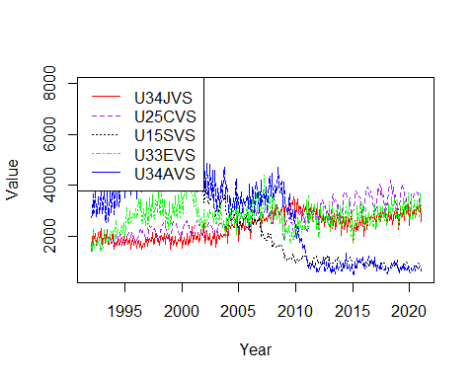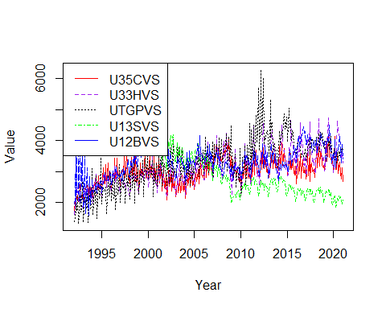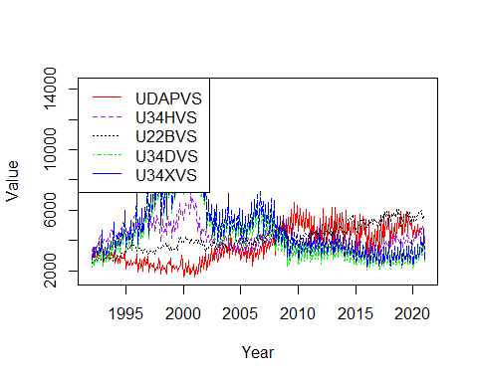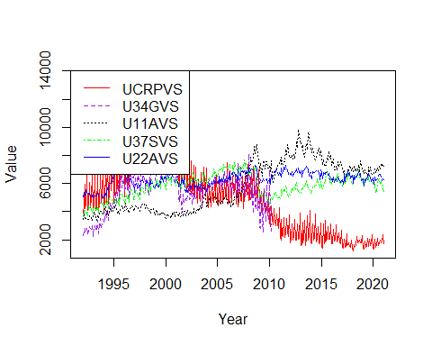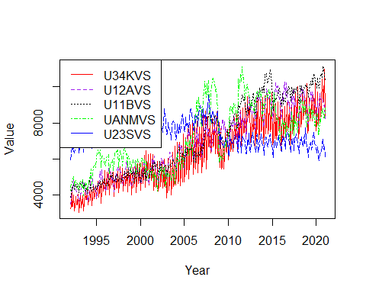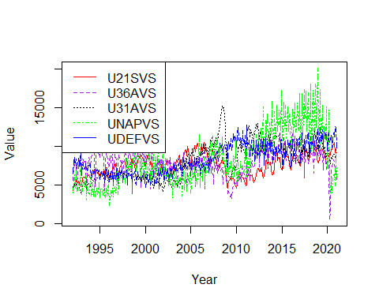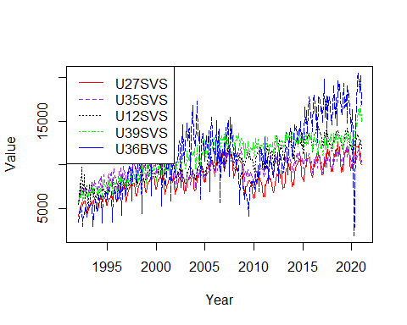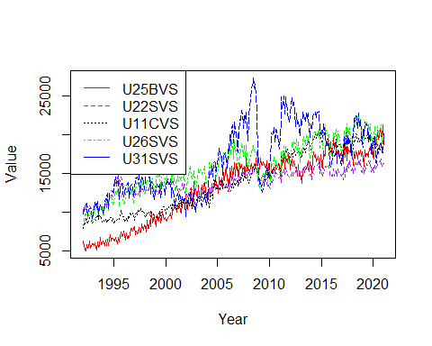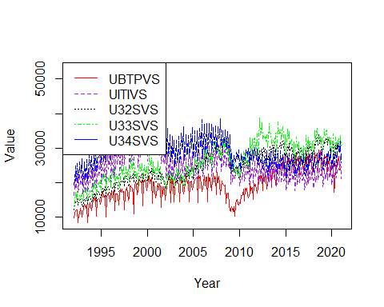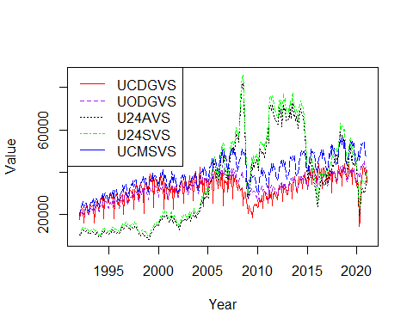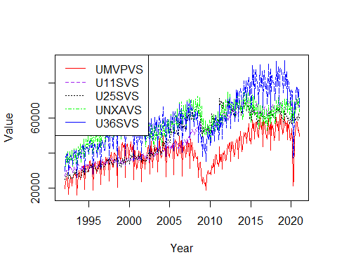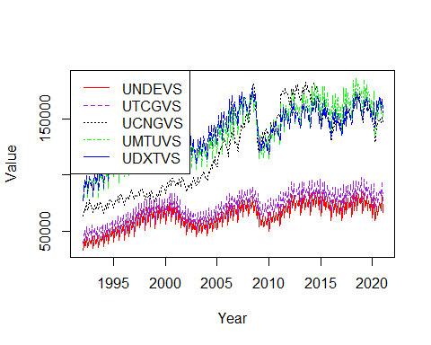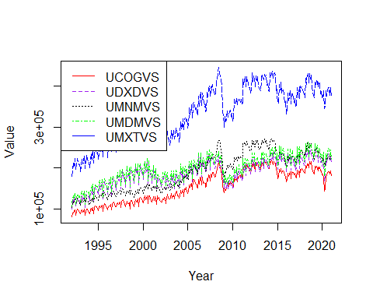

neworders_order <- order(colMeans(neworders_dataframe_time[sapply(neworders_dataframe_time, is.numeric)],na.rm = TRUE))  
neworders_mmv_ordered_mean <- neworders_mmv %>% select(all_of(neworders_order), ncol(neworders_mmv))  
neworders_mmv_ordered_mean_adj <- neworders_mmv_ordered_mean %>% select(starts_with('A')) #52 Columns  
neworders_mmv_ordered_mean_unadj <- neworders_mmv_ordered_mean %>% select(starts_with('U')) #52 Columns  
for (i in c(1,6,11,16,21,26,31,36,41,46))  
{  
 Series1 <- ts(data = neworders_mmv_ordered_mean_adj[,i], start=c(1992), end=c(2021), frequency = 12)  
 Series2 <- ts(data = neworders_mmv_ordered_mean_adj[,i+1], start=c(1992), end=c(2021), frequency = 12)  
 Series3 <- ts(data = neworders_mmv_ordered_mean_adj[,i+2], start=c(1992), end=c(2021), frequency = 12)  
 Series4 <- ts(data = neworders_mmv_ordered_mean_adj[,i+3], start=c(1992), end=c(2021), frequency = 12)  
 Series5 <- ts(data = neworders_mmv_ordered_mean_adj[,i+4], start=c(1992), end=c(2021), frequency = 12)  
 ts.plot(Series1, Series2, Series3, Series4, Series5, gpars=list(xlab="Year", ylab="Value",lty=c(1:5)), col=rep(c("red","purple","black","green","blue")))  
 legend("topleft", legend = c(colnames(neworders_mmv_ordered_mean_adj)[i],colnames(neworders_mmv_ordered_mean_adj)[i+1],colnames(neworders_mmv_ordered_mean_adj)[i+2],colnames(neworders_mmv_ordered_mean_adj)[i+3],colnames(neworders_mmv_ordered_mean_adj)[i+4]), col = c("red","purple","black","green","blue"), lty=c(1:4))  
}

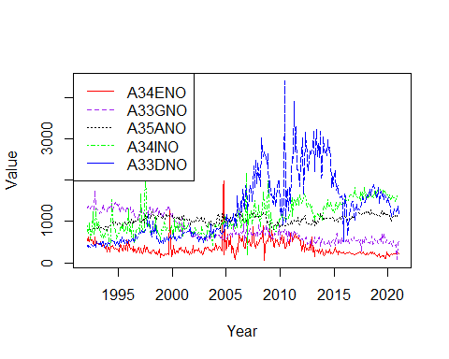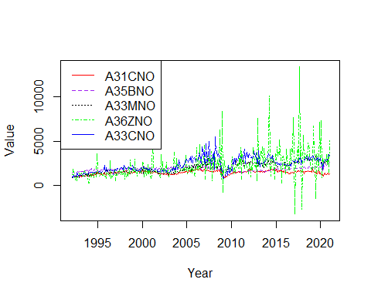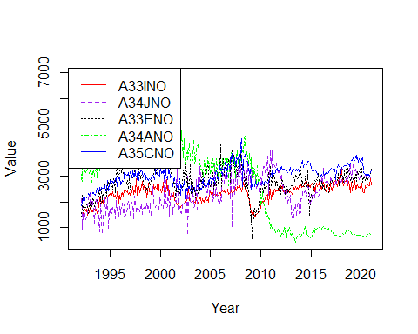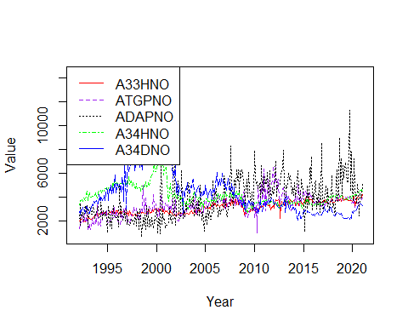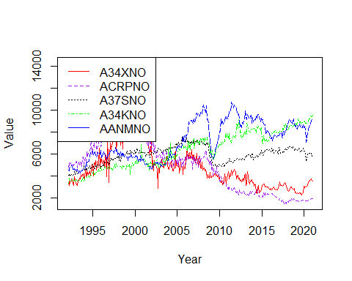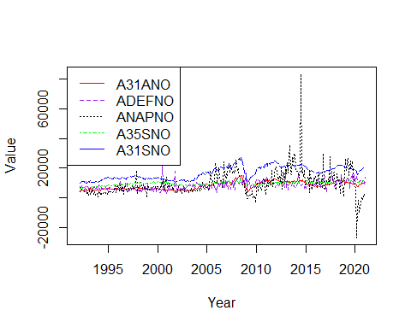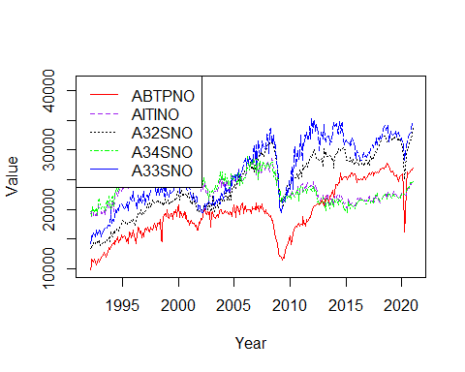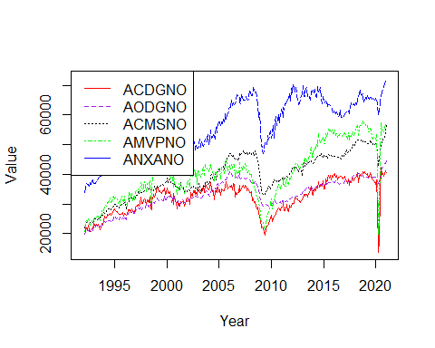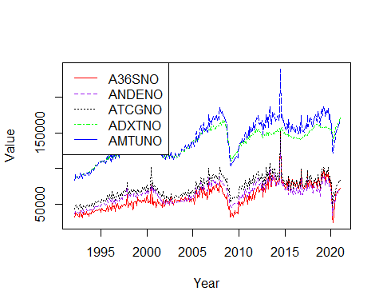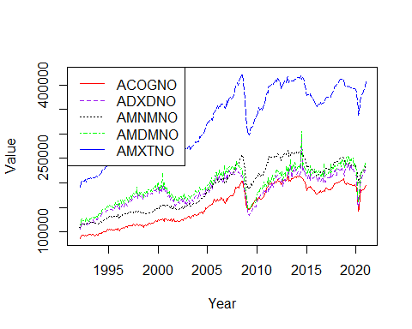

for (i in c(1,6,11,16,21,26,31,36,41,46))  
{  
 Series1 <- ts(data = neworders_mmv_ordered_mean_unadj[,i], start=c(1992), end=c(2021), frequency = 12)  
 Series2 <- ts(data = neworders_mmv_ordered_mean_unadj[,i+1], start=c(1992), end=c(2021), frequency = 12)  
 Series3 <- ts(data = neworders_mmv_ordered_mean_unadj[,i+2], start=c(1992), end=c(2021), frequency = 12)  
 Series4 <- ts(data = neworders_mmv_ordered_mean_unadj[,i+3], start=c(1992), end=c(2021), frequency = 12)  
 Series5 <- ts(data = neworders_mmv_ordered_mean_unadj[,i+4], start=c(1992), end=c(2021), frequency = 12)  
 ts.plot(Series1, Series2, Series3, Series4, Series5, gpars=list(xlab="Year", ylab="Value",lty=c(1:5)), col=rep(c("red","purple","black","green","blue")))  
 legend("topleft", legend = c(colnames(neworders_mmv_ordered_mean_unadj)[i],colnames(neworders_mmv_ordered_mean_unadj)[i+1],colnames(neworders_mmv_ordered_mean_unadj)[i+2],colnames(neworders_mmv_ordered_mean_unadj)[i+3],colnames(neworders_mmv_ordered_mean_unadj)[i+4]), col = c("red","purple","black","green","blue"), lty=c(1:4))  
}

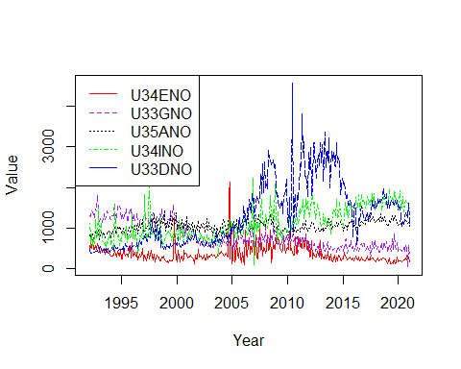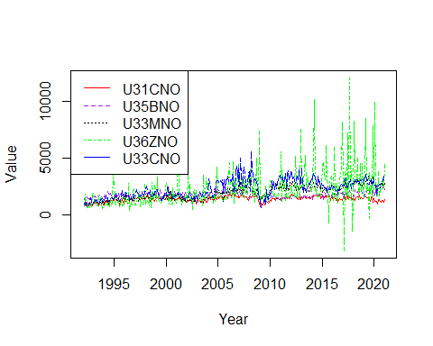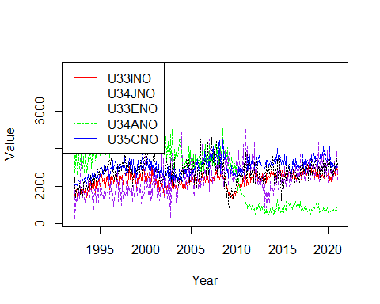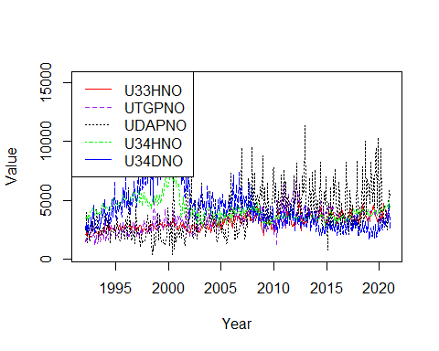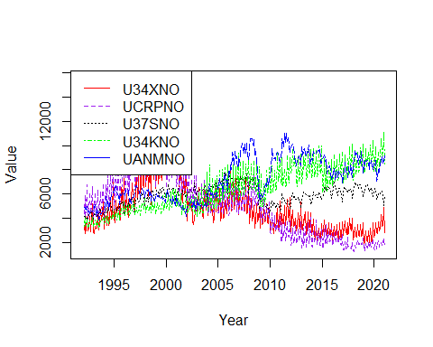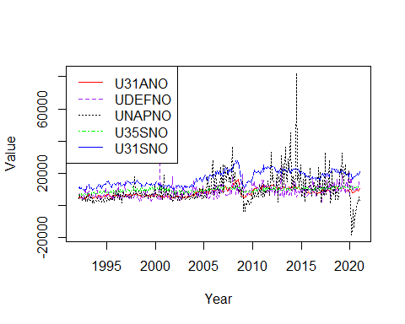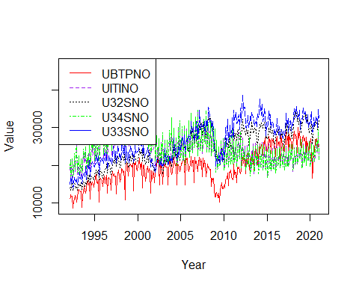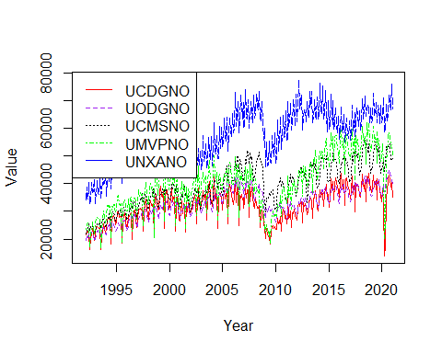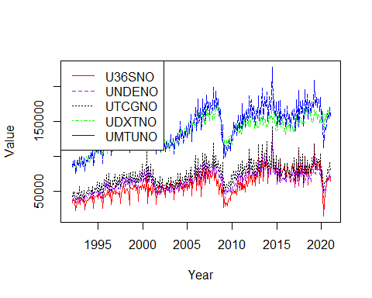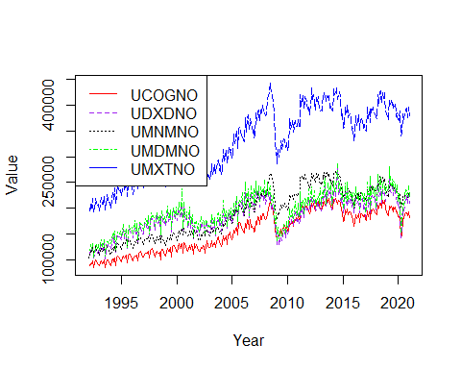

unfilledorders_order <- order(colMeans(unfilledorders_dataframe_time[sapply(unfilledorders_dataframe_time, is.numeric)],na.rm = TRUE))  
unfilledorders_mmv_ordered_mean <- unfillord_mmv %>% select(all_of(unfilledorders_order), ncol(unfillord_mmv))  
unfilledorders_mmv_ordered_mean_adj <- unfilledorders_mmv_ordered_mean %>% select(starts_with('A')) #50 Columns  
unfilledorders_mmv_ordered_mean_unadj <- unfilledorders_mmv_ordered_mean %>% select(starts_with('U')) #52 Columns  
for (i in c(1,6,11,16,21,26,31,36,41,46))  
{  
 Series1 <- ts(data = unfilledorders_mmv_ordered_mean_adj[,i], start=c(1992), end=c(2021), frequency = 12)  
 Series2 <- ts(data = unfilledorders_mmv_ordered_mean_adj[,i+1], start=c(1992), end=c(2021), frequency = 12)  
 Series3 <- ts(data = unfilledorders_mmv_ordered_mean_adj[,i+2], start=c(1992), end=c(2021), frequency = 12)  
 Series4 <- ts(data = unfilledorders_mmv_ordered_mean_adj[,i+3], start=c(1992), end=c(2021), frequency = 12)  
 Series5 <- ts(data = unfilledorders_mmv_ordered_mean_adj[,i+4], start=c(1992), end=c(2021), frequency = 12)  
 ts.plot(Series1, Series2, Series3, Series4, Series5, gpars=list(xlab="Year", ylab="Value",lty=c(1:5)), col=rep(c("red","purple","black","green","blue")))  
 legend("topleft", legend = c(colnames(unfilledorders_mmv_ordered_mean_adj)[i],colnames(unfilledorders_mmv_ordered_mean_adj)[i+1],colnames(unfilledorders_mmv_ordered_mean_adj)[i+2],colnames(unfilledorders_mmv_ordered_mean_adj)[i+3],colnames(unfilledorders_mmv_ordered_mean_adj)[i+4]), col = c("red","purple","black","green","blue"), lty=c(1:4))  
}

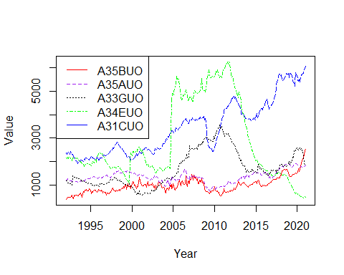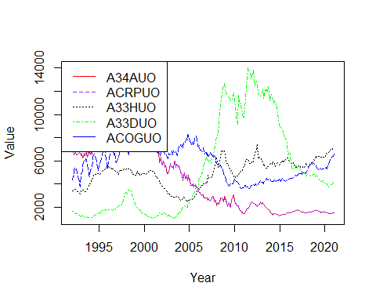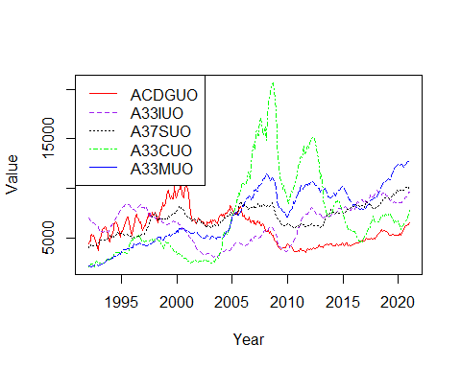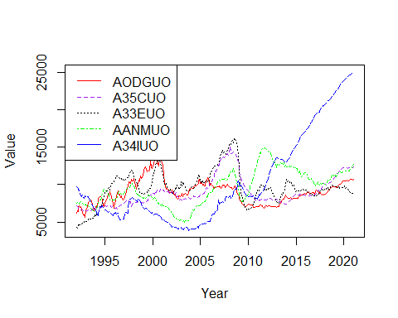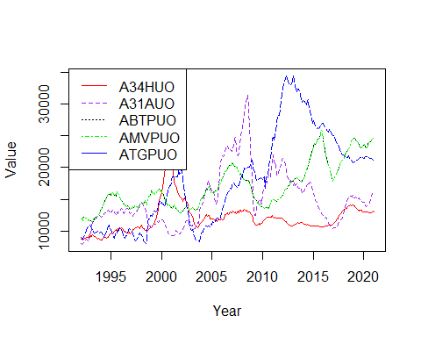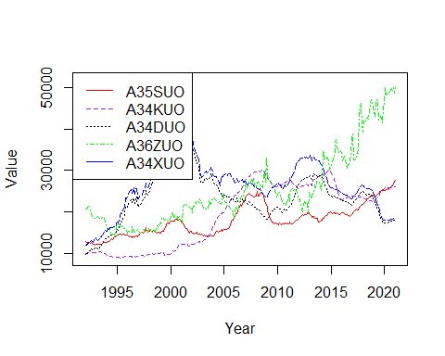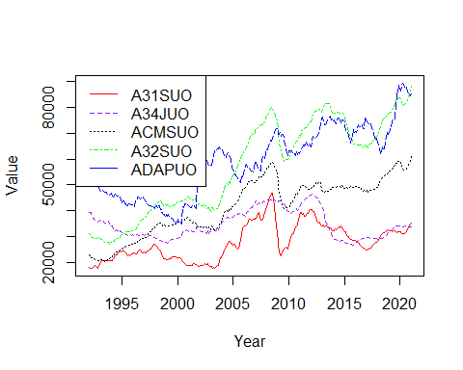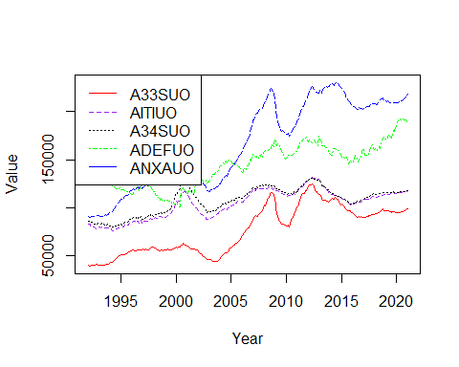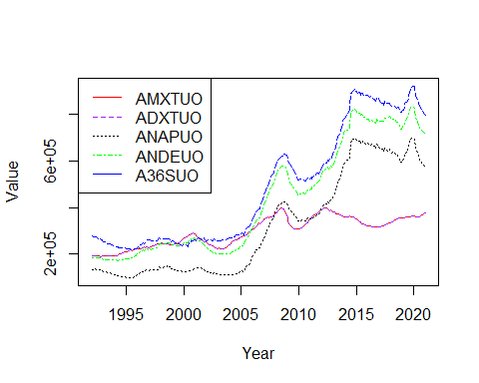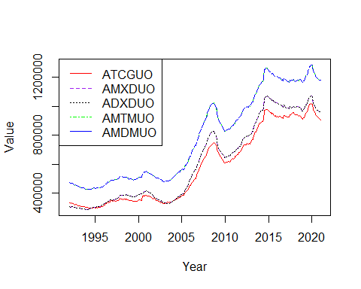

for (i in c(1,6,11,16,21,26,31,36,41,46))  
{  
 Series1 <- ts(data = unfilledorders_mmv_ordered_mean_unadj[,i], start=c(1992), end=c(2021), frequency = 12)  
 Series2 <- ts(data = unfilledorders_mmv_ordered_mean_unadj[,i+1], start=c(1992), end=c(2021), frequency = 12)  
 Series3 <- ts(data = unfilledorders_mmv_ordered_mean_unadj[,i+2], start=c(1992), end=c(2021), frequency = 12)  
 Series4 <- ts(data = unfilledorders_mmv_ordered_mean_unadj[,i+3], start=c(1992), end=c(2021), frequency = 12)  
 Series5 <- ts(data = unfilledorders_mmv_ordered_mean_unadj[,i+4], start=c(1992), end=c(2021), frequency = 12)  
 ts.plot(Series1, Series2, Series3, Series4, Series5, gpars=list(xlab="Year", ylab="Value",lty=c(1:5)), col=rep(c("red","purple","black","green","blue")))  
 legend("topleft", legend = c(colnames(unfilledorders_mmv_ordered_mean_unadj)[i],colnames(unfilledorders_mmv_ordered_mean_unadj)[i+1],colnames(unfilledorders_mmv_ordered_mean_unadj)[i+2],colnames(unfilledorders_mmv_ordered_mean_unadj)[i+3],colnames(unfilledorders_mmv_ordered_mean_unadj)[i+4]), col = c("red","purple","black","green","blue"), lty=c(1:4))  
}

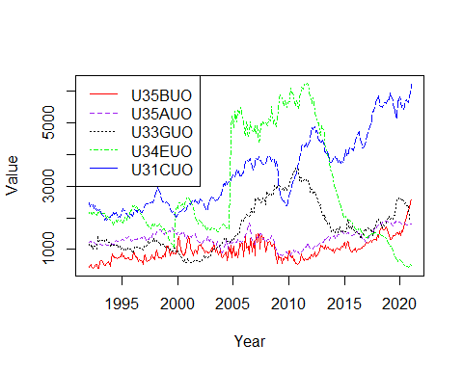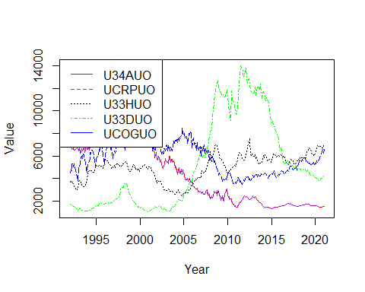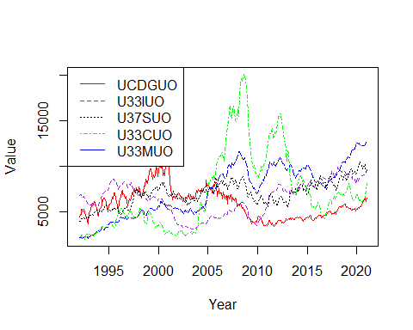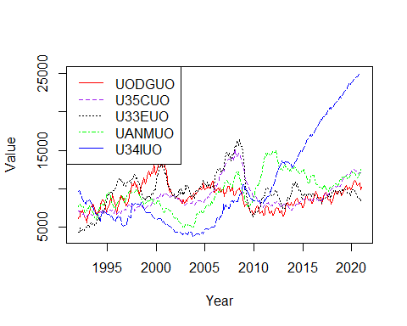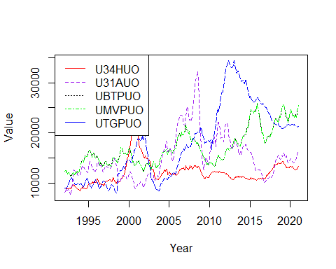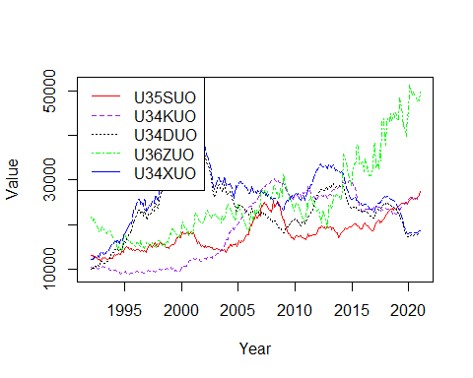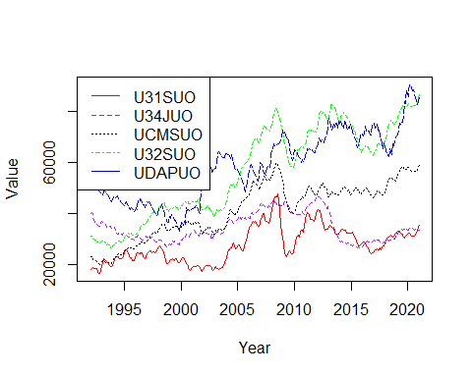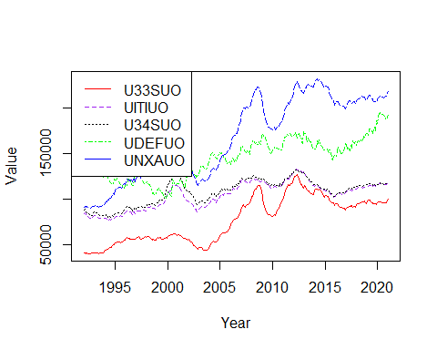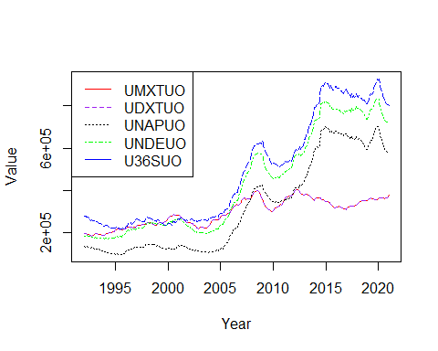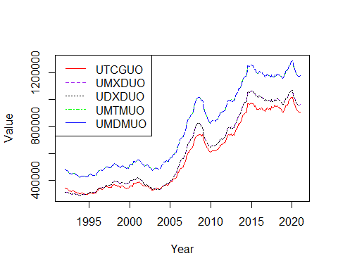

totalinv_order <- order(colMeans(totalinventories_dataframe_time[sapply(totalinventories_dataframe_time, is.numeric)],na.rm = TRUE))  
totalinv_mmv_ordered_mean <- totalinv_mmv %>% select(all_of(totalinv_order), ncol(totalinv_mmv))  
totalinv_mmv_ordered_mean_adj <- totalinv_mmv_ordered_mean %>% select(starts_with('A')) #158 Columns  
totalinv_mmv_ordered_mean_unadj <- totalinv_mmv_ordered_mean %>% select(starts_with('U')) #158 Columns  
for (i in c(1,6,11,16,21,26,31,36,41,46,51,56,61,66,71,76,81,86,91,96,101,106,111,116,121,126,131,136,141,146,151))  
{  
 Series1 <- ts(data = totalinv_mmv_ordered_mean_adj[,i], start=c(1992), end=c(2021), frequency = 12)  
 Series2 <- ts(data = totalinv_mmv_ordered_mean_adj[,i+1], start=c(1992), end=c(2021), frequency = 12)  
 Series3 <- ts(data = totalinv_mmv_ordered_mean_adj[,i+2], start=c(1992), end=c(2021), frequency = 12)  
 Series4 <- ts(data = totalinv_mmv_ordered_mean_adj[,i+3], start=c(1992), end=c(2021), frequency = 12)  
 Series5 <- ts(data = totalinv_mmv_ordered_mean_adj[,i+4], start=c(1992), end=c(2021), frequency = 12)  
 ts.plot(Series1, Series2, Series3, Series4, Series5, gpars=list(xlab="Year", ylab="Value",lty=c(1:5)), col=rep(c("red","purple","black","green","blue")))  
 legend("topleft", legend = c(colnames(totalinv_mmv_ordered_mean_adj)[i],colnames(totalinv_mmv_ordered_mean_adj)[i+1],colnames(totalinv_mmv_ordered_mean_adj)[i+2],colnames(totalinv_mmv_ordered_mean_adj)[i+3],colnames(totalinv_mmv_ordered_mean_adj)[i+4]), col = c("red","purple","black","green","blue"), lty=c(1:4))  
}

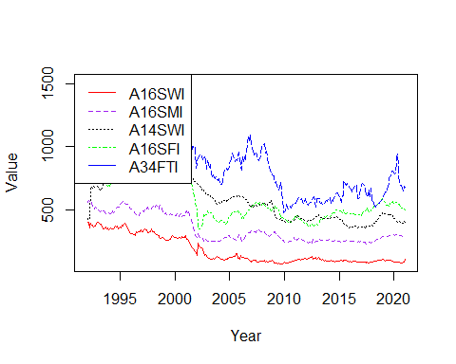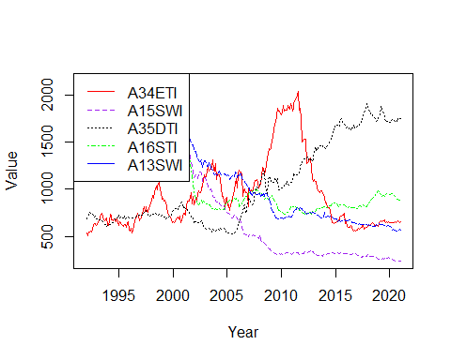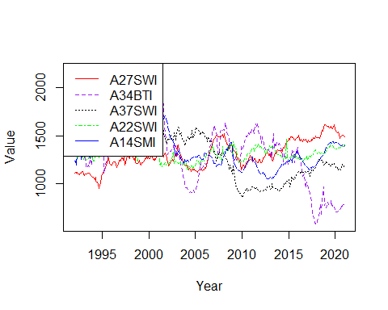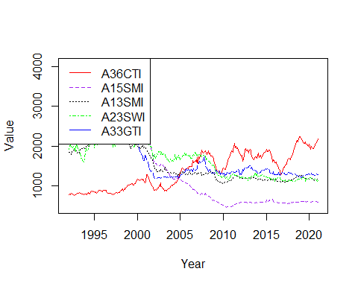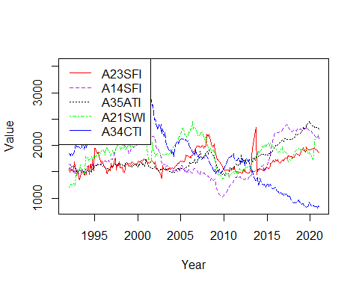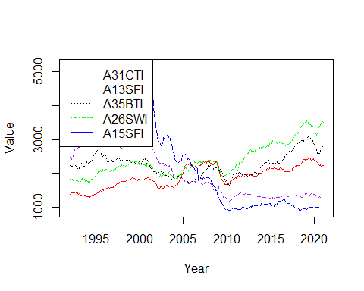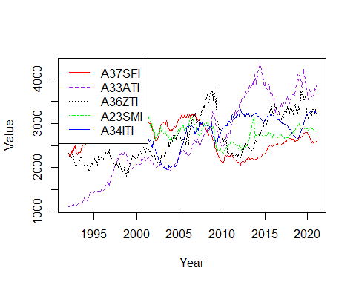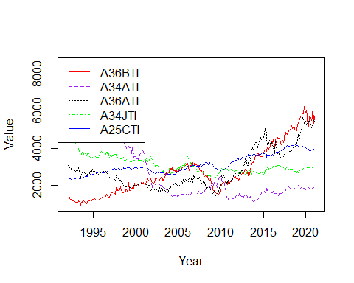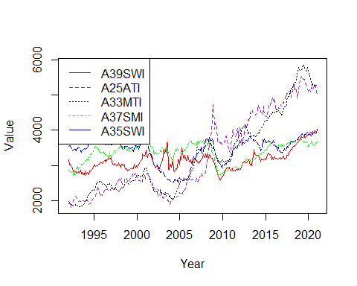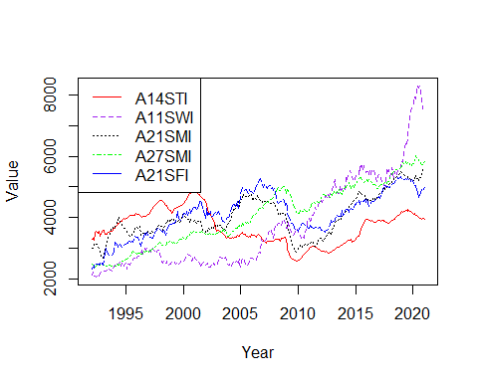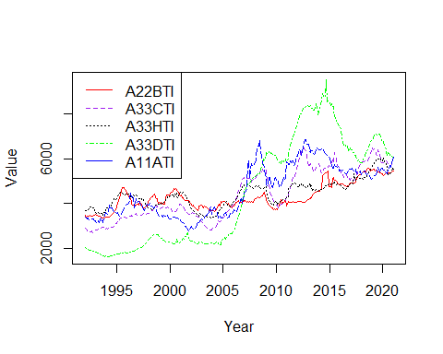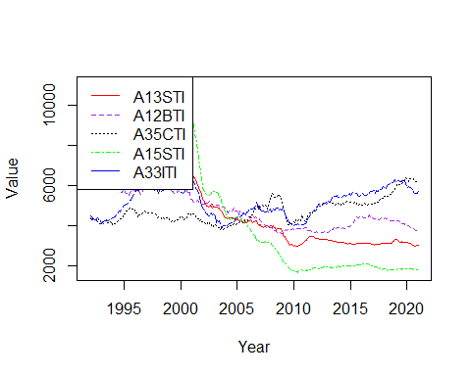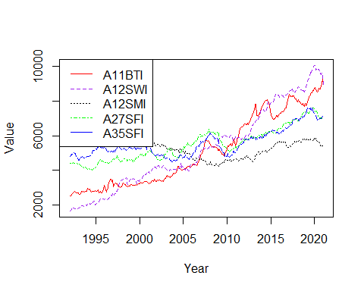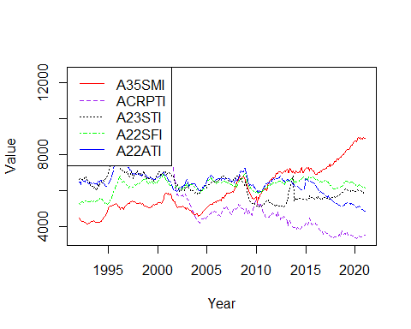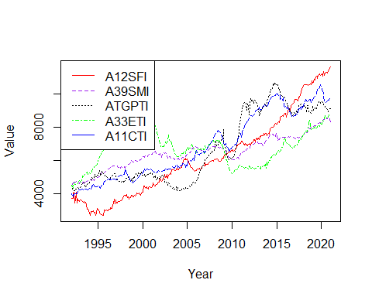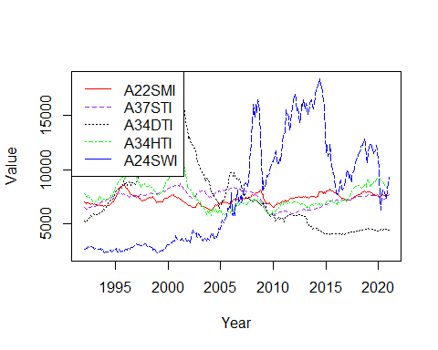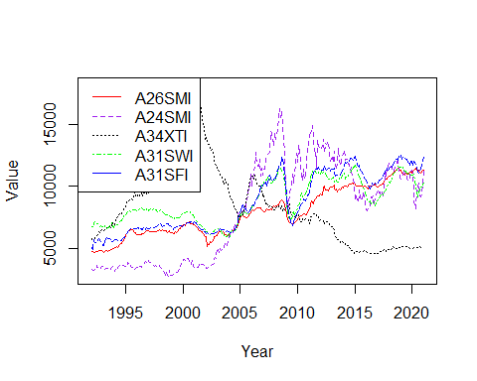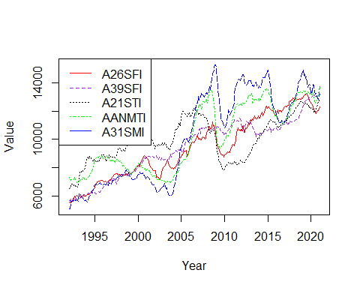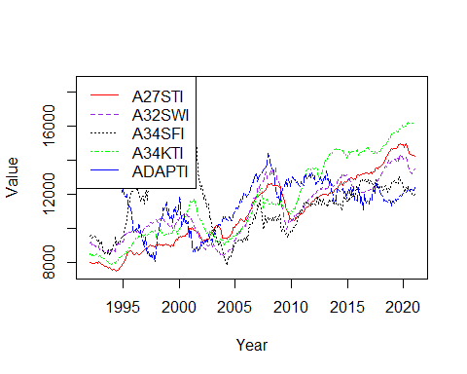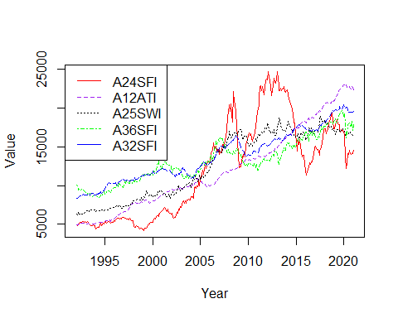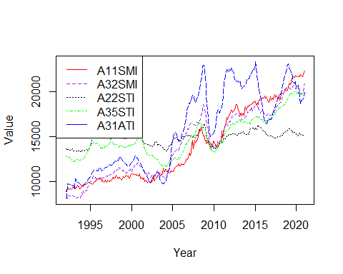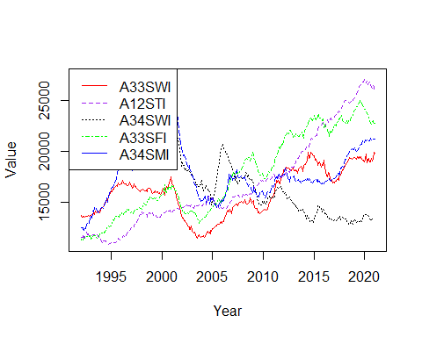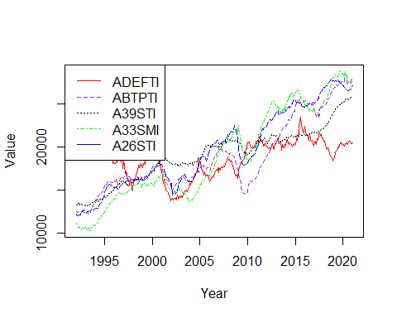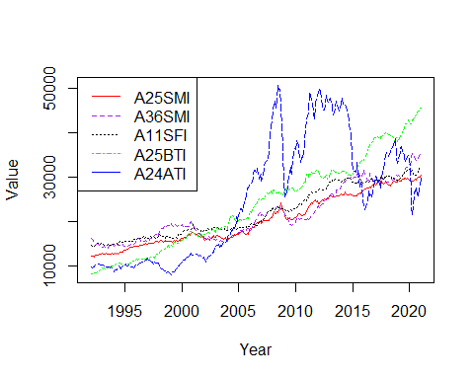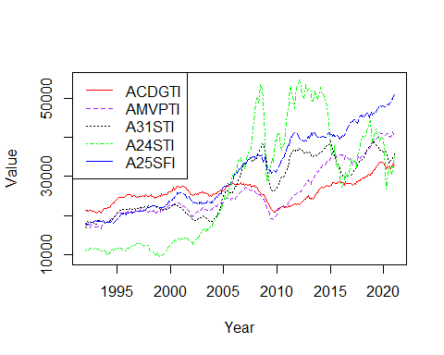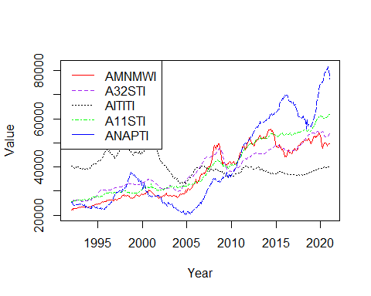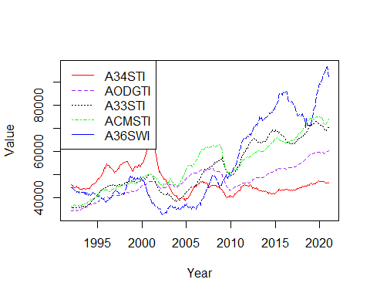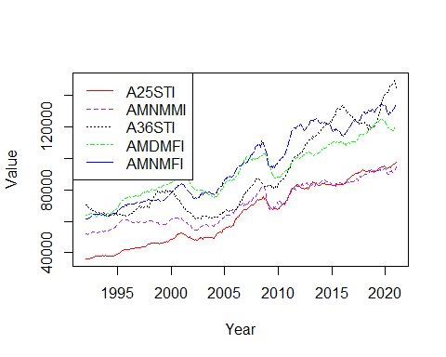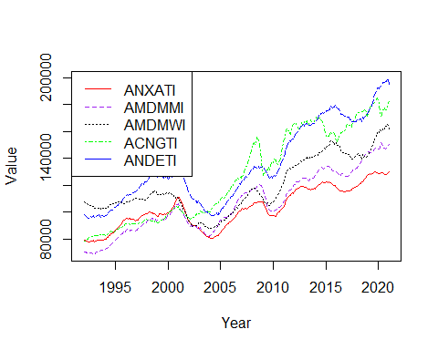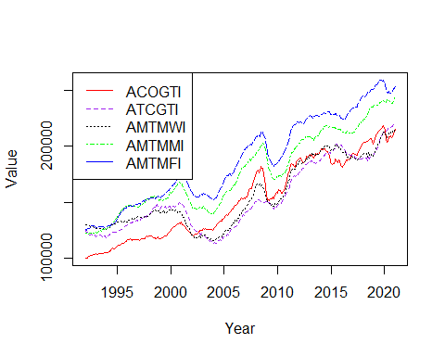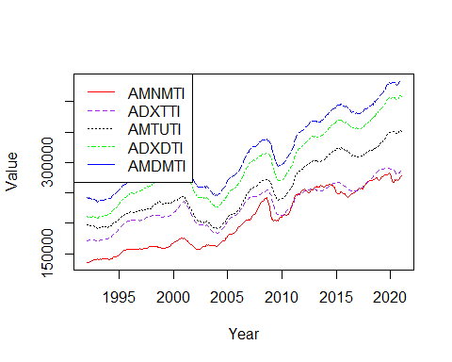

for (i in c(1,6,11,16,21,26,31,36,41,46,51,56,61,66,71,76,81,86,91,96,101,106,111,116,121,126,131,136,141,146,151))  
{  
 Series1 <- ts(data = totalinv_mmv_ordered_mean_unadj[,i], start=c(1992), end=c(2021), frequency = 12)  
 Series2 <- ts(data = totalinv_mmv_ordered_mean_unadj[,i+1], start=c(1992), end=c(2021), frequency = 12)  
 Series3 <- ts(data = totalinv_mmv_ordered_mean_unadj[,i+2], start=c(1992), end=c(2021), frequency = 12)  
 Series4 <- ts(data = totalinv_mmv_ordered_mean_unadj[,i+3], start=c(1992), end=c(2021), frequency = 12)  
 Series5 <- ts(data = totalinv_mmv_ordered_mean_unadj[,i+4], start=c(1992), end=c(2021), frequency = 12)  
 ts.plot(Series1, Series2, Series3, Series4, Series5, gpars=list(xlab="Year", ylab="Value",lty=c(1:5)), col=rep(c("red","purple","black","green","blue")))  
 legend("topleft", legend = c(colnames(totalinv_mmv_ordered_mean_unadj)[i],colnames(totalinv_mmv_ordered_mean_unadj)[i+1],colnames(totalinv_mmv_ordered_mean_unadj)[i+2],colnames(totalinv_mmv_ordered_mean_unadj)[i+3],colnames(totalinv_mmv_ordered_mean_unadj)[i+4]), col = c("red","purple","black","green","blue"), lty=c(1:4))  
}

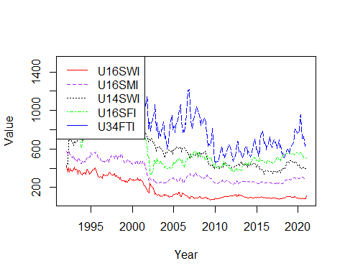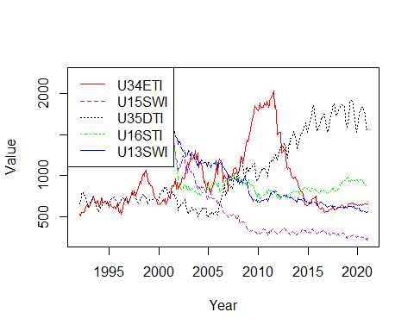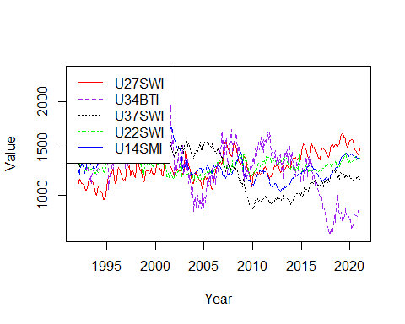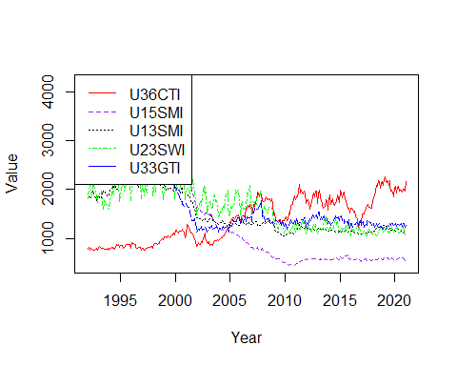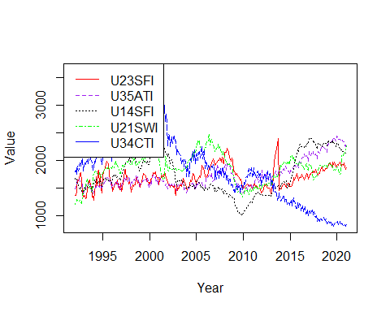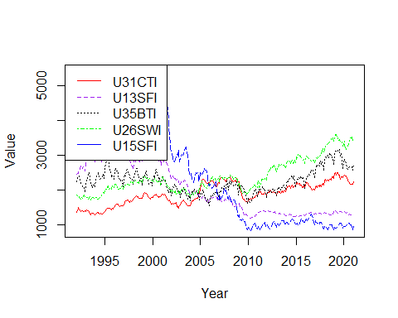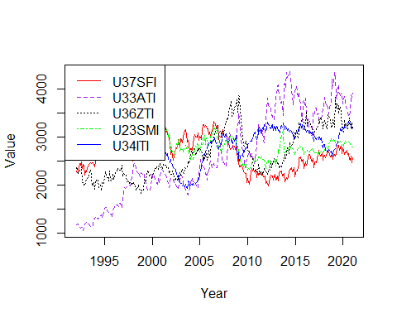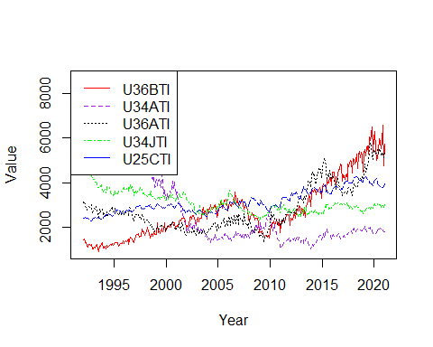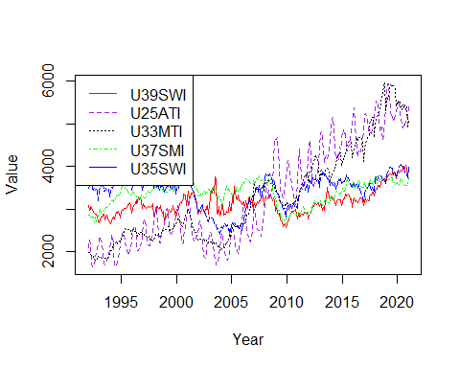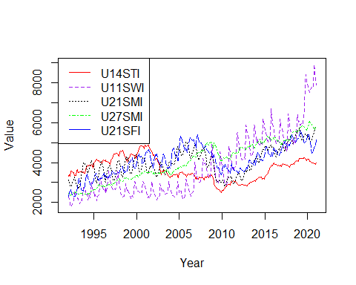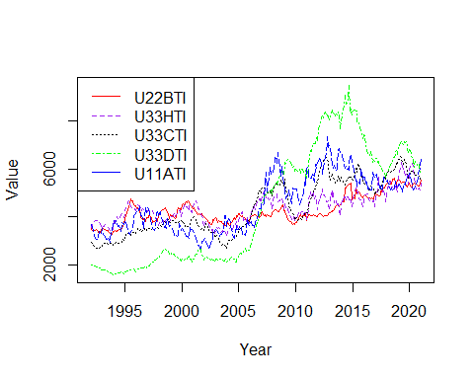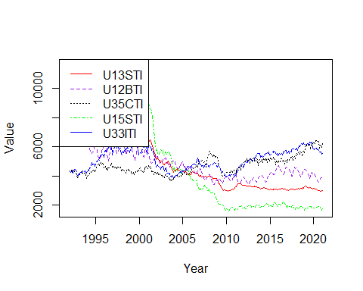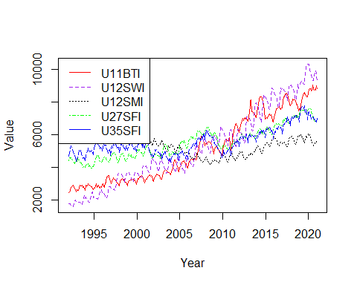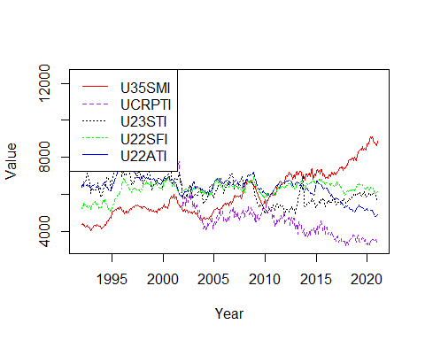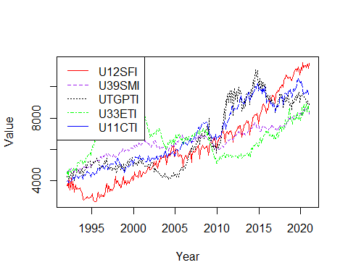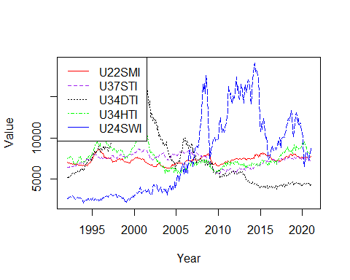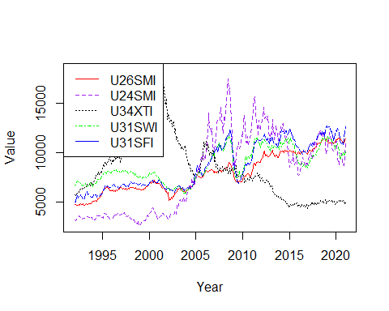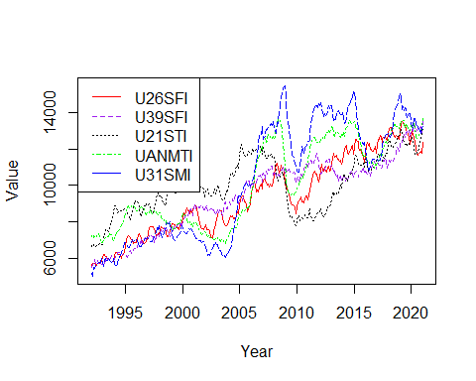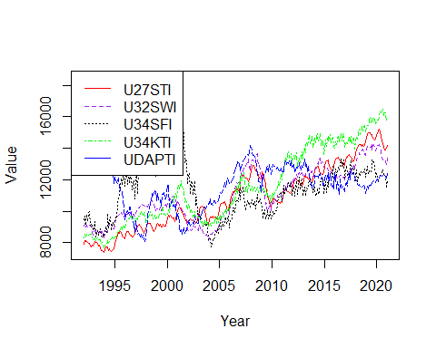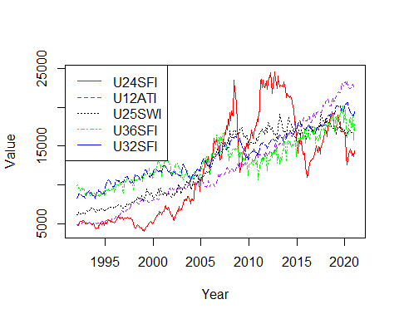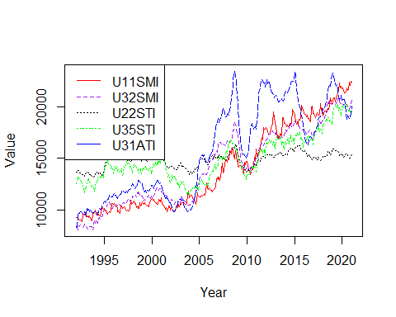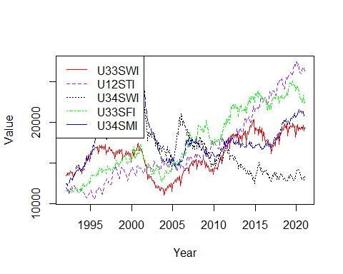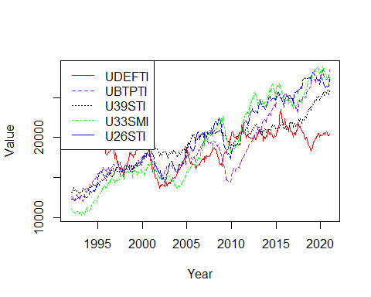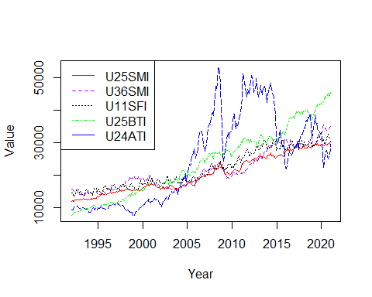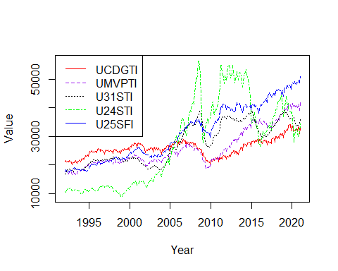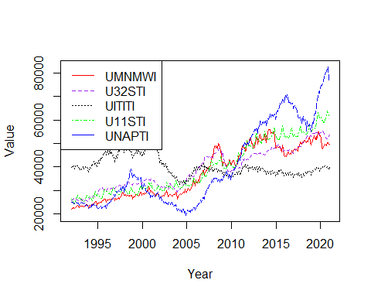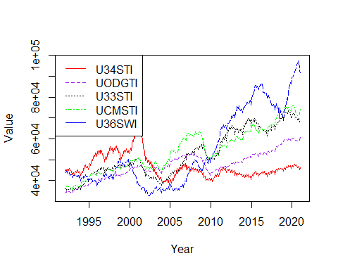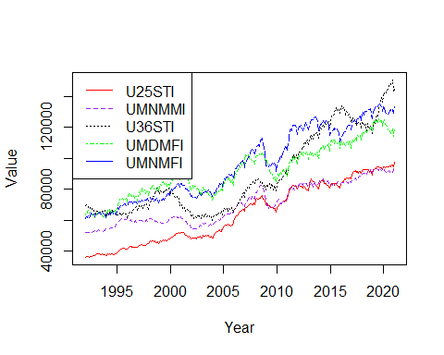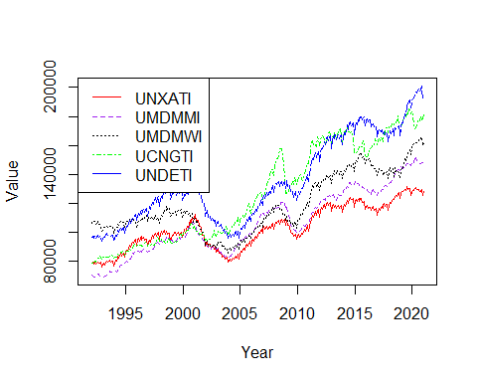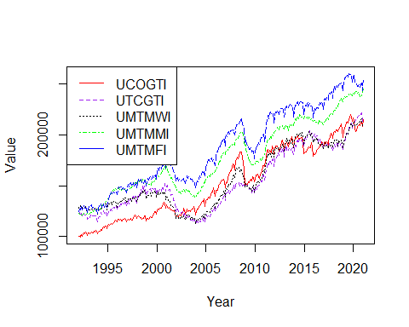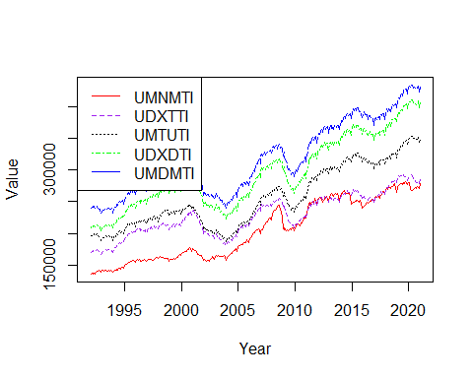

invtoship_order <- order(colMeans(inventoriestoshipments_dataframe_time[sapply(inventoriestoshipments_dataframe_time, is.numeric)],na.rm = TRUE))  
invtoship_mmv_ordered_mean <- invtoship_mmv %>% select(all_of(invtoship_order), ncol(invtoship_mmv))  
invtoship_mmv_ordered_mean_adj <- invtoship_mmv_ordered_mean %>% select(starts_with('A')) #24 Columns  
invtoship_mmv_ordered_mean_unadj <- invtoship_mmv_ordered_mean %>% select(starts_with('U')) #24 Columns  
for (i in c(1,6,11,16))  
{  
 Series1 <- ts(data = invtoship_mmv_ordered_mean_adj[,i], start=c(1992), end=c(2021), frequency = 12)  
 Series2 <- ts(data = invtoship_mmv_ordered_mean_adj[,i+1], start=c(1992), end=c(2021), frequency = 12)  
 Series3 <- ts(data = invtoship_mmv_ordered_mean_adj[,i+2], start=c(1992), end=c(2021), frequency = 12)  
 Series4 <- ts(data = invtoship_mmv_ordered_mean_adj[,i+3], start=c(1992), end=c(2021), frequency = 12)  
 Series5 <- ts(data = invtoship_mmv_ordered_mean_adj[,i+4], start=c(1992), end=c(2021), frequency = 12)  
 ts.plot(Series1, Series2, Series3, Series4, Series5, gpars=list(xlab="Year", ylab="Value",lty=c(1:5)), col=rep(c("red","purple","black","green","blue")))  
 legend("topleft", legend = c(colnames(invtoship_mmv_ordered_mean_adj)[i],colnames(invtoship_mmv_ordered_mean_adj)[i+1],colnames(invtoship_mmv_ordered_mean_adj)[i+2],colnames(invtoship_mmv_ordered_mean_adj)[i+3],colnames(invtoship_mmv_ordered_mean_adj)[i+4]), col = c("red","purple","black","green","blue"), lty=c(1:4))  
}

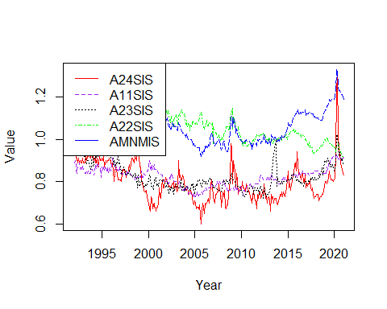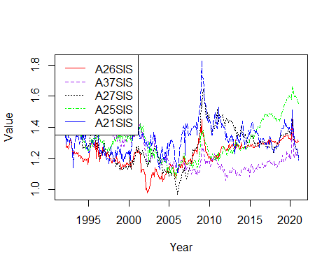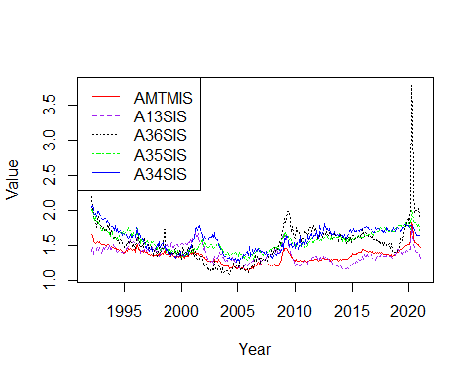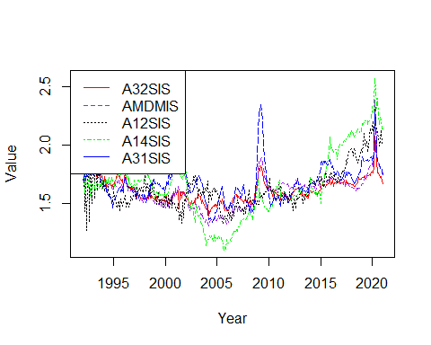

for (i in c(1,6,11,16))  
{  
 Series1 <- ts(data = invtoship_mmv_ordered_mean_unadj[,i], start=c(1992), end=c(2021), frequency = 12)  
 Series2 <- ts(data = invtoship_mmv_ordered_mean_unadj[,i+1], start=c(1992), end=c(2021), frequency = 12)  
 Series3 <- ts(data = invtoship_mmv_ordered_mean_unadj[,i+2], start=c(1992), end=c(2021), frequency = 12)  
 Series4 <- ts(data = invtoship_mmv_ordered_mean_unadj[,i+3], start=c(1992), end=c(2021), frequency = 12)  
 Series5 <- ts(data = invtoship_mmv_ordered_mean_unadj[,i+4], start=c(1992), end=c(2021), frequency = 12)  
 ts.plot(Series1, Series2, Series3, Series4, Series5, gpars=list(xlab="Year", ylab="Value",lty=c(1:5)), col=rep(c("red","purple","black","green","blue")))  
 legend("topleft", legend = c(colnames(invtoship_mmv_ordered_mean_unadj)[i],colnames(invtoship_mmv_ordered_mean_unadj)[i+1],colnames(invtoship_mmv_ordered_mean_unadj)[i+2],colnames(invtoship_mmv_ordered_mean_unadj)[i+3],colnames(invtoship_mmv_ordered_mean_unadj)[i+4]), col = c("red","purple","black","green","blue"), lty=c(1:4))  
}

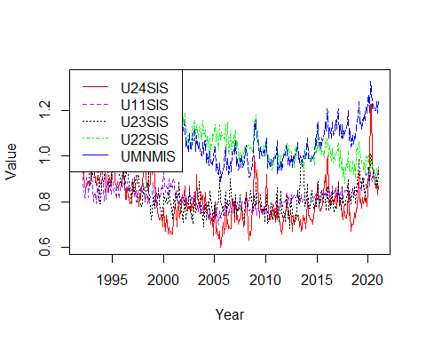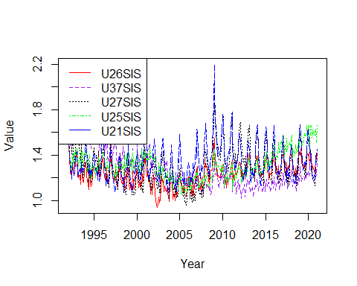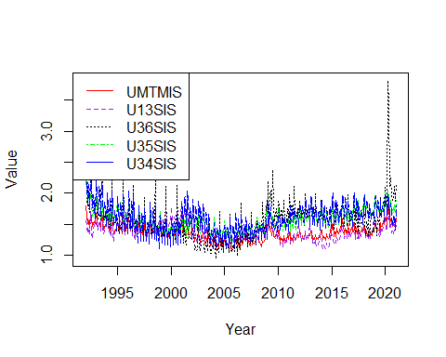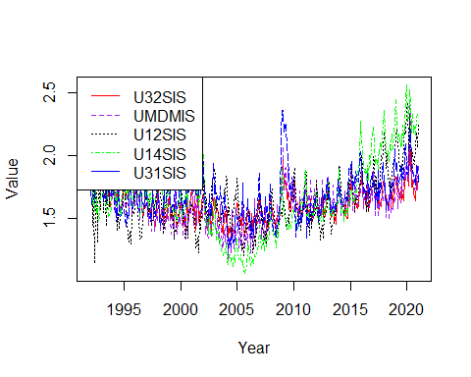

unfilltoship_order <- order(colMeans(unfilledorderstoshipments_dataframe_time[sapply(unfilledorderstoshipments_dataframe_time, is.numeric)],na.rm = TRUE))  
unfilltoship_mmv_ordered_mean <- unfilltoship_mmv %>% select(all_of(unfilltoship_order), ncol(unfilltoship_mmv))  
unfilltoship_mmv_ordered_mean_adj <- unfilltoship_mmv_ordered_mean %>% select(starts_with('A')) #9 Columns  
unfilltoship_mmv_ordered_mean_unadj <- unfilltoship_mmv_ordered_mean %>% select(starts_with('U')) #9 Columns  
for (i in c(1))  
{  
 Series1 <- ts(data = unfilltoship_mmv_ordered_mean_adj[,i], start=c(1992), end=c(2021), frequency = 12)  
 Series2 <- ts(data = unfilltoship_mmv_ordered_mean_adj[,i+1], start=c(1992), end=c(2021), frequency = 12)  
 Series3 <- ts(data = unfilltoship_mmv_ordered_mean_adj[,i+2], start=c(1992), end=c(2021), frequency = 12)  
 Series4 <- ts(data = unfilltoship_mmv_ordered_mean_adj[,i+3], start=c(1992), end=c(2021), frequency = 12)  
 Series5 <- ts(data = unfilltoship_mmv_ordered_mean_adj[,i+4], start=c(1992), end=c(2021), frequency = 12)  
 ts.plot(Series1, Series2, Series3, Series4, Series5, gpars=list(xlab="Year", ylab="Value",lty=c(1:5)), col=rep(c("red","purple","black","green","blue")))  
 legend("topleft", legend = c(colnames(unfilltoship_mmv_ordered_mean_adj)[i],colnames(unfilltoship_mmv_ordered_mean_adj)[i+1],colnames(unfilltoship_mmv_ordered_mean_adj)[i+2],colnames(unfilltoship_mmv_ordered_mean_adj)[i+3],colnames(unfilltoship_mmv_ordered_mean_adj)[i+4]), col = c("red","purple","black","green","blue"), lty=c(1:4))  
}

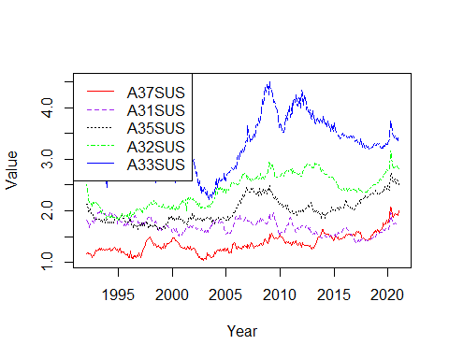

for (i in c(1))  
{  
 Series1 <- ts(data = unfilltoship_mmv_ordered_mean_unadj[,i], start=c(1992), end=c(2021), frequency = 12)  
 Series2 <- ts(data = unfilltoship_mmv_ordered_mean_unadj[,i+1], start=c(1992), end=c(2021), frequency = 12)  
 Series3 <- ts(data = unfilltoship_mmv_ordered_mean_unadj[,i+2], start=c(1992), end=c(2021), frequency = 12)  
 Series4 <- ts(data = unfilltoship_mmv_ordered_mean_unadj[,i+3], start=c(1992), end=c(2021), frequency = 12)  
 Series5 <- ts(data = unfilltoship_mmv_ordered_mean_unadj[,i+4], start=c(1992), end=c(2021), frequency = 12)  
 ts.plot(Series1, Series2, Series3, Series4, Series5, gpars=list(xlab="Year", ylab="Value",lty=c(1:5)), col=rep(c("red","purple","black","green","blue")))  
 legend("topleft", legend = c(colnames(unfilltoship_mmv_ordered_mean_unadj)[i],colnames(unfilltoship_mmv_ordered_mean_unadj)[i+1],colnames(unfilltoship_mmv_ordered_mean_unadj)[i+2],colnames(unfilltoship_mmv_ordered_mean_unadj)[i+3],colnames(unfilltoship_mmv_ordered_mean_unadj)[i+4]), col = c("red","purple","black","green","blue"), lty=c(1:4))  
}

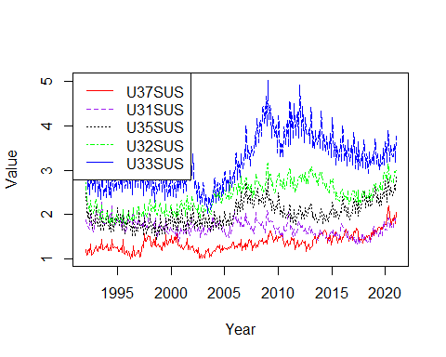

shipments_order_med <- order(colMedians(as.matrix(shipments_dataframe_time[sapply(shipments_dataframe_time, is.numeric)]),na.rm = TRUE))  
shipments_mmv_ordered_median <- shipments_mmv %>% select(all_of(shipments_order_med), ncol(shipments_mmv))  
shipments_mmv_ordered_median_adj <- shipments_mmv_ordered_median %>% select(starts_with('A')) #87 Columns  
shipments_mmv_ordered_median_unadj <- shipments_mmv_ordered_median %>% select(starts_with('U')) #87 Columns  
for (i in c(1,6,11,16,21,26,31,36,41,46,51,56,61,66,71,76,81))  
{  
 Series1 <- ts(data = shipments_mmv_ordered_median_adj[,i], start=c(1992), end=c(2021), frequency = 12)  
 Series2 <- ts(data = shipments_mmv_ordered_median_adj[,i+1], start=c(1992), end=c(2021), frequency = 12)  
 Series3 <- ts(data = shipments_mmv_ordered_median_adj[,i+2], start=c(1992), end=c(2021), frequency = 12)  
 Series4 <- ts(data = shipments_mmv_ordered_median_adj[,i+3], start=c(1992), end=c(2021), frequency = 12)  
 Series5 <- ts(data = shipments_mmv_ordered_median_adj[,i+4], start=c(1992), end=c(2021), frequency = 12)  
 ts.plot(Series1, Series2, Series3, Series4, Series5, gpars=list(xlab="Year", ylab="Value",lty=c(1:5)), col=rep(c("red","purple","black","green","blue")))  
 legend("topleft", legend = c(colnames(shipments_mmv_ordered_median_adj)[i],colnames(shipments_mmv_ordered_median_adj)[i+1],colnames(shipments_mmv_ordered_median_adj)[i+2],colnames(shipments_mmv_ordered_median_adj)[i+3],colnames(shipments_mmv_ordered_median_adj)[i+4]), col = c("red","purple","black","green","blue"), lty=c(1:4))  
}

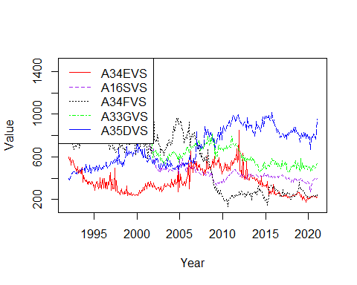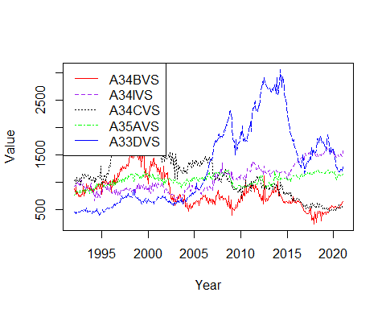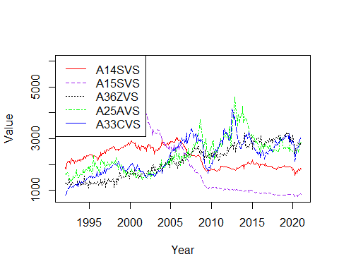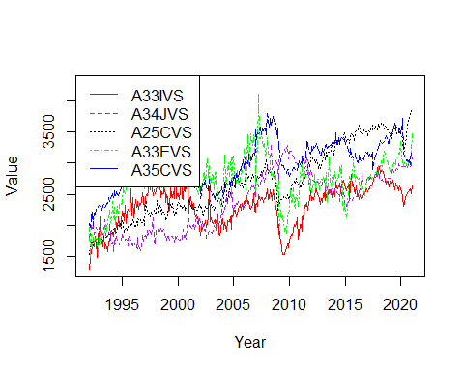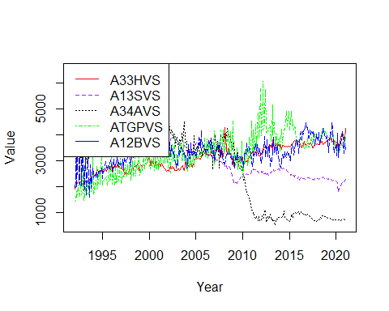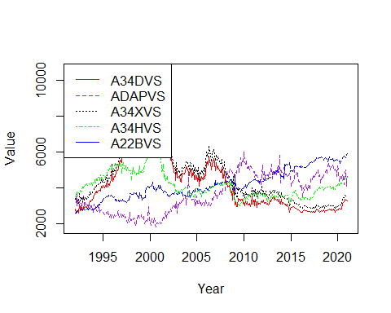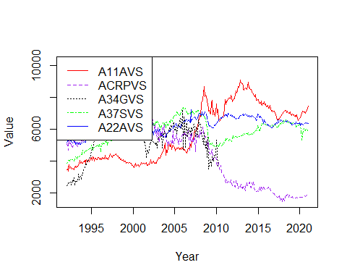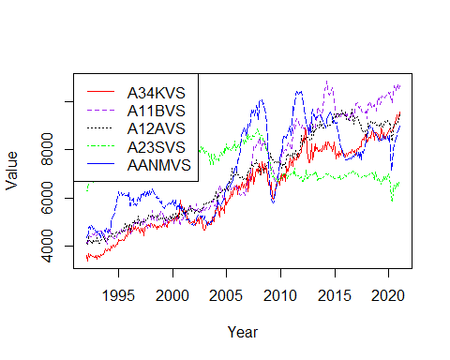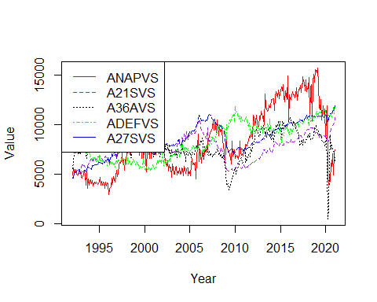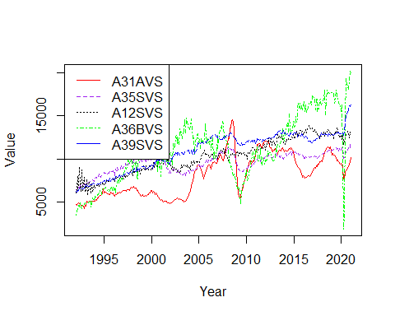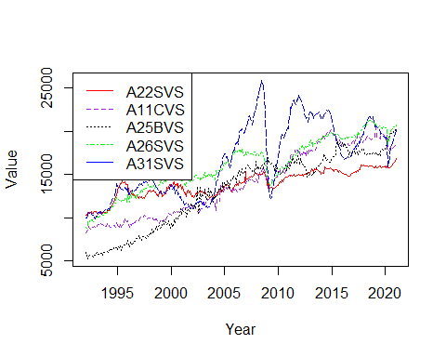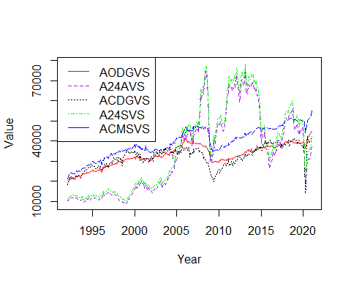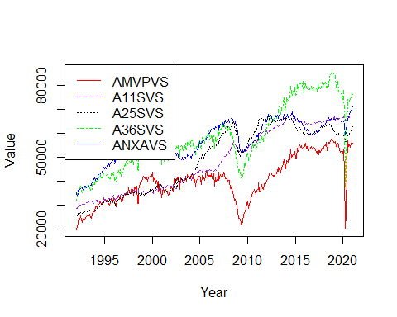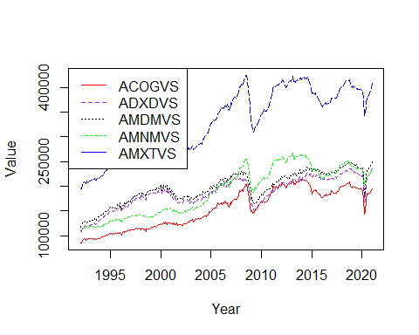

for (i in c(1,6,11,16,21,26,31,36,41,46,51,56,61,66,71,76,81))  
{  
 Series1 <- ts(data = shipments_mmv_ordered_median_unadj[,i], start=c(1992), end=c(2021), frequency = 12)  
 Series2 <- ts(data = shipments_mmv_ordered_median_unadj[,i+1], start=c(1992), end=c(2021), frequency = 12)  
 Series3 <- ts(data = shipments_mmv_ordered_median_unadj[,i+2], start=c(1992), end=c(2021), frequency = 12)  
 Series4 <- ts(data = shipments_mmv_ordered_median_unadj[,i+3], start=c(1992), end=c(2021), frequency = 12)  
 Series5 <- ts(data = shipments_mmv_ordered_median_unadj[,i+4], start=c(1992), end=c(2021), frequency = 12)  
 ts.plot(Series1, Series2, Series3, Series4, Series5, gpars=list(xlab="Year", ylab="Value",lty=c(1:5)), col=rep(c("red","purple","black","green","blue")))  
 legend("topleft", legend = c(colnames(shipments_mmv_ordered_median_unadj)[i],colnames(shipments_mmv_ordered_median_unadj)[i+1],colnames(shipments_mmv_ordered_median_unadj)[i+2],colnames(shipments_mmv_ordered_median_unadj)[i+3],colnames(shipments_mmv_ordered_median_unadj)[i+4]), col = c("red","purple","black","green","blue"), lty=c(1:4))  
}

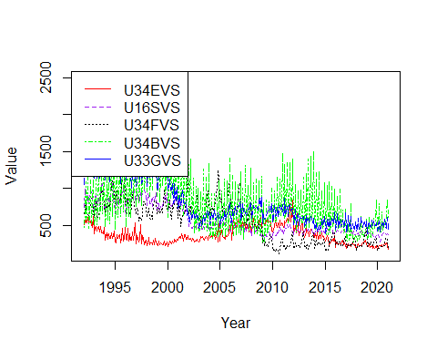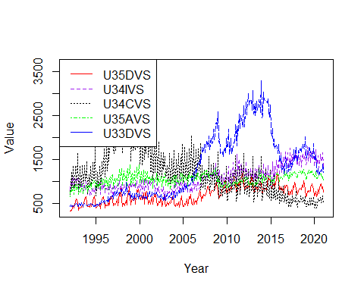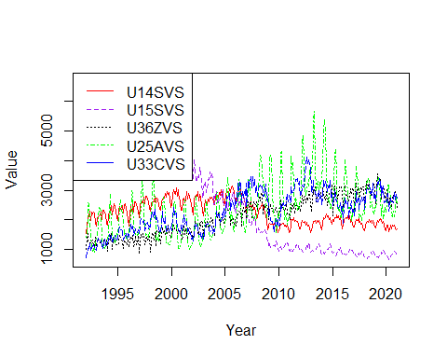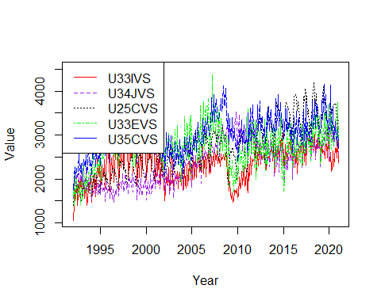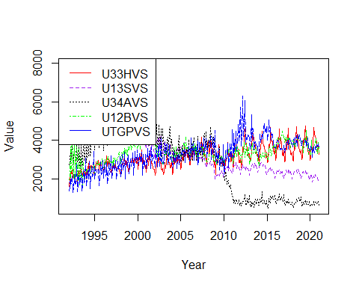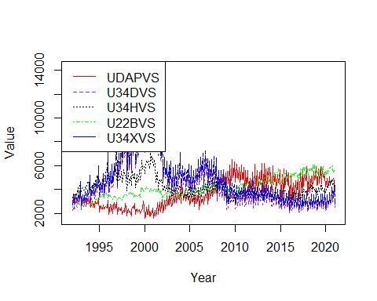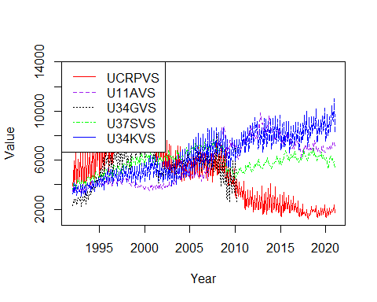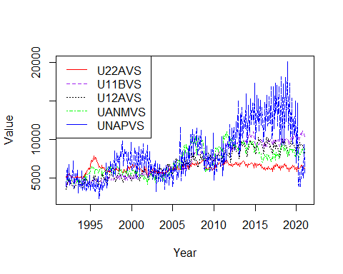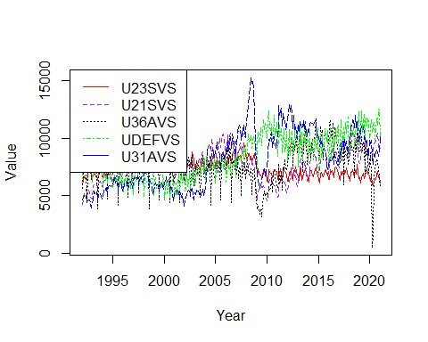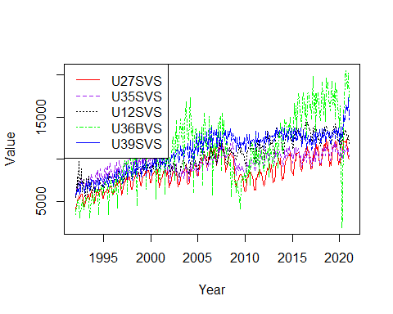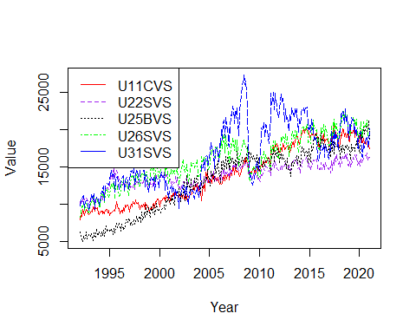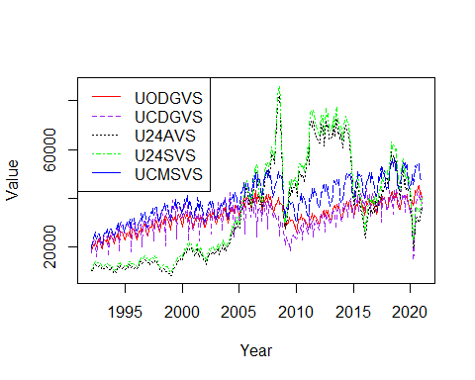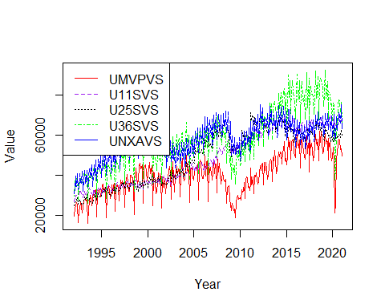

neworders_order_med <- order(colMeans(as.matrix(neworders_dataframe_time[sapply(neworders_dataframe_time, is.numeric)]),na.rm = TRUE))  
neworders_mmv_ordered_median <- neworders_mmv %>% select(all_of(neworders_order_med), ncol(neworders_mmv))  
neworders_mmv_ordered_median_adj <- neworders_mmv_ordered_median %>% select(starts_with('A')) #52 Columns  
neworders_mmv_ordered_median_unadj <- neworders_mmv_ordered_median %>% select(starts_with('U')) #52 Columns  
for (i in c(1,6,11,16,21,26,31,36,41,46))  
{  
 Series1 <- ts(data = neworders_mmv_ordered_median_adj[,i], start=c(1992), end=c(2021), frequency = 12)  
 Series2 <- ts(data = neworders_mmv_ordered_median_adj[,i+1], start=c(1992), end=c(2021), frequency = 12)  
 Series3 <- ts(data = neworders_mmv_ordered_median_adj[,i+2], start=c(1992), end=c(2021), frequency = 12)  
 Series4 <- ts(data = neworders_mmv_ordered_median_adj[,i+3], start=c(1992), end=c(2021), frequency = 12)  
 Series5 <- ts(data = neworders_mmv_ordered_median_adj[,i+4], start=c(1992), end=c(2021), frequency = 12)  
 ts.plot(Series1, Series2, Series3, Series4, Series5, gpars=list(xlab="Year", ylab="Value",lty=c(1:5)), col=rep(c("red","purple","black","green","blue")))  
 legend("topleft", legend = c(colnames(neworders_mmv_ordered_median_adj)[i],colnames(neworders_mmv_ordered_median_adj)[i+1],colnames(neworders_mmv_ordered_median_adj)[i+2],colnames(neworders_mmv_ordered_median_adj)[i+3],colnames(neworders_mmv_ordered_median_adj)[i+4]), col = c("red","purple","black","green","blue"), lty=c(1:4))  
}



for (i in c(1,6,11,16,21,26,31,36,41,46))  
{  
 Series1 <- ts(data = neworders_mmv_ordered_median_unadj[,i], start=c(1992), end=c(2021), frequency = 12)  
 Series2 <- ts(data = neworders_mmv_ordered_median_unadj[,i+1], start=c(1992), end=c(2021), frequency = 12)  
 Series3 <- ts(data = neworders_mmv_ordered_median_unadj[,i+2], start=c(1992), end=c(2021), frequency = 12)  
 Series4 <- ts(data = neworders_mmv_ordered_median_unadj[,i+3], start=c(1992), end=c(2021), frequency = 12)  
 Series5 <- ts(data = neworders_mmv_ordered_median_unadj[,i+4], start=c(1992), end=c(2021), frequency = 12)  
 ts.plot(Series1, Series2, Series3, Series4, Series5, gpars=list(xlab="Year", ylab="Value",lty=c(1:5)), col=rep(c("red","purple","black","green","blue")))  
 legend("topleft", legend = c(colnames(neworders_mmv_ordered_median_unadj)[i],colnames(neworders_mmv_ordered_median_unadj)[i+1],colnames(neworders_mmv_ordered_median_unadj)[i+2],colnames(neworders_mmv_ordered_median_unadj)[i+3],colnames(neworders_mmv_ordered_median_unadj)[i+4]), col = c("red","purple","black","green","blue"), lty=c(1:4))  
}



unfilledorders_order_med <- order(colMedians(as.matrix(unfilledorders_dataframe_time[sapply(unfilledorders_dataframe_time, is.numeric)]),na.rm = TRUE))  
unfilledorders_mmv_ordered_median <- unfillord_mmv %>% select(all_of(unfilledorders_order_med), ncol(unfillord_mmv))  
unfilledorders_mmv_ordered_median_adj <- unfilledorders_mmv_ordered_median %>% select(starts_with('A')) #50 Columns  
unfilledorders_mmv_ordered_median_unadj <- unfilledorders_mmv_ordered_median %>% select(starts_with('U')) #52 Columns  
for (i in c(1,6,11,16,21,26,31,36,41,46))  
{  
 Series1 <- ts(data = unfilledorders_mmv_ordered_median_adj[,i], start=c(1992), end=c(2021), frequency = 12)  
 Series2 <- ts(data = unfilledorders_mmv_ordered_median_adj[,i+1], start=c(1992), end=c(2021), frequency = 12)  
 Series3 <- ts(data = unfilledorders_mmv_ordered_median_adj[,i+2], start=c(1992), end=c(2021), frequency = 12)  
 Series4 <- ts(data = unfilledorders_mmv_ordered_median_adj[,i+3], start=c(1992), end=c(2021), frequency = 12)  
 Series5 <- ts(data = unfilledorders_mmv_ordered_median_adj[,i+4], start=c(1992), end=c(2021), frequency = 12)  
 ts.plot(Series1, Series2, Series3, Series4, Series5, gpars=list(xlab="Year", ylab="Value",lty=c(1:5)), col=rep(c("red","purple","black","green","blue")))  
 legend("topleft", legend = c(colnames(unfilledorders_mmv_ordered_median_adj)[i],colnames(unfilledorders_mmv_ordered_median_adj)[i+1],colnames(unfilledorders_mmv_ordered_median_adj)[i+2],colnames(unfilledorders_mmv_ordered_median_adj)[i+3],colnames(unfilledorders_mmv_ordered_median_adj)[i+4]), col = c("red","purple","black","green","blue"), lty=c(1:4))  
}

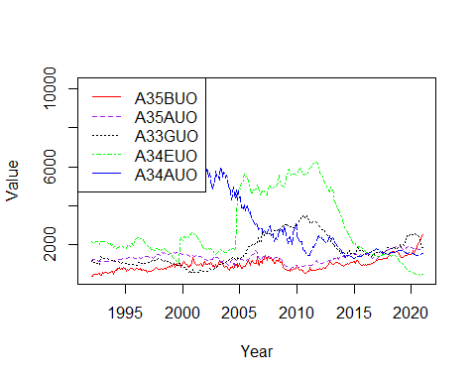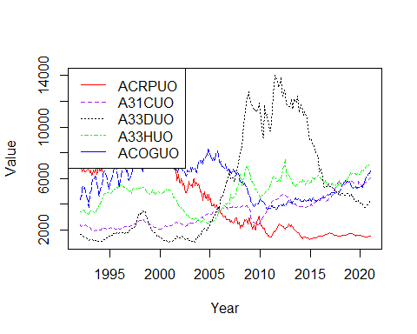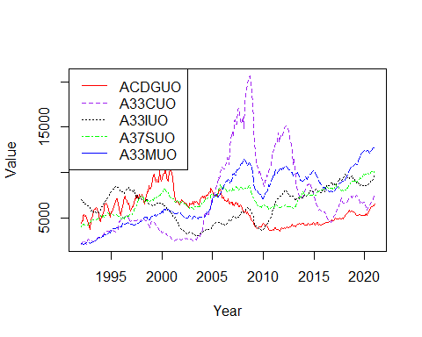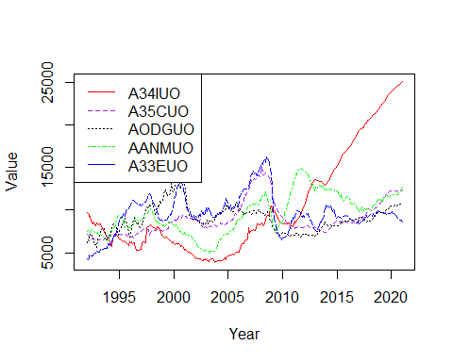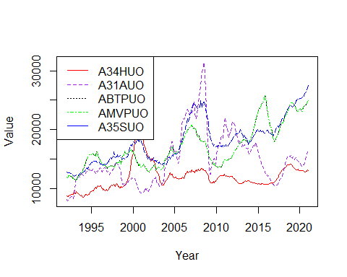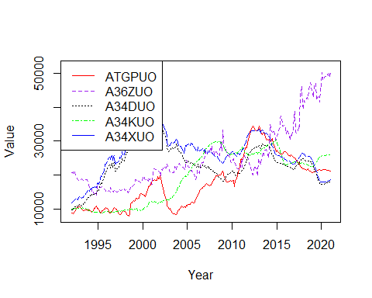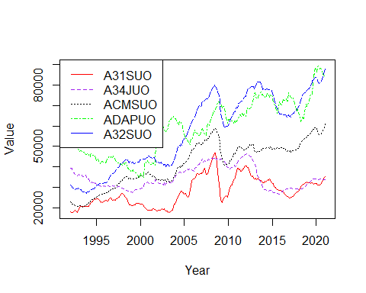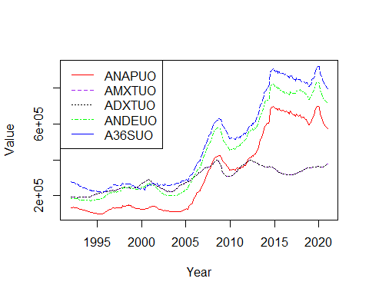

for (i in c(1,6,11,16,21,26,31,36,41,46))  
{  
 Series1 <- ts(data = unfilledorders_mmv_ordered_median_unadj[,i], start=c(1992), end=c(2021), frequency = 12)  
 Series2 <- ts(data = unfilledorders_mmv_ordered_median_unadj[,i+1], start=c(1992), end=c(2021), frequency = 12)  
 Series3 <- ts(data = unfilledorders_mmv_ordered_median_unadj[,i+2], start=c(1992), end=c(2021), frequency = 12)  
 Series4 <- ts(data = unfilledorders_mmv_ordered_median_unadj[,i+3], start=c(1992), end=c(2021), frequency = 12)  
 Series5 <- ts(data = unfilledorders_mmv_ordered_median_unadj[,i+4], start=c(1992), end=c(2021), frequency = 12)  
 ts.plot(Series1, Series2, Series3, Series4, Series5, gpars=list(xlab="Year", ylab="Value",lty=c(1:5)), col=rep(c("red","purple","black","green","blue")))  
 legend("topleft", legend = c(colnames(unfilledorders_mmv_ordered_median_unadj)[i],colnames(unfilledorders_mmv_ordered_median_unadj)[i+1],colnames(unfilledorders_mmv_ordered_median_unadj)[i+2],colnames(unfilledorders_mmv_ordered_median_unadj)[i+3],colnames(unfilledorders_mmv_ordered_median_unadj)[i+4]), col = c("red","purple","black","green","blue"), lty=c(1:4))  
}

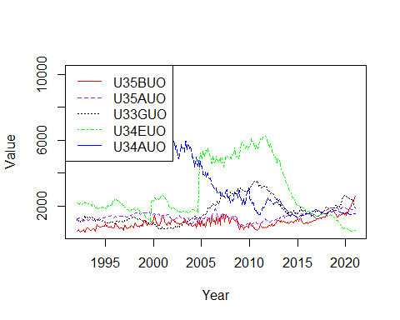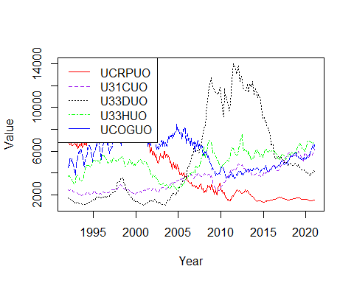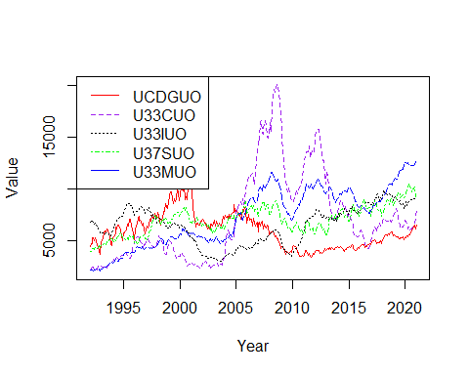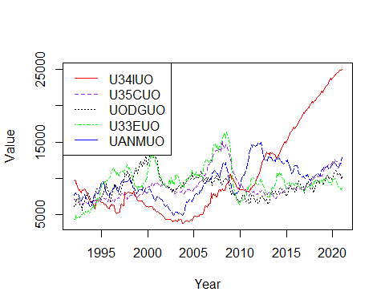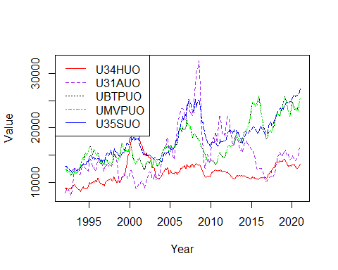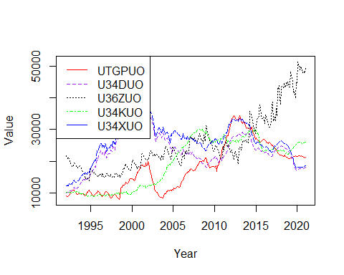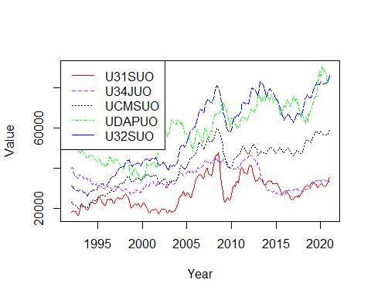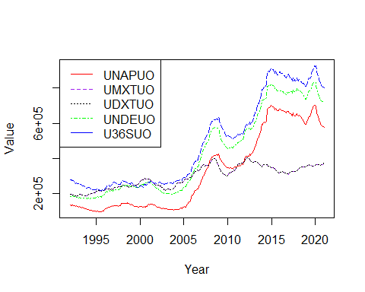

totalinv_order_med <- order(colMedians(as.matrix(totalinventories_dataframe_time[sapply(totalinventories_dataframe_time, is.numeric)]),na.rm = TRUE))  
totalinv_mmv_ordered_median <- totalinv_mmv %>% select(all_of(totalinv_order_med), ncol(totalinv_mmv))  
totalinv_mmv_ordered_median_adj <- totalinv_mmv_ordered_median %>% select(starts_with('A')) #158 Columns  
totalinv_mmv_ordered_median_unadj <- totalinv_mmv_ordered_median %>% select(starts_with('U')) #158 Columns  
for (i in c(1,6,11,16,21,26,31,36,41,46,51,56,61,66,71,76,81,86,91,96,101,106,111,116,121,126,131,136,141,146,151))  
{  
 Series1 <- ts(data = totalinv_mmv_ordered_median_adj[,i], start=c(1992), end=c(2021), frequency = 12)  
 Series2 <- ts(data = totalinv_mmv_ordered_median_adj[,i+1], start=c(1992), end=c(2021), frequency = 12)  
 Series3 <- ts(data = totalinv_mmv_ordered_median_adj[,i+2], start=c(1992), end=c(2021), frequency = 12)  
 Series4 <- ts(data = totalinv_mmv_ordered_median_adj[,i+3], start=c(1992), end=c(2021), frequency = 12)  
 Series5 <- ts(data = totalinv_mmv_ordered_median_adj[,i+4], start=c(1992), end=c(2021), frequency = 12)  
 ts.plot(Series1, Series2, Series3, Series4, Series5, gpars=list(xlab="Year", ylab="Value",lty=c(1:5)), col=rep(c("red","purple","black","green","blue")))  
 legend("topleft", legend = c(colnames(totalinv_mmv_ordered_median_adj)[i],colnames(totalinv_mmv_ordered_median_adj)[i+1],colnames(totalinv_mmv_ordered_median_adj)[i+2],colnames(totalinv_mmv_ordered_median_adj)[i+3],colnames(totalinv_mmv_ordered_median_adj)[i+4]), col = c("red","purple","black","green","blue"), lty=c(1:4))  
}

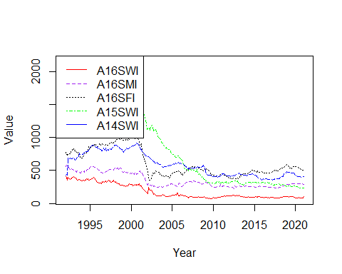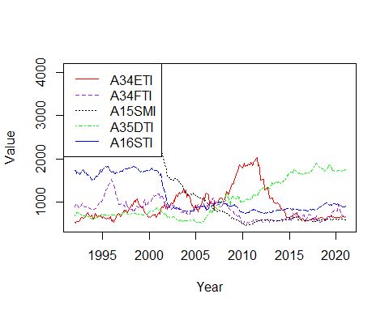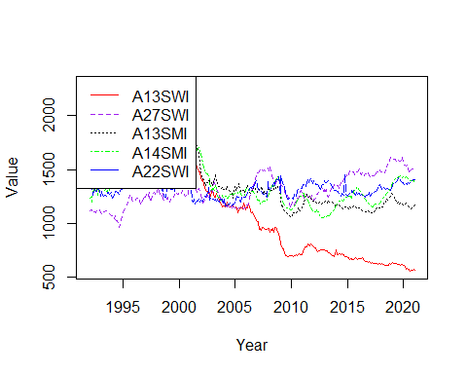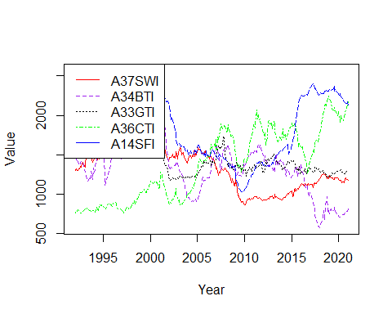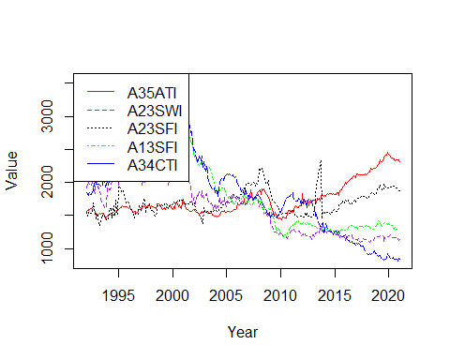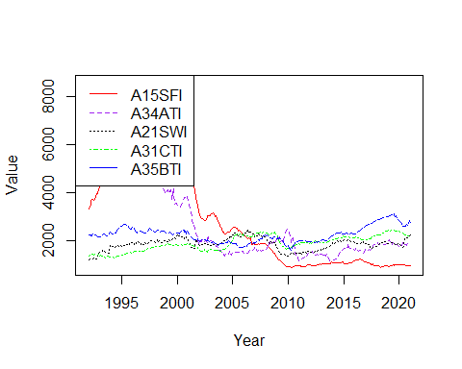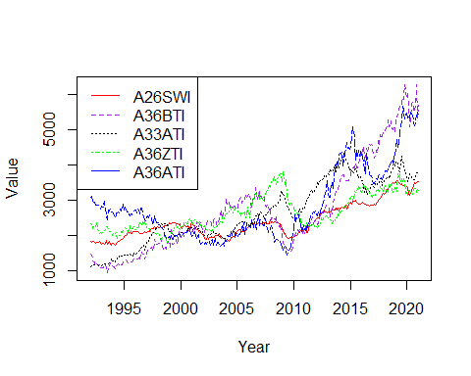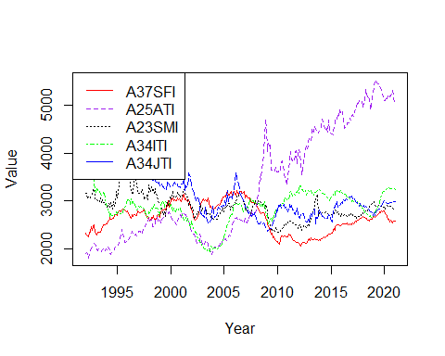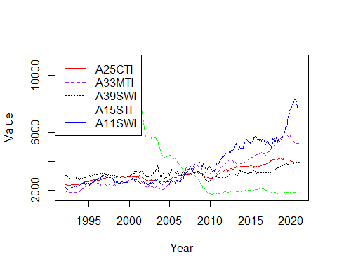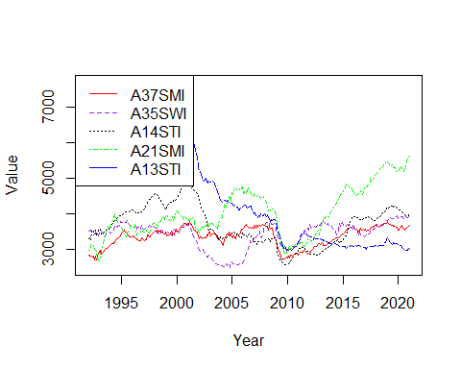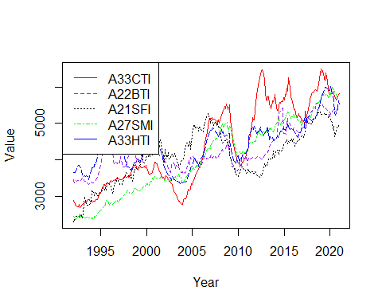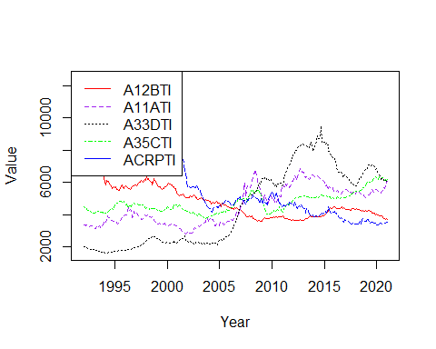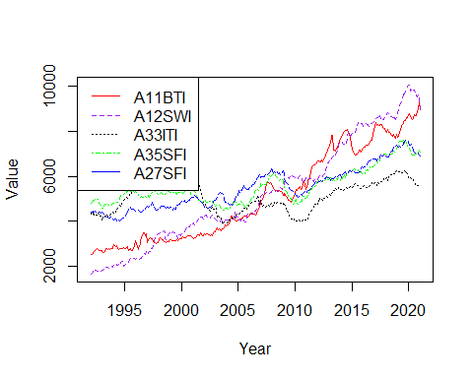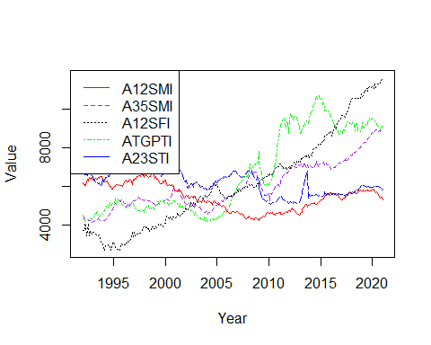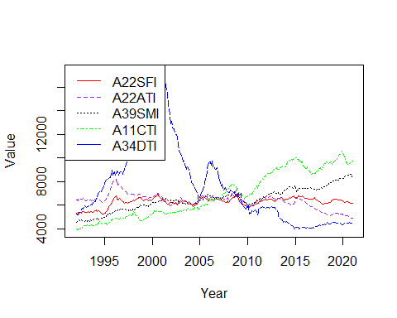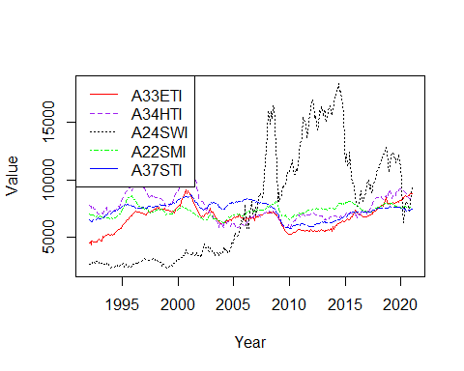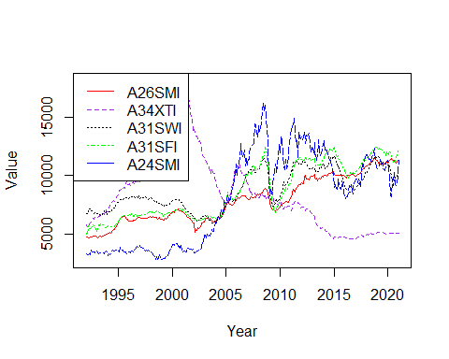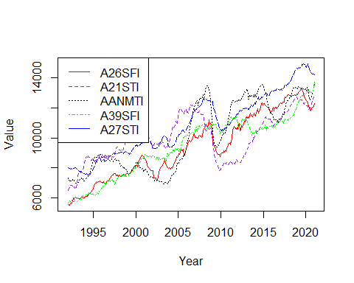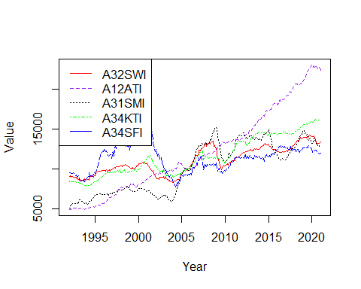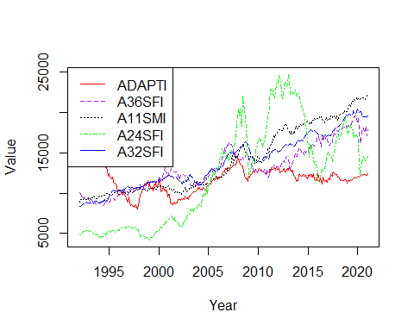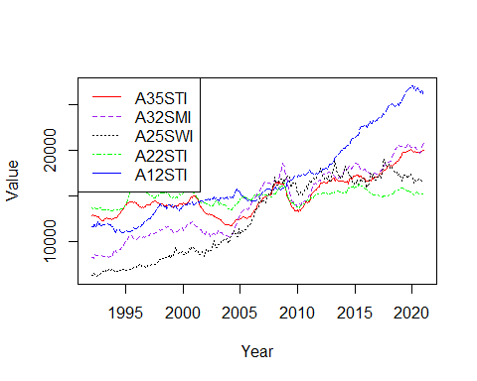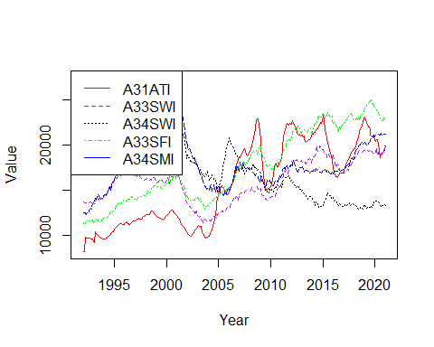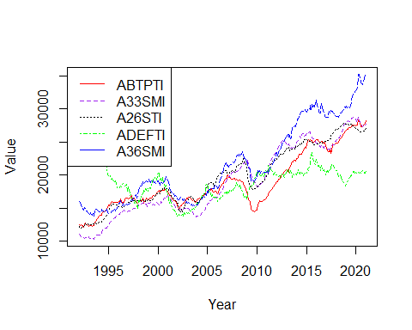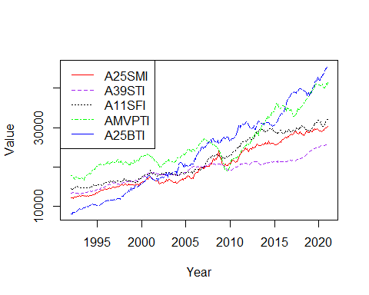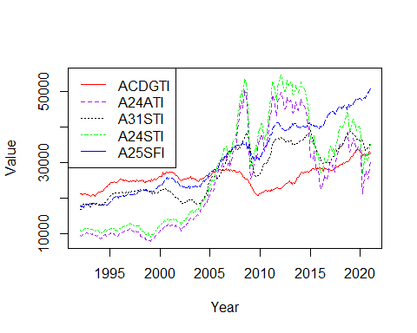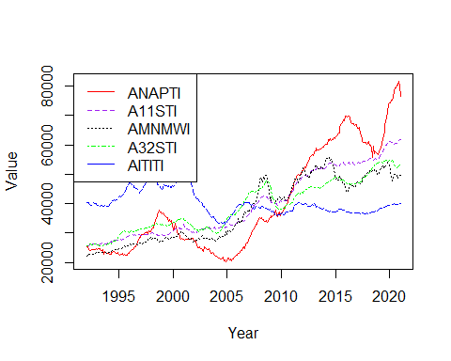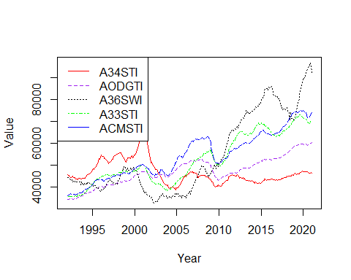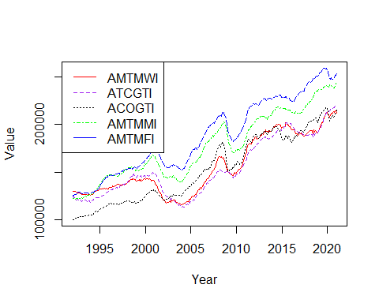

for (i in c(1,6,11,16,21,26,31,36,41,46,51,56,61,66,71,76,81,86,91,96,101,106,111,116,121,126,131,136,141,146,151))  
{  
 Series1 <- ts(data = totalinv_mmv_ordered_median_unadj[,i], start=c(1992), end=c(2021), frequency = 12)  
 Series2 <- ts(data = totalinv_mmv_ordered_median_unadj[,i+1], start=c(1992), end=c(2021), frequency = 12)  
 Series3 <- ts(data = totalinv_mmv_ordered_median_unadj[,i+2], start=c(1992), end=c(2021), frequency = 12)  
 Series4 <- ts(data = totalinv_mmv_ordered_median_unadj[,i+3], start=c(1992), end=c(2021), frequency = 12)  
 Series5 <- ts(data = totalinv_mmv_ordered_median_unadj[,i+4], start=c(1992), end=c(2021), frequency = 12)  
 ts.plot(Series1, Series2, Series3, Series4, Series5, gpars=list(xlab="Year", ylab="Value",lty=c(1:5)), col=rep(c("red","purple","black","green","blue")))  
 legend("topleft", legend = c(colnames(totalinv_mmv_ordered_median_unadj)[i],colnames(totalinv_mmv_ordered_median_unadj)[i+1],colnames(totalinv_mmv_ordered_median_unadj)[i+2],colnames(totalinv_mmv_ordered_median_unadj)[i+3],colnames(totalinv_mmv_ordered_median_unadj)[i+4]), col = c("red","purple","black","green","blue"), lty=c(1:4))  
}

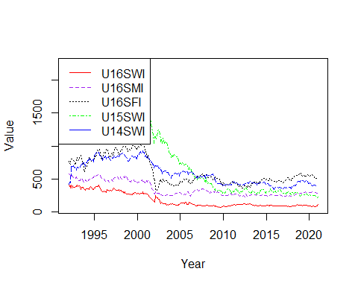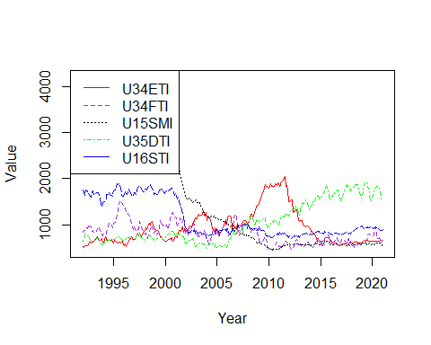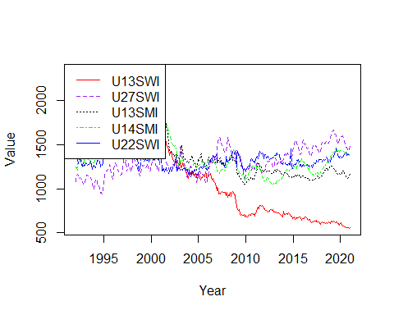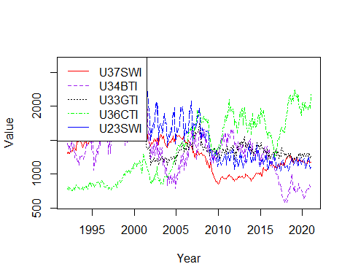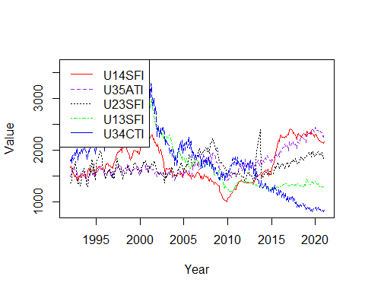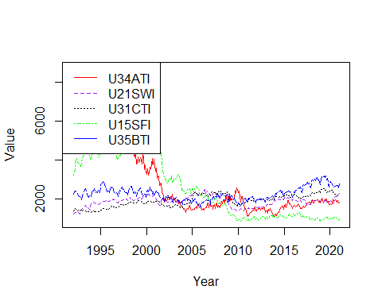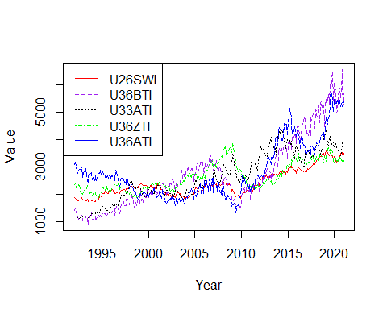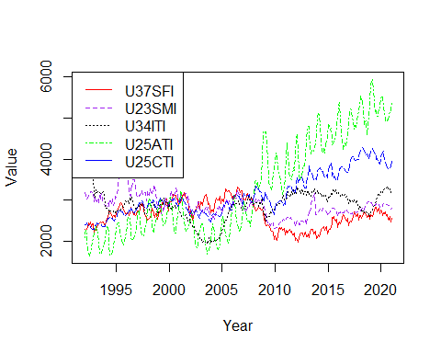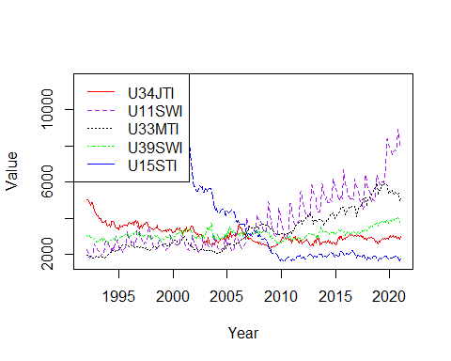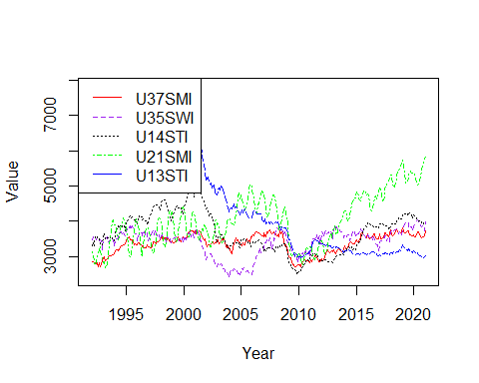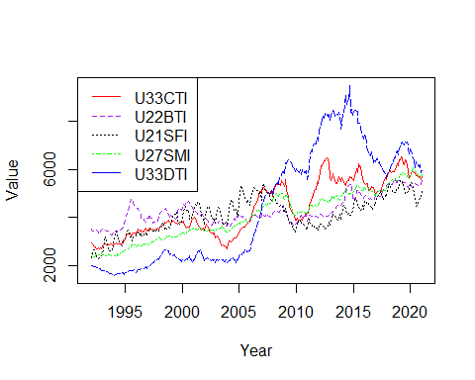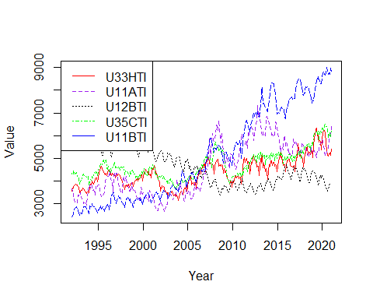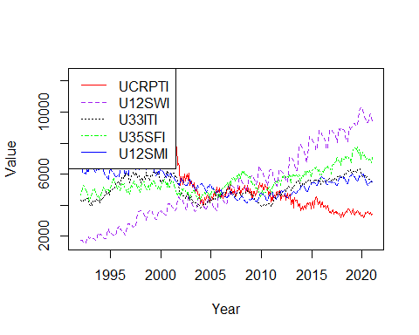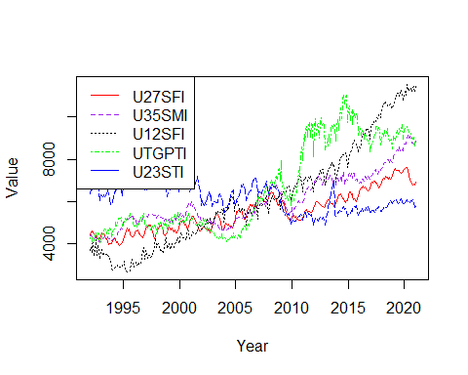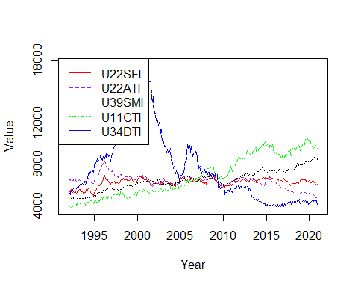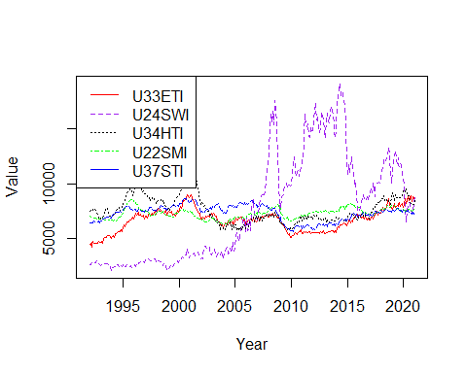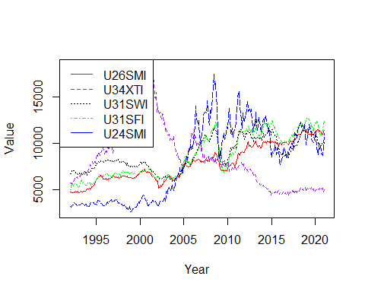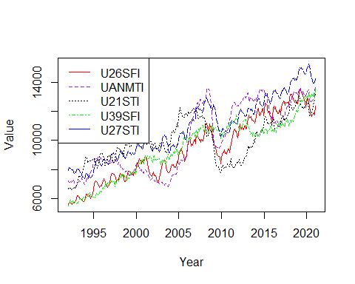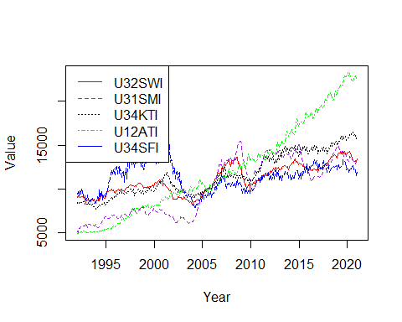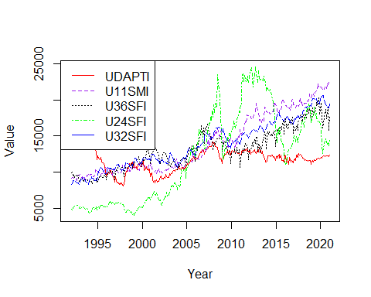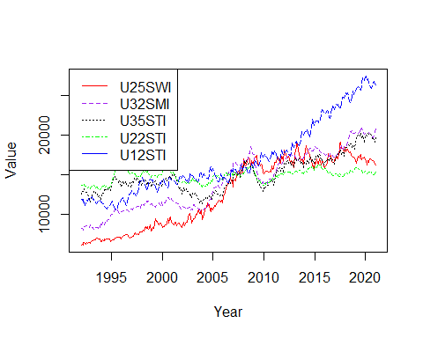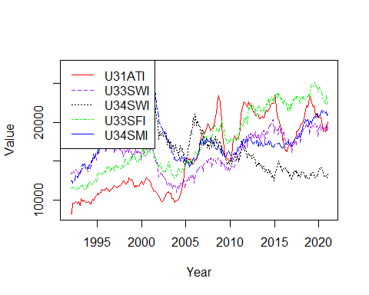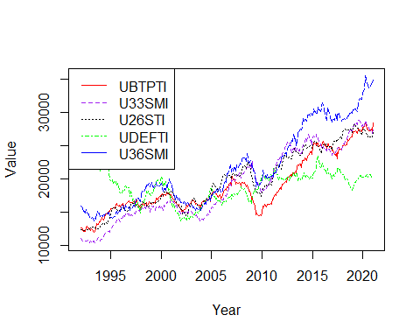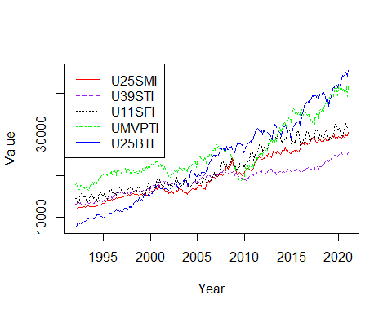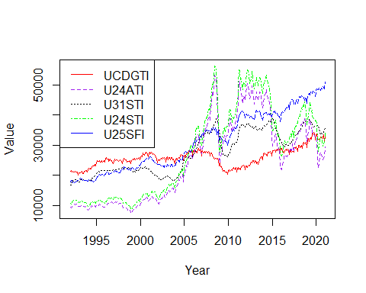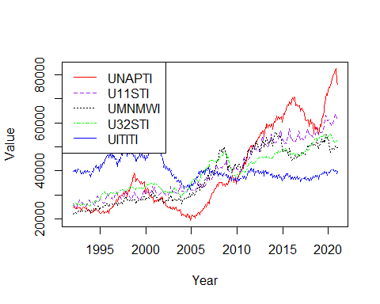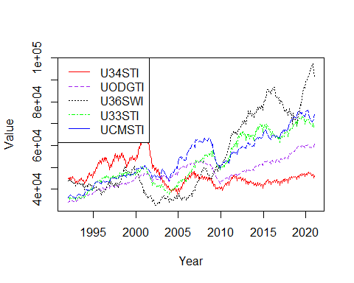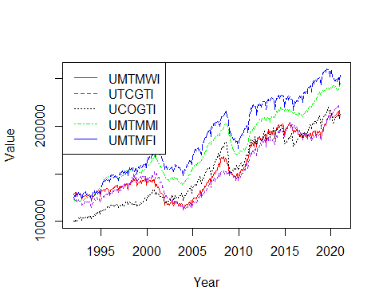

invtoship_order_med <- order(colMedians(as.matrix(inventoriestoshipments_dataframe_time[sapply(inventoriestoshipments_dataframe_time, is.numeric)]),na.rm = TRUE))  
invtoship_mmv_ordered_median <- invtoship_mmv %>% select(all_of(invtoship_order_med), ncol(invtoship_mmv))  
invtoship_mmv_ordered_median_adj <- invtoship_mmv_ordered_median %>% select(starts_with('A')) #24 Columns  
invtoship_mmv_ordered_median_unadj <- invtoship_mmv_ordered_median %>% select(starts_with('U')) #24 Columns  
for (i in c(1,6,11,16))  
{  
 Series1 <- ts(data = invtoship_mmv_ordered_median_adj[,i], start=c(1992), end=c(2021), frequency = 12)  
 Series2 <- ts(data = invtoship_mmv_ordered_median_adj[,i+1], start=c(1992), end=c(2021), frequency = 12)  
 Series3 <- ts(data = invtoship_mmv_ordered_median_adj[,i+2], start=c(1992), end=c(2021), frequency = 12)  
 Series4 <- ts(data = invtoship_mmv_ordered_median_adj[,i+3], start=c(1992), end=c(2021), frequency = 12)  
 Series5 <- ts(data = invtoship_mmv_ordered_median_adj[,i+4], start=c(1992), end=c(2021), frequency = 12)  
 ts.plot(Series1, Series2, Series3, Series4, Series5, gpars=list(xlab="Year", ylab="Value",lty=c(1:5)), col=rep(c("red","purple","black","green","blue")))  
 legend("topleft", legend = c(colnames(invtoship_mmv_ordered_median_adj)[i],colnames(invtoship_mmv_ordered_median_adj)[i+1],colnames(invtoship_mmv_ordered_median_adj)[i+2],colnames(invtoship_mmv_ordered_median_adj)[i+3],colnames(invtoship_mmv_ordered_median_adj)[i+4]), col = c("red","purple","black","green","blue"), lty=c(1:4))  
}

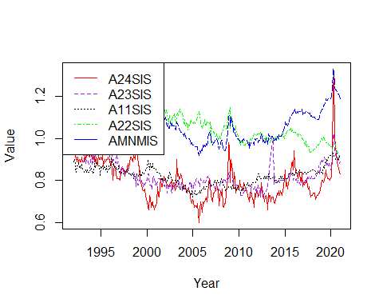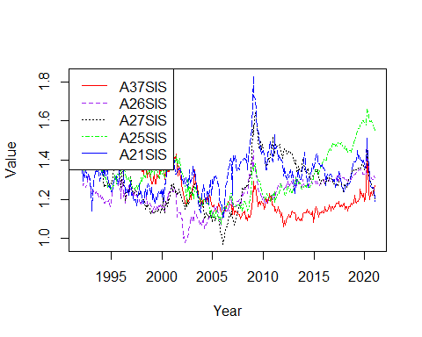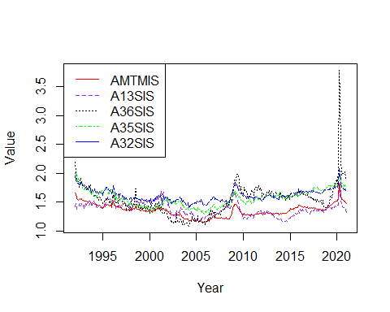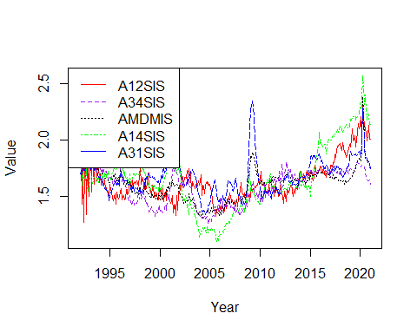

for (i in c(1,6,11,16))  
{  
 Series1 <- ts(data = invtoship_mmv_ordered_median_unadj[,i], start=c(1992), end=c(2021), frequency = 12)  
 Series2 <- ts(data = invtoship_mmv_ordered_median_unadj[,i+1], start=c(1992), end=c(2021), frequency = 12)  
 Series3 <- ts(data = invtoship_mmv_ordered_median_unadj[,i+2], start=c(1992), end=c(2021), frequency = 12)  
 Series4 <- ts(data = invtoship_mmv_ordered_median_unadj[,i+3], start=c(1992), end=c(2021), frequency = 12)  
 Series5 <- ts(data = invtoship_mmv_ordered_median_unadj[,i+4], start=c(1992), end=c(2021), frequency = 12)  
 ts.plot(Series1, Series2, Series3, Series4, Series5, gpars=list(xlab="Year", ylab="Value",lty=c(1:5)), col=rep(c("red","purple","black","green","blue")))  
 legend("topleft", legend = c(colnames(invtoship_mmv_ordered_median_unadj)[i],colnames(invtoship_mmv_ordered_median_unadj)[i+1],colnames(invtoship_mmv_ordered_median_unadj)[i+2],colnames(invtoship_mmv_ordered_median_unadj)[i+3],colnames(invtoship_mmv_ordered_median_unadj)[i+4]), col = c("red","purple","black","green","blue"), lty=c(1:4))  
}

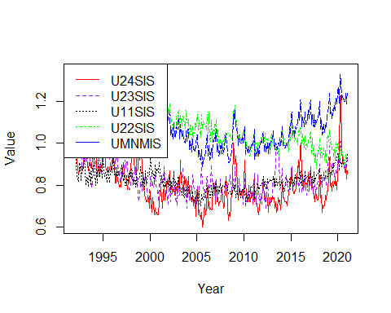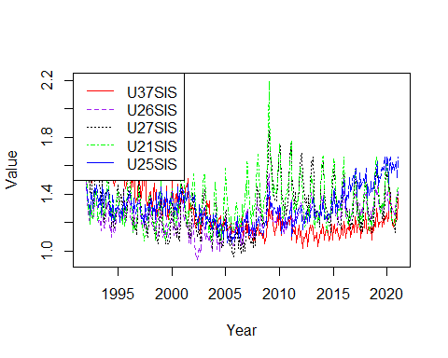

unfilltoship_order_med <- order(colMedians(as.matrix(unfilledorderstoshipments_dataframe_time[sapply(unfilledorderstoshipments_dataframe_time, is.numeric)]),na.rm = TRUE))  
unfilltoship_mmv_ordered_median <- unfilltoship_mmv %>% select(all_of(unfilltoship_order_med), ncol(unfilltoship_mmv))  
unfilltoship_mmv_ordered_median_adj <- unfilltoship_mmv_ordered_median %>% select(starts_with('A')) #9 Columns  
unfilltoship_mmv_ordered_median_unadj <- unfilltoship_mmv_ordered_median %>% select(starts_with('U')) #9 Columns  
for (i in c(1))  
{  
 Series1 <- ts(data = unfilltoship_mmv_ordered_median_adj[,i], start=c(1992), end=c(2021), frequency = 12)  
 Series2 <- ts(data = unfilltoship_mmv_ordered_median_adj[,i+1], start=c(1992), end=c(2021), frequency = 12)  
 Series3 <- ts(data = unfilltoship_mmv_ordered_median_adj[,i+2], start=c(1992), end=c(2021), frequency = 12)  
 Series4 <- ts(data = unfilltoship_mmv_ordered_median_adj[,i+3], start=c(1992), end=c(2021), frequency = 12)  
 Series5 <- ts(data = unfilltoship_mmv_ordered_median_adj[,i+4], start=c(1992), end=c(2021), frequency = 12)  
 ts.plot(Series1, Series2, Series3, Series4, Series5, gpars=list(xlab="Year", ylab="Value",lty=c(1:5)), col=rep(c("red","purple","black","green","blue")))  
 legend("topleft", legend = c(colnames(unfilltoship_mmv_ordered_median_adj)[i],colnames(unfilltoship_mmv_ordered_median_adj)[i+1],colnames(unfilltoship_mmv_ordered_median_adj)[i+2],colnames(unfilltoship_mmv_ordered_median_adj)[i+3],colnames(unfilltoship_mmv_ordered_median_adj)[i+4]), col = c("red","purple","black","green","blue"), lty=c(1:4))  
}



for (i in c(1))  
{  
 Series1 <- ts(data = unfilltoship_mmv_ordered_median_unadj[,i], start=c(1992), end=c(2021), frequency = 12)  
 Series2 <- ts(data = unfilltoship_mmv_ordered_median_unadj[,i+1], start=c(1992), end=c(2021), frequency = 12)  
 Series3 <- ts(data = unfilltoship_mmv_ordered_median_unadj[,i+2], start=c(1992), end=c(2021), frequency = 12)  
 Series4 <- ts(data = unfilltoship_mmv_ordered_median_unadj[,i+3], start=c(1992), end=c(2021), frequency = 12)  
 Series5 <- ts(data = unfilltoship_mmv_ordered_median_unadj[,i+4], start=c(1992), end=c(2021), frequency = 12)  
 ts.plot(Series1, Series2, Series3, Series4, Series5, gpars=list(xlab="Year", ylab="Value",lty=c(1:5)), col=rep(c("red","purple","black","green","blue")))  
 legend("topleft", legend = c(colnames(unfilltoship_mmv_ordered_median_unadj)[i],colnames(unfilltoship_mmv_ordered_median_unadj)[i+1],colnames(unfilltoship_mmv_ordered_median_unadj)[i+2],colnames(unfilltoship_mmv_ordered_median_unadj)[i+3],colnames(unfilltoship_mmv_ordered_median_unadj)[i+4]), col = c("red","purple","black","green","blue"), lty=c(1:4))  
}



shipments_order_sd <- order(colSds(as.matrix(shipments_dataframe_time[sapply(shipments_dataframe_time, is.numeric)]),na.rm = TRUE))  
shipments_mmv_ordered_standev <- shipments_mmv %>% select(all_of(shipments_order_sd), ncol(shipments_mmv))  
shipments_mmv_ordered_standev_adj <- shipments_mmv_ordered_standev %>% select(starts_with('A')) #9 Columns  
shipments_mmv_ordered_standev_unadj <- shipments_mmv_ordered_standev %>% select(starts_with('U')) #9 Columns  
for (i in c(1,6,11,16,21,26,31,36,41,46,51,56,61,66,71,76,81))  
{  
 Series1 <- ts(data = shipments_mmv_ordered_standev_adj[,i], start=c(1992), end=c(2021), frequency = 12)  
 Series2 <- ts(data = shipments_mmv_ordered_standev_adj[,i+1], start=c(1992), end=c(2021), frequency = 12)  
 Series3 <- ts(data = shipments_mmv_ordered_standev_adj[,i+2], start=c(1992), end=c(2021), frequency = 12)  
 Series4 <- ts(data = shipments_mmv_ordered_standev_adj[,i+3], start=c(1992), end=c(2021), frequency = 12)  
 Series5 <- ts(data = shipments_mmv_ordered_standev_adj[,i+4], start=c(1992), end=c(2021), frequency = 12)  
 ts.plot(Series1, Series2, Series3, Series4, Series5, gpars=list(xlab="Year", ylab="Value",lty=c(1:5)), col=rep(c("red","purple","black","green","blue")))  
 legend("topleft", legend = c(colnames(shipments_mmv_ordered_standev_adj)[i],colnames(shipments_mmv_ordered_standev_adj)[i+1],colnames(shipments_mmv_ordered_standev_adj)[i+2],colnames(shipments_mmv_ordered_standev_adj)[i+3],colnames(shipments_mmv_ordered_standev_adj)[i+4]), col = c("red","purple","black","green","blue"), lty=c(1:4))  
}

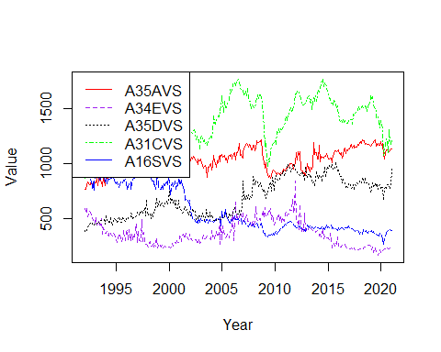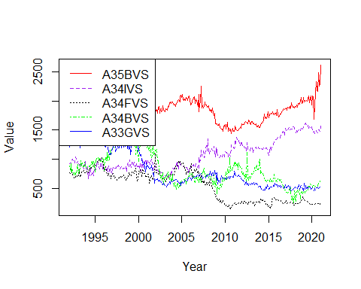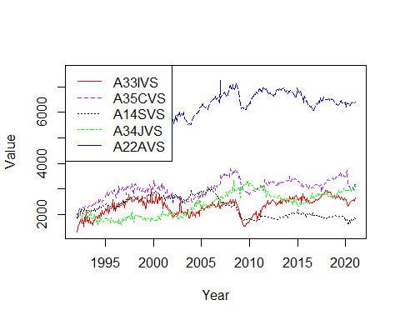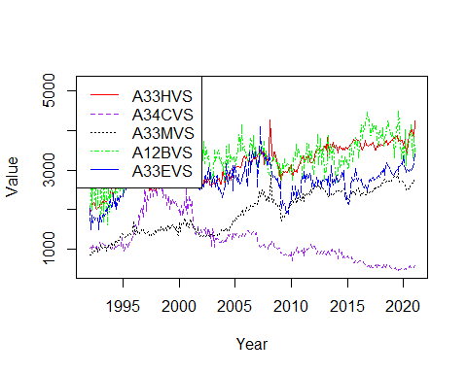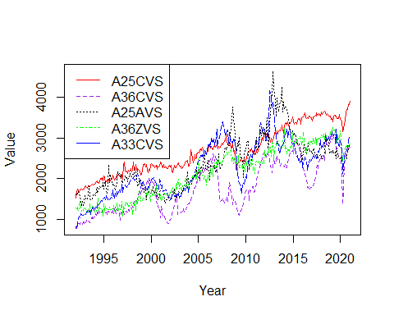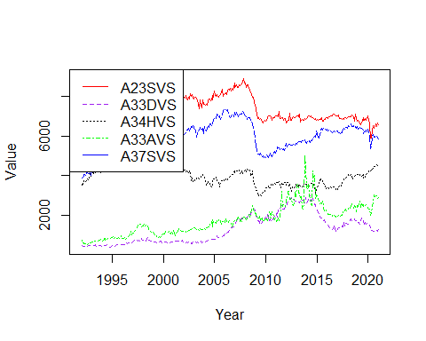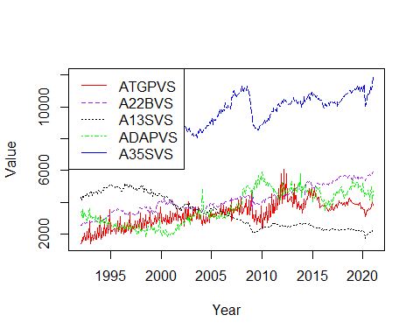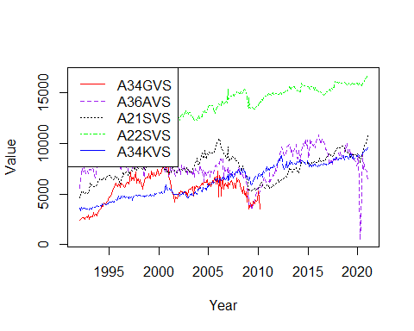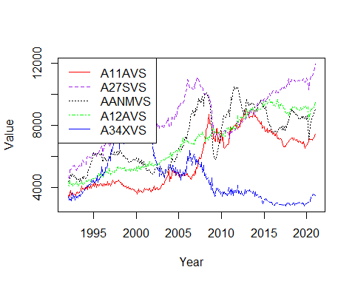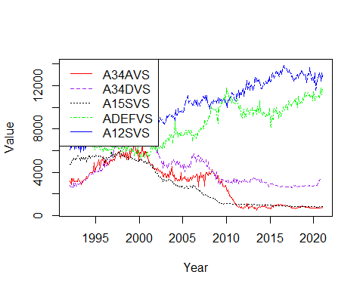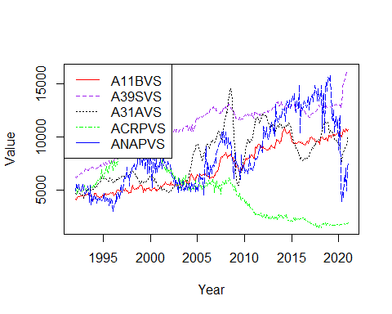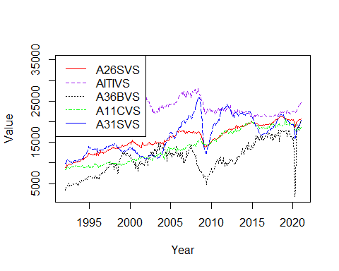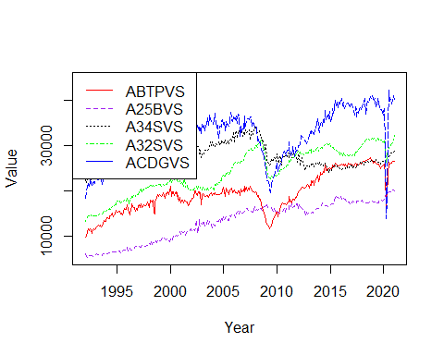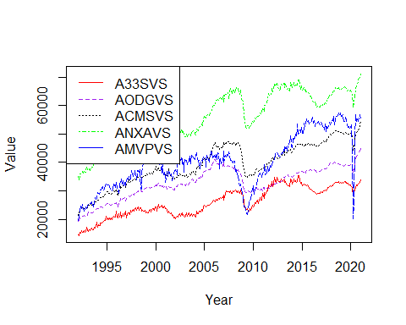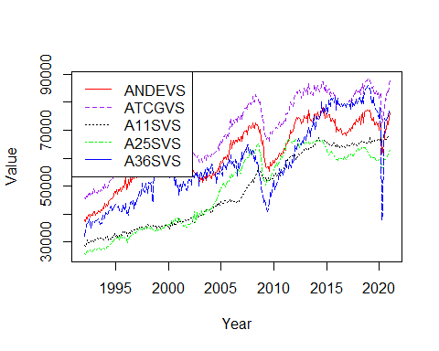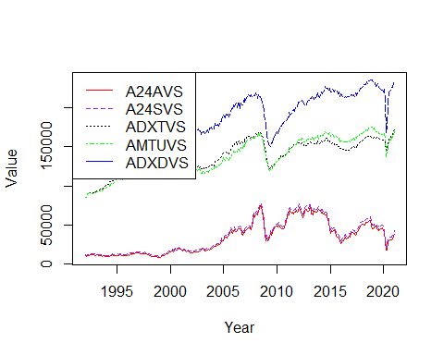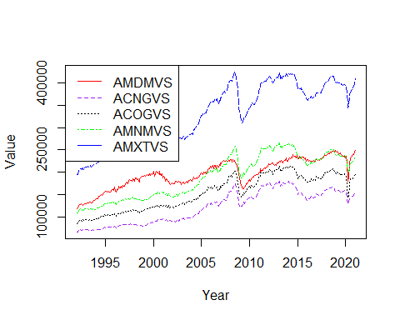

for (i in c(1,6,11,16,21,26,31,36,41,46,51,56,61,66,71,76,81))  
{  
 Series1 <- ts(data = shipments_mmv_ordered_standev_unadj[,i], start=c(1992), end=c(2021), frequency = 12)  
 Series2 <- ts(data = shipments_mmv_ordered_standev_unadj[,i+1], start=c(1992), end=c(2021), frequency = 12)  
 Series3 <- ts(data = shipments_mmv_ordered_standev_unadj[,i+2], start=c(1992), end=c(2021), frequency = 12)  
 Series4 <- ts(data = shipments_mmv_ordered_standev_unadj[,i+3], start=c(1992), end=c(2021), frequency = 12)  
 Series5 <- ts(data = shipments_mmv_ordered_standev_unadj[,i+4], start=c(1992), end=c(2021), frequency = 12)  
 ts.plot(Series1, Series2, Series3, Series4, Series5, gpars=list(xlab="Year", ylab="Value",lty=c(1:5)), col=rep(c("red","purple","black","green","blue")))  
 legend("topleft", legend = c(colnames(shipments_mmv_ordered_standev_unadj)[i],colnames(shipments_mmv_ordered_standev_unadj)[i+1],colnames(shipments_mmv_ordered_standev_unadj)[i+2],colnames(shipments_mmv_ordered_standev_unadj)[i+3],colnames(shipments_mmv_ordered_standev_unadj)[i+4]), col = c("red","purple","black","green","blue"), lty=c(1:4))  
}

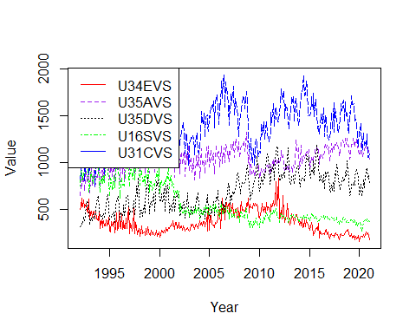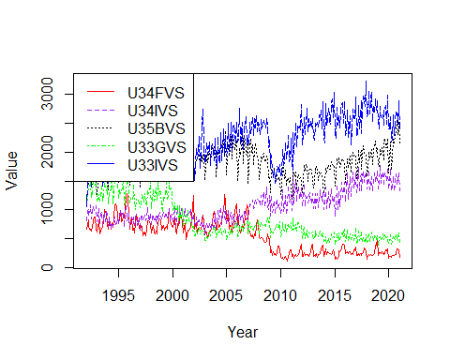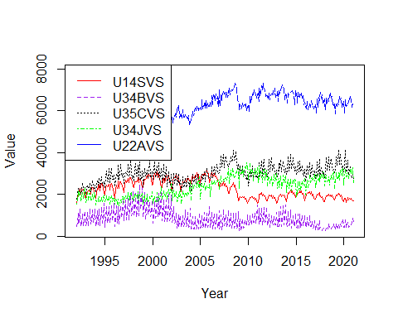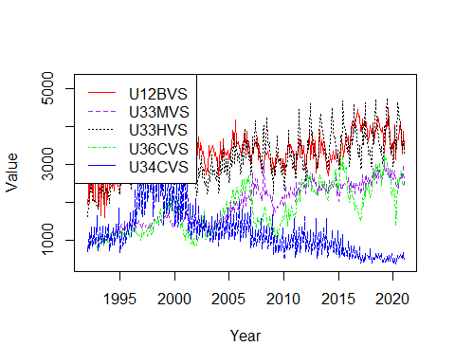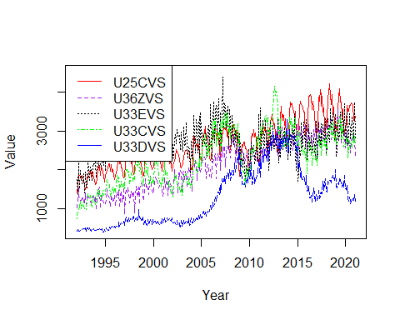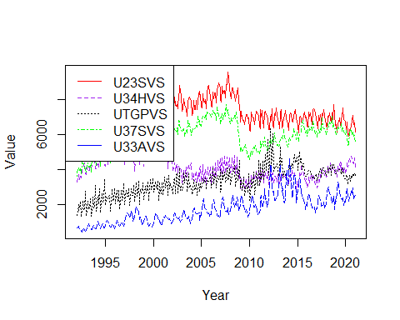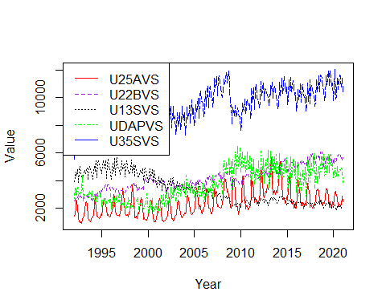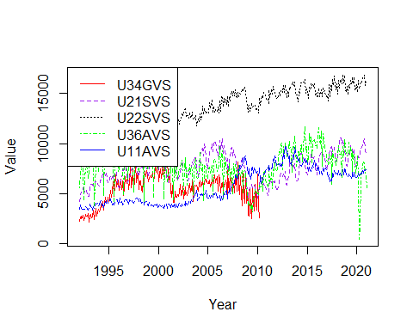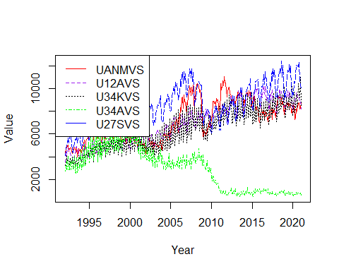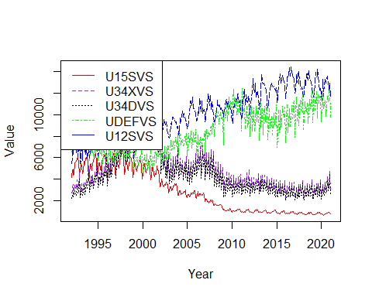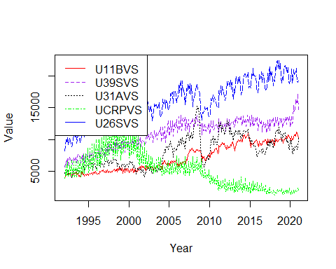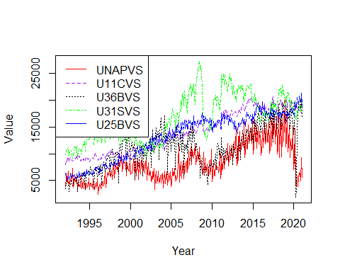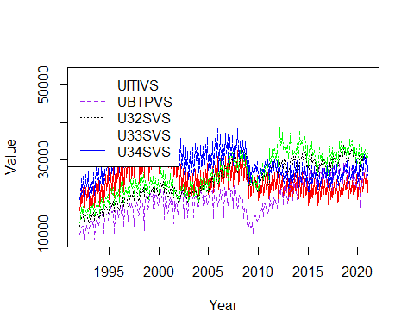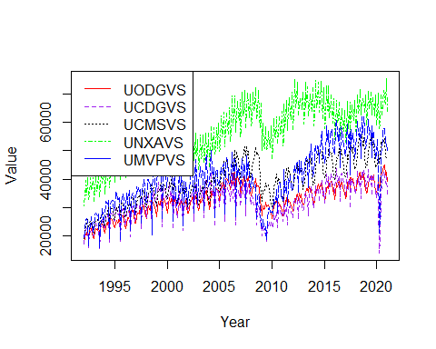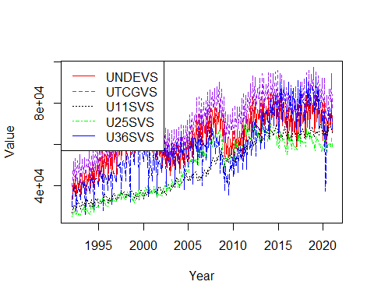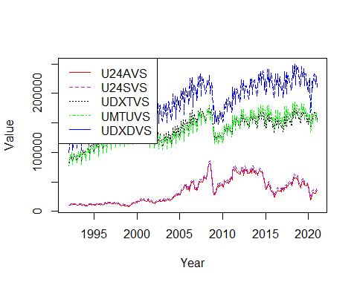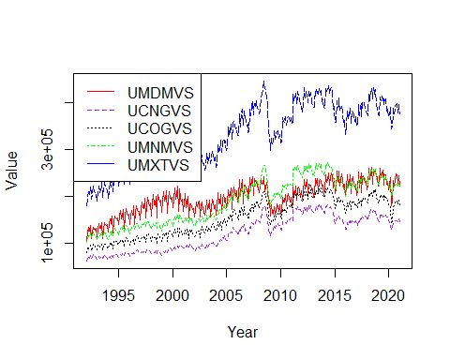

neworders_order_sd <- order(colSds(as.matrix(neworders_dataframe_time[sapply(neworders_dataframe_time, is.numeric)]),na.rm = TRUE))  
neworders_mmv_ordered_standev <- neworders_mmv %>% select(all_of(neworders_order_sd), ncol(neworders_mmv))  
neworders_mmv_ordered_standev_adj <- neworders_mmv_ordered_standev %>% select(starts_with('A')) #52 Columns  
neworders_mmv_ordered_standev_unadj <- neworders_mmv_ordered_standev %>% select(starts_with('U')) #52 Columns  
for (i in c(1,6,11,16,21,26,31,36,41,46))  
{  
 Series1 <- ts(data = neworders_mmv_ordered_standev_adj[,i], start=c(1992), end=c(2021), frequency = 12)  
 Series2 <- ts(data = neworders_mmv_ordered_standev_adj[,i+1], start=c(1992), end=c(2021), frequency = 12)  
 Series3 <- ts(data = neworders_mmv_ordered_standev_adj[,i+2], start=c(1992), end=c(2021), frequency = 12)  
 Series4 <- ts(data = neworders_mmv_ordered_standev_adj[,i+3], start=c(1992), end=c(2021), frequency = 12)  
 Series5 <- ts(data = neworders_mmv_ordered_standev_adj[,i+4], start=c(1992), end=c(2021), frequency = 12)  
 ts.plot(Series1, Series2, Series3, Series4, Series5, gpars=list(xlab="Year", ylab="Value",lty=c(1:5)), col=rep(c("red","purple","black","green","blue")))  
 legend("topleft", legend = c(colnames(neworders_mmv_ordered_standev_adj)[i],colnames(neworders_mmv_ordered_standev_adj)[i+1],colnames(neworders_mmv_ordered_standev_adj)[i+2],colnames(neworders_mmv_ordered_standev_adj)[i+3],colnames(neworders_mmv_ordered_standev_adj)[i+4]), col = c("red","purple","black","green","blue"), lty=c(1:4))  
}

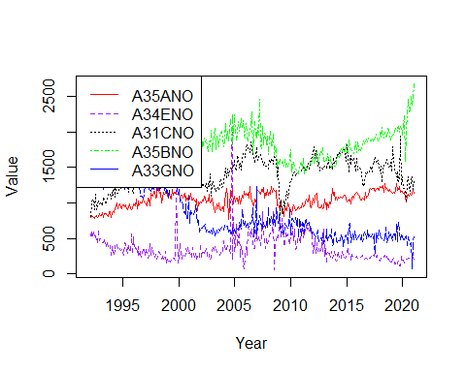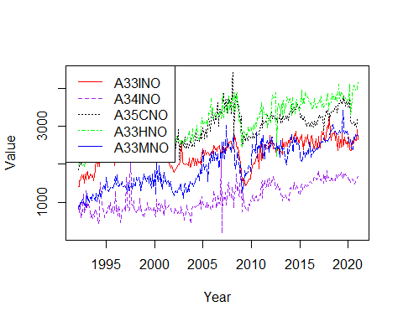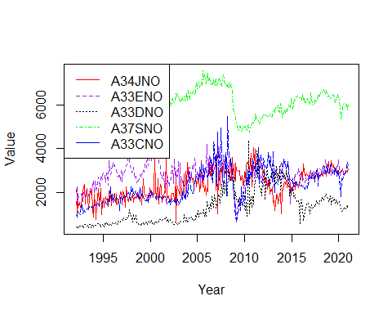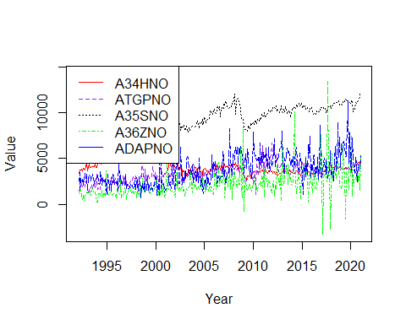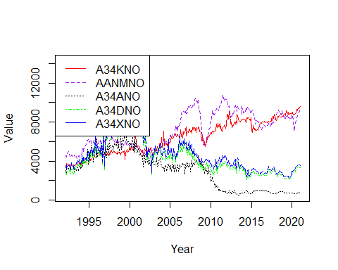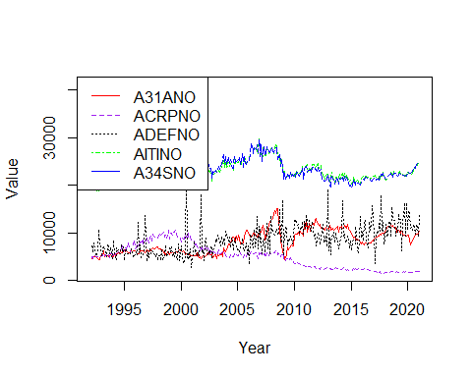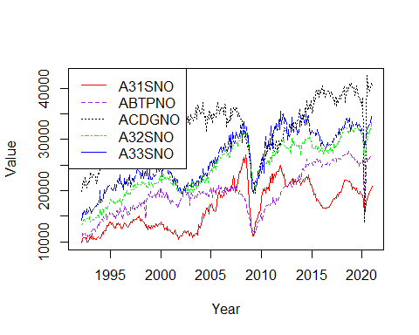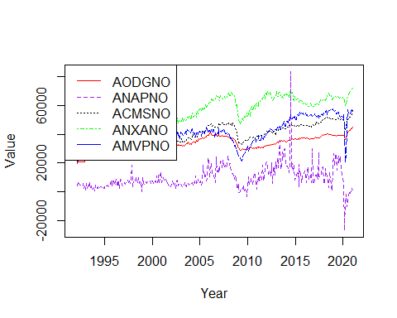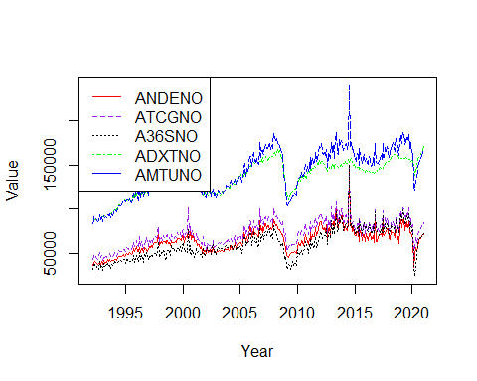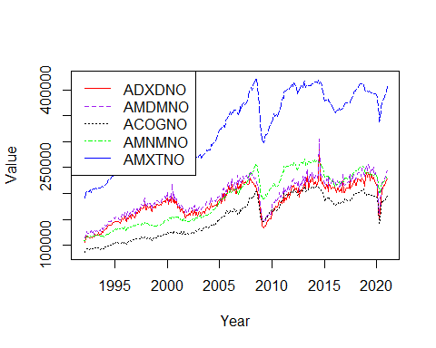

for (i in c(1,6,11,16,21,26,31,36,41,46))  
{  
 Series1 <- ts(data = neworders_mmv_ordered_standev_unadj[,i], start=c(1992), end=c(2021), frequency = 12)  
 Series2 <- ts(data = neworders_mmv_ordered_standev_unadj[,i+1], start=c(1992), end=c(2021), frequency = 12)  
 Series3 <- ts(data = neworders_mmv_ordered_standev_unadj[,i+2], start=c(1992), end=c(2021), frequency = 12)  
 Series4 <- ts(data = neworders_mmv_ordered_standev_unadj[,i+3], start=c(1992), end=c(2021), frequency = 12)  
 Series5 <- ts(data = neworders_mmv_ordered_standev_unadj[,i+4], start=c(1992), end=c(2021), frequency = 12)  
 ts.plot(Series1, Series2, Series3, Series4, Series5, gpars=list(xlab="Year", ylab="Value",lty=c(1:5)), col=rep(c("red","purple","black","green","blue")))  
 legend("topleft", legend = c(colnames(neworders_mmv_ordered_standev_unadj)[i],colnames(neworders_mmv_ordered_standev_unadj)[i+1],colnames(neworders_mmv_ordered_standev_unadj)[i+2],colnames(neworders_mmv_ordered_standev_unadj)[i+3],colnames(neworders_mmv_ordered_standev_unadj)[i+4]), col = c("red","purple","black","green","blue"), lty=c(1:4))  
}

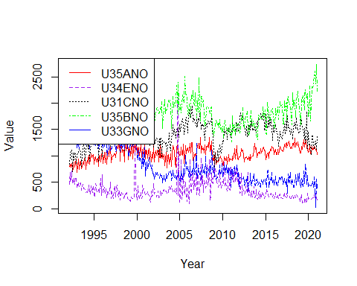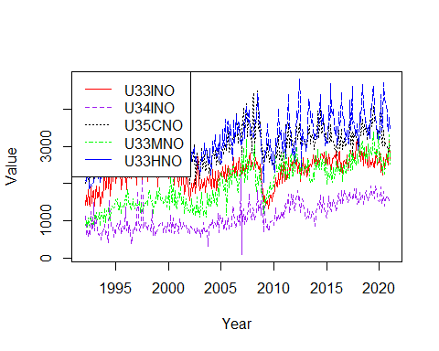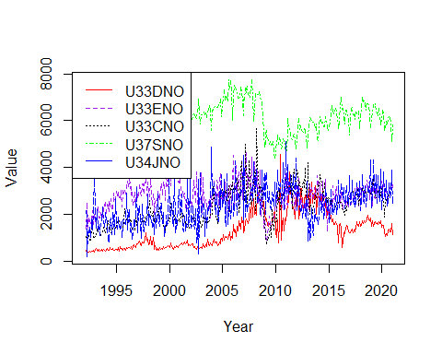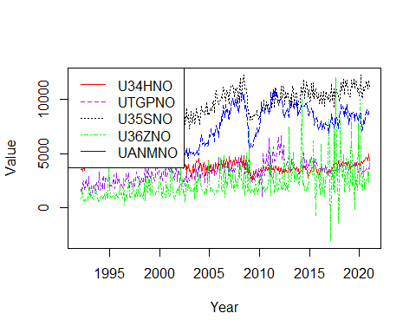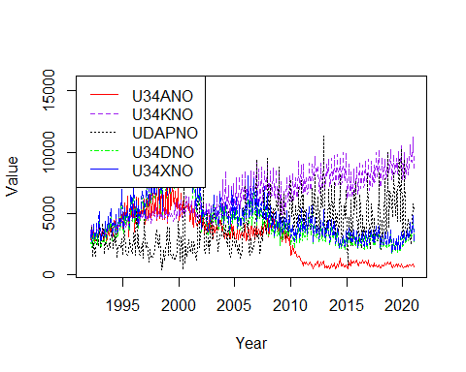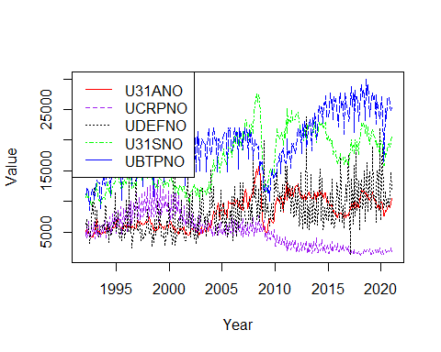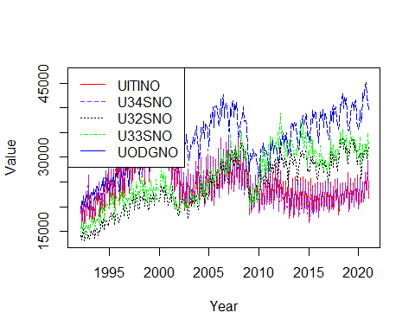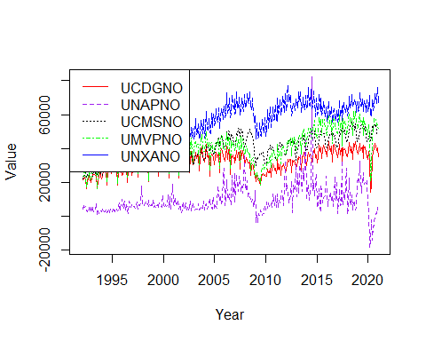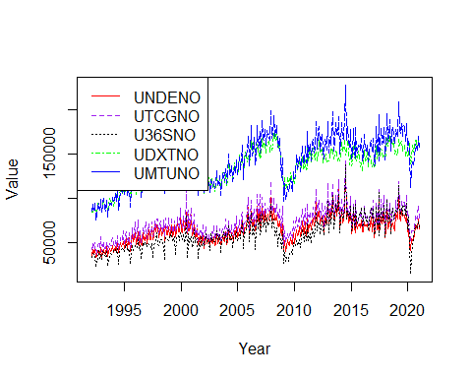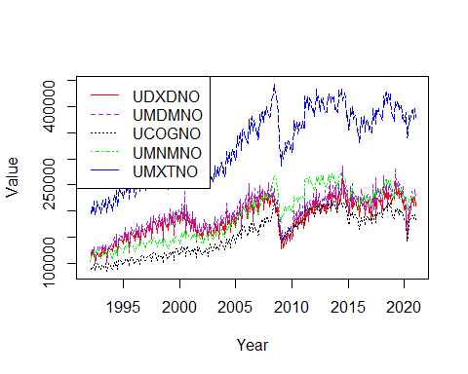

unfilledorders_order_sd <- order(colSds(as.matrix(unfilledorders_dataframe_time[sapply(unfilledorders_dataframe_time, is.numeric)]),na.rm = TRUE))  
unfilledorders_mmv_ordered_standev <- unfillord_mmv %>% select(all_of(unfilledorders_order_sd), ncol(unfillord_mmv))  
unfilledorders_mmv_ordered_standev_adj <- unfilledorders_mmv_ordered_standev %>% select(starts_with('A')) #50 Columns  
unfilledorders_mmv_ordered_standev_unadj <- unfilledorders_mmv_ordered_standev %>% select(starts_with('U')) #52 Columns  
for (i in c(1,6,11,16,21,26,31,36,41,46))  
{  
 Series1 <- ts(data = unfilledorders_mmv_ordered_standev_adj[,i], start=c(1992), end=c(2021), frequency = 12)  
 Series2 <- ts(data = unfilledorders_mmv_ordered_standev_adj[,i+1], start=c(1992), end=c(2021), frequency = 12)  
 Series3 <- ts(data = unfilledorders_mmv_ordered_standev_adj[,i+2], start=c(1992), end=c(2021), frequency = 12)  
 Series4 <- ts(data = unfilledorders_mmv_ordered_standev_adj[,i+3], start=c(1992), end=c(2021), frequency = 12)  
 Series5 <- ts(data = unfilledorders_mmv_ordered_standev_adj[,i+4], start=c(1992), end=c(2021), frequency = 12)  
 ts.plot(Series1, Series2, Series3, Series4, Series5, gpars=list(xlab="Year", ylab="Value",lty=c(1:5)), col=rep(c("red","purple","black","green","blue")))  
 legend("topleft", legend = c(colnames(unfilledorders_mmv_ordered_standev_adj)[i],colnames(unfilledorders_mmv_ordered_standev_adj)[i+1],colnames(unfilledorders_mmv_ordered_standev_adj)[i+2],colnames(unfilledorders_mmv_ordered_standev_adj)[i+3],colnames(unfilledorders_mmv_ordered_standev_adj)[i+4]), col = c("red","purple","black","green","blue"), lty=c(1:4))  
}

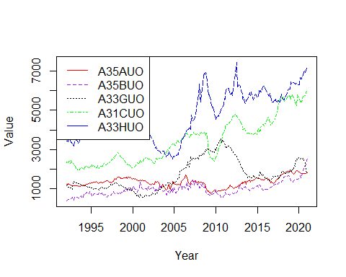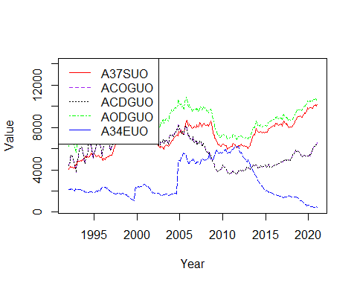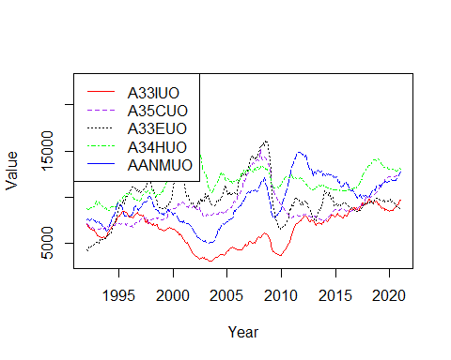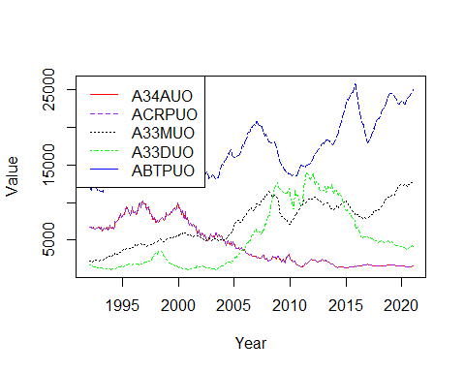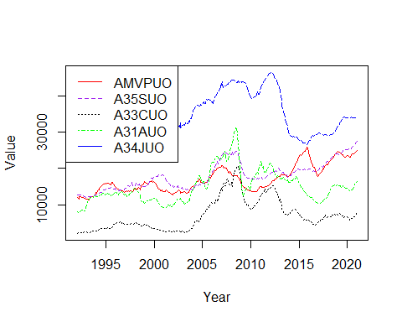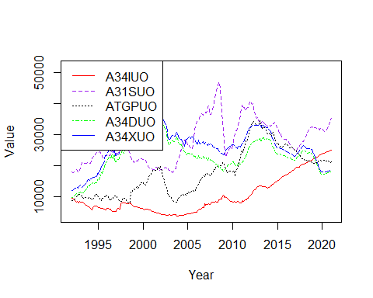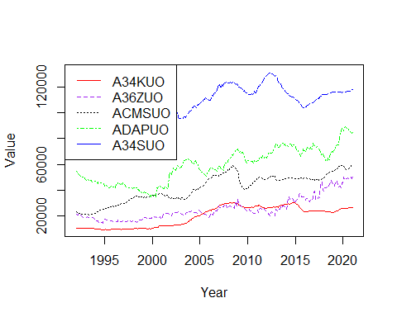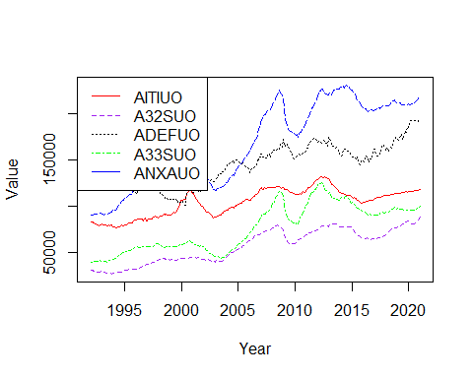

for (i in c(1,6,11,16,21,26,31,36,41,46))  
{  
 Series1 <- ts(data = unfilledorders_mmv_ordered_standev_unadj[,i], start=c(1992), end=c(2021), frequency = 12)  
 Series2 <- ts(data = unfilledorders_mmv_ordered_standev_unadj[,i+1], start=c(1992), end=c(2021), frequency = 12)  
 Series3 <- ts(data = unfilledorders_mmv_ordered_standev_unadj[,i+2], start=c(1992), end=c(2021), frequency = 12)  
 Series4 <- ts(data = unfilledorders_mmv_ordered_standev_unadj[,i+3], start=c(1992), end=c(2021), frequency = 12)  
 Series5 <- ts(data = unfilledorders_mmv_ordered_standev_unadj[,i+4], start=c(1992), end=c(2021), frequency = 12)  
 ts.plot(Series1, Series2, Series3, Series4, Series5, gpars=list(xlab="Year", ylab="Value",lty=c(1:5)), col=rep(c("red","purple","black","green","blue")))  
 legend("topleft", legend = c(colnames(unfilledorders_mmv_ordered_standev_unadj)[i],colnames(unfilledorders_mmv_ordered_standev_unadj)[i+1],colnames(unfilledorders_mmv_ordered_standev_unadj)[i+2],colnames(unfilledorders_mmv_ordered_standev_unadj)[i+3],colnames(unfilledorders_mmv_ordered_standev_unadj)[i+4]), col = c("red","purple","black","green","blue"), lty=c(1:4))  
}

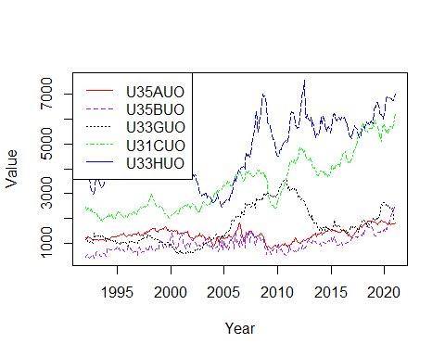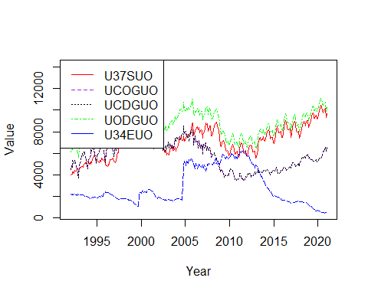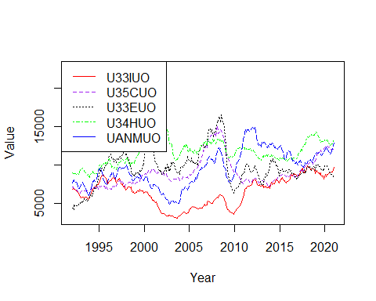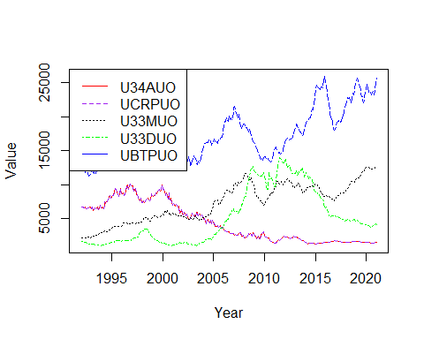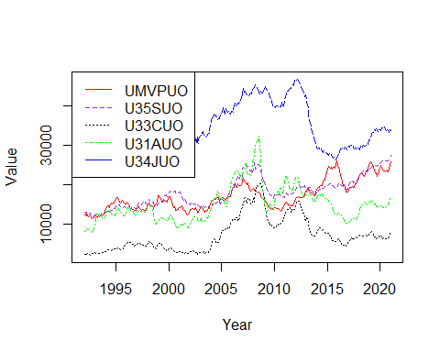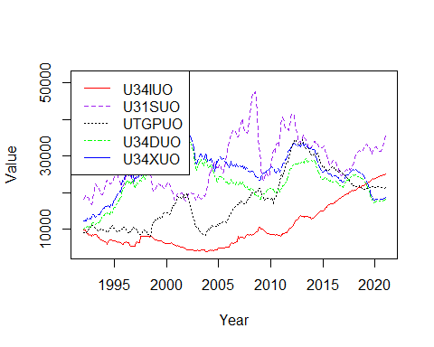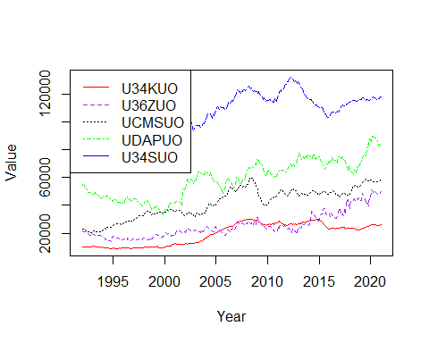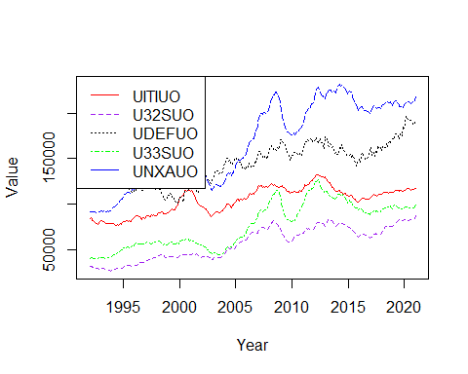

totalinv_order_sd <- order(colSds(as.matrix(totalinventories_dataframe_time[sapply(totalinventories_dataframe_time, is.numeric)]),na.rm = TRUE))  
totalinv_mmv_ordered_standev <- totalinv_mmv %>% select(all_of(totalinv_order_sd), ncol(totalinv_mmv))  
totalinv_mmv_ordered_standev_adj <- totalinv_mmv_ordered_standev %>% select(starts_with('A')) #158 Columns  
totalinv_mmv_ordered_standev_unadj <- totalinv_mmv_ordered_standev %>% select(starts_with('U')) #158 Columns  
for (i in c(1,6,11,16,21,26,31,36,41,46,51,56,61,66,71,76,81,86,91,96,101,106,111,116,121,126,131,136,141,146,151))  
{  
 Series1 <- ts(data = totalinv_mmv_ordered_standev_adj[,i], start=c(1992), end=c(2021), frequency = 12)  
 Series2 <- ts(data = totalinv_mmv_ordered_standev_adj[,i+1], start=c(1992), end=c(2021), frequency = 12)  
 Series3 <- ts(data = totalinv_mmv_ordered_standev_adj[,i+2], start=c(1992), end=c(2021), frequency = 12)  
 Series4 <- ts(data = totalinv_mmv_ordered_standev_adj[,i+3], start=c(1992), end=c(2021), frequency = 12)  
 Series5 <- ts(data = totalinv_mmv_ordered_standev_adj[,i+4], start=c(1992), end=c(2021), frequency = 12)  
 ts.plot(Series1, Series2, Series3, Series4, Series5, gpars=list(xlab="Year", ylab="Value",lty=c(1:5)), col=rep(c("red","purple","black","green","blue")))  
 legend("topleft", legend = c(colnames(totalinv_mmv_ordered_standev_adj)[i],colnames(totalinv_mmv_ordered_standev_adj)[i+1],colnames(totalinv_mmv_ordered_standev_adj)[i+2],colnames(totalinv_mmv_ordered_standev_adj)[i+3],colnames(totalinv_mmv_ordered_standev_adj)[i+4]), col = c("red","purple","black","green","blue"), lty=c(1:4))  
}

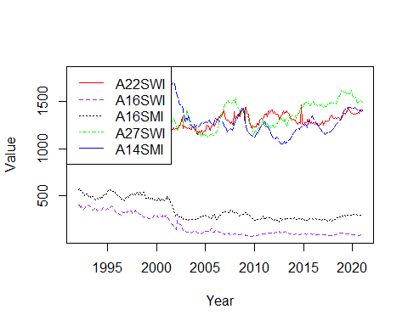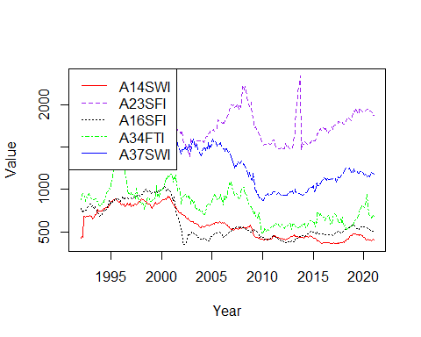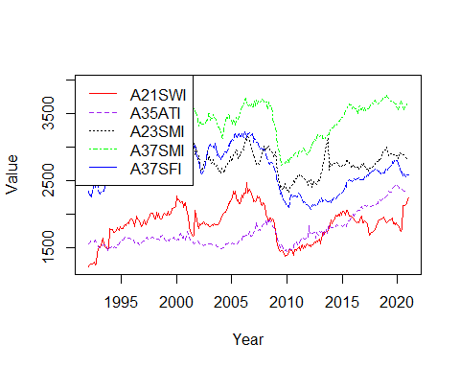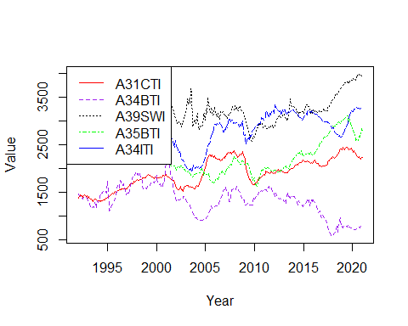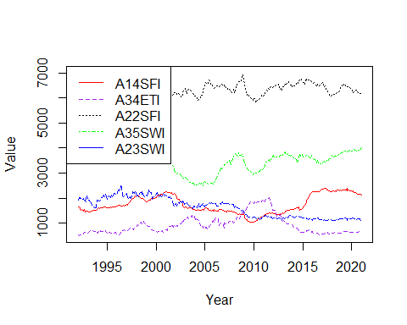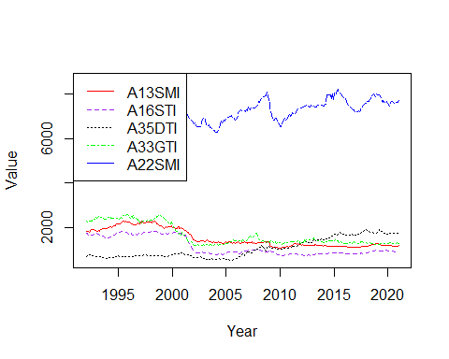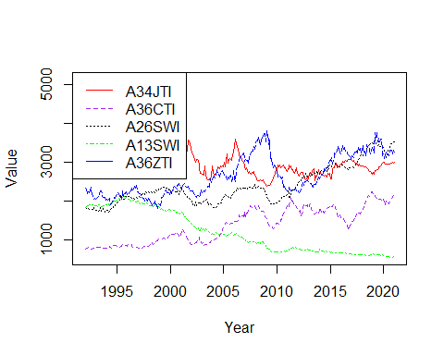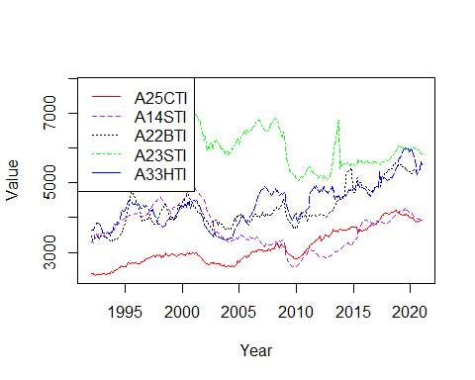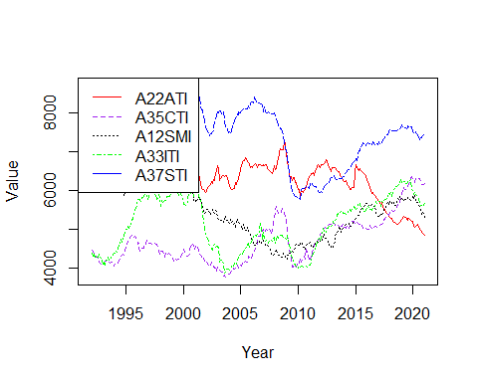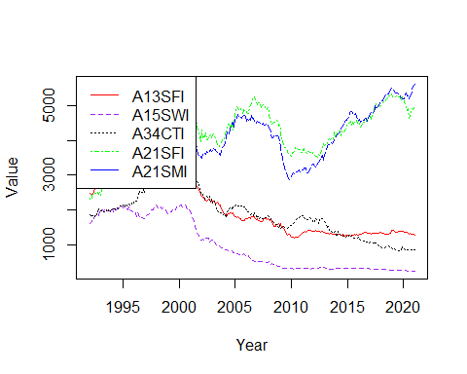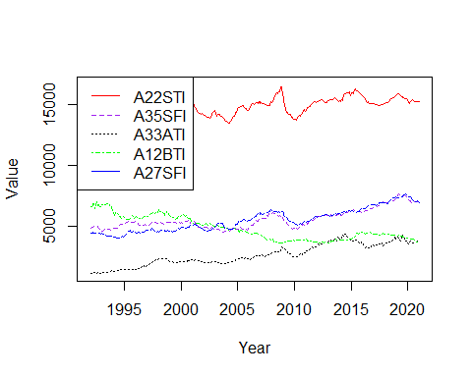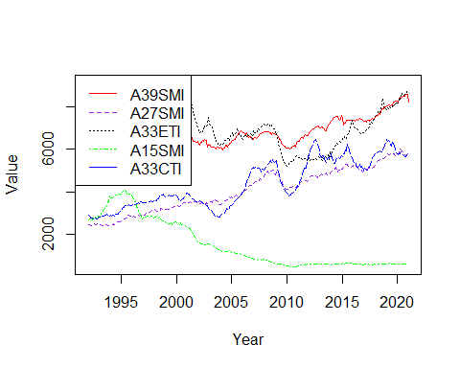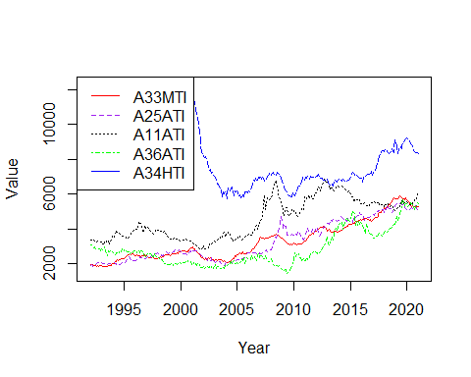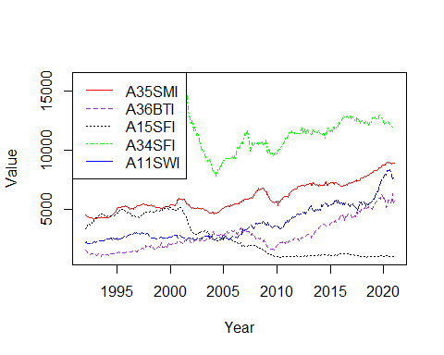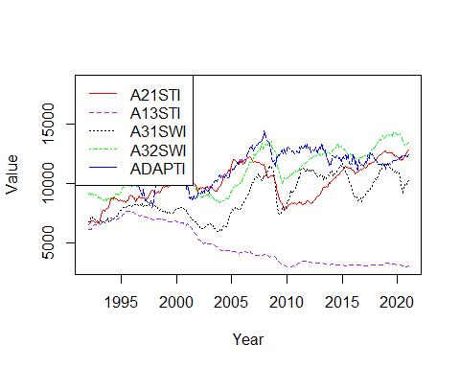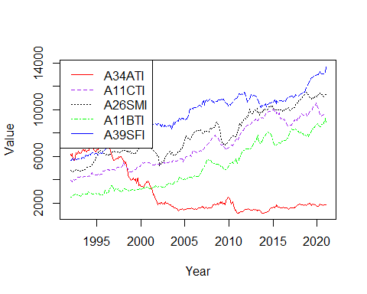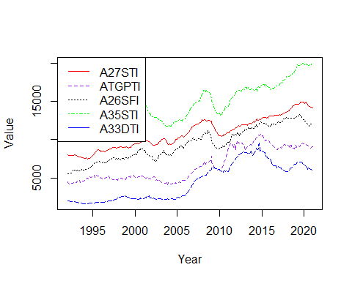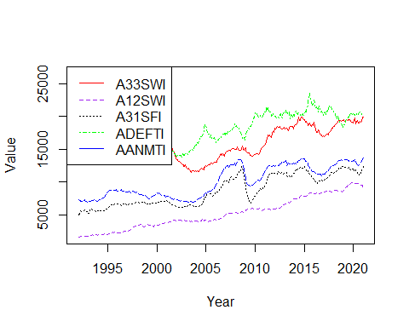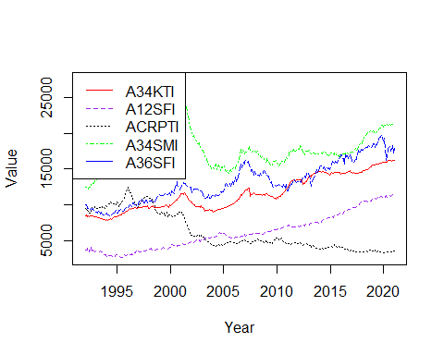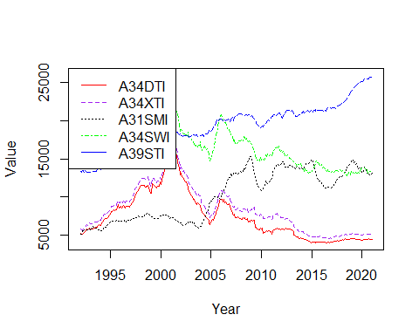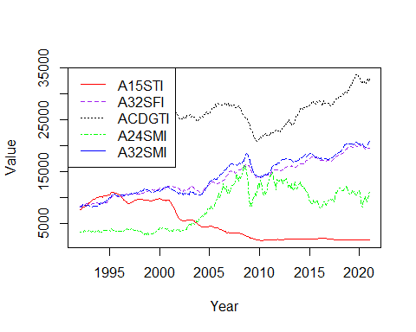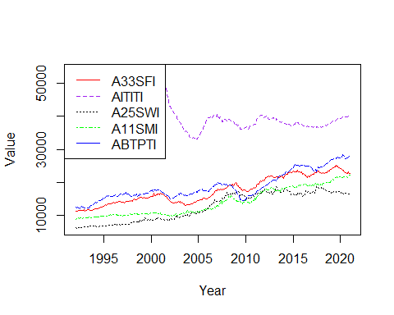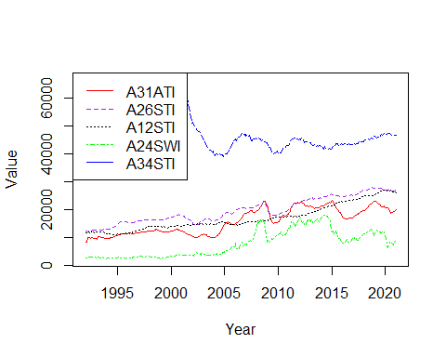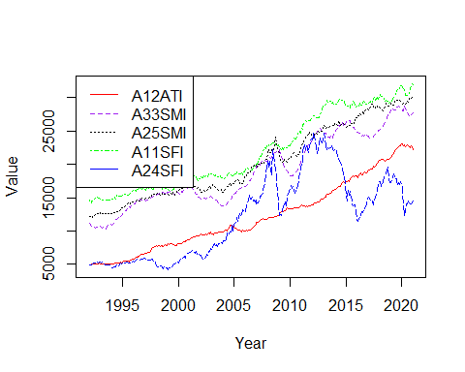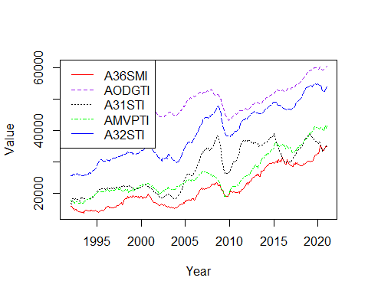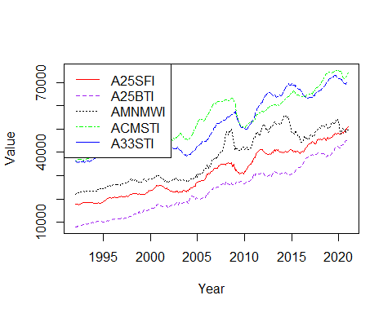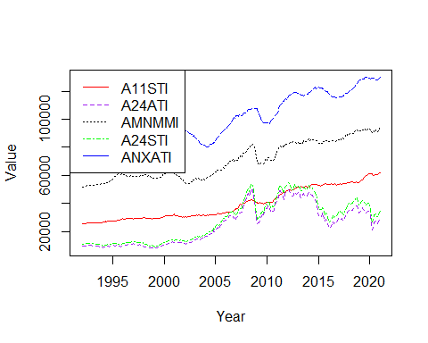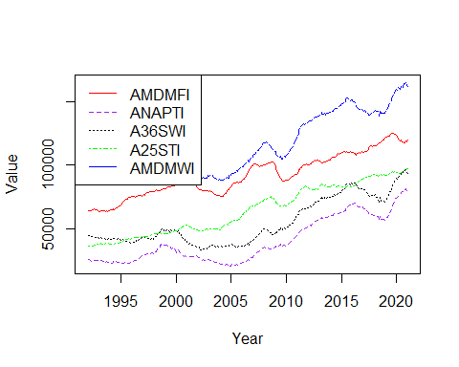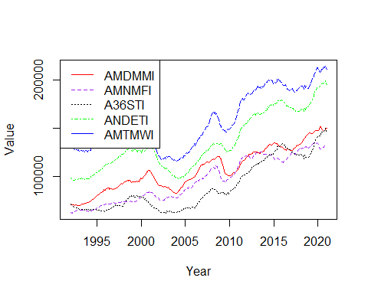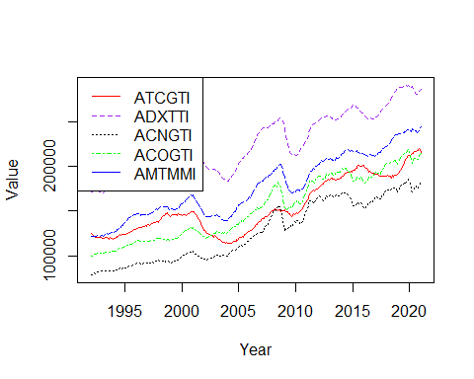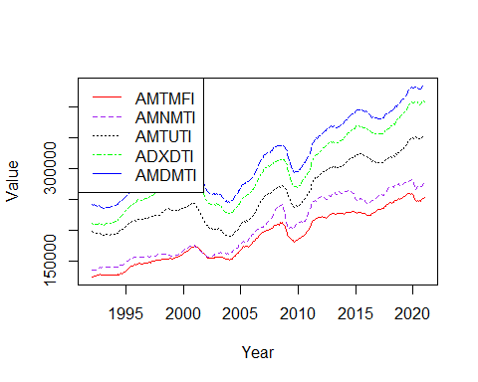

for (i in c(1,6,11,16,21,26,31,36,41,46,51,56,61,66,71,76,81,86,91,96,101,106,111,116,121,126,131,136,141,146,151))  
{  
 Series1 <- ts(data = totalinv_mmv_ordered_standev_unadj[,i], start=c(1992), end=c(2021), frequency = 12)  
 Series2 <- ts(data = totalinv_mmv_ordered_standev_unadj[,i+1], start=c(1992), end=c(2021), frequency = 12)  
 Series3 <- ts(data = totalinv_mmv_ordered_standev_unadj[,i+2], start=c(1992), end=c(2021), frequency = 12)  
 Series4 <- ts(data = totalinv_mmv_ordered_standev_unadj[,i+3], start=c(1992), end=c(2021), frequency = 12)  
 Series5 <- ts(data = totalinv_mmv_ordered_standev_unadj[,i+4], start=c(1992), end=c(2021), frequency = 12)  
 ts.plot(Series1, Series2, Series3, Series4, Series5, gpars=list(xlab="Year", ylab="Value",lty=c(1:5)), col=rep(c("red","purple","black","green","blue")))  
 legend("topleft", legend = c(colnames(totalinv_mmv_ordered_standev_unadj)[i],colnames(totalinv_mmv_ordered_standev_unadj)[i+1],colnames(totalinv_mmv_ordered_standev_unadj)[i+2],colnames(totalinv_mmv_ordered_standev_unadj)[i+3],colnames(totalinv_mmv_ordered_standev_unadj)[i+4]), col = c("red","purple","black","green","blue"), lty=c(1:4))  
}

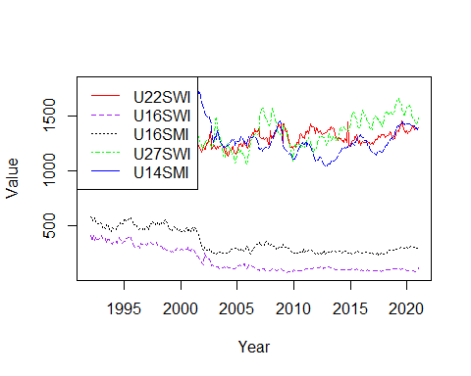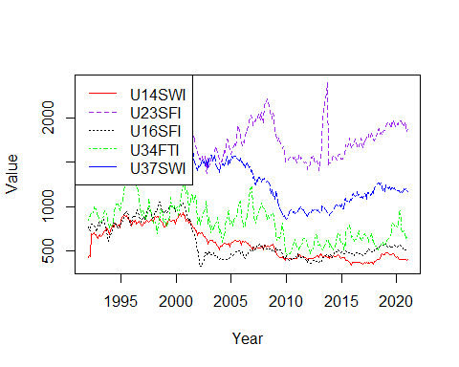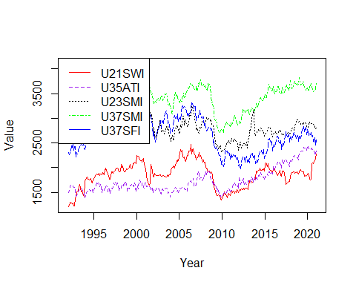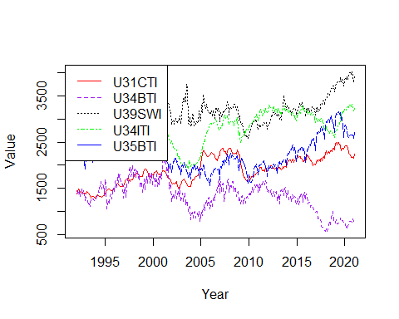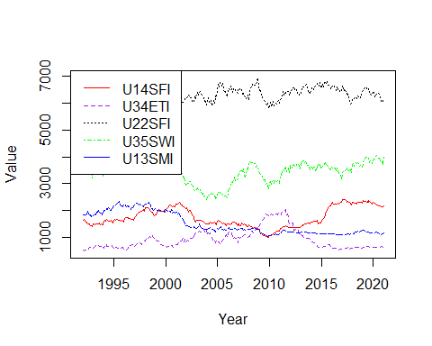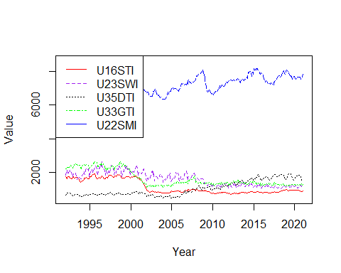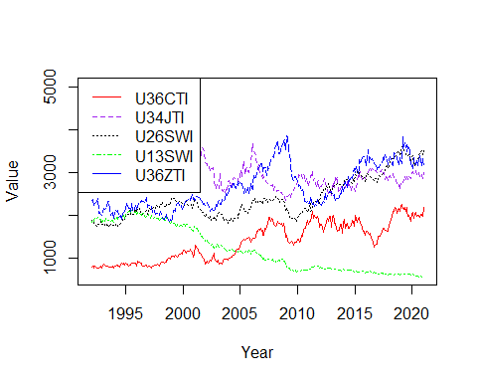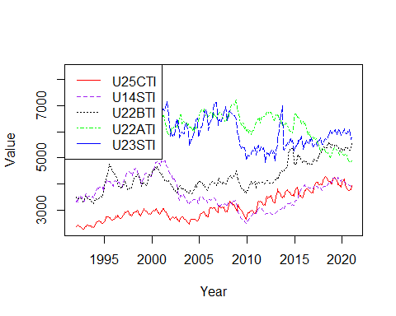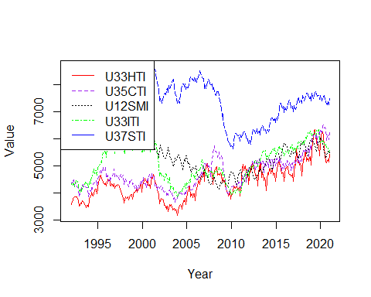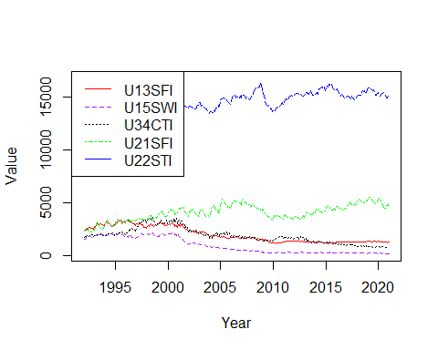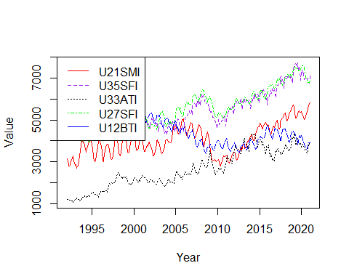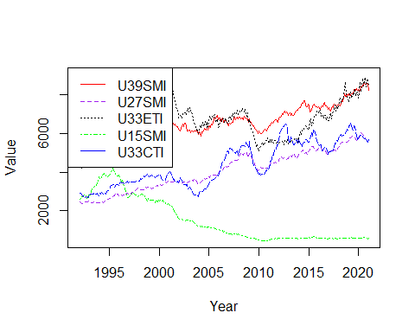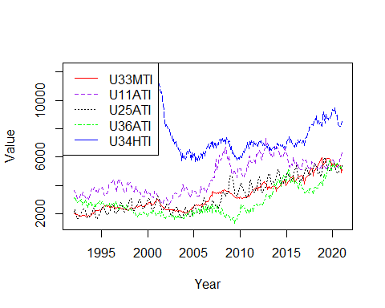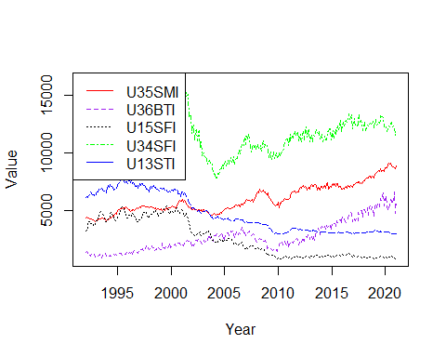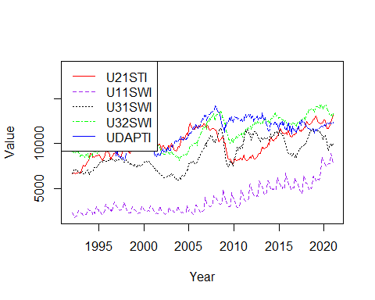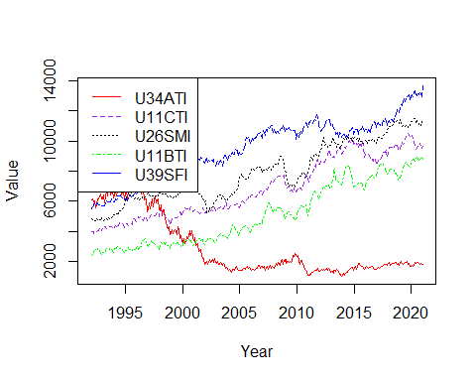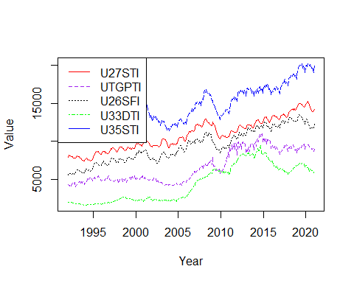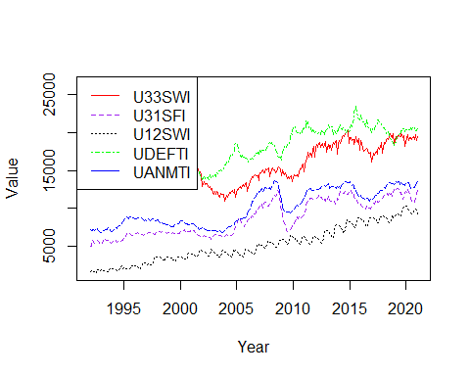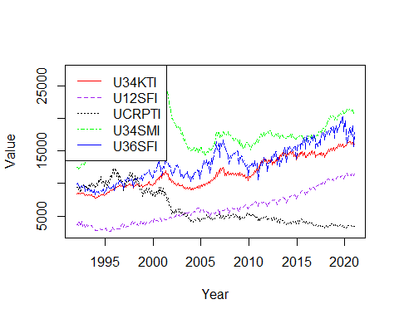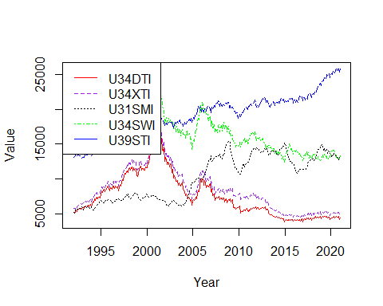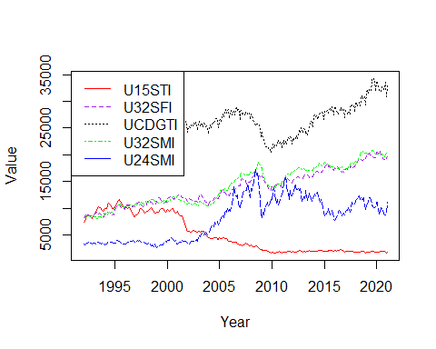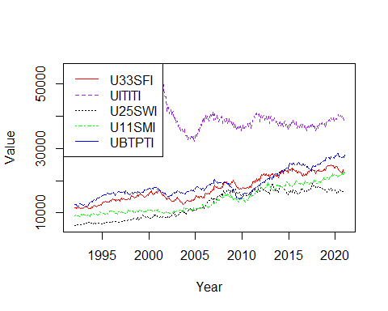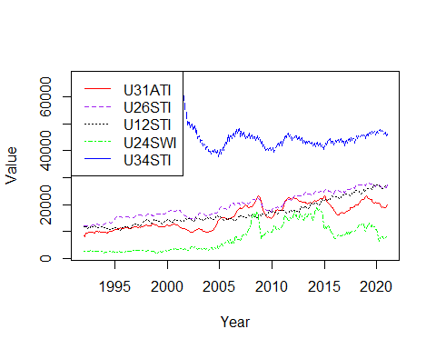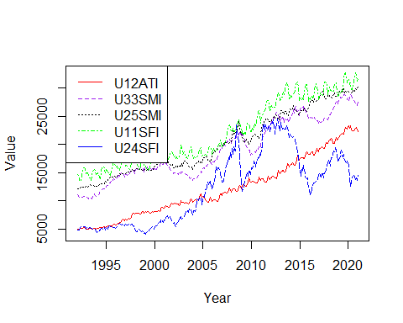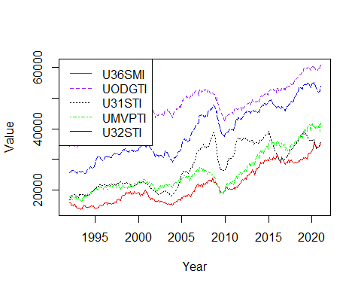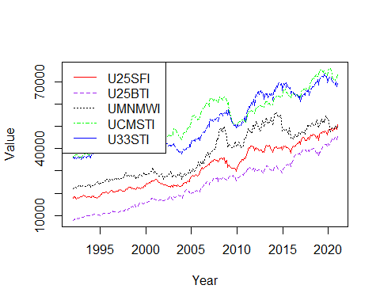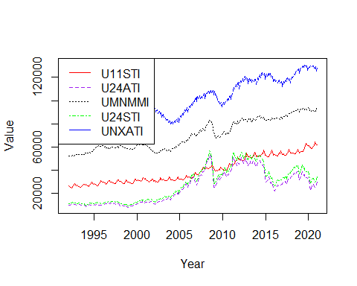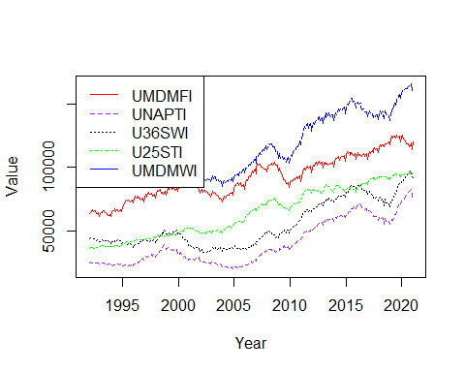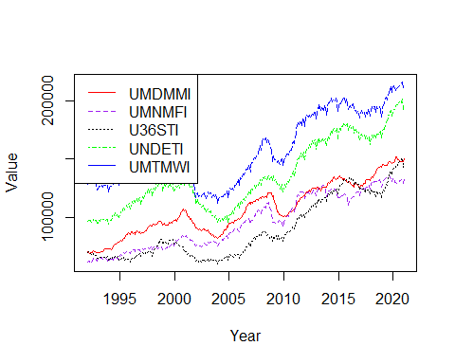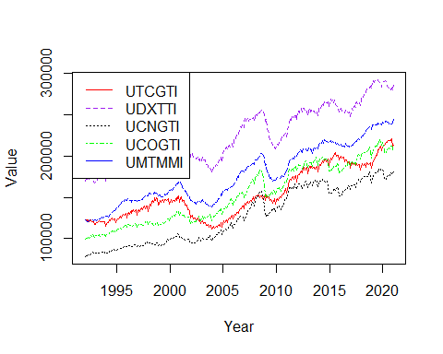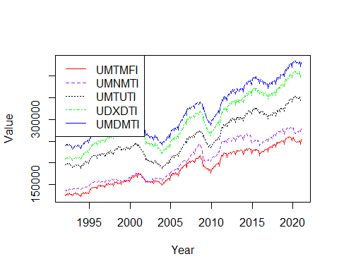

invtoship_order_sd <- order(colSds(as.matrix(inventoriestoshipments_dataframe_time[sapply(inventoriestoshipments_dataframe_time, is.numeric)]),na.rm = TRUE))  
invtoship_mmv_ordered_standev <- invtoship_mmv %>% select(all_of(invtoship_order_sd), ncol(invtoship_mmv))  
invtoship_mmv_ordered_standev_adj <- invtoship_mmv_ordered_standev %>% select(starts_with('A')) #24 Columns  
invtoship_mmv_ordered_standev_unadj <- invtoship_mmv_ordered_standev %>% select(starts_with('U')) #24 Columns  
for (i in c(1,6,11,16))  
{  
 Series1 <- ts(data = invtoship_mmv_ordered_standev_adj[,i], start=c(1992), end=c(2021), frequency = 12)  
 Series2 <- ts(data = invtoship_mmv_ordered_standev_adj[,i+1], start=c(1992), end=c(2021), frequency = 12)  
 Series3 <- ts(data = invtoship_mmv_ordered_standev_adj[,i+2], start=c(1992), end=c(2021), frequency = 12)  
 Series4 <- ts(data = invtoship_mmv_ordered_standev_adj[,i+3], start=c(1992), end=c(2021), frequency = 12)  
 Series5 <- ts(data = invtoship_mmv_ordered_standev_adj[,i+4], start=c(1992), end=c(2021), frequency = 12)  
 ts.plot(Series1, Series2, Series3, Series4, Series5, gpars=list(xlab="Year", ylab="Value",lty=c(1:5)), col=rep(c("red","purple","black","green","blue")))  
 legend("topleft", legend = c(colnames(invtoship_mmv_ordered_standev_adj)[i],colnames(invtoship_mmv_ordered_standev_adj)[i+1],colnames(invtoship_mmv_ordered_standev_adj)[i+2],colnames(invtoship_mmv_ordered_standev_adj)[i+3],colnames(invtoship_mmv_ordered_standev_adj)[i+4]), col = c("red","purple","black","green","blue"), lty=c(1:4))  
}

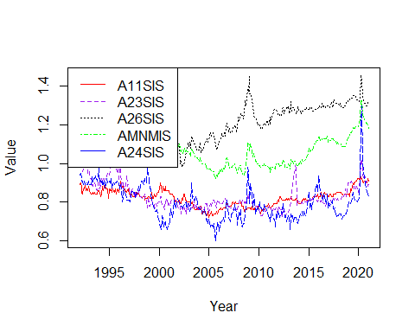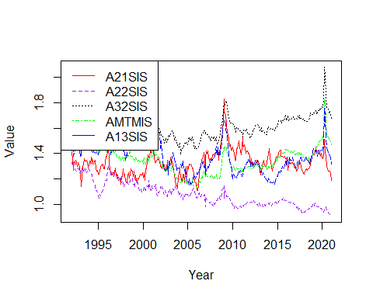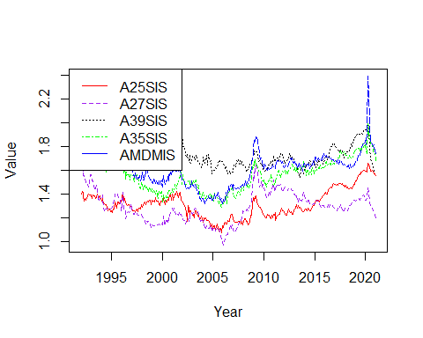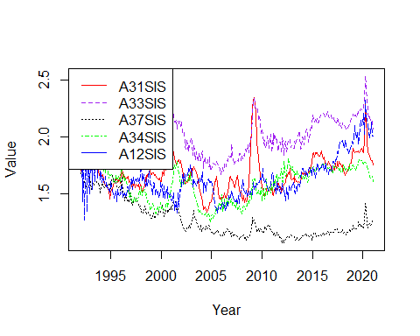

for (i in c(1,6,11,16))  
{  
 Series1 <- ts(data = invtoship_mmv_ordered_standev_unadj[,i], start=c(1992), end=c(2021), frequency = 12)  
 Series2 <- ts(data = invtoship_mmv_ordered_standev_unadj[,i+1], start=c(1992), end=c(2021), frequency = 12)  
 Series3 <- ts(data = invtoship_mmv_ordered_standev_unadj[,i+2], start=c(1992), end=c(2021), frequency = 12)  
 Series4 <- ts(data = invtoship_mmv_ordered_standev_unadj[,i+3], start=c(1992), end=c(2021), frequency = 12)  
 Series5 <- ts(data = invtoship_mmv_ordered_standev_unadj[,i+4], start=c(1992), end=c(2021), frequency = 12)  
 ts.plot(Series1, Series2, Series3, Series4, Series5, gpars=list(xlab="Year", ylab="Value",lty=c(1:5)), col=rep(c("red","purple","black","green","blue")))  
 legend("topleft", legend = c(colnames(invtoship_mmv_ordered_standev_unadj)[i],colnames(invtoship_mmv_ordered_standev_unadj)[i+1],colnames(invtoship_mmv_ordered_standev_unadj)[i+2],colnames(invtoship_mmv_ordered_standev_unadj)[i+3],colnames(invtoship_mmv_ordered_standev_unadj)[i+4]), col = c("red","purple","black","green","blue"), lty=c(1:4))  
}

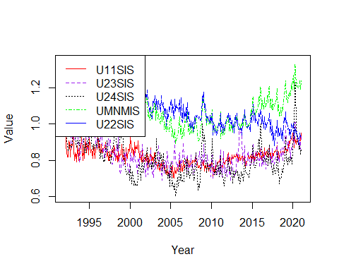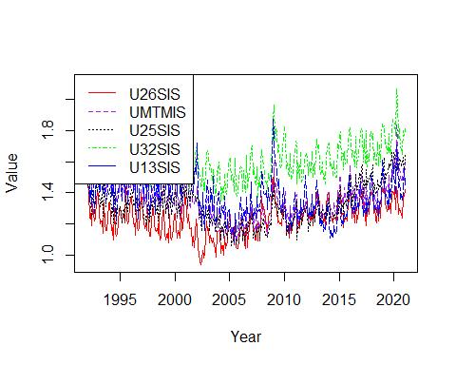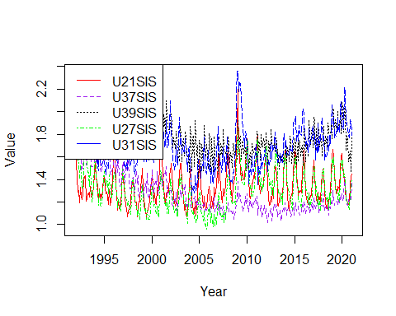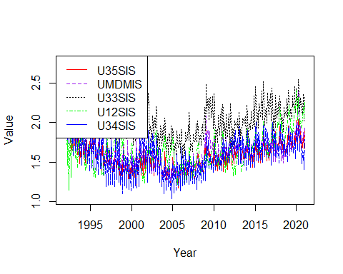

unfilltoship_order_sd <- order(colSds(as.matrix(unfilledorderstoshipments_dataframe_time[sapply(unfilledorderstoshipments_dataframe_time, is.numeric)]),na.rm = TRUE))  
unfilltoship_mmv_ordered_standev <- unfilltoship_mmv %>% select(all_of(unfilltoship_order_sd), ncol(unfilltoship_mmv))  
unfilltoship_mmv_ordered_standev_adj <- unfilltoship_mmv_ordered_standev %>% select(starts_with('A')) #9 Columns  
unfilltoship_mmv_ordered_standev_unadj <- unfilltoship_mmv_ordered_standev %>% select(starts_with('U')) #9 Columns  
for (i in c(1))  
{  
 Series1 <- ts(data = unfilltoship_mmv_ordered_standev_adj[,i], start=c(1992), end=c(2021), frequency = 12)  
 Series2 <- ts(data = unfilltoship_mmv_ordered_standev_adj[,i+1], start=c(1992), end=c(2021), frequency = 12)  
 Series3 <- ts(data = unfilltoship_mmv_ordered_standev_adj[,i+2], start=c(1992), end=c(2021), frequency = 12)  
 Series4 <- ts(data = unfilltoship_mmv_ordered_standev_adj[,i+3], start=c(1992), end=c(2021), frequency = 12)  
 Series5 <- ts(data = unfilltoship_mmv_ordered_standev_adj[,i+4], start=c(1992), end=c(2021), frequency = 12)  
 ts.plot(Series1, Series2, Series3, Series4, Series5, gpars=list(xlab="Year", ylab="Value",lty=c(1:5)), col=rep(c("red","purple","black","green","blue")))  
 legend("topleft", legend = c(colnames(unfilltoship_mmv_ordered_standev_adj)[i],colnames(unfilltoship_mmv_ordered_standev_adj)[i+1],colnames(unfilltoship_mmv_ordered_standev_adj)[i+2],colnames(unfilltoship_mmv_ordered_standev_adj)[i+3],colnames(unfilltoship_mmv_ordered_standev_adj)[i+4]), col = c("red","purple","black","green","blue"), lty=c(1:4))  
}

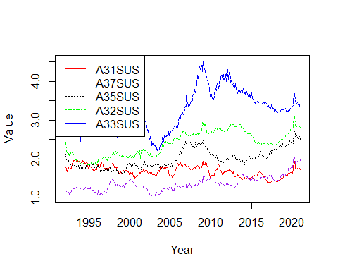

for (i in c(1))  
{  
 Series1 <- ts(data = unfilltoship_mmv_ordered_standev_unadj[,i], start=c(1992), end=c(2021), frequency = 12)  
 Series2 <- ts(data = unfilltoship_mmv_ordered_standev_unadj[,i+1], start=c(1992), end=c(2021), frequency = 12)  
 Series3 <- ts(data = unfilltoship_mmv_ordered_standev_unadj[,i+2], start=c(1992), end=c(2021), frequency = 12)  
 Series4 <- ts(data = unfilltoship_mmv_ordered_standev_unadj[,i+3], start=c(1992), end=c(2021), frequency = 12)  
 Series5 <- ts(data = unfilltoship_mmv_ordered_standev_unadj[,i+4], start=c(1992), end=c(2021), frequency = 12)  
 ts.plot(Series1, Series2, Series3, Series4, Series5, gpars=list(xlab="Year", ylab="Value",lty=c(1:5)), col=rep(c("red","purple","black","green","blue")))  
 legend("topleft", legend = c(colnames(unfilltoship_mmv_ordered_standev_unadj)[i],colnames(unfilltoship_mmv_ordered_standev_unadj)[i+1],colnames(unfilltoship_mmv_ordered_standev_unadj)[i+2],colnames(unfilltoship_mmv_ordered_standev_unadj)[i+3],colnames(unfilltoship_mmv_ordered_standev_unadj)[i+4]), col = c("red","purple","black","green","blue"), lty=c(1:4))  
}

